Advanced Character Animation ACCA5038
Beccy Burrows 2200741
Research of Animation Principles and Progression Reel

Contents Page

- Research into animation principles

- What went well

- What did not go well

- Storyboard

- Bibliography

- Early Animation

- Finished Animation

Research into Animation Principles

The 12 Animation Principles [1] And Applying Them to My Animation

- Timing and Spacing – speed and frame distance
- Squash and Stretch – gives objects flexibility
- Anticipation – sets audience up for an action about to happen
- Ease In and Ease Out – acceleration and deceleration for natural movement
- Follow Through/Overlapping Action – separate parts of objects move for natural movement
- Arcs – realistic movements are not usually straight, but arched
- Exaggeration – adds more appeal and more readability
- Solid Drawing – clear silhouette, correct balance, and weight
- Appeal – adding charisma/individualism to your character
- Straight Ahead Action and Pose to Pose – adds detail and simplicity when combined
- Secondary Action – adds more life to animation
- Staging – placement and background to make purpose

Timing and Spacing

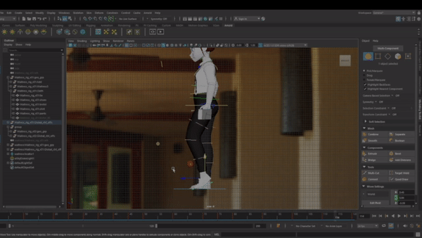

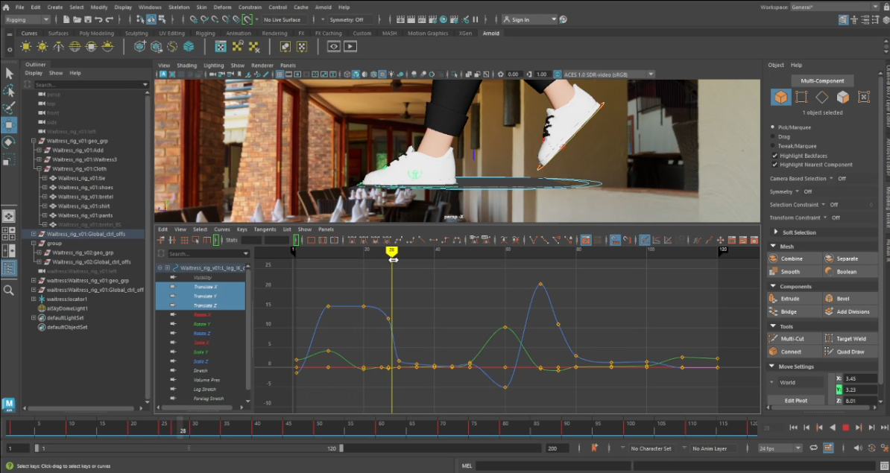

My animation is 24fps and 120 frames. I used the graph editor to show the timing and spacing of my animation and used it to edit to create smoother transitions between moves.

Squash and Stretch

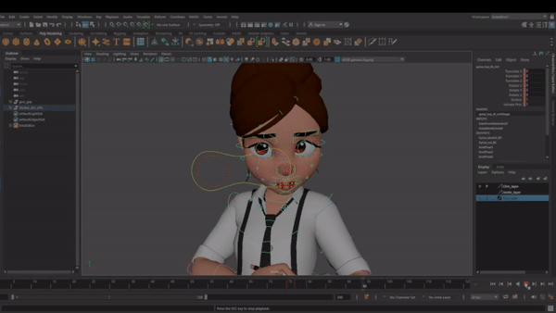

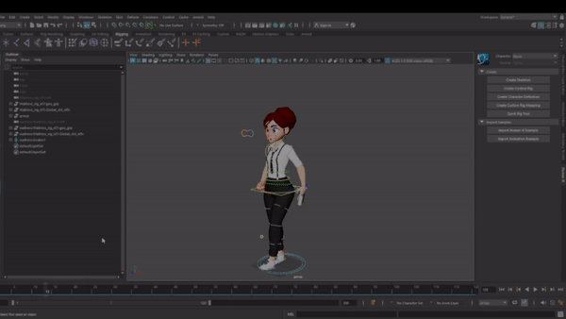

I demonstrated the use of squashing and stretching through stretching the torso and squashing it when my character walks, which shows a shift in weight and adds more character to my animation. I also showed squash and stretching through sucking in the cheeks and blowing them out when the character blows hair out of her face and lifting the shoulders and torso to seem surprised.

Anticipation

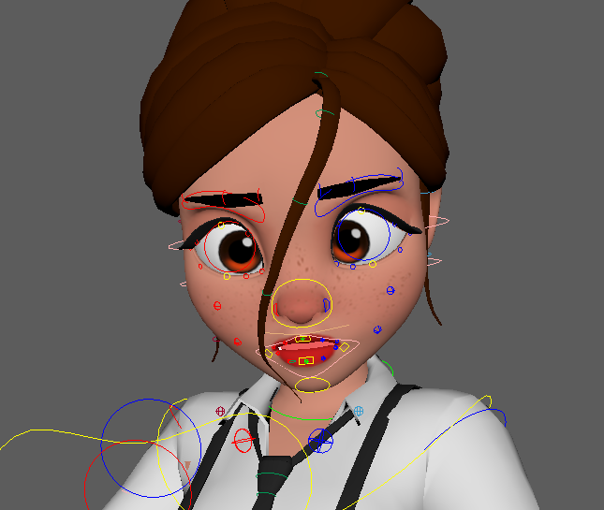

I showed anticipation through sucking in the characters cheeks, which suggests to the audience she is about to blow out to push her hair back into place.

Ease in and ease out.

I used easing in and easing out to simulate a more natural movement with my characters walk reel. Originally, my character was to stop walking and start again which shows the use of easing in and out and the deceleration of coming to a natural stop when walking.

Follow through and overlapping action

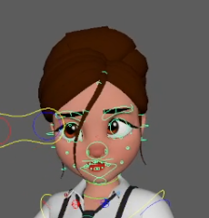

The use of easing in and out with my walk shows the follow through and overlapping of the arms swinging down once my character has come to a stop. It is also demonstrated when my character’s facial expressions stop moving after blowing her hair, yet her hair still moves from the impact of the blow hitting it.

Arcs

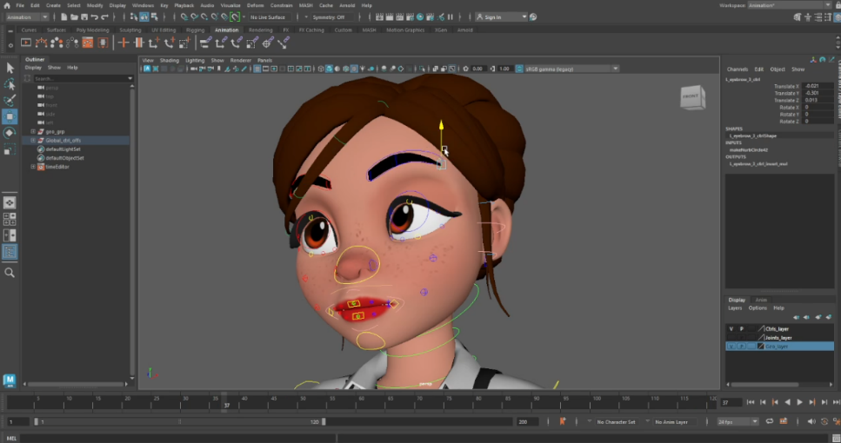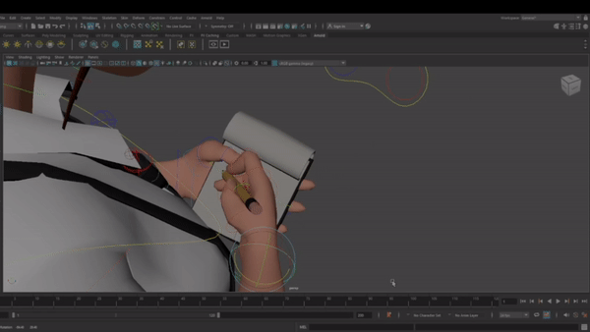

Arcs are shown throughout my character’s movement, especially when my character looks up from writing in a swooping motion, and the writing on the paper. Arcs are also noticeable when my character moves her legs in the walk reel.

Exaggeration

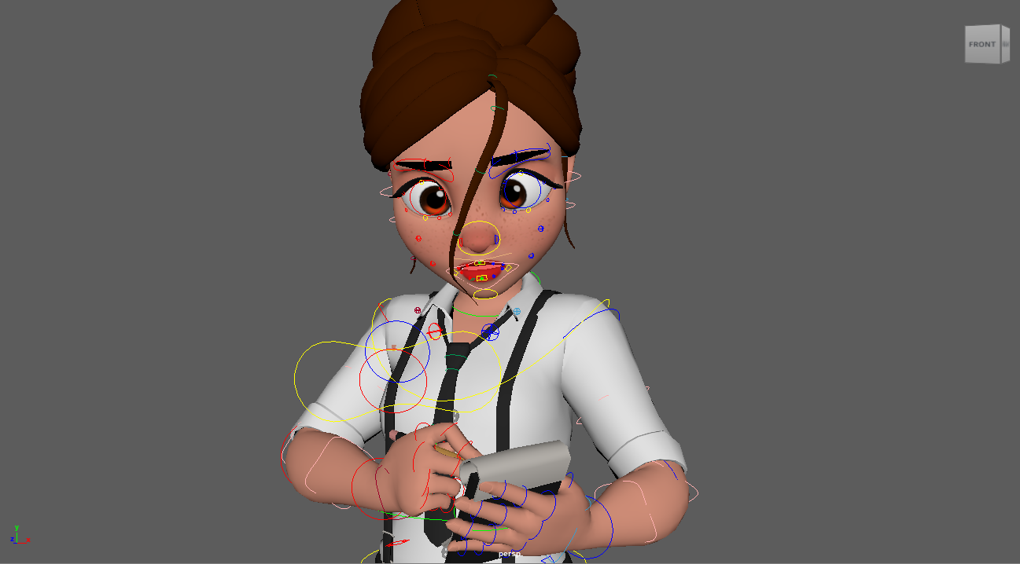

Exaggeration is clear in my animation through the exaggerated movements of the squashing and stretching within the walk reel, and the puffing out cheeks and the amount that the characters hair falls into her face.

Solid drawing

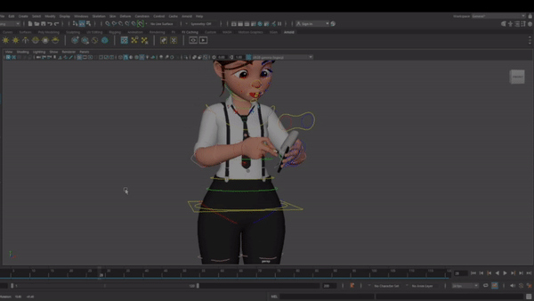
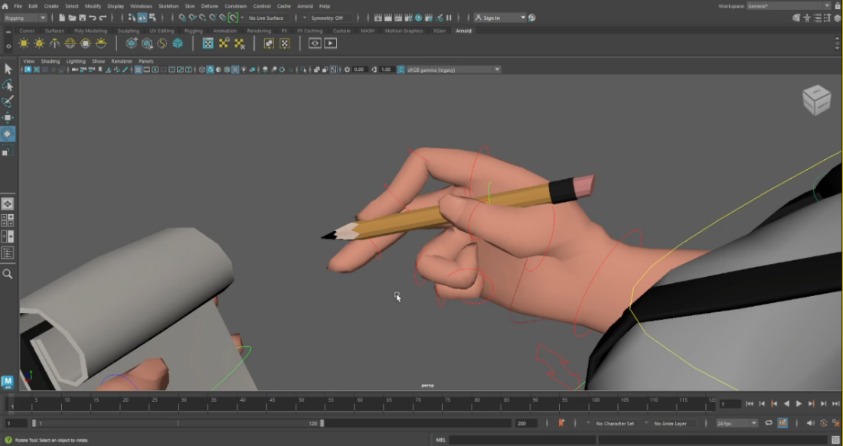
Elements of solid drawing are noticeable from my character's clear silhouette and showing correct weight and balance during the walk. Correct weight and balance are also shown through the positioning of holding the pencil and notepad, symbolizing they are quite light through the hold my character is positioned in.

Appeal

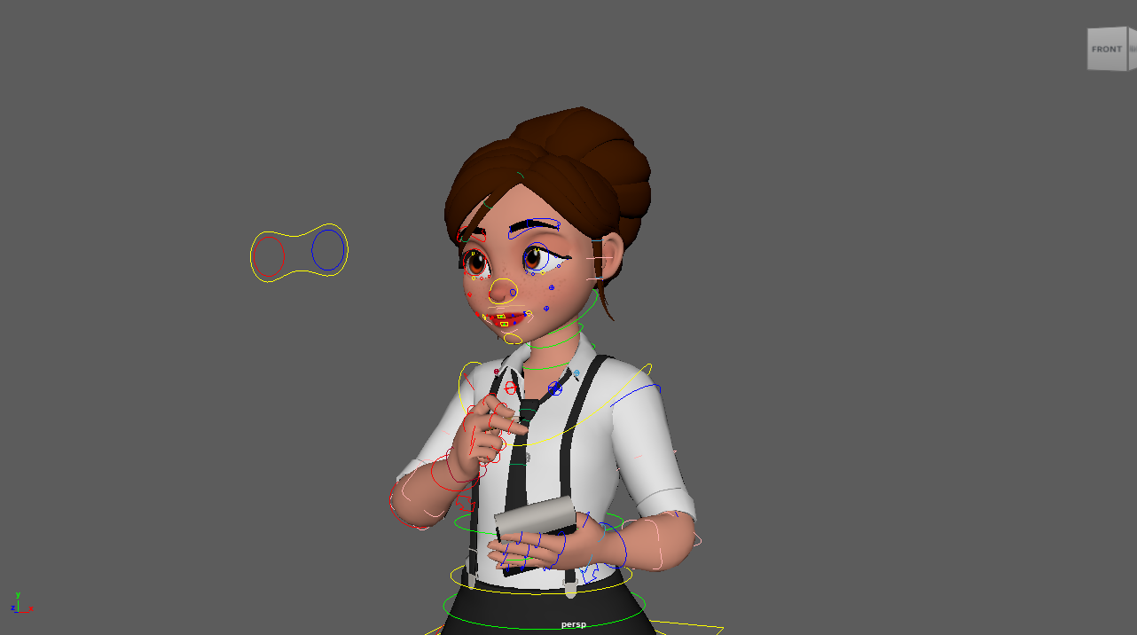
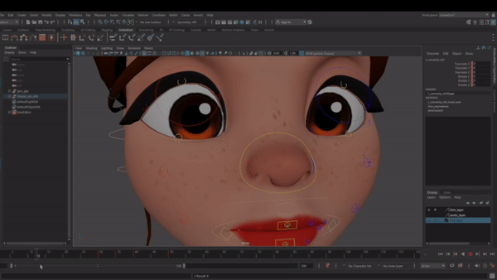

My character holds appeal most through her stylized features and large doe like eyes. This adds a gentle feel to my character, and gives of a friendly aura, which is what you would like to see in a waitress.

Straight ahead action and pose to pose
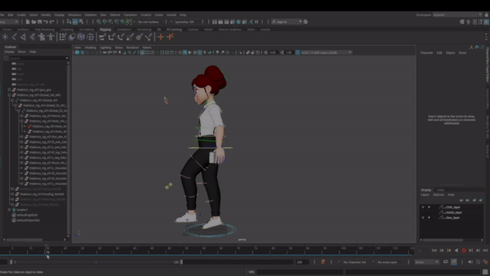
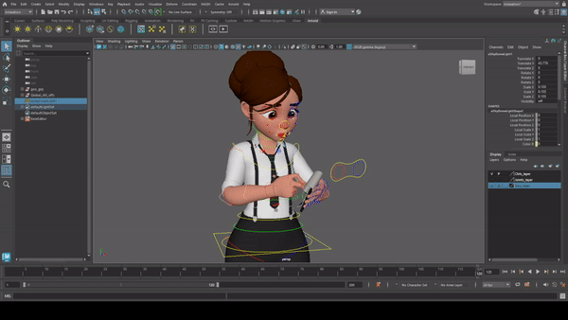

Pose to pose is shown through my characters walk reel, and how I positioned the main poses first. Straight ahead action is shown through the writing and nodding of my character, where I moved each pose slightly to imitate a smaller movement.

Secondary action

Secondary actions are shown through the movement of my character's shoulders when writing and walking, not only to show movement but also breathing, especially when my character gasps in surprise. Another way secondary action is implemented is through my characters blinking and smiling.

Staging

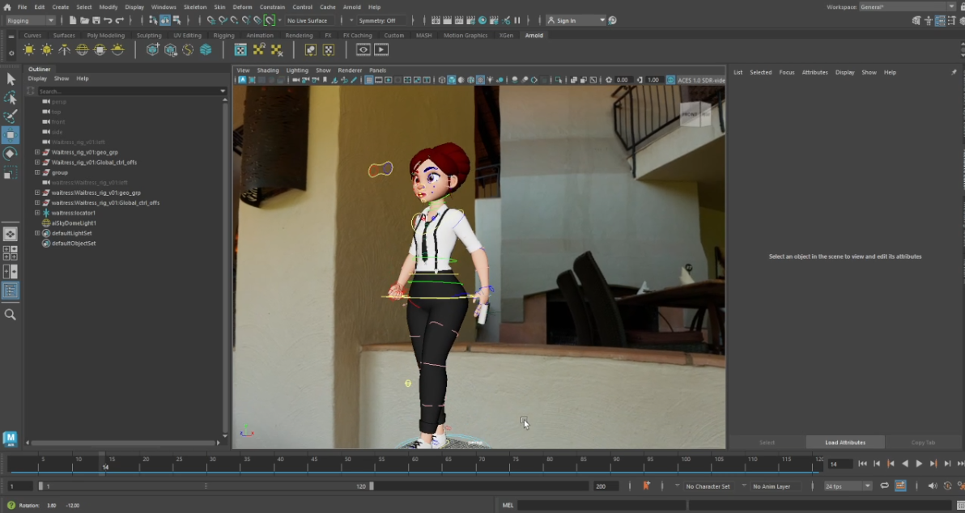
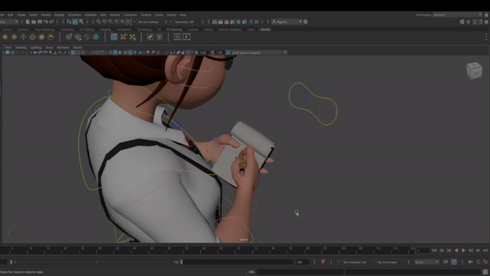

Staging is implemented through the actions my character takes, as writing on a notepad and pen and walking would be required within a waitress occupation. It is also implemented through the hdri that I used of a restaurant [2] which would be a place of interest for a waitress.

What went well with my animation

With my animation, I wanted to add a looped walk reel and a close-up, with facial expressions. I believe that I was able to successfully animate the facial expressions of my character, writing notes whilst listening to customers and blowing hair out of her face. I am proud of the hair movements as I was able to study my course mates face pulling similar expressions I wanted to implement, so I was able to really focus on the smaller details and movements of the face. My character responded to her hair falling with emotions of surprise and acted quickly by blowing her hair out of her face to be able to quickly get back to her job. I was able to add life to my animation through breathing, natural movement, and blinking. I also used locators within my animation, which meant I was able to move the pencil and notepad when the hand of my character would move, which made my animation simpler to animate, smoother and more realistic. I was able to model my character to hold a pencil accurately which I was also proud of as I struggled with this initially and had to improvise. And I was able to show realistic movement of writing within my animation.
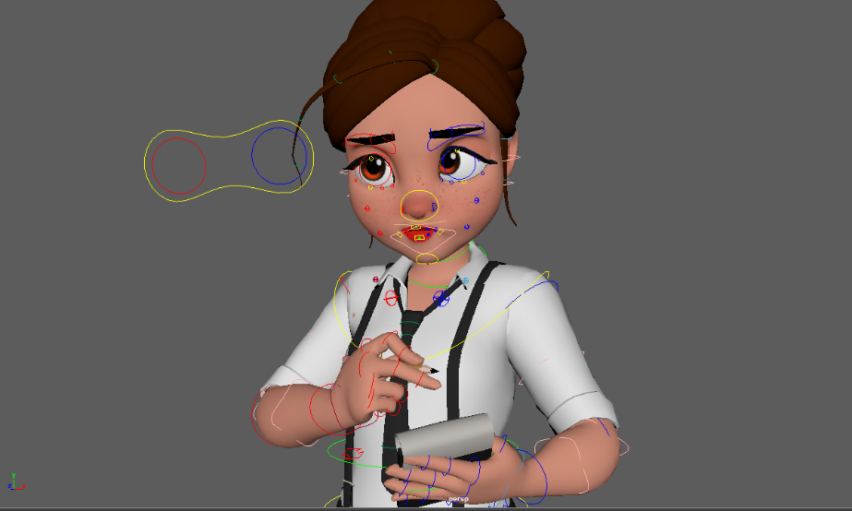
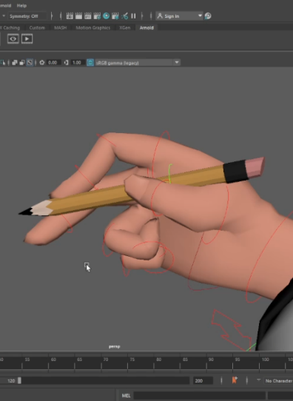
What did not go well with my animation

I ran into a lot of problems within creating my animation. I had trouble using locators in my animation as every time my character would walk, the pencil and notebook would not follow. I ended up deleting the pencil and notebook models as I was unsure how to fix this issue, however afterwards I found out that it was due to me highlighting my entire model when I was setting a key, which I now know is not how you animate, and my animating has improved drastically since learning this. To improve my animation, I added in the pencil and notebook model again with correct locators and animated the walk whilst my character holds the objects, to add realism to my waitress. Another issue I had with my animation was making the walk smoother and more realistic. I can notice there are elements of sliding the feet, which I tried to fix by moving the feet and bending them when my character moves them, and making sure they are straight when they are on the floor and moving my character not too much to prevent anymore sliding, however it is still noticeable and not to my standard of animation that I would of hoped. The pinky finger of my model also broke early on as I moved one of the nodes by accident and did not want to undo as I had perfected a part of my animation before realizing, so to fix this issue I attempted to move the pinky back into place, which was stressful, but I managed to make it look normal. I was also unable to render my character as the materials broke in Arnold renderer.
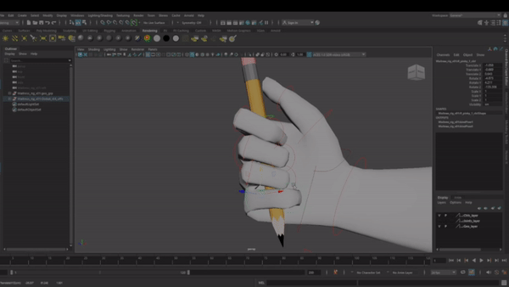
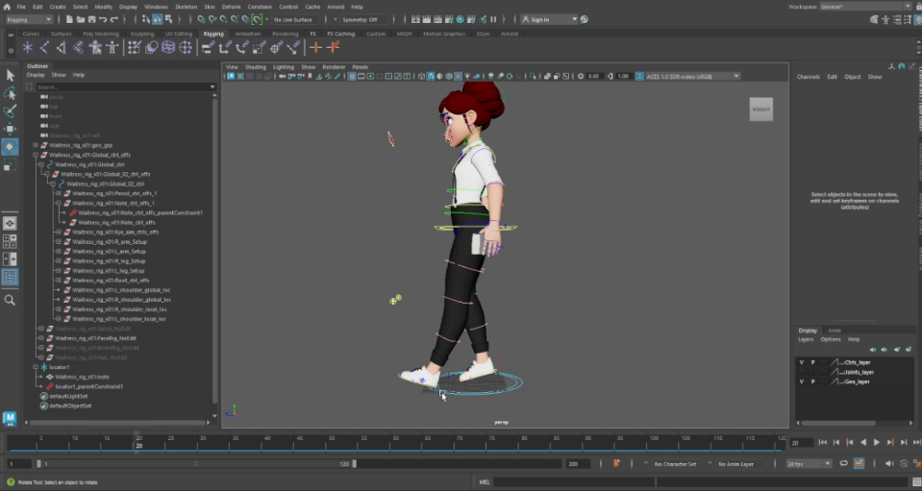

Storyboard
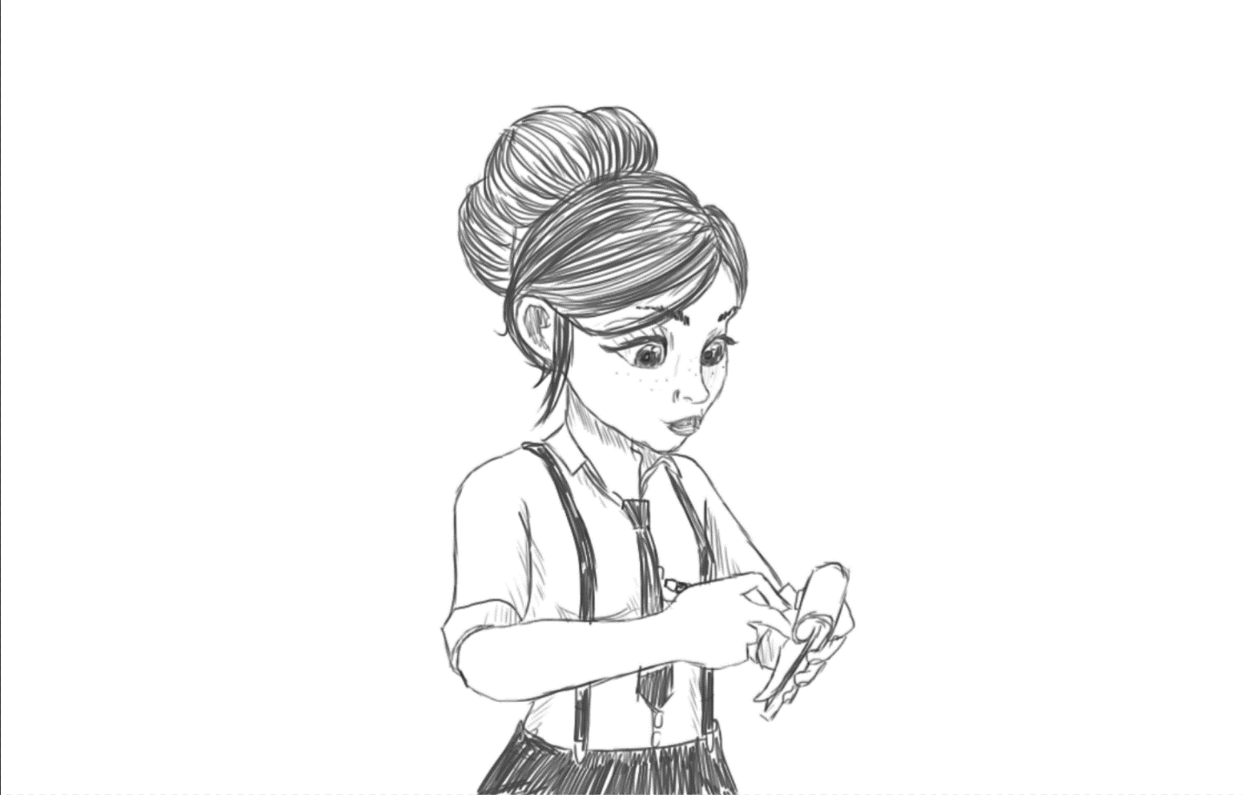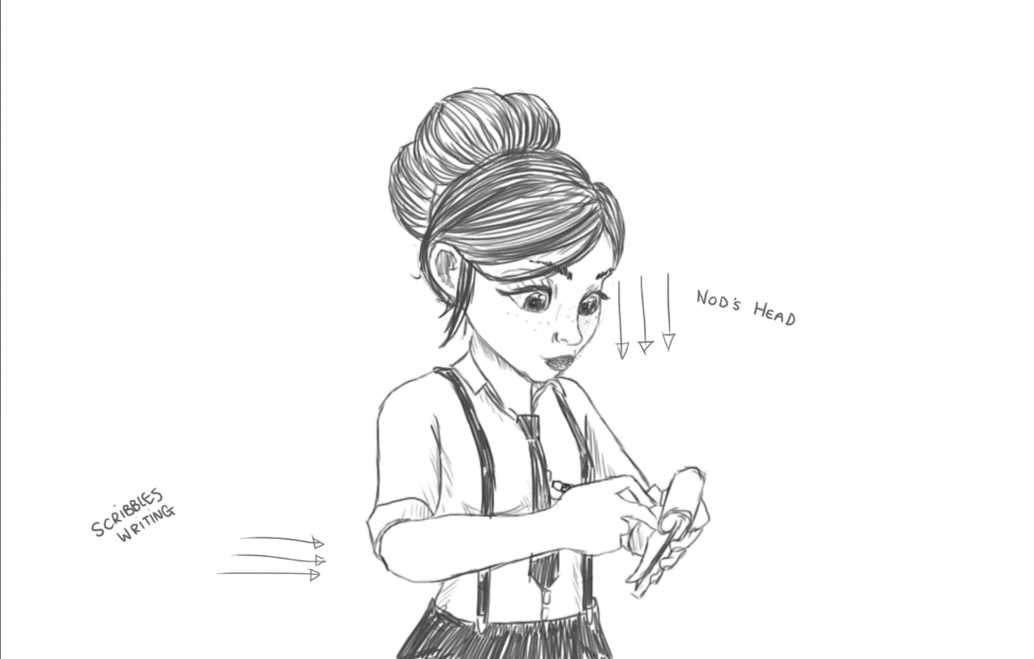
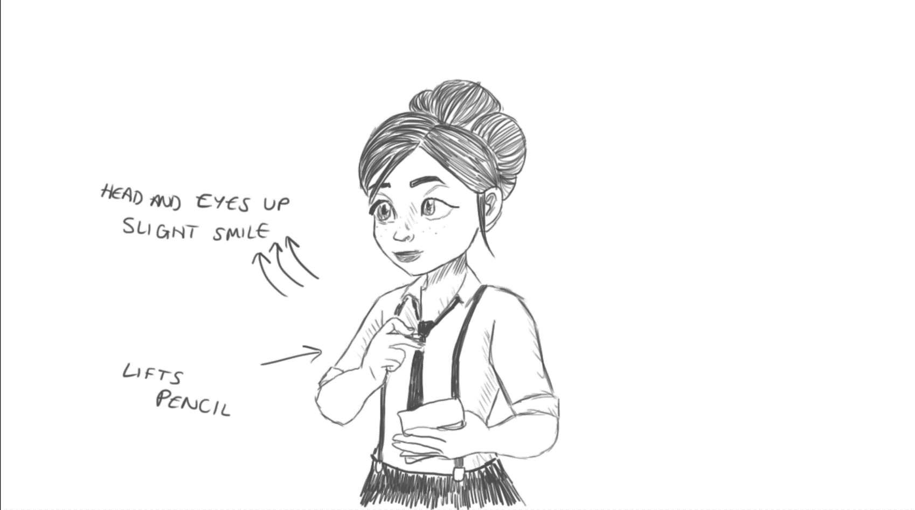

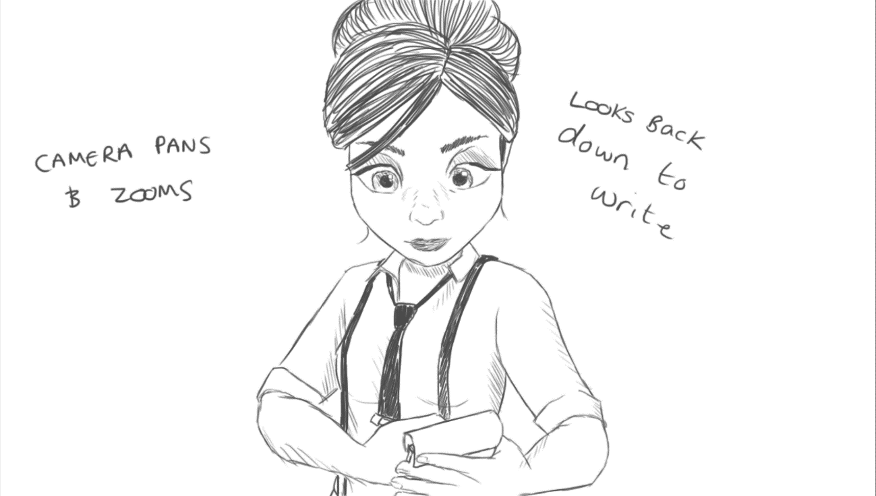

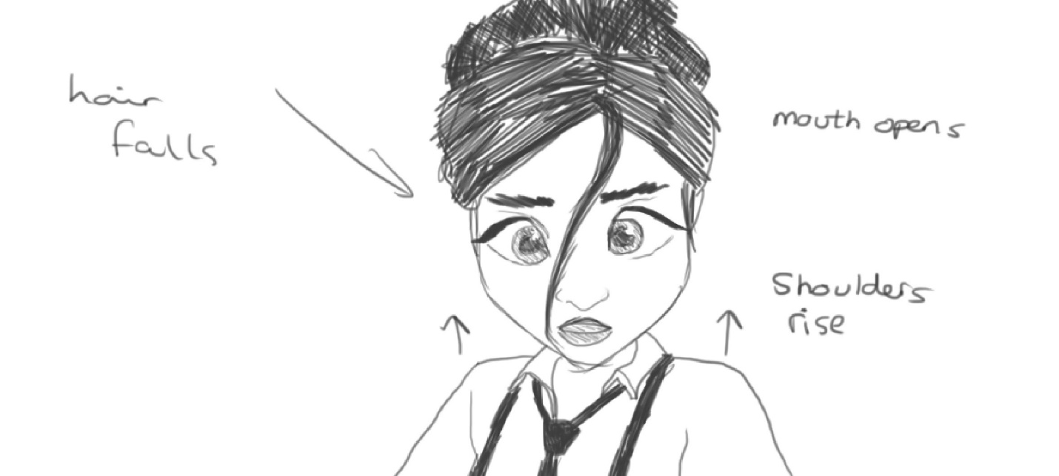

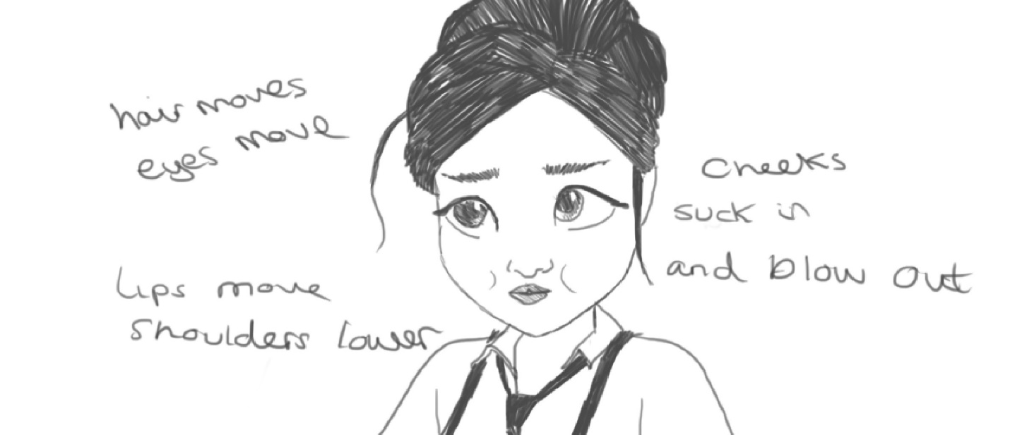

Bibliography

Links to websites I looked at for research.

[1] “What are the 12 principles of animation?” Pluralsight, https://www.pluralsight.com/blog/film-games/understanding-12-principles-animation (accessed Oct. 15, 2023).
[2] G. Zaal, “Bush restaurant HDRI • poly haven,” Poly Haven, https://polyhaven.com/a/bush_restaurant (accessed Nov. 19, 2023).

Beemore et al., “Writing stock photo,” Hand Holding Pencil Photos and Premium High Res Pictures - Getty Images, https://www.gettyimages.co.uk/photos/hand-holding-pencil (accessed Nov. 1, 2023).
Bing, https://www.bing.com/images/search?view=detailV2&ccid=FfWbXIb0&id=A0EFBA731C46CBCC396DF44579B9912D7485A707&thid=OIP.FfWbXIb09sshnRM6qcw9cAHaGt&mediaurl=https%3A%2F%2Fwebneel.com%2Fdaily%2Fsites%2Fdefault%2Ffiles%2Fimages%2Fdaily%2F04-2021%2F39-man-walking-cycle-2d-front-side-gif.gif&cdnurl=https%3A%2F%2Fth.bing.com%2Fth%2Fid%2FR.15f59b5c86f4f6cb219d133aa9cc3d70%3Frik%3DB6eFdC2RuXlF9A%26pid%3DImgRaw%26r%3D0&exph=876&expw=966&q=walking%2Banimation&simid=608011123106320087&FORM=IRPRST&ck=5B6E7989B7E4AABC31A74106D435D4D7&selectedIndex=2&itb=0&ajaxhist=0&ajaxserp=0 (accessed Nov. 4, 2023).
Neel, “40 human walk cycle animation GIF files for animators,” Webneel.com, https://webneel.com/human-walk-cycle-animation-gif-files-animators (accessed Nov. 4, 2023).
“Animated people walking,” Animated People Walking - ClipArt Best, https://www.clipartbest.com/animated-people-walking (accessed Nov. 4, 2023).
21 best animation tips for beginners and beyond | skillshare blog, https://www.skillshare.com/en/blog/21-best-animation-tips-for-beginners-and-beyond/ (accessed Nov. 7, 2023).
Bizofan, “The ultimate guide to how to improve your animation skills,” Business of Animation, https://businessofanimation.com/ultimate-guide-to-improve-your-animation-skills-for-animators/ (accessed Nov. 7, 2023).
Roanokecollege, “Class writing GIF by Roanoke College - Find & Share on giphy,” GIPHY, https://giphy.com/gifs/roanokecollege-writing-take-notes-ronokecollege-ME34OYOE0dTajpPRhZ (accessed Nov. 7, 2023).

ShotStash, “Download writing on Notepad Royalty Free Stock Photo and image,” ShotStash, https://shotstash.com/photo/writing-notepad/ (accessed Nov. 7, 2023).
T. Argentin, “10 Clés Pour Faire de Bonnes Fiches de Révision,” Femme d’Influence Magazine, https://femmedinfluence.fr/10-cles-faire-bonnes-fiches-de-revision/ (accessed Nov. 7, 2023).
J. K. Riki, F. Engländer, and J. Taback, “51 great animation exercises to master,” Animator Island, https://www.animatorisland.com/51-great-animation-exercises-to-master/ (accessed Nov. 9, 2023).
Rustyanimation, “Walk cycle animation - step by step tutorial,” Rusty Animator, https://rustyanimator.com/animation-walk-cycle/ (accessed Nov. 10, 2023).
Top 10 best ’waitress’-movies from the years 2010 to 2019, https://www.moviemeter.com/movies/top-10-best-waitress-movies-released-in-the-years-2010-to-2019 (accessed Nov. 12, 2023).
Photo of Debora - &#26144; &#30011;.com, “【映画食べ歩き日記】第6回：「パルプ・フィクション」「ベイビー・ドライバー」...映画ファンに捧げる"シネマごはん"アメリカンダイナー編！: 映画ニュース,” 映画.com, https://eiga.com/news/20200828/4/ (accessed Dec. 7, 2023).
Photo of Ally Bing, https://www.bing.com/images/search?view=detailV2&ccid=qojNnpnM&id=D5A0AFF4E71BF4E0367517629A1C7FBCE91224D9&thid=OIP.qojNnpnMjflKFs6ek2eaDgHaKd&mediaurl=https%3A%2F%2Fi.pinimg.com%2Foriginals%2Ffe%2Fa8%2F6d%2Ffea86d139788408bf08e8fbb1021868d.jpg&cdnurl=https%3A%2F%2Fth.bing.com%2Fth%2Fid%2FR.aa88cd9e99cc8df94a16ce9e93679a0e%3Frik%3D2SQS6bx%252fHJpiFw%26pid%3DImgRaw%26r%3D0&exph=1200&expw=850&q=a%2Bstar%2Bisc%2Bborn%2Bally%2Bwaitress&simid=608019863381048067&form=IRPRST&ck=81ED3DD6A5E0FE3CD2F732376A005323&selectedindex=32&itb=0&ajaxhist=0&ajaxserp=0&vt=0&sim=11 (accessed Dec. 7, 2023).
Photo of Jenna
AcidBanter, “Waitress photo: Waitress promos,” Fanpop, https://www.fanpop.com/clubs/waitress/images/12417828/title/waitress-promos-photo (accessed Dec. 7, 2023).
Photo of Jill - “Amanda Seyfried,” IMDb, https://www.imdb.com/media/rm4164071680/nm1086543 (accessed Dec. 7, 2023)

Films that inspired me

Baby Driver - Edgar Wright, Baby Driver. 2017.
A Star Is Born – Bradley Cooper, A Star Is Born, 2018
Waitress the Musical – Sara Bareilles and Jessie Nelson, Waitress the Musical, 2016
Waitress – Adrienne Shelly, Waitress, 2007
Gone – Heitor Dhalia and Allison Burnett, Gone, 2012
The Incredibles 2 – Brad Bird, The Incredibles 2, 2018
Moana – Ron Clements, John Musker, Don Hall, Chris Williams, Moana, 2016
How to Train Your Dragon – Dean DeBlois, Chris Sanders, How to Train Your Dragon, 2010
Big Hero 6 – Don Hall, Chris Williams, Big Hero 6, 2014
Tangled – Nathan Greno, Byron Howard, Tangled, 2010
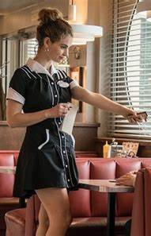
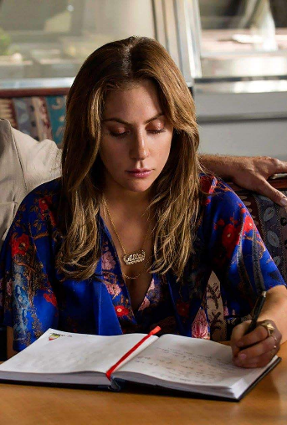
Characters that inspired me
Debora – Edgar Wright, Baby Driver, 2017.
Ally - Bradley Cooper, A Star Is Born, 2018
Jenna – Adrienne Shelly, Waitress, 2007
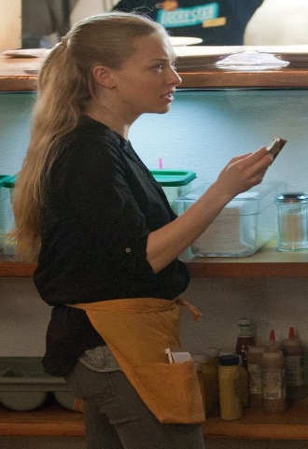
Jill - Heitor Dhalia and Allison Burnett,

Gone, 2012

Books read for research (All taken from UWTSD Library)

R. Taylor, Encyclopaedia of Animation Techniques. New Jersey: Chartwell Books, 2003.
A. Selby, Animation in Process. London: Laurence King, 2009.
S. Roberts, Character Animation in 3D. Oxford: Focal, 2004.
S. Roberts, Character Animation: 2d Skills for Better 3D. Oxford: Focal Press, 2007.
R. Williams, The Animator’s Survival Kit: A Manual of Methods, Principles and Formulas for Classical, Computer, Games, Stop Motion and Internet Animators. Farrar Straus & Giroux, 2012.
H. Rall, Animation: From Concept to Production. Boca Raton: CRC Press, 2018.

Videos watched for research
“Maya tutorial: How to create your first animation in maya,” YouTube, https://www.youtube.com/watch?v=-KZGAC19nHU (accessed Oct. 16, 2023).
“12 principles of animation (official full series),” YouTube, https://www.youtube.com/watch?v=uDqjIdI4bF4&t=237s (accessed Oct. 19, 2023).
“The 12 principles of animation with Emanuele Colombo,” YouTube, https://www.youtube.com/watch?v=EqMi1AzbFqs (accessed Nov. 6, 2023).
“How to start animating your characters: 4 principles,” YouTube, https://www.youtube.com/watch?v=ynBENQJBQbE (accessed Nov. 6, 2023).
“How to animate anything - 4 types of motion,” YouTube, https://www.youtube.com/watch?v=iZBKWoSTVX8 (accessed Nov. 6, 2023).
“Creating a walk cycle in Maya - part 1,” YouTube, https://www.youtube.com/watch?v=GGDqV7swin4 (accessed Nov. 10, 2023).
“Creating a walk cycle in Maya - part 2,” YouTube, https://www.youtube.com/watch?v=gAQDK1F9y0I (accessed Nov. 10, 2023).

Videos Created on my animation

Broken Leg – I had created a better walk fr my final animation, however I struggled with the one leg twisting backwards

https://youtu.be/FEBm_LhsiiM
Broken Pinky Finger and Using Locators to bind objects to my character’s hands
https://youtu.be/hlFkU8IzF7c

Extra Screenshots

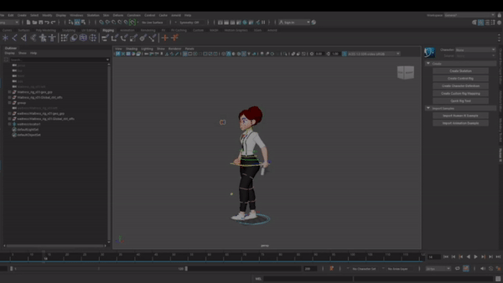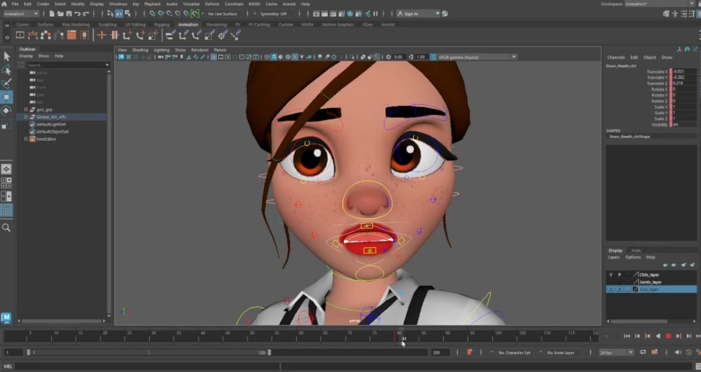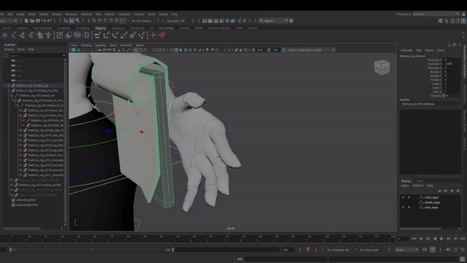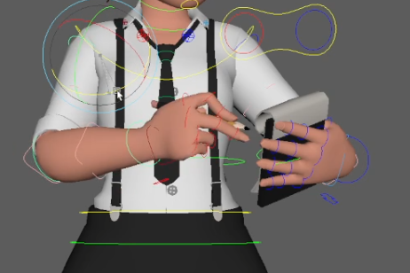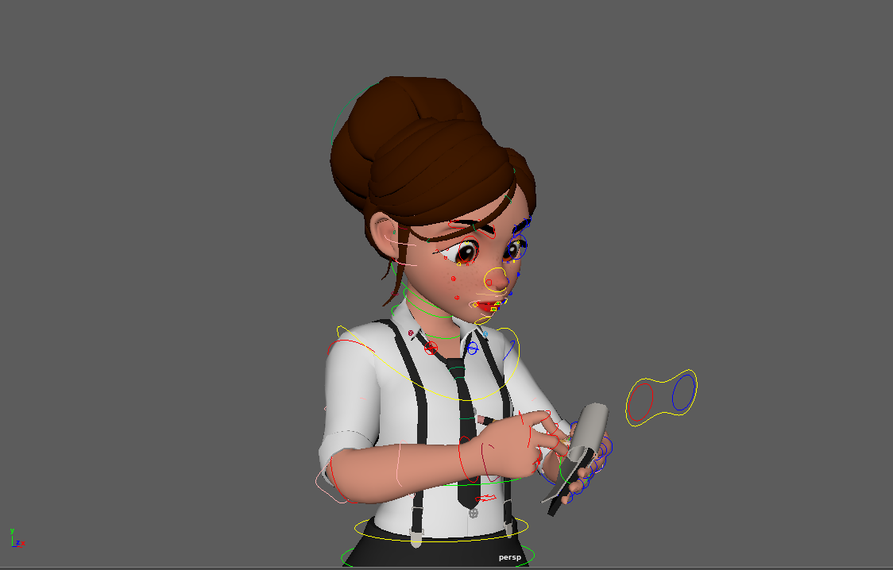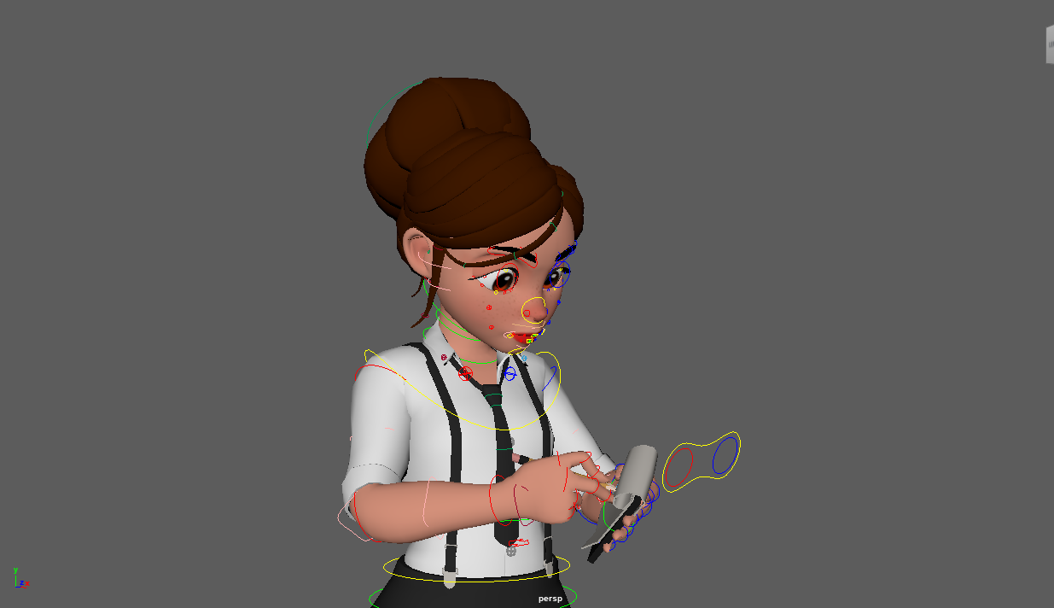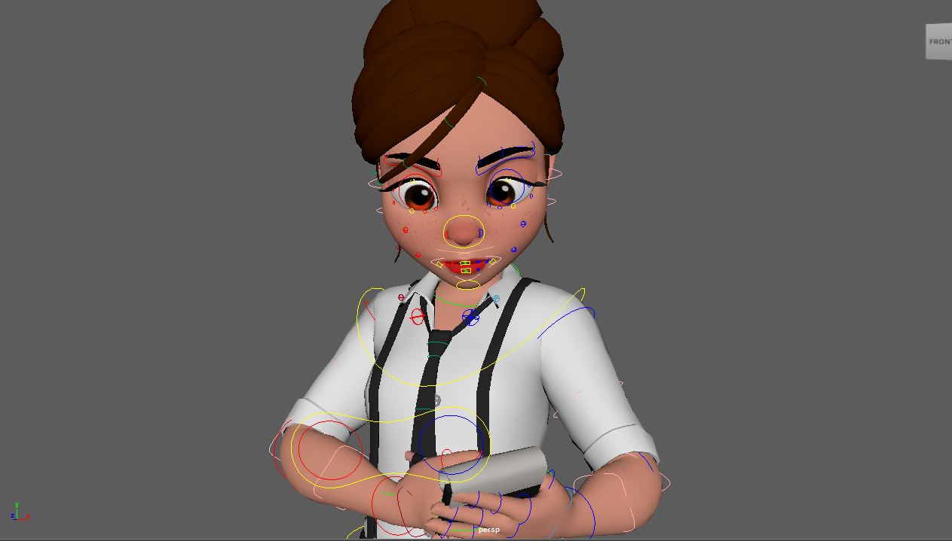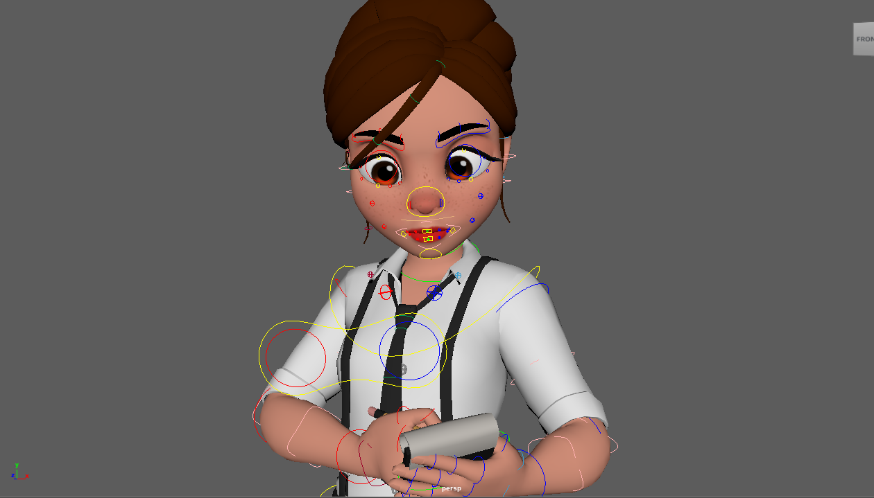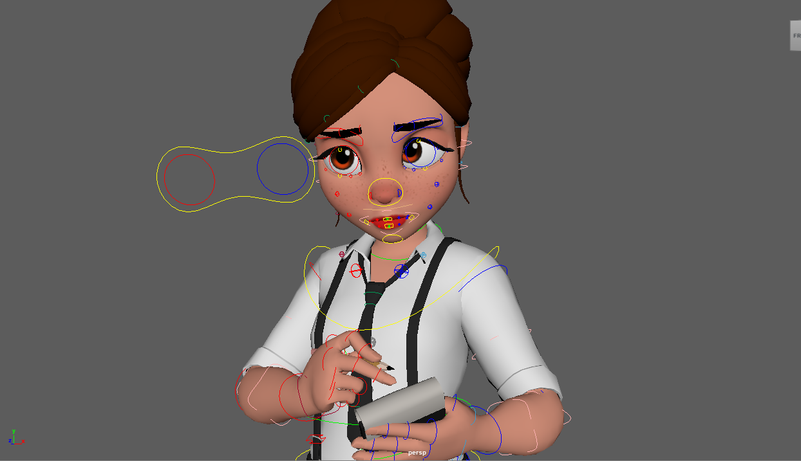

Early Animation

Link -

https://youtu.be/K1-XrNXQILA

Finished Animation

Link -

https://youtu.be/aKZZVBFREU8

