
Costco Wholesale Corporation Strategy Analysis, Strategic International Expansion & Brazilian Market Entry Report
Module name: International Business Concepts
Module Code: LCMB7034

Lecturer: Dr. Charles Oham

Student Name: Soham Yadav
Student ID: 2503139

Word Count: 4870 Words
Submission Date: 14 August 2026

Acknowledgement
I would like to express my sincere appreciation to Dr. Charles Oham for his guidance and academic support throughout the preparation of this report. I am also grateful for the learning, concepts and perspectives developed through the International Business Environment and Strategy module, which supported the analysis presented in this study.
AI Acknowledgement
In accordance with the permitted use of Generative AI stated in the assessment guidance, I used AI support for proofreading and correcting grammatical and syntactical mistakes in my own work, and for generating creative images used in the report. The analysis, interpretation, strategic arguments, recommendations and final academic judgement presented in this report remain my responsibility.
Soham Yadav 2503139
Master of Business Administration
University of Wales Trinity Saint David- London
August 2026

Executive Summary
This report evaluates the strategic feasibility of Costco Wholesale Corporation entering the Brazilian retail market and assesses how its established warehouse-club model could be adapted to Brazil's institutional, economic, cultural and competitive conditions. Costco's core competitive advantage is based on high-volume purchasing, a limited product assortment, low margins, membership income, operational efficiency and strong customer retention. The analysis therefore considers whether these strengths can be transferred effectively while allowing sufficient localisation for the Brazilian environment.
The report first classifies Costco's international strategy using the Bartlett and Ghoshal integration–responsiveness framework and evaluates the contribution of its international footprint, supply-chain architecture, cost leadership and human-capital practices to competitive advantage. It then assesses Brazil's market attractiveness through PESTLE-related analysis, with particular attention to political and procedural risk, Custo Brasil, infrastructure constraints, inflation, exchange-rate volatility, tax reform, labour regulation, cultural expectations and digital consumer engagement. The competitive landscape is also examined, particularly the Atacarejo formats operated by Assaí Atacadista and Atacadão, alongside the positioning of Costco as a premium warehouse club.
Dunning's Eclectic (OLI) Paradigm is used to synthesise Costco's ownership advantages, Brazil's location advantages and the benefits of internalising key capabilities. The entry-mode analysis compares exporting, franchising/licensing, wholly owned investment and an equity joint venture. The evidence supports a phased 51/49 equity joint venture with a strong Brazilian partner as the most suitable initial approach. The recommended strategy is to pilot three to four warehouses in suburban Greater São Paulo, establish local logistics capability, localise approximately 70% of SKU sourcing and retain selected Kirkland Signature imports. Subject to performance and the stabilisation of the dual-VAT transition, Costco could subsequently exercise a pre-negotiated option to move towards wholly owned operations after 2032.
The report concludes that Brazil presents substantial long-term potential but also significant operational and institutional risks. A phased entry approach provides a controlled mechanism for learning, protects Costco's standardised core model and permits selective localisation where Brazilian conditions require it. The final reflective section applies the Gibbs Reflective Cycle to evaluate the research process, the use of theoretical frameworks, source triangulation, challenges encountered and areas for future improvement.

Table of Contents
Acknowledgement 0
Executive Summary 2
Introduction 6
Section 1: Strategic Analysis 6
1. Organisational Classification and Global Strategy 6
Critical Evaluation of Strategic Classifications 8
Theoretical Deconstruction of Operational Efficiencies and Cost Architecture 9
Supply Chain Integration and Global Logistics Mechanics 9
Corporate Governance, Culture, and Employee Relations 10
2. Macro-Environmental Appraisal and Market Attractiveness 11
Macro-Environmental Evaluation 13
Cultural Dimensions and Consumer Dynamics 15
In-Depth Evaluation of the Brazilian Domestic Retail Landscape 16
Detailed Comparative Analysis: Costco vs. Domestic Entrants 18
Institutional Void Analysis and Environmental Hazards 19
Strategic Synthesis: The Eclectic (OLI) Paradigm 19
3. Entry Mode Strategy and Strategic Synthesis 20
Comprehensive Evaluation of Alternative Entry Modes 21
Strategic Action Plan for Brazil Market Entry 22
Operational Implementation Roadmap & Phased Execution Matrix 22
Risk Assessment, Mitigation Matrix, and Financial Feasibility 24
Detailed Scenario Analysis: Economic Volatility and Exchange Rate Shifts 25
Conclusion 26
Section 2: Reflective Account 27
Description 27
Feelings 27
Evaluation 28
Analysis 28
Methodological Reflection on Academic Sourcing and Data Synthesis 29
Conclusion 30
Action Plan 30
References 31

Introduction
This strategic report evaluates the feasibility of Costco Wholesale Corporation entering Brazil's retail market and assesses whether its established international business model can be adapted successfully to the opportunities and constraints of the Brazilian environment. Costco is a global warehouse-club leader, known for its membership model and high-volume, low-margin strategy, while Brazil is Latin America's largest consumer market but presents significant entry barriers associated with 'Custo Brasil' and intense domestic competition. The central objective is therefore to critically evaluate Costco's international strategy, examine the macro-environmental and competitive conditions that will shape entry success, and develop a justified recommendation on the most appropriate mode of market engagement. To achieve this, the report first classifies Costco's organisational and global strategy and evaluates how its international footprint contributes to competitive advantage. It then critically analyses the political, economic, legal and cultural conditions of Brazil, together with the domestic retail landscape and institutional challenges, before synthesising these findings through Bartlett and Ghoshal's strategic matrix, Dunning's Eclectic (OLI) Paradigm and PESTLE-related macro-environmental analysis. The subsequent entry-mode section compares alternative modes of entry and integrates the earlier evidence into a final strategic recommendation and implementation pathway. Finally, a Gibbs cycle reflection evaluates the research process, methodological choices, challenges, learning and future improvements, ensuring that both the strategic conclusions and the process used to develop them are critically examined.

Section 1: Strategic Analysis

1. Organisational Classification and Global Strategy
Costco Wholesale operates primarily under a highly globalised standardisation strategy, which can be explained through Bartlett and Ghoshal's strategic matrix. The model balances pressures for local responsiveness against pressures for global integration (Bartlett & Ghoshal, 1989). Costco faces exceptionally high global integration pressure because its profit model depends on purchasing power and operational simplicity, while local responsiveness remains relatively low through a standard warehouse layout. It carries only about 3,700 to 4,000 Stock Keeping Units (SKUs), compared with over 30,000 in a typical supermarket, allowing highly centralised purchasing (Alphabridge, 2025). This concentration strengthens international supplier bargaining power. Costco therefore fits the 'Global Strategy' archetype because it treats markets as broadly unified while making limited local adjustments, supporting a lean cost structure.

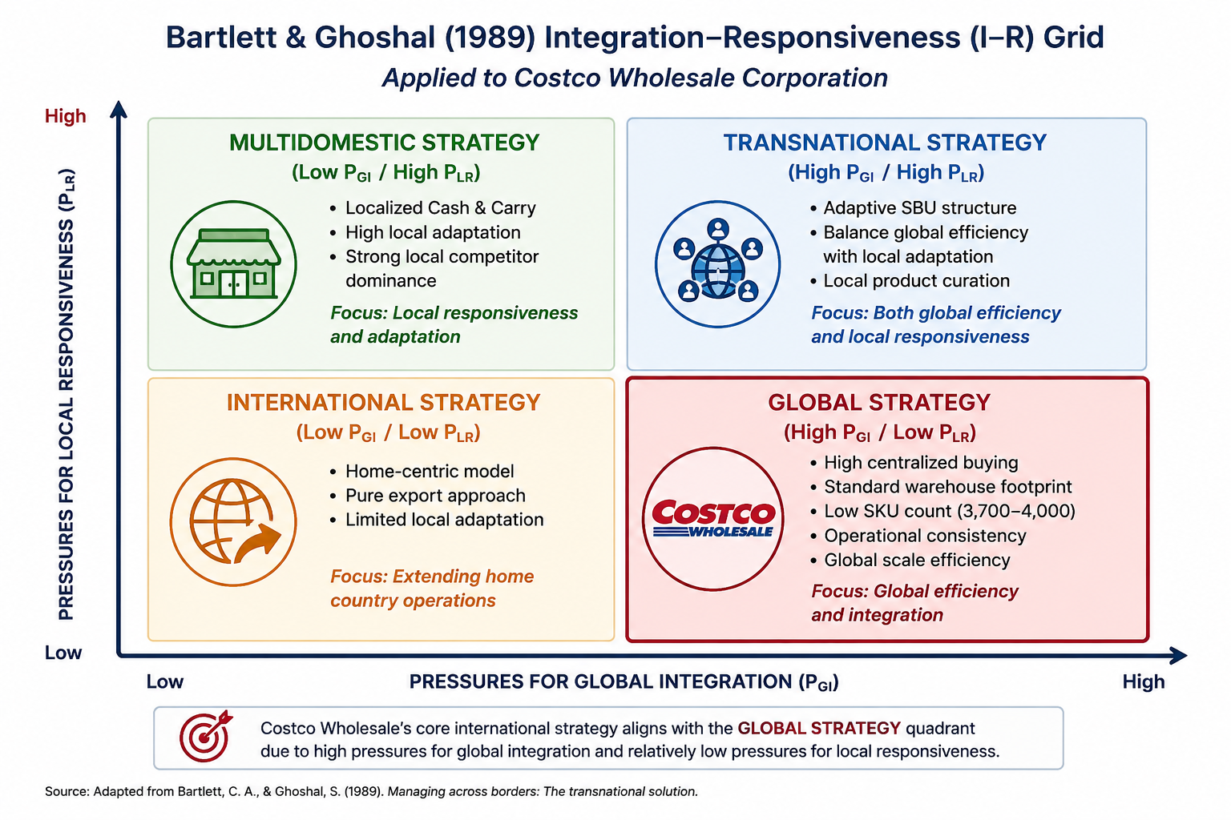
Figure 1: Bartlett and Ghoshal's Integration–Responsiveness Grid Applied to Costco

From the perspective of Perlmutter's EPRG framework, Costco's global configuration leans heavily Ethnocentric in its core operational architecture—relying on parent-country standards and centralized governance—while incorporating Geocentric elements when sourcing talent and inventory regionally (Tarique et al., 2015)

Critical Evaluation of Strategic Classifications
Scholars nevertheless question whether Costco is a pure global archetype or incorporates subtle multi-domestic features. Although structural standardisation remains high, Costco shows elements of a transnational posture through targeted inventory adaptations to local tastes, which can support cross-border sustainability (Bartlett & Ghoshal, 2008). In Japan, for example, Costco introduced high-end sushi, while in Taiwan managers modified beef cuts for traditional hotpot cooking (Alphabridge, 2025). These adjustments show that membership governance and warehouse design remain standardised while product curation reduces cultural alienation.
However, Bartlett and Ghoshal's framework can be criticised for placing firms into discrete quadrants when organisations operate along a continuum. The extent of local adaptation may also be overstated because SKU changes represent only a small part of overall inventory. This tension matters in Brazil: excessive adaptation could weaken Costco's operating efficiencies, while insufficient adaptation could lead to rejection by consumers accustomed to local retail formats.
Costco's geographic footprint also reinforces its competitive advantage. It operates over 923 warehouses globally, concentrated in North America, with deliberate expansion into Europe, Asia, and Oceania (Costco, 2026). Locations are selected around dense, affluent suburban populations where customers have cars and storage space for bulk purchases. This alignment with the target customer profile supports high sales volume per square foot and shows that geographic expansion is a mechanism for reinforcing the low-cost model.
Costco's value creation is driven by high volume, low margins, and membership loyalty. Its competitive advantage is anchored on capping markups at 14–15%, compared with 25% to 50% for traditional supermarkets (Alphabridge, 2025). This supports Porter's Low-Cost Leadership strategy because savings from bulk procurement and minimal store decor can be passed to consumers (Porter, 1985). Costco derives most operating profit from membership fees, with a 93% renewal rate in core markets such as the US and Canada (Alphabridge, 2025). The upfront fee allows razor-thin product margins while reinforcing customer loyalty.
This pricing dynamic creates a powerful psychological lock-in effect: because customers have already paid an annual fee, they feel compelled to shop at Costco to get their 'money's worth'. Sceptics may argue that this fee structure introduces friction in developing economies where consumers resist paying upfront access fees. Nevertheless, historical renewal metrics demonstrate that once value is established, the model builds high defensibility that competitors struggle to replicate, particularly in emerging consumer environments like Brazil.

Theoretical Deconstruction of Operational Efficiencies and Cost Architecture
Costco's operational architecture is built around supply chain velocity and minimal touchpoints. Unlike conventional retailers with complex distribution networks, Costco moves most inventory from manufacturers to cross-docking depots before rapid dispatch to warehouses. Merchandise is transferred across depot loading bays within 24 hours, maximising vehicle fill rates and reducing holding costs.
This mechanism supports Low-Cost Leadership by reducing inventory and handling costs. Restricting the assortment to approximately 3,700–4,000 SKUs also concentrates purchasing power and enables Costco to negotiate high-volume supplier terms.

Store-level operations also minimise labour overhead. Display-ready pallets can be placed directly onto warehouse shelving, reducing shelf-stocking activity and allowing the sales floor to function as both retail space and fulfilment infrastructure.

Supply Chain Integration and Global Logistics Mechanics
To maintain cross-border cost advantages, Costco's global logistics framework relies on standard shipping containers, predictive inventory replenishment algorithms, and high-density store layouts. Standardising ocean freight loads and utilising full-container-load (FCL) transport ensures that per-unit freight costs remain negligible relative to retail value.
When entering a new market, this logistics framework is stressed if infrastructure lacks multimodal connectivity. North American rail and highway networks support continuous cross-docking, but emerging markets may face port congestion, customs delays, or fragmented trucking. Such disruptions slow inventory turns, increase holding costs, and threaten Costco's low-margin model. Therefore, regional logistics capability is a critical entry condition.

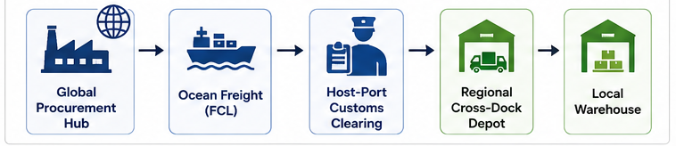
Figure 2: Costco's Proposed Global Supply Chain and Cross-Docking Flow for Brazil

To reduce supply-chain vulnerabilities, Costco can use vendor-managed inventory (VMI), with key suppliers monitoring inventory through point-of-sale data. This can reduce stock volatility and the need for large buffer inventories.

Corporate Governance, Culture, and Employee Relations
Costco's operational model also relies on an internal human resource strategy that differs from traditional low-wage, high-turnover retail. It follows a high-wage, high-retention philosophy, providing above-market compensation, healthcare benefits, and retirement contributions. This contributes to turnover rates below 10% for staff with more than one year of service.
This strategy aligns with Human Capital Theory, which argues that investment in compensation, training, and working conditions can improve long-term productivity and quality. In high-volume warehouses, high turnover creates hidden costs through training, accidents, shrinkage, and weaker customer service. Costco's egalitarian culture, where managers often begin on the warehouse floor, also builds operational knowledge and reinforces member satisfaction.
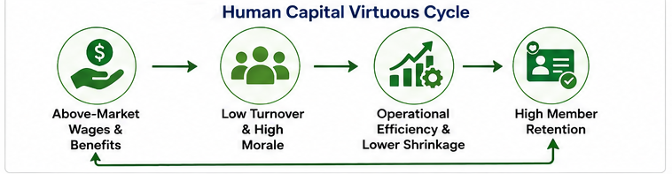
Figure 3: Costco's Human Capital Virtuous Cycle

Costco's egalitarian workplace culture—where store managers frequently begin their careers on the warehouse floor—fosters deep operational knowledge across all administrative levels. This human-centric governance model protects brand integrity and drives member satisfaction, ultimately reinforcing the high renewal rates that sustain the firm's fee-based profit architecture.

2. Macro-Environmental Appraisal and Market Attractiveness
Before establishing a warehouse in Brazil, Costco must navigate a complex macro-environment. Brazil offers a large retail opportunity but has proved difficult for foreign retailers that fail to account for local conditions (Altios, 2025). Carrefour and Casino have faced long-term challenges, while Walmart suffered major losses before retreating and selling control to a local private equity firm. PESTLE analysis therefore identifies the Political, Economic, Social/Cultural, Technological, Legal, and Environmental factors affecting entry viability.

Table 1: PESTLE Analysis of Brazil and Its Operational Implications for Costco
PESTLE Dimension | Key Brazilian Environmental Drivers | Operational Direct Impact on Costco
Political | Bureaucratic friction, infrastructure bottlenecks, Custo Brasil. | Demands state-level strategic alignment and Localised logistics partnerships.
Economic | Dual-VAT reform (2026–2032), interest rate volatility, currency fluctuation. | Inflation drives demand for bulk bargains; requires dual tax compliance software.
Social / Cultural | High Power Distance, Collectivism, High-Context relationships. | Calls for structured hierarchy, employee community building, and warm social marketing.
Technological | High WhatsApp/Instagram digital integration. | Demands proactive digital engagement for membership acquisition.
Legal | Paternalistic Labour Code (CLT) & complex environmental zoning. | Prevents US flexible scheduling; prolongs land acquisition and store development.
Environmental | Municipal master plans & environmental impact approvals. | Requires rigorous legal due diligence to prevent construction gridlock.

Macro-Environmental Evaluation

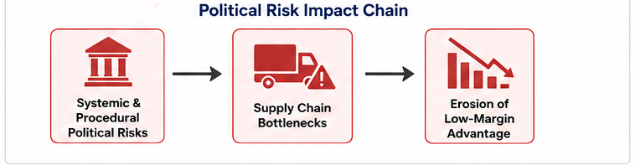
Figure 4: Political Risk Impact Chain for Costco's Brazilian Market Entry

Political stability in Brazil remains a complex variable influencing foreign direct investment. The political landscape is fragmented, with shifting coalitions leading to sudden policy shifts and regulatory changes (Trade.gov, 2025). In international business theory, these challenges encompass both Systemic Risk (broader macro-policy shifts) and Procedural Risk, which stems from bureaucratic friction and public administrative delays that raise transaction costs (Daniels et al., 2022).
This dynamic creates barriers for long-term capital investments, which directly impacts warehouse club expansion since constructing a single warehouse requires extensive upfront real estate capital. Furthermore, structural inefficiencies known as 'Custo Brasil' inflate business operations (Trade.gov, 2025). For Costco, navigating this landscape requires securing municipal, state, and federal approvals for zoning and construction. Thus, while the political environment permits foreign direct investment, administrative complexity presents a persistent operational risk that can delay launches and inflate setup expenditures.
Government policy around logistics and infrastructure creates another political-economic hurdle. Brazil relies heavily on highways rather than railways, leaving goods movement vulnerable to fuel prices and driver strikes (Altios, 2025). Because Costco depends on rapid, low-cost movement of high volumes, transport bottlenecks directly threaten margins. A disruption can create stock-outs in a retailer carrying only about 4,000 SKUs. Costco should therefore align with state infrastructure projects and established local logistics providers.
Economically, Brazil features a population exceeding 215 million, representing a substantial prospective membership base. The country is the largest economy in Latin America, showing consumer growth despite macro headwinds (Altios, 2025). The expanding middle class (Class C) forms a key target demographic because these consumers seek high value while managing constrained household budgets. This market scale provides the volume potential required to justify capital expenditures for distribution centres. Consequently, Brazil's economic scale makes it a high-potential retail market, offering an environment suitable for volume-driven retail formats.
However, inflation and fluctuating interest rates challenge purchasing power. The Brazilian Central Bank has historically maintained elevated rates to manage inflation, increasing domestic financing costs (Trade.gov, 2025). Inflation also squeezes household budgets, although it can increase demand for wholesale bargains. Local cash-and-carry formats such as 'Atacadão' have expanded during downturns because of lower unit costs. Costco therefore needs competitive pricing while differentiating its membership proposition.
Exchange rate volatility poses an additional financial risk. The Brazilian Real (BRL) experiences fluctuations against the US Dollar (USD), impacting the landed cost of imported inventory and foreign profit repatriation. Because Costco relies on its private label, Kirkland Signature, which includes imported items, a depreciated Real raises local retail prices for these goods (Alphabridge, 2025). Passing currency costs to consumers damages the retailer's value proposition. Consequently, Costco must shift toward local procurement for the majority of its SKUs, adapting its traditional US-centric supply chain to mitigate exchange rate exposure.
Brazil's legal and tax structures present operational complexities. The tax system involves multiple cascading taxes (PIS, Cofins, IPI, and state-level ICMS) that vary across state borders (Trade.gov, 2025). A major tax reform scheduled for implementation between 2026 and 2032 aims to consolidate these into a dual Value Added Tax (VAT) system (Trade.gov, 2025). However, the transition requires managing dual compliance frameworks simultaneously. For Costco, this operational environment demands specialised local tax counsel and tailored Enterprise Resource Planning (ERP) adaptations to prevent compliance penalties, establishing legal execution as a core prerequisite for market entry.
Labour regulations also require specific compliance strategies. Brazil's Labour code (Consolidação das Leis do Trabalho - CLT) enforces mandatory employee benefits, operational limits on working hours, and specific dismissal procedures (Trade.gov, 2025). While Costco maintains high compensation levels and low global turnover (Alphabridge, 2025), applying standard US flexible scheduling models directly would clash with local Labour laws. Aligning human resource policies with CLT requirements is necessary to maintain Labour efficiency while avoiding litigation costs.
Real estate development involves strict municipal master plans and environmental impact assessments (SIAL Paris, 2025). Licensing delays tie up capital and delay operational timelines. Costco must execute detailed legal due diligence and work with local municipal planning authorities to prevent regulatory gridlock during site development.

Cultural Dimensions and Consumer Dynamics
Cross-cultural frameworks highlight structural differences between American and Brazilian operational environments. According to Hofstede's cultural dimensions, Brazil scores higher in Power Distance (69) than the United States (40), indicating a preference for structured Organisational hierarchies (Scribd, 2016). In store operations, Brazilian staff generally expect defined managerial oversight.
Although Hofstede's framework can oversimplify cultural differences, it provides a useful baseline for organisational design. Respecting local hierarchical expectations can support operational control while maintaining Costco's supportive culture.

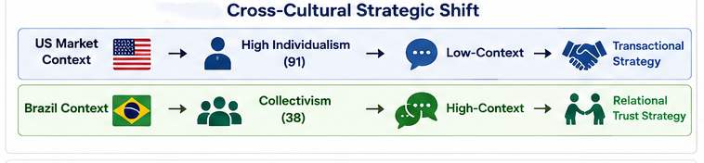
Figure 5: Cross-Cultural Strategic Shift from the US to Brazil

The contrast between US individualism (91) and Brazilian collectivism (38), together with Brazil's high-context orientation, suggests that trust and relationships matter in workforce management and customer acquisition (Scribd, 2016; Wild & Wild, 2023). Brazil's Uncertainty Avoidance score (76) further supports building familiarity and trust (Hofstede Insights, 2022). Costco should therefore strengthen local community engagement and relational initiatives.
Brazilian retail habits centre on the 'Atacarejo' format, combining wholesale (atacado) and retail (varejo). Households often make monthly bulk purchases to manage inflation, while Assaí and Atacadão dominate the segment. Costco cannot compete on price alone; it should differentiate through a higher-end club experience, Kirkland Signature products, premium imports, and member services not normally offered by local formats.
Finally, marketing strategies must reflect local engagement preferences. While Costco limits traditional advertising in North America (Alphabridge, 2025), Brazilian consumers demonstrate high engagement on platforms such as WhatsApp and Instagram for commerce and brand interactions (Altios, 2025). A purely passive marketing approach risks low brand awareness. Adapting to active social media engagement and local digital channels is necessary to drive early membership adoption.

In-Depth Evaluation of the Brazilian Domestic Retail Landscape
The Brazilian grocery and wholesale landscape is currently characterised by intense consolidation among domestic giants and well-entrenched multinational survivors. To successfully position itself, Costco must undergo a rigorous competitive appraisal against established market leaders, primarily Assaí Atacadista, Atacadão (owned by Carrefour Brazil), and Grupo Pão de Açúcar (GPA).

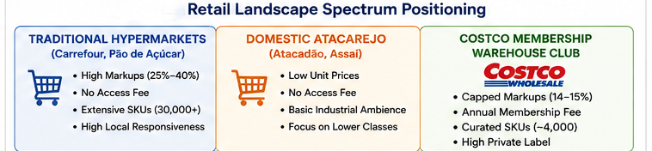
Figure 6: Competitive Positioning of Costco within the Brazilian Retail Landscape

The domestic Atacarejo model combines wholesale cash-and-carry pricing with retail accessibility. Atacadão and Assaí operate warehouse-style facilities in major urban corridors, serving small businesses and cost-conscious consumers. Their competitive leverage relies on basic store fit-outs, limited customer service, and low-cost essential staples.
Costco instead occupies a Premium Warehouse Club position. Atacadão and Assaí compete through simpler stores and low prices, while Kirkland Signature, premium imports and member services provide differentiation. Direct price competition with lower-income consumers could compress margins.
Costco should target middle and upper-middle income groups (Class A, B, and upper Class C) in dense suburban areas. These customers are more able to pay annual membership fees, own vehicles for bulk purchases, and value quality imported products alongside domestic staples. This positioning avoids direct price competition while building brand equity.

Detailed Comparative Analysis: Costco vs. Domestic Entrants

Table 2: Comparative Analysis of Costco and Major Brazilian Retail Competitors
Operational Variable | Costco Wholesale | Assaí Atacadista | Atacadão (Carrefour) | Traditional Hypermarkets
Access Model | Annual Paid Membership | Free / Open Public Access | Free / Open Public Access | Free / Open Public Access
SKU Density | Ultra-Low (3,700–4,000) | Moderate (7,000–9,000) | Moderate (8,000–10,000) | High (30,000–50,000)
Target Demographic | Classes A, B, Upper C | Classes C, D, E & B2B | Classes C, D, E & B2B | Classes A, B, C
Gross Margin Cap | Strictly Capped (14–15%) | Variable (16–20%) | Variable (15–18%) | High (25–35%)
Private Label Share | High (Kirkland ~30%) | Low to Moderate | Low to Moderate | Moderate
Store Atmosphere | Clean, High-End Industrial | Basic Industrial Cash & Carry | No-Frills Cash & Carry | Full-Service Supermarket

This operational layout illustrates why directly copying North American store locations would fail in Brazil. Domestic Atacarejo competitors operate on slim margins but lack premium product lines and member services. Costco's competitive advantage in Brazil hinges on leveraging its proprietary private label and superior store environment to capture affluent urban consumers who currently lack a dedicated wholesale club experience.

Institutional Void Analysis and Environmental Hazards
Emerging markets often contain institutional voids—gaps in intermediaries, regulatory enforcement, and infrastructure. Khanna and Palepu's Institutional Void Framework provides a lens for evaluating Brazil's structural challenges beyond PESTLE indicators.
- Logistics & Contracting Voids: In Brazil, interstate logistics face security risks, toll variations, and highway congestion. Costco should develop dedicated logistics partnerships or invest in regional depots to protect cross-docking performance.
- Regulatory & Judicial Ambiguity: Tax interpretations and municipal permits can create prolonged disputes and delays. Costco should establish robust internal legal audit mechanisms rather than relying only on external generalist firms.
- Capital Market Frictions: Volatile Brazilian interest rates make local-currency debt expensive. Costco should use parent-company equity or specialised cross-border financing while hedging local currency exposure.

Strategic Synthesis: The Eclectic (OLI) Paradigm
To integrate these internal capabilities with external market factors, John Dunning's Eclectic (OLI) Paradigm provides a framework for evaluating foreign direct investment suitability through Ownership (O), Location (L), and Internalisation (I) advantages (Scribd, 2023).

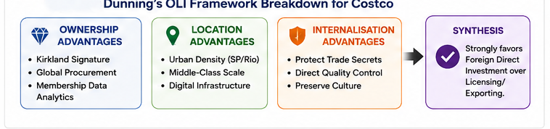
Figure 7: Dunning's OLI Framework Applied to Costco's Brazilian Market Entry

- Ownership (O) Advantages: Costco possesses proprietary assets including the Kirkland Signature brand, advanced membership analytics, and high-volume global procurement scale (Scribd, 2023). Kirkland Signature offers national-brand quality at 20% to 30% lower prices (Alphabridge, 2025), providing a distinct private-label option that domestic competitors cannot easily replicate. This global buying scale provides cost advantages that support aggressive local pricing.
- Location (L) Advantages: Brazil offers dense metropolitan centres, specifically in southeastern regions like São Paulo and Rio de Janeiro (Altios, 2025). These areas contain target demographics with disposable income, personal vehicle ownership, and adequate home storage capacity. Additionally, Brazil's established digital payment infrastructure supports online membership services (Altios, 2025).
- Internalisation (I) Advantages: Transaction Cost Economics (TCE) suggests firms internalise operations when licensing or franchising creates contractual and quality-control risks (Hill, 2023). Direct ownership protects Costco's logistics processes, pricing governance, and corporate culture (Scribd, 2023). Franchising could dilute the brand or increase margins, weakening the value proposition. Controlled internalisation is therefore essential.

3. Entry Mode Strategy and Strategic Synthesis
Costco's international entry history shows a deliberate balance between operational control and market risk (Alphabridge, 2025). In lower-distance markets such as Canada and the UK, it used Wholly Owned Subsidiaries (WOS) through greenfield expansion. In complex Asian markets such as Taiwan and South Korea, it initially used Joint Ventures (JV) to navigate real estate and regulation before buying partner stakes and assuming full ownership (Alphabridge, 2025).

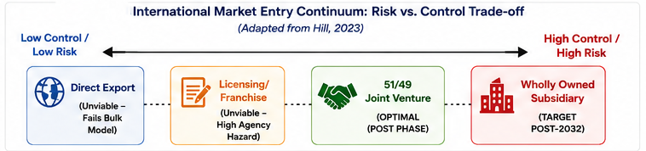
Figure 8: International Market Entry Mode Continuum: Risk–Control Trade-off

Comprehensive Evaluation of Alternative Entry Modes
Selecting an entry mode requires evaluating control, resource commitment, risk exposure and speed to market. The main alternatives are assessed below:
- Direct Exporting: Minimal capital commitment and low resource involvement. Strategic Failure in Brazil: exporting without physical warehouses makes the membership model non-functional, while tariffs and port delays can remove Costco's cost advantage.
- Franchising and Licensing: These reduce Costco's capital commitment and can accelerate expansion. Strategic Failure in Brazil: Transaction Cost Theory highlights agency hazards and monitoring costs. A franchisee could raise markups above the 14–15% limit, undermining pricing discipline, membership renewal, and brand equity.
- Wholly Owned Subsidiary via Greenfield Investment: This provides full operational control and protects proprietary processes. Strategic Vulnerability in Brazil: Costco would face land acquisition, zoning, environmental approvals, and complex taxes without local assistance. Walmart's experience illustrates how exposure to 'Custo Brasil' can consume capital before scale is achieved.
- Equity Joint Venture (51/49 Majority Ownership - Optimal Strategy): This balances resource commitment with operational control and supports organisational learning through local partners (Griffin & Pustay, 2013). A Brazilian partner can provide access to real estate, zoning expertise, and tax navigation, while Costco's 51% stake preserves board control over pricing, membership governance, and human resource standards.
Entry Mode Strategy and Strategic Synthesis: In this section, 'strategic synthesis' means the integration of the earlier organisational, macro-environmental, competitive, OLI and risk analyses into one coherent entry recommendation. Rather than treating the choice of entry mode as an isolated decision, the section brings together the evidence on control, local knowledge, resource commitment, operational risk, regulatory complexity and long-term strategic fit to determine which mode best supports Costco's objectives in Brazil.
An initial 51/49 Equity Joint Venture (JV) with a strong local partner is the most viable entry mode, providing a risk-managed bridge toward an eventual Wholly Owned Subsidiary.

Strategic Action Plan for Brazil Market Entry
- Phase 1: Pilot Launch (Years 1–3): Establish a 51/49 JV to launch a controlled pilot of 3 to 4 warehouses in suburban Greater São Paulo. Secure local logistics partnerships to bypass transportation bottlenecks.
- Phase 2: Localised Sourcing: Localise at least 70% of SKU inventory to eliminate high import tariff barriers and foreign exchange volatility, using Kirkland Signature for the remaining imported lines.
- Phase 3: Buyout & Transition (Post-2032): Execute a contractually pre-negotiated call option to buy out the local partner's 49% stake once the dual-VAT reform stabilizes by 2032 (Trade.gov, 2025), converting the entity into a Wholly Owned Subsidiary for long-term regional scaling.

Operational Implementation Roadmap & Phased Execution Matrix
Executing a strategic expansion into Brazil demands a structured timeline. The implementation roadmap below outlines the key operational milestones required over a five-year horizon:
- Secure 51/49 Equity Joint Venture Partnership Agreement
- Establish Primary Cross-Dock Depot in Greater São Paulo
- Implement Custom ERP Software for Dual-VAT Compliance
- Construct & Launch 2 Pilot Warehouses (Campinas & Alphaville)
- Contract Local Agribusiness & Consumer Goods Suppliers (70% SKU Target)
- Initiate Targeted Social Media Membership Campaigns (WhatsApp/Instagram)
- Open 2 Additional Warehouses in Southeastern Corridor (Rio de Janeiro/Belo Horizonte)
- Achieve 85%+ Membership Renewal Rate across Pilot Warehouses
- Optimise Cold-Chain Fleet Performance with Dedicated 3PL Partners
- Evaluate Operational Cash Flows & Dual-VAT Transition Metrics
- Prepare Pre-Negotiated Call Option Purchase to Buy Out Partner Equity (Target: 100% WOS)

Strategic recommendation Summery
A phased rollout reduces risk by testing demand and operating performance before wider expansion. The recommended 51/49 joint venture would give Costco majority control while providing local expertise in real estate, licensing, tax and logistics. The initial pilot should focus on high-income suburban Greater São Paulo, supported by approximately 70% local sourcing and selective Kirkland Signature imports. Performance evidence should determine whether Costco expands and eventually exercises a pre-negotiated option to move toward wholly owned operations. This approach preserves Costco's standardised core while selectively adapting activities where Brazil-specific conditions require localisation.

Risk Assessment, Mitigation Matrix, and Financial Feasibility
Table 3: Risk Assessment and Mitigation Strategies for Costco's Brazilian Market Entry
Threat Category | Specific Risk Scenario | Operational Impact | Mitigation Strategy
Macro-Economic | BRL Currency Depreciation vs. USD | Landed cost of imported Kirkland items increases dramatically. | Shift to 70%+ local SKU sourcing; use FX hedging for import commitments.
Regulatory / Tax | Complex Dual-VAT Compliance Errors | Heavy administrative fines from state/federal tax authorities. | Deploy Localised ERP architecture; retain embedded Brazilian legal & tax audit teams.
Operational | Interstate Highway Disruptions / Strikes | Stock-outs across low-SKU warehouses; margin erosion. | Implement Vendor-Managed Inventory (VMI) at regional cross-dock hubs.
Cultural | Resistance to Upfront Annual Access Fee | Low membership conversion rate during initial launch phase. | Offer high-value introductory Kirkland incentives and Localised digital trial offers.
Labour | CLT Litigation & Structural Union Grievances | Payroll expenses rise; operational disputes. | Adapt US scheduling models to fit mandatory CLT guidelines while keeping total pay high.

Warehouse club entry requires substantial upfront capital for land, construction, structural steel, and initial inventory. A single warehouse requires tens of millions in capital expenditure.

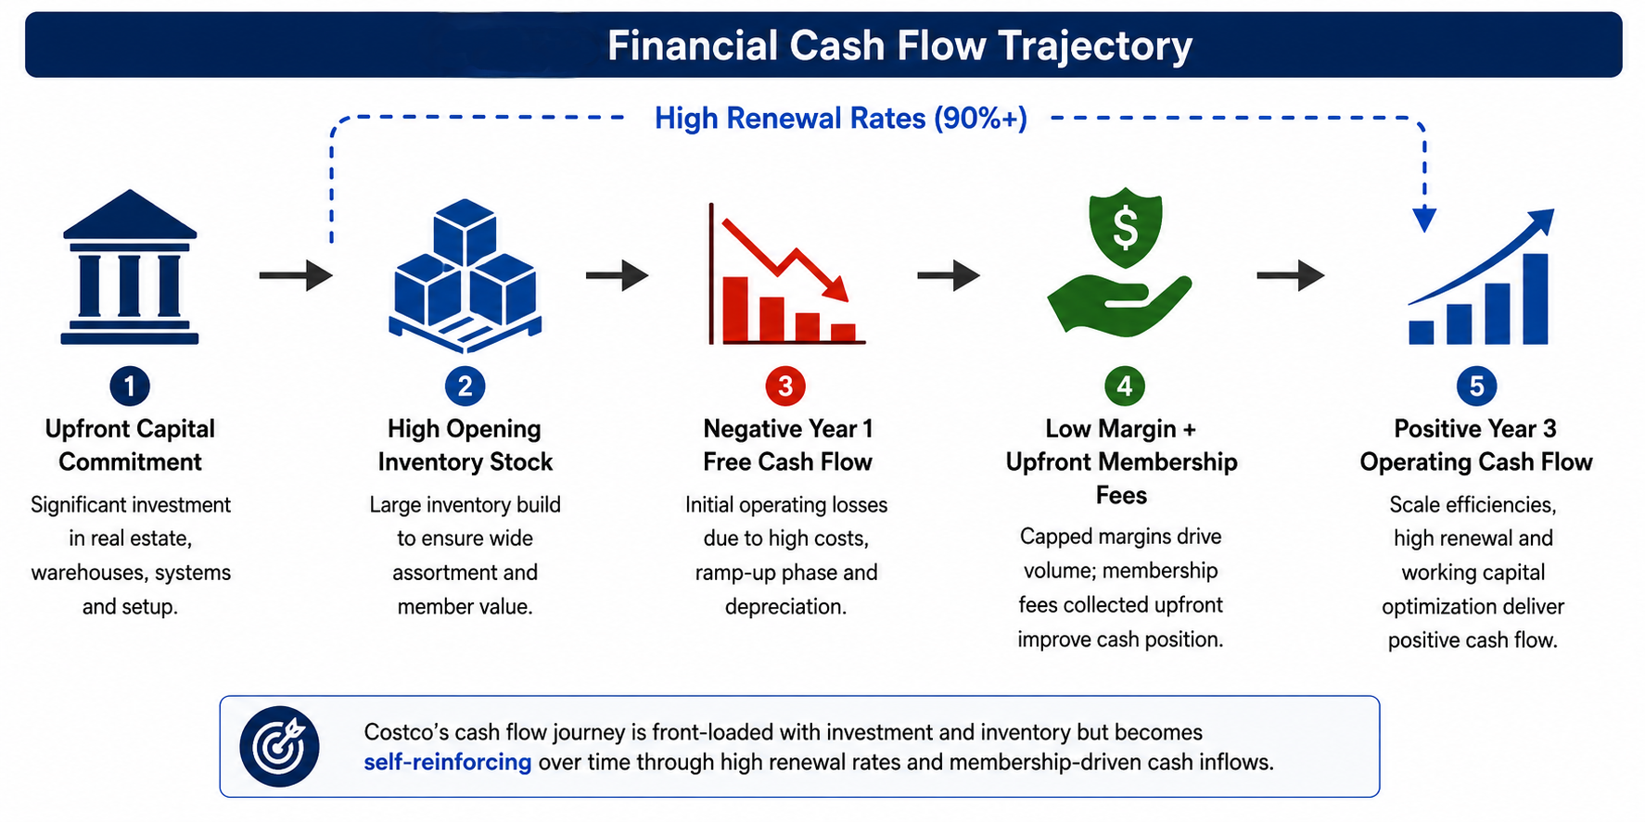
Figure 9: Costco's Proposed Financial Cash Flow Trajectory During Market Entry

Because membership fees are collected upfront, operating cash flow benefits from favourable working-capital dynamics. Members pay annual dues before purchases, while rapid inventory turns can occur before supplier payment terms expire. This cash-conversion cycle provides liquidity without heavy reliance on domestic short-term debt.

Detailed Scenario Analysis: Economic Volatility and Exchange Rate Shifts
Given the historical volatility of the Brazilian Real (BRL) and shifting interest rate environments, strategic planning must evaluate performance under varying macroeconomic scenarios.
- Base Case Scenario (Moderate BRL Depreciation & Steady GDP Growth): BRL depreciates at single-digit annual rates; dual-VAT reform follows legislative schedules; inflation remains within target corridors. Strategic Response: maintain 70% local sourcing, 30% Kirkland/imported lines, open 3 to 4 warehouses in Greater São Paulo, and execute the partner buyout post-2032.
- Bullish Scenario (BRL Currency Appreciation & Rapid Middle-Class Expansion): The currency strengthens, purchasing power expands, and tax reform simplifies inter-state commerce. Strategic Response: increase imported Kirkland SKUs, accelerate expansion into Curitiba and Porto Alegre, and shorten the JV buyout timeline.
- Bearish Scenario (Severe BRL Devaluation, High Inflation & Regulatory Gridlock): BRL depreciates sharply, inflation reduces real incomes, and permits face delays. Strategic Response: raise local sourcing above 85%, pause new warehouse capital expenditure, and focus on staple bulk goods as consumers trade down from traditional hypermarkets.

Conclusion
The evidence supports a phased 51/49 joint venture as Costco's most suitable initial entry mode for Brazil. It balances the firm's need for control with the local knowledge required to manage regulatory, logistical and cultural complexity. A Greater São Paulo pilot, supported by local sourcing and clear performance measures, provides a controlled basis for learning before any transition to wholly owned operations.

Section 2: Reflective Account
This reflective account uses the Gibbs Reflective Cycle (Gibbs, 1988) to evaluate my learning and research process during preparation of the international business strategy report. The cycle covers Description, Feelings, Evaluation, Analysis, Conclusion, and Action Plan.

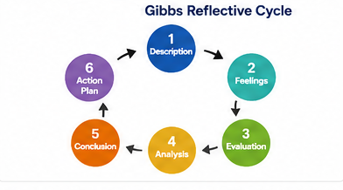
Figure 10: Gibbs Reflective Cycle Applied to the Research Process

Description
The task required selecting Costco Wholesale and developing a strategy for entering Brazil, a market where it has not operated. The project combined corporate operational data with macro-environmental research using Dunning's OLI Paradigm, Bartlett and Ghoshal's I-R Grid, and PESTLE analysis.

Feelings
Initially, I felt enthusiastic about studying Costco's membership-driven revenue model. However, researching Brazil created anxiety because of 'Custo Brasil' and the multi-year dual-VAT transition. I was concerned about connecting these complex realities to theoretical frameworks without relying on generic generalisations.

Evaluation
The main positive outcome was developing a functional understanding of how academic frameworks support real-world strategic decisions. Module lectures, readings and case discussions helped me connect these frameworks to practical international expansion decisions. Applying OLI clarified why direct ownership or majority control is important for firms with valuable trade secrets (Scribd, 2023). The main challenge was critically evaluating frameworks rather than applying them uncritically while maintaining an analytical tone.

Analysis
Navigating Brazil's complex tax environment was an important learning point. Applying the VUCA framework (Volatility, Uncertainty, Complexity, Ambiguity) helped structure external challenges into actionable managerial steps (Bennett & Lemoine, 2014).

Table 4: VUCA-Based Classification of Operational and Adaptive Challenges
Operational Problem Type | Strategic Classification | Applicable Managerial Strategy
Technical Problems (Complicated) | ERP Dual-VAT system updates, legal CLT Labour compliance. | Solved via domain expert analysis, legal counsel, and software updates.
Adaptive Challenges (Complex) | Shifting consumer habits to paid membership clubs in an established 'Atacarejo' market. | Requires Organisational learning, trust-building, and Localised marketing.

The Cynefin Framework further showed that Brazil's retail environment operates within the Complex Domain (Probe-Sense-Respond) (Snowden & Boone, 2007). This supported recommending a phased 3-to-4 store pilot before broader expansion. I recognised that strategic failures often occur when complex adaptive challenges are treated as simple technical operations.

Methodological Reflection on Academic Sourcing and Data Synthesis
Maintaining academic rigour required balancing primary institutional reports, corporate filings, and peer-reviewed international business literature. Generic business media can produce superficial strategic conclusions; for example, it may treat Brazil as a uniform consumer market while overlooking regional differences between states such as São Paulo and Rio de Janeiro.

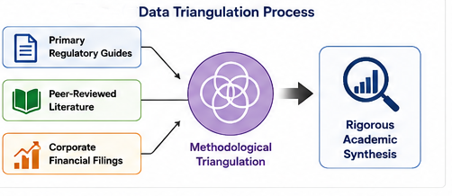
Figure 11: Data Triangulation Process for Academic Research and Strategic Analysis

I prioritised data triangulation because no single source type was sufficient to answer the assessment question reliably or connect theory with Costco's Brazilian entry conditions. Corporate and regulatory sources provided current factual evidence, while academic literature provided theoretical explanation; each also had limitations when used alone. I therefore cross-referenced government and corporate evidence with peer-reviewed international business literature. This allowed me to compare different perspectives, identify convergence, reduce reliance on a single potentially biased source, and test whether the final recommendation was supported by both empirical evidence and established theory.

Conclusion
This project demonstrated that theoretical models are practical decision-making tools rather than purely abstract academic exercises. Structuring the analysis around regulatory reports and academic literature provided a solid foundation for evaluating strategic entry choices.

Action Plan
In future strategic projects, I will:
- Map out target-market regulatory and tax structures early using primary government data to establish an empirical base before selecting entry modes.
- Critically challenge theoretical models by highlighting their practical boundary conditions and operational limitations.
- Maintain an analytical academic tone focused on clear strategic implications and direct cause-and-effect conclusions.

References
Alphabridge (2025) Costco’s strategy for sustainable growth: discipline beats diversification. Available at: https://alphabridge.co/corporate-strategy/costcos-strategy-for-sustainable-growth/ (Accessed: 5 August 2026).

Altios (2025) Brazil market entry strategy: overcoming challenges for success. Available at: https://altios.com/publication/brazil-market-entry-strategy/ (Accessed: 8 August 2026).

Bartlett, C.A. and Ghoshal, S. (1989) Managing across borders: the transnational solution. Boston: Harvard Business School Press.

Bartlett, C.A., Ghoshal, S. and Beamish, P.W. (2008) Transnational management: text, cases, and readings in cross-border management. 5th edn. Boston: McGraw-Hill.

Bennett, N. and Lemoine, G.J. (2014) ‘What VUCA really means for you’, Harvard Business Review, 92(1/2). Available at: https://hbr.org/2014/01/what-vuca-really-means-for-you (Accessed: 2 August 2026).

Collinson, S., Narula, R. and Rugman, A.M. (2020) International business. 8th edn. Harlow: Pearson. Available at: Pearson – International Business, 8th edition (Accessed: 5 August 2026).

Daniels, J.D., Radebaugh, L.H., Sullivan, D.P. and Click, R.W. (2024) International business: environments and operations. 17th edn. Harlow: Pearson. Available at: Pearson – International Business: Environments & Operations (Accessed: 7 August 2026).

Dunning, J.H. (2000) ‘The eclectic paradigm as an envelope for economic and business theories of MNE activity’, International Business Review, 9(2), pp. 163–190. Available at: https://doi.org/10.1016/S0969-5931(99)00035-9 (Accessed: 5 August 2026).

Gibbs, G. (1988) Learning by doing: a guide to teaching and learning methods. London: Further Education Unit. Available at: WorldCat – Learning by doing (Accessed: 7 August 2026).

Griffin, R.W. and Pustay, M.W. (2013) International business. Pearson.

Heifetz, R.A. and Linsky, M. (2002) Leadership on the line: staying alive through the dangers of leading. Boston: Harvard Business Press. Available at: Google Books – Leadership on the Line (Accessed: 5 August 2026).

Hill, C.W.L. (2023) International business: competing in the global marketplace. 14th edn. New York: McGraw-Hill. Available at: McGraw Hill – International Business, 14th edition (Accessed: 5 August 2026).

Hofstede Insights (2022) Country comparison. Available at: Hofstede Insights – Country Comparison (Accessed: 7 August 2026).

Porter, M.E. (1985) Competitive advantage: creating and sustaining superior performance. New York: Free Press. Available at: Google Books – Competitive Advantage (Accessed: 7 August 2026).

Scribd (2016) Moving Costco from Canada to Brazil: cultural insights and Hofstede dimensions.

Scribd (2023) Dunning’s OLI (ownership, location, and internalisation) theory applied to Costco Wholesale global expansion.

SIAL Paris (2025) The Costco phenomenon: global scale, local nuance and European recapitalisation strategies.

Snowden, D.J. and Boone, M.E. (2007) ‘A leader’s framework for decision making’, Harvard Business Review, 85(11), pp. 68–76. Available at: PubMed – A leader’s framework for decision making (Accessed: 3 August 2026).

Tarique, I., Briscoe, D.R. and Schuler, R.S. (2016) International human resource management: policies and practices for multinational enterprises. 5th edn. New York: Routledge. Available at: Routledge – International Human Resource Management (Accessed: 3 August 2026).

Trade.gov (2025) Brazil – country commercial guide. Washington, DC: International Trade Administration. Available at: Trade.gov – Brazil Country Commercial Guide (Accessed: 5 August 2026).

Wild, J.J. and Wild, K.L. (2023) International business: the challenges of globalization. 10th edn. Harlow: Pearson. Available at: Pearson – International Business: The Challenges of Globalization (Accessed: 5 August 2026).

Costco (2026) Costco Wholesale Corporation reports December sales results. Available at: Costco Investor Relations – December 2025 Sales Results (Accessed: 1 August 2026).

