
Skills for the Workplace
Module Assignment Submission
Student Name: | Charley Louise O’Sullivan
Student Number: | 2008694
Module No: | BMSK4006
Module Title: | Part 1 Business Plan

Statement of Confirmation of Authenticity
By the act of making this submission, the student declares that this is the work of the student named above. The work has not, in whole or in part, been knowingly presented elsewhere for assessment, or where assessment has been built on a previous assessment, this has been identified. Where materials have been used from other sources it has been properly acknowledged. If this statement is untrue, the student acknowledges that an assessment offence has been committed.
Attention is drawn to the plagiarism and unfair practice policies of both the University and of ILM.

Table of Contents
AC Fitness 3
Changing your family fitness today for a healthy outlook tomorrow. 3
Executive Summary 4
Business/Industry Overview 4
The personal fitness industry as we know it today is a direct result of the evolution of exercise over the years. Although exercising in many forms can be found documented as beginning decades ago, fitness as we know it as see expanding rapidly is merely less than 200 years old. 4
Market Analysis and Competition 5
Sales and Marketing Plan 5
Product or Service Offerings 5
Pricing Strategy 5
Sales and Distribution 5
Advertising and Promotion 6
Ownership and Management Plan 6
Operating Plan 6
Financial Plan 6
Appendices 7

AC Fitness

‘Changing your family fitness today for a healthier outlook tomorrow’.

Executive Summary

AC Fitness is a family oriented, goal driven business. The primary focus is to deliver consistent, competitive, and successful fitness programmes for the whole family at cost effective prices.

The business has been developed by an experienced team. With both their extensive experience in the fitness industry combined with the discipline installed in one party from years of service within the British Army and teaching/nurturing experience of the second. They have created a business model that allows the whole family to participate in a fitness club that has two strands which run adjacent to each other resulting in all members being able to physically work out, in a safe and nurturing environment for the youth and a disciplined, challenging programme for adults whilst all members also improve their mental well-being.

The business model has been designed at minimal costs initially, with clear avenues of expansion in place. The target market has been developed to allow the business to develop the two strands to enable maximum opportunities for profit. Furthermore, the business model is adaptive to an online programme running function, reducing further risk if a pandemic were to escalate again like previously.

Within this business proposal you will see extensive primary and secondary data illustrating further the potential success awaiting AC Fitness once launched onto the market. Thank you for taking the time to read.

Business/Industry Overview

The personal fitness industry as we know it today is a direct result of the evolution of exercise over the years. Although exercising in many forms can be found documented as beginning decades ago, fitness as we know it and see expanding rapidly is merely less than 200 years old.

One of the earliest examples comes from an illustrated guidebook written in 1861 in Victorian England, which shows women in petticoats and men in neckties exercising different muscle groups. The idea for the daily regime came from Gustav Ernst, an orthopaedic machinist in London who invented the portable home gym, a device made of mahogany boards, cords, weights, and pulleys – Lufkin, B (2021), BBC, 01/07/2021.

Move forward to the present and it is still estimated that the personal fitness industry in 2021 even with the pandemic of COVID has a market size inclusive of gyms, health & fitness clubs, and the personal training industry in the United Kingdom (UK) worth 1.6 billion pounds. Statics produced by Statista, (Jan 2021), (Market size of the gym, health & fitness clubs’ industry in the United Kingdom (UK) from 2011 to 2021), 30/06/2021. This can be found in appendix A to further evidence that even with the worldwide crisis this industry still is profitable and adaptable to result in a net profit with adaptions in place.

Who is AC Fitness? AC Fitness is a dynamic, energetic partnership established from a love for exercise, wealth of experience and noticing a gap in the market. The business comprises of two joint, equal share partners. The target market of the business is 3years to 99 years. A unique selling point as under one business all the family can train, develop physically whilst having fun.

Alan Brown is a serving solider of the British Army for 13 years. Qualified as a level 2 PTI and holding a level 3 Personal trainer qualification. Alan regularly conducts PT sessions for his current unit daily. He has experience of what it takes to train to compete at competition level due to being part of both the Military weight-lifting team and ice hockey team. Due to volunteering and being a school governor, he also holds advance DBS checks, first aid training and safeguarding training.

Charley Louise O’Sullivan works in Primary Education. Qualified in PT level 3, Advanced safeguarding of children in sports and safeguarding online. Advanced DBS checked. Yearly trains and participates in two/three charity endurance hikes of 26miles to raise both awareness and funds. For fun takes parts in one/two monthly 5/10k runs also. Furthermore, to this Charley is currently undertaking a university degree in Business Management. (See Appendix A for a selection of qualification certificates)

What makes AC Fitness different to other fitness business’ currently available on the market? As this business plan will illuminate further AC Fitness has found a gap in the industry that can be unitised to produce a larger target market encapsulated resulting in a higher revenue achieved.

Combining both parties’ experiences AC Fitness Is able to branch out to two target markets under one brand and one pricing structure. Something that currently widely available.

“Changing your family’s fitness today for a healthier outlook tomorrow”.

Market Analysis and Competition

Our Market analysis first reviewed the industry in an overview within the UK and then moved onto the local demographic AC Fitness will be initially launching the brand and services too.

To ensure that full Market Analysis is conducted in a fair, reflective manner, AC Fitness conducted a PESTLE (See Appendix A). This model identified a percentage of factors that needed to be considered prior to conducting a marketing and sales plan.

The PESTLE was effective in highlighting the following potential threats; need for sales to be competitive due to low income demographically. The need to ensure marketing reaches a wide audience. It also illuminated strengths to use to a business, key example of this would be the use of technology to market in a cost-effective manner.

Focusing on the planned area to deliver our service the obtained data highlighted the following. As of the 2011 census Larkhill was recorded with a population of 2,358 – Checkmypostcode, (2020), (SP48NT), 01/07/2021. Further research illuminated that in the county of Salisbury in which Larkhill falls there is a total population of 470,981 – Wiltshire Council, (2021), (2021 Census), 03/07/2021. Further data covering youth and adult population, army base population and school volume within the county is illustrated in Appendix A. As you will see from the figures there is a justified footfall to continue within this desired area.

Next logical step is to ensure there is a ‘need’ by establishing other competitions, that there are viable opportunities to launch and sustain finically. To have concrete evidence of the viability competition needed to be investigated.

To conduct a successful Market competitor analysis the business applied several methods to establish a true reflection of what is needed to compete and sustain in the industry. The first method was to locate similar businesses to our model, for both strands within our model.

Starting with the youth strand, we had identified two similar competitors. First was Stow Sports. This business page/advertisement is advertised as “Multi-sports” (See Appendix A) This business is approx. 25minutes via car from our proposed location and a total of 18.5miles (See Appendix A for location map). The second was “Coyote Fitness” this club was also located within 19miles of Larkhill and has 8 clubs weekly in three different areas, party option and is award winning. (See Appendix A for marketing example and business information)

The secondary strand of the business to increase revenue is the ‘bootcamp’16+ years. For this our competitor research identified there are two main competitors that are to be considered.

Firstly, I conducted research into a local bootcamp, Bfit. This bootcamp has been established for the last 12 months and has regular footfall on a weekly basis, the reviews (See Appendix A) state 5 stars reviews. It is located 10.9 miles away from our chosen location. (See Appendix A). Although the business on primary competitor research seems tough competition after producing a SWOT on this competitor, I was able to identify several weaknesses which allow AC Fitness to maximize on, further evidencing a gap in the market for us. The biggest two weakness illuminated to us from this research was employee base and volume of classes. As a result, we used this, created a SMART Objective to ensure in our ‘Product’ we addressed this. (See Appendix A).

The second bootcamp competitor research was conducted on ‘Bootcamp UK’. This business has been established over 5 years. Bootcamp UK has 6 locations currently and an employee base of 10. Each employee is either currently servicing or a veteran with the British Forces. The nearest camp to our location is currently 12.1 miles (See Appendix A). Using the initial primary research AC fitness continued and conducted a SWOT on this business model and found weaknesses that we have as strengths illustrating this business not to be a challenge to our footfall/Target Market – (See Appendix A).

Sales and Marketing Plan

The most successful marketing occurs by being aware of potential and existing/in waiting customer base, your target market.

To maximize sales via the marketing AC Fitness carried out The Marketing 7P’s, (See Appendix B). The 7P’s is an adaption of the 4P’s Model. Completion of this model identified that the chosen location “Physical Environment” was smart, accessible facilities, lighting to accommodate lesson all year round, easy access.

Product illuminated that the design was eye-catching. Use of technology provided a modern and more accessible avenue for the business. Branding was clear, prioritised, and accessible to both strands of AC Fitness’ target market.

Next was the choices of ‘Promotion’. Ensuring costs are kept to a minimum the methods of promotion have been researched to exploit effectiveness while being cost effective. After primary and secondary research using the internet to publish an online survey and to research effective advertising methods it was determined that social media, promotions, and leaflet drops was the initial starting point.

With this is mind for full transparency it is imperative to understand that nothing is perfect, weaknesses occur, and contingency plans need to be established. Therefore, a SWOT analysis was produced and SMART objectives to ensure no financial loss would occur as a direct result, (See Appendix B).

Product or Service Offering

The product offered by AC Fitness in an overview within the simplest form is a fitness bootcamp appealing to ages 6-99years. The reason why this personal fitness/ group sessions as needed within the market is because they offer a fitness solution for the whole family inclusive of all learning and physical needs, whilst being at an affordable price. Initially the product will offer the opportunity for two bootcamps under two categories of youth 6years-15years and Adult 16-99years. There will be various bootcamps running, outside of working hours to enable the maximum footfall to attend.

After the first 12-month period there will be expansion plans in place to execute. This will involve the product expanding to an additional location and holding “Family” event days and summer holiday camps for the youth strand. After a further 12 months expansion will continue with a third location and potential for access to on-line pre-recorded lessons for a fee to allow the brand audience 24/7 access to the service provided. It would be at this stage the product offered would also introduce a merchandise section to the captive audience, providing a further revenue for the business.

Pricing Strategy

To identify the best pricing strategy for our business model, AC Fitness conducted primary data gathering in the initial form of a questionnaire which was published on a free online social media site, a further example of the business’ cost-effective methods. (See Appendix B). The data was then collected in the form of a pie chart of what methods of payment and pricing the target market would prefer. Further data was then collected in a secondary source of prices of competitors currently offering a similar service, including the four example businesses used within this plan plus additional. This information was recorded within a bar model. After applying both primary and secondary data gathering methods, overall results were produced using the mean, mode and median. The results concluded that the average price the target market would be willing to pay would be £7.20 and furthermore they would prefer a payment method of per session instead of in advance even though this would equal a further discount.

Using the secondary data results of Mean = £7.20, Median = £7 and for this quantitative data no recorded mode available AC Fitness was able to see what the target market would pay, current paying scales of competitors and establish a pricing scale for our sessions. To be competitive, while still covering costs AC Fitness has made the financial decision to launch session prices at £6 per session. This decision allows the business to uncut competitors, give the target market an appealing offer while still being financially sustainable for the business.

Sales and Distribution

AC Fitness is very privileged to appeal to a wide target market age range. As a direct result of this it means as a business model, they have a variety of effective methods to both deliver the service and measure the effectiveness of the methods they use. The first aspects to disclose is the methods for the distribution of the service short, mid, and long term.

Short term (This is during the initial launch period and first 12-months): AC Fitness will deliver its product through:
- Free Trails at chosen location.
- Advertisement via social media platforms
- Induction lessons via Zoom.
- Half price lesson for “Refer a friend scheme”.

Mid-term the business will continue to deliver its service by:
- Regular classes at competitive prices.
- Rewarding regular/loyal customers.
- Increased timetable of classes and Free sessions for local schools.

Long term distribution will continue and develop by:
- The option to buy access to pre-recorded fitness classes able to stream 24/7.
- Regular classes Evenings and weekends.
- Introduction of Early Morning Bootcamps.

The methods that AC Fitness plan to use to record the distribution and sales are as follows:
- Attendance logs for every class
- Accounts of sales (Kept for the legal requirement of 5 years)
- Expansion rate and net profit combined with forecasts for following business year.

Advertising and Promotion

Advertising is imperative to increasing footfall, building brand awareness, and making a business financially stable whilst ensuring steady growth to occur year on year.

Advertising informs the public so that they can be aware of products and make informed choices among different products or brands – Francis, A, (February 20th, 2015), (Role of Advertising in the Present Business World), 06/07/2021.

Research shows that to successfully advertise you must follow the ‘five steps’ to determine your best methods in practice. These vary depending on source however as a general overview AC Fitness has followed each step and is confident, they have been successful in implementing. After implementing this advertising method with the further aid of a ‘advertising cycle’ it is concluded the best methods for advertising to proceed would be as follows. Firstly, social media, this is a free platform that would allow the business to create ‘awareness’ and reach a wider audience at no cost. This method also increases the success rate within the desired target market. The second method with the largest outlay financially would be flyers and leaflet drops. This method targets the ‘ACT’ section of the advertising cycle and would create new potential leads to increase footfall.

This in mind the final aspect to consider would be Promotion. Promotion has both pros and cons to be considered and can become counterproductive if not used correctly. Therefore, AC Fitness has taken the approach to have a “New starter’ promotion which applies the stage 3 of the cycle of ensuring potential customers are converted. There will also be a secondary promotion running with no expiry date, this promotion will ensure stage 4 of the cycle is met, loyally. Existing customers will have monthly promotional perks to retain their valued custom.

Ownership and Management Plan

The ownership of AC Fitness will be initially established from launch as a partnership with equal shares of 50%. The partners involved will be Alan James Brown and Charley Louise O’Sullivan. Each partner will be accountable for 50% of all aspects of the business including the financial burdens associated. Once a comprehensive 5-year plan is completed and profit and loss statements reflect a profitable business model AC Fitness would then look at the expansion of the “Brand” developing. This would be generated by creating a “Franchise”.

With ownership determined and procession routes investigated the next step is to create a Management Plan. The plan identifies the following in a structured manner; Goals and Objectives as these are key for effectiveness. The plan is inclusive of management tasks. It is imperative to stress that a management plan is a tool to be used as a working document throughout the business lifespan as a working document and not just the start-up phase.

AC Fitness has created an initial Management plan, splitting roles, responsibilities, and tasks as per the ownership status of a “Partnership”. See Appendix C for a copy of this document.

Operating Plan

The operation plan is an extensive document covering all operational aspects of the business. First part of this plan is the generated income from each stream of the business, for this AC Fitness has created a spreadsheet of potential revenue over a 12-month forecast from initial launch. See Appendix C.

Next is the location, premises, and equipment. Included in appendices C is a map of location, images of equipment and supplier chosen and finally cost for premises. All expenses are put together in a “Start-up” financial projective.

Staffing and working patterns are also key to operational effectiveness. As a result of this within appendices C you will find examples of a working rota, illustrating when and who will be running what classes.

The final operational area within the plan to be included is the health and safety of the business and the associated legal compliance. For this to be adhered to regular training will need to be taken and checks on equipment carried out, as well as disclosures signed by all customers taking up the service.

Financial Plan

To ensure the business is both sustainable and profitable throughout all potential risks many aspects have had to be considered. These areas have been documented for you below with a conclusion of the findings and further evidenced in Appendix C.

Cashflow Statement:- The cash flow statement is also known as Statement of cash flows. These have been set up to highlight the initial amount for the business start of year and then be used as a working document to record and manage the cash flow within a business. The statement breaks down each section within the finances and analysis’ the flow in and out. As a new business AC Fitness has began their Cashflow records with a Cashflow forecast.

The Forecast highlights the business start up funds of £20,000 through savings and highlights the known outgoing expected as well as the expected revenue generated from the service being offered.

Profit and Loss statement 12-month forecast:- This statement is used to illustrate both the sales/gross profit minus the total allowable expenses. Once both areas of the spreadsheet are completed the NET profit for the year can be forecast. When conducting this for AC Fitness it was established that at the end of the first 12 month the business would come in at a small margin profit. This is only due to the initial start up investment and a few other key factors making this possible. Most new businesses need 18 to 24 months to reach profitability. And then there is the reality that 25 percent of new businesses fail in their first year - FreshBooks, (May 2019), (Tools to support your business), 11/07/2021.

Sales Start up Forecast:- This has also been based on a 12-month period. The forecast is imperative as it allows you to see potential risks and see where losses could occur. The forecast sheet (See Appendix C) shows that year one AC Fitness would make a small profit of £1,530. Although initially its fantastic to see a profit there is clear reasons for this that the following year would need to be included as an expense.

In the first year AC Fitness will not be taking a salary. This is fundamentally one of the reasons why there is a profit. Second to this for the first year, airing on the side of caution the business will only be replacing and maintaining current fitness kit and focusing on Cardio sessions more so. However, projections for year two will need to include “New Kit” also.

Risk Analysis:- Risk analysis is an essential aspect to all businesses for many reasons. The first reason risk analysis must occur is to allow a business to have valid insurance. This is to protect the business if an incident should occur outside of controllable measures. The second reasons risk needs to be addressed is so can protect profit and the business model.

When applying the risk analysis to AC Fitness there was several key areas that needed a contingency plan to be put into place. The first was Transportation. The risk analysis illuminated that the business would be at high risk if transport were not available. This would be due to the fact the equipment would not be easily moved to location without this method and it would be harder for the instructors to attend also. As a direct result the business has put in two steps. One, to have a back up lesson plan for a period of one week which can be taught without equipment so it would only involve the transportation of the instructor themselves. The second, step would be an additional expense listed on financials for a rental if events happened.

The second Risk that would need a contingency plan is Technology. As a small business technology places a virtual part in promotion, record keeping and planning of lessons. The backup solution to minimise risk would be to have additional leaflets available for letter drops to occur if happens, paper records of sales and finally plans made in advanced and hard copies stored.

In conclusion AC Fitness has concluded that financially small profit margins are to occur in the first year and all risks have been identified and a plan of action put in place to erase potential damages to the business model.

Appendix A
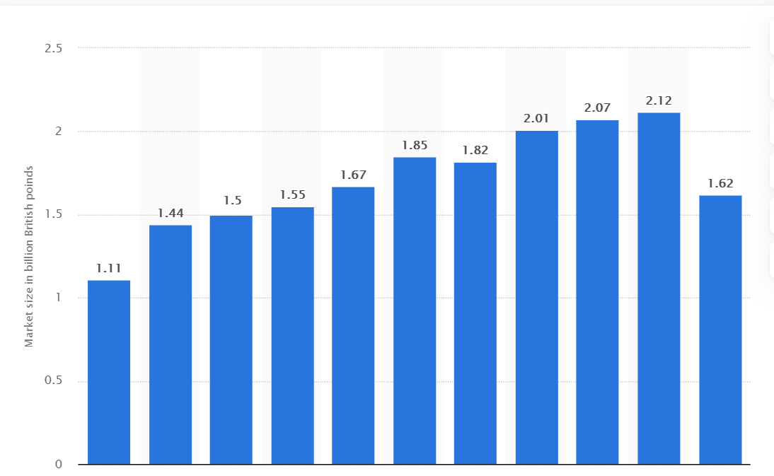

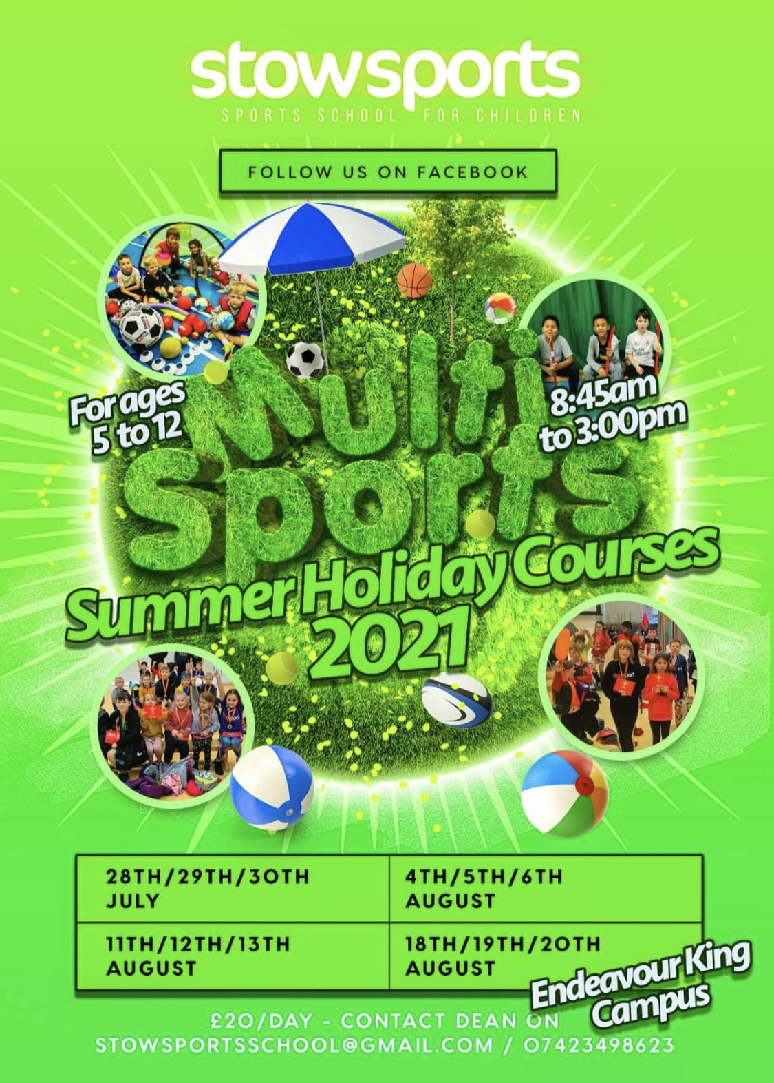
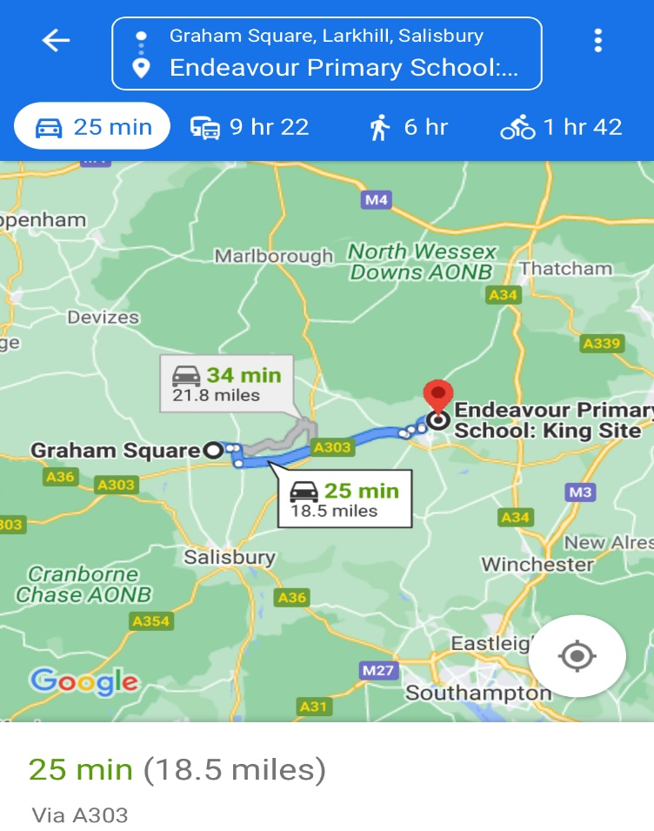
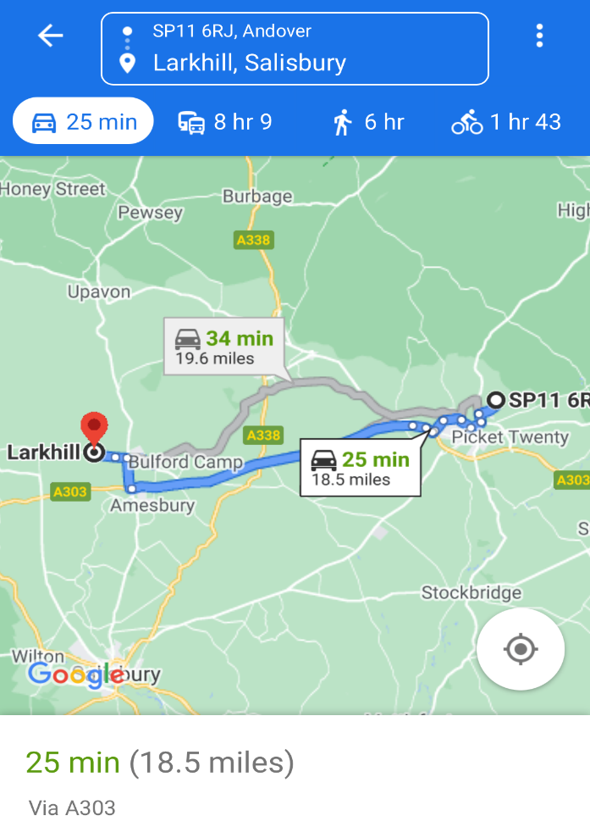
Stow Sports Map Location Coyote Fitness Map Location

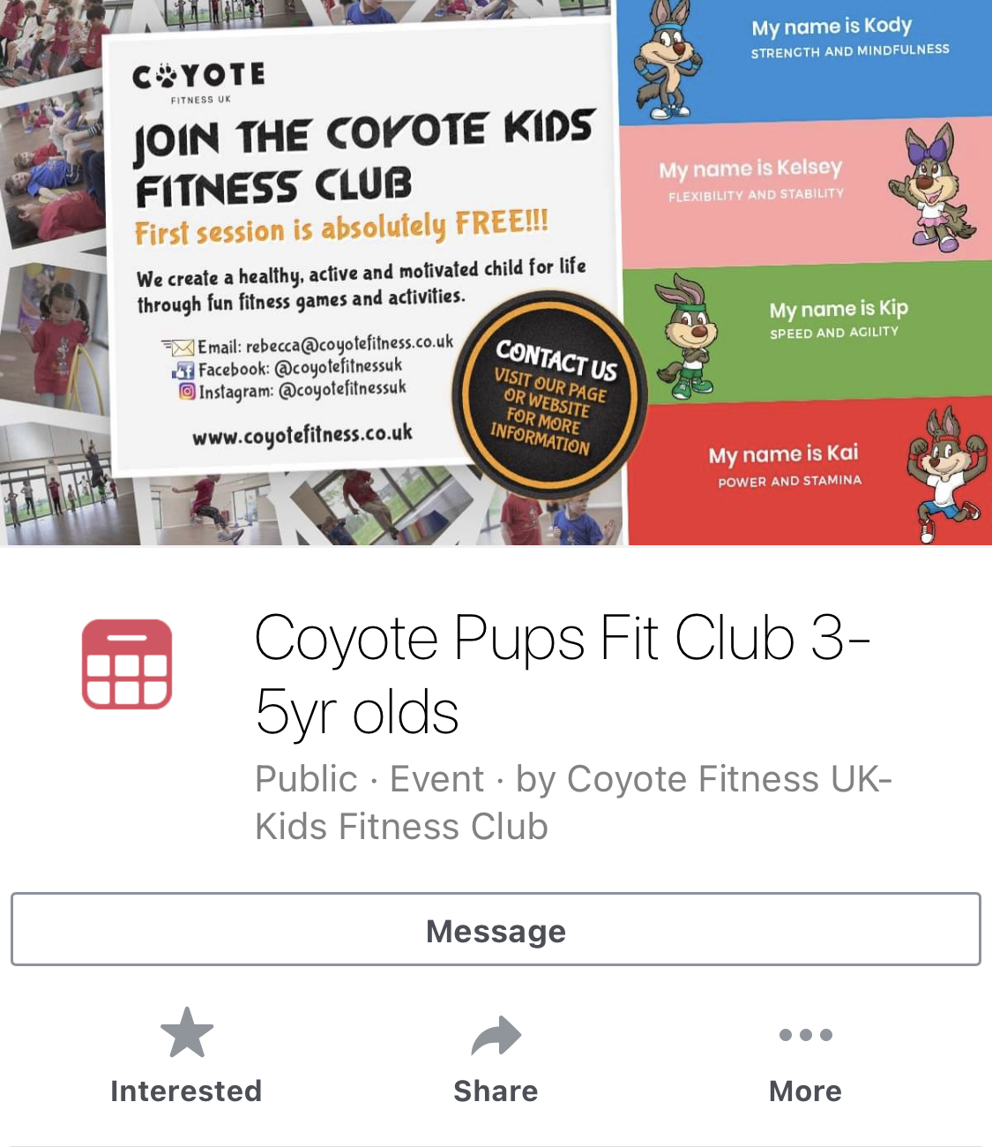

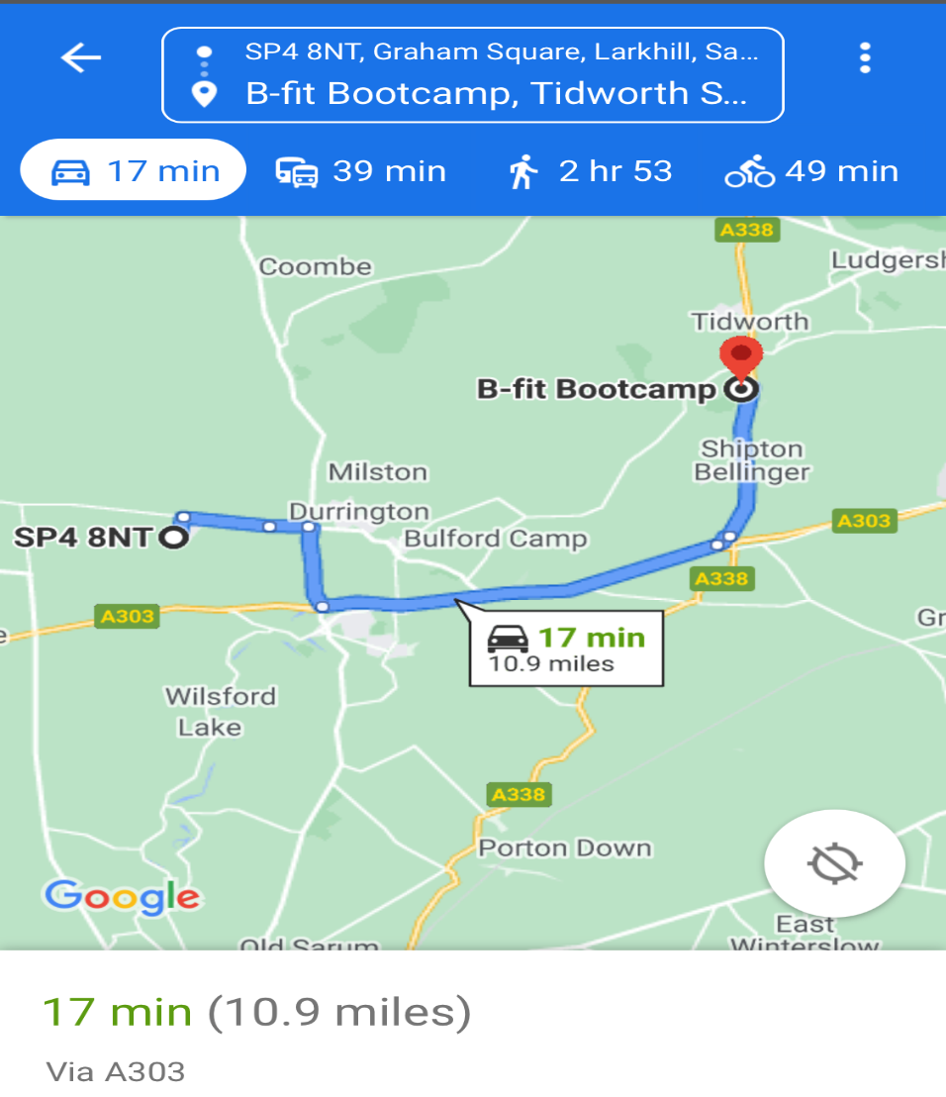
Bfit Fitness Map Location
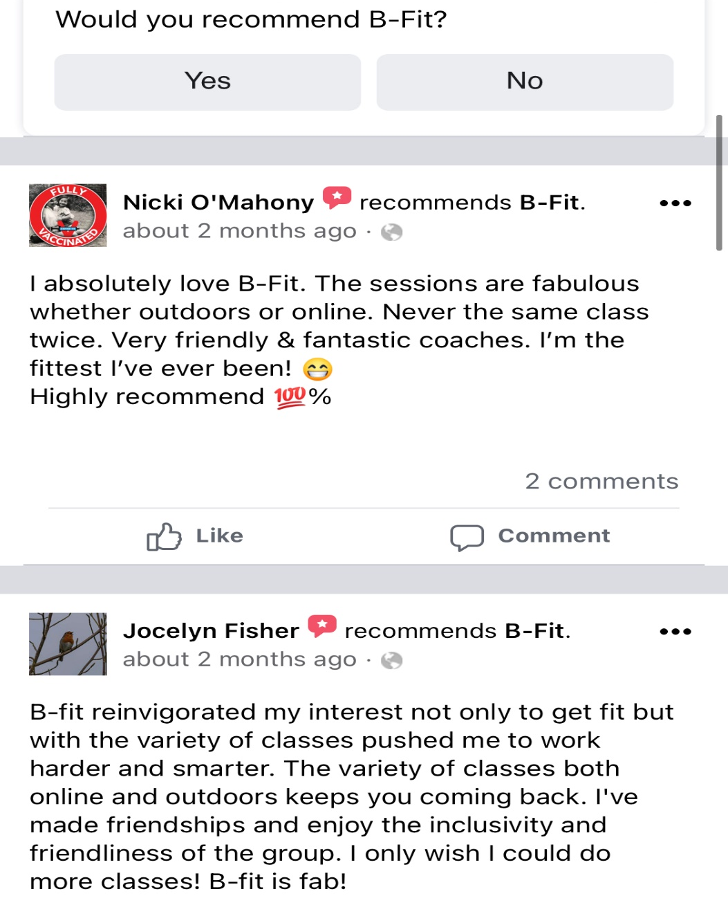

Bfit Facebook Reviews

SWOT Analysis – Bfit Bootcamp
Strengths  - Regular footfall  - Polished business model  - Minimum out goings  - Good Branding | Weaknesses  - Only one person, staffing matrix.  - Limited to number of classes can deliver.  - Advertising is female oriented, non-intentional.
Opportunities  - Expansion would increase income.  - Promotions to attract footfall. | Threats  - Competitors  - Lost of customers due to limited hours.  - Weather  - Premise’s access

SMART Objective Bfit Bootcamp
Based on the findings of competitor Bfit, within AC Fitness business model by Monday 12th July 2021 5pm will ensure to have a higher staffing matrix and more universal advertising.

SWOT Analysis – Bootcamp UK
Strengths  - Regular footfall  - Polished business model  - Minimum out goings  - Good Branding  - Merchandise available to buy increasing sales. | Weaknesses  - Staffing is current serving military resulting in regular change of faces.  - Only employ staff who are current or previously served, limiting employment options.
Opportunities  - Nationwide  - Kid bootcamp  - Promotions to attract footfall. | Threats  - Competitors  - Weather  - Premise’s access

Appendix B


PEOPLE
Small teams = More profit
Experience gained through external methods appeal to the target demographic.
PROCESS
Deliverance through outdoor face-to-face classes
Delivered via recorded ZOOM lessons.
Teams meeting to deliver help to clients.
PROMOTION
Special offers appeal to gaining new customers.
Leaflets/Posters: Spread the brand throughout the demographic area.
PHYSICAL ENVIROMENT
Facilities are important but not necessary.
Clean, well lite area to allow all year-round business to occur.

PRODUCT
Value for money, advertised clearly.
Bold design, simple logo.
Branding eye-catching and appealing to target market.

PRICE
Research shows even numbers are more receptive in acceptance by client.
Strategies:- Bulk purchases. Discount for regular purchases
PLACE
Retail sales of a service.
Peer-peer working resulting in direct sales.
SWOT Analysis – Marketing 7p’s
Strengths  - Physical Environment  - Process: Model streamlined. Consumed via several methods. | Weaknesses  - Product BRANDING new to the market.  - Wholesale not a viable option early on.
Opportunities  - Special offers  - Leaflet drops  - Use of social media | Threats  - Competitors  - Management new to the role.

SMART Objective – Marketing Objectives

Ac Fitness by Friday 9th July 2021 will complete “Five Steps” marketing plan and use as a working document up to and including launch.

Pricing Questionnaire VIA social media
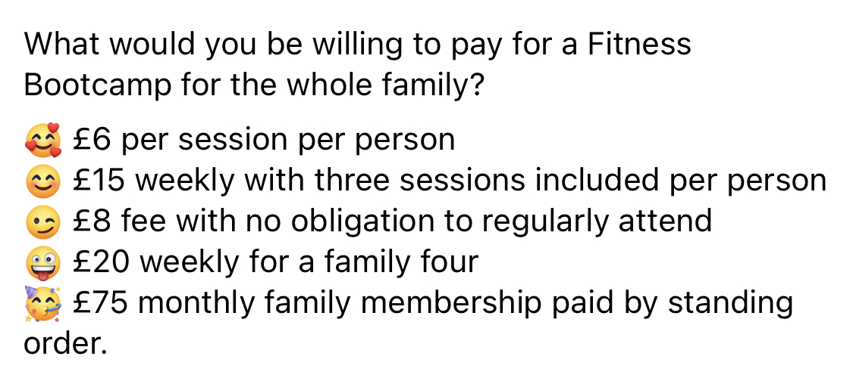

Appendix C

References

Checkmypostcode, (2020), (SP48NT), 01/07/2021 SP4 8NN - Check My Postcode

Francis, A, (February 20th, 2015), (Role of Advertising in the Present Business World), Role of Advertising in the Present Business World (linkedin.com) 06/07/2021

FreshBooks, (May 2019), (Tools to support your business), Invoice and Accounting Software for Small Businesses | FreshBooks 11/07/2021.

Lufkin, B (2021), BBC, The evolution of home fitness - BBC Worklife 01/07/2021.

Statista, (Jan 2021), (Market size of the gym, health & fitness clubs industry in the United Kingdom (UK) from 2011 to 2021) • UK fitness/health club market size 2021 | Statista, 30/06/2021.

Wiltshire Council, (2021), (2021 Census), 2021 Census - Wiltshire Council 03/07/2021.

