RESEARCH PROPOSAL

Developing and Evaluating a Graph Neural Network Framework for Detecting Coordinated Fraudulent Behaviour in Digital Transaction Networks

Prepared by Rohan Mendapara (2520811)
Guided by Abdallah naser

Table of Contents
1. Introduction 3
2. Research Aim, Objectives, and Novelty 3
3. Importance of Research 4
4. Literature Review 4
5. Research Questions and Hypotheses 5
6. Research Design and Methodology 6
7. Research Limitations 7
8. Timeline with Professional Practice 8
9. Expected Findings 9
References 10

1. Introduction
Normal systems are monitoring transactions for possible frauds on an individual basis. These are the people who operate these racket businesses and that have obtained various connections with seemingly genuine transactions. The graph method considers this by referencing the accounts in a graph. Van Belle et al. [1], for example, found that these couplings convey extra information that isn't available from what is said in the transactions. It remains to be seen at this point, however, whether a complex Graph Neural Networks (GNNs) are more effective at detecting this concerted fraud.
Interestingly, this is not one of the prime concerns of most GNN studies as noted by Motie and Raahemi [2]. However, it's very important to look at groups. Collaborative tasks have been proven to be important in online frauds [3], while the identification of a whole money laundering network is more effective than the detection of bad accounts as individual targets [4]. Also, these criminal networks change quickly over time. A one user perspective is not enough to visualize the fraudsters collaborating, claimed Ren et al., 2023. The study needs models for such rapidly changing networks that can be applied, but models are no needed that move as the networks change, Jiang et al. [6] explained.
So, the real question is what the scope of the ability of GNNs is to locate bad accounts, knowing that they can. Instead, it is asked if learning from relationships a good idea for GNNs is to find fraud groups, in comparison to simple methods. To test this out, the project will develop only a prototype and not a proper banking system. The new method is to intercept the bad guys and find out about the network first-hand.

2. Research Aim, Objectives, and Novelty
Research Aim
The primary objective of this study is to develop and evaluate a Coordinated Fraud Group Detection (CFGD) system based on Graph Neural Network (GNN). This will be different from a simple account to account analysis and will analyse what happens between accounts and between interactions to identify hidden fraud rings.
What is New (Research Novelty)
In general, the level of fraud detection will be only for the particular transaction. What is new and unique about this research piece, is that it moves from the aspect of individual accounts to the aspect of relationships. Structure the network by own and learning from it: Learns from the structure of the network by producing a graph of it, with accounts being connected with the transactions. What is novel about it, is a fusion of both feature learning of GNN and group detection to check whether this additional effort in graph construction is justified or not.
Research Objectives
- RO1: To create time-series transaction graphs that visualize the relationships between accounts in coordinated fraud.
- RO2: To design a GNN system that renders the fraud score rate for an individual account and then identifies groups of interacting suspicious accounts.
- RO3: To benchmark this new GNN system with standard machine learning models, using the exact same testing conditions.
- RO4: To assess the value of the graph-based enhanced fraud detection, a benefit of the model over traditional, roughly equally sophisticated fraud detection, against cost of the additional computer hardware and complexity of the model.

3. Importance of Research
This is a significant finding, as the research seeks to identify fraud networks rather than individual fraudulent accounts [7]. The discovery of single bad accounts isn't a snowballing effect to uncover the entire fraudulent activities. For instance, Ji et al. [8] detected frauds of cashing out through tight account networks. Another helpful aspect of exposing these money laundering chains was demonstrated by Chai et al. [4].
But there are some drawbacks to graphs. May contain unnecessary information from regular accounts and need significantly more computer resources. Thus, this new system would only pay off if there are sufficiently exceptional amounts of fraud to justify those additional expenses.

4. Literature Review
Recent studies around digital fraud reveals three key trends. First of all, when it comes to accounts, there are additional clues in the links between accounts than just in the standard transaction information. Van Belle et al. [1] discovered that learning from the relationships between the graphs helps to provide additional information that can aid in fraud prediction. The researchers Zhang et al. [9] demonstrated the efficacy of graph learning under the following two scenarios: when the actual fraud strategy is unknown and evolving. Moreover, there are also more normal transactions than fake transactions, so Huang et al. [10] proposed a specific GNN model for the unbalanced transaction data. That implies measurement based on the effectiveness of a model to capture those rare fraud cases.
Second, fraud is seldom a solo act and searching for all suspicious group behaviour will yield results in addition to just bad accounts. Some subgraphs (groups of connections) are used to identify individuals that were involved in the cash out of stolen funds [8]. Yu et al. [3] looked specifically at group-based fraud, and Chai et al. [4] focused on finding hidden money laundering networks. Although it has been demonstrated in these studies that viewing relationships is significant, there is not a single model that is always preferable to simple, single-account approaches.
Thirdly, bad actor networks evolve over time. According to Zhang et al. [11], coordinated fraud takes place in spurges, where fraudsters team up to cover their activities. It is also a call to consider the dynamic cooperation of fraudsters as a factor over time, as per Ren et al. [5]. Due to these findings, there is an apparent lack of research. Previous studies demonstrate the effectiveness of GNNs, dynamic networks and group detection on their own. But a simple way of combining these tools to identify the coordinated fraud groups and to put them together in direct comparisons to simpler, non-graph models is required.
Moreover, most of the existing works are based on conventional supervised learning algorithms without consideration of the complicated network structure. In the financial fraud domain, studies generally aim to detect individual fraudsters [2]. Very little research has been conducted to investigate their relationships (edges) and whole graph layers, they said. It demonstrates a recognition that graphs can be valuable tools but haven't been fully leveraged for the purpose of identifying organised crime rings. A strategic need to expel our attention on individual accounts and more towards investigating ways in which groups of accounts act.
Constantly evolving transaction networks make it hard for modern fraud detection systems. In the real world, financial interactions happen and change very quickly, and static graphs simply can't document the speed at which things take place. For instance, Jiang et al. [6] explicitly pointed out that static processing cannot be used in the analysis of dynamic transactions in networks. Moreover, recent research on dynamic graph streams such as FiFrauD demonstrates that networks of the financial sector need to be considered as dynamic. Thus, the study intends to address this deficit in this project by introducing a kind of dynamic group-based graph model and compare its performance with conventional benchmark models.

5. Research Questions and Hypotheses
Main Research Question
What are the differences between a Graph Neural Networks (GNNs) approach and the ‘non-graph’ machine learning approach for detecting organised groups of offenders?
Supporting Research Questions
- RQ1: Whether examining a user's ‘neighbourhood’, the variety of users with whom they transact, will lead to improved identification of hidden fraudulent user accounts as compared to the user alone.
- RQ2: Have GNN features and subgraph (group) features demonstrated to add value to identifying coordinated fraud over a single account approach?
- RQ3: What is the trade-off between getting better fraud detection and the extra computer time and memory needed to run the GNN?
Hypotheses
- H₁: The GNN framework can get much higher scores (F1-score and PR-AUC) when identifying the minority fraud class, than any baseline models.
- H₂: GNNs will be better able to identify the complete fraud families (recall) when compared to account-by-account classification.
- H₃: The GNN framework will involve a considerable amount of time and computer memory to run, as analysing relationships is more complex, as compared to the non-graph models.

6. Research Design and Methodology
This research is an experimental design for construction and testing of a new system. It incorporates AMLSim data, involving the synthetic banking networks with known money laundering cohorts. An Elliptic++ cryptocurrency dataset will also be experimented with to determine if the system operates well in realistic networks. In a network graph, accounts are represented by points (nodes), and transactions are represented by the lines (edges) between them. These connections will help existing models, such as GraphSAGE, determine the probability of fraud for an account. Lastly, the system identifies suspicious, related clusters of users from these individual risks.
It is a simple two step approach and is very practical to use for a Masters' level project. It gives valuable and reproducible research results, rather than creating a new model from scratch.
Two main baselines will be used:
- Non-graph baseline: Logistic Regression and/or XGBoost on account and transaction data.
- Graph baseline: Standard GraphSAGE/GAT model with the production of node-level predictions and no subgraph detection.
Matching number of training and testing sets will be used where possible. Simple accuracy is not a suitable measure because they commit little in the way of frauds. Instead, the study will measure the following aspects during testing: Precision, Recall, F1-score, PR-AUC and ROC-AUC. The study is going to specifically measure the efficacy of the system of intercepting known ringers in particular.
This will be demonstrated not only in time, but also in the amount of memory taken up and show the efficiency of the system. For the results to be valid, not a result of luck, use of statistical tests (t-tests) will be ensured. Python libraries such as PyTorch Geometric, NetworkX, Scikit-learn and Pandas will be used in the project. Last and foremost, this study does not involve human subjects and uses existing or fake data.

7. Research Limitations
In this research study four important limitation concerns have been mentioned which should be taken into consideration. There are of course some data constraints. AMLSim is a nice presentation tool for coordinated fraud and is simulated but can't do tricks as they are done in the real world. Information for real-world cryptocurrencies are added to the Elliptic++ dataset, and full groups of fraud are not clearly labelled.
Further, making a network graph is an uncertain initiative. Very precise connections between accounts should exist in a Graph neural Network. When the graph is unrelated, the model will learn "useless" noises from the graph, which will take the predictive power out of the graph.
Third, they require a high level of computing power: Compared to simple models such as XGBoost, graph models are more memory- and time-consuming. At the bank, typically, a large GNN could be too slow or expensive to assist millions of transactions with all of them occurring every day.
Last but not least, there is also a high probability of triggering false alarms. A normal user that would just trade together with others a lot of time, might be mistaken in identified as part of a suspicious group by the model while searching.

8. Timeline with Professional Practice
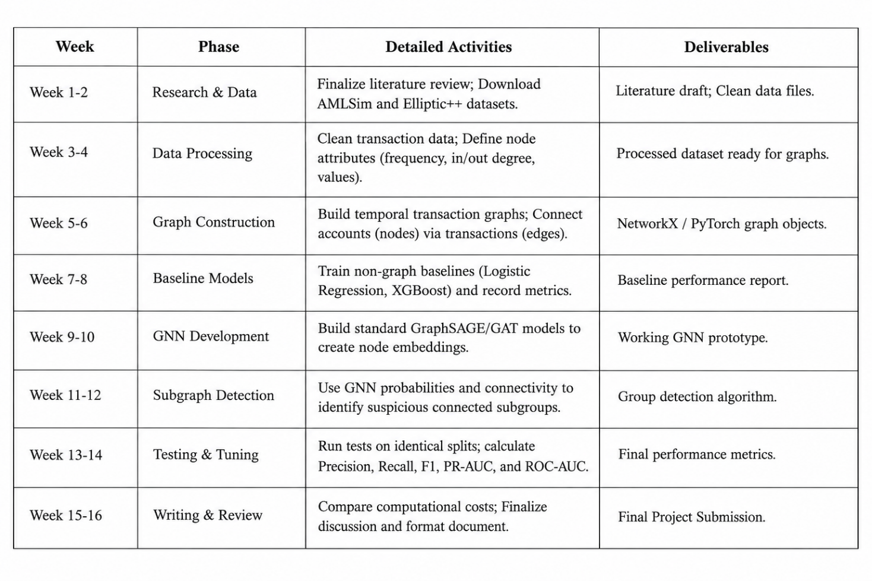
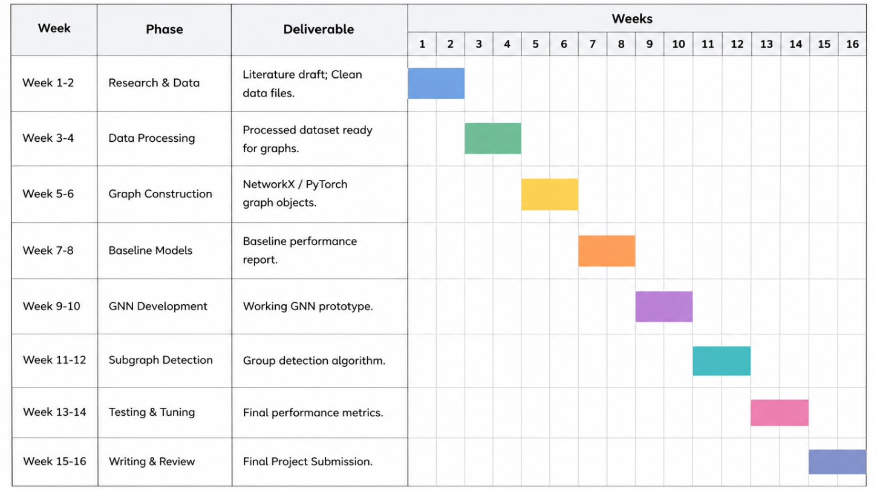
A project timeline for 16 weeks is scheduled to complete the project in a proper manner. The study will review previously completed research and set up AMLSim and Elliptic++ data in the first month. The second month involves network graph construction and the testing of simple baseline models. In month 3, the research will develop the Graph Neural Network (GNN) and design the group detection system in order to identify group frauds. The last month shall be devoted to testing the models, verifying results and creating the "Final" report. This open communication of a timeline allows us sufficient time to address any one or multi-computer issues.

9. Expected Findings
In hope it proves that it would be the relations which would have to be observed and not the acts of organized crime; otherwise, it will never be detected. The study believes GNN to be a framework that is highly effective in detecting clusters of clustered fraud. Group detection rates and PR-AUC will therefore be most important to observe for improvement rather than basic accuracy, as a consequence.
Another side of the coin the study should take note of, though, is a compromise that is rigidly based on performance or efficiency. The heavy usage of computer processing power and memory of the GNN model will definitely be using up more than the traditional models. Moreover, the study would have expected that groups of an association of legitimate users may be classified as a botnet, and some false positives may be generated.
In the end, this study will simply say that GNNs are better! Instead, it is the cost of graph learning that will be completely exhibited and verified under certain circumstances. It will give the researchers and banks a clear indication of what to look for to get a "right balance" between the high cost of GNNs and their ability to detect coordinated digital fraud.

References
[1] R. Van Belle, C. Van Damme, H. Tytgat, and J. De Weerdt, "Inductive graph representation learning for fraud detection," Expert Systems with Applications, vol. 193, p. 116463, 2022. DOI: https://doi.org/10.1016/j.eswa.2021.116463
[2] S. Motie and B. Raahemi, "Financial fraud detection using graph neural networks: A systematic review," Expert Systems with Applications, vol. 240, p. 122156, 2024. DOI: https://doi.org/10.1016/j.eswa.2023.122156
[3] J. Yu et al., "Group-based fraud detection network on e-commerce platforms," in Proceedings of the 29th ACM SIGKDD Conference on Knowledge Discovery and Data Mining, pp. 5463–5475, 2023. DOI: https://doi.org/10.1145/3580305.3599836
[4] Z. Chai et al., "Towards learning to discover money laundering sub-network in massive transaction network," in Proceedings of the AAAI Conference on Artificial Intelligence, vol. 37, no. 12, pp. 14153–14160, 2023. DOI: https://doi.org/10.1609/aaai.v37i12.26656
[5] L. Ren et al., "Dynamic graph neural network-based fraud detectors against collaborative fraudsters," Knowledge-Based Systems, vol. 278, p. 110888, 2023. DOI: https://doi.org/10.1016/j.knosys.2023.110888
[6] J. Jiang, Y. Chen, B. He, M. Chen, and J. Chen, "Spade+: A generic real-time fraud detection framework on dynamic graphs," IEEE Transactions on Knowledge and Data Engineering, vol. 36, no. 11, pp. 7058–7073, 2024. DOI: https://doi.org/10.1109/tkde.2024.3394155
[7] Y. Elmougy and L. Liu, "Demystifying fraudulent transactions and illicit nodes in the Bitcoin network for financial forensics," in Proceedings of the 29th ACM SIGKDD Conference on Knowledge Discovery and Data Mining, pp. 3979–3990, 2023. DOI: https://doi.org/10.1145/3580305.3599803
[8] Y. Ji et al., "Detecting cash-out users via dense subgraphs," in Proceedings of the 28th ACM SIGKDD Conference on Knowledge Discovery and Data Mining, pp. 687–697, 2022. DOI: https://doi.org/10.1145/3534678.3539321
[9] G. Zhang et al., "eFraudCom: An e-commerce fraud detection system via competitive graph neural networks," ACM Transactions on Information Systems, vol. 40, no. 3, Art. 47, 2022. DOI: https://doi.org/10.1145/3474379
[10] M. Huang et al., "AUC-oriented graph neural network for fraud detection," in Proceedings of the ACM Web Conference 2022, 2022. DOI: https://doi.org/10.1145/3485447.3512178
[11] Z. Zhang et al., "Temporal burstiness and collaborative camouflage aware fraud detection," Information Processing & Management, vol. 60, no. 2, p. 103170, 2023. DOI: https://doi.org/10.1016/j.ipm.2022.103170

