Understanding Self and Values
BMSE4016D | Assignment 1 | Portfolio
Student name: Simion Alex Mihai Student ID: 2621631
Editable example draft • Replace the highlighted personal examples with your real experiences before submitting.

Portfolio Element 1

1. Personal Values Map
My values are the things that guide how I behave and make decisions. For this portfolio, I have chosen respect, honesty, responsibility and kindness as example values. [EDIT: Keep only the values that are really important to you.] Respect means listening to other people, even when they have different ideas. Honesty means being truthful and admitting mistakes. Responsibility means finishing my work and keeping promises. Kindness means thinking about how my actions affect others.
These values can also guide a small business or social enterprise. For example, a business should be fair to customers and staff, not only focused on money. Schwartz (2012) explains that values influence what people see as important. I think values are useful because they help me make decisions when there is no easy answer. However, sometimes values can compete. Being kind does not mean I should avoid giving honest feedback. I need to balance both.
MY VALUES | WHAT THEY MEAN IN PRACTICE
Respect | Listen and include other people
Honesty | Give clear and truthful information
Responsibility | Complete tasks and learn from mistakes
Kindness | Consider the needs of others

2. Personal SWOT Analysis
A SWOT analysis helps me look at my strengths, weaknesses, opportunities and threats. It is a simple way to plan improvement. The examples below are suggestions only. [EDIT: Change the entries so they describe you.]
STRENGTHS | WEAKNESSES
I try to be reliable; I listen carefully; I enjoy learning. | I can feel nervous speaking to a large group; I sometimes take too long checking my work.
OPPORTUNITIES | THREATS
College activities; feedback from teachers; learning digital skills. | Limited time; lack of experience; fear of making mistakes.
One strength I would like to use in enterprise is listening. It can help me understand what customers or community members really need. A weakness I would like to improve is confidence when presenting ideas. I can practise this by speaking in small groups first. SWOT is useful, but it is not a test: my answers may change as I gain experience. This is why I should review it regularly.

3. My Motivations
Motivation is the reason I work towards a goal. In this example, my main motivations are learning, becoming more independent and building a stable future. [EDIT: Replace with your real motivations.] I want to improve my skills so I can have more choices in my career. I also want to feel proud when I finish a difficult task. Deci and Ryan (2000) explain that people are motivated by autonomy, competence and connection with others. I can relate this idea to studying: I feel more motivated when I understand a task, can make choices and receive useful support.
Motivation is not always the same every day. When work is difficult, I may lose confidence. Breaking a large task into smaller steps can help me continue. I can also set weekly goals and check my progress. This makes my motivation more practical rather than depending only on how I feel.

4. Influences on My Thinking
People and experiences can shape how I think about work and success. [EDIT: Add a real person, experience or situation that influenced you.] For example, seeing someone work hard and treat others fairly can show that success is not only about earning money. Teachers and classmates can also help me see different ways to solve a problem. Bandura (1977) explains that people can learn by watching others. This reminds me to choose good role models and think carefully about the behaviours I copy.
I also learn from mistakes. If a group task does not go well, I can ask what I could do differently next time. Reflection is useful because it turns an experience into a lesson (Kolb, 1984). However, I should not assume that one experience tells me everything. I need to listen to other views and try new approaches.

5. Future Ambitions
My example short-term goal is to improve my communication and time management during this academic year. My medium-term goal is to gain more practical experience through study, volunteering or work. My longer-term goal is to find a career where I can use my skills and help other people.
To make these goals realistic, I can use SMART planning: specific, measurable, achievable, relevant and time-bound (Doran, 1981). For example, I could aim to contribute at least once in every group discussion for the next six weeks. I could also plan my assignments earlier and ask for feedback before deadlines. These steps are small, but they can build confidence over time.
I am interested in the idea of social enterprise because it connects business activity with a social purpose. A social enterprise should think about the people it serves as well as how it pays its costs (Social Enterprise UK, n.d.). My values could support this approach, but good intentions are not enough. I would need to understand real needs, manage resources and measure whether an idea helps people.
Overall, this portfolio helps me see that my strengths and values can support future opportunities. I also have areas to improve. My next step is to use feedback and real experience to make a clearer personal development plan.

Portfolio Element 2
Digital Evidence Trail (approximately 500 words)
IMPORTANT: The three entries below are writing examples, not evidence of completed Moodle activities. Replace each title, activity description and reflection with the actual work you completed in Weeks 1–5.

Evidence 1: Personal Values Activity
[EDIT: Insert the exact Moodle activity name and describe what YOU submitted.]
In this example activity, I identified values that matter to me and thought about how they affect my choices. I noticed that being respectful and responsible can influence how I work with others. The main lesson was that values are not just words; they should be visible in everyday behaviour. Schwartz (2012) suggests that values help explain people’s priorities. In future group work, I want to listen to others and be honest about what I can do. I would also check whether my actions match the values I say I have.
[INSERT REAL MOODLE SCREENSHOT 1 HERE]

Evidence 2: SWOT Self-Assessment
[EDIT: Insert the exact Moodle activity name and describe what YOU submitted.]
In this example activity, I considered possible strengths and weaknesses and thought about opportunities to develop. I learned that confidence can improve with practice, and that a weakness is not permanent. A SWOT analysis can help me plan, but it only works if I answer honestly. In future, I would set one small improvement goal and ask for feedback. This could help me recognise progress rather than focus only on mistakes.

Evidence 3: Creative Problem-Solving Activity
[EDIT: Insert the exact Moodle activity name and describe what YOU submitted.]
In this example activity, I explored different ideas for solving a problem before choosing one. I learned that the first idea is not always the best one. It can be helpful to ask questions, listen to others and compare possible solutions. Kolb (1984) shows the value of learning through experience and reflection. In the future, I want to test ideas on a small scale, learn from feedback and improve them. This could help me in study, work or a social enterprise project.
[INSERT REAL MOODLE SCREENSHOT 3 HERE]

References
Bandura, A. (1977) Social Learning Theory. Englewood Cliffs, NJ: Prentice Hall.
Deci, E.L. and Ryan, R.M. (2000) ‘The “what” and “why” of goal pursuits: Human needs and the self-determination of behavior’, Psychological Inquiry, 11(4), pp. 227–268.
Doran, G.T. (1981) ‘There’s a S.M.A.R.T. way to write management’s goals and objectives’, Management Review, 70(11), pp. 35–36.
Kolb, D.A. (1984) Experiential Learning: Experience as the Source of Learning and Development. Englewood Cliffs, NJ: Prentice Hall.
Schwartz, S.H. (2012) ‘An overview of the Schwartz theory of basic values’, Online Readings in Psychology and Culture, 2(1).
Social Enterprise UK (n.d.) What is social enterprise? Available at: https://www.socialenterprise.org.uk/ (Accessed: 13 October 2026).

Appendix: Moodle Evidence
Insert three screenshots of your completed activities from Weeks 1–5. Include the post date/name or completion confirmation where possible. Do not use screenshots of instructions alone as proof of completion.
Appendix 1: Identity Map – Moodle post
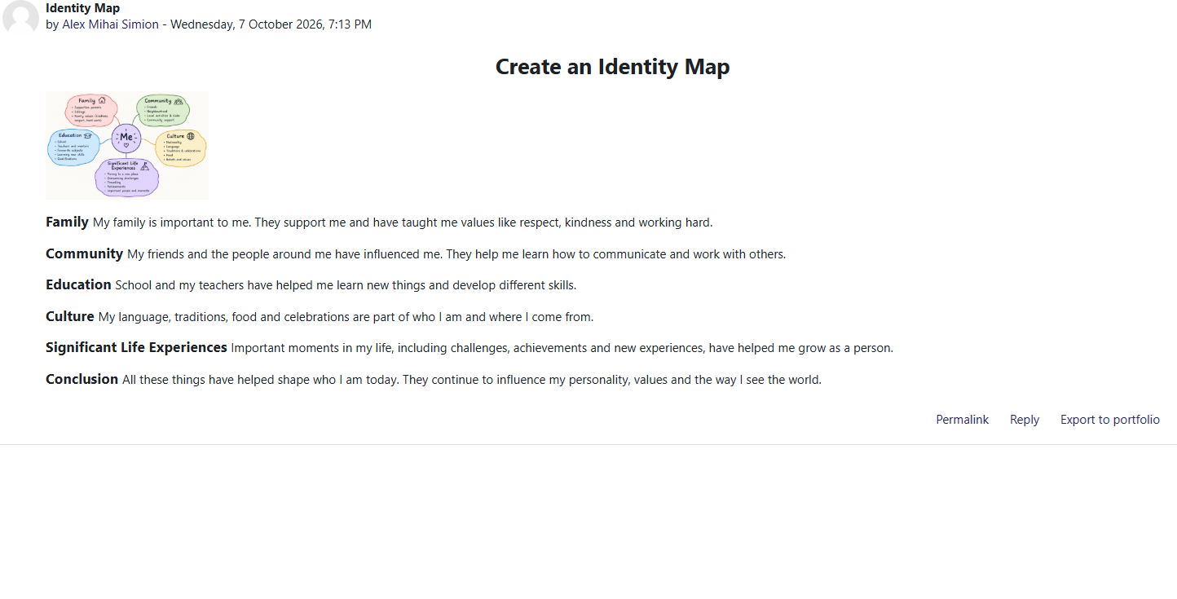
Appendix 2: Reflection on My Identity – Moodle post


