Forging a Path to Success: The Stages of Quad Chart Brainstorming, Iron Triangle, and Risk Assessment
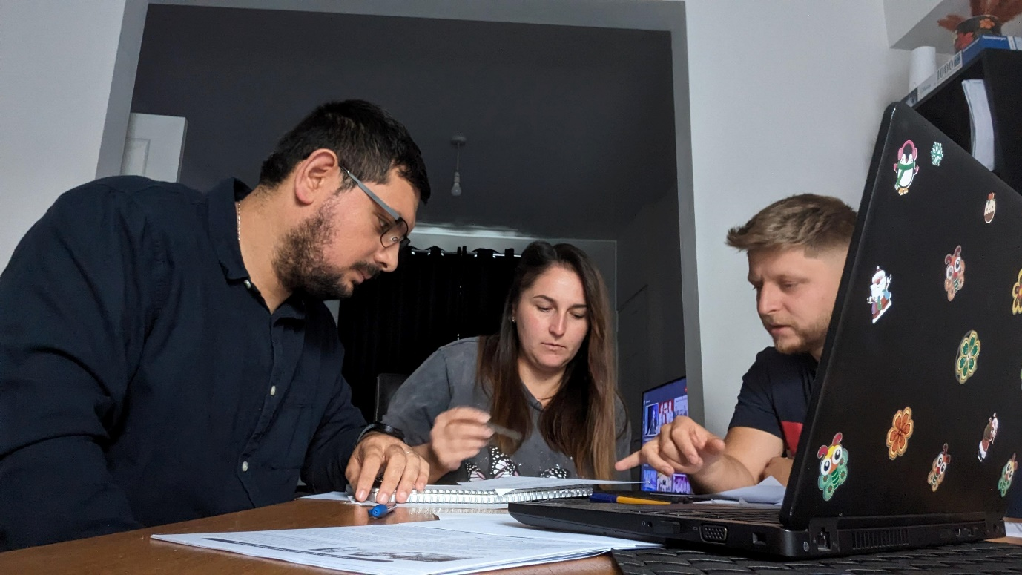
Introduction:
In our relentless pursuit to create a remarkable book bus station, our journey encompasses several crucial stages that guide us towards success. Three essential stages in this process are Quad Chart brainstorming, Iron Triangle analysis, and risk assessment. Each stage brings valuable insights and helps us navigate challenges effectively.

Quad Chart Brainstorming:
The Quad Chart technique enables us to categorise and prioritise ideas effectively, aligning them with key aspects of our business. Through collaborative brainstorming, we leverage diverse perspectives to generate creative strategies that align with our vision and goals.

Iron Triangle Analysis:
The Iron Triangle, consisting of time, cost, and quality, allows us to assess project constraints and make informed decisions. By analysing the interplay between these factors, we strike a balance that ensures timely implementation, cost-effectiveness, and high-quality outcomes (Atkinson,1999).

Risk Assessment:
Conducting a comprehensive risk assessment enables us to identify and mitigate potential challenges and uncertainties. By proactively addressing risks, we develop contingency plans and minimise potential disruptions, ensuring a smoother journey towards our goals.

Conclusion:
The stages of Quad Chart brainstorming, Iron Triangle analysis, and risk assessment are vital pillars of our journey towards creating a remarkable book bus station. By harnessing the power of collective creativity, considering project constraints, and mitigating risks, we forge a path to success. With these stages in place, we are confident in our ability to overcome challenges, optimise resources, and deliver a captivating literary haven that delights our customers.

References:
Atkinson, R. (1999). Project management: Cost, time, and quality, two best guesses, and a phenomenon, its time to accept other success criteria. International Journal of Project Management, 17(6), 337-342.

