Data Handling and Business Intelligence: SBUS5105
Georgina Buckland: 1404838
Dr Roisin Mullins

PART 1-
Recognising a Problem
For the purposes of this assignment, my aim was to use a traditional software package to determine the causes of reduced profits of, ‘Canada Shopper’. The initial step I undertook was recognising that I needed to build a model in which to distinguish the possible reasons for this decreased profit. This form of descriptive analytics would allow me to, ‘condense big data into smaller, more useful nuggets of information’ (Bertolucci, 2013). This step into analytics is an essential step for organisations like ‘Canada Shopper’, as it has been argued, ‘Analysing large data sets will become a key basis of competition, underpinning new waves of productivity growth, innovation, and consumer surplus as long as the right policies and enablers are in place.’ (McKinsey, 2011)
Defining the Problem
I had to conceptualise that ‘Canada Shopper’ was intending to use this mathematical model to better inform their decision making process. ‘The two variants; Big Data and traditional analytics must work together for maximum results of Big Data application.’ (Farooq, 2017) The process of defining a problem may be relatively multifaceted due to an innumerable amount of conceivable trends within the data. I must analyse the dataset as a whole company to assess the causes for ‘Canada Shopper’s’ reduced profits, based on their strengths and weaknesses. Although this allows me to gain more of an insight into the complete business, this could be a reason for complexity where, ‘the problem belongs to a group and not an individual.’ (Evans, 2014) The dataset of ‘Canada Shopper’s’ is relatively large, consisting of a high volume and variety of both attributes and tuples. This could also act to brand it problematic to define the problem as the time limitation could act to restrict the outcomes for the explanations for ‘Canada Shopper’s’ diminished profits.
Structuring the Problem
The dataset provided by ‘Canada Shopper’ had not been cleaned, so I ensured the data was pre-processed to certify its correct and standardised nature and to categorise any redundant cells as anomalies. Microsoft Excel was beneficial to the pre-processing procedure as the dataset provided was so large, it would have been too time consuming to have done so manually, where the use of filers saved both time and effort. (Appendix 1). The therefore automated nature of the pre-processing procedure was much more effective to this particular piece of work as it was not prone to inducing any additional errors, unlike a manual method. However, as an unexperienced user of Microsoft Excel, I found it particularly challenging to use this system until I had sufficient enough knowledge and experience with the software. This has connotations to Williams’ theory where BI is dependent on having knowledgeable personnel. (Steve Williams, 2011)
Analysing the Problem
By using this software to analyse the problem, it is clear to see that Excel is effective for a range of generic and specific functions. Microsoft Excel allowed the use of formulas that were of both simple and intermediate complexibility to product basic calculations from the organisation’s data. (Appendix 2, 3 and 4). This is where the data analysis begun and the data was being transformed into information.
I evaluated the relationship between order quantity and order priority to see if there were any priority issues in which a “Large” quantity order was labelled as “Low” priority. By using filters on the Order dates column, this allowed me to narrow down the interval data into specific years that I could look at individually. (Appendix 5). Although issues were identified, it seems that the relationship between the two factors has not changed drastically between the 4 years and has in fact stayed moderately consistent. While no trend was evident, Microsoft Excel was effective in allowing me to look into specific compartments of data to identify any trends.
Another possibility I explored was the relationship between returned items and ‘Canada Shopper’s’ profit or loss. Excel was beneficial to this process as it allowed me to create a relational database. With Order ID acting as the key field, I used a V-Lookup to share data between tables which allowed me to view all returned and non-returned orders as a whole. (Appendix 6). This use of a V-Lookup was beneficial to the analysis of data as it was much more resourceful to share data between tables and keep on the required tabs. My next step was to create a multiple IF statement which would present data that has been returned and was making a loss. (Appendix 7). The way in which the software allowed me to carry out these particular tasks, indicates its practicality for mathematical and computer based models. However, insufficient analytical skills and a lack of understanding for the software could limit your performance as some tasks can be relatively complex to complete. Although, with sufficient training, executing this multiple IF statement enabled me to identify a conceivable factor as to why ‘Canada Shopper’ has a decreasing profit. My spreadsheet indicates that 56% of returns are in fact making a loss. Similarly to the previous findings, (Appendix 8), Count IF formulas were used to reveal that a massive 7643 of sales had been discounted and 3914 of these were making a loss.
As established, Microsoft Excel is a useful tool for statistical analysis. The benefits of the software for graphical information became palpable to me when I used the software to produce a variety of graphs and charts. I created line graphs to show the inventory figures and two moving average forecasts. (Appendix 9,10 and 11). This demonstrates how Excel is an effective tool for stimulation modelling, whereby ‘the model ‘simulates’ the working of the system so the output ‘happens’’. (Oakshoot, 1997) This type of predictive analytics could prove extremely beneficial to ‘Canada Shopper’ where by extrapolation, historical trends within the business can provide an insight into the future where different methods could be tested to improve the company’s profits. Both graphs allowed me to visualise the company’s performance and detect trends, where the dataset of statistics was difficult to see any patterns.
After producing a pivot table in Excel, (Appendix 12), I went on to create a product summary chart to visualise the performance of each product type between regions. (Appendix 13). From using both a linear and a polynomial trend line on the graph, I was able to generalise data much more effectively by visually recognising the patterns within the data. This chart presented data in a format that allowed me to see clearly which regions were producing the highest and lowest profits. From this graph, I identified a possible issue for the company with the region of Nunavut only producing 0.2% of ‘Canada Shopper’s’ overall profits. This is a prime example of how Excel was enormously useful in allowing its user to visualise complex data. However, although proven useful for computations on small segments, when handling a large dataset like that of ‘Canada Shopper’, it seems that the software’s practicality is limited.
Using a variety of formulas, I created tables on each type of product packaging. (Appendix 14). From accessing smaller pockets of the data, I was able to detect that the ‘Small Box’ attribute made up for 51% of losses as a whole. The ability to format cells and give them unique styles made it much more visually appealing to the viewer. (Appendix 15). This was supported by Microsoft Excel’s well-structured and precise nature.

Interpreting Results and Making a Decision
The ‘Dashboard’ tab of my spreadsheet can be used by ‘Canada Shopper’s’ managers to construe. (Appendix 16). This is the, ‘visual display of the most important information needed to achieve one or more objectives; consolidated and arranged on a single screen so the information can be monitored at a glance’. (Few, 2006) This tab of the spreadsheet is vital for the organisations as ‘data visualisation is important in order to stay close to data’. (Morrison, 2010) From my dashboard, summary models can be seen, with their information containing the profit per region, forecasts, inventory and the product summary chart along with the summary pivot table. Although this clearly visualised my key findings, the managers of ‘Canada Shopper’ must be aware of the limitations of this model as a whole as it cannot comprise all the details of the real issue.
Implementing the Solution
With the use of Microsoft Excel, the dataset of ‘Canada Shopper’ has been analysed and conclusions can be drawn.
With discounts making up 90% of all sales, it is likely that a reduction of discounts would see an improvement on ‘Canada Shopper’s’ profits. This is a way in which the software allowed me to ‘determine an optimal solution’ (Evans, 2014) by analyzing the data to highlight a positive correlation between attributes.
With an unmistakeable pattern between returns and losses, perhaps if the company was to enforce a stricter returns policy that reduced the quantity of returns within the organisation, ‘Canada Shopper’ may in turn act to reduce their losses. The use of Excel was beneficial to these findings where automatic computations allowed for a more structured investigation with a reduced risk of human errors. The formulas, such as IF statements and V-Lookups were sometimes challenging to use until I had sufficient enough practice, however they allowed me to look at specific pieces of data whereby analysis could take place. This is also evident throughout my investigation between product packaging. The data suggests small boxes are the priciest and if ‘Canada Shopper’ was to reduce their amount, perhaps this would have an improvement on their currently reducing profit.
The product summary chart was an example of how Microsoft Excel was useful in visualising complex data. However, the data had to be condensed before creating the chart which highlights its reduced practicality on larger datasets. However, this form of visualisation allows conclusions to be drawn; Perhaps the company could focus more on the higher income stores in Prairie and Ontario where technology is incredibly high in demand. With furniture sales being consistently low throughout the company, an emphasis on higher profitability products would be wise.
Overall, Microsoft Excel has assisted with the pre-processing, analysis and visualisation of the dataset. The automated nature and use of filters deems Excel useful in the ‘cleaning’ of data. Automated computations are beneficial to the structuring and analysis of data, where it can be transformed into information. However, the complexity of some formulas can have an impact on some user’s experiences with the software, where insufficient knowledge can act as a barrier to use. Visualising complex data was another custom of Excel where the options of graphs or charts were readily available.

PART 2-
Business Understanding
From the investigation into ‘Canada Shopper’s’ dataset, the use of Microsoft Excel has allowed me to identify some key issues. The company offers a huge amount of discounts of their sales which has shown a correlation with orders that have been making a loss. Pivot tables and charts have produced visualised information into the profitability of different product types and it is clear to see that technology is the most profitable product type between all regions. Although, where technology seems to be doing well, furniture probability is consistently low throughout all regions. I will use WEKA as a form of data mining to, ‘identify valid, novel, potentially useful, and ultimately understandable patterns in data’. (Fayyad, 1996)
Data Understanding
The data I selected then had to be pre-processed. As WEKA is a tool that accepts data in a well-structured format, I had to use the filter tools to identify any blank fields and anomalies, which then had to be eliminated. (Appendix 17). In order to prepare adequate data to input into WEKA, I had to use a form of data reduction. I used data that was from specifically 2016 as this would allow me to get an insight into the most recent year of trade for ‘Canada Shopper’. I also reduced the data to 1000 tuples as too much data would be difficult for WEKA to process. I felt this was a sufficient quantity of tuples to effectively identify trends within the data, whilst ensuring the practicality of the software was not sacrificed.
Data Preparation
Decision Trees
Once I opened my CSV folder in WEKA, issues were identified where my data was not sufficiently cleaned. This meant I had to go back to my dataset and distinguish where these errors were. Although the Excel software package made it easy to do, it seems that the lack of allowance of specific cells may be a limitation for WEKA. An advantage of this data tree model is the way in which decision trees are able to incorporate both categorical and numerical data. This is evident in (Appendix 17), where I used profit data and categorical data on the product subcategories. ‘Certain columns of data are ideal for inclusion in a prediction data mining approach using a classification which is a supervised approach.’ (Sharda, 2008)
Prediction Regression
As regression is the process whereby existing data can be transformed into numerical predictions for future data, I needed to ensure that the data I selected would be sufficient enough to act as the template to these predictions. One factor which can have an impact on WEKA’s output is the ‘noise’ within the data. I had to try to eliminate inconsistencies and normalise ‘Canada Shopper’s’ data. (Appendix 17 and 18).
Clustering
As an unsupervised learning technique, I required data that would allow me into an insight of the different segments of data. Clustering techniques are useful to identify natural groupings and detect patterns between these segments. Therefore, I aimed at using the attributes of data that would reveal the qualities of customers purchasing each product type. The columns I selected had to be consistently formatted to reduce erroneous results. As a result of requiring well-formed data, perhaps this is a downfall of WEKA as it is easy to overlook an unformatted or missing cell which could easily cause erroneous outputs. (Appendix 30).
Association
For this type of data mining, I needed to select data that could be analysed to gather sufficient information about the types of products consumers were purchasing. As an unsupervised sequence analysis technique, I needed to investigate any correlation between product types and affinities between different variables. Some of the cells in ‘Canada Shopper’s’ dataset were blank cells so I had to use filters to only select the cells with information.
Model Building
Decision Trees
‘Classification maps data into predefined groups or classes’. (Dunham, 2002) This is a model that allows users to have a better understanding of the production rules by presenting them in a comprehensible way. I used a variety of different algorithms in an attempt to compare their outputs to find the most accurate. Some correctly classified percentages were relatively high with that of ‘J48’ being 74% and ‘RandomForest’ being a moderate 69%. (Appendix 19 and 22). However, some of the tree algorithms were unreliable with ‘Decision Stump’ producing a 42% percentage. Using algorithms like ‘Lazy’ and ‘Bayes’ also only produced relatively low percentages. (Appendix 24 and 26). I chose five classification methods to use as I felt this was sufficient enough to distinguish the more reliable outputs.
Linear Regression
‘Regression is a technique that uses equation into a given dataset and assumes the data fits in some kind of function, such as linear or logistic.’ (Anon., 2015) Performing linear regression was relatively simple. Using the ‘Functions’ algorithm, the output of the linear regression was comparatively high with 86%. (Appendix 31).
Clustering
With WEKA, I had to pre-determine the number of clusters I wished to identify. I found this particularly challenging as if I predicted an inaccurate number of groups, my results may have been non-deterministic. I found that throughout the model building process, I had to alter this number several times in an attempt to find clusters that had a closer link to the initial centroid. I found that ‘Canada Shopper’ had a distinguishable 5 clusters. (Appendix 28 and 29).
Association
I needed a model that would transform simple, point of sales transaction data to show the most frequent affinities between products. My choice of algorithm is apriori as this should allow me to generate association rules.
Testing and Evaluation
Decision Trees Outputs
Classification via decision trees is clearly an effective method as they have in fact been applied successfully to real problems, providing a reason as to why they are probably the most popular structure for supervised data mining. This type of classification means that ‘rules are easier for humans to understand’, (Kamber, 2000) The time spent on the model construction was relatively short, meaning the process of accessing this knowledge was quick. However, the time taken for the classification process was shortened due to only inputting a small selection of data. This implies that perhaps one of WEKA’s downfalls is that it is only useful for focussing on a relatively small dataset. The actual visualisation of the decision trees was quite problematic. Many of the trees produced were so unclear, it was difficult to understand the visualisation. (Appendix 32). However, I did receive relatively high accuracy results with the J48 algorithm with 74% correctly classified. (Appendix 19 and 33).
Linear Regression Outputs
The regression outputs produced for ‘Canada Shopper’s’ dataset were highly accurate with a correctly classified percentage of 86%. This demonstrates the high relationship between variables for ‘Canada Shopper’. ‘Data Mining brings out the patterns and relationships, but the significance and validity of those patterns must be made by the user.’ (Anon., 2015)
Clustering
There were an identifiable 5 clusters evident in ‘Canada Shopper’s’ data. (Appendix 28 and 29). The segments that are evident in ‘Canada Shopper’s’ data suggest that a significant mass of ‘Canada Shopper’s’ orders are small, office based orders made by companies. Another large percentage were orders made by home offices on computer products and they were ordering in mass. This indicates the way in which a clustering model is useful in providing an insight into the natural groups of an organisation’s data. This process was relatively easy to perform although it was challenging to try to pre-determine the number of clusters to identify. However, although this was moderately time consuming, I was able to perform this process a number of times to choose the highest quality results.
Association
The output of WEKA made it clear that no noteworthy affinities were recognised. (Appendix 34). I attempted on numerous occasions to change the number of rules or upper bound minimum support, however still no trends were detected. Perhaps no items in the dataset matched the support and confidence measurements of the association rule.
Deployment
Decision Trees Outputs
Overall, a total of 2 decision tree algorithms gave a correctly classified percentage of over 65%. This shows that the outputs produced were relatively accurate. The decision trees produced, ‘provide a highly effective structure within which you can lay out options and investigate the possible outcomes of choosing those options. They also help you to form a balanced picture of the risks and rewards associated with each possible course of action.’ (Anon., 2016) (Appendix 33). Perhaps with the information ‘Canada Shopper’ has gained through the use of WEKA, they should consider increasing the price of the technology and office supplies due to their high demand. Although decision trees are useful, it seems that inexperience and insufficient data can act as a barrier from producing reliable visualisations and therefore this particular method of data mining had its limitations of worth.

Regression Outputs
With a high degree of accuracy being evident in my regression outputs a strong correlation can be found between ‘Canada Shopper’s’ customer segment and order quantity variables. If the organisation was to encourage further bulk buying, then this may act to increase this relation between attributes. However, as data reduction took place before entering it into WEKA, the outputs provided by the software are therefore only smaller snapshots of the whole data and are not fully representative.
Clustering
This information could be used for ‘Canada Shopper’ to base their marketing campaigns as they know their specific target market is predominantly corporate companies. Perhaps less focus could be made to the less popular clusters like the small office based orders made by small businesses as this is clearly not their most profitable segment. Although this shows how WEKA can produce outputs for several forms of data mining, the way in which the user has to interpret the results given could allow the opportunity for misjudgement. However, it is clear to see how this software differs from Microsoft Excel as the formulas are done for you. This is a way in which the ease of use of this system is more imposing, where all that users need to do is interpret provided outputs.
Association
Although no rules were detected using the software, WEKA would have been a suitable software in which conclusions could be drawn. Had association rules been applied, companies like ‘Canada Shopper’ could use this to consider their promotion techniques. They could sell the associated products as a package to encourage further sales. Had trends between product types have been identified, this could have been a way in which ‘Canada Shopper’ could have increased profit by ensuring the optimisation of their online advertising. They could have assessed their e-commerce site design to use the identified affinities to their advantage to generate more sales. Perhaps using a wider dataset would have permitted affinities to be distinguished.
Overall, WEKA is undoubtedly a useful tool for data mining. The ability to find patterns within the data can be considered tremendously beneficial to companies like ‘Canada Shopper’. Data mining can,’provide incremental insight into relationships between the organisation and its customers or between services or products. It might trigger an entirely different path of analysis.’ (Nicolson, 2008) Although the software only acts to produce a small snapshot of the whole data, it is valuable in allowing a deeper insight into these reduced segments.

References
Anon., 2015. Advantages and Disadvantages of Data Mining. [Online]
Available at: https://www.ukessays.com/essays/information-technology/advantages-and-disadvantages-of-data-mining-information-technology-essay.php
[Accessed 1st December 2017].
Anon., 2016. Decision Tree Analysis. [Online]
Available at: https://www.mindtools.com/dectree.html
[Accessed 3rd December 2017].
Bertolucci, J., 2013. Big Data Analytics: Descriptive Vs Predictive. [Online]
Available at: https://www.informationweek.com/big-data/big-data-analytics/big-data-analytics-descriptive-vs-predictive-vs-prescriptive/d/d-id/1113279?
[Accessed 1st December 2017].
Dunham, 2002. Knowledge Discovery and Data Mining. A Forecasting Framework for Spatiotemporal data.
Evans, J. R., 2014. Business Analytics. 2nd ed. s.l.:Pearson.
Farooq, M., 2017. How Does Big Data Analytics Help In Decision Making. [Online]
Available at: https://datafloq.com/read/how-does-big-data-analytics-help-decision-making/2199
[Accessed 1st December 2017].
Fayyad, U., 1996. Knowledge Discovery and Data Mining. s.l.:s.n.
Few, 2006. Information Dashboard Design. s.l.:O'Reilly Media, Inc.
Kamber, M., 2000. Data Mining: Concepts and Techniques. 3rd ed. s.l.:s.n.
McKinsey, 2011. Big Data: The Next Fronteer of Innovation.. McKinsey Global Institute.
Morrison, 2010. Alalytics at Work. 3rd ed. s.l.:Harvard Business Press.
Nicolson, 2008. Intergration of Data Mining in Business Intelligence Systems. s.l.:Azevedo.
Oakshoot, L., 1997. Business Modelling and Simulation. s.l.:Pitmas Publishing.
Sharda, 2008. Bisiness Intelligence: A Managerial Approach. s.l.:s.n.
Steve Williams, e. a., 2011. The Profit Impact of Business Intelligence. 1st ed. New York: Morgan Kauffman Publishers.

Appendix
Appendix 1
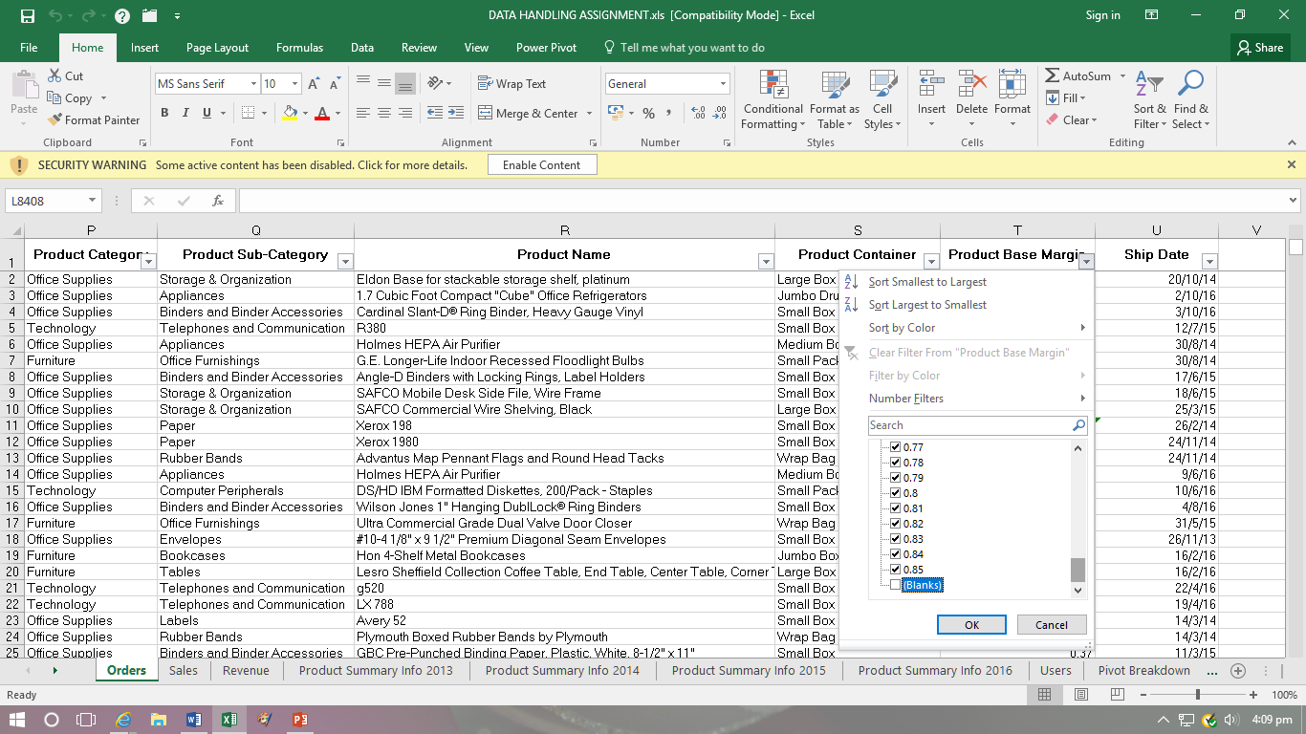
Filtering the ‘Product Based Margin’ column and unselecting any blanks.

Appendix 2

Using the SUM formula to work out total sales.

Appendix 3

Using the AVERAGE formula to work out average sales.
Appendix 4

Using a formula to work out sales as a percentage. Formula contains absolute cell referencing.

Appendix 5
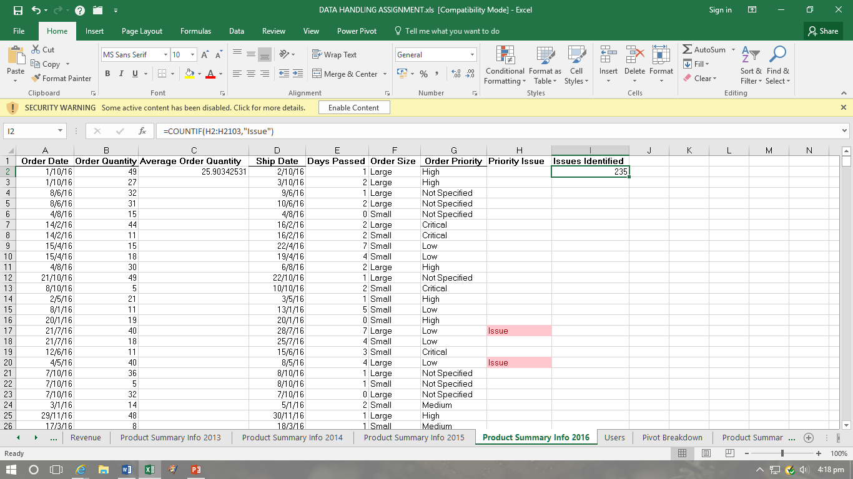
Individual yearly breakdown of data to identify priority issues.

Appendix 6
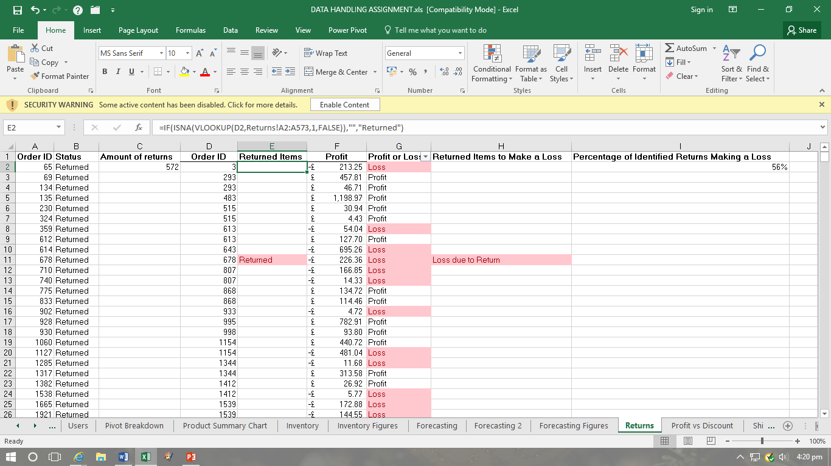
Vlookup to share information between the ‘Orders’ and ‘Returns’ tab.

Appendix 7
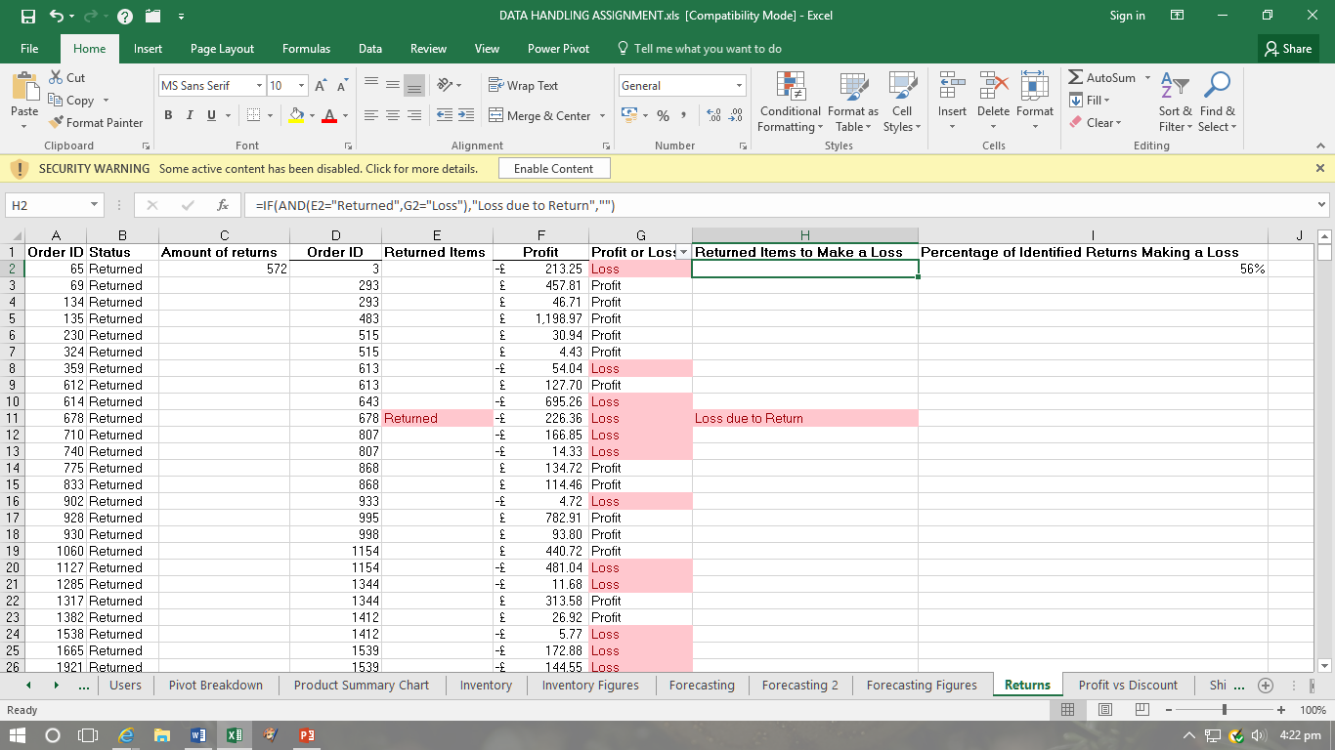
Multiple IF statement to identify returned items making a loss.

Appendix 8
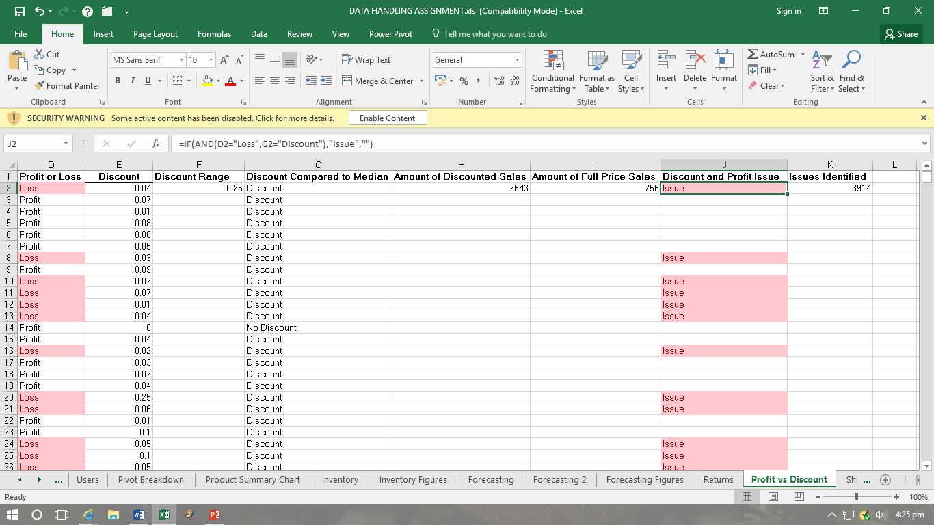
Multiple IF statement to identify discounted orders making a loss.

Appendix 9
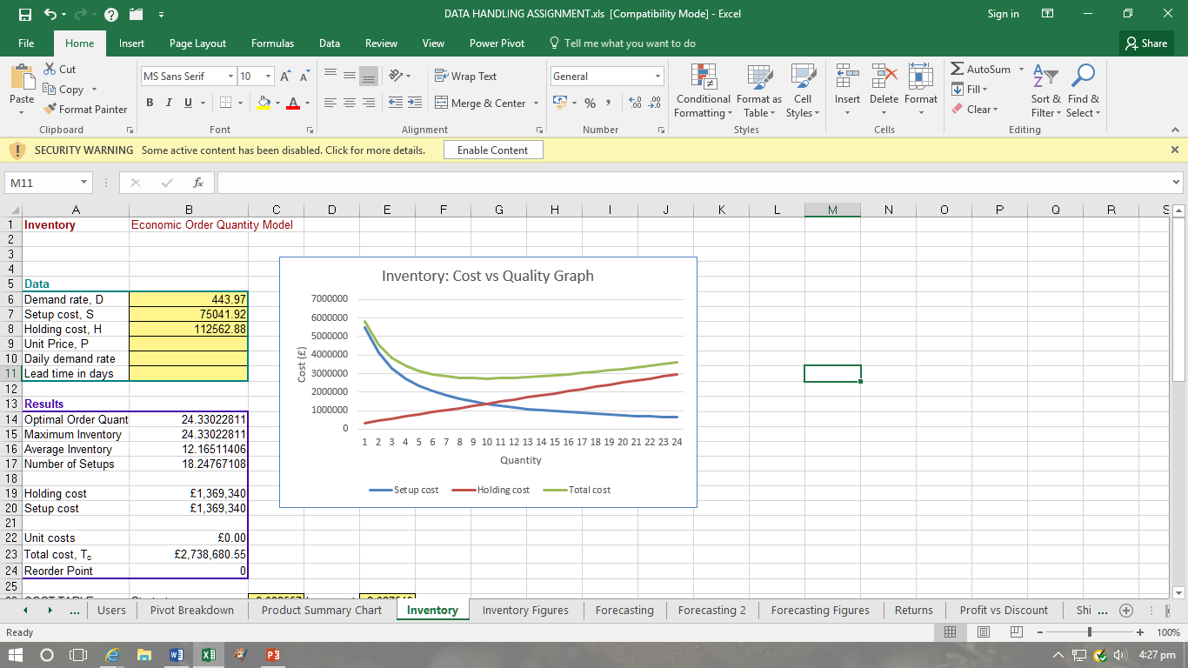
Line chart to visually represent the Inventory data.

Appendix 10
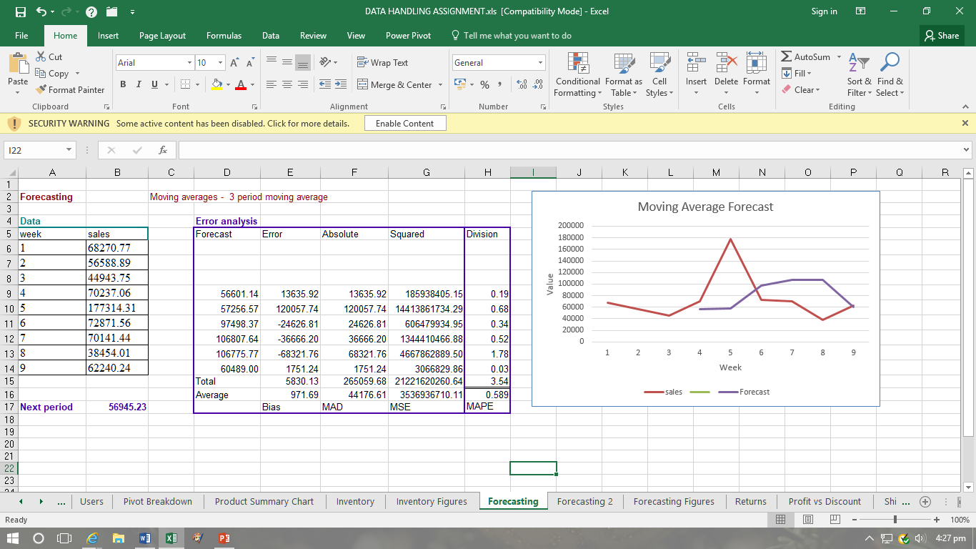
Line chart to visually represent the moving average forecast data.

Appendix 11
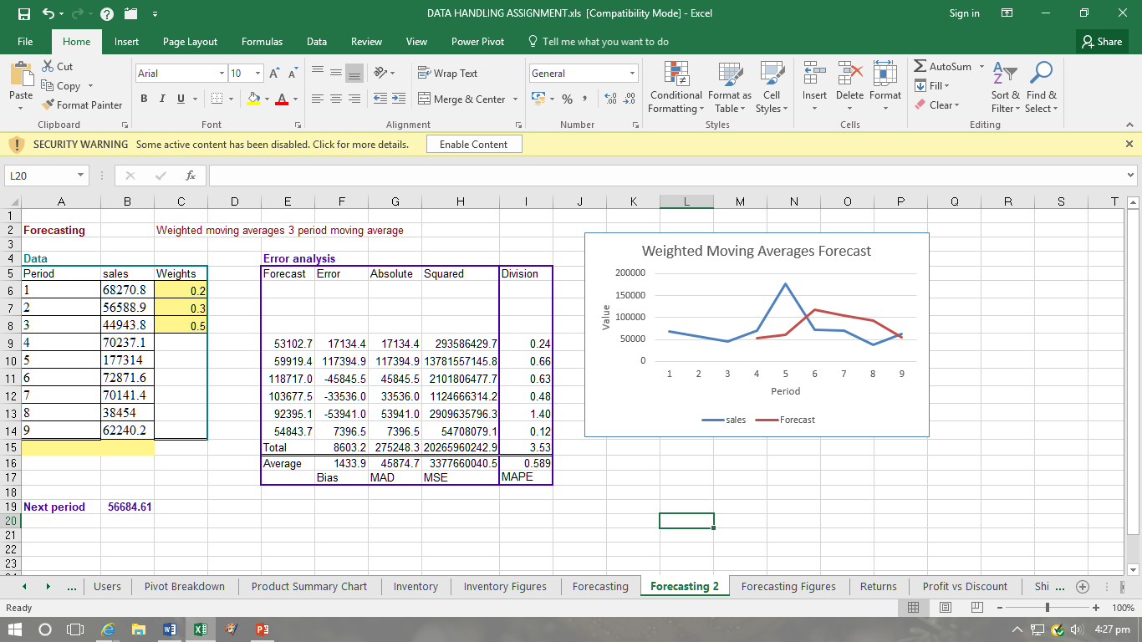
Line chart to visually represent the weighted moving averages forecast data.

Appendix 12

Pivot table, located on the pivot breakdown tab.

Appendix 13
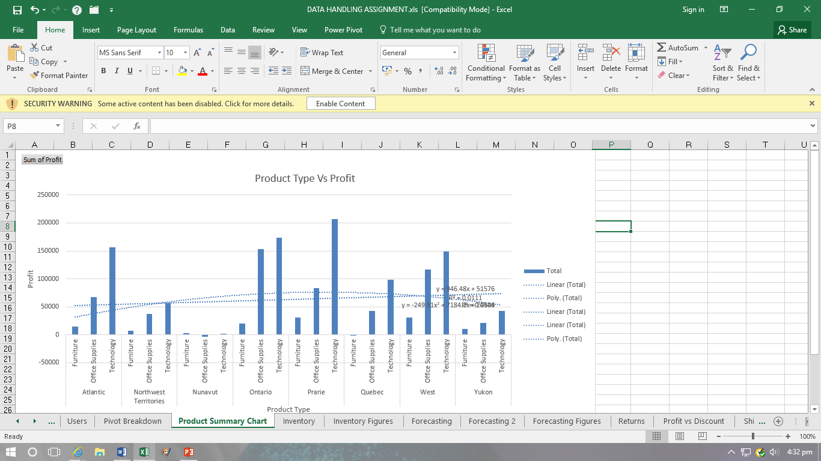
Product summary chart, including trend lines and line formulas.

Appendix 14
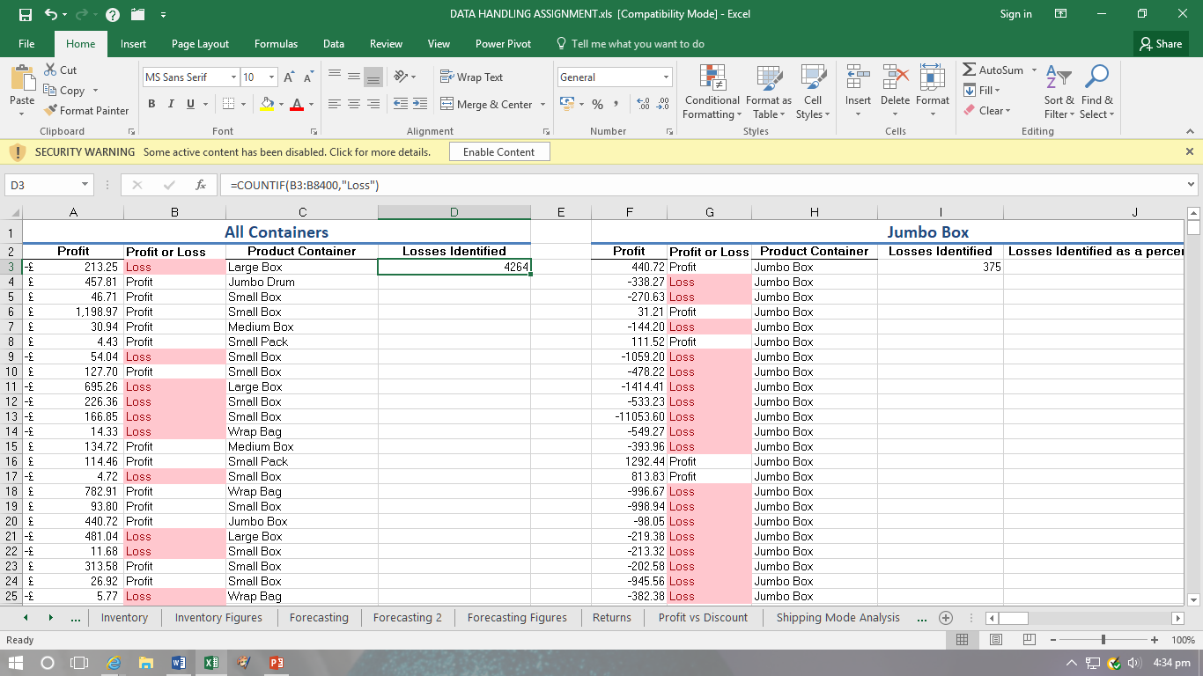
Count IF formula used to identify number of losses found.

Appendix 15
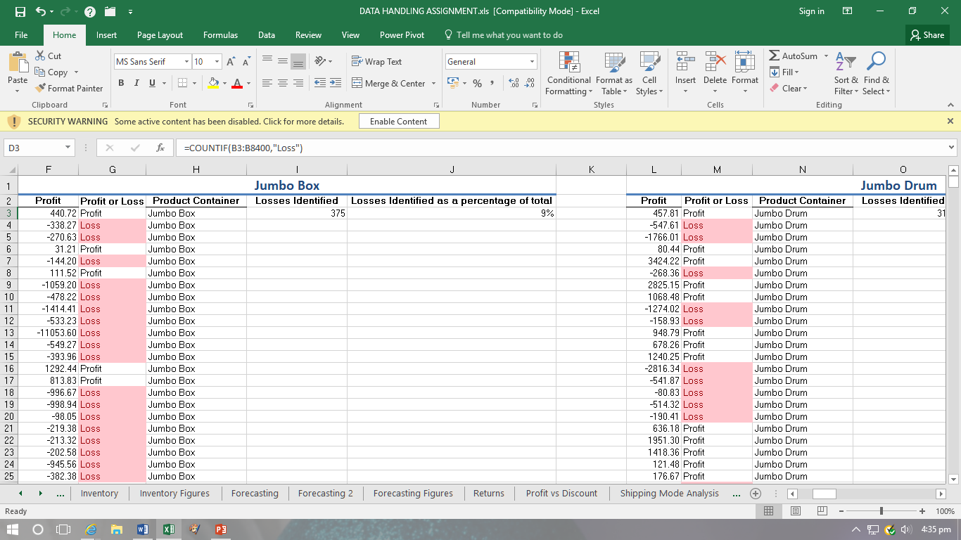
Formatted cells to present findings clearer.

Appendix 16

Findings presented on the ‘Dashboard’ tab.

Appendix 17

Pre-processing data by using filters.

Appendix 18
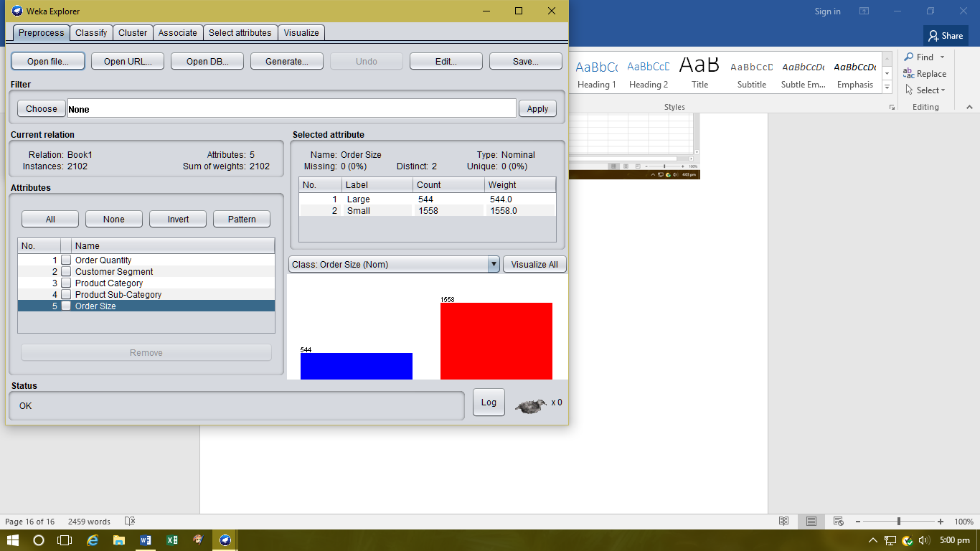
Pre-processing the data after importing it into WEKA.

Appendix 19
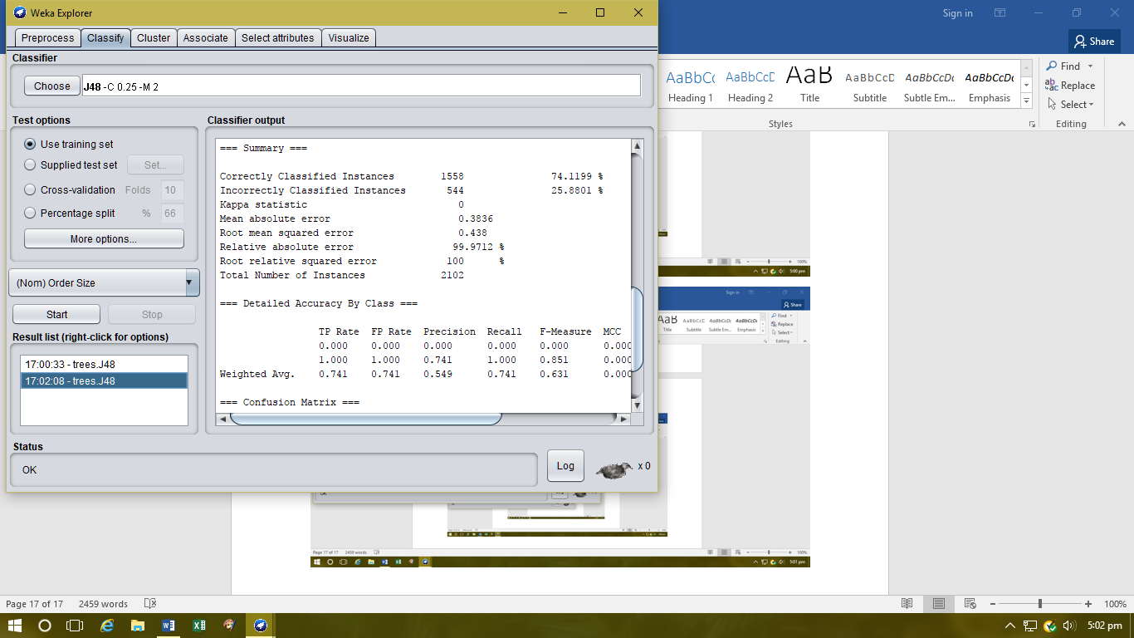
Decision tree J48 Correctly Classified percentage.

Appendix 20
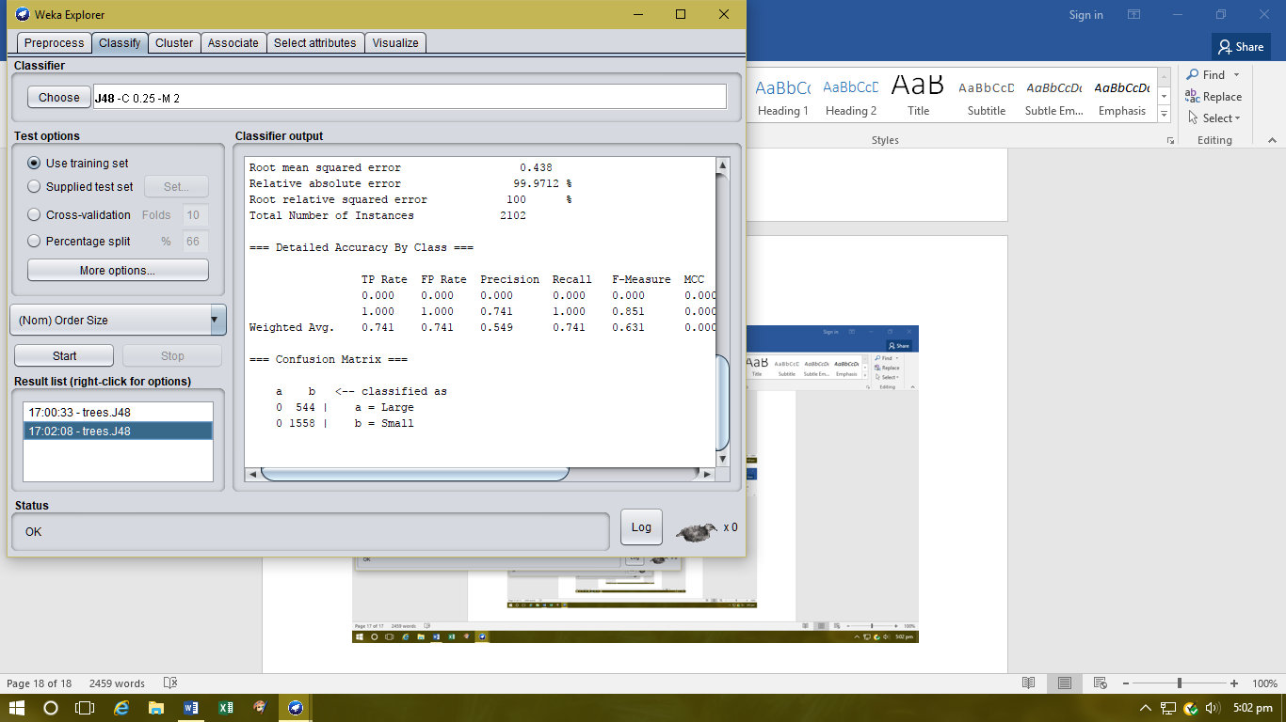
Decision Tree J48 Confusion Matrix.

Appendix 21
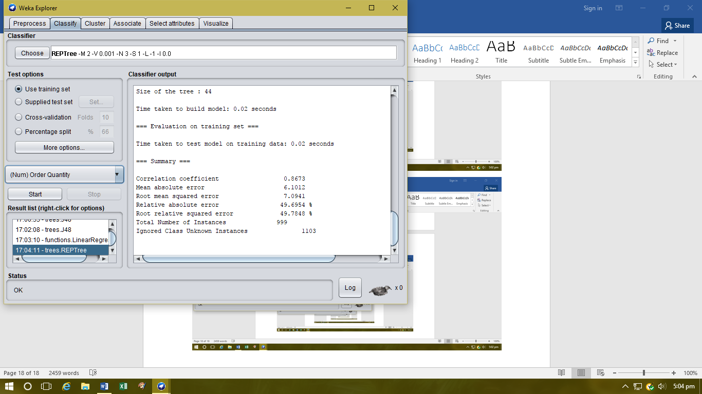
Classification REPTree percentage.

Appendix 22
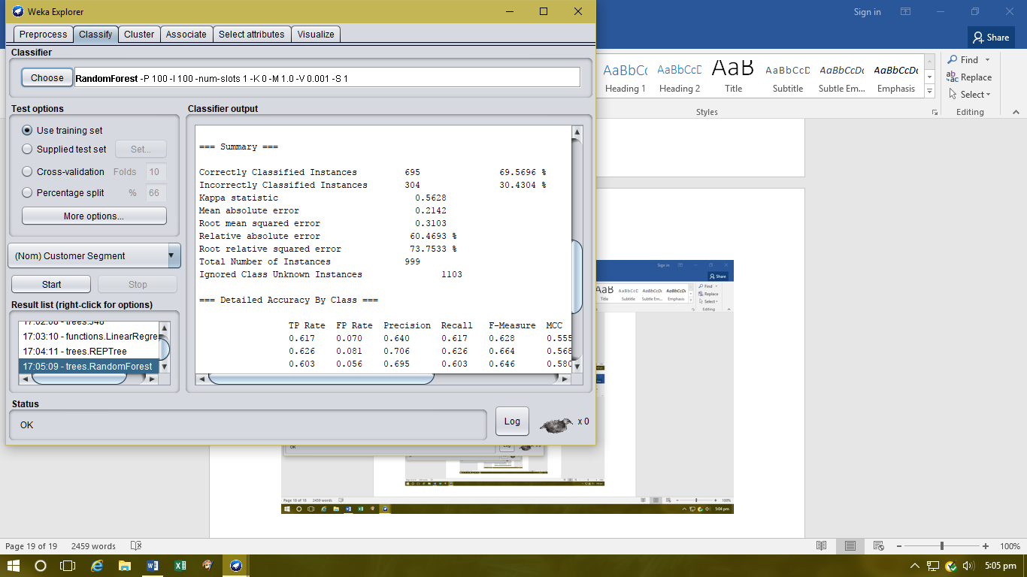
Classification RandomForest percentage.

Appendix 23
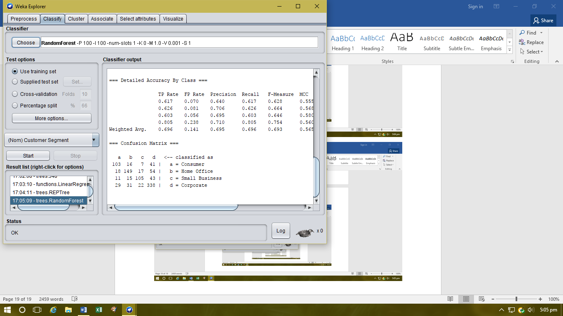
Classification RandomForest confusion matrix.

Appendix 24
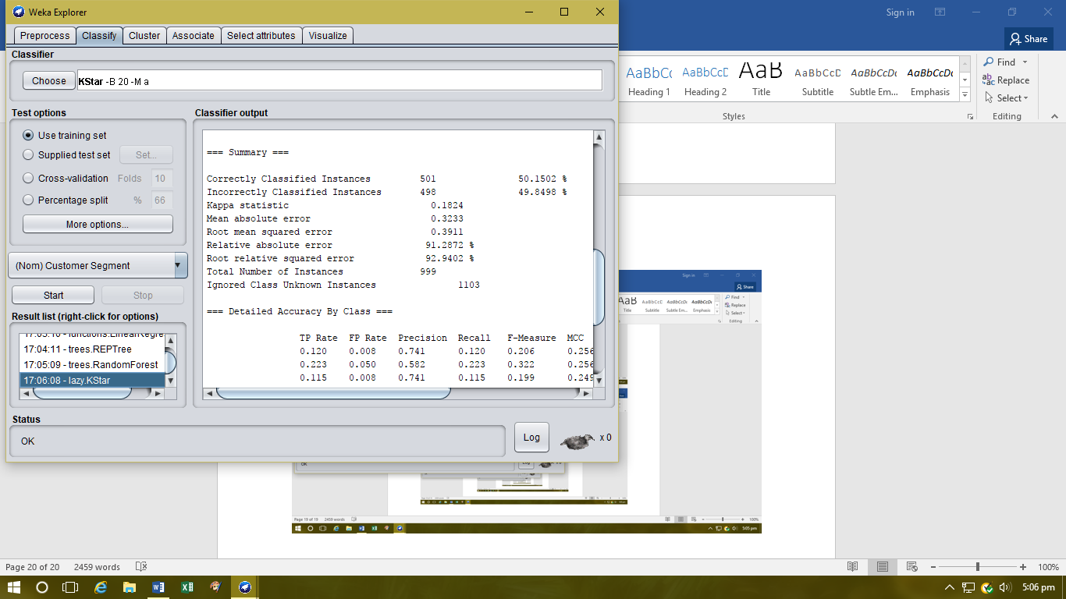
Classification KStar percentage.

Appendix 25
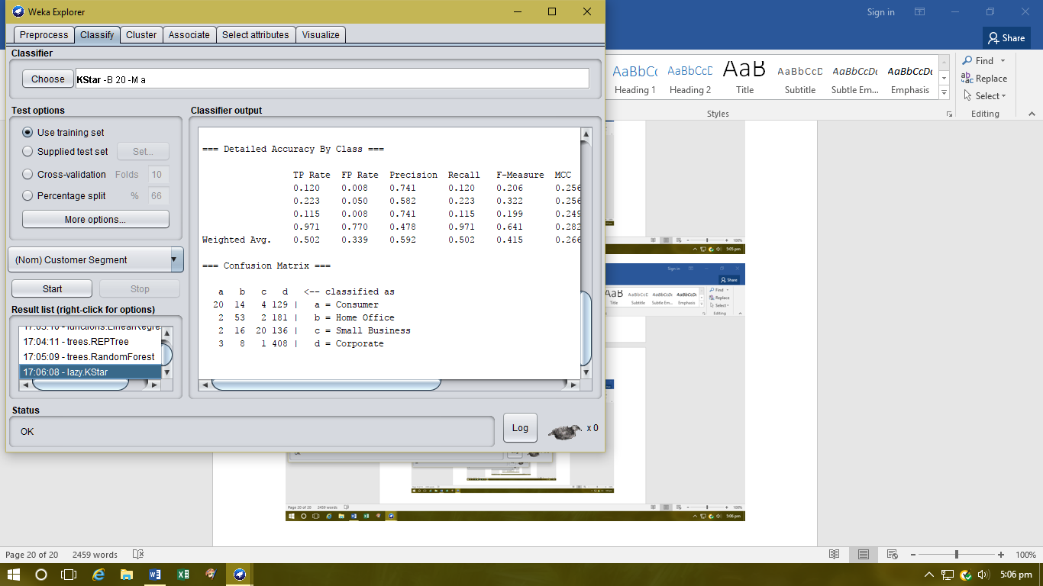
Classification KStar confusion matrix.

Appendix 26
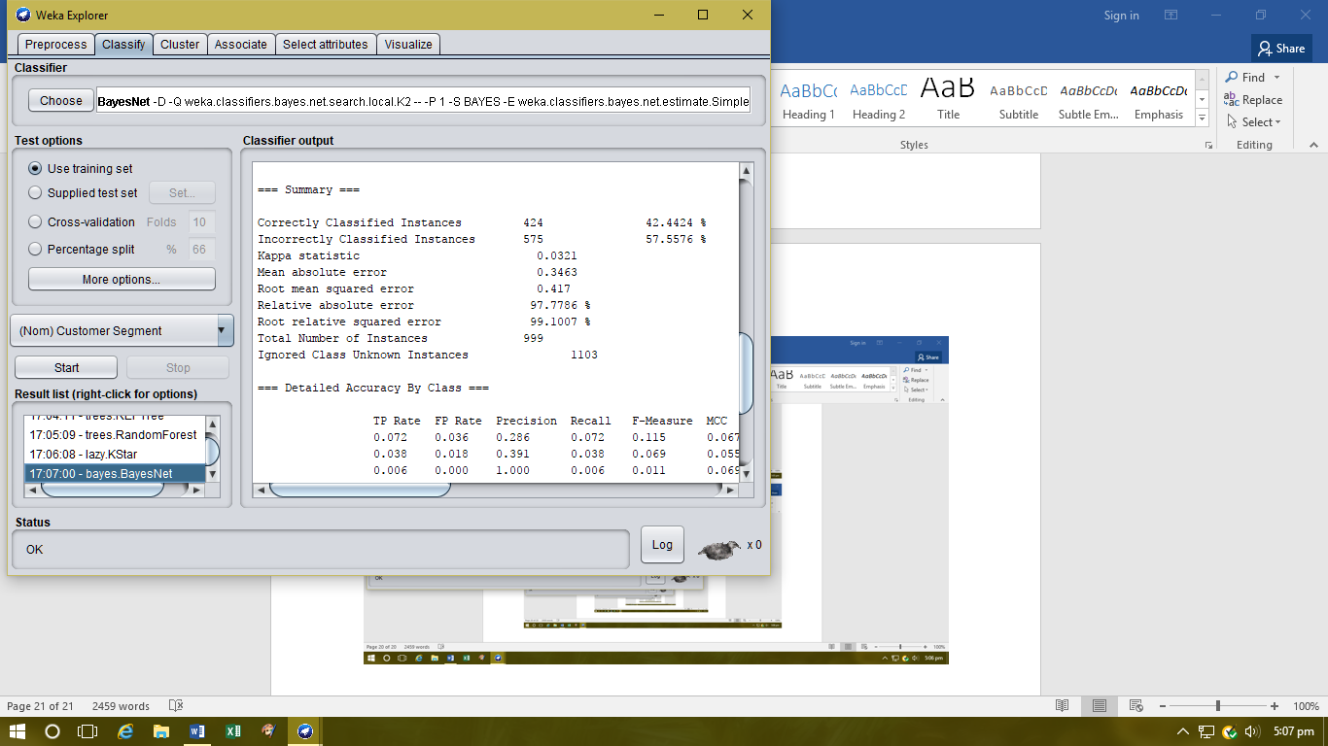
Classification BayesNet percentage.

Appendix 27
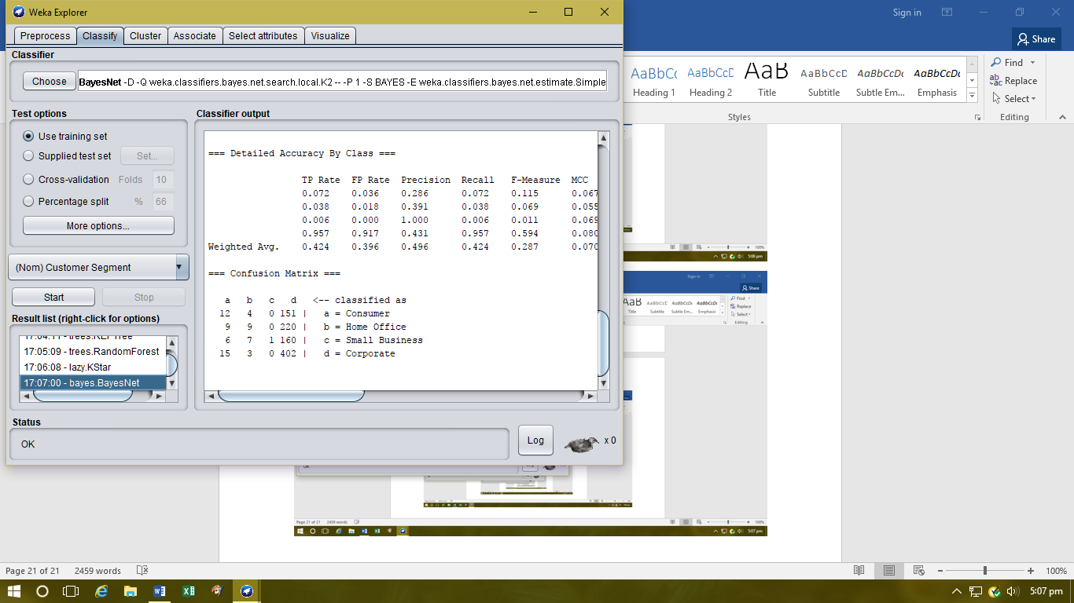
Classification BayesNet confusion matrix.

Appendix 28
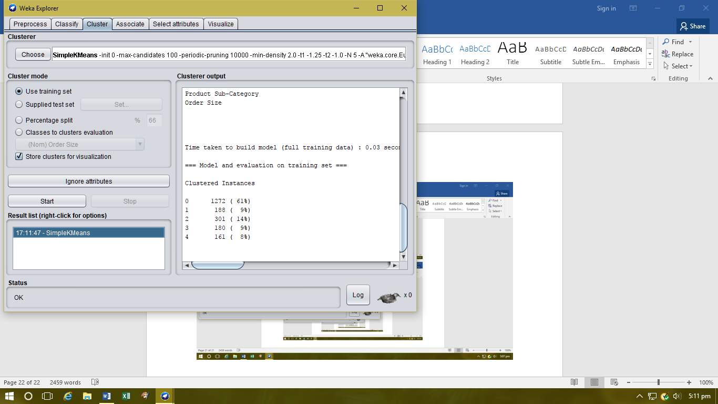
Clustering into 5 groups.

Appendix 29
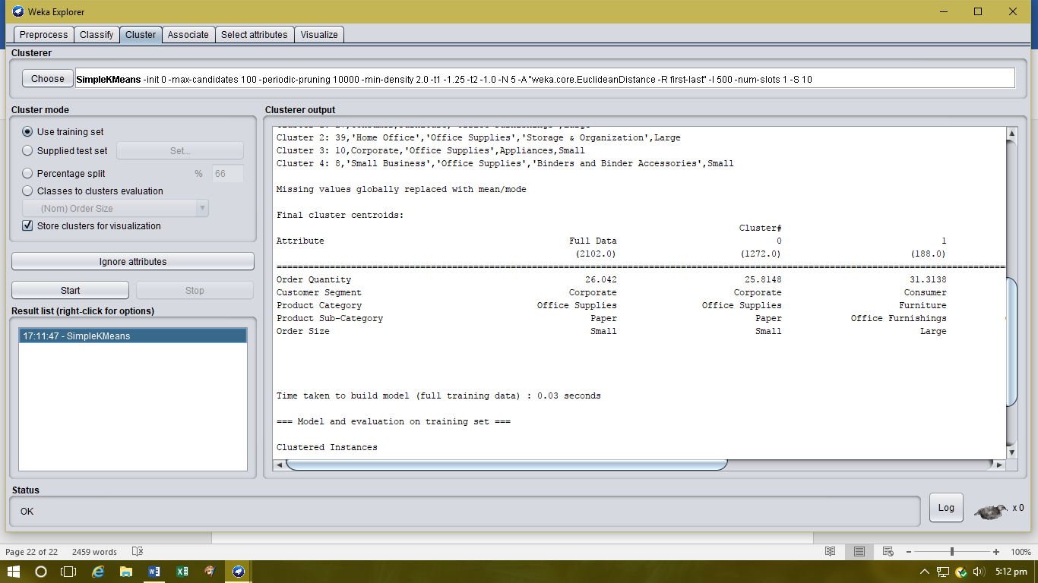
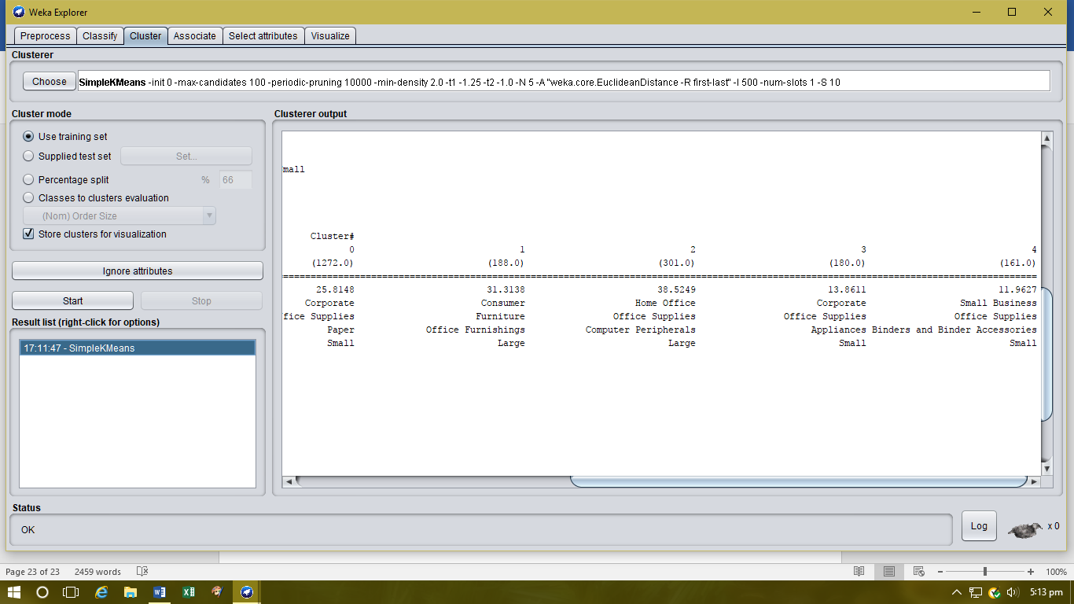
Clusters identified.

Appendix 30
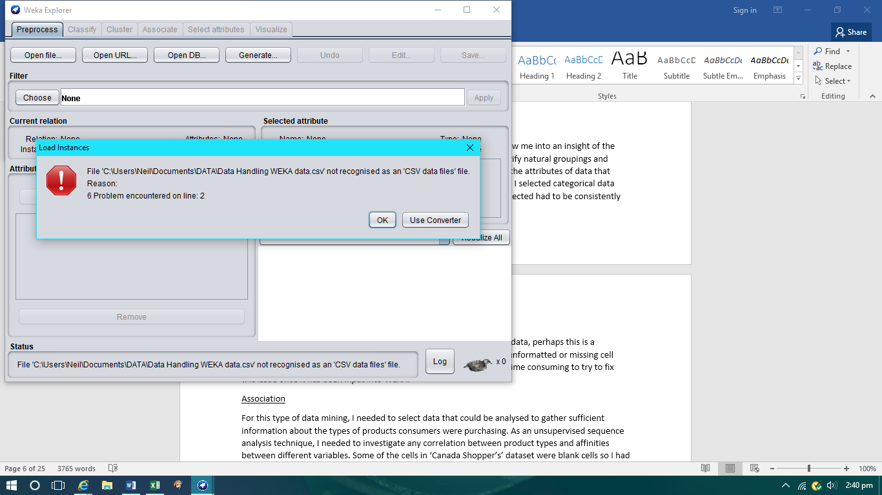
Error message when importing data.

Appendix 31
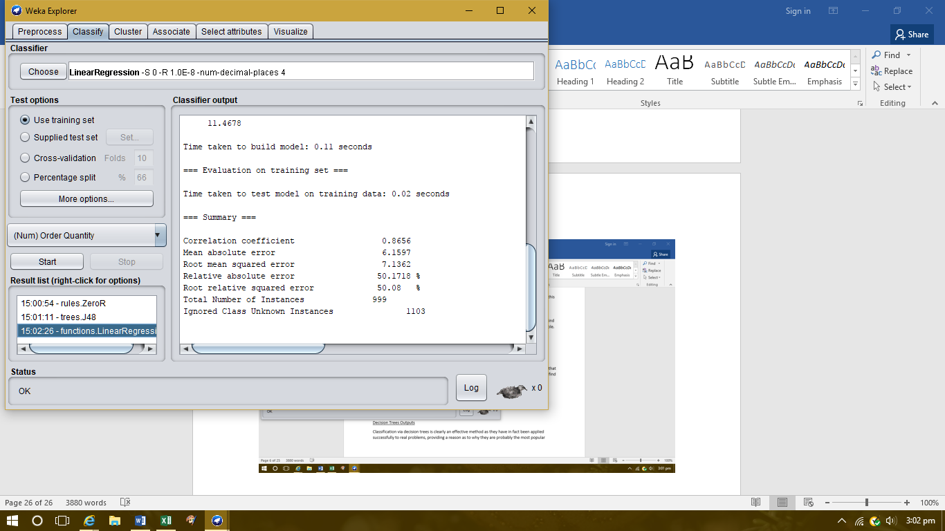
Linear Regression output.

Appendix 32
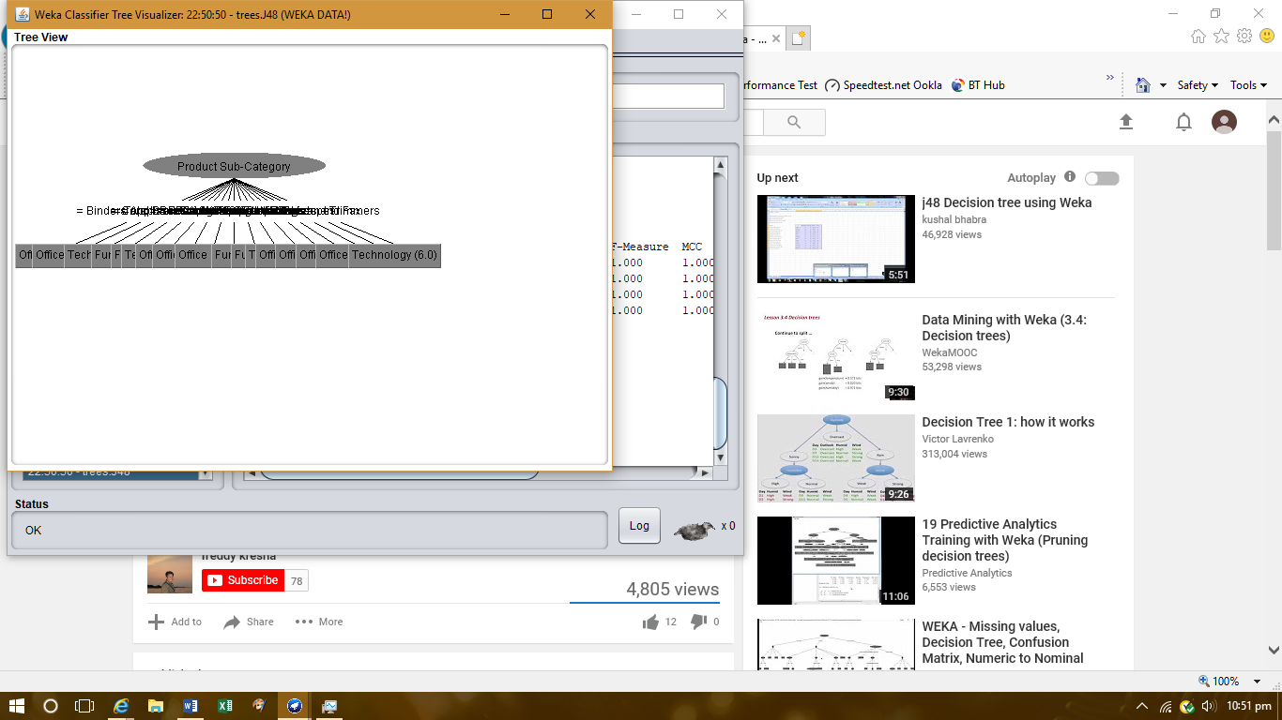

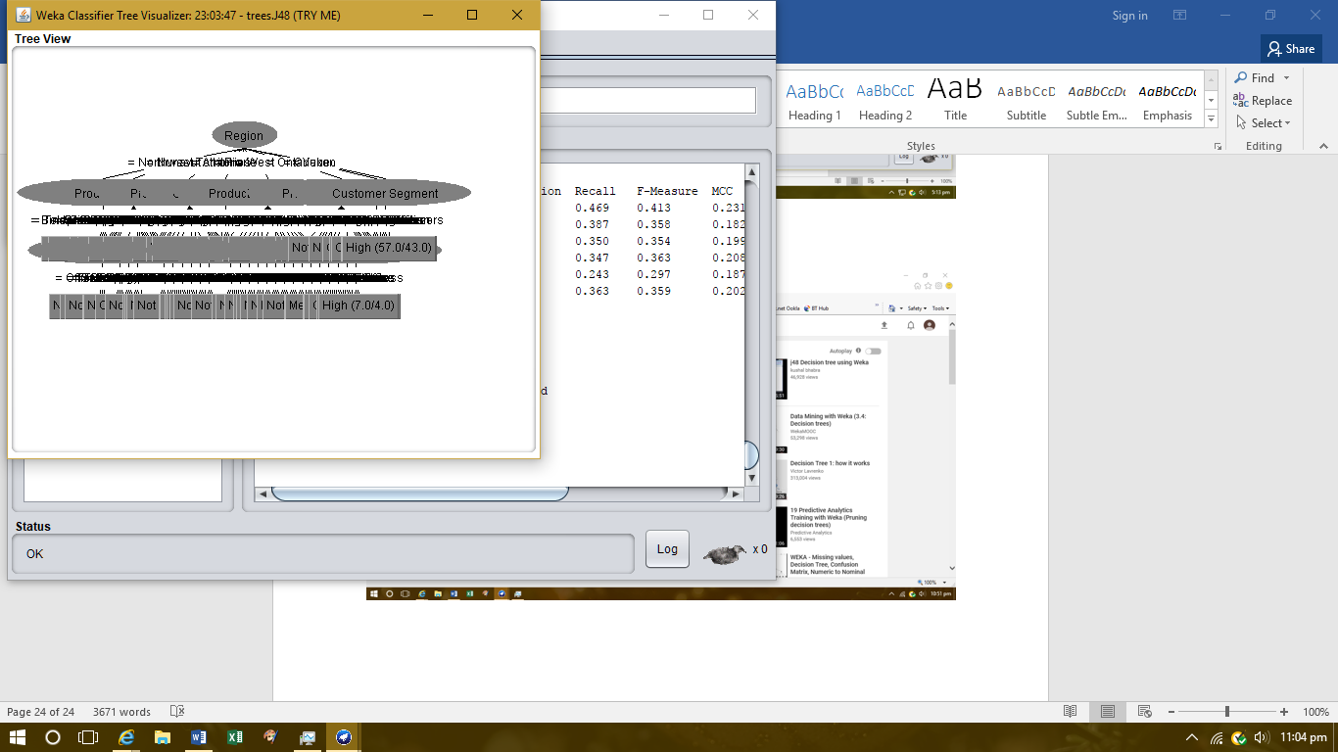
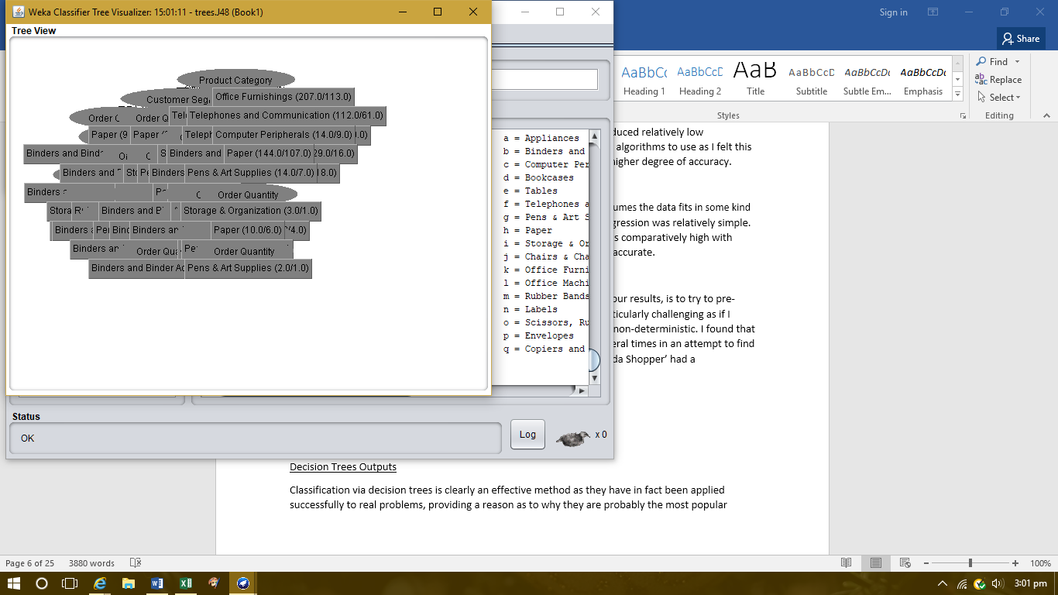
Decision trees that were difficult to visualise.

Appendix 33
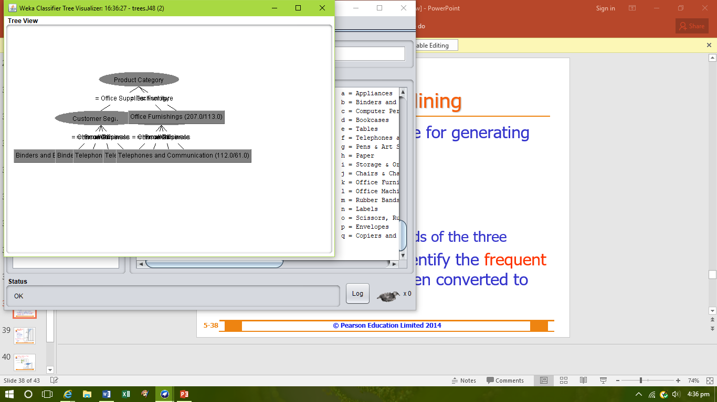
Decision tree visualised.

Appendix 34
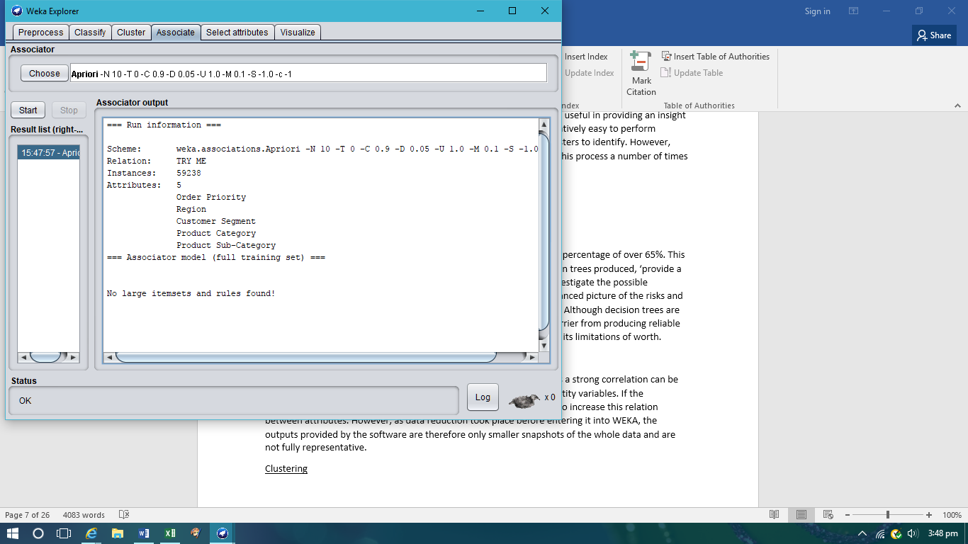
Association, apriori output.

