

RESULT

BACHELORS DEGREE ASSIGNMENT SPECIFICATION

Student name: |  | Student P number:
Programmes: | BEng (Hons) Engineering Portfolio
Module: | Engineering Design | Module Level (4, 5, 6): | Level 4
Module code: | M4X01160 | Contribution to Overall  Module Assessment (%):
Lecturers: | Pedro Monteiro Ferreira  Richard Morgan | Internal Verifier: | Andrew Harrison
Assignment Title: | The Production of 3D Solid Modelled Components and Assemblies | Assignment No (x of x): | 1 of 2
Hand Out Date: | 12/03/15 | Submission deadline: | 13/03/15 (lab session 9:00am – 12:00 noon)
Referencing: | In the main body of your submission you must give credit to authors on whose research your work is based. Append to your submission a reference list that indicates the books, articles, etc. that you have read or quoted in order to complete this assignment (e.g. for books: surname of author and initials, year of publication, title of book, edition, publisher: place of publication).
Disclosure: | I declare that this assignment is all my own work and that I have acknowledged all materials used from the published or unpublished works of other people. All references have been duly cited.
Student’s Signature: | Assignments will not be accepted without a signature here | Date:
Turnitin: Lecturer to tick to indicate if an electronic version of the assignment must be submitted to Turnitin. Note: the Turnitin version is the primary submission and acts as a receipt for the student. Both electronic and paper versions MUST be submitted by the same deadline. No marks will be released until both submissions are received. Late submission of the electronic version will result in a late penalty mark. Penalties for late submission: Up to one week late, maximum mark of 40%. Over one week late, Refer. | YES
 | NO

Learning Outcomes tested  (from module syllabus) | Assessment Criteria To achieve each outcome a student must demonstrate the ability to:
Use computer technology in the design process. | - identify the key features of a computer-aided design system  - use computer-aided design software to prepare a design drawing  - demonstrate an understanding of the principles of computer-aided design.

- Please submit the assignment parts in a suitable report folder– not in polypockets.
- This form (ALL PAGES) MUST be at the front of the paper submission. Assignments will not be accepted without this form as it is a requirement that you sign the disclosure regarding referencing convention.
- DO NOT put this form into Turnitin or it will match many similarities with other students’ submissions.

Introduction
Computer Aided Design (CAD) is used extensively throughout many mechanical and manufacturing industries. Although two-dimensional CAD software is still appropriate for some applications, three dimensional solid modelling is becoming increasingly prevalent. In this assignment you will gain experience in using a Computer Aided Engineering Solid Modelling package in the production of three dimensional solid models of components and assemblies.

TASK DESCRIPTION

(Lecturer – please insert task(s) / questions / what the student must do, here)

Using the SolidWorks Computer Aided Engineering software, you are required to construct an assembly of the following parts:

- Wishbone_Arm
- Rose-Joint_Insert
- Suspension_Mount_Brkt
- Chassis_Plate
- Suspension_Upright

The Wishbone_Arm, Rose-Joint_Insert, Suspension_Mount_Brkt and Chassis_Plate geometry have already been modelled and should be downloaded from Moodle as separate part (.SLDPRT) files. You are required to position and constrain each of the components within the assembly in order that the inter-part assembly geometry is correct.

You are required to build the Suspension_Upright geometry around the other parts, paying due regard to their position, dimensions and form. The Wishbone_Arms should be constrained to be parallel during suspension articulation. You are free to establish appropriate dimensions for the remaining undefined Suspension_Upright geometry. It is therefore expected that each student will produce a unique model. Suggested features to include on your Suspension_Upright model include;

- A shouldered wheel bearing surface
- A control arm for a steering linkage
- An appropriate brake calliper mount
Wheel bearing surface

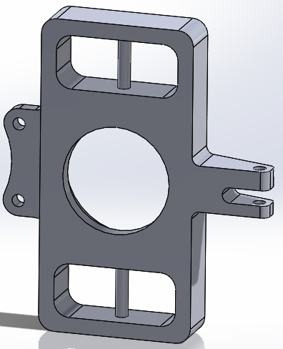
Brake calliper mount
Control arm for steering linkage

You are to begin and finish your modelling/assembly activity in a single, session lasting 3 hours. However, you may practice and prepare for your assessment activity beforehand. Completed models/assemblies will be collected and the end of the assignment session. Please note that the assessment Lab session will take place on Friday 12th March between 9:00am and 12:00 noon in rooms MT302 and MT303 on the third floor of the Cadogan building.

At the beginning of the assignment lab session, you will be issued with a CD. You are required to copy your assignment model file along with the model files of each of the components you have ‘instanced’ in your assembly, onto the CD at the end of the session. The CD should be marked with:

- Your name
- Your programme of study (e.g. BEng Mechanical Engineering or BEng Automotive Engineering
- The date on which the assessment has been completed (12/03/15).
- The assignment title

Incorrectly copied, corrupt or missing files will receive at referral grade. It is the student’s responsibility to ensure that each of the necessary files are correctly copied onto the CD and that the CD is correctly marked/identified. When prompted to electronically ‘name’ the CD as the work is saved, it is advised that the students name be used as an additional method of identification.

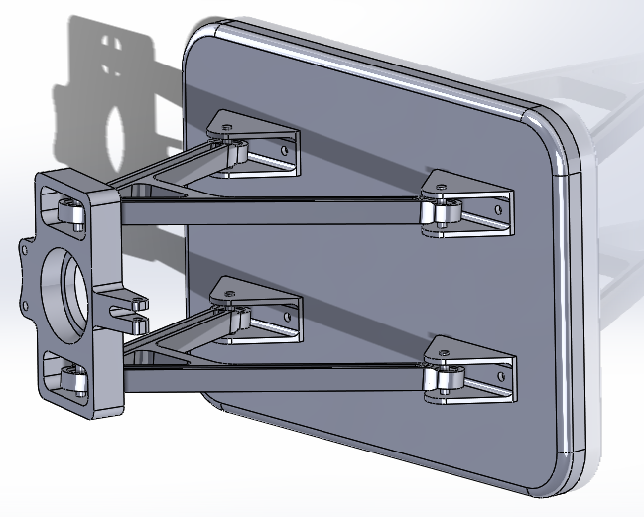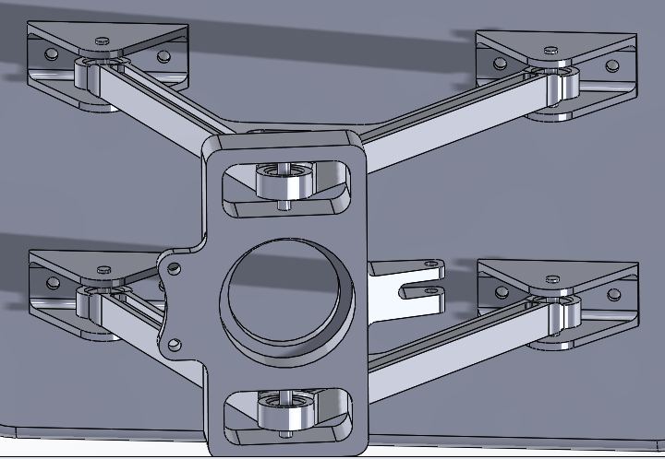

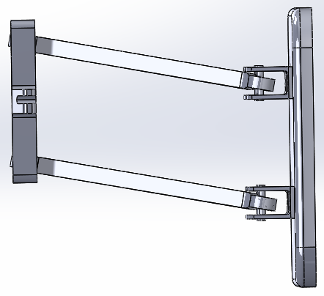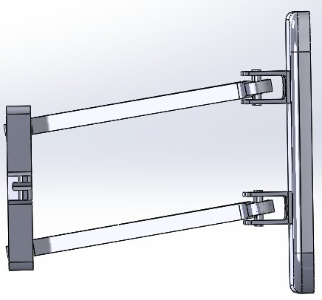

The Recommended Assembly Configuration

GUIDANCE FOR Students IN THE COMPLETION OF TASKS

(Lecturer – please insert guidance for students here. Please link the task to the five common assessment criteria overleaf)

You will be marked on your ability to:

- Create correct Part Geometry
- Use a range of appropriate tools when modelling
- Manage and organise the part structure
- Create a suitable assembly structure with appropriate mating conditions and degrees of freedom.

It is advised that regular saves are carried out during the lab session in case of IT/software crashes or interruptions.

Saving Your Work
Remember that the assembly file along with the files of any parts instanced within the assembly should be saved onto the CD. Therefore, the files saved onto the CD should look like the list below (not necessarily in order).

It is advised that regular saves are carried out during the lab session in case of IT/software crashes or interruptions. It is best to work of the ‘C’ drive of the machine during the assignment session (create a file in ‘Documents’ and then to copy the entire file onto the CD once you have finished.

Suspension Assembly (or whatever you have called your assembly)
Chassis_Plate
Rose-Joint_Insert
Wishbone_Arm
Suspension_Mount_Brkt
Suspension_Upright (or whatever you have called/named the suspension upright that you have modelled)

Also include any other parts which you have referenced in the assembly structure (included in the assembly), such as bolts etc.

Remember, if you include a part in the assembly and it’s not on the CD or has had its file name changed since you’ve included it in the assembly, the part will be missing when the assembly is opened for marking.

marking criteria and Student FEEDBACK

This section details the assessment criteria. The extent to which these are demonstrated by you determines your mark. The marks available for each criterion are shown. Lecturers will use the space provided to comment on the achievement of the task(s), including those areas in which you have performed well and areas that would benefit from development/improvement.

Common Assessment Criteria Applied | Marks available | Marks  awarded
1. Research-informed Literature
Extent of research and/or own reading, selection of credible sources, application of appropriate referencing conventions.
 | 0
2. Knowledge and Understanding of Subject
Extent of knowledge and understanding of concepts and underlying principles associated with the discipline.
Manage and organise the part structure | 20
3. Analysis
Analysis, evaluation and synthesis; logic, argument and judgement; analytical reflection; organisation of ideas and evidence
Create correct Part Geometry

Create correct Part Geometry | 20
4. Practical Application and Deployment
Deployment of methods, materials, tools and techniques; application of concepts; formulation of innovative and creative solutions to solve problems.
Use a range of appropriate tools when modelling | 20
5. Skills for Professional Practice
Attributes in professional practice: individual and collaborative working; deployment of appropriate media; presentation and organisation.
Create a suitable assembly structure with appropriate mating conditions and degrees of freedom. | 40

Assignment Mark (Assessment marks are subject to ratification at the Exam Board. These comments and marks are to give feedback on module work and are for guidance only until they are confirmed. ) | Late Submission Penalties (tick if appropriate) |  | %
 | Up to one-week late |  | %
 | Over one week late |  | %

COMMON ASSESSMENT AND MARKING CRITERIA

 | OUTRIGHT FAIL | UNSATISFACTORY | SATISFACTORY | GOOD | VERY GOOD | EXCELLENT | EXCEPTIONAL
Assessment Criteria | 0-29% | 30-39%* | 40-49% | 50-59% | 60-69% | 70-79% | 80-100%
1. Research-informed Literature  Extent of research and/or own reading, selection of credible sources, application of appropriate referencing conventions | Little or no evidence of reading.  Views and findings unsupported and non-authoritative.  Referencing conventions largely ignored. | Poor evidence of reading and/or of reliance on inappropriate sources, and/or indiscriminate use of sources.  Referencing conventions used inconsistently. | References to a limited range of mostly relevant sources. Some omissions and minor errors.  Referencing conventions evident though not always applied consistently. | Inclusion of a range of research-informed literature, including sources retrieved independently. Referencing conventions mostly consistently applied. | Inclusion of a wide range of research-informed literature, including sources retrieved independently.  Selection of relevant and credible sources. Very good use of referencing conventions, consistently applied. | A comprehensive range of research informed literature embedded in the work. Excellent selection of relevant and credible sources. High-level referencing skills, consistently applied. | Outstanding knowledge of research-informed literature embedded in the work. Outstanding selection of relevant and credible sources. High-level referencing skills consistently and professionally applied.
2. Knowledge and Understanding of Subject  Extent of knowledge and understanding of concepts and underlying principles associated with the discipline. | Major gaps in knowledge and understanding of material at this level. Substantial inaccuracies. | Gaps in knowledge, with only superficial understanding. Some significant inaccuracies. | Evidence of basic knowledge and understanding of the relevant concepts and underlying principles. | Knowledge is accurate with a good understanding of the field of study. | Knowledge is extensive. Exhibits understanding of the breadth and depth of established views. | Excellent knowledge and understanding of the main concepts and key theories. Clear awareness of challenges to established views and the limitations of the knowledge base. | Highly detailed knowledge and understanding of the main theories/concepts, and a critical awareness of the ambiguities and limitations of knowledge.
3. Analysis  Analysis, evaluation and synthesis; logic, argument and judgement; analytical reflection; organisation of ideas and evidence | Unsubstantiated generalisations, made without use of any credible evidence. Lack of logic, leading to unsupportable/ missing conclusions. Lack of any attempt to analyse, synthesise or evaluate. | Some evidence of analytical intellectual skills, but for the most part descriptive. Ideas/findings sometimes illogical and contradictory. Generalised statements made with scant evidence. Conclusions lack relevance. | Evidence of some logical, analytical thinking and some attempts to synthesise, albeit with some weaknesses.  Some evidence to support findings/ views, but evidence not consistently interpreted.  Some relevant conclusions and recommendations, where relevant | Evidence of some logical, analytical thinking and synthesis. Can analyse new and/or abstract data and situations without guidance.  An emerging awareness of different stances and ability to use evidence to support the argument.  Valid conclusions and recommendations, where relevant | Sound, logical, analytical thinking; synthesis and evaluation. Ability to devise and sustain persuasive arguments, and to review the reliability, validity & significance of evidence. Ability to communicate ideas and evidence accurately and convincingly.  Sound, convincing conclusions / recommendations. | Thoroughly logical work, supported by evaluated evidence. High quality analysis, developed independently or through effective collaboration.  Ability to investigate contradictory information and identify reasons for contradictions.  Strong, persuasive, conclusions, justifiable recommendations. | Exceptional work; judiciously selected and evaluated evidence. Very high quality analysis, developed independently or through effective collaboration.  Ability to investigate contradictory information and identify reasons for contradictions.  Highly persuasive conclusions
4. Practical Application and Deployment  Effective deployment of appropriate methods, materials, tools and techniques; extent of skill demonstrated in the application of concepts to a variety of processes and/or contexts; formulation of innovative and creative solutions to solve problems. | Limited or no use of methods, materials, tools and/or techniques.  Little or no appreciation of the context of the application. | Rudimentary application of methods, materials, tools and/or techniques but without consideration and competence. Flawed appreciation of the context of the application. | An adequate awareness and mostly appropriate application of well established methods, materials, tools and/or techniques.  Basic appreciation of the context of the application. | A good and appropriate application of standard methods, materials, tools and/or techniques.  Good appreciation of the context of the application, with some use of examples, where relevant. | A very good application of a range of methods, materials, tools and/or techniques.  Very good consideration of the context of the application, with perceptive use of examples, where relevant.  Evidence of some innovation and creativity. | An advanced application of a range of methods, materials, tools and/or techniques.  The context of the application is well considered, with extensive use of relevant examples.  Application and deployment extend beyond established conventions. Innovation and creativity evident throughout. | Outstanding levels of application and deployment skills. Assimilation and development of cutting edge processes and techniques.
5. Skills for Professional Practice  Demonstrates attributes expected in professional practice including: individual initiative and collaborative working; deployment of appropriate media to communicate (including written and oral); clarity and effectiveness in presentation and organisation. | Communication media is inappropriate or misapplied.  Little or no evidence of autonomy in the completion of tasks.  Work is poorly structured and/or largely incoherent. | Media is poorly designed and/or not suitable for the audience.  Poor independent or collaborative initiative.  Work lacks structure, organisation, and/or coherence | Can communicate in a suitable format but with some room for improvement.  Can work as part of a team, but with limited involvement in group activities.  Work lacks coherence in places and could be better structured. | Can communicate effectively in a suitable format, but may have minor errors.  Can work effectively as part of a team, with clear contribution to group activities.  Mostly coherent work and is in a suitable structure. | Can communicate well, confidently and consistently in a suitable format.  Can work very well as part of a team, with very good contribution to group activities.  Work is coherent and fluent and is well structured and organised. | Can communicate professionally and, confidently in a suitable format.  Can work professionally within a team, showing leadership skills as appropriate, managing conflict and meeting obligations.  Work is coherent, very fluent and is presented professionally. | Can communicate with an exceptionally high level of professionalism.  Can work exceptionally well and professionally within a team, showing advanced leadership skills.  Work is exceptionally coherent, very fluent and is presented professionally.

Student Self Evaluation Form (Lab Work)
Student name: |  | Student P number:
Programme: |  | Year of programme
Assignment Title:

This section repeats in brief the common assessment criteria detailed on previous pages. The extent to which these are demonstrated by you determines your mark. Using these criteria, tick the box that best indicates the level of achievement you feel you have achieved with regard to each of them.

Common Assessment Criteria Applied | Level of Achievement
Common Assessment Criteria Applied | REFER |  |  | 3rd |  | 2:2 |  | 2:1 | 1st | 1st
 | OUTRIGHT FAIL | UNSATISFACTORY | SATISFACTORY |  | GOOD |  | VERY GOOD |  | EXCELLENT | EXCEPTIONAL
1. Research-informed Literature | 0-29% | 30-39% | 40-49% |  | 50-59% |  | 60-69% |  | 70-79% | 80-100%
2. Knowledge and Understanding of Subject | 0-29% | 30-39% | 40-49% |  | 50-59% |  | 60-69% |  | 70-79% | 80-100%
3. Analysis | 0-29% | 30-39% | 40-49% |  | 50-59% |  | 60-69% |  | 70-79% | 80-100%
4. Practical Application and Deployment | 0-29% | 30-39% | 40-49% |  | 50-59% |  | 60-69% |  | 70-79% | 80-100%
5. Skills for Professional Practice | 0-29% | 30-39% | 40-49% |  | 50-59% |  | 60-69% |  | 70-79% | 80-100%

PLEASE COMMENT ON AREAS IN WHICH YOU FEEL THAT YOU HAVE PERFORMED WELL | PLEASE COMMENT ON AREAS you feel that you need TO DEVELOP

Student’s Name |  | Date
Student’s Signature

