Effective Team Work and Communication

Executive summary
This paper is premised on the effectiveness of a team work and related how communication is important in building a team. Nevertheless, communication is a key skill that is involved in the progress of an organisation. As Michael Jordan said that talent win games but teamwork and intelligence win champions, so a team is important for an organisation to achieve small and large goals. In order to achieve, it is important to plan for a good strategy for the progress of the work. A team needs to work together if anyone falls, the whole group have to face the situation and if anyone goes up, the achievement is shared among all the members within the group. This paper will be discussing the Tuckman model and the Belbin model for building a group in a proper manner.

Table of Contents
Introduction 4
Effective Teamwork and Communication 4
Analysis 6
Applications 7
Skills 9
Conclusion 12
Reference List 13
Appendices 16

Introduction
Teamwork and communication can be considered as two flip sides of a coin whose existence is immensely crucial for an organisation to survive and thrive. Communicating within a group makes a successful team and thus improving the organisation. This paper is about the effective working of a team and the communication among the team workers. In order to build an effective team, it is necessary to identify the properties of the team workers. A team moves with a unified commitment toward the goal.
Effective Teamwork and Communication
A team interacts with the members effectively and create an open environment for its members to easily communicate within the group. If any issues arise, it is tried to solve by face-to-face communication. Members of a group are respected and talking to each other can create a bad environment within the team. Members with brilliant ideas form a great team while solving a problem. According to Brock et al. (2013), team members must ensure a smooth communication channel in order to catalyze the decision-making process. For example, a healthcare team is formed in the area where members must interact with each other with a special role. Healthcare team is formed with the members including doctors, nurses, pharmacists, physician assistants, technicians and technologists, support providers, therapists, staffs, health workers and patient navigators. In the opinion of Mestre et al. (2017), a team flows with the effort of all of its members present in a team. Communication failure in the team can lead to the negative outcome of the health. So, for the purpose of the patient safety, an effective team has to be formed in order to demonstrate the positive attitude, personality, and character of the healthcare.
One of the most popular theoretical models of team formation is Tuckman's model which is composed of four individual yet interrelated stages that are discussed with real-life example in the following section-
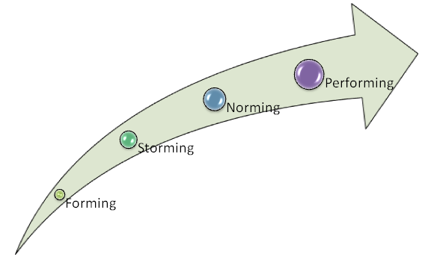
Figure 1: Model of four stages of team performance
(Source: Mestre et al. (2017)
- Forming- In the healthcare sector, it is important to meet with the opportunities and the challenges, a team learns about the tackle. The main strategy in forming a team successful is coordinating the behaviour of the members. It is the position where a team forms the stage of it.
- Storming- In this stage, many teams fail to move together. There can be conflicts between the members of the healthcare team for a natural working style. The members of the team can start challenging the authority for the roles of the individual are clarified.
- Norming- In this stage, the team settles the differences, strength between the members of the team and respect the members of the health care authority.
- Performing- This stage of the model indicates that the team has succeeded with the hard work of each of the members reaching its goal. This stage is the easy stage where the people who join or leave the team does not disrupt the performance of the team.

Analysis
Tuckman model is used to improve a team in step by step formation. Some of the useful applications of team development from the model of Tuckman's theory are to build and develop the team. It also helps in analyzing the behaviour of the members of the team.
This model has some disadvantages that are overcome by the Belbin Team Roles. The disadvantages are that the Tuckman model is basically designed to apply the different stages in small groups. It is not appropriate for a large group. As Tuckman has described the model, a group is not working in a linear procedure as it has shown in the theory, rather it is cyclical. The characteristics for each of the stages are not set, when a team moves from one step to the other. The team members are not aware and the matter stays unclear to them. Sometimes there are overlaps between the different stages. This model does not take description or explanation from each of the members of the group. A team must know the description of a group in order to create a better group or team, but the Tuckman model has the disadvantage of not taking account of the members of the group. This model also has another limitation that is it has no guidance on the time span while moving from one stage to the other. This model is overcome by Belbin team roles model management.
The Belbin model theory is designed to apply the talents and personality of the members of a group. In order to improve the performance of the members of a group, it is important to work together by applying the full potential of each and learning the use of psychological diversity. Each team role is a plan of working with the members.

Figure 2: main disadvantages of Tuckman’s theory.
Source: (Stringer et al. (2015))
Applications
The Belbin Model is used to improve the performance of the member of the team. It says that the team must consist of different roles for achieving performance. This model has nine roles and these are as follows:
Implementer: it is the practical role of a member of a team. In this role, a member needs to be disciplined, task-oriented and accordingly in order. This role put in order the plans and the ideas to execute the task easily. A member needs to be hardworking, maintain a realistic character within the profession, observe the task if it is working or not.
Resource Investigator: A member has to be cheerful, opportunities and extroverted. One has to be enthusiastic, open-minded and curious about the new ideas for a work. For the person in this role, have to be good by nature in developing and maintaining contacts with each other.
Plant: the role has a unique character in which a person has to be a creative thinker, original and realistic. This role is not always practical and therefore many people misses what was asked of him. An introvert person can achieve the role of its creativity.
Monitor: This role is sensible and critical. A person is always observing situations and tries to go to the bottom of the matter. A person is thoughtful, questioner and must have the skill of exploring logical reasoning.
Shaper: A shaper role has the ability to be passionate, willful and competitive. These people search for a strong base to argue on topics and always search for challenges. In this roles, most of the time, a person becomes angry and irritated about a matter and behaves accordingly. Shapers always make sure that the deadlines are met at the right time and the goal are achieved. It helps in forwarding the team by its participation.
Coordinator: These people are the natural coordinator of the team are calm and positive. The role of the coordinator is to clarify the doubt of the members of the group. They trust others and creates unity within the group. It has the power of uniting the group and the power of decision making, but sometimes the person has a tendency of making other work more than the usual.
Completer Finisher: the person in this role has the ability to feel if something goes wrong and are named as the risk analyzer. These are the person with perfection, focused and concerned about the work. They are curious about quality, safe and secure matter. These people find it difficult to represent things to other.
Team worker: the members of the team are the team workers and are helpful, focused on the work. Creating a united atmosphere are the responsibility of the people of a team. There may be some critical times when the team worker have difficulty to be pleasant and may have conflicts for decision making and having trouble with the other members. The members have to solve it by themselves and build the relationship better within the team.
Specialist: The role of the members are to be dedicated and highly task oriented. A person expertizes and contributes the specialized knowledge to the team. These people are working independence and are peaceful and regular to the work.
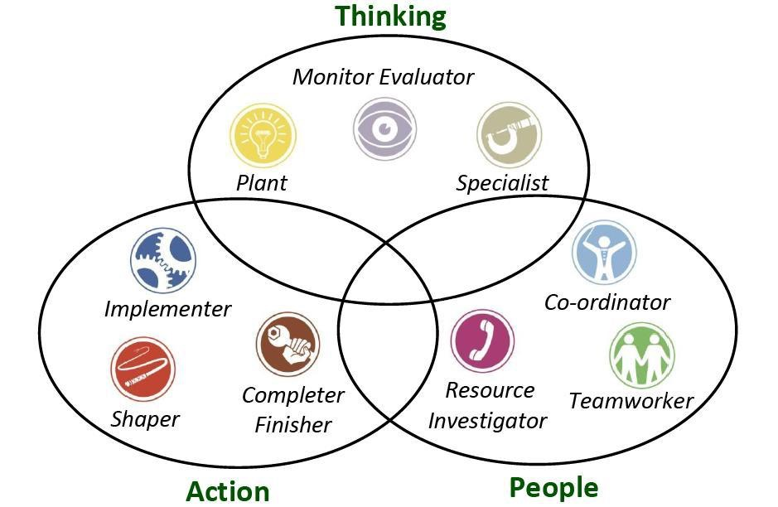
Figure 3: Nine roles of Belbin model
Source: (Sanchez-Anguix et al. (2014))

Skills
Teamwork is necessary for every field, ranging from a restaurant to a business service to an It company. An individual work in a huge bulk alone but that too for the benefit of the company, to meet the goal of the company and also communicate with the other member of the organisation may have a hand in one’s achievement.
A company always search employees with good knowledge and better skills. An employer always searches for a resume or in a job application during an interview is the new skills in the applicant. Emphasizing the skills that are mentioned in the resume of an applicant can help in growing and solving the work given to the organisation as well as improving the individual. According to Baker et al. (2015), a team not only works together but also teaches each other that helps in improving trauma in performance. Communication is one the skills that a team member must acquire while discussing and sharing ideas. It involves the way of talking; the tone of the voice must be professional and so on. Another important skill is to solve problems without conflict between the members of the team. In order to do so, a member must be able to negotiate freely with the other members of the team. Teamwork helps a person to become a good listener. While working in a group, it is important to understand the listen and observe the different ideas and values of the peers. In the opinion of Walker (2016), working in an effective team involves time management, make one reliable and gain trust with the colleagues.

Figure 4: Key skills of forming an effective team
Source: (Nadarajah and Sundaraj (2013))
Team working means working with and for the other people of the group. Some of the key skills of forming an effective team can be the following:
- Communication skills- There are many types of research done on the scenario about communication. This skill is the most important and is required among all the members of the group. Questioning and listening to each other make a group with good understanding and trust.
- Building a rapport- As the team understands each other well, they are good in building a sense of balance within the team. They build support among themselves for creating a good and effective team.
- Skills to influence- One of the key to build an effective team can be the skill to influence. When a team comes at a point of taking a decision, members must have the skill to influence and encourage.
- Skill to facilitate- in order to manage a team, it basically means facilitating it and making it easier. A skill to facilitate are vital in working within a team, but sometimes it is found that the members are seen becoming crucial only while managing it.
- Feedback- In a team, it is important to receive and give feedback. This helps in building the team stronger and run the group in a flow. This also involves feedback from the member of the team that helps in ensuring that anyone is not angry or irritated with the behaviour of the other member.
- Resolution of conflicts- This skill is important to manage a group while there is a situation in dealing with the difficult person.

Conclusion
In this paper, it has been shown how a team works together in an effective and efficient manner. This paper discussed the importance of communication while working in a team. The model of Tuckman theory has shown the importance of it in building a team in steps. While researching for the Tuckman theory, some of its disadvantages are also found and later has discussed how to overcome its limitations. To overcome the disadvantage of Tuckman theory, Belbin’s theory is used. This paper has shown the importance of the different roles of Belbin’s theory and the application of those nine roles in real life team group. Teamwork is possible with the coordination of the members present in the group and the key skills of forming an effective and efficient group are discussed as well. So, to conclude this is important to contribute the knowledge and skills of the members present in a team in order to achieve goals for any organisation.

Reference List
Journal
Brock, D., Abu-Rish, E., Chiu, C.R., Hammer, D., Wilson, S., Vorvick, L., Blondon, K., Schaad, D., Liner, D. and Zierler, B., 2013. Interprofessional education in team communication: working together to improve patient safety. BMJ Qual Saf, 22(5), pp.414-423.
Mestre, M.J.O., Palao, C.G. and Flor, M., 2017. Teamwork dynamics analysis as a teaching resource in operations management courses. WPOM-Working Papers on Operations Management, 8, pp.76-80.
Mestre, M.J.O., Palao, C.G. and Flor, M., 2017. Teamwork dynamics analysis as a teaching resource in operations management courses. WPOM-Working Papers on Operations Management, 8, pp.76-80.
Stringer, M., Weld, L., Ebertowski, J., Baumgartner, T., Kasprenski, M., Kelley, J., Cho, D., Tieva, E. and Weld, K., 2015. Mp16-01 Team Strategies And Tools To Enhance Performance And Patient Safety (teamstepps) Improves Operating Room Efficiency. The Journal of Urology, 193(4), p.e168-179.
McLeod, S., Mulder, C., McGregor, M., Katz, A., Singer, A., Liddy, C., Barry, A., Eibl, J., Klein, D., Holmes, S. and Viner, G., 2017. Family Medicine Forum Research Proceedings 2016Do urine cultures in the emergency department change management of young women with symptoms of uncomplicated urinary tract infection? Ontario data support Starfield’s theory on practice quality and costHome-based primary care for frail eldersMeasuring the social determinants of health with linked administrative dataUsing big data to understand medication adherence in ManitobaUnderstanding patient referral wait times in OntarioDevelopment of a pharmacist .... Canadian Family Physician, 63(2), pp.S1-S108.
Nadarajah, S. and Sundaraj, K., 2013. A survey on team strategies in robot soccer: team strategies and role description. Artificial Intelligence Review, 40(3), pp.271-304.
Cohen, E.V., Hagestuen, R., González-Ramos, G., Cohen, H.W., Bassich, C., Book, E., Bradley, K.P., Carter, J.H., Di Minno, M., Gardner, J. and Giroux, M., 2016. Interprofessional education increases knowledge, promotes team building, and changes practice in the care of Parkinson's disease. Parkinsonism & related disorders, 22, pp.21-27.
Liechty, J.M., Clarke, S., Birky, J.P., Harrison, K. and Team, S.K., 2016. Perceptions of early body image socialization in families: Exploring knowledge, beliefs, and strategies among mothers of preschoolers. Body image, 19, pp.68-78.
Orlando, J.P., Bortle, C.D., Carter, M., Joshi, A., White, P. and May, H., 2014. 161 The Impact of Multidisciplinary Team Training on Adherence to Central Venous Catheter Patient Safety Protocols. Annals of Emergency Medicine, 64(4), p.S59-91.
Articles
Baker, V.O.T., Cuzzola, R., Knox, C., Liotta, C., Cornfield, C.S., Tarkowski, R.D., Masters, C., McCarthy, M., Sturdivant, S. and Carlson, J.N., 2015. Teamwork education improves trauma team performance in undergraduate health professional students. Journal of educational evaluation for health professions, 12(5). Available from: https://www.ncbi.nlm.nih.gov/pmc/articles/PMC4536358/ [accessed on 07/12/17]
Heaton, L.E., Davis, J.K., Rawson, E.S., Nuccio, R.P., Witard, O.C., Stein, K.W., Baar, K., Carter, J.M. and Baker, L.B., 2017. Selected In-Season Nutritional Strategies to Enhance Recovery for Team Sport Athletes: A Practical Overview. Sports Medicine, 47(11), pp.2201-2218. Available from https://link.springer.com/article/10.1007/s40279-017-0759-2 [accessed on 07/12/17]
Website
Ukhealthcare.uky.edu, 2017, UK Health care, Available at: http://ukhealthcare.uky.edu/ [accessed on 28/11/17].
Books
- Grunig, J.E. ed., 2013. Excellence in public relations and communication management. Abindon: Routledge.
- Sanchez-Anguix, V., Aydoğan, R., Julian, V. and Jonker, C.M., 2014. Intra-Team Strategies for Teams Negotiating Against Competitor, Matchers, and Conceders. In Novel Insights in Agent-based Complex Automated Negotiation. Berlin: Springer.
- Walker, R., 2016. Improving Perinatal Team Communication to Decrease Patient Harm With Team Strategies and Tools to Enhance Performance and Patient Safety Training Doctoral dissertation. Minnesota: Walden University.
- Dyer, W.G. and Dyer, J.H., 2013. Team building: Proven strategies for improving team performance. John Wiley & Sons.

Appendices
- Appendix 1
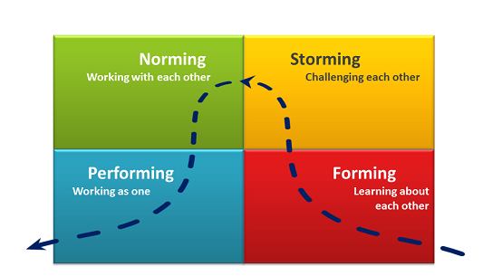
Source: https://www.google.co.in/search?biw=1366&bih=637&tbm=isch&sa=1&ei=494nWu--LsXGvgSnxaXoDg&q=tuckman+model&oq=tuckman+model&gs_l=psy-ab.3...11348.14025.0.14205.0.0.0.0.0.0.0.0..0.0....0...1c.1.64.psy-ab..0.0.0....0.CwcPTR0YMjo#imgrc=QjicfO5BrQWcAM:

- Appendix 2

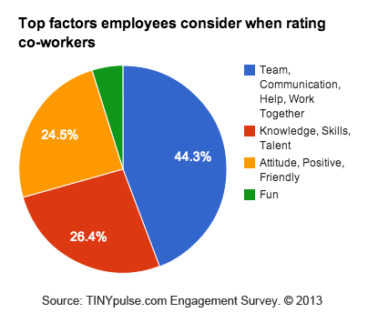
Source: https://www.google.co.in/search?biw=1366&bih=588&tbm=isch&sa=1&ei=Yd8nWpuuAojrvgTshIi4CQ&q=communication+graph+in+a+team&oq=communication+graph+in+a+team&gs_l=psy-ab.3...45453.46575.0.47249.0.0.0.0.0.0.0.0..0.0....0...1c.1.64.psy-ab..0.0.0....0.vm1_fznRmBM#imgrc=0AotjMGthT64FM:

