

Assessment 1
Supporting Paper

Student name: ​Melanie Okine
Student ID: ​1907289
Module name: Mental Disorders and Psychopathology​
Module code: BMHP6006
Lecturer name: Bianca Sanfilippo ​

Contents
Introduction 3
Mental Health Disorder 3
Historical Context of Mental Health Disorder 4
Mental and behavioural disorder due to multiple drug use and use of other psychoactive substances 5
CASE STUDY 6
Analysis of Case Study 7
Aetiology of this disorder 7
Signs of this mental disorder 8
Historical treatments for this disorder and the current treatments available. 8
Professional Practice 9
Analysis 10
Statistics 10
Conclusion 11
References 11
Appendices 14

Introduction

This supporting paper will be looking at mental health disorder, giving a general definition of what mental health disorder is, and more specifically Mental and behavioural disorder due to multiple drug use and other psychoactive substances as found in the ICD-10 classification under F19 (WHO, 2010).
Looking at the causes and the symptoms and what treatments are available. Looking at the link between mental health disorder and substance use disorder (SUD). How things have changed throughout time and the importance of a person-centred approach.
Looking at previous and current legislation. Providing a general overview of historical treatments and perspectives regarding mental and behavioural disorders.
Discussing the Aetiology, signs, symptoms, historical context, legislation, statistics, treatments, and professional principles for mental and behavioural disorder due to multiple drug use and the use of other psychoactive substances.

Mental Health Disorder

Mental health disorder is the materialisation of behavioural, biological, or psychological dysfunction in individuals (Stein et al. 2010). It is an affliction within the brain that has a negative impact on the behaviour, thoughts, and emotions of individuals. Affecting their day-to-day life. (Peterson, 2019). There are many different types of disorders ranging from mild to severe. In the Mental Health Act 2007 it is defined as a disorder or disability of the mind (Mental Health Act, 2007).

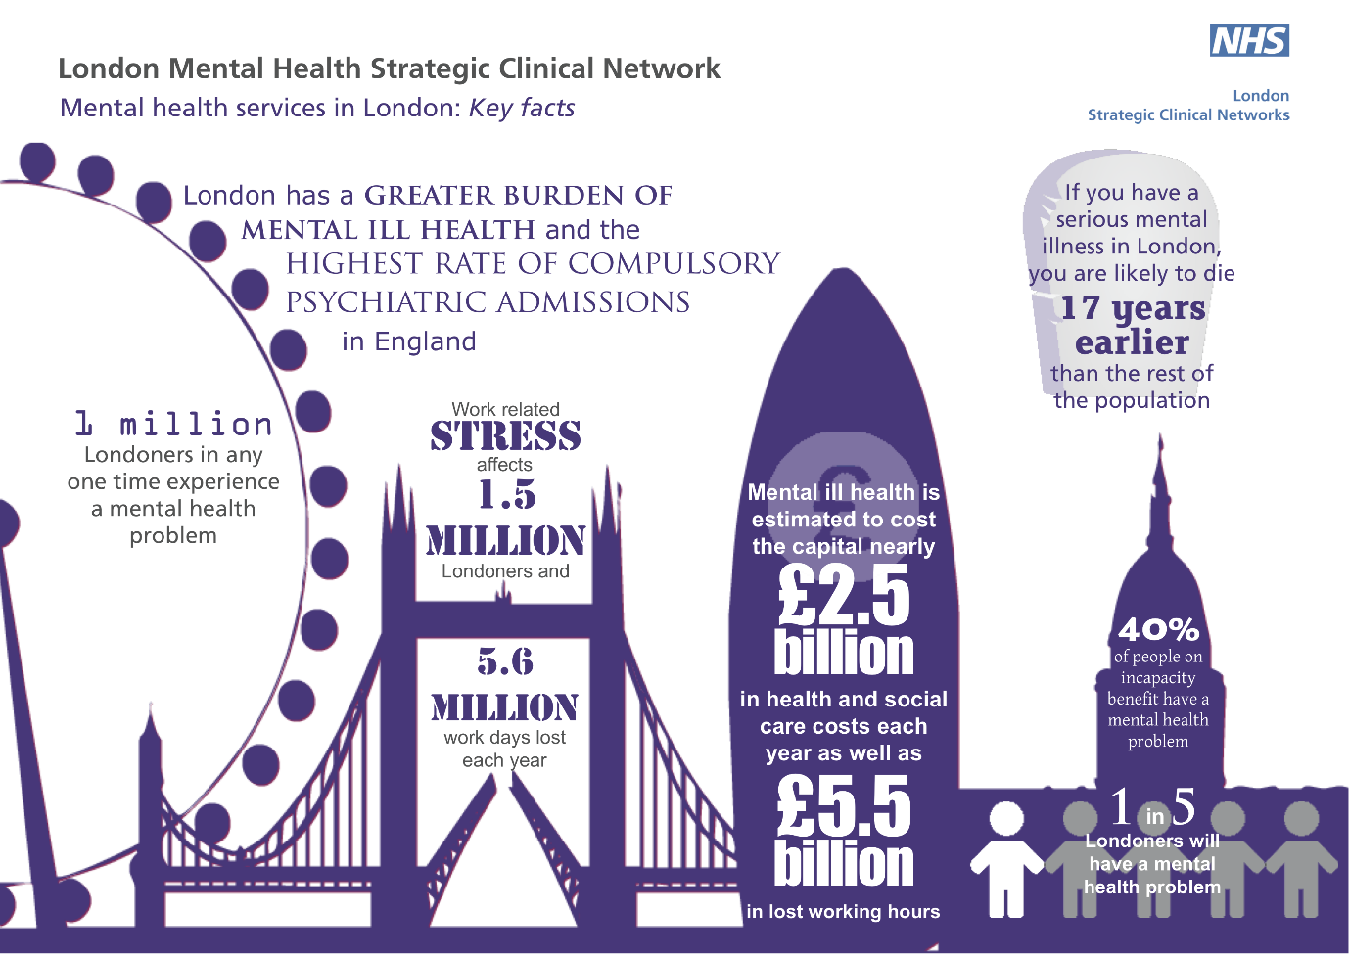
Source: https://mentalhealthpartnerships.com/wp-content/uploads/sites/3/london-mental-health-facts-1.png

Historical Context of Mental Health Disorder

Mental health has come a long way. The first lunatic asylum in Europe that has been recorded was the Bethlem Royal hospital located in London. It became a hospital in 1330 and admitted its first mentally ill patient in 1407. Treatment of the mentally ill before the Madhouse Act 1774 was unregulated and carried out by practitioners that were not licensed. When the Madhouse Act 1774 came into effect licensing was required for any property that was used to house the mentally ill (The Time Chamber, 2017).
The York Retreat was then set up by William Tuke in 1792 this is when patients were offered a therapeutic setting and treated like human beings for the very first time (The Time Chamber, 2017).
The treatment of patients within these times was horrendous some of the methods used to treat the mentally ill included restraints; lobotomy; electro convulsive therapy (although this is still used in current times); trepidation; the spinning chair or rotational therapy (Desmond, 2015).
It was thought that people who were mentally ill had been possessed by demons and exorcisms were the main treatments ( Espí Forcén and Espí Forcén, 2014).
The Lunacy Act 1845 was when a lot of the offensive wording changed however, the name of this act alone was still offensive. This is when asylums changed to being called hospitals, people were no longer called lunatics they were now referred to as patients and from insane to unsound mind. This Act also made it possible for voluntary admissions and outpatient treatment.
The Mental Health Act 1983 included the Human rights and Equality which also includes the assessments, treatments, and care planning. The Mental Health Act 2007 is an amended version to reflect the changes that have been made (NHS, 2019).

Mental and behavioural disorder due to multiple drug use and use of other psychoactive substances

This disorder is the intoxication of multiple psychoactive substances resulting in dysfunctional behaviour, psychological and physical harm (Johnston and Lawrie. 2010, p. 1).
Mental and behavioural disorder due to drug use and the use of other psychoactive substances is the intoxication of a substance that results in physical and psychological harm. Including Acute intoxication (WHO, 2010). As found in the ICD-10 manual these may also include but are not limited to; harmful use; dependence syndrome; withdrawal state; psychotic disorder; amnesic syndrome; residual and late-onset psychotic disorder; depression; anxiety; and alcoholic dementia (WHO, 2010).
Within the drug and alcohol recovery/treatment industry mental and behavioural disorder due to multiple drug use and the use of other psychoactive substances is more commonly referred to as drug induced psychosis (Curmi, 2021). This disorder is caused by substances resulting in a psychotic episode which causes paranoia, hallucinations, and delusions.
This is a condition that looks a lot like schizophrenia or bipolar resulting from the use of one or multiple drugs (Arete Recovery, 2021). The use of cocaine and alcohol results in this turning into a completely different and very dangerous drug called cocaethylene (COE). This can result in heart attack and psychosis. Multiple drug use can cause individuals to lose sight of reality and result in aggressive and violent outburst. A fear for their own safety, resulting in the fight, flight, freeze or flop response. Alcohol and drugs have been known to cause psychosis these drugs include cocaine, amphetamines (speed), methamphetamine (crystal meth), ecstasy (MDMA), mephedrone (MCAT), cannabis, ketamine among others. Psychosis can also be caused by the side effects in certain prescribed medication although this is rare (NHS, 2019).

CASE STUDY

Patient A started to experience severe depression, anxiety and psychosis, she was struggling to manage day to day life having a constant feeling of fear and panic. Suffering from delusions and paranoia believing she was being watched, people were talking about her and laughing at her. It got so bad that she thought people were out to harm her resulting in her heart beating so fast she thought she was going to have a heart attack. Being a mental health first aider, she was able to rationalise and use the strategies and techniques that she had learnt; concentrating on her breathing distracting her thoughts by reading road signs, shop signs and car registration numbers, until her heart rate slowed down, and the incapacitating fear had diminished. When she returned home, she checked the side effects on the medications she was taking and realised that both could cause anxiety, depression and psychosis. She stopped taking the medication immediately and called her G.P who offered her anti-depressants which she declined but accepted the suggestion of accessing talking therapy. They sent her the number and website address to complete a self-referral to IAPT psychology. As she didn’t use any illicit substances, she was accepted by IAPT however, since stopping the medication she is feeling much better and is no longer suffering from any of the symptoms of psychosis (Anonymised case study, 2021).

Analysis of Case Study

This case study shows that although it is rare for people to suffer from Mental and behavioural disorder due to drug use and the use of other psychoactive substances from the use of prescription medication, the side effects can be very real and in some cases like the case study above it can happen.
Because the patient understood how mental health disorders work, she was able to rationalise it and keep herself calm. For others who have no understanding in this area, it could have ended very differently, possibly resulting in heart attack or suicidal ideation/attempts.

Aetiology of this disorder

The Aetiology of mental and behavioural disorder due to drug use and the use of other psychoactive substances is answered in the name of this disorder. It is the use of drugs, alcohol, and other psychoactive substances. Abusing substances such as marijuana or methamphetamine can cause prolonged psychotic reactions, while alcohol can make depression and anxiety symptoms worse. As far as psychosis is concerned, there is research to suggest that there is too much dopamine in individuals with psychosis and that the constant flood of information into the brain is simply too overwhelming (Tost, Alam, and Meyer-Lindenberg, 2009). Another cause of this disorder is the withdrawals from drugs. Although it is not clear whether drugs cause depression and anxiety or just trigger an underlying condition, it is clear that there is a link between mental health disorders and substance abuse disorder (Quello, Brady and Sonne, 2005).

Signs of this mental disorder

Some of the signs of this disorder include social withdrawal; lack of motivation; paranoia; delusions; hallucinations; depression; anxiety; aggression; violent behaviour and suicidal ideation (Arete Recovery, 2021; NHS, 2019).
Paranoia: feelings of being under threat, someone is going to harm you, people are watching you laughing at you talking about you and out to get you.
Delusions: believing in something untrue to be true.
Hallucinations: seeing something that just isn’t there (Arete Recovery, 2021; NHS, 2019).

Historical treatments for this disorder and the current treatments available.
The historical treatments of patients were horrendous some of the methods used to treat the mentally ill included restraints; lobotomy; electro convulsive therapy; trepidation; the spinning
chair or rotational therapy (Desmond, 2015). Sedation and hydrotherapy, inducing fevers with malaria infected blood, body part removal technique, and insulin shock therapy.
Today however, the treatments offered are much more humane. Referrals will be made to the community mental health team for assessments and diagnosis. Referrals to drug and alcohol treatment centres will be made to address drug use either residentially or in the community, complimentary therapies including massage therapy, aromatherapy, acupuncture, yoga, meditation, and mindfulness amongst many others can be very good to reduce cravings and stress and to promote calmness and relaxation. Anti-depressants and anti-psychotic medication can also be prescribed some of the most common anti-depressants are Fluoxetine, Citalopram and Sertraline. These come under the category of selective serotonin reuptake inhibitors (SSRI’s). The other types of anti-depressants are Serotonin-noradrenaline reuptake inhibitors (SNRI’s) such as Duloxetine. Noradrenaline and specific serotonergic antidepressants (NASSA’s) for example Mirtazapine. Tricyclic antidepressants (TCA’s) such as mirtazapine. Although these are rarely given as they are more dangerous if one was to overdose (NHS, 2021). Anti-psychotics include Clozapine, Aripiprazole, Olanzapine, and Risperidone (Knott, 2018). Talking therapies are also an option however Services like IAPT will rarely work with people until they have addressed their substance misuse. A multidisciplinary approach where the substance misuse team and mental health services deliver care side by side is essential for the best possible outcomes (Public Health England, 2019).
Cognitive behavioural therapy is one of the most commonly used methods of talking therapies. Other therapies include interpersonal therapy, and counselling. There is a NHS resource called IAPT which is a self-referral so is very easy to access, however they rarely offer a service if the person is still using drugs. For this service you need to be substance free, so the importance of addressing the drug issue takes priority. Unfortunately, a high percentage of people who have a mental health condition also suffer from substance abuse disorder.

Professional Practice

When working with individuals it is important to have a person-Centred approach as every person is unique and has different individual needs. It is important to build trusting relationships, whilst maintaining healthy boundaries. Ensuring confidentiality, privacy, dignity, and respect. These practices are embedded within the policies that are underpinned by legislation. For example, the policy for a person-centred approach comes under the Health and Social Care Act 2008 (Regulated Activities) Regulation 2014 (Care Quality Commission, 2022).

Analysis

Current treatments for this disorder are predominantly drug and alcohol treatment. Medication can be given dependant of the drug that is being taken. For example, people who are taking heroin can be given a prescription for Methadone, Subutex Physeptone or Espranor. Therapies are also important for example talking therapy and Cognitive Behavioural Therapy. The mental health service and IAPT currently do not like to offer a service if the client is unable to abstain from drugs or alcohol for at least 2 days per week without experiencing withdrawal symptoms (NHS, n,d). They require the individuals to address their drug use first. However, if the drug use has triggered an underlying mental health disorder or exacerbated an ongoing mental health condition, this will need to be assessed by the Mental health team, and the appropriate care can be given. (Manley, 2013).
Drug use and mental health should be treated side by side for the best possible outcomes as one can trigger the other. Better relationships and communication between the two services is essential and more research is needed for this disorder for the right treatments to be delivered. There is ample research on substance abuse and a wide range of mental health disorders, however there is very little research on mental and behaviour disorder due to multiple drug use and other psychoactive substances.

Statistics
The statistics are presented in the PowerPoint presentation in the appendix.
(Please see Appendix 1: statistics)

Conclusion

Mental and behavioural disorder due to the use of psychoactive substances can relate to illicit and prescribed medication. It is of paramount importance to use a person-centred approach when working with such individuals as the needs of each individual is unique. Looking at the various options for example community or residential is based on what would be best for that individual to offer the best possible outcomes. Working to manage or stop the drug use is the main treatment for this disorder unless this has triggered an underlying mental health illness. A multi-agency approach is also essential.

References
[Anonymised case study] (2021) Case study 1; [Anonymised case study] London. Unpublished.
Arete Recovery (2022) ‘The 5 Clearest Symptoms of Drug-Induced Psychosis (and Recovering from it)’, Arete Recovery. Available at: https://areterecovery.com/addiction/drug-induced-psychosis/ (Accessed: 22 April 2022).
Care Quality Commission. (2022) ‘Regulation 9: Person-Centred Care’, Care Quality Commission. Available at: https://www.cqc.org.uk/guidance-providers/regulations-enforcement/regulation-9-person-centred-care (Accessed: 9 January 2022).
Curmi, J. (2021) Conversation with Melanie Okine at Change Grow Live Lewisham, 20 December.
Derbyshire Healthcare NHS Foundation Trust. (n.d) ‘IAPT and Drug and Alcohol Services’. Derbyshire Healthcare NHS Foundation Trust. Available at: https://www.derbyshirehealthcareft.nhs.uk/application/files/9915/5370/1978/IAPT_Substance_Misuse_Protocol.pdf (Accessed: 18 December 2021).
Desmond, A. (2015) ‘The Dubious History of the Rotational chair’. Hearing Health& Technology Matters. Available at: https://hearinghealthmatters.org/dizzinessdepot/2015/the-sordid-history-of-the-rotational-chair/ (Accessed: 19 December 2021).
Espí Forcén, C., & Espí Forcén, F. (2014). Demonic possessions and mental illness: discussion of selected cases in late medieval hagiographical literature. Early science and medicine, 19(3), 258–279. https://doi.org/10.1163/15733823-00193p03
Johnston, E.C., and Lawrie, S.M. (2010) Companion to Psychiatric Studies. 8th Edn. St Louis: Church: Livingston.
Knott, L. (2018) ‘Anti-Psychotic Medicines’. Patient. Available at: https://patient.info/mental-health/schizophrenia-leaflet/antipsychotic-medicines (Accessed: 29 November 2021).
Mental Health Act 2007, c.12. Available at: https://www.legislation.gov.uk/ukpga/2007/12/section/1 (Accessed: 18 December 2021).
National Health Service (2019) ‘Mental Health Act’. NHS. Available at: https://www.nhs.uk/mental-health/social-care-and-your-rights/mental-health-and-the-law/mental-health-act/ (Accessed: 20 December 2021).
National Health Service (2021) ‘Overview - Antidepressants’. NHS. Available at: https://www.nhs.uk/mental-health/talking-therapies-medicine-treatments/medicines-and-psychiatry/antidepressants/overview/ (Accessed: 22 December 2021).
Manley (2013) ‘Dual Diagnosis: co-existence of Drug, Alcohol and Mental Health Problems’. British journal of Nursing. 14(2), https://doi.org/10.12968/bjon.2005.14.2.17439 cc
Peterson, T.J. (2019) ‘Mental Health Definition: What is Mental Health?’ Healthy Place. Available at: https://www.healthyplace.com/other-info/mental-illness-overview/mental-health-definition-what-is-mental-health#:~:text=One%20definition%20of%20mental%20illness%20is%20a%20dysfunction,in%20society%20%28Adult%20Symptoms%20of%20Mental%20Health%20Disorders%29. (Accessed: 18 December 2021). Public Health England (2019) ‘Mental health and substance misuse: joined-up services’. GOV.UK. Available at: https://www.gov.uk/government/case-studies/mental-health-and-substance-misuse-joined-up-services (Accessed: 18 December 2021).
Quello, S. B., Brady, K. T., & Sonne, S. C. (2005). ‘Mood disorders and substance use disorder: a complex comorbidity’. Science & practice perspectives, 3(1), 13–21. https://doi.org/10.1151/spp053113
Stein, D.J., Philips, K.A., Bolton, D., Fulford, K.W.M., Sadler, J.Z., Kendler, K.S. (2021) ‘What is Mental/Psychiatric Disorder? From DSM-IV to DSM-V’. Psychological Medicine. 40(11)1759-1765 DOI: 10.1017/S0033291709992261
Tost, H., Alam, T., and Meyer-Lindenberg, A. (2009) ‘Dopamine and psychosis: theory, pathomechanisms and intermediate phenotypes’. Neuroscience and biobehavioural reviews, 34(5), 689–700. https://doi.org/10.1016/j.neubiorev.2009.06.005

World Health Organization (2010) ‘Mental and Behavioural Disorders Due to drug Use and the Use of other Psychoactive substances (F10-F19)’. ICD 10: Version 2010. Available at: https://icd.who.int/browse10/2010/en#/F10-F19 (Accessed 29 November 2021).

Appendices

Appendix 1

