Managing enterprises in the 21st century
Module BMSW4006
Final-part 2 Business plan
Student name Abibatu Sesay
Student number: 2028276
Lecturer name: DR Olu Adegbite

VFF – Vegan Fast Food
Thursday, June 9, 2022
4:12 PM

Pros ; catering to a wider audience of eaters
Good for the environment
More morally acceptable
More sustainable than ordinary fast food restaurants.
Aimed at both meat eaters and non meat eaters but 100% vegan down to the packaging
Cons; doesn’t actually provide meat options so is discriminatory to meat eaters
To improve this issue we could have a separate area in the store which provides small meat options for those that just want to try vegan but would prefer meat however this may highly impact the success of the store

Vegan research: 7.2 m people following a meat free diet in the UK as of 2022
Many considered dietary vegans which means they prefer a vegan diet but do not necessarily uphold a vegan lifestyle.
In 2020 almost 500,000 brits gave up a meat filled diet
It has been documented in recent surveys that 12% of the population intended to give up meat in 2021
25% of Gen Z are currently following a meat free diet

Location? London
The main location for vegan fast food chains are the US and singapore .
The uk has a few new opening vegan fast food style restaurants however they are not well established yet and have not been open long enough to show a profit or loss.

In london there are a number of vegan Deliveroo restaurants, such as 'Oowee vegan' that only operate on Deliveroo and do not yet have any physical resturants where customers can get food in store and fast paced.
There are also many new vegan restaurants popping up over London like 'tofu vegan' that offer completely plant based menus, however they are not fast food restaurants and do not aim to become chains at this point so they only exist in London.
The largest share of vegans can be found in London with 600,000 vegans found in the uk 2.67% are located in London.
The midlands however only hosts 1% of that 600,000
From research it is determined that the first fast food restaurant should be opened in London, to be shortly followed by another branch in Birmingham depending on success and turn over rate.

There are currently no completely vegan fast food restaurants in the uk, there are however 1953 restaurant outlets in the uk that offer few vegan options. That being said I conducted my own personal research by visiting various fast food outlets on the weekend in my local area and documented the availability of the vegan options and how many there were;
- Macdonalds – mcplant and the spicy veggie wrap are the only vegetarian options however I was told that only the mcplant is suitable for vegans. Also there is no vegan fries option as the fries are cooked in meat juices. also at the time I visited this particular macdonalds there were no veggie wraps either. The mcplant was like uncooked meat is was not tasty and was not appealing to the eye. Having looked online at reviews of this burger they are also quite bad
- KFC – currently has no vegan options at all (the have a vegan burger which I was advised has not been in store for the past month but is advertised online)
- Burger King – vegan nuggets, vegan royale, vegan bean burger, kids vegan burger and also the plant based whopper. All these options were available at the burger king branch I visited, I tried the vegan whopper and also the vegan nuggets and in my personal opinion the whopper tasted exactly like the meat version the nuggets however were not very nice and didn’t mimic chicken nuggets very well
- Greggs – vegan sausage bean and cheese melt, vegan sausage roll, southern fried wedges, vegan ham and cheese baguette with quorn, vegan glazed doughnut, vegan sausage breakfast roll. Most of these options were available, only the breakfast roll was not due to the time and there were no ham and cheese baguettes left (due to being sold out)

Marketing

these i would say are the main competitors for my completely vegan Fast food shop. Burger king is the main competitor that stands out as from my personal research the options were more available and definitely tastier

 | VFF | Macdonalds | Burger King | KFC | Greggs | Subway
Overview | A fast paced fast food  Vegan restaurant, with  indoor seating and a fast  takeaway service available. A drive thru service (accommodation permitting) | Fast food  restaurant serving  burgers fries and various American themed  sides | American style fast food restaurant | Leading high street fried chicken fast food restaurant | Leading high street lunch time restaurant | Leading high street sandwich store.
Target market | 3 – 99 Years  Vegan/plant based products only | Fast food lovers. Parents and children | Males, 18-35 | 4 – 45 year olds | Working people. 18 – 65 year olds | Young adults 16 – 39 years old
Products and  services | A wide variety of vegan fast foods. Taken from around the world. Not specifically american styled fast food. Serves breakfast also. | American style fast food. Burgers, fries, apple pies, ice cream and a small variety of hot and cold beverages. Also serves breakfast | American style fast food with few options | Fried chicken dishes only | Sandwiches mainly lunchtime styled foods. Hot pasties and more recently small warm snacks like wedges and chicken strips. | Hand made sub sandwiches created in front of you to your specification. Currently 18 different options completely customisable.
Costs | Ranging from £0.49p - £8 being most expensive item on the menu | £0.79 - £7.19 | £0.99 - £8.99 | £0.79 - £25.99 | £0.79 - £16 | £0.60 - £6.69
Marketing/ offers | Loyalty app/card scheme.  Vouchers in leading newspapers.  Displays on side of buses  Social media accounts and paid for promotion | Own app occassional discounts.

Menu.
Consist of- a vegan beef burger on its own £3.99 as meal £5.09 a meal will come with a choice of 1 side and a drink
Sourced from https://www.fruugo.co.uk/vivera-frozen-vegan-quarter-pounder-burgers
At £37.02 for 10 113g quarter pounders
Each burger will cost £3.72
£185.10 one week supply = £1,295.70
First month supply = £5,182.80

, a vegan chicken burger on its own £3.99 as a meal £5.09
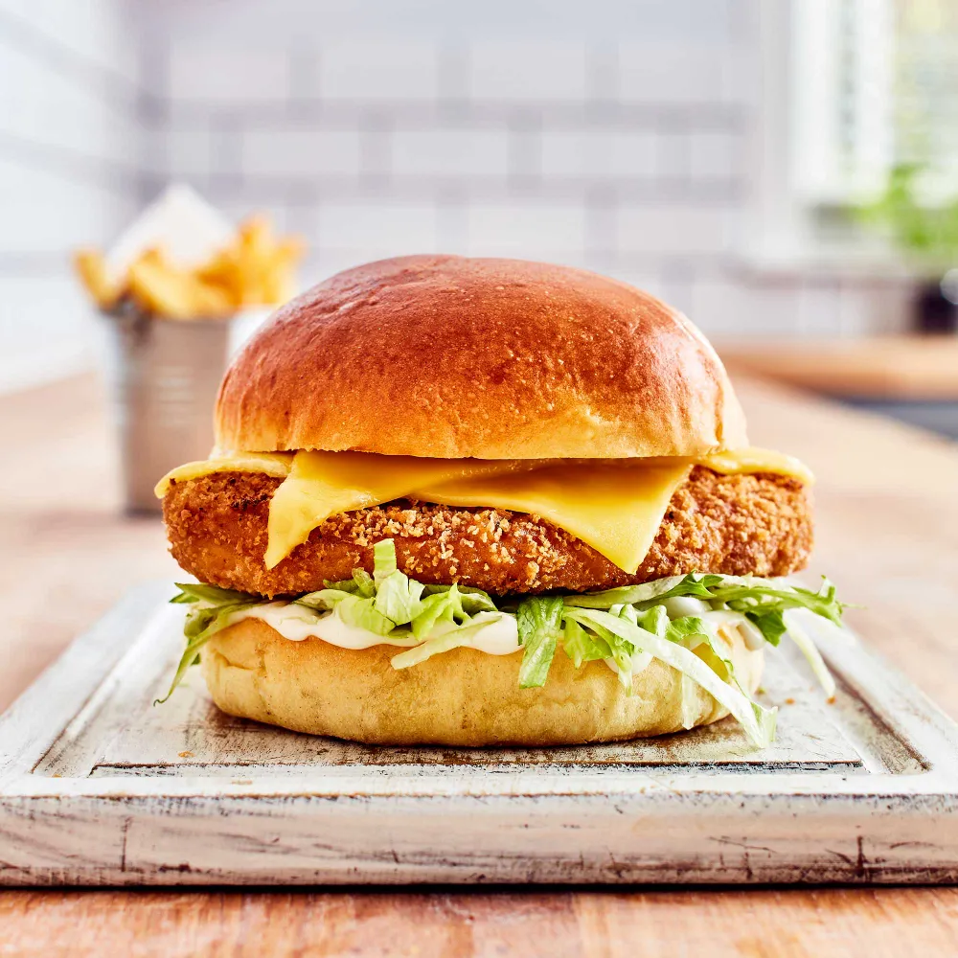
Sourced from https://www.thomasridley.co.uk/quorn-vegan-buttermilk-style-chicken-burger-
At £37.64 each pack contains 20 burgers making each burger £1.88
One week supply = £526.96
First month supply = £2,107.84

A plant based hot dog called crazy dogs (due to the variety of toppings provided)
£3.99 on its own £5.09 as a a meal \
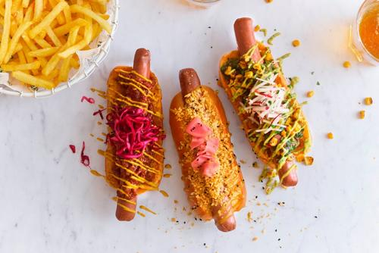
Sourced from https://www.brake.co.uk/meal-solutions/meat-free-vegetarian/sausages/
At £9.09 a pack with 10 in a pack making each hot dog £0.99
One week supply = £318.15
First month supply = £1,272.60

vegan fries £0.99 for a large portion of fries. Potatoes will be sourced from https://www.fruitandveg.co.uk/fresh-produce/vegetables/potatoes/chippies-choice-potatoes/
At £13.80 per 25kg. Our fries will be cut and fried fresh in store.
Est 100 kg needed per day in first month then 200kg needed a day for following months
First week supply = 386.40
First month supply =1,545.60

All food will be fried in rapeseed oil costing £19.25 per 5l
We estimate we will need at least 10l a week as rapeseed oil has a long frying life so would not need changing as often. Many items in store will be air fried.
One week supply = 38.50
First month supply = 77

Kfc style sides – corn on cob sourced from https://www.fruitandveg.co.uk/frozen/frozen-vegetables/other-frozen-vegetables/frozen-corn-on-the-cob/ at £33.88 for 24 x 500g bags. That is one weeks worth
First months supply = 135.52

vegan coleslaw sourced from https://www.fruugo.co.uk/flavours-coleslaw/
At £11.99 per 2kg. We would need 6kg for one week
One week supply = 35.97
First month supply = 143.88

vegan gravy sourced from https://www.fruugo.co.uk/major-gluten-free-gravy-granules-for-poultry-vegan-dishes/
At £23.82 per 2kg est. 6kg needed for one week
One week supply = 71.46
First months supply = 285.84

Refreshments – 3 different flavoured vegan milkshake, plain vanilla, chocolate cookies and cream, and strawberry veegz. These would be made using our milkshake machine already equipped in kitchen of property. Ice creams would be sold at £3.99 for a medium sized shake £4.69 for a large

Ice cream in bulk from https://www.brake.co.uk/desserts/ice-cream-gelato-sorbet/ice-cream/scooping/brakes-vegan-vanilla-flavoured-ice-cream/p/130799
At £11.99 for 4l est 12l for 1 week £33.97
First months supply = 135.88

Milk bought in bulk from https://food-republic.com/product-category/milk-alternatives/
At £9.95 for 6x 1ltr est 10l for 1 week £99.50
First months supply = 398

Oreos bought in bulk from https://www.hancocks.co.uk/oreo
At £2.49 for 400g est 4000g needed for 1 week £24.90
First months supply = 99.60

Vanilla milkshake syrup from https://www.ebay.co.uk/itm/
at $14.50 for 5l est 20l needed for 1 week £58
First month supply = 232

raspberry milkshake syrup from https://www.ebay.co.uk/itm/
At £14.50 for 5l est 20l needed for 1 week £58
First month = 232

Range of vegan friendly juices dispensed from a large dispenser sauced from https://www.cs-catering-equipment.co.uk/valera-deluxe123-triple-bowl-juice-dispenser
Juices will be made fresh daily depending on fruit in season

Desserts- plant based ice cream cups or cones with a range of vegan friendly toppings to choose from.
Ice cream cups - £3.09
Ice cream cones £1.89
Extra toppings 10p per topping

Based on 400 customers per week in first month then 800 customers per week in following months
Based on one meal per customer and a dessert
Based on 14 staff members in 2nd month, 2 front of house, 3 kitchen members (one on drinks and desserts, one on fries, one on burgers and dogs)
Each staff member does 3-4 days working 10 hour shifts with a 1hr break and free food at work
Minimum wage £9.50
57 customers a day in first month
114 customers a day in following month

 | jan | feb | march | april | may | june | End of 6  Months total
Grants and  investments | 50,000  100,00 (from owner)  50,000 (Private investor)  75,000 (bank loan) |  |  |  |  |  | 275,000
Sales income | 13,088 | 26,176 | 26,176 | 26,176 | 26,176 | 26,176
Total incoming | 288,088 | 26,176 | 26,176 | 26,176 | 26,176 | 26,176 | 445,144
premise | 34,478 |  |  |  |  |  | 34,478
wages | 0.00 | 5,320 | 5,320 | 5,320 | 5,320 | 5,320 | 26,600
stock | 23,032.32 | 46,064.64 | 46,064.64 | 46,064.64 | 46,064.64 | 46,064.64 | 253,355.52
Total outgoing | 176,239.60  (wages, stock for first 3 months and premise will all be accounted for out of start up funds) leaving 98,760.40 | 0.00 | 0.00 | 46,064 | 46,064 | 46,064 | 314,433.52

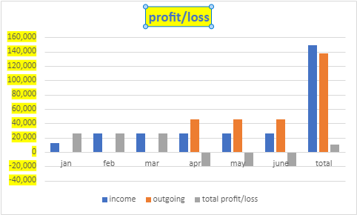

Strengths  One of a kind vegan/plant based menu found nowhere else  Available in store and fast paced  Loyalty app scheme- each time you order via the app in store you receive 1 point per £1 spent every 100 points you can get on free item off the menu.  Completely plant based restaurant – even the furniture will be vegan friendly, no products tested on animals, and all packaging will be 100% recyclable.  This restaurant will have vegan based values at the core.  Location will mean it is the only vegan fast food restaurant.  Plant based meat like options to cater to the non vegans also.  Available online via deliveroo just eat and restaurant website.  Electric cars only used for delivery. | Weaknesses  Only one location at the moment  Not yet established.  Slow flow of customer  No petrol cars will be used.
Oppurtunities  Vegan is a growing trending community at the moment.  Use of social networks to interact with the vegan community  Expand into a chain eventually branching out to the main cities I.e. Birmingham, Manchester Liverpool.  Target market consumer will be gen z/x | Threats Lack of staff due to avaliability. Staff would of course have to be of a plant based diet to avoid cross contamination.  New vegan food companies are popping up everyday and could provide competition.  The increase in vegans could slow down which would mean less custom.  Have to stay up to date on food trends and the vegan alternatives for them as to monopolise on the food market  The increase of food stock may incline rapidly once business picks up and the restaurant becomes more established.  Main threat would be the main fast food chains creating a vegan branch, I.e. vegan macdonalds, due to their reputation already being established that would be major competition

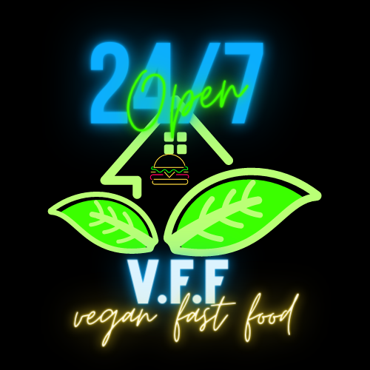

Marketing strategy;
Marketing will begin with a heavy presence on social media. There will be instagram, twitter, youtube and tik tok accounts for VFF. The slogan implemented alongside the social media campaign will be, 'go vegan, change ya life...dont be a meat head!'
Head of social media for VFF will be active on the accounts 1 month before the opening of the restaurant building a social rapport with potential customers, advertising any opening offers and making sure the posts are in time with trending topics on social media.
A month before opening someone from the vegetarian society will be invited down to try test and approve all items on the menu and possibly do a review (this is completely necessary before opening can commence due to credibility)

Property

Brick Lane, Spitalfields, E1
https://www.onthemarket.com/details/11984026/?channel=commercial
Ready made property fitted with fast food style kitchen and front of house display.
Also has some seating for any people that want to sit in. Possibility for outdoor seating and upstairs seating as there is also a property attached upstairs.
Price is £65,000 PA
Situated on bricklane a very active road in london filled with many different food shops.
Area is described as a hipster area, which may be perfect for vegan customers.
Although the grant is only for 50,000., this property can be leased on a 6 month upfront basis at £5,413 per month
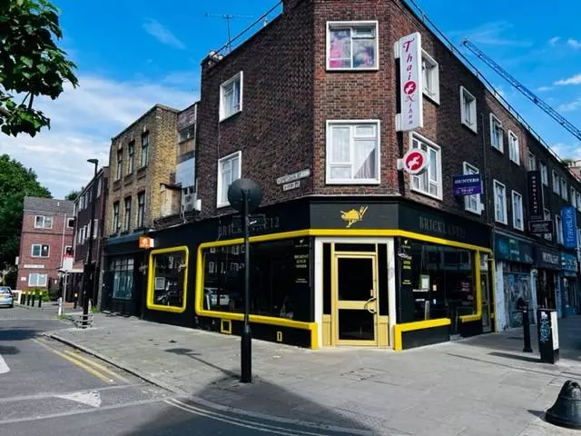

Large premises suitable for extra seating.
Based on the turnover figures we believe that the premise is affordable.

Upfront costs = 32, 478 for rent
17,522 left

Nappy pros

- A few good initiatives that would be good if implemented within my community;
Free school meal initiative introduced by marcus rashford which has now been withdrawn by the government. I believe this is well needed within the community and definitely more needed during the current economic crisis

3. afro carribbean supermarkets
Home car valet service
A phone holder that does not drop when in your car
An app for women drivers to organise important car issues like tax/mot/insurance
Baby vegan food
Completely compostable nappies

