What is digital literacy

Digital Literacy refers to an individual's ability to find, evaluate and communicate information through
Typing and other media on various digital platforms
It also means having skills you need live and learn and work the 4 principles are
INTERDEPENDENCE
COMPREHENSION
SOCIAL FACTORS
CURATION
Digital literacy skills are important to allow you to find use and create info online in a productive way [2]

TIME MANAGEMENT
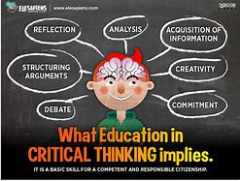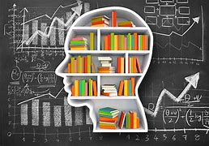https://www.highspeedtraining.co.uk/time-management

Time management entails calculating and managing the time spent on tasks,
Properly set objectives. Set attainable and quantifiable objective
pause in between jobs
Plan certain that you have allotted sufficient time to complete your task
Planning and exerting deliberate control over the amount of time spent on tasks, especially to boost effectiveness, efficiency, and productivity, is the practise of time management [1].

CRITICAL THINKING

critical thinking - Bing images

Analysing the information at hand—facts, evidence, observations, and arguments—to plan is known as critical thinking. The topic is complicated, and there are many various definitions of what it means to analyse or evaluate factual data in a reasonable, sceptical, and objective manner. “Self-directed, self-disciplined, self-monitored, and self-corrective thinking are all characteristics of critical thinking. problem-solving and communication skills as well as a dedication to overcoming ingrained egocentrism and sociocentrism. [3] [4]

HOW TO INPROVE MY SIMULARTY SCORE

Similarity

Estimate my marks
ITY nt., (2008).

Using Mendeley – Automatic Referencing Tool
Introduce Mendeley (add citations):

Install:
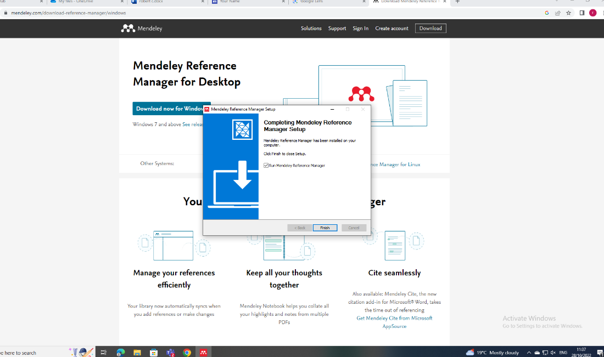

Register:
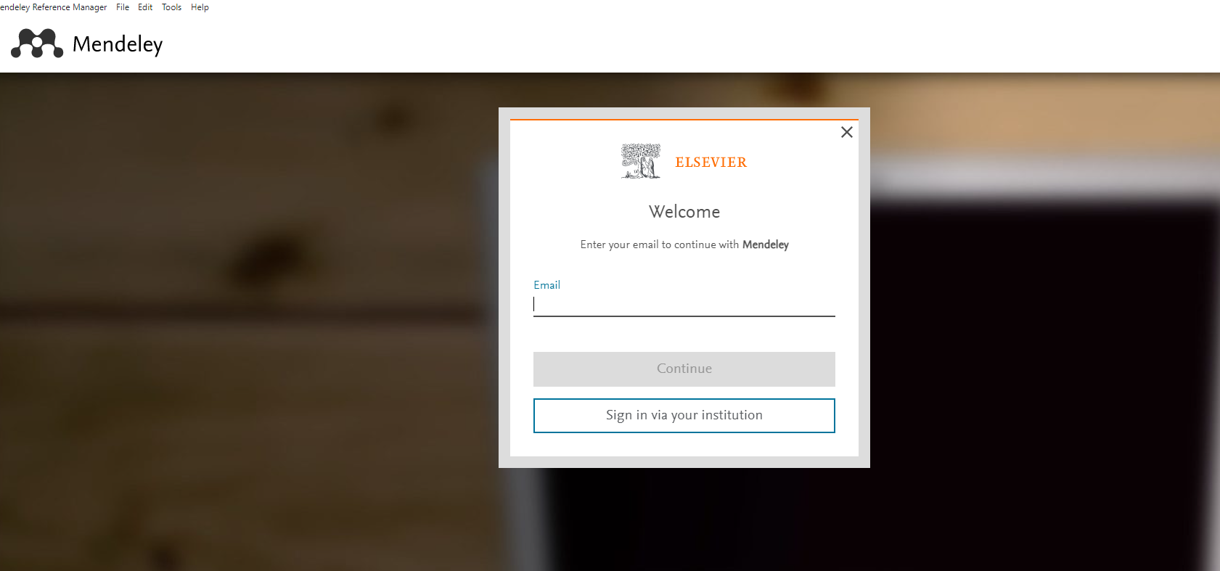

Add References:
Adding My References to Mendeley
Several ways: Upload pdf, Web importer, manually....
[1] [2] [3] [4]
- Upload pdf
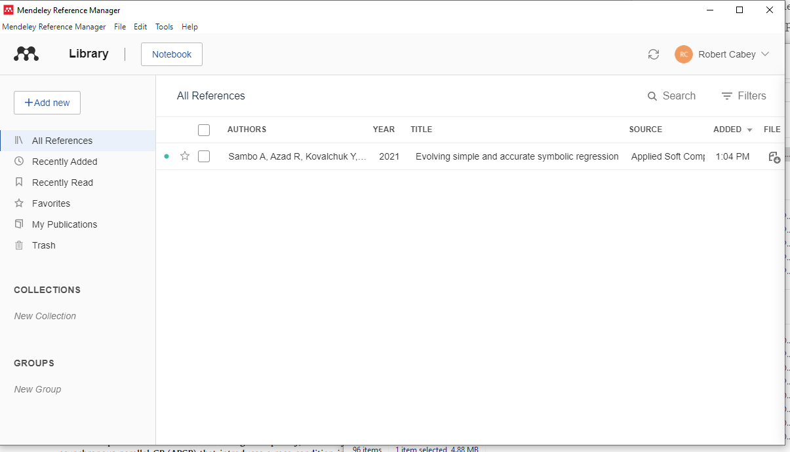

- Use Web Importer
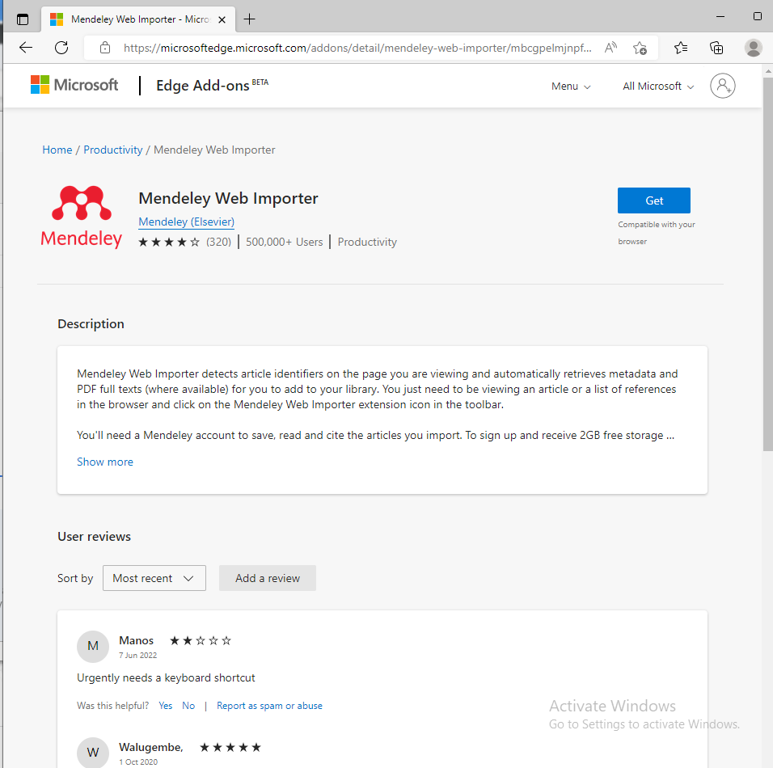
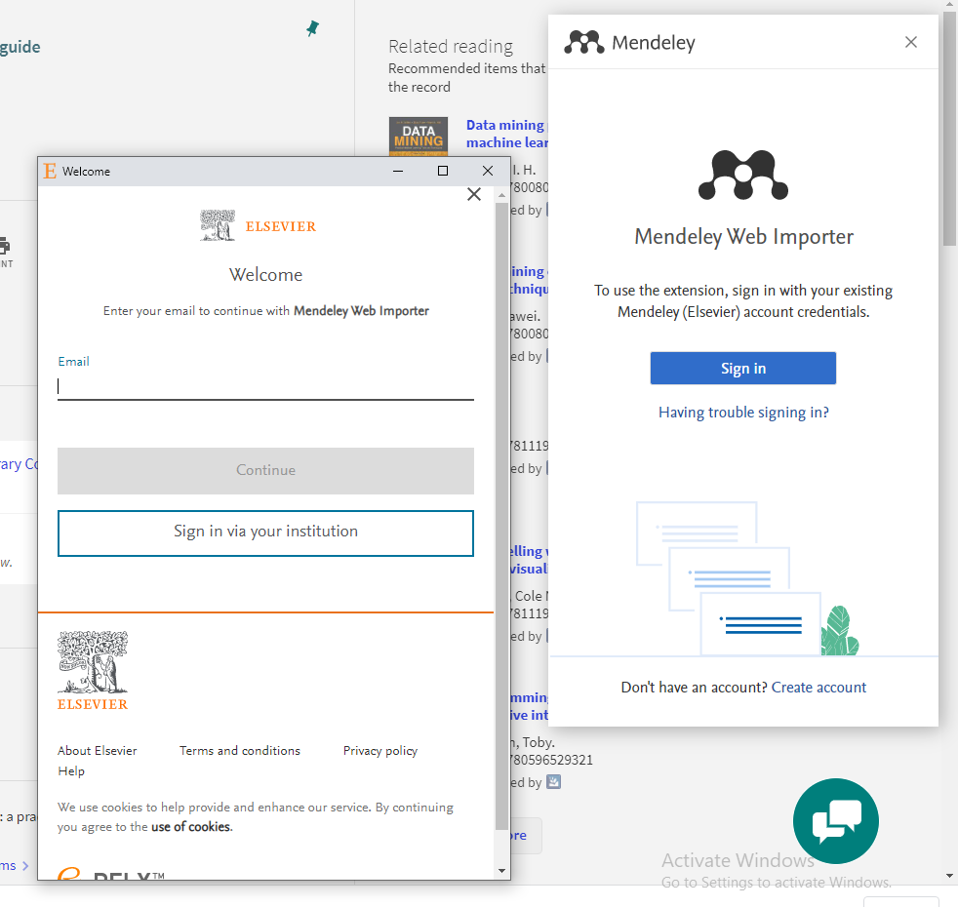

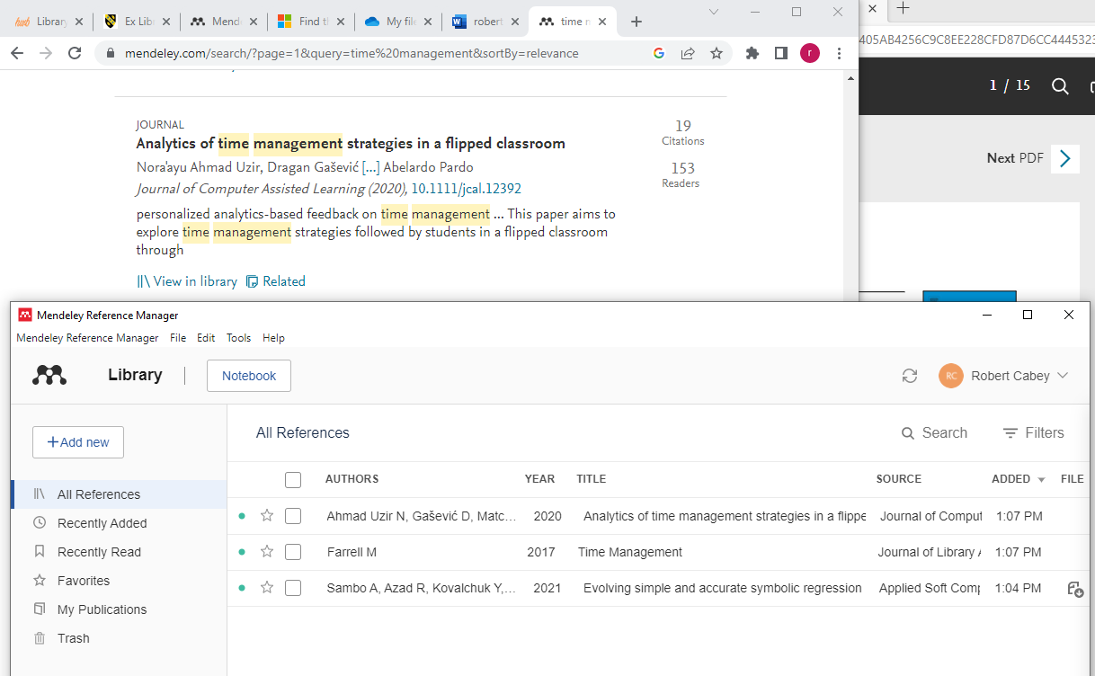

Add Citation

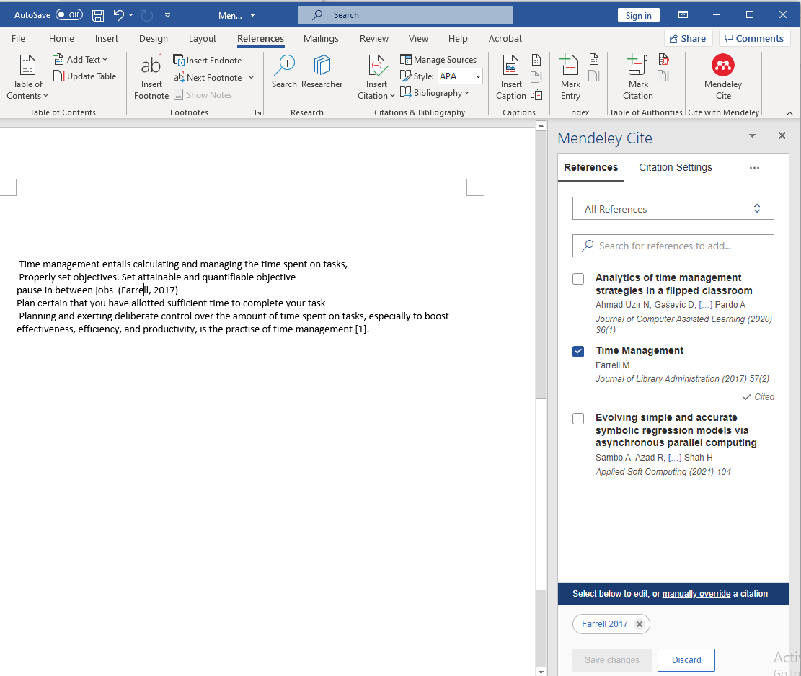

Add Reference list
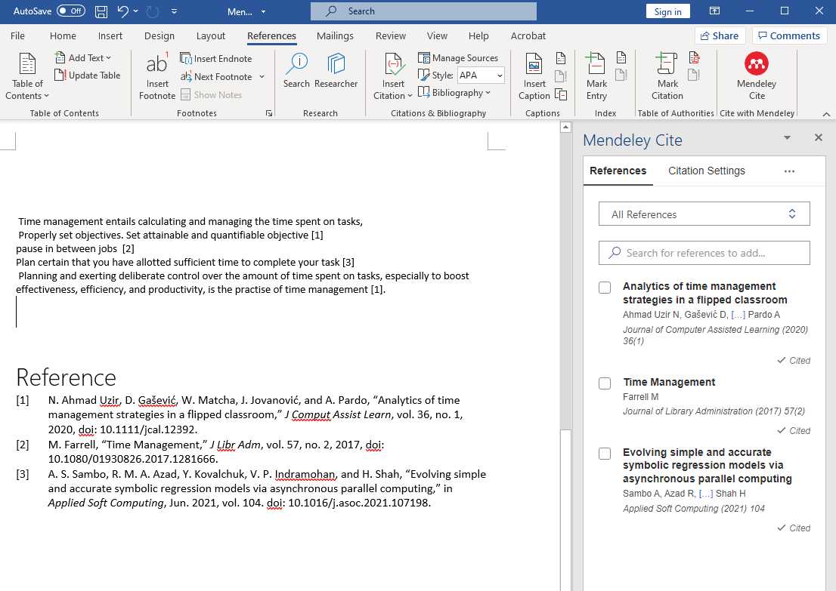

Reference List
[1] - Iskandar and A. A. Patak, “The significance of Mendeley usage on the accuracy of citation and references,” International Journal of Humanities and Innovation (IJHI), vol. 2, no. 4, 2019, Doi: 10.33750/ijhi.v2i4.51.
[2] A. A. Patak and M. Tahir, “Avoiding plagiarism using Mendeley in Indonesian higher education setting,” International Journal of Evaluation and Research in Education, vol. 8, no. 4, 2019, Doi: 10.11591/ijere.v8i4.20268.
[3] M. A. F. Reis, J. Favret too, N. M. Favretto, L. M. H. Favretto, and R. P. dos Santos, “Knowledge management in the classroom using Mendeley technology,” Journal of Academic Librarianship, vol. 48, no. 4, 2022, Doi: 10.1016/j.acalib.2021.102486.
[4] The Mendeley Support Team et al., “Import citations into your library using the Mendeley Web Importer | Mendeley,” International Journal of Hygiene and Environmental Health, 2013.

