
University of Wales Trinity Saint David
School of Engineering

Thermofluid Mechanics
M5X00406

Jonathan Lloyd-Williams
1805620
20/04/2020
Table of Contents
List of Appendices 1
1 Introduction & Background Research 2
2 Experiment 1 – The Effect of Varying Water Flow Rate 3
2.1 Methodology 3
2.2 Calculations 3
2.2.1 Constants 3
2.2.2 Water Density (Wρ) 3
2.2.3 Air Density (Aρ) 4
2.2.4 Water Flow Conversion (ṁW) 4
2.2.5 Air Flow (ṁA) 4
2.2.6 Specific Heat Capacity of Water at Constant Pressure (CpW) 5
2.2.7 Specific Heat Capacity of Air (CpA) 5
2.2.8 Water Heat (Power) Emitted (Qw) 5
2.2.9 Hot Water Circuit Temperature Efficiency 6
2.2.10 Heat (Power) Absorbed by Air (Qa) 6
2.2.11 Cooler Air Circuit Temperature Efficiency 6
2.2.12 Mean Temperature Efficiency 7
2.2.13 Logarithmic Mean Temperature Difference (LMTD) 7
2.2.14 Heat Transfer Coefficient (U) 7
2.2.15 Repeating for Varying Water Flow Rates 8
2.3 Results Analysis & Conclusions 8
3 Experiment 2 – The Effect of Varying Air Flow Rate 11
3.1 Methodology 11
3.2 Calculations 11
3.3 Results Analysis & Conclusions 11
4 Experiment 3 – Effect of Varying Temperature (Driving Force) 14
4.1 Methodology 14
4.2 Calculations 14
4.3 Results Analysis & Conclusions 14
5 Bibliography 17
6 Appendix 1 – Excel Sheet for Experiment One 18
7 Appendix 2 – Excel Sheet for Experiment Two 19
8 Appendix 3 – Excel Sheet for Experiment Three 20
9 Appendix 3 Continued 21

List of Appendices
Appendix 1 – Excel Sheet for Experiment One
Appendix 2 – Excel Sheet for Experiment Two
Appendix 3 – Excel Sheet for Experiment Three

Introduction & Background Research
A heat exchanger is a device designed to transfer heat between multiple fluids, i.e liquids vapours or gases of varying temperatures, whilst preventing direct contact of these fluids using a solid barrier (Ronquillo, 2020).
The type of heat exchanger used for this report was designed specifically for heat transfer between liquid and gas, in this case air and water. The heat exchanger allows for varying flow rates and configurations with regards to both the available water and air flow. The heat exchanger used for this experiment was a TecQuipment TD1007, a picture of which can be seen below. 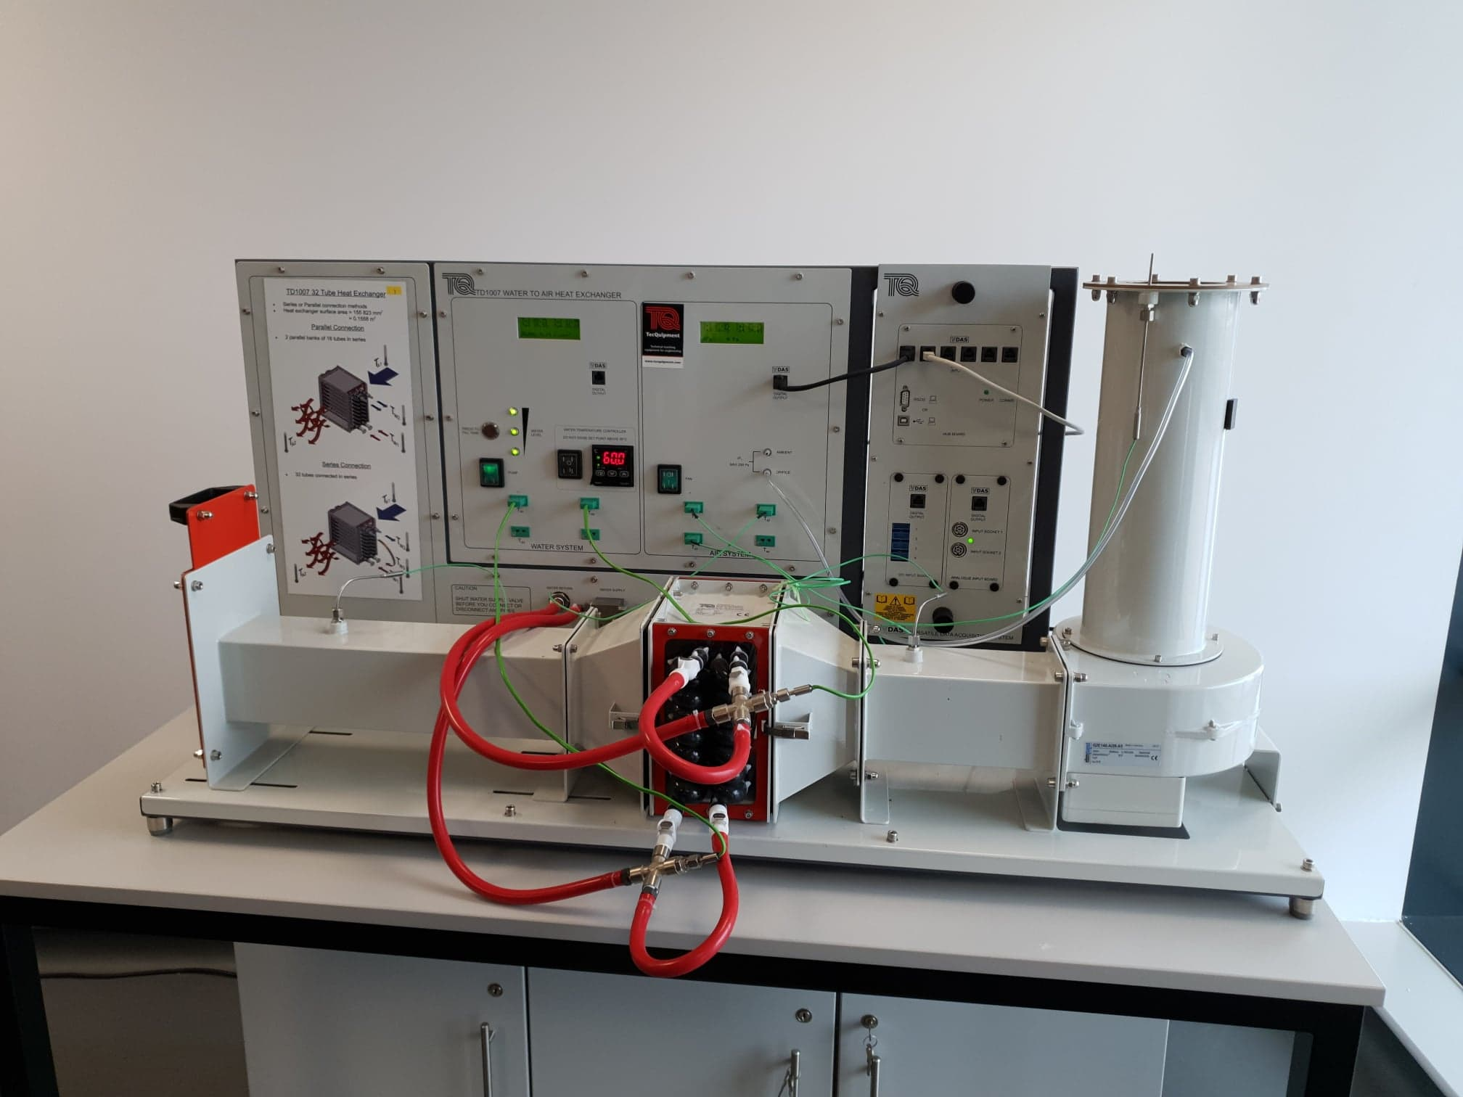 This heat exchanger uses two bundles of 16 tubes in loops to provide a pathway for the heated water, whilst the air passes over the tube bundles. For the purposes of this report; three experiments were carried out using a parallel flow configuration in order to determine the effects of varying these flow rates, as well as the effect of varying original temperature of the water as it enters the heat exchanger. A parallel flow configuration is when both the cold and warm fluids’ directions of flow are the same (The Editors of Encylopaedia Brtannica , 1998). This report will focus on explaining the methods involved in carrying out these experiments; analysing the results, drawing conclusions as to the effects of air and water flow rates on the heat exchanger’s performance, and highlighting potential theories of how this performance could be improved.

Experiment 1 – The Effect of Varying Water Flow Rate

Methodology
- Connect and set up the standard 32 tube heat exchanger. Connect as for parallel flow and set a heater tank temperature of 60°C. Water enters the bottom of the heat exchanger and exits from the top.
- Note the ambient air pressure. Inspect the orifice and check its diameter - this is stamped on the surface of the orifice.
- Switch on the fan and use the slide valve to set the airflow to give an orifice pressure drop of 250 Pa (+/- 5 Pa tolerance).
- Switch on the pump and use the hand operated water supply valve to set the water flow to 2.25 L/minute (+/- 0.01 L/minute).
- Allow at least five minutes for the heat exchanger temperatures to stabilize, then record all readings.
(University of Wales Trinity St David, 2020)

Calculations
For the purposes of detailing the calculations used in this experiment, the first water flow rate of 0.25 l/min, will be used as an example below.

Constants
Constants |  | Unit
Air Pressure | 1004 | Mb
Air in Diameter | 0.10011 | m
Discharge coefficient (Cd) | 0.6 | N/A
Water Pipes Area | 0.1558 | m
Air Intake Area | 0.00787127 | m²
Air Flow | 250 | Pa

Water Density (Wρ)
Firstly, the water density was calculated using the equation below:
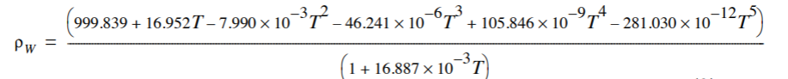
(TecQuipment LTD , 2014)
Where T = the average temperature (°c) of the hot water circuit.
In the case of the example of 0.25L/min water flow rate, the calculation can be seen below:
$=\frac{\left(999.839+16.952\left(49.4\right)-7.990*{10}^{-3}\left({49.4}^{2}\right)-46.24*{10}^{-6}\left({49.4}^{3}\right)+105.846*{10}^{-9}\left({49.4}^{4}\right)-281.03*{10}^{-12}\left({49.4}^{5}\right)\right)}{(1+16.887*{10}^{-3}(49.4))}$
= 988.29183 Kg/m³

Air Density (Aρ)
Second was to calculate the air density, the equation for which can be seen below.
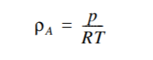 (TecQuipment LTD , 2014)
Where p = Air Pressure (Pa), R = Specific Gas Constant (287.05 J.Kg/K), T = Average Temperature of Cooler Air Circuit (°c)
The calculation for 0.25L/min can be seen below:
$$=\frac{1004*{10}^{2}}{287.05(26.8)}$$
= 1.666606 Kg/m³

Water Flow Conversion (ṁW)
Next was the water flow conversion into mass flow. The equation for which can be seen below:
(TecQuipment LTD , 2014)
The calculation for 0.25l/min can be seen below:
$=\left(\frac{0.25}{60000}\right)988.29183$
= 0.0041179 Kg/s

Air Flow (ṁA)
Next was to find the mass flow of the air circuit. The equation used for this can be seen below:
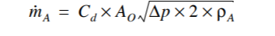 (TecQuipment LTD , 2014)
Where Cd = Discharge Coefficient (0.6), Ao = Area of the Air Intake, Δp = Change in pressure over orifice = Air Flow (Pa), Pa = Density of Air (Kg/m³)
The calculation for 0.25l/min can be seen below:
$=0.6×0.00787127\sqrt{250×2×1.1666606}$
=0.1140652 Kg/s

Specific Heat Capacity of Water at Constant Pressure (CpW)
Next, was to calculate the specific heat capacity of the water. The equation used for this is shown below:
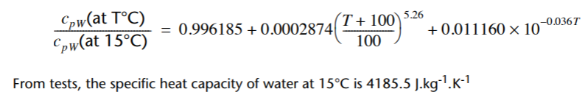 (TecQuipment LTD , 2014)
Where T = Average Temperature of the Hot Water Circuit (°c)
The calculation for 0.25l/min can be seen below:
$\frac{CpW\left(at 41°c\right)}{CpW \left(at 15°c\right)}=0.996185+0.0002874{\left(\frac{149.4}{100}\right)}^{5.26}+0.011160×{10}^{-0.036\left(49.4\right)}$ $CpW\left(at 41°c\right)=0.9987454×4185.5$
= 4180.2488 J.Kg/K

Specific Heat Capacity of Air (CpA)
For the purposes of this experiment, the specific heat capacity of air has been assumed to be 1005 J.Kg/K.

Water Heat (Power) Emitted (Qw)
Next was calculating the power emitted from the hot water. The equation used for this is show below:
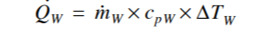 (TecQuipment LTD , 2014)
Where ṁw = Water Mass Flow (Kg/s), CpW = Specific Heat Capacity of Water (J.Kg/K), ΔTw= Change in Temperature of Water Circuit (°c)
The calculation for 0.25l/min can be seen below:
Qw = 0.0041179 $×$ 4180.2488 $×$ -21.2
= -364.93201 W

Hot Water Circuit Temperature Efficiency
Next was to calculate the temperature efficiency of the hot water circuit. To do this, the equation shown below was used:
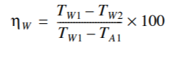 (TecQuipment LTD , 2014)
The calculation for 0.25L/min can be seen below:
$=\frac{21.2}{60-27.1}×100$
= 64.44%

Heat (Power) Absorbed by Air (Qa)
Next was calculating the heat (power) absorbed by the cooling air. The equation used to calculate this is shown below:
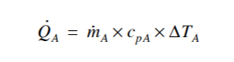 (TecQuipment LTD , 2014)
Where ṁa = Air Mass Flow (Kg/s), Cpa = Specific Heat Capacity of Air (J.Kg/K), ΔTa= Change in Temperature of Air Circuit (°c)
The calculation for 0.25L/min can be seen below:
$Qa= 0.1140652 ×1005 ×2.9$
= 332.44315 W

Cooler Air Circuit Temperature Efficiency
Next was to calculate the temperature efficient of the cooler air circuit. The equation used to do this is shown below.
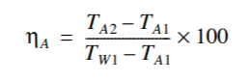 (TecQuipment LTD , 2014)
The calculation for 0.25L/min can be seen below:
$=\frac{2.9}{60-27.1}×100$
= 8.81%

Mean Temperature Efficiency
Next was to calculate the mean temperature efficiency of both circuits. This is done by simply taking an average of the two.
For 0.25L/min the calculation can be seen below:
$=\frac{8.81+64.44 }{2}$

= 36.63%

Logarithmic Mean Temperature Difference (LMTD)
Next was calculating the logarithmic mean temperature difference (LMTD). This was done using the equation shown below:
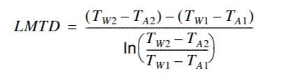 (TecQuipment LTD , 2014)
The calculation for 0.25L/min can be seen below:
$LMTD=\frac{\left(38.8-30\right)-\left(60-27.1\right)}{ln⁡(\frac{\left(38.8-30\right)}{\left(60-27.1\right)})}$
= 18.275284

Heat Transfer Coefficient (U)
The final step was to calculate the heat transfer coefficient (U). The equation used for this is shown below:
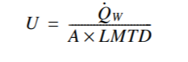 (TecQuipment LTD , 2014)
Where Qw = Water Power (W), A = Water Pipe Area (m²), LMTD = Logarithmic Mean Temperature Difference
The calculation for 0.25L/min can be seen below:
$U= \frac{-364.93201}{0.1558×18.275284}$
$U= -128.16822$W.m²/K

Repeating for Varying Water Flow Rates
Once these calculations had been done for the first flow rate, it was simply a case of copying and pasting the cells formulas in a block, into the appropriate cells, they were then calculated quickly for each flow rate.

Results Analysis & Conclusions

As can be seen above the heat energy results from the first experiment indicates that power transfer improves with increased water flow. However, the relationship is non-linear and in the case of water power, can be seen to begin to plateau. This is as would be expected and suggests that a maximum power transfer value would be found quickly if we were to continue the experiment with increased water flow rates. Although the heat absorbed by the air provides similar values to the heat emitted from the water, slight variations in external conditions tend to cause the two values to differ, however, we would expect that it would decrease similarly to the water power. This does not appear to happen here and as such may indicate an anomaly in the results.

As can be seen above the results from the experiment show that the water temperature efficiency decreases with increased water flow rates, whilst the air temperature efficiency increases with the water flow. However, the change in water efficiency is generally comparatively larger than the change in air efficiency. This is as would be expected due to the higher temperature changes seen in the water circuit in comparison with the air.

The expected results should show an initial increase as the water flow increases, followed by the values plateauing to a certain level, suggesting that increasing the water flow past a specific optimum value would have no benefit on performance. However, the results we collected showed an initial increase, followed by a decrease, that suggests a continuing decrease in performance past a specific point. This however, does not follow what we originally expected, and the experiment would need to be repeated with further increased water flow rates in order to confirm if this was an anomaly.

Experiment 2 – The Effect of Varying Air Flow Rate

Methodology
- Check connections are set for parallel flow and set a heater tank temperature of 60°C. Water enters the bottom of the heat exchanger and exits from the top.
- Note the ambient air pressure. Inspect the orifice and check its diameter - this is stamped on the surface of the orifice.
- Switch on the fan and use the slide valve to set the airflow to give an orifice pressure drop of 250 Pa (+/- 5 Pa).
- Switch on the pump and use the hand operated water supply valve to set the flow to 0.25 L/minute (+/- 0.01 L/minute).
- Allow at least five minutes for the heat exchanger temperatures to stabilize, then record all readings.
- Repeat the procedure for lower air flow rates of 200, 150, 100 and 50 Pa pressure drop
(University of Wales Trinity St David, 2018)

Calculations
To carry out the required calculations for the second experiment, it was simply a case of copying the block cell of formulas into the appropriate sheet, and making some small edits required. These involved ensuring that the Water flow rate had been changed to a fixed variable within the formulas, whilst the Air flow was dependent on the varying flow rate.

Results Analysis & Conclusions

As shown in the graph above the results from the second experiment show that heat energy transfer improves as airflow increases, with a relatively linear relationship. The trend does not plateau as it did in the first experiment, suggesting that increasing the air flow rate could have further benefit on the heat exchangers performance. This follows the expected trend and suggests that at slower air flow rates there are greater losses to the surroundings, as more heat is emitted from the water than is absorbed by the air. Once the air flow passes a specific vale, the external losses begin to decrease and the values become closer.

The temperature efficiencies calculated from the results of the second experiment indicate that water efficiency increases slightly with increased air flow, whilst air efficiency decreases. The mean temperature efficiency shows a gradual increase as air flow increases, however, appears as though it may plateau at the higher air flow rates. Further tests at higher air flow rates would need to be carried out to determine whether this would continue to gradually increase, or level out.

The results from the second experiment show that the heat transfer coefficient increases with increased airflow. This furthers the previous suggestion that an increased air flow rate would provide performance benefits to the heat exchanger.

Experiment 3 – Effect of Varying Temperature (Driving Force)

Methodology
- Check connections are for parallel flow and set a heater tank temperature of 45°C. Water enters the bottom of the heat exchanger and exits from the top.
- Repeat Experiment 2 - The Effect of Varying Air Flow Rate.
(University of Wales Trinity St David, 2020)

Calculations
As this experiment was the same procedure as experiment two, it was simply a case of returning to the second experiment and copying the formulas as a block into the appropriate cells.

Results Analysis & Conclusions

The results for heat energy absorbed by the air follow the expected trend, in that its shows an initial increase that begins to plateau. However, there was a clear anomaly within the results for the 200 Pa airflow rate. This anomaly was noticed in the first instance and as such the experiment was repeated for a further two times and an average of the results was used in order to improve reliability. However, the anomaly persisted, and is further evidenced in the graphs shown below.

If the anomaly was to be ignored, it is expected that fairly similar results would have been produced.

Bibliography
Act, H. a. S. a. W. e., 1974. s.l.:s.n.
Ronquillo, R., 2020. Understanding Heat Exxhangers. [Online]
Available at: https://www.thomasnet.com/articles/process-equipment/understanding-heat-exchangers/
[Accessed 20 04 2020].
TecQuipment LTD , 2014. TD1007 Water to Air Heat Exchangers User Guide. Nottingham: s.n.
The Editors of Encylopaedia Brtannica , 1998. Heat Exchanger Energy Conversion. [Online]
Available at: https://www.britannica.com/technology/heat-exchanger
[Accessed 20 04 2020].
University of Wales Trinity St David, 2020. Thermo Fluid Mechanics Level 5 Assessment Specification. Swansea : s.n.

Appendix 1 – Excel Sheet for Experiment One
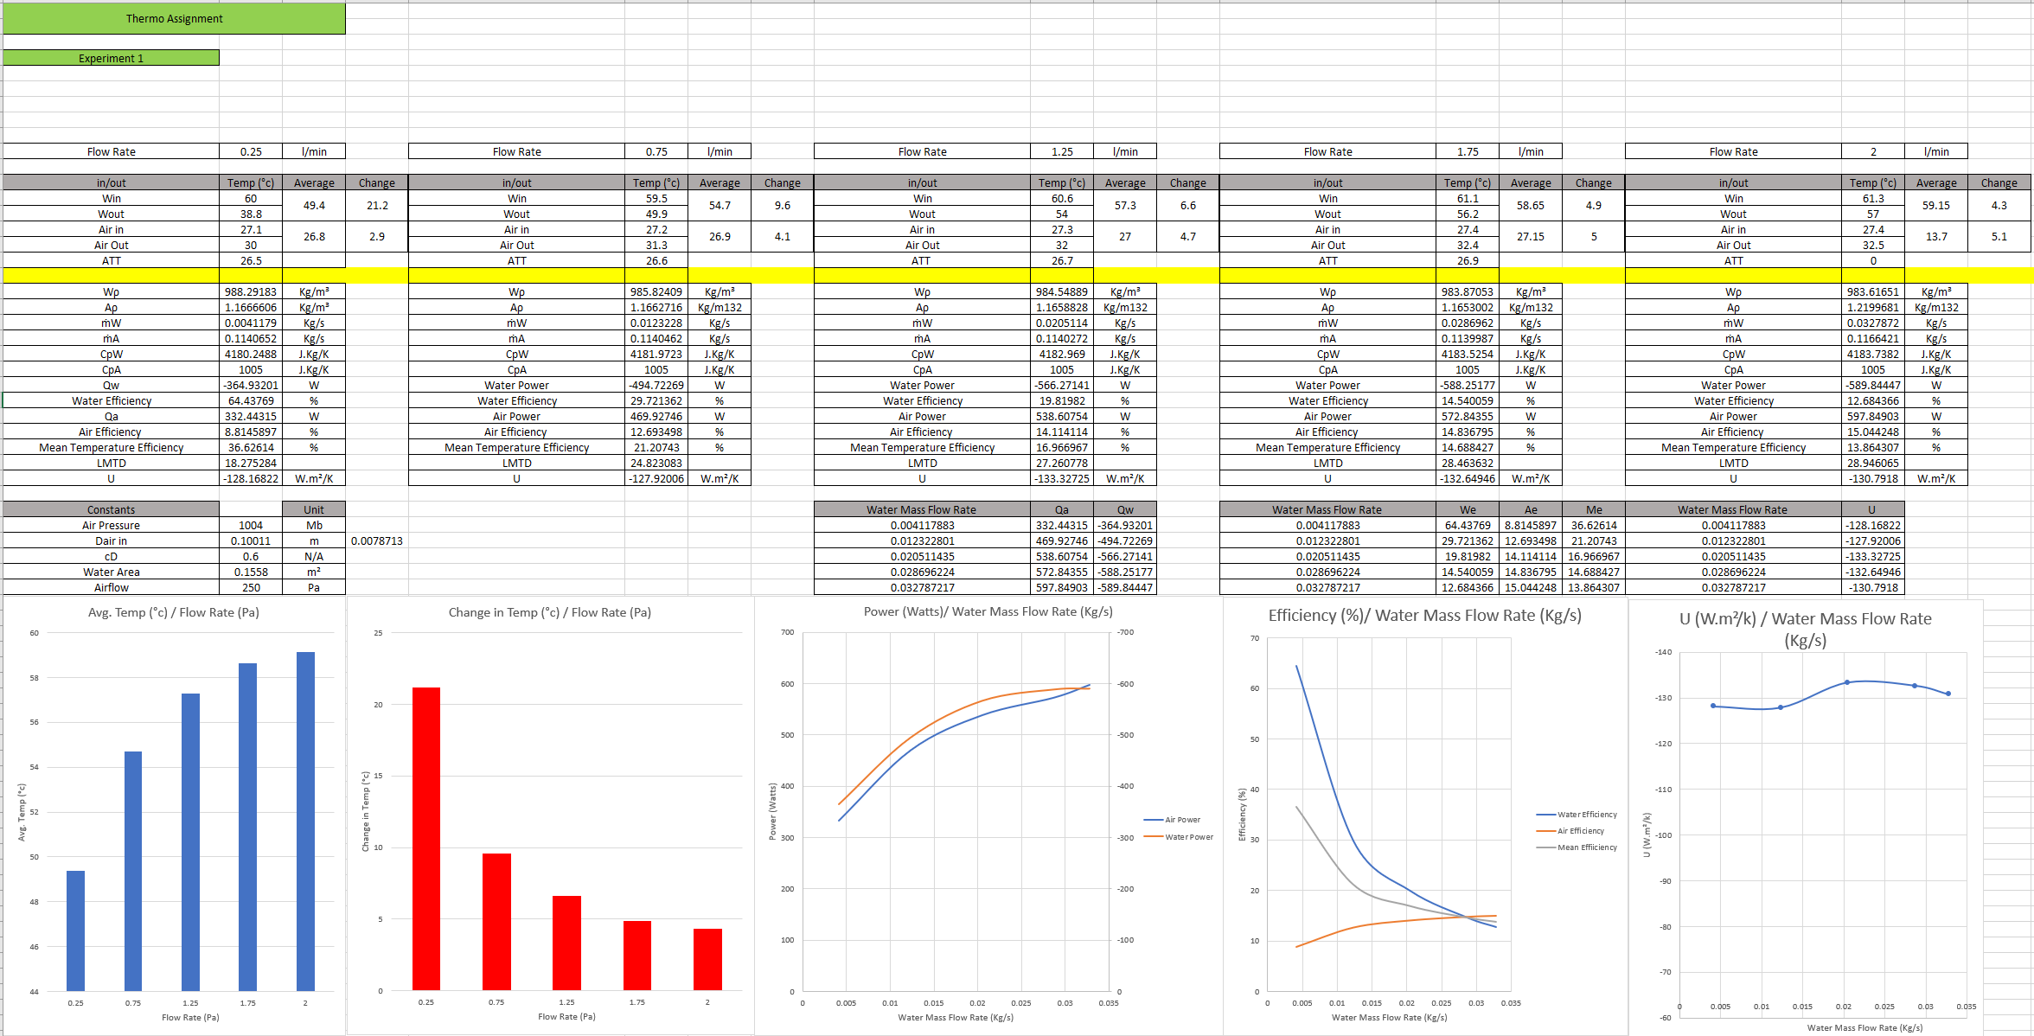

Appendix 2 – Excel Sheet for Experiment Two
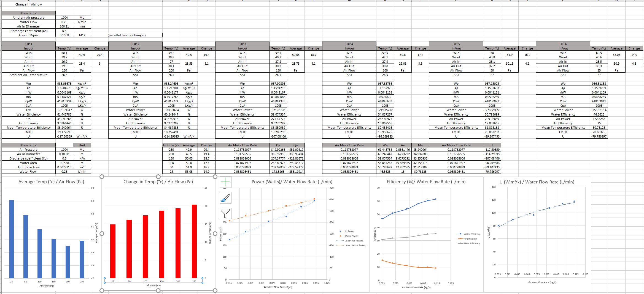

Appendix 3 – Excel Sheet for Experiment Three
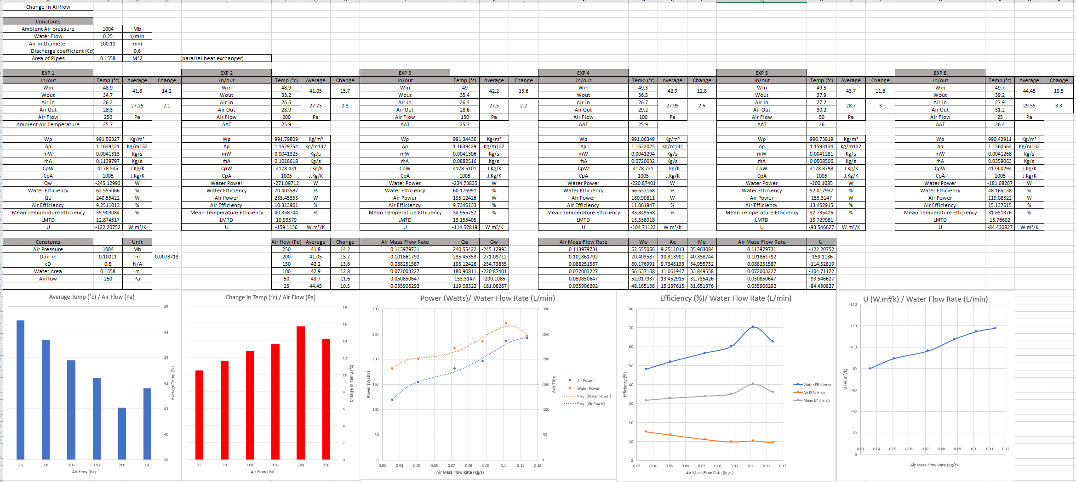

Appendix 3 Continued


