Student Name: Majida Waseem
Student Number: 2321115
Module Code: BMHP 5019
Module Title: Introduction to Independent research skills C1
Lecturer Name: Rizwan Nadim

Mind Map

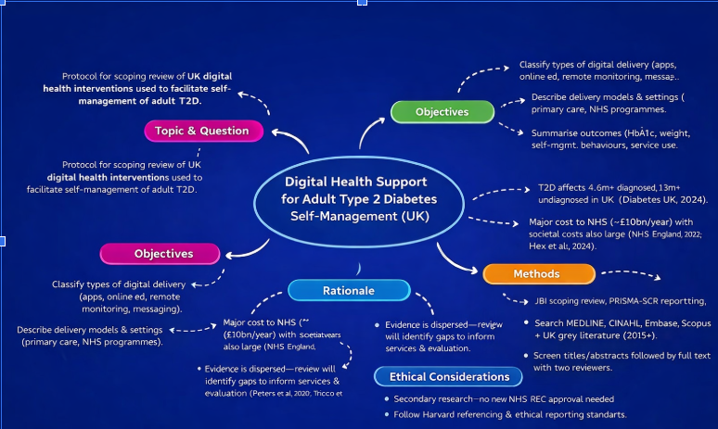

Digital health support for adult Type 2 diabetes self-management (UK):

Review proposal:

Topic
This is a protocol for a scoping review of UK evidence pertaining to digital health interventions (e.g. mobile applications, web app) that have been used to facilitate self-management of T2D(Diabetes) in health and/or social care in service provision for adults with T2D.

Review question
What digital health interventions have been implemented or assessed in UK health and social care for the self-management of T2D diabetes in adults and what outcomes, patterns of engagement and equity issues have been described?

Objectives
- Describe the modes of digital delivery among UK (app, web-based education, remote monitoring, coaching, messaging).
- Specify the mode of delivery/service model (eg, general practice, community services, NHS tiered provision).
- Summarize reported outcomes including HbA1c, weight, self-management behaviors and service use.
- Identify barriers/facilitators (eg, usability, acceptability) and evidence gaps including equity considerations.

Rationale
Diabetes is a major burden on health and care services in the UK, and complications add even more strain to the NHS and social care. Diabetes UK state there are 5.8 million people living with diabetes in the UK; 4.6 million have been diagnosed and over 1.3 million may be living with undiagnosed T2D (Diabetes UK, 2024).Although digital interventions are increasingly being implemented in UK services, the evidence varies by intervention type and study design. A scoping review is appropriate to scope out the literature and identify gaps to inform future service development and evaluation (Peters et al., 2020; Tricco et al., 2018).

Methods (data collection and analysis)
This review will follow JBI scoping review methodology (Peters et al., 2020) and will be reported using PRISMA-ScR (Tricco et al., 2018). Searches will include MEDLINE, CINAHL, Embase, Scopus and Web of Science. UK grey literature will also be searched (NHS England, NICE, ONS, Diabetes UK and relevant NHS programme reports). The review will include UK evidence from 2015–present to reflect contemporary digital health practice.

Ethical considerations
As this is secondary research using published sources, NHS REC approval is not expected.
- Ethical practice will include:
- Open record of methods and constraints.
- Proper use of quotation and the avoidance of distortion.
- Reflection about what is fair and potential harms, in particular through digital exclusion among those who are poor, disabled or do not speak the language.

References
- Diabetes UK (2024) How many people in the UK have diabetes? Available at: https://www.diabetes.org.uk/about-us/about-the-charity/our-strategy/statistics (Accessed: 25 January 2026).
- Hex, N. et al. (2024) ‘Estimation of the direct health and indirect societal costs of diabetes in the UK using a cost of illness model’, Diabetic Medicine, 41(9), e15326. doi: 10.1111/dme.15326.
- NHS England (2022) NHS Prevention Programme cuts chances of Type 2 diabetes for thousands (28 March). Available at: https://www.england.nhs.uk/2022/03/nhs-prevention-programme-cuts-chances-of-type-2-diabetes-for-thousands/
- Peters, M.D.J. et al. (2020) ‘Updated methodological guidance for the conduct of scoping reviews’, JBI Evidence Synthesis, 18(10), pp. 2119–2126. doi: 10.11124/JBIES-20-00167.
- Tricco, A.C. et al. (2018) ‘PRISMA Extension for Scoping Reviews (PRISMA-ScR): Checklist and Explanation’, Annals of Internal Medicine, 169(7), pp. 467–473. doi: 10.7326/M18-0850.

