BACHELOR’S DISSERTATION


Above: Gustav Metzger in 1961. Photo by Getty Images.
Gustav Metzger: The Man Who Ensouled the World
What impact did his life experiences have on the practice of Gustav Metzger?
Author: Jeremy Gluck P151365
Submission Date: December 11, 2018

Educational Program: (M6X01791): Historical and Contextual Studies
Educational Institution: University of Wales Trinity St. David
Supervisor: Tim Davies
Second Reader: Ryan Moule

TABLE OF CONTENTS
Summary of topic 3

INTROduction 3

Chapter 1 HOTTING UP 6

chapter 2 FULLY ALIVE 14

chapter 3 19

conclusion 30

bibliography 32

list of illustrations 46

Word Count: 6284 words

Summary of topic

This dissertation critically examines the life and work of the refugee expatriate German Jewish artist Gustav Metzger (10 April 1926 – 1 March 2017), with an emphasis on how his formative experiences informed his unique body of conceptual, installation and performance art. The aim is to offer a critical reflection and analysis of the artist, corroborating the calibre and legacy of his work, and presenting new ways of understanding it. It will be argued that this unusual, important work, little covered by academia, is often underestimated in its significance and influence. The objective of this dissertation is to encourage the community of conceptual and other artists, and especially young British artists, to explore and be inspired by his life and work.
Introduction
This dissertation is an examination of and reflection upon the life and work of the refugee German Jewish artist Gustav Metzger (10 April 1926 – 1 March 2017). Throughout his life and since his death in 2017 academic research into Metzger’s life and practice has been scant (Grimes, 2017); the Finnish academic, Pontyus Kyander, a notable exception. Stated Kyander - curator of, collaborator with and essayist on the artist - “Metzger’s practice is founded in a dark vision of Man and History,” (Kyander, 2006). Metzger’s “dark vision” (Kyander, 2006) reflects his uncommon transit. In investigating his entanglement with his times, it is found that Metzger’s apparently marginal presence in modern art belies an influence and importance warranting continual review (Shanken, 2005).
After lengthy duration in its exhibition, this year Tate Modern consigned one of Metzger’s signature works, Liquid Crystal Environment (O’Brien, 2009), to its archives. Tate Britain, with a body of his paintings in its collection, now exhibits none; it’s All Too Human show (February 28 to August 27, 1028), whilst giving Metzger contemporaries David Bomberg, Leon Kossoff and Frank Auerbach prominence, excluded him, despite his relevance to that group of painters.
Given Gustav Metzger’s story, this could be inevitable. A determined loner (O’Rorke, 1998), distancing himself as a matter of principle, he made a stand on the history that shaped him, fashioning from it art intended to destroy itself or by its maker be destroyed (Jones, 2009). For the practice of this founder of Auto-destruction is synonymous with possibly the greatest ‘performance’ of automated destruction of modern history - the Final Solution – and its infamous ‘installations’, the death camps. After the war, Metzger’s story broke like a tide from the cataclysm that unleashed it, becoming one of his own performances and installations. Metzger literally reaped the whirlwind, or rather harvested and reshaped it, creating a testament to a post-Holocaust, post-industrial, proto-technological world often as intangibly evanescent as the wind itself. Ephemerality, disposability – even of the human being – and types of futility are telegraphed by this work, yet despite its unalloyed starkness, its humanity and humility are equally present.
Perhaps because Metzger made himself and his art hard to hold close, interest in his contribution to post-modern art fluctuates; the partial aim of this dissertation is to celebrate it. The overall lack of academic research means that most coverage tends to be favourable or neutral in its critical analysis. Coverage from online newspapers and journals constitute much of the detailed sources, as well as online videos where the artist expresses himself spontaneously. What little dissenting opinion there is administers a harsh but welcome bromide to otherwise benign, sometimes slavish praise. A substantial picture of the artist must be assembled piecemeal, leaving many gaps; the wide but often shallow coverage of a long, productive life necessitates in this dissertation an idiosyncratic cross-section of Metzger’s life and work, including features less remarked upon. In the wake of his death, for a complex artist who originated abstruse work dedicated to its own temperality, this may be appropriate.
Metzger’s life spanned nearly a century, and he made use of all of it. Ever a consummate outsider (Jones, 2009), his visionary art reveals a will of deceptively tractile iron, bespeaking deliverance from the fate shared by many of his family at the hands of the Nazis (Brown, 2017). Art that militated against artifice and disingenuousness, in a sense becoming a cynosure of the human being to come as it would elect to imagine itself: benevolent and principled, with unclouded self-concept. Metzger’s importance may never be wholly validated (Renton, 2004) but his measure can be better understood. His story for me resoundingly plangent, this dissertation comes from my heart as well as mind.
My generation of Post-Holocaust Jews materialised from its shadow and so, born a year before Metzger’s breakaway 1959 work, Cardboards, discussed in this dissertation, I find in Metzger a deeply affecting Muse and putative mentor. Discovering and deconstructing him, I rediscover and reconstruct myself, aware anew of how my own post-Holocaust experience shapes my practice, nature and life, bringing a recognition that my work, before and through my discovery of Metzger’s practice, is so resonant with it. Ameliorating diverse glimpses of his character suggests fascinating themes. Gripped by his catalytic creativity, I have come to love Metzger’s work. I owe him a great debt, which will no doubt increase. This piece of writing attempts instating repayment.
Hotting Up, my first chapter, will examine Metzger’s formative years, the pivotal impact of the Holocaust upon him, his refugee journey to Great Britain, and his eventual entrance to the London artist community, leading to his decisive break with his mentor David Bomberg. Chapter Two, Fully Alive, deals with the genesis and legacy of Auto-destructive art for Metzger and his transition to Auto-creative art. In Chapter Three, Hate into Love, his manifestos trigger a scrutiny of his later years and his influence on contemporary art.
Chapter 1 Hotting Up

New York Times reviewer Ken Johnson at the end of his report of Gustav Metzger’s debut solo show in the United States, the 2011 Historic Photographs installation at New York’s New Museum of Contemporary Art, mused:

Frankly, I am mystified. How does it happen that the international art world intelligentsia has rallied around such punishingly obvious, politically banal, morally bullying and aesthetically enervating work? Is the New Museum’s audience really as dim as this show implicitly assumes? Finally, I wonder, what purpose and whose interests are served by an exhibition that treats its viewers with such contempt? Is it a European thing to think that any art about the Holocaust must be important? (Johnson, 2011)

At eighty-five Gustav Metzger had lost neither his maverick status nor power to exercise critics (Ivry, B. 2011); given his journey, Johnson’s question might seem insensitive but is apposite. Only in 1981 did Metzger begin to deal explicitly in his work with the Holocaust, with an exhibition of anti-Semitic laws at Bern’s Kunstmuseum (Watling, 2012). The Holocaust was central to the exhibition, and fully to his life and practice (Jones, 1998): from it came much that emerged from him as art. “I was twelve years old, when things were hotting up related to Jews...all of that is a constant inner world I live in” (Metzger, 2015 cited in Wilson, 2015). By his own admission, the Holocaust and its destruction of his family made the imprimatur upon him responsible for art that later would, with its apparent embrace of ruin, evoke “the politics of horror” (Yahav, 2014; Jones, 2009). Growing up in Nuremberg before the war, witnessing stormtroopers marching to crush his existence, escape from which would catalyse his destiny, and later when most of his family were killed by the Nazis, was internalised as a toxic, transformative cache which art one day safely unpacked (Brown, 2017). Seeing malign power glorified, he had to expunge its signature somehow. And, raised an Orthodox Jew, he reacted from a rejection of power rooted in ancient Judaism, which disdains power and instead glorifies renunciation of the material and surrender to the Divine (Metzger, 2009 cited in Jones, 2009).
Metzger’s work could be transliteration, glimpses through glyphs of his omnipresent inner suffering, part of his quest post-war for a family and future, for himself and all humanity (Metzger, 2004 cited in Brown, 2014). Taken in safety with his brother Mendel to wartime Britain on a Kindertransport, the British government initiative put into effect in 1938 giving Jewish children safe passage to Britain (Oppeheimer, 2017), meanwhile much of his close family perished, although his two sisters escaped to England on the eve of the war, too. Metzger’s father, Juda, having brought his wife Fanny and five children to Nuremberg from Przemsyl in Poland in 1918, had made a living as a salesman. In October 1938, deported due to his Polish origin, he entered a transit camp, followed soon by his wife; both were probably killed in a concentration camp in 1942 (Cork, 2004). A year later, Chaim, Metzger’s eldest brother, was deported from France, where he resided, and exterminated (Jochem, 2017; Watling, 2012).

Rooted in religion (Jones, 2009; Kapic &Vander Lugt, 2013) yet expressly secular, Metzger became an artist whose fractious practice survived his century and himself, defying his determination to shun the commodified art world’s “boxes of deceit” (Metzger, 1962 cited in O’Rorke, 1998; Fisher, 2017), his innovation Auto-destruction ironically constructing his reputation and influence. Commonly, Metzger’s impedance of commercialisation and sale of his work (The Economist, 2017), and of profit-making art venues, is viewed as antipathy for the art world; a rare contrary perspective, though, sees this as love, protectiveness and reparation of it, an outcome of his witnessing the Nazi’s weaponisation of art through uniform, theatricality and political exploitation. Metzger, so schooled in how power can be channelled through art, would turn his lessons to unpredictable ends (Powell, 2007).

With insight, Kristine Stiles states:
Precisely twenty years after Metzger was sent to England in 1939 at the age of 12, when his family was arrested by the Gestapo in Nuremburg, he formulated his theory. Twenty seconds, then, is a temporal analogy for the seconds it took to destroy his personal world by killing his family; twenty years, the two decades of gestation in his own auto-transformation (Stiles, 2015).

Post-war, the form of family suggesting itself to Metzger was the diaspora of his fellow artist Jews. Surveying this period, we find the chief features of this “auto-transformation” (Stiles, 2015) that led, in 1959, to Metzger’s breaks with this adopted family, and their group energy.
In 1948, having travelled the Netherlands, Belgium, and France, in Antwerp briefly enrolling at the Royal Academy of Fine Arts, returning to Britain in 1949, Metzger’s crucial involvement with David Bomberg, a native British Jewish artist expelled from The Slade for breaches of their conventional approach of the time, began. While after the war the latter enjoyed an eight-year teaching tenure at Borough Polytechnic, (Wilson, 2014) Bomberg with some of his students furthered the Borough Group founded by one of his former students, Clifford Holden, in 1946 (Westbury, 2005). While Bomberg’s student, Metzger encountered two other Jewish artists, and as though mirroring his relationship to Bomberg, one, Auerbach, was a Kindertransport refugee, while the other, Kossoff, a native British Jew. This trio became Metzger’s metaphorical artist father (Cork, 2004) and brothers, his underpinning for the next seven years, adopting Bomberg’s style, exhibiting together (Wilson, 2014). Under Bomberg’s tutelage Metzger, enamoured of the former as man and maker, enjoyed a period of relative harmony. During this time, the group reformed with new members – Metzger included - from1953–56 as the Borough Bottega.
Enthralling him with his avant-garde status, contrarian battles with Wyndham Lewis and elusive edginess (Metzger, 2007, cited in Obrist, 2007), David Bomberg was Metzger’s biggest influence, (Suchin, 2003). Fatefully, in 1953, following their collective exhibition at the Berkeley Galleries, Bomberg severed relations with Metzger after the latter’s resignation from the Bottega group, (Wilson, 2014). Metzger bequeathed his former studio in Camden, London to Kossoff (Webb, 2011); it subsequently was passed to Auerbach. Smarting from his expulsion, Metzger departed London for Kings Lynn, earning a living as a junk dealer (Wilson, 2014). Had he remained with Bomberg, logically he could have taken his place, with Auerbach and Kossoff - and RB Kitaj - as an expressive, “School of London” painter (Kyander, 2015).
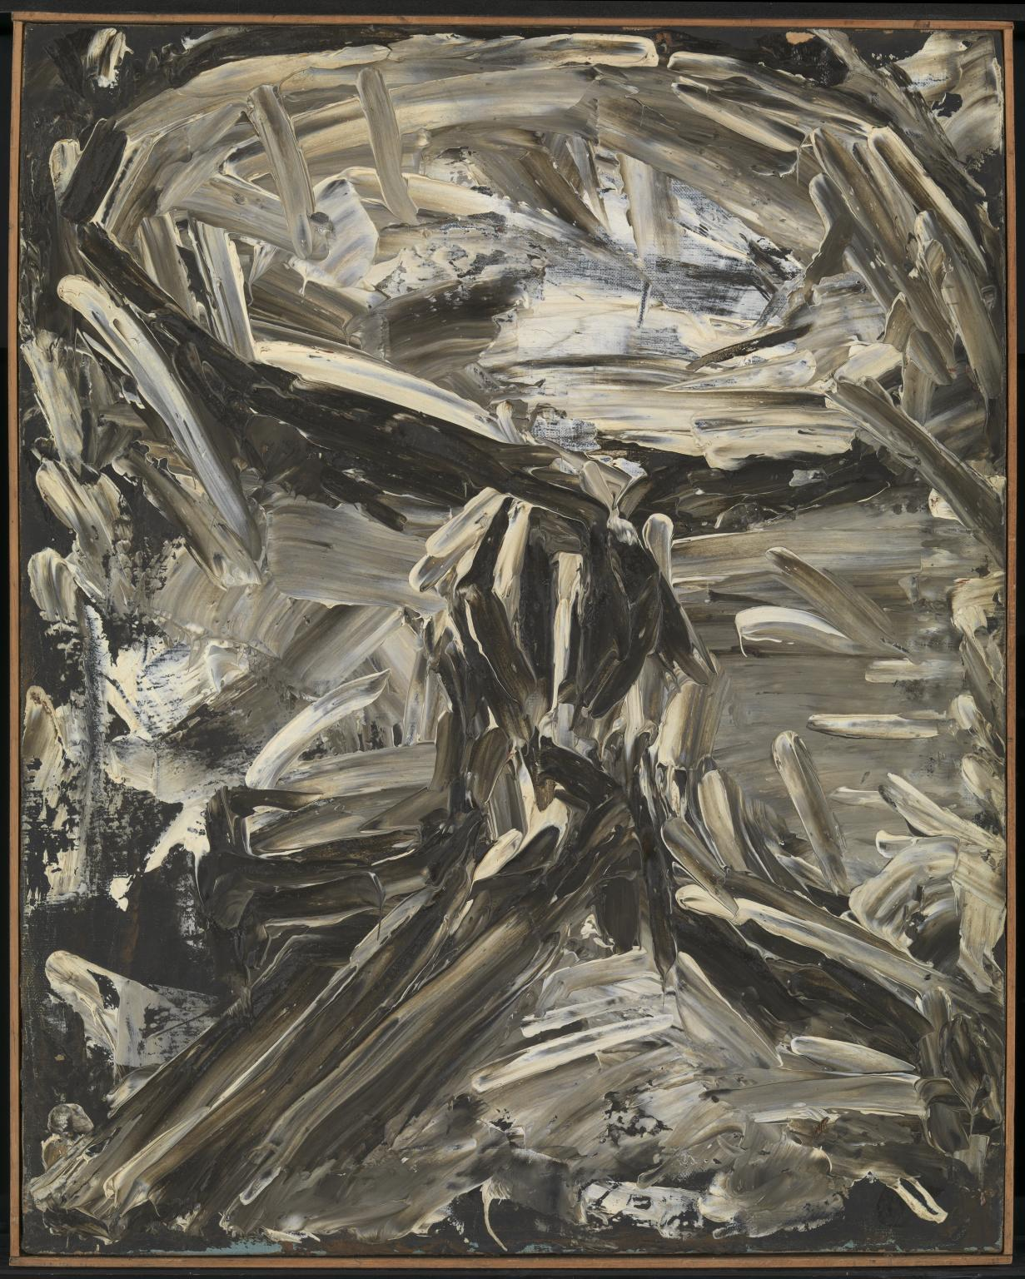
Figure 1. Table, 1959
Returning to his practice in 1956, Metzger resumed painting, climaxing in 1959 with the Table series that though more radical than his previous work (Wilson, 2014) could not anticipate his imminent shift to conceptual and performance art. Tracking Metzger’s progression beyond painting, while Bomberg was instrumental in Metzger’s artistic development, there were diverse influences upon him, not least Kurt Schwitters, whom it has been suggested inspired Cardboards: from a young age turned by Dada, Surrealism, Constructivism and Futurism, Schwitters’s collages that influenced him most (Metzger, 2013 cited in Obrist, 2013). Metzger meanwhile trawled the art bookshops of Charing Cross Road for inspiration (Metzger, 2007 cited in Obrist, 2007). Perceptibly, he was moving to supplant painting with work more personal and unprecedented.
There were portents. Gabo and Moholy-Nagy’s efforts to challenge sculpture with motion and light, and the disruption of canonical, figurative painting by Abstract Expressionism baited Metzger to extend kinetic art forms through literal destruction (Suchin, 2003; Metzger,1965 cited in Glew, 1995). In 1958, in the catalogue for the Kurt Schwitter’s retrospective at the Lord’s Gallery in London that Metzger visited London to explore, Alan Bowness observed that Metzger’s art
[…] one could interpret [...] as a protest against the false and shiny standards of
modern society, or as an almost mystical affirmation of the value of everything,
even that which is rejected and despised, or perhaps as a psychological
necessity on the artist’s part to identify himself with what has been cast out
(Bowness, 1958 cited in Wilson, 2008: 184)

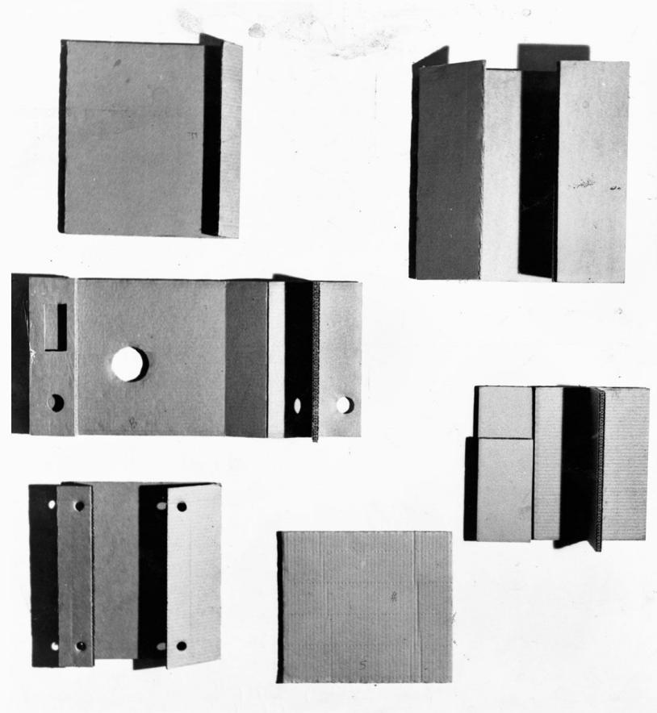
When it came, Metzger’s response to the challenge of a soulless world was masterfully, oddly mute. Facing a world remade by events challenging the notion we have souls at all, in the wake of an exhibition of his paintings on steel at the same venue, in November 1959 he showed six found cardboard packing boxes at Brian Robin’s Coffee House in Monmouth Street (Keshvani, 2017). Cardboards, covered in the Daily Express by John Rydon, pages from which years later Metzger used in his installation for the Tate’s 2008 Festival of Missed Fits (Tate, 2008; Monoskop, 2017), Cardboards established themes informing his work thereafter: aspiration for ensoulment of the mass, evoked by the most ingenious, improbable means as the disposable and deliberately, ultimately, destroyed. The impact on Metzger of his severance from Bomberg, a “painful, wrenching experience” (Metzger, 2008), excluded him from an intimate circle the asylum of which had called a truce in the civil war in his soul. With a shadow of rootlessness cast upon him again, he may have felt his hard-won sense of inclusion and acceptance deconstructed. Auto-destructed, even.
Figure 2: Cardboards, 1959

Befitting a maverick, Metzger’s work never lost its ability to challenge opinion. A difficult man making difficult art, it is well to account his refugee experience and the Holocaust as its cause, without which his life and practice might seem rather than flesh on a skeleton fed by early trauma and fortified by a vaulting, virtuous aspiration just strewn bones. His parents and elder brother claimed by the Final Solution, Metzger spent the rest of his life seeking forms of family, and fraternity, negotiating an embedded anguish which became a forge upon which he struck a body of work unlike any other of his century. His ill-fated closeness with Bomberg and his acolytes proved instrumental in his great break with canonical art that suited a man always antagonistic to the art economy and gallery environment. For this intentionally stateless, “escaped Jew” (Metzger, 2015 cited in Schudel, 2017), a deceptive destructiveness educed a world of conceptual expansion, signally Auto-destructive art, for which he is best known, but which cannot define all his work, nor indeed character.
Chapter 2 Fully Alive
Auto-destructive art. With it Metzger found his voice, the inheritance of the Holocaust taking strange, consumptive form evoking spectral lives seemingly lost if not to memory, then to matter. The experiences stamped in him from childhood flowing through him were metamorphosed into alarming performance, using challenging techniques involving disruptions of commonplace awareness, meanwhile circumventing apathy or defeatism. The South Bank Demonstration of 1961, when Metzger first demonstrated his new practice, took extraordinary form as, donning a gas mask, he sprayed hydrochloric acid onto nylon sheets to make his marks. The acid consumed the sheets, leaving them deconstructed as rips and tears, eventually almost destroying them (Powell, J 2007: 16-18). This performance would be reprised in 1966, at the Destruction in Art Symposium (or DIAS) held in London from 9-11 September 1966, when Metzger, its “Honorary Secretary”, was joined by an international cast of prominent counterculture and underground figures, amongst them contemporaries important to British art and Auto-destruction, John Latham – who burned columns of copies of the Encyclopaedia Britannica and Metropolitan Seminars on Art - and Welsh radical artist Ivor Davies. (White, 2013: 32-44)
It was Metzger’s voracious appetite to educate himself in art, Andrew Wilson claims (2010: 187), compounded by his relationship with Bomberg and its cold closure, that brought him to Auto-destruction and by the early Sixties to “Auto-creation”, refashioning his stygian crucible to produce light. Metzger did not with his art as much dissent as withdraw consent from the world we live in, his aspiration to trigger a fundamental shift (Grimes, 2017). Metzger never feared – seemed to delight in – getting his hands dirty given he felt he had right on his side. “I have been about change” (Metzger, 2009 cited in Rosenthal, 2009) he attested, and hunger for change informed his work, transmogrifying Auto-destructive to Auto-creative art a foremost example. Although Auto-creative art was expressly positive, it was far from frivolous. “For Gustav Metzger, there is no irony or distance. I would say he brings some existential approaches to the postmodernist model. His is a real engagement. He is in fact the most serious artist I know, in every sense of the word” (Kyander, 2015). Metzger’s concerns were existential: survival equated with a celebration of existence by implication, then dismissing it with the same apparent cursoriness accorded his parents and brother.

Metzger’s Auto-creative future, incepted with his first interest in art, when as a child he fixated on the sound of fountains in the centre of Nuremberg, which he said was the harbinger of his engagement with kinetic art, sound and colour, bore eventually as Liquid Crystal Environments (Davis, 2014). Involving positioning liquid crystals between Polaroid films, heating and projecting them to create kinetic displays, these environments actualised his desire to mutate Auto-destruction to Auto-creation, his experiments extending to a three-week residency in the then new Filtration Laboratory in 1968 at the Chemical Engineering Department of University College, Swansea (Amdam, 2015). Launched in 1965 as a performance, Liquid Crystal Environments reanimated in 1999 as a restaging’s of the original work at galleries worldwide, a future whose time had come and finally caught up with Gustav Metzger (Leslie, 224).
Metzger’s initial committal to Auto-creative art was signposted as early as 1962: “In this art form, as in Auto-Destructive Art, time, space, motion, metamorphosis and sound have a different far more important role in the conception, construction and appreciation of the work […]” (Metzger, 1962 cited in Copeland, M., Percebois, H., 2013) In this way, in his practice destruction and creation were corollaries of each other (Copeland, M., Percebois, H., 2013).
Metzger had reinvented himself the citizen of a new world part imaginary, part incendiary, where old models exploded and their debris – with his art literally – rebirthed into a simulacrum of a world devoid of the selfishness and sordidness of the mass. A redeemed world, its retrospection chaste, as mirrored in Viktor Frankl’s famous caution at the end of his masterpiece of Holocaust survivor literature, “Man’s Search for Meaning”: “So, let us be alert – alert in a twofold sense: Since Auschwitz we know what man is capable of. And since Hiroshima we know what is at stake” (Frankl:154). With so much at stake, Metzger invested his determinative experiences into transforming suffering into joy, resulting in revolutionary work, expressing ultimately the joy of existence, the love to be:
Whatever may happen in the future, we are alive now; we are fully alive. And the first need of life is to find out where one is. Finding out where we are is the most important task, and we need courage for that. And energy. And love. WH Auden’s line, “We must love one another or die”, is, I think, really the key (Metzger, 2014 cited in Wilson, 2014).

With his apparent love of destruction perhaps love’s most unlikely exponent, nevertheless through his practice Metzger voiced the unspoken ultimate human right: the right to love.
Auto-destructive art confounded, startled and disconcerted. Yet it was a natural outcome of a process in Metzger, a visceral, retrospective response to his experiences, telling his story by destroying it. Far from passive or victimised, Auto-destructive art challenged humanity in rapid flux to face its past, present and imputed future and own its own capacities for destruction at all levels. Impermanence its leitmotif, it could only have come from one so nearly prematurely extinguished. Out of it emerged Auto-creation, its luminous, numinous shadow of light, epitomised in his Liquid Crystal Environments. Metzger kept faith with and in step with his times in a restless search for means to give meaning to love in man for himself and others. Fully alive, Metzger became a man with an erased past consciously creating a possible future.
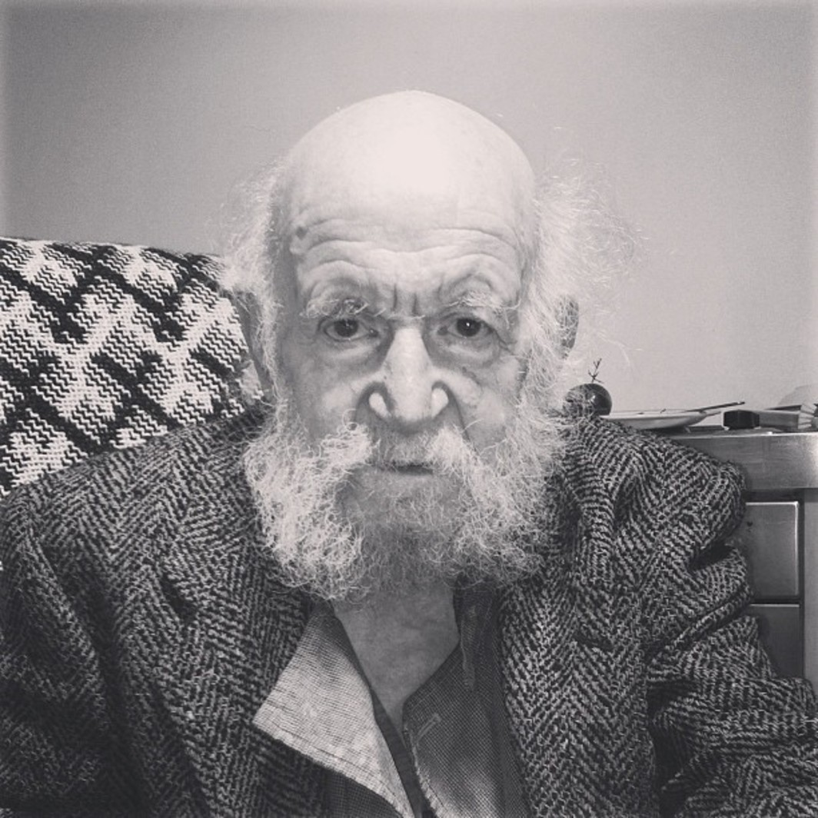 Figure 3: Gustav Metzger by Hans Ulrich Obrist, 2013

Chapter 3 Hate into Love
Over 1959 to 1961, Metzger published three manifestos (Metzger 1959, 1960, 1961 cited in Danchev, 2007). In the first, as with the second simply entitled Auto-destructive art (the third is entitled Auto-destructive art Machine Art Auto-Creative Art), he specified the lifespan of Auto-destructive works as moments to twenty years, after which it would be removed and junked (Metzger, 1959) and, in the second that certain forms of Auto-destructive art necessitated rigid control over the triggering and timing of the disintegrative process, with others necessitating cursory control. (Metzger, 1961).
Aptly, then, in August 2004, during the Tate’s Recreation of First Public Demonstration of Auto-destructive art, while Metzger’s pioneering work was recreated for a new generation, a bag of rubbish central to the installation was mistakenly discarded by a cleaner. The damaged bag, retrieved by the Tate, was nevertheless replaced by Metzger with a new one (BBC News, 2004). Almost fifty years after Cardboards, this fate befalling Metzger’s work strikes one as contextually perfect: having arrived at last at exhibiting in major galleries, his work was relegated to rubbish to be accidentally auto-destructed. It is warming to imagine Metzger savouring the humour in this; his earnestness makes this unlikely. “With his cloth cap and fiery eyes and beard he sometimes resembled an angry Van Gogh, but his anger was actually turned inward, towards his own painful memories and his fear for the future” (Tessler, 2017). There is in this story a paradoxical poetic justice at play.
Metzger was dominated by an ambulatory quality based in his struggle to reconcile himself to his childhood trauma. “You suppress your emotions to deal with tragedy but there was no closure for me. It must still be an ongoing problem: I'm very on edge, I start things and they don't get completed. I’ve moved from one country to another, and one kind of art to another” (Metzger, 2004 cited in Cork, 2004). Events beyond his control thrusting him from place to placelessness; then, further global events beyond his control urging him to activism and his political, socially aware art for the upliftment of all.
Figure 4: Flailing Trees, Manchester, 2009

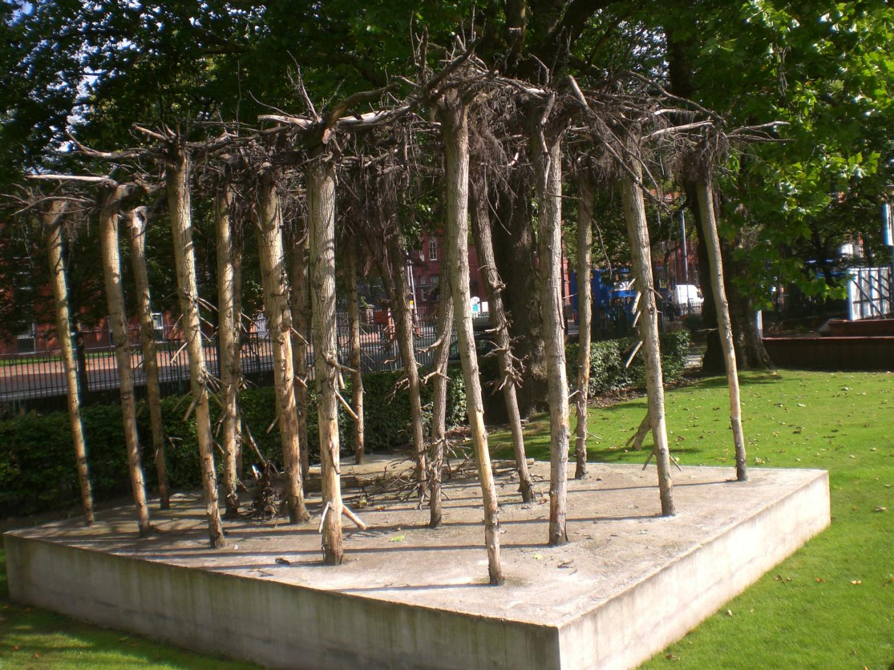
Late in life, Metzger increasingly exhibited a tenacious dedication to raising awareness of the predicament of ecological crisis. As ever, Metzger confronted the specific threat of nature’s extinction in a most novel way. Commissioned in 2009 by the Manchester International Festival, Flailing Trees comprised twenty-one willow trees uprooted and replanted in concrete. To some, Flailing Trees summoned images of a Gothic chapel, tree trunks its columns, exposed roots tokens of architectural tracery (Rosenthal, 2009), faithful to both Auto-destructive and Auto-creative art:
It is not just a question of showing destruction, how we misuse nature. Beyond
that there is a potential to find beauty in this chaos, in this overturning of
normality. In the period that the work was up, the roots were covered with a
kind of brown skin, and it began to fall off and reveal a white structure
underneath. As the years go by, it will change (Metzger, 2009 cited in Marris,
2009).

Tracing a crooked line from spraying acid on nylon to upending trees in concrete, transcendence through his work Metzger found literally rifling and rummaging “the hardcore stuff of existence” (Keshvani, 2017). A realist rebel, despite relative obscurity (Metzger, 2014 cited in McNay, 2014) Metzger seminally influences numerous artists, some of whom have established affluent careers. For example, his “anti-architecture” tract, enshrined in his 1964 lecture to the Architecture Association, that became a bellwether for the decade, influenced a new generation of designers to reinvent plush homes for the wealthy, Zara Hadid, David Chipperfield and Richard Rogers amongst them. And contemporary British art, not least Damian Hirst and Jeremy Deller – the latter whom compared KLF’s notorious incineration of a million pounds with Metzger’s acid deconstructions (Deller, 2017 cited in Hodgkinson, 2017) - variously evidence his ideas. (Halifax, 2017).
Regarding his pioneering projects merging art and technology, outside of devotees and informed experts Metzger’s influence is hardly known. It might be his sense of rootlessness that rendered Metzger’s relationship with the future uneven. One of the earliest explorers interacting art with technology (Fisher, 2017), he shunned mass, machine communication, deigning to own a telephone, television, mobile phone or computer. “He [forced] leading figures in the international art world to meet with him face-to-face, to make eye contact, to converse” (Yahav, 2014).
In my practice, with relevance to the above, and contrary to my self-concept as an artist, and character in general, I’ve made connections in my practice with Metzger’s that delight me. Metzger’s focal realisation that “…one could fuse the political idea of social change with art” that saw him shift his aspiration to foment change with political means to those artistic (Metzger, 2014 cited in Ridgway, 2016) was echoed by me in work addressing issues of mental health and austerity through performance and installation respectively, making that work much more personal, pointed and visceral than the slippery strategies I’d employed previously.
Metzger’s influences correspond with a generation of artists emerging amid pervasive digital technology and acute environmental challenges (Wilson, 2015). Digital artist Joseph Nechvatal, whose computer-robotic assisted paintings and software animations are exhibited worldwide (Liu, 2004: 331–336 & 485–486), and his self-eating computer virus, inspired in part (Stiles 2005: 41-65) by Auto-destruction. New media theorist Jussi Parikka (Parikka, 2012 P. 15) divines Metzger’s pathfinding role in this kind of ‘viral art’ dating from his 1960 Manifesto for Auto-destructive art that grappled with disorganisation as intrinsic to systems.
Viral art – as memes – represent another intersection point of my practice with that of Metzger. My embrace of digital art, as with Metzger after a determination to paint, reflects a consideration of Auto-destruction as a form of ultimate deconstructivism and minimalism, both commanding influences on my style. Aspiring to create work that destroys not only itself, but also effaces or obscures its creator, my digital practice reflects an ephemerality and ambiguity responding to Metzger’s influence.
An intriguing connection between Metzger and American literary maverick William S. Burroughs is established by the latter’s close friend Kathleen Gray, who suggests he and his collaborator Brion Gysin encountered Metzger at his fledgling lectures at Cambridge, the pair then applying auto-destructive theory to their evolving cutup work deconstructing language (Gray, 2012 cited in Eastham, 2014). From my youth Burroughs’ cutup technique has influenced my creative work. Metzger’s prescient pursuit of destruction as art has been part of passages in post-modern culture, exerting pressure on artists of my generation to push their practice harder to challenge the inheritances of the canon and conservatism (White, 2005). Finding Metzger shortly after my adventure in visual art began, his uncompromised ethos interrupted my hesitancies to embrace a new self-concept as an artist unbounded by any obligations to the past and present, both my own and culturally. His wisdom born of trial informs my work now persistently, warding off temptations to conform.
Perhaps Metzger’s most famous adherent of Auto-destruction is Pete Townshend of The Who. Having in 1962 attended a lecture by Metzger on Auto-destructive art at Ealing College of Art, where he was a student, Townshend promoted the artist’s manifestos and one night smashed his guitar in performance, an act that became a defining feature of Who shows. “I was brought up in a period when war still cast shadows,” (Townshend, 2017), suggesting a sub-textual, shared experience with the artist. Townshend’s support for Metzger continued into the new century; behind the scenes, he was often a funder and patron of exhibitions and events featuring the latter.
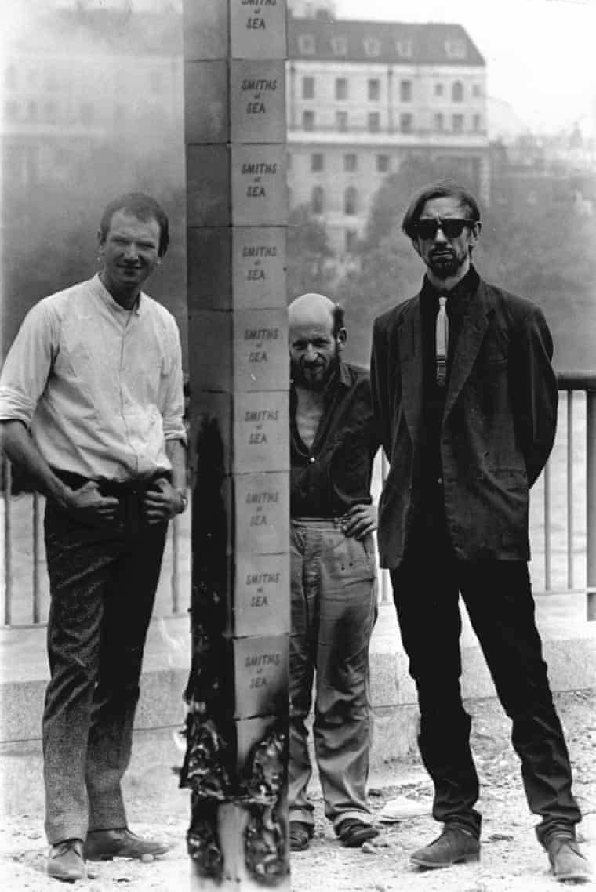
Figure 5: John Latham, right, with fellow artists Ivor Davies and Gustav Metzger (centre) in 1966.
By inference, other artists’ work bears the hallmarks of auto-destruction, Andy Goldworthy, Mona Hatoum, the late Dieter Roth, Michael Landy and Cornelia Parker (Renton, 2004: 7; Obrist, 2017):
He knew my work involved a lot of destruction - my blown-up garden shed, for example - and […] I realised that although his manifesto had not directly influenced me, it had come through the ether. His work infiltrated into popular culture. He believes that the destructive act is a creative one, but because he refuses to make anything saleable, he gets overlooked. And because of his idealism, he is not very well-off (Parker, 2004 cited in Cripps, 2004)

It is the implicit power of his work that imparts to the art – and life – of Gustav Metzger perennial potency. Out of rife adversity, he chose to declare for life: “I transform hate into love” (Gustav Metzger, 2015 cited in Tate, 2015). Transformation, or perhaps, better transmutation seems to define Metzger, a man surrendered to his function: art. According to Rozemin Keshvani (Keshvani, 2017) who, having pursued him through his art, met Metzger in 2011, he was a tireless perfectionist, with a genial presence and piquant humour; possessed of surpassing insight into the human dilemma, his tenacity and humanity offering assurance that his legacy will impact generations of artists to come. In an effort to secure this outcome, in the past year Robert Craig, the executor of Gustav Metzger’s estate, has founded a charity, The Gustav Metzger Foundation, with objects including advancing public awareness and appreciation of Metzger’s work and, eventually, providing funding to relieve the hardship of artists (Craig, 2018).
Elfin, garbed as ever as a gentrified vagrant, soft-spoken, and persistent with an alert mien, in his dotage Metzger despite the wider acceptance of his work never lost the sense of radical rejection of the norm that gave his work its edge to chop through things trivial and trite. With the aspect almost of a mystic or seer, eyes piercing, Metzger yet radiated a youthful energy of intense curiosity and contrariness. Closing one circle, toward the end of his life his interest returned to painting, which he intended to embrace once again (McNay, 2014).
At ninety, after some months weakened, Metzger was dying, but still working. In his final days long-time friend and colleague, Hans Ulrich Obrist, artistic director of London's Serpentine Galleries (Ellis-Petersen, 2016), visited him. The artist, after exhorting Obrist to sustain his commitment to activism, then, recounts Obrist, “asked for a piece of paper, which he crumpled into his palm and for fifteen minutes moulded with his hands until it became this strange, beautiful sculpture, the very last work he created,” adding with poignancy, “Watching him work, it could have been 1959” (Obrist, 2017).
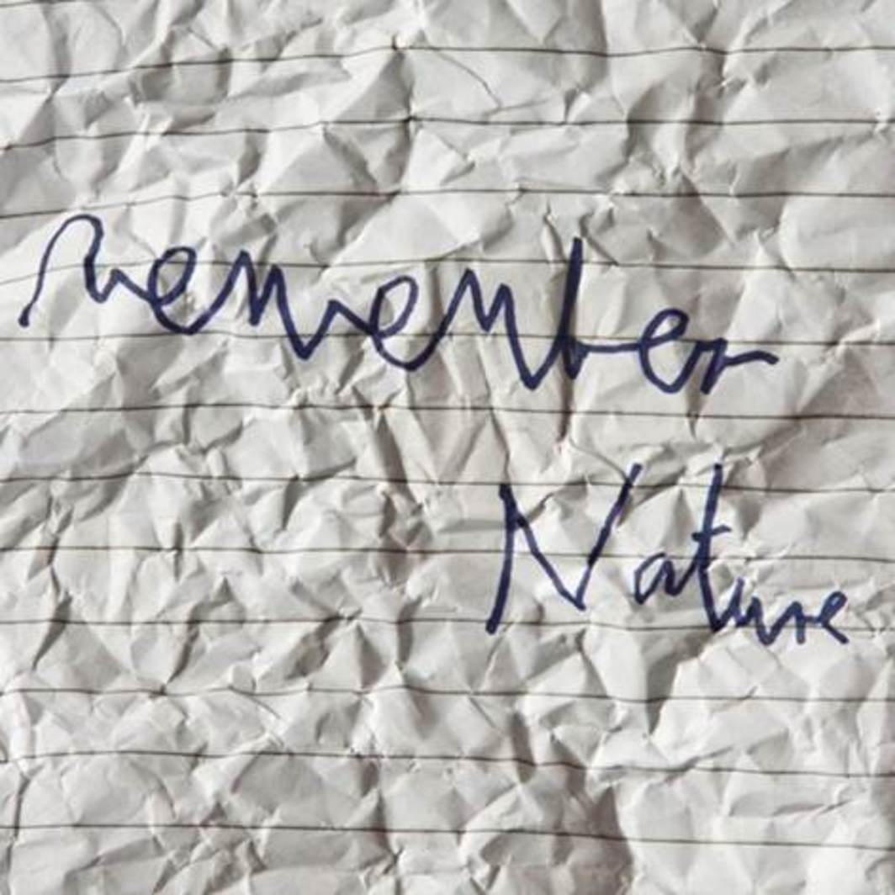
Figure 6: Screenshot of a drawing by Gustav Metzger, as it appeared on Hans Ulrich Obrist’s Instagram account, March 2017.
Metzger’s three Auto-destructive art manifestoes, published between 1959 and 1961, constituted a statement of intent specifying degrees of process control that from that point would inform his practice and shape perceptions of his art but far from confining him propelled him through imaginative thresholds (O’Brien, 2009: 33-4). A bag of rubbish that was part of an installation he exhibited at the Tate in 2004 provides a comical metaphor for a body of work fulfilling its auto-destructive destiny. Yet this story points to a man whose life was itself rootless and inherently unpredictable. Having been saved from the base manifestations of humanity, he was driven by a powerful urge to help save humanity from itself. With Metzger, place and placelessness was not a theory or practice, it was his very nature and foundation of his worldview. A futurist afraid of the future, his work became a rebuke to complacency and neutrality: for Metzger there was always something at stake. His 2009 work, Flailing Trees, typified a pure yet perverse evocation of our species’ abuse of the planet. If only because it can seem pervasive in spirit but absent in matter, his influence can be hard to determine, but it is everywhere in art, commanding respect in equal measure from those who knew and worked with him, carrying forward how he inspired them.

CONCLUSION
Gustav Metzger was, amongst the many other things enumerated above, a survivor. Though he survived it vicariously, not, literally, of the Holocaust. No, Metzger was foremost a survivor of himself. Mired in an aesthetic of undoing and ruination, the sublimity of his work is subtle (Ciuffi, 2009). His was a life of implication, and of implicate order, legible to the intellect by enshrouded signs. His instinct to survive an art world he felt hostile to and his moral stance drove him to make caustic, cryptic statements. A man seemingly afraid of being forgotten, who yet strove to depersonalise his public image and work, his expression of the famous post-Holocaust caution “Never forget” materialised in his art as a moving centre of witnessing. He witnessed the Nazis, as a child witnessed their handiwork in his native Nuremberg, and in due course arrived at a sense of moral obligation to witness – as many Holocaust survivors did, in a multitude of ways – the historical, present and possible future folly of mankind. Diminutive, unadorned, deceptively iconoclastic, Metzger made art worthy of capturing life and the living as ghosts of the dead. In the literal sense, what is spiritual and what is material is easy to distinguish: the spiritual is that which is not matter. Metzger apprehended this and seized it with a passion. He was not religious but had a religion. Art. Believing in and proselytising its power to change the world, of his many gifts foremost of them was an unstinting giving of himself to his practice. A selfish master, it took all he was. What he received back was simply himself, his life. Far from Faustian, it was fair. Knowing its worth he submitted himself to it.
Metzger’s influence will endure and grow. Much as academic research on him remains wanting - a search of ProQuest, for example, finds no dissertations and theses specifically on him – his work is insinuating itself into the art world collective unconscious. His work is finally finding its rightful audience, by a wide margin unborn when already he had destroyed and created new worlds of art. Lee Paul, writing for Outside Left, a Californian alternative art website, provides a fine informal testimonial to a man in his times, but not of them. “You know he was a refugee, Gustav, his life saved from the Nazi’s by Kindertransport. If one of those kids staring across the channel from Calais today could get an ounce of compassion and get over here, maybe in a decade or so they might set out on a path to destroy art too. Where would they start? I’d love to see.”
Myself now nearer the end than the beginning, positioned ideally in time and space and in my practice to empathise with and celebrate Gustav Metzger, with the years left to me I declare, with Paul: I would, too.

Bibliography
Books

Brown, T., Lison, A. (2014) The Global Sixties in Sound and Vision: Media, Counterculture, Revolt Palgrave London: Macmillan.
Frankl, V.E. (2004) Man’s Search for Meaning Croydon: Ebury
Kelly M. Kapic and Wesley Vander Lugt (2013) Pocket Dictionary of the Reformed Tradition. Grove, Illinois: Inter-Varsity Press.
Leslie, E. (2016) Liquid Crystals: The Science and Art of a Fluid Form London: Reaktion
Liu, A. (2004) The Laws of Cool Chicago: University of Chicago.
Obrist, H. U. (2008) The Conversation Series 16: Gustav Metzger by Hans Ulrich Obrist

Koln: Verlag der Buchhandlung Walther Konig.

Oppenheimer, D. (2017) Into the Arms of Strangers: Stories of the Kindertransport London: Bloomsbury.
Parikka, J. (2012) What is Media Archaeology? Cambridge: Polity Press
Powell, J. (2007) Preserving the unpreservable: A study of the destruction of art in the contemporary museum MA Museum Studies University of Leicester: Leicester
Redhead, S. (2011) We Have Never Been Postmodern: Theory at the Speed of Light Edinburgh: Edinburgh University Press.
Trigg, D. (2006) The Aesthetics of Decay: Nothingness, Nostalgia, and the Absence of Reason (New Studies in Aesthetics) New York: Peter Land Publishing.
Walker, John A. (2001) Left Shift: Radical Art in 1970s Britain London: I. B. Tauris

Van Mourik Broekman, P., Slater, J. B. (2013) Proud to Be Flesh - A Mute Magazine Anthology of Cultural Politics After the Net London: Mute.
DVD and Videos
Tate (2008) Gustav Metzger: Festival of missed fits - The German artist's career has spanned sixty years of art and political activism Available at: https://youtu.be/a7sbfNIemF0 (Accessed July 5, 2108).

Tate (2015) BP Spotlight Gustav Metzger Towards Auto-Destructive Art 1950-1962 http://www.tate.org.uk/whats-on/tate-britain/display/bp-spotlight-gustav-metzger-towards-auto-destructive-art-1950-1962 (Accessed July 5, 2108).
Pioneers in Art and Science: Metzger (2004) Ken McMullen, UK

Tate (2015) Gustav Metzger –Auto-Destructive Art. Available at: https://youtu.be/5ioYs20rnL8 (Accessed February 15, 2018).

E-books

Metzger, G. (1969) Notes on the Crisis in Technological Art, 1969. Monoskop [Online]. Available at: https://monoskop.org/File:Metzger_Gustav_Notes_on_the_Crisis_in_Technological_Art_1969.pdf (Accessed October 24, 2017).

Essays In Edited Books

Metzger, G. (2007) Auto-Destructive Art (1959, 1960, 1961) in Danchev, A. 100 Artists' Manifestos: From the Futurists to the Stuckists London: London: Penguin Modern Classics :343-45
O’Brien, S. (2009) ‘Transformation and Transcendence’, in Larner, M., O’Brien, S. (ed) Gustav Metzger Decades: 1959-2009. London: Koenig Books: 48-53.
O’Neill, M. (2007) Art and Money: Experience Destruction Exposure
Money and Culture, in Cox, F. and Schmidt-Hannisa, H-W. (ed) Money and Culture.
Oxford: Peter Lang: 72.
Rosenthal, R. (2009) ‘Survival’, in Larner, M., O’Brien, S. (ed) Gustav Metzger Decades: 1959-2009. London: Koenig Books: 32-40.
Stiles, K. (1992) ‘Selected Comments on Destruction Art’, in Adriaansens, A., Brouwer, J., Delhaas, R. and den Uyl, E. (ed) Book for the Unstable Media. Rotterdam: V2: ----.
Stiles, K. (2005) The Story of the Destruction in Art Symposium and the 'DIAS Affect’, in Metzger, G., Breitwieser, S., Generali Foundation (ed)
Gustav Metzger: History History Vienna: Vienna and Ostfildern-Ruit: 41-65.

Images
Anon. Flailing Trees by Gustav Metzger [Online]. Available at: https://patternsthatconnext.wordpress.com/2011/09/04/flailing-trees-by-gustav-metzger/ (Accessed: February 11, 2018).

Anon. (2014) Gustav Metzger Table c.1957–8 [Online]. Available at:
http://www.tate.org.uk/art/artworks/metzger-table-t14290 (Accessed: June 21, 2018)
Cox, J. Cardboards, 1959 [Online]. Available at: http://artishockrevista.com/2015/09/09/debemos-convertirnos-idealistas-morir-gustav-metzger/ (Accessed: 11 February 2018).
Goodway, B. (1966) John Latham, right, with fellow artists Ivor Davies and Gustav Metzger (centre) in 1966. [Online] Available at: https://www.theguardian.com/artanddesign/2017/mar/05/john-latham-a-world-view-serpentine-gallery-speak-bruguera-gordon-prouvost-spooner Accessed: October 17, 2018
Obrist, H.U. (2013) Gustav Metzger, 2013 [Online]. Available at: https://www.artforum.com/passages/hans-ulrich-obrist-on-gustav-metzger-1926-2017-67595 (Accessed: June 22, 2108)
Obrist, H.U. (2013) Screenshot of a drawing by Gustav Metzger, as it appeared on Hans Ulrich Obrist’s Instagram account, March 2017. [Online]. Available at: https://www.artforum.com/passages/hans-ulrich-obrist-on-gustav-metzger-1926-2017-67595 (Accessed: June 22, 2108)
Journals
Kunzru, H. (2005) Waste Product, Mute, 1(29): Not available, [Online] Available at: http://www.metamute.org/editorial/articles/waste-product (Accessed: 10 July 2018).
Marris, E. (2009) Q&A: Gustav Metzger on destruction Nature Volume 461, page 598 [Online] Available at: https://www.nature.com/articles/461598a (Accessed: 10 July 2018).
White, D. (2013) Art After the Destruction of Experience Millennium Film Spring 2013: 32-44. (Accessed: 10 July 2018).
Wilson, A. (2008) Gustav Metzger’s Auto-Destructive/Auto-Creative Art: An Art of Manifesto, 1959–1969’ Third Text, 22 (2): 184 Taylor and Francis Group [Online.] Available at: www.tandfonline.com/doi/abs/10.1080/09528820802012844 (Accessed February 17, 2018).
Newspaper Articles
Alberge, D. (2004) Cleaner thought Tate exhibit was a load of rubbish The Times, August 27: 9.

Cork, R. (2004) Metzger's new bag: 'I intend to draw and paint again The Times, Oct 19: 8.
Cripps, C. (2004) Forgotten Heroes: Cornelia Parker - The Turner nominee on the artist Gustav Metzger The Independent 18 June: 2.
Davis, B. (2014) May 30. Make and break. Jerusalem Post, 6.

The Economist (2017) Art as weapon; Gustav Metzger The Economist Vol. 422, Iss. 9032, 18 March: 90.
Grimes, W. (2017) Gustav Metzger, Artist and Provocateur, Dies at 90 New York Times. Mar 12: 47.
Hodgkinson, W (2017) Why did the KLF burn a million pounds? 'Because it was fun - Will Hodgkinson joins the pop group and art pranksters at a happening to celebrate 23 years since the 1994 blaze on the Scottish island of Jura, The Times, August 25: 4,5.
Ivry, B. (2011) An Angry Old Artist Reaches the Big Apple, Forward, June 10: 11,13.
Jones, J. (1998). Guru in a gas mask He set up CND, was jailed with Bertrand Russell, showed The Who how to smash their guitars and inspired Damien Hirst. So why is Gustav Metzger still living out of a plastic bag? The Guardian Oct 31: ---
O'Rorke, I. (1998) Back on the road to ruin After years of obscurity, Gustav Metzger has returned with the art of self-destruction The Independent, Oct 26: 17.
Rosenthal, N. (2009) The saintly anarchist: The octogenarian artist and activist Gustav Metzger is still out to save the world Financial Times 05 Sep 2009: 13.
White, T., 2006, Mar 25. Weekend: Inspiration: Pictures with meaning: Tony White, writer: The acid-nylon technique (1960), by Gustav Metzger. The Guardian, 102. ISSN 02613077.
Web
Amdam, P. (2015) Activist Acidity Available at: http://www.kunstkritikk.no/kritikk/activist-acidity/ (Accessed July 19, 2018).
No Author (2017) Auto Destructive art pioneer Gustav Metzger has died Available at: http://petetownshend.net/news/auto-destructive-art-pioneer-gustav-metzger-has-died (Accessed July 1, 2018).
Anon. (2017) Gustav Metzger Holocaust child survivor who developed the Auto-destructive art form Available at: https://www.pressreader.com/uk/the-jewish-chronicle/20170623/282475708829248 (Accessed June 16, 2018).
BBC News (2004) Cleaner bins rubbish bag artwork Available at: http://news.bbc.co.uk/1/hi/entertainment/3604278.stm (Accessed July 15, 2018).
Berridge, D. (2010) The Conversation Series 16: Gustav Metzger by Hans Ulrich Obrist Available at: https://doi.org/10.1111/j.1467-8357.2010.01079.x (Accessed November 2, 2018)
Black, P. (2016) Gustav Metzger, Yoko Ono, David Maljkovic – Among Artists At Modern Art Oxford Available at: http://www.artlyst.com/reviews/gustav-metzger-yoko-ono-david-maljkovic-among-artists-at-modern-art-oxford/ (Accessed June 26, 2108).

Brown, A. (2017) Gustav Metzger, pioneer of auto-destructive art, dies aged 90
Available at: https://www.theguardian.com/education/2017/mar/02/auto-destructive-art-pioneer-gustav-metzger-dies-aged-90 (Accessed July 18, 2018).

Cielątkowska, Z.M., Kyander, P. (2015) Art is always about not being understood. Interview with the curators of the Gustav Metzger retrospective Available at: http://archiwum-obieg.u-jazdowski.pl/english/35362 (Accessed June 16, 2018).
Ciuffi, V. (2009) Gustav Metzger: Decades 1959-2009 Available at: http://www.abitare.it/en/archive/2009/11/02/gustav-metzger-decades-1959-2009-2/ (Accessed December, 11, 2018).
Craig, R. (2018) The Gustav Metzger Foundation Available at: http://beta.charitycommission.gov.uk/charity-details/?regid=1176404&subid=0 (Accessed July 1, 2018).
Eastham, B. (2012) William S. Burroughs's Shot Gun Paintings Available at: http://www.dazeddigital.com/artsandculture/article/15208/1/william-s-burroughss-shot-gun-paintings (Accessed July 15, 2018).
Ebenkamp, B. (2017) In a Bad Time: On Art Strikes and Auto-Destructive Art. Available at: https://openspace.sfmoma.org/2017/05/in-a-bad-time-on-art-strikes-and-auto-destructive-art/ (Accessed February 20, 2018).
Ellis-Peterson, H. (2104) The Extinction Marathon: the art world's bid to save the human race Available at: https://www.theguardian.com/artanddesign/2014/oct/20/serpentine-extinction-marathon-yoko-ono-gilbert-george (Accessed June 26, 2108).

Ellis-Petersen, H. (2106) Hans-Ulrich Obrist tops list of art world's most powerful

Available at: https://www.theguardian.com/artanddesign/2016/oct/20/hans-ulrich-obrist-tops-list-art-worlds-most-powerful-artreview-power-100 (Accessed July 26, 2108).
Fisher, E. (2107) Gustav Metzger (1926–2017) Available at: https://www.apollo-magazine.com/gustav-metzger-1926-2017/ (Accessed June 26, 2108).
Griffin, J. (2013) The seeds of destruction. Available at: http://www.tate.org.uk/context-comment/articles/seeds-destruction (Accessed February 25, 2018).

Grimes, W. (2017) Gustav Metzger, ‘Auto-Destructive Art’ Provocateur, Dies at 90 Available at: https://www.nytimes.com/2017/03/08/arts/design/gustav-metzger-dead-auto-destructive-artist.html (Accessed July 15, 2018).

Halifax, N. (2017) Gustav Metzger, 1926 to 2017. Available at: http://socialistreview.org.uk/423/gustav-metzger-1926-2017
(Accessed June 16, 2018).

Hyperallergic (2018 ) Joseph Nechvatal Available at: https://hyperallergic.com/author/joseph_nechvatal/ (Accessed June 16, 2018).
Jochem, G. (2017) Gustav Metzger: Painter, performance artist, writer (April 10, 1926 in Nuremberg – March 1, 2017nin London) Available at: http://www.rijo.homepage.t-online.de/pdf/en_nu_ju_metzger_gustav.pdf (Accessed June 16, 2018).
Jones, A. (n.d.) Introduction to the Historic Photographs of Gustav Metzger. Available at: http://www.ucl.ac.uk/forum-for-holocaust-studies/metzger.html (Accessed February 17, 2018).
Jones, J. (2009) Gustav Metzger: the liquid crystal revolutionary. Available at: https://www.theguardian.com/artanddesign/2009/sep/28/gustav-metzger-auto-destructive (Accessed February 17, 2018).

Johns, K. (2011) Interview with Joseph Nechvatal Available at: http://kayjohns.blogspot.com/2011/08/interview-with-joseph-nechvatal.html (Accessed June 16, 2018).

Johnson, K. (2011) If It’s About Atrocity, Does That Make It Good? Available at: https://www.nytimes.com/2011/06/17/arts/design/gustav-metzger-at-the-new-museum-review.html (Accessed June 16, 2018).
Keshvani, R. (2017) Gustav Metzger (10 April 1926 - 1 March 2017) - Auto Destructive Art. Available at: https://theimaginedstate.blogspot.com/2017/03/gustav-metzger-10-april-1926-1-march.html (Accessed June 16, 2018).
McNay, A. (2014) Gustav Metzger: interview Available at: http://www.studiointernational.com/index.php/gustav-metzger-interview-kettles-yard-auto-destructive-auto-creative-art-liquid-crystal (Accessed July 16, 2018).
Obrist, H. U. (2017) Passages: Gustav Metzger (1926–2017) Available at: https://www.artforum.com/passages/hans-ulrich-obrist-on-gustav-metzger-1926-2017-67595 (Accessed June 29, 2018).
Obrist, H.U. (2017) Gustav Metzger (1926-2017) Available at: https://www.artforum.com/passages/hans-ulrich-obrist-on-gustav-metzger-1926-2017-67595 April 05, 2017 (Accessed June 16, 2018).
Obrist, H.U. (2007) Gustav Metzger: Revolutionary Constructions Available at: https://mapmagazine.co.uk/gustav-metzger-revolutionary (Accessed June 16, 2018).
Orton, K. (2015) "We Must Become Idealists or Die". Available at: http://www.anothermag.com/design-living/8123/gustav-metzger-we-must-become-idealists-or-die (Accessed February 11, 2018).
Ridgway, E. (2016) Gustav Metzger on Art as Energy for Life Available at: https://www.modernartoxford.org.uk/gustav-metzger-art-energy-life/ (Accessed June 26, 2108).
Ridgway, E. (2009) Emma Ridgway, curator of The RSA Arts & Ecology Centre, interviews Gustav Metzger. Available at: http://umintermediai501.blogspot.com/2009/11/interview-gustav-metzger.html (Accessed June 16, 2018).

Riggs, T. (1997) R.B. Kitaj 1932–2007. Available at: https://www.tate.org.uk/art/artists/r-b-kitaj-1416 (Accessed November 2, 2018)
Rosenthal, N. (2009) Octogenarian artist out to save the world. Available at: https://www.ft.com/content/f2d8295e-98e3-11de-aa1b-00144feabdc0 (Accessed February 12, 2018).
Shanken, E. (2005) Pioneers in Art and Science: Metzger Available at: http://drainmag.com/index_feb.htm (Accessed July 10, 2018).
Schudel, M., (2017) Gustav Metzger, provocative artist who developed ‘auto-destructive’ art, dies at 90. Available at: https://www.washingtonpost.com/entertainment/museums/gustav-metzger-provocative-artist-who-developed-auto-destructive-art-dies-at-90/2017/03/02/0ef43478-ff6d-11e6-8ebe-e0dbe4f2bca_story.html?utm_term=.2516236756dd (Accessed February 12, 2018).

Stiles, K. (2015) Selected Comments Kristine Stiles, Ph.D. ‘Selected Comments on Destruction Art’ – Book for Unstable Media (1992). Available at: http://www.scrapclub.co.uk/texts/kristine-stiles-selected-comments (Accessed June 16, 2018).

Suchin, P. (2003) Gustav Metzger t1/2 artspace. Available at: https://frieze.com/article/gustav-metzger (Accessed February 11, 2018). (Accessed June 16, 2018).
Tessler, G (2017) Gustav Metzger Holocaust child survivor who developed the Auto-Destructive art form Available at: https://www.pressreader.com/uk/the-jewish-chronicle/20170623/282475708829248 (Accessed July 15, 2018).

Watling, L. (2012) Gustav Metzger To Crawl into - Anschluss, Vienna, March 1938 – 1996 Available at: http://www.tate.org.uk/art/artworks/metzger-to-crawl-into-anschluss-vienna-march-1938-t13323 (Accessed June 26, 2108).
Watling, L. (2012) Gustav Metzger Recreation of First Public Demonstration of Auto-Destructive Art 1960, remade 2004, 2015 Available at: http://www.tate.org.uk/art/artworks/metzger-recreation-of-first-public-demonstration-of-auto-destructive-art-t12156 (Accessed June 26, 2018).

Watling, L. (2012) Gustav Metzger Recreation of First Public Demonstration of Auto-Destructive Art 1960, remade 2004, 2015 Available at: http://www.tate.org.uk/art/artworks/metzger-recreation-of-first-public-demonstration-of-auto-destructive-art-t12156 (Accessed June 16, 2018).
Webb, P. (2011) Available at: http://poulwebb.blogspot.com/2011/09/frank-auerbach-1952-summer-building.html (Accessed July 1, 2018).
Westbury, D. (2005) Available at: http://www.cliffholden.co.uk/borough.shtml (Accessed October 17, 2018)

Wilson, A. (2014) Gustav Metzger Homage to the Starving Poet 1951. Available at: www.tate.org.uk/art/artworks/metzger-homage-to-the-starving-poet-l03660 (Accessed June 16, 2018).

Wilson, A. (2014) Gustav Metzger Painting on Cardboard c.1961–2. Available at: www.tate.org.uk/art/artworks/metzger-painting-on-cardboard-t14291 (Accessed June 16, 2018).

Wilson, A. (2014) Gustav Metzger Table c.1957-8. Available at: http://www.tate.org.uk/art/artworks/metzger-table-t14290 (Accessed June 16, 2018).

Wilson, A. (2011) Gustav Metzger obituary. Available at: https://www.theguardian.com/artanddesign/2017/mar/03/gustav-metzger-obituary (Accessed February 11, 2018).
Windsor-Clive, I. (2011) Interview with Gustav Metzger. Available at: http://blog.saatchigallery.com/interview-gustav-metzger (Accessed March 3, 2018).
Windsor-Clive, I. (2011) Interview with Gustav Metzger. Available at: http://blog.saatchigallery.com/interview-gustav-metzger (Accessed March 3, 2018).

Yahav, G. (2014) Nazism, Nukes and 'Nam: The Art of 'Perpetual Refugee' Gustav Metzger. Available at: https://www.haaretz.com/israel-news/culture/.premium-a-radical-artist-s-work-come-to-tel-aviv-1.5323267 (Accessed March 6, 2018).

List of Illustrations

Figure 1: Metzger, G. (1959) Table [Oil on canvas]. Available at:
http://www.tate.org.uk/art/artworks/metzger-table-t14290 (Accessed: June 21, 2018).
Figure 2: Metzger, G. (1959) Cardboards [Installation] Available at: http://artishockrevista.com/2015/09/09/debemos-convertirnos-idealistas-morir-gustav-metzger/ (Accessed: 11 February 2018).
Figure 3: Obrist, H.U. (2013) Gustav Metzger, 2013 [Digital photograph]. Available at: https://www.artforum.com/passages/hans-ulrich-obrist-on-gustav-metzger-1926-2017-67595 (Accessed: June 22, 2108)
Figure 4: Anon. (2009) Flailing Trees by Gustav Metzger [Digital photograph] Available at: https://patternsthatconnext.wordpress.com/2011/09/04/flailing-trees-by-gustav-metzger/ (Accessed: February 11, 2018).
Figure 5: Goodway, B. (1966) John Latham, right, with fellow artists Ivor Davies and Gustav Metzger (centre) in 1966. Available at: https://www.theguardian.com/artanddesign/2017/mar/05/john-latham-a-world-view-serpentine-gallery-speak-bruguera-gordon-prouvost-spooner Accessed: October 17, 2018.
Figure 6: Obrist, H.U. (2013) Screenshot of a drawing by Gustav Metzger, as it appeared on Hans Ulrich Obrist’s Instagram account, March 2017. Available at: https://www.artforum.com/passages/hans-ulrich-obrist-on-gustav-metzger-1926-2017-67595 (Accessed: June 22, 2108).

R.B. Kitaj (Ronald Brooks Kitaj [1932-2007], born in Ohio, USA), originated the term “School of London” in an essay in the catalogue for the 1976 show he curated, The Human Clay that comprised significant British artists, including fellow Jews Auerbach and Kossoff. In his 1989 book, The First Diasporist Manifesto, which proved very influential, he expounded his ideas on the central importance to him of his Jewish identity in his life and practice (Riggs, 1997).
compressed air – Metzger observes ‘where Anthony Caro and his students at Saint Martins were trying to liberate sculpture from the ground, to take it off the pedestal . . . I feel I achieved something . . . literally off the ground’. Talking of his 1968 residency in a filtration laboratory at Swansea University – in particular an unnamed piece in which three pieces of polystyrene floated on a cushion of compressed air – Metzger observes ‘where Anthony Caro and his students at Saint Martins were trying to liberate sculpture from the ground, to take it off the pedestal . . . I feel I achieved something . . . literally off the ground’. 2 Speaking of his 1968 residency at Swansea University – specifically an untitled piece in which three pieces of polystyrene floated on compressed air – Metzger comments ‘where Anthony Caro and his students at Saint Martins were trying to liberate sculpture from the ground, to take it off the pedestal … I feel I achieved something …literally off the ground’.” (Metzger, 2008 cited in Berridge, 2010).

