
Learning in the Digital Era
BMBM4008

VLOG

Supporting Material

Sarah-Jayne James

2517480

Lecturer: Ffion Cumberpatch

8th December 2025

Wordcount: 631

Video Link:
Recording-20251207_160441.webm

Supporting Material
These notes outline the key reflections that will be discussed in my VLOG, where I will be using Gibbs reflective model to structure my reflection on my learning and how my skills have developed.
I have chosen Gibbs reflective model as it gives clear structure and allows to continually analyse my experiences and improve outcomes (McLeod, 2025).

Stage One: Description
- Learning Harvard referencing.
- Learning of digital tools such as Microsoft PowerPoint, Google Scholar, Online Library Resources, LinkedIn Learning, RefWorks and Moodle.
- Effective use of AI.

Stage Two: Feelings
- Nervous on whether I was correctly using AI to be within the assignment guidelines.
- Anxiety and lack of confidence for the upcoming presentation.
- Overwhelmed by referencing.
- Uncertain on academic expectations.
I recognised that my emotions could reflect on the quality of my work. During my presentation I had adapted to use positive body language, effectively referred to my slides and spoke directly to the audience rather than read from a script and confidently engaged in questions. As the module progressed, I felt more capable and organised when conducting research and referencing those using Harvard referencing. Toward the end of this module, I now feel proud of the progress I have made to better prepare myself for future assignments.

Stage Three: Evaluation

What went well
- Source evaluation. Use of CRAAP test (Blakeslee, 2004) to evaluate sources for reliability and credibility.
- Become confident on presenting.
- Use of pomodoro technique to manage my time and structure my independent learning and planning efficiently.

Challenges:
- Understanding Harvard referencing.
- Finding information to use for reference.
- Use of AI to support research.
An achievement I am proud of is completing my first presentation in front of class, which helped me progress my ability to communicate my work confidently.

Stage Four: Analysis
- Referencing was difficult at first due to overwhelming amount of information on the Harvard Referencing Handbook. I had underestimated its detail and requirements.
- Difficulty finding information that was current and credible.
- Using the CRAAP test to evaluate the credibility of sources (See appendix two)
- Use of AI tools to support my research in gathering information, that aligns with assignment guidelines.
Throughout the challenges I faced, I learned that asking for support was crucial for me to improve my studies. By using University resources, I had booked a meeting with Lisa Ellis our Library Liaison, to assist me in understanding Harvard referencing and how to utilise the online library resources to find information. Alongside this I had developed my skills in evaluating sources through the CRAAP test to understand the credibility of the information I had been referring to in my assignments.

Stage Five: Conclusion
- Learned to use AI responsibly and not to rely on it, also to consider its use to assignment guidelines.
- The module helped understand how digital skills can help with not only my academic work but in my future career.
- I gained confidence in presenting.
Throughout this module, I recognised the importance of digital and personal learning skills. For example, not only has improving my research skills helped complete assignments efficiently but strengthened my ability to critically evaluate credibility and relevance of sources. I have also learned that I work best with structured approaches, such as calendar planners and the use of the pomodoro technique to manage my study time effectively.

Stage Six: Action Plan
- Continue use of pomodoro technique to structure my research and writing.
- Further develop my digital skills to adapt to the technological evolution.
- Continue to apply the CRAAP test in future assignments and in the workplace to determine the credibility of sources.
Finally, my personal goal is to start planning for my future and progress to a career in marketing. By building a portfolio and my LinkedIn profile to showcase my knowledge and skills.

Reference List
Blakeslee, S. (2004) 'The CRAAP test', LOEX Quarterly, 31(3) Available at: https://commons.emich.edu/loexquarterly/vol31/iss3/4
McLeod, S. (2025) 'Gibbs Reflective Cycle', Simply Psychology. Available at: https://www.simplypsychology.org/gibbs-reflective-cycle.html (Accessed on 4 December 2025).

Appendices

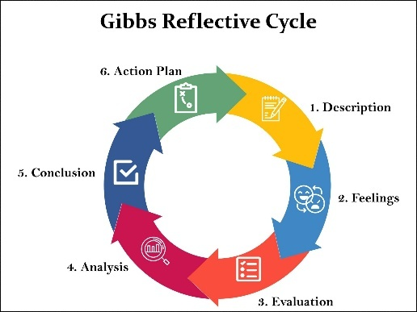
Appendix One: Gibbs Reflective Model
I applied Gibbs’ reflective model, as shown by McLeod (2025) to guide the structure of my reflection.

Appendix Two: CRAAP Test
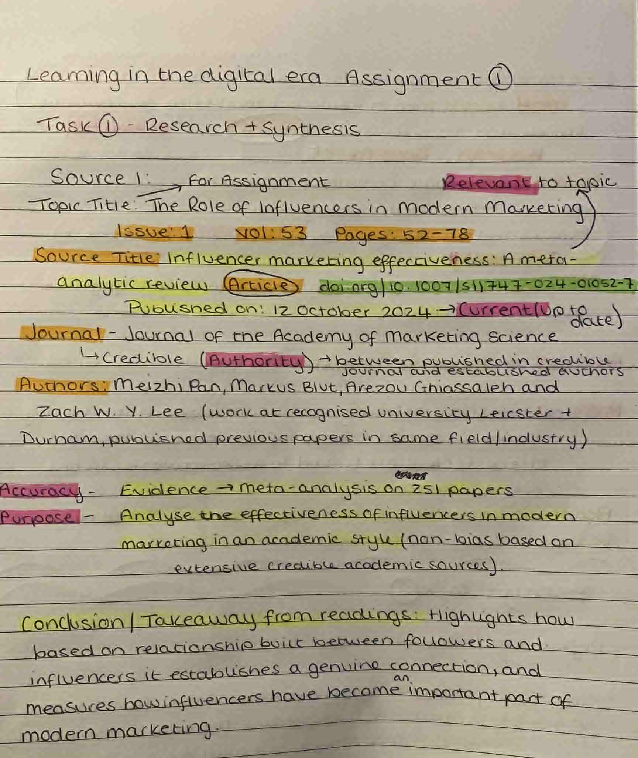
Example of my CRAAP Test to evaluate the credibility and relevance of the source. This was used for my module Learning in The Digital Era on my first assignment topic on The Role of Influencer Marketing.

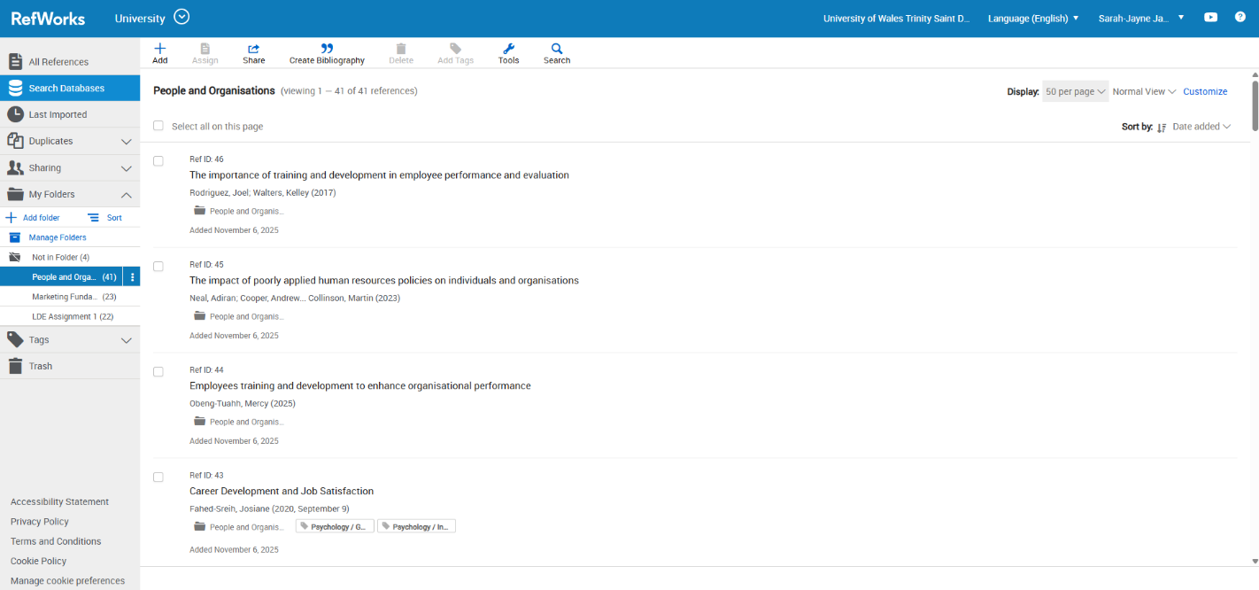
Appendix Three: Evidence of Digital Skills

Example above outlines the use of a reference manager (RefWorks) to store all my references in an organised space in designated folders for each module.
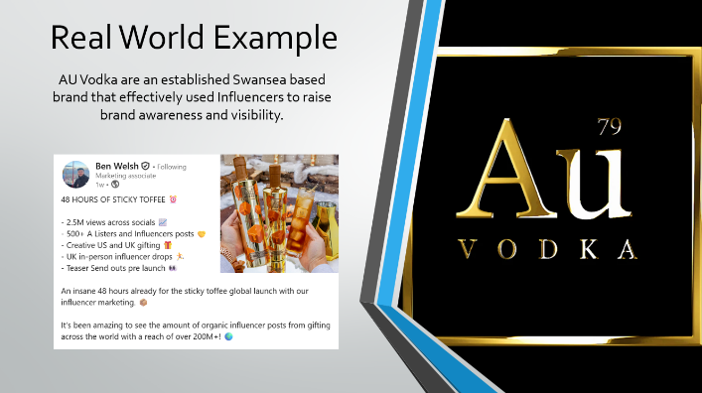
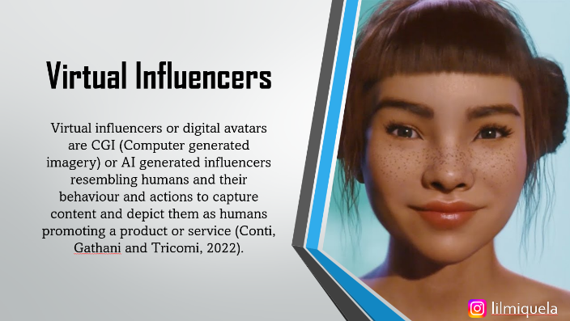
The examples as shown are of my presentation from one of my assignment tasks during this module, highlighting the use of my digital and communication skills.

Use of AI Tools
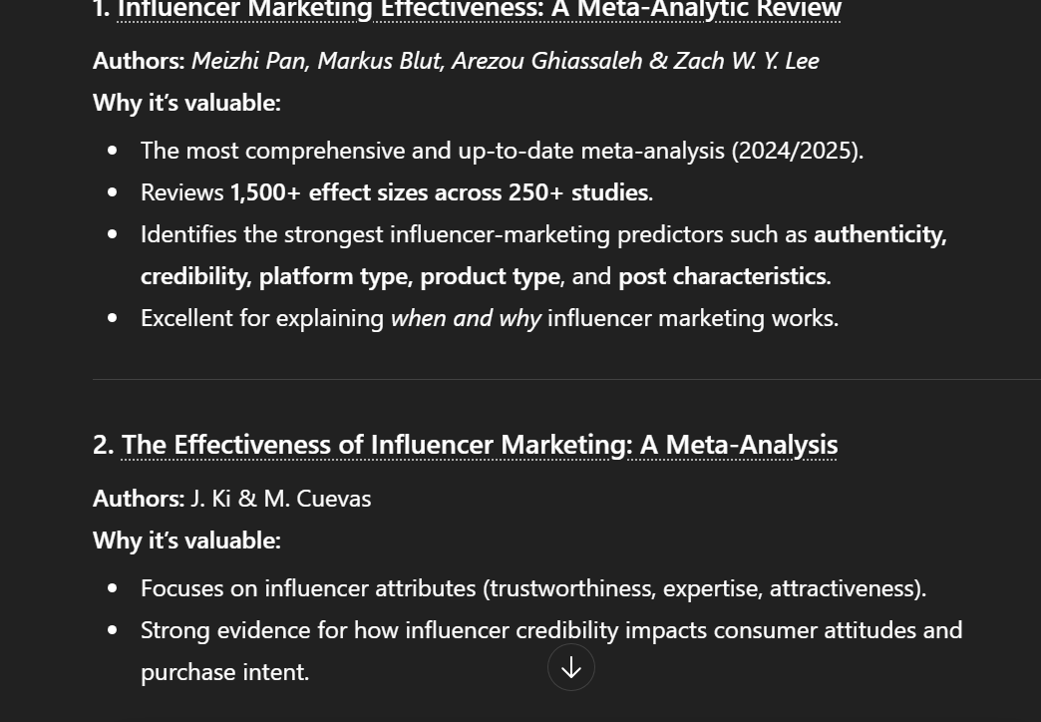
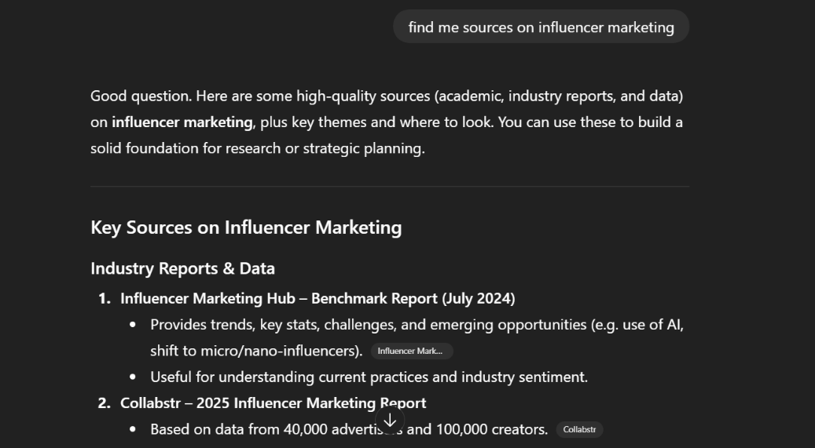
With this, I then implemented the CRAAP Test to evaluate the credibilty and relevance of the source to my chosen research topic. Highlighting my ability to test the sources that AI has given.

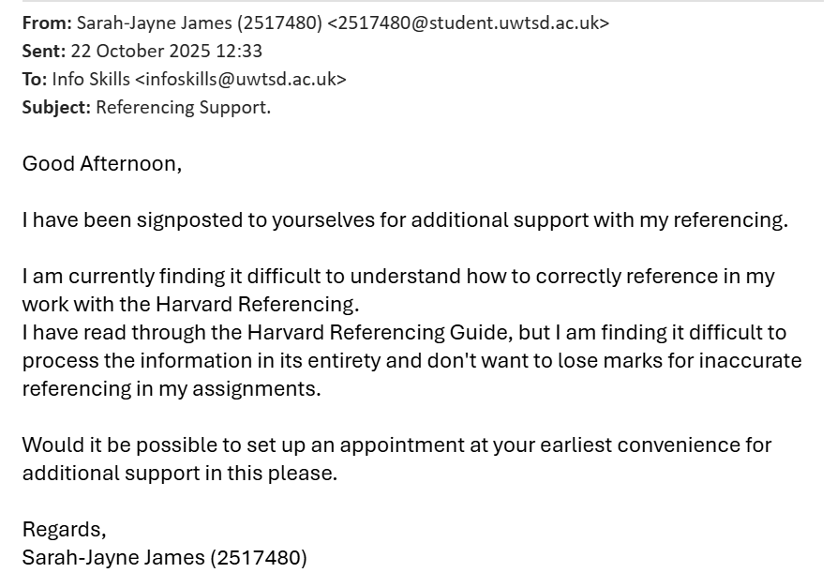
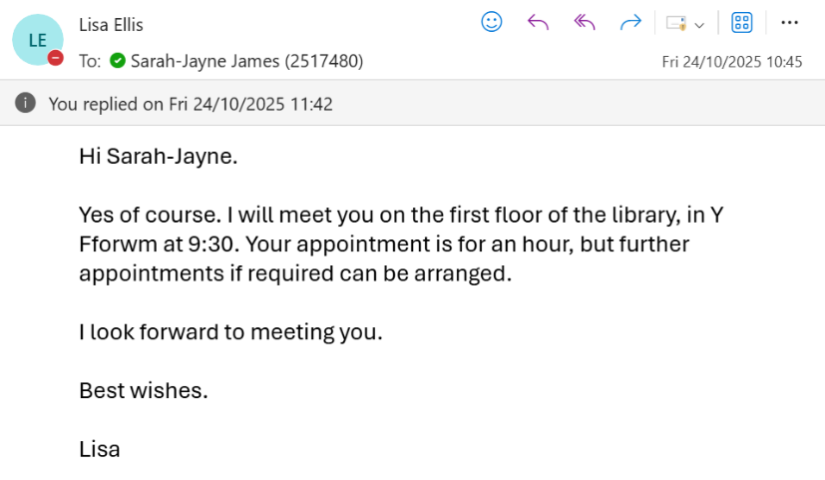
Appendix Four: Meeting with Academic Library Liaison

Supporting the development in my referencing. I have provided corresponding emails with Lisa Ellis outlining where support was directly required and appointment confirmation.

