University of Wales Trinity Saint David
Wales Institute of Science & Art



Undertaking a Green Belt Project
Six Sigma Green Belt (ACMA5005)

Owen Bell
2316885
5th May 2026

Contents
1 Introduction 1
2 Define 2
3 Measure 7
4 Analyse 11
5 Improve 22
6 Control 25
7 Bibliography 26
8 Appendix A: Containment and Rework Material Costs 27
8.1 Appendix A-A: Butyl Patch Cost per Unit 27
8.2 Appendix A-B: Betafill Sealer Cost (12 x 600ml) 27
9 Appendix B: FMEA Guidelines (Aston Martin Lagonda Ltd, 2026) 28
9.1 Appendix B-A: Severity Ranking 28
9.2 Appendix B-B: Occurrence Ranking 29
9.3 Appendix B-C: Detection Ranking 30
9.4 Appendix B-D: Risk Limiting Matrix Scoring 31
10 Appendix C: Gauge R&R Data 32
10.1 Appendix C-A: Metrology PVC Grommet Data Table 32
10.2 Appendix C-B: Metrology EPDM Grommet Data Table 32
10.3 Appendix C-C: Metrology Tailgate Lid Data Table 33
10.4 Appendix C-D: VLQ PVC Grommet Data Table 33
10.5 Appendix C-E: VLQ EPDM Grommet Data Table 34
10.6 Appendix C-F: VLQ Tailgate Lid Data Table 34
10.7 Appendix C-G: PVC Grommet Engineering Drawing 35
10.8 Appendix C-H: EPDM Grommet Engineering Drawing 35
10.9 Appendix C-I: Tailgate Lid Engineering Drawing 36
11 Appendix D: Cost Breakdown 37
11.1 Appendix D-A: Total Cost Breakdown 37
11.2 Appendix D-A: PVC Grommet Quotation 37
11.3 Appendix D-A: EPDM Grommet Quotation 38
12 Appendix E: EPDM Grommet w/Containment FLAGs Data 39

Figure 1 - Water Test Rework Process Map 2
Figure 2 - CTQ Tree 4
Figure 3 - Project Charter (Aston Martin Lagonda Ltd, 2026) 6
Figure 4 - Pareto of Water Leak Issues at Water Test 8
Figure 5 - Tow Bar Grommet Ishikawa 8
Figure 6 - EPDM Tow Bar Grommet FLAGs Pie 12
Figure 7 - EPDM Tow Bar Grommet FLAGs Data 12
Figure 8 - PVC Tow Bar Grommet Introduction FLAGs Pie 13
Figure 9 - PVC Tow Bar Grommet Introduction FLAGs Data 13
Figure 10 - PVC Tow Bar Grommet FLAGs Pie 14
Figure 11 - PVC Tow Bar Grommet FLAGs Data 14
Figure 12 - PVC Tow Bar Grommet w/Containment FLAGs Pie 15
Figure 13 - PVC Tow Bar Grommet w/Containment FLAGs Data 15
Figure 14 - Tow Bar Blanking Grommet FMEA 1/4 (Aston Martin Lagonda Ltd, 2026) 17
Figure 15 - Tow Bar Blanking Grommet FMEA 2/4 (Aston Martin Lagonda Ltd, 2026) 17
Figure 16 - Tow Bar Blanking Grommet FMEA 3/4 (Aston Martin Lagonda Ltd, 2026) 17
Figure 17 - Tow Bar Blanking Grommet FMEA 4/4 (Aston Martin Lagonda Ltd, 2026) 17
Figure 18 - PVC Grommet Bell Curve Charts 18
Figure 19 - EPDM Grommet Bell Curve Charts 19
Figure 20 - Tailgate Lid Bell Curve Charts 19
Figure 21 - Tow Bar Grommet Water Leak 5 Whys 20
Figure 22 - EPDM Tow Bar Grommet w/Containment FLAGs Pie 22
Figure 23 - EPDM Tow Bar Grommet w/Containment FLAGs Data 23
Figure 24 - Tow Bar Blanking Grommet Updated FMEA Scores (Aston Martin Lagonda Ltd, 2026) 24

Introduction
This report covers the project conducted at Aston Martin St. Athan in Wales, which is responsible for the manufacture of the DBX, a luxury sport SUV. The project was an investigation into water leaks that were detected at water test where an increase in the quantity of vehicles failing water test for water leaks in the tailgate was observed in comparison to previous levels believed to be linked to build issues and poor quality components.

The benefit of conducting this project is, it will improve the quality of the vehicles by reducing the likelihood of water leaks experienced with the consumer. Additionally, this project will reduce the quantity of resources spent during assembly and rework from water leaks or showcase that appropriate actions are already being taken to reduce Water Test DPV.

Define
An increase in the defects per vehicles (DPV) has been observed at Water Test where water leaks are being detected resulting in rework to rectify the leaks compromising vehicle quality and introducing additional cost, processing time and delaying the release of vehicles to the next stage of the manufacturing process.

The project aims to identify key contributors towards Water Test DPV, investigate these main contributors and review actions which can mitigate the water leaks from occurring. This project should lead to corrective actions in the assembly process of the vehicle or sourcing of vehicle components to reduce the occurrence of water leaks being observed whilst also reducing the number of vehicles which are reworked due to water leaks.

The process in place for when a vehicle has failed water test involves production putting the vehicle through water test which is an automated process that exposes the vehicle to a high volume of pressurised water. Upon completion of the water test procedure a production technician will conduct an entire vehicle inspection for water leaks to validate if the vehicle has passed the results will be logged into a system known as FLAGs. If the vehicle fails the inspection the vehicle is sent to a rework bay where the technician will rectify all logged water leaks, once reworked the vehicle is processed through water test again to validate the rework conducted has been successful before being handed over to the next stage of the process. A diagram of the water test procedure if a water leak is found is shown in Figure 1.
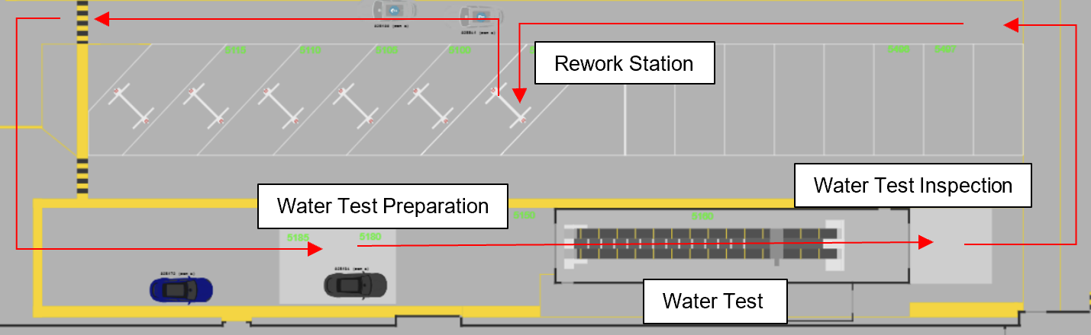
Figure 1 - Water Test Rework Process Map
From the water test process a general understanding of where the failure is occurring can be determined. However, certainty on the cause of the water leaks can often be unclear with a variety of faults potentially responsible.

This project has a variety of customers where some of the main customers are Water Test, Pass to Sales, Customer Perception Audit (CPA) and the consumers who have purchased the vehicle. By taking the Voice of Customer (VoC), insight into how the customers is impacted by the problem can be gained. The overall consensus from the customers is that the increase in DPV for water leaks has customers questioning the quality of the vehicles being manufactured and wanting to understand as to what are the key contributors and the potential actions that can be taken to improve the overall quality of vehicles and reduce the DPV that has been observed at Water Test, with Water Test noting that the tailgate of the vehicle has become a problematic area recently. Moreover, Water Test feel DPV that is being assigned against them is caused from issues earlier in the assembly process such as geometric problems, poor part fitment and design alongside processing faults, causing additional processing time to rework and verify that the corrective action taken has eliminated the issue.

From discussions with the customers an outline of what is critical to quality (CTQ) to the customer can be made. Where the wants of the customer are to understand the key contributors for the water leaks in the tailgate area of the vehicle and identify corrective actions which could be taken to reduce the volume of vehicles failing Water Test. To measure the success of the project and meeting the customer want a target of 1.00 Average Water Test DPV or below and the percentage of vehicle first time through (FTT) for the top 5 Water Leak issues to be greater than 90%. To further breakdown the customer wants identified through the VoC a CTQ tree has been created to outline the key characteristics that will be investigated as part of this project and the associated data that will be utilised shown below in Figure 2.

Figure 2 - CTQ Tree
The CTQ tree identifies the key areas of investigation for water leaks being, occurrence of the issue using FLAGs data and fault investigations through process review, part measurement data and the associated rework costs through hidden factory cost analysis. These characteristics will form the basis of the investigations conducted throughout the project to ensure both quality and cost impacts of water leaks are understood and considered when implementing corrective actions.

Based on the VoC and CTQ the project will highlight the key contributors to Water Test DPV and will be considered successful by a reduction in the average DPV at Water Test and an increase in the percentage of vehicles that are FTT. The impact of the project will be observed in FLAGs where data will be logged and compared to past DPV scores and the percentage of vehicles FTT to illustrate if the changes have been effective.

To ensure that the project is achievable within a realistic timeframe a project scope has been created using an Is – Is Not analysis
- Is In Scope
  - Water Test DPV categorised as Water Leaks
  - Investigate root cause and where applicable implement corrective actions related to contributing areas liaising with appropriate departments
  - Review historical FLAGs data to understand past performance of the issue and understand timeline of any changes that might be relevant
- Is Not In Scope
  - Any FLAGs Water Test DPV related to missing/incorrect components or inherited geometry issues are not to be considered.
  - FLAGs data prior to September 2024 due to relevance of data being reviewed as this is when major changes were made to the DBX.
  - Reported Water Leak issues outside of the Top 5 will not be considered for investigation with priority placed on higher occurring issues
With the projects scope outlined, SMART objectives can be defined to provide clear and measurable goals that determine the successful completion of the project. The project will be considered complete when both of the following conditions are met:
- Average Water Test DPV is below 1.00
- The percentage of vehicles FTT relating to the top 5 water test issues is above 90%
Or if the key contributors of Water Test DPV have been fully reviewed and appropriate corrective actions have been identified and are in place.

This project involves several stakeholders across multiple departments. The departments who are affected by the project include Production, CPA, Current Model Engineering (CME), Vehicle Line Quality (VLQ), PTS, Production Improvement Engineering (PIE), Metrology, Manufacturing Business Office (MBO) and the Consumer. Of the affected departments, Production, CME, VLQ, PIE, Metrology and MBO will have a level of control over the project and will form the core of the project team.

To successfully deliver the project within a 3 month timeframe and understand the increase in DPV at Water Test, the available FLAGs data will be reviewed to identify what are the top contributors to Water Test DPV. Once the key contributors have been established, investigations will be conducted and where applicable corrective actions will be implemented in liaison with the relevant departments once an understanding of the top issues has been established. The impact of any corrective actions taken will be monitored through Water Test, where FLAGs data will be reassessed to understand the improvements made and compared against the SMART objectives to determine whether the project has been successful.

A summary of the project as defined above, including the problem statement, business case, objectives, stakeholders and project plan is captured in the project charter found in Figure 3.
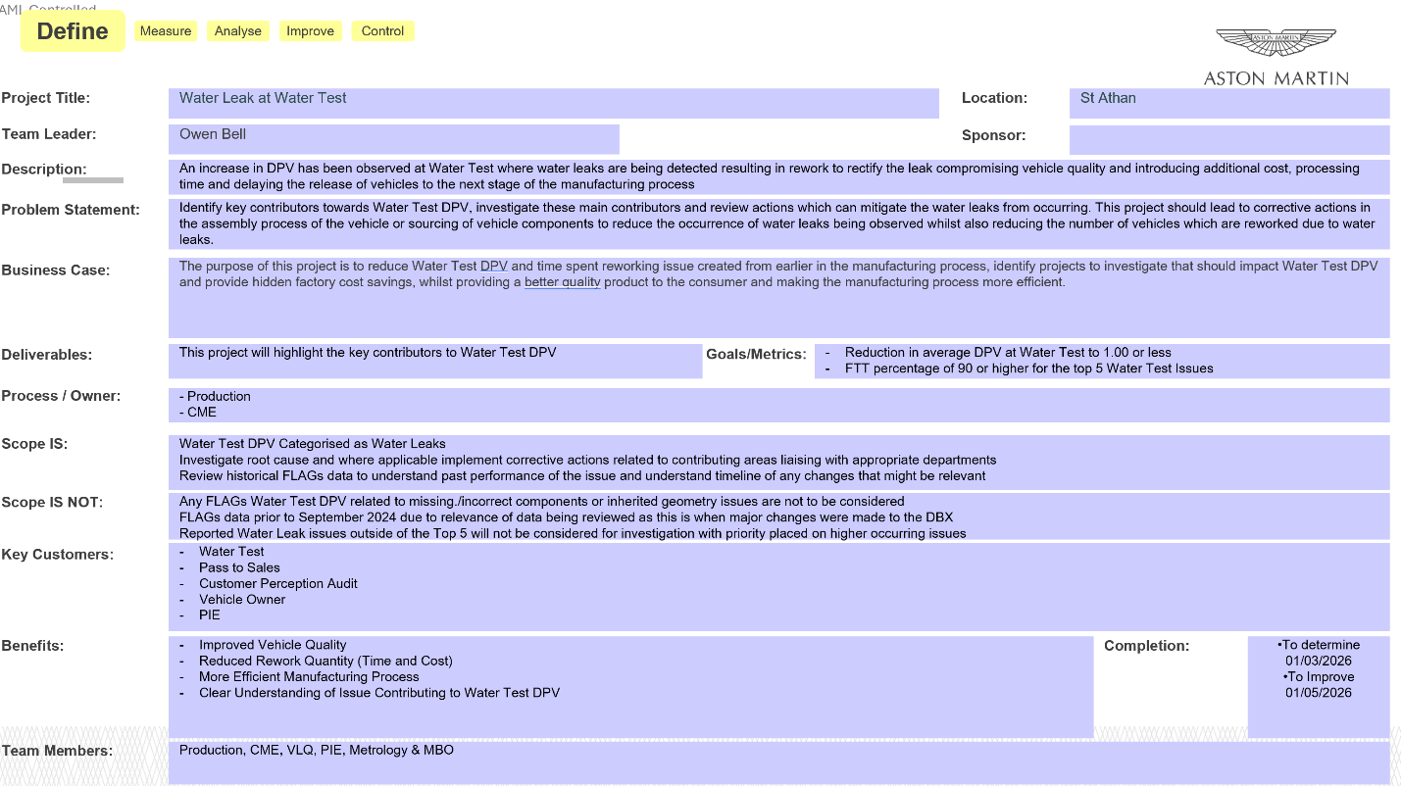
Figure 3 - Project Charter (Aston Martin Lagonda Ltd, 2026)

Measure
FLAGs can be used to find the Average DPV of Water Test and the percentage of vehicles which have been FTT (%OK) to provide a high level summary of the issues detected at Water Test and logged by production & PIE. FLAGs data is classed as attribute data, with defects at water test recorded on a pass/fail basis. However, the accuracy of this data is dependent on technician judgement and quality of inspection introducing potential sources of variation. These variations include technician to technician variation where different technicians may categorise the same defect differently. Additionally, the logging of water leaks is subjective as FLAGs data records the causal area or part rather than the location where water is found, where multiple factors could contribute to the water leak and the categorisation is down to technician judgement. Furthermore, underreporting is possible where defects are not captured due to inconsistent inspection, or rework being performed without being inputted into FLAGs. These factors should be acknowledged when interpreting the data, the issues reported require investigation, but additional faults may exist that are not currently being detected by the process. Should the reliability of the FLAGs data be questioned during investigations with suitable measures already in place, an attribute agreement analysis could be performed to assess the agreement between technicians when categorising water leak defects, this would provide a score to determine if the FLAGs data is a reliable basis for determining which investigations should be prioritised.

A Pareto chart was used to prioritise the most significant water leak issues recorded at Water Test within FLAGs with Brooks (2014) noting the tool “helps prioritise decisions by highlighting which decision will have the greatest influence on the goal and what will have the least impact”. Analysing the FLAGs data from 29th October 2025 to 20th January 2026 a total of 484 water leaks were logged, of which 166 were attributed to the Tow Bar Blanking Grommets making up 34.29% of all reported water leaks see Figure 4.

Figure 4 - Pareto of Water Leak Issues at Water Test
With the Tow Bar Blanking Grommet identified as the highest contributing causal area for water leaks, an Ishikawa diagram was produced to map the potential causes for water leaks occurring at the Tow Bar Blanking Grommet see Figure 5 below.
Man
Material
Machine
Method
Incorrect Orientation of Grommet
Grommet not Flush to Panel
Poor Operation of Tooling
Incorrect Tooling
Grommet Material Quality
Grommet Dimension not in Specification
Dimension of Hole in Body Panel
Verification of Fitment
Suitability of Process
Water Leaks occurring at the Tow Bar Blanking Grommet
Figure 5 - Tow Bar Grommet Ishikawa
Building from this, the project team developed a data collection plan structured around both the Ishikawa and the CTQ characteristics previously identified see Figure 2. The plan covers key areas such as part measurement and tolerance validation, process review at point of fit and rework and hidden factory cost analysis.
To determine whether the Tow Bar Blanking Grommets meet specification, engineering drawings will be reviewed by the VLQ and Metrology to validate functional tolerances and design suitability. Supplier part data will also be reviewed to validate the grommets material and property data meets specification. The dimensions of the grommet are variable data, by performing a Gauge R&R it can be determined whether any observed variation in part measurements is attributable to the operator or is down to genuine part variation. The results of the Gauge R&R will be evaluated against the industry standard acceptance threshold according to Dian and Hodinář (2018), where below 10% study variation is considered acceptable, 10% to 30% is marginally acceptable and above 30% is deemed unacceptable, when determining the reliability of the measurements taken. The outcome of this activity will provide part capability highlighting if the grommet dimensions fall within the defined tolerance and confirming the suitability of the grommets.

To understand if water leaks in the Tow Bar Blanking Grommet area are attributable to poor processing, a review at the point of fit will be performed by CME, Production, MBO, VLQ & PIE. This review will assess whether the grommet is fitted flush and sealing the impacted area identify any containments that are currently in place and evaluate their effectiveness, with FLAGs data used to contextualise the current process state and provide a timeline of the impact previous changes have had in relation to preventing water leak occurrences. Moreover, the project team will examine additional assembly stages that impact the Tow Bar Blanking Grommet and could result in water ingress in the affected region.

To analyse the hidden factory costs associated with the Tow Bar Blanking Grommet water leaks, rework data will be captured by Production, PIE, MBO & VLQ. FLAGs can be utilised to take the Mean Time to Repair, providing an indicator of the average time taken to rework an occurrence of a water leak. However, this variable data is manually entered by the technician making the accuracy of this data subject to the same reliability considerations as other manually logged FLAGs data such as the categorisation of water leaks and should be treated as an approximation rather than an exact representation of the time taken. The time taken to reprocess the vehicle through Water Test following rework will be provided by MBO, with the assumption that the vehicle has no further faults when reprocessed and the rework is successful. Alongside the time based costs, the parts and material costs consumed during the rework will be recorded to establish an average cost per occurrence for reworking the Tow Bar Blanking Grommet. If containments are in place at the point of fit, a cost analysis will also be performed, capturing the additional time and material cost associated by carrying out the containment, as this represents a hidden cost not reflected within the standard process. This data will contribute to calculating an accurate HPC for the Tow Bar Blanking Grommet and support the business case for improvements to be implemented.

Analyse
Following on from the data collection activities discussed in the Measure phase, the findings of each activity to identify root causes of the water occurring at the Tow Bar Blanking Grommet will be reviewed.

Starting with the build process where a review at point of fit was conducted. The current process involves fitting a PVC grommet to each of the holes in the body panel with the larger surface on the outer surface of the vehicle by hand. This grommet is fitted to both sides if the vehicle is a Non Tow Bar Vehicle. However, if the vehicle is a Tow Bar vehicle one blanking grommet is fitted to the passenger side and a towing loom grommet is fitted to the driver side. The review performed by the project team assessed whether the grommet is fitted flush to the panels surface and properly sealing the impacted area, ensured the orientation of the grommet was correct and identified any assembly stages post point of fit that would impact the quality of the seal. The project team’s review of the grommets orientation confirmed that the fitment was correct with the larger surface of the grommet consistently positioned on the outer surface of the panel as per the process. Furthermore, the assembly stages post point of fit were confirmed to have no impact to the quality of the seal, eliminating both orientation and downstream assembly processes as contributing sources of variation to water leak occurrences from the Tow Bar Blanking Grommet.

However, the project team noted a containment process had recently been introduced where grey sealant was applied around the grommet edges to ensure water leaks could not occur at Water Test from the Tow Bar Blanking Grommets with MBO noting the containment introduced an additional minute of processing time per car.

To understand the introduction of the containment, the history of changes relating to the Tow Bar Blanking Grommets needed to be understood first, approximate dates of these changes were provided by production and PIE which matched changes seen in FLAGs relating to the performance of water leaks in the Tow Bar Grommet area.
The changes previously made included the material change of the Grommet originally made from EPDM to PVC where FLAGs data showed that 141 of 1023 (13.78%) vehicles had an EPDM Tow Bar Grommet fail at water test and 154 individual grommets had a water leak with some vehicles having both grommets fail see Figures 6 & 7.

Figure 6 - EPDM Tow Bar Grommet FLAGs Pie
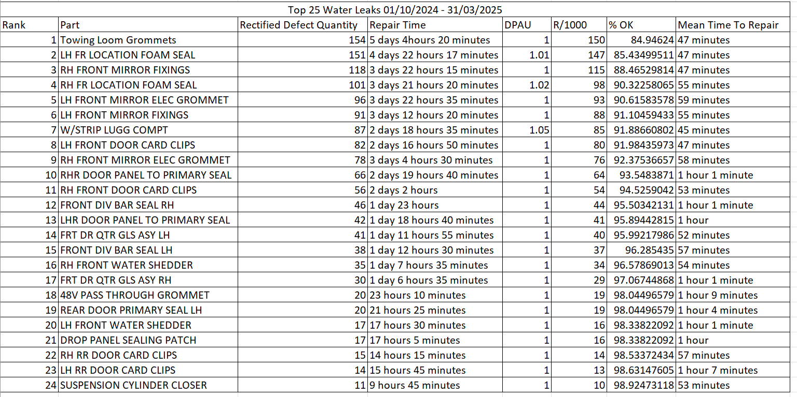
Figure 7 - EPDM Tow Bar Grommet FLAGs Data
Following the introduction of the PVC grommet over 82 vehicles was found to have 0 Tow Bar Blanking Grommet water leaks see Figures 8 & 9 resulting in the change of grommet fitted.

Figure 8 - PVC Tow Bar Grommet Introduction FLAGs Pie
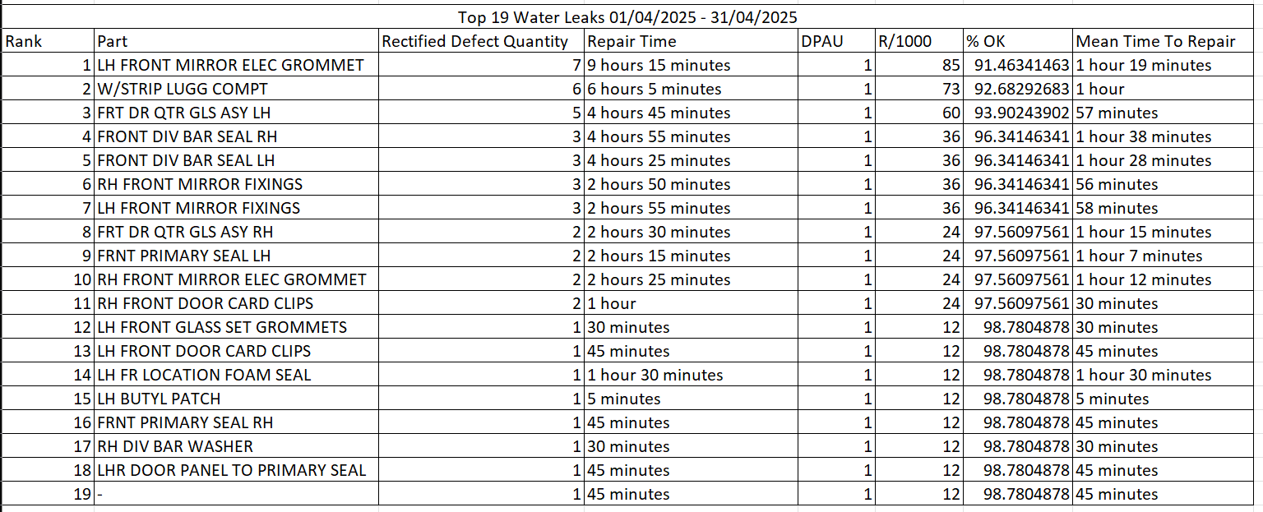
Figure 9 - PVC Tow Bar Grommet Introduction FLAGs Data
However, water leaks then reoccurred in the Tow Bar Blanking Grommet area where 140 of 382 (36.65%) of vehicles had a Tow Bar Grommet water leak and 166 Tow Bar Grommets had failed to prevent a water leak with failures seen on both sides for a few vehicles shown in Figures 10 & 11.

Figure 10 - PVC Tow Bar Grommet FLAGs Pie
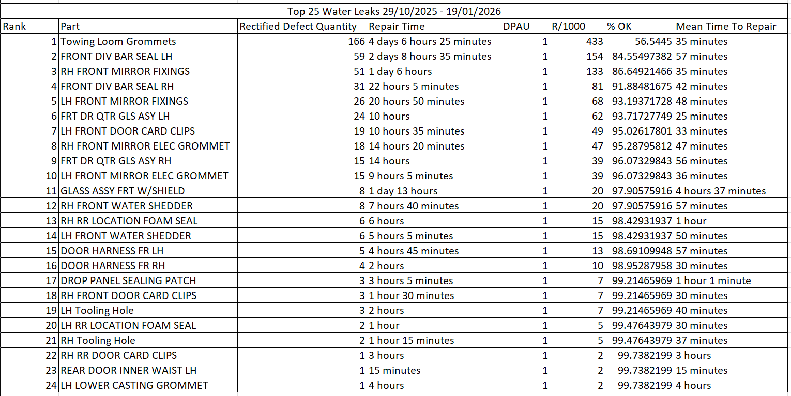
Figure 11 - PVC Tow Bar Grommet FLAGs Data
As the grommets were now failing to prevent water leaks with a water leak being present on over 1/3 of vehicles in the Tow Bar Grommet area, a containment was introduced where over 52 vehicles had no water leaks from the Tow Bar Grommets as seen in Figures 12 & 13.

Figure 12 - PVC Tow Bar Grommet w/Containment FLAGs Pie
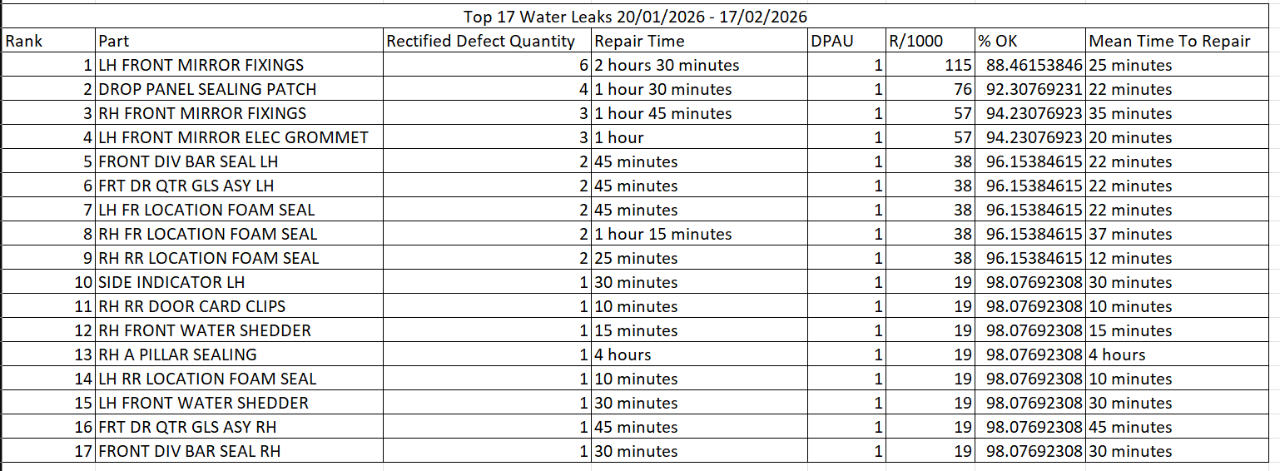
Figure 13 - PVC Tow Bar Grommet w/Containment FLAGs Data
Reviewing the FLAGs data a clear understanding as to why changes were previously made to the Tow Bar Grommets can be gained with the FLAGs data providing justification for the containments introduction.

Further justification for the containments introduction can be made from a financial perspective by carrying out a cost benefit analysis comparing the cost of reworking Tow Bar Grommet water leaks against completing the containment. Taking the Mean Time to Repair a Tow Bar Grommet Water Leak of 35 minutes from Figure 11, which includes the reprocessing time through water test and applying a technician rate of £34.69 per hour provided by MBO, the labour cost per Tow Bar Grommet rework equates to £20.24. In addition to the labour cost, the parts consumed during the rework amounts to 62p with three butyl patches fitted, see Appendix A-A for supporting data, giving a total rework cost per occurrence of £20.86. To understand the cost per vehicle if the percentage of vehicles which had a Tow Bar Grommet water leak before the introduction of the containment which was 36.65% and apply this to the total rework cost per occurrence, the rework cost per vehicle is approximately £7.65. However, since the containments introduction this rework is no longer present as shown in Figure 13 and has been replaced with the containments cost, as previously mentioned the time to perform the containment was noted as 1 minute making the labour cost of the containment equal 58p, additionally the cost of parts and materials used during the containment equals approximately 0.3p per vehicle with the cost of material shown in Appendix A-B where approximately 2500 PVC grommets can be sealed resulting in a total containment cost per vehicle of approximately 58.3p. From the cost benefit analysis, it demonstrates that the introduction of the containment provides a saving of approximately £7.07 per vehicle providing further justification for the containments introduction.

Moreover, the FLAGs data shows that the EPDM grommet demonstrated a lower failure rate than what was being observed with the PVC grommet prior to the introduction of the containment, with 13.78% of vehicles failing compared to 36.65% with the PVC grommet. However, the reason as to why the Tow Bar Grommet is no longer capable of sealing the hole without the containment is unknown.

To assess the Tow Bar Grommet and the risk of it failing to seal a Failure Mode and Effects Analysis (FMEA) was conducted, see Figures 14 – 17 and see Appendix B for scoring guidelines. The purpose of an FMEA is that it provides “a systematic method of identifying and preventing process problems” (Mikulak, McDermott and Beauregard, 2017).
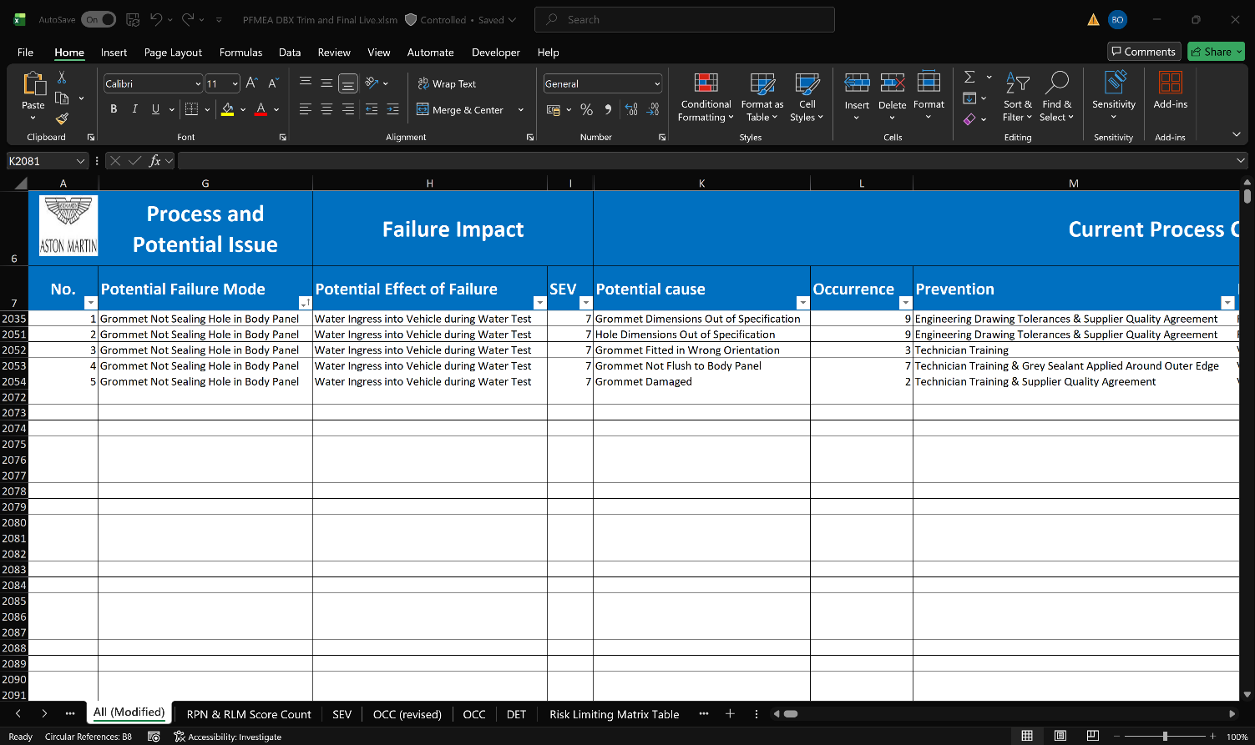
Figure 14 - Tow Bar Blanking Grommet FMEA 1/4 (Aston Martin Lagonda Ltd, 2026)
Figure 15 - Tow Bar Blanking Grommet FMEA 2/4 (Aston Martin Lagonda Ltd, 2026)
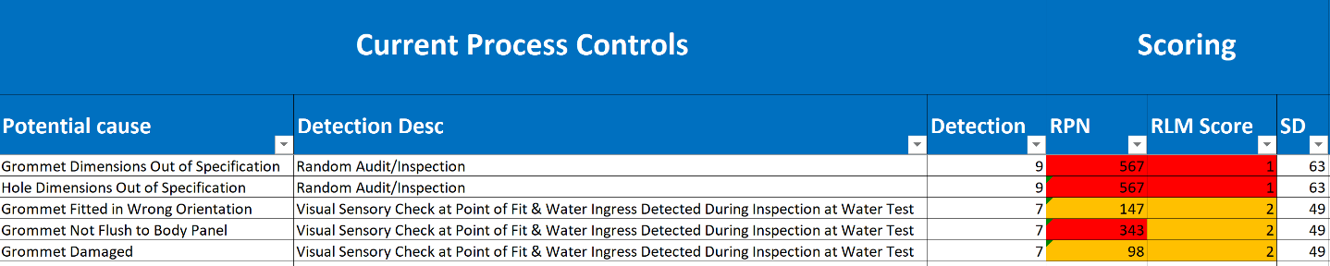
Figure 16 - Tow Bar Blanking Grommet FMEA 3/4 (Aston Martin Lagonda Ltd, 2026)
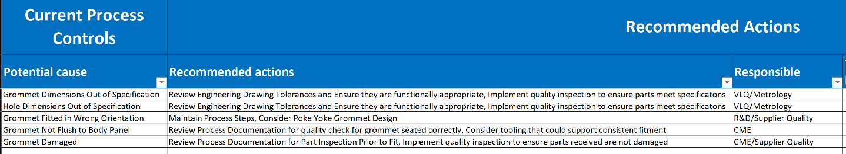
Figure 17 - Tow Bar Blanking Grommet FMEA 4/4 (Aston Martin Lagonda Ltd, 2026)
The FMEA resulted in several potential causes for the grommets failing to seal with the highest scoring items relating to the dimensional suitability of the parts and the capability for the part to be fitted flush to the body panel, with the FMEA highlighting that the actions in place do not address the root cause of the problem despite the effectiveness of the containment in preventing water leaks being observed at Water Test.

Following from the FMEA displaying that the potential causes for the grommet failure are most likely related to the dimensions of the grommets prompting a Gauge R&R of the tailgate hole, the EPDM and PVC grommets where a sample size of 10 of each part was measured by VLQ and Metrology using a shadowgraph and vernier in line with the agreed upon data collection plan with the results shown in the Figures 18 - 20 and supporting data found in Appendix C.
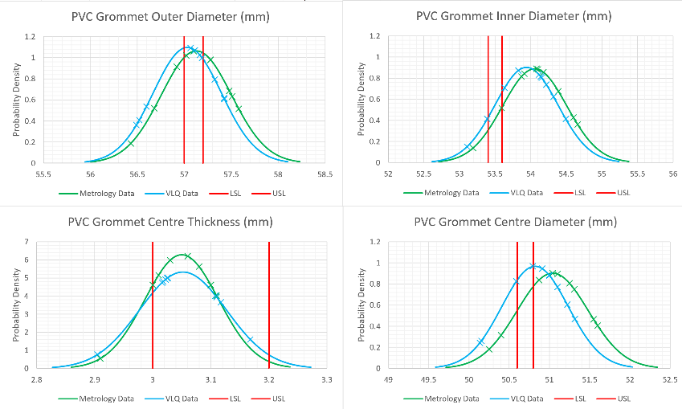
Figure 18 - PVC Grommet Bell Curve Charts

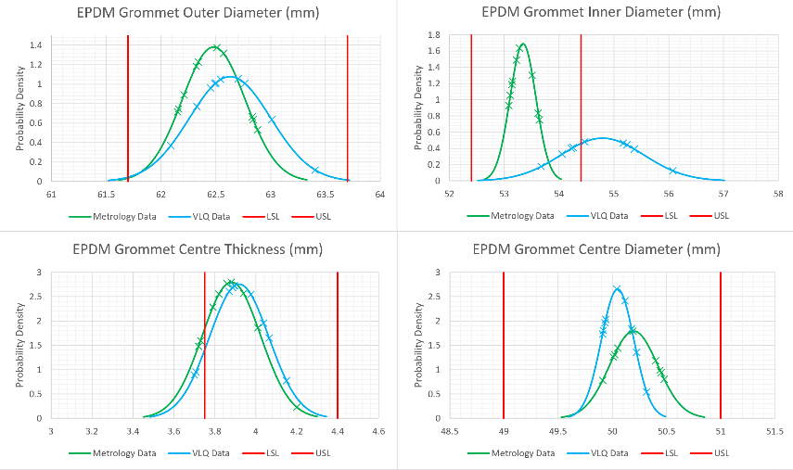
Figure 19 - EPDM Grommet Bell Curve Charts
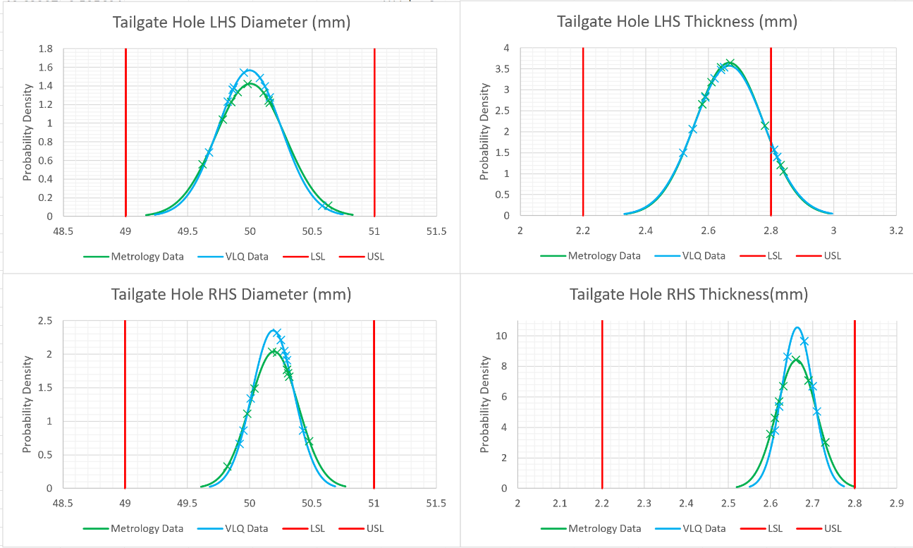
Figure 20 - Tailgate Lid Bell Curve Charts
Reviewing the measurement data, the PVC grommet shows consistently poor capability across both the Metrology and VLQ datasets with Cp and Cpk values significantly below 1.0 across all dimensions and various Cpk values returning negative, indicating the mean value is outside of the specification limits as shown in Figure 18. Whilst the PVC grommet cannot meet the defined specification, it should be noted that the tolerances applied are extremely tight and the poor Cp and Cpk values could be a result of unsuitable tolerances.

In contrast the EPDM grommet displayed significantly better dimensional capability across both datasets with Cp and Cpk values above or close to 1.0 demonstrated in Figure 19. However, a difference can be seen for the Inner Diameter amongst the datasets which can be attributed to operator variation when taking the measurements.

The Tailgate Hole dimensions showed consistent results across both datasets with the diameter dimensions returning acceptable Cp and Cpk values above 1.0 for both LHS and RHS illustrated in Figure 20. Contrastingly, the thickness dimensions displayed a notable drop in Cp and Cpk values, with Cp near 1.0 demonstrating the part is dimensionally capable in most instances but the lower Cpk values suggest the parts dimensions are not well centred in the tolerance range.

Overall, the similarity between the Metrology and VLQ datasets across each component provides confidence in the reliability of the measurement data despite the discrepancy previously noted, with the data highlighting that the PVC grommet has poor dimensional capability against its specification, particularly when compared to the EPDM grommet which shows significantly better capability for the same dimensions. Furthermore, the EPDM can be considered more dimensionally suitable with the centre diameter being closer to the Tailgate Hole diameters and a greater outer diameter providing the EPDM grommet more contact to the surface of the tailgate. However, a likely factor for why water leaks occurred when either grommet was fitted previously is the centre thickness with both the PVC and EPDM grommet being far greater than the thickness of the tailgate hole suggesting the grommets are not fitted flush to the tailgate. The findings from the measurement data are consistent with the FMEA which identified the dimensional suitability of parts and the capability to fit the grommet flush to the body panel as the highest scoring failures.

Following the completion of the data collection plan and analysis of the relevant data a 5 Whys analysis was conducted to identify the root cause of the water leak occurrences from the Tow Bar Blanking Grommet shown in Figure 21. The purpose for using the 5 why analysis tool is “that it systematically delves into the root cause of an issue by asking the question Why? Typically, 5 times or until the fundamental cause is discovered” (Majka, 2024)

Figure 21 - Tow Bar Grommet Water Leak 5 Whys
The 5 Whys analysis performed identified the root cause of the water leaks occurring at the Tow Bar Blanking Grommet to be the unnecessary presence of holes in the tailgate body panel with the hole only required on the driver side of tow bar vehicles to fit the towing loom grommet. However, the current part design results in holes being present on both sides of vehicles regardless of vehicle options introducing avoidable risk of water ingress occurring.

Improve
Following the identification of the root cause and the data collection plan, two improvements were identified to address the water leaks at the Tow Bar Grommet.

The first improvement is the optimisation of the containment in place by moving its application into the Body process and replacing the PVC grommet with the EPDM grommet. This change is supported by the historical FLAGs data suggesting EPDM is a more effective grommet with a lower percentage of vehicles failing at water test and the measurement data displaying the EPDM grommet as a more suitable part to seal the tailgate hole.

Previously this was not possible with the PVC grommet’s material properties not capable of passing through the paint ovens without compromising the part integrity whilst the EPDM grommet is able to withstand the heat intensive paint process and maintain part integrity proven with the FLAGs data shown below in Figures 22 & 23, where no water leaks were recorded.
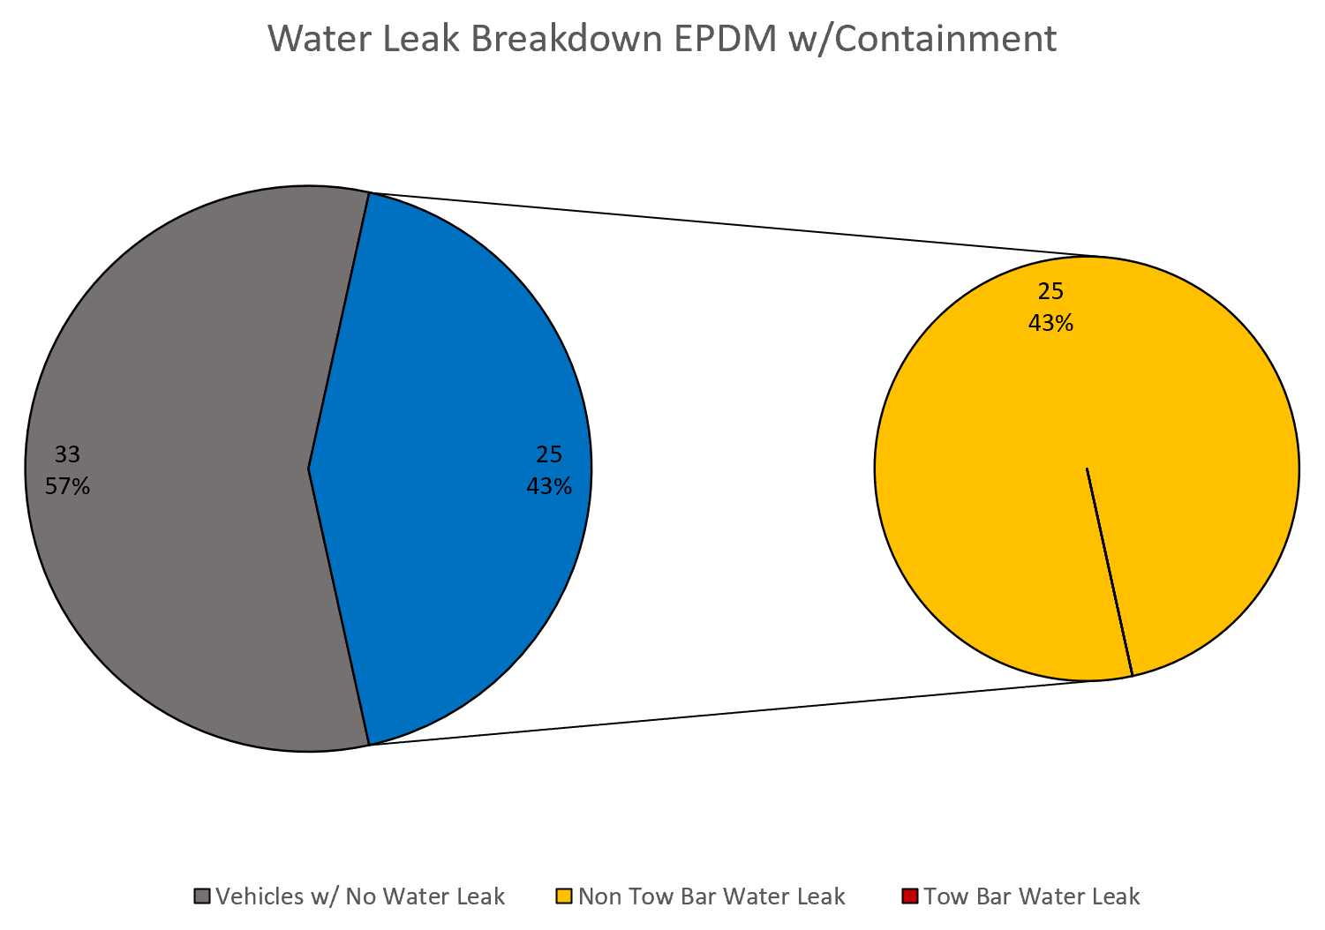
Figure 22 - EPDM Tow Bar Grommet w/Containment FLAGs Pie
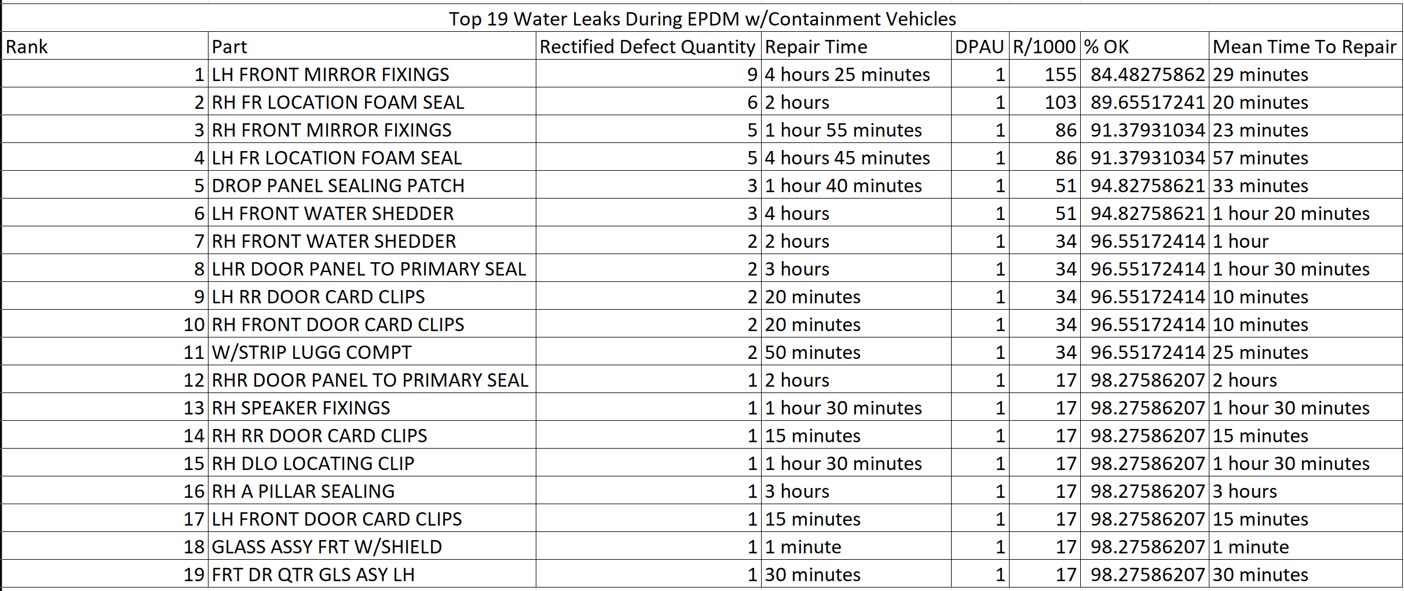
Figure 23 - EPDM Tow Bar Grommet w/Containment FLAGs Data
By making these changes a time save of 54 seconds was noted by MBO with the tooling and sealer used in the containment already incorporated in the body technician’s process providing a labour cost save of 52p per vehicle and a further 6p per grommet fitted providing an approximate further 64p saving per vehicle, in addition to the £7.07 per vehicle saving achieved by the containments introduction previously discussed in the Analyse phase.

The second improvement identified is the use of multiple tailgate parts to eliminate the root cause identified from the 5 Whys see Figure 21. The proposed improvement would introduce three tailgate variants, one without a hole for non tow bar vehicles and two with a single driver side hole for tow bar vehicles (LHS & RHS) where the towing loom grommet would be fitted.

By eliminating the unnecessary holes in the tailgate, the risk of water ingress from the holes is removed, with the blanking grommets and sealer containment no longer required, representing a permanent solution and replacing the first improvement when implemented.

The implementation of the tailgate variants would eliminate the remaining 6.3p labour cost for carrying out the containment and remove the EPDM grommet cost of £1.20 per vehicle. Moreover, the cost of the tailgate lid should remain the same as the same supplier would be used and the part variants would not introduce any additional processing or tooling, this would result in a total cost save of approximately £8.97 per vehicle from the beginning of the investigation upon the implementation of multiple tailgate variants, see Appendix D for full cost breakdown.

Based on the improvements identified the FMEA was updated to display the impact the improvements have on the risk associated with the Tow Bar Blanking Grommets see Figure 24.
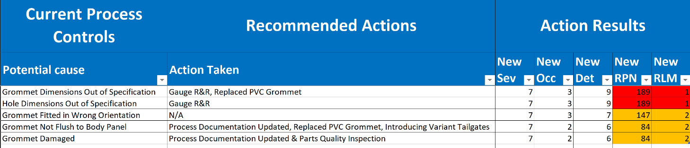
Figure 24 - Tow Bar Blanking Grommet Updated FMEA Scores (Aston Martin Lagonda Ltd, 2026)
With the change of the grommet a reduction in the RPN scores for the grommet not being fitted flush and the grommet dimensions can be observed, with the EPDM grommet providing superior dimensional capability which assists in achieving consistent flush fitment to the tailgate panel. Furthermore, the planned implementation for variant tailgate lids reduces the RPN scores further as the improvement will eliminate the presence of unnecessary holes and the need to fit Tow Bar Blanking Grommets entirely.

Control
To implement and control the introduction of the tailgate part variants and act as an effective permanent solution, option codes will be used to ensure the correct tailgate is fitted to the correct vehicle. This will be done through a part verification (PV) scan where the tailgate variant will be scanned at point of fit and compared against a list of parts assigned to the vehicle to confirm the correct tailgate has been selected. Adding option codes to each tailgate variant ensures only the correct tailgate variant will be possible to PV to the vehicle with the option codes being non tow bar, left hand drive coupled with tow bar and right hand drive coupled with tow bar. This eliminates the risk of technicians selecting and scanning the incorrect tailgate variant, with the technicians also unable to complete their process unless all PV scans have been correctly completed.

To understand if the project has been successful the performance of the improvements implemented was assessed against the SMART objectives outlined during the Define phase, where the criteria to be considered successful was for the average Water Test DPV to fall below 1.00 and the percentage of vehicles FTT for the top 5 water leak issues to be greater than 90%.

Reviewing the FLAGs data following the implementation of the containment in body, the average Water Test DPV was 0.84 and the percentage of vehicles FTT for the top 5 issues was 90.34% meeting both SMART objectives and confirming the actions implemented have been effective in reducing water leak occurrences at the Tow Bar Blanking Grommet and improving the quality of vehicles provided to the customer, see Figure 23 & Appendix E for supporting FLAGs data.

Bibliography
Brooks, C. (2014). What Is a Pareto Analysis? [online] Burke Advisory. Available at: https://www.burkeadvisory.com/wp-content/uploads/2018/07/What-Is-a-Pareto-Analysis.pdf [Accessed 3 May 2026].
Dian, M. and Hodinář, L. (2018). The GRR a Fundamental Tool for Dealing with Measurement System Variability. Manufacturing Technology, [online] 18(1), pp.29–34. doi:https://doi.org/10.21062/ujep/48.2018/a/1213-2489/mt/18/1/29.
Majka, M. (2024). Mastering Root Cause Analysis with the 5 Whys Method. [online] Research Gate. Available at: https://www.researchgate.net/profile/Marcin-Majka-2/publication/385047019_Mastering_Root_Cause_Analysis_with_the_5_Whys_Method/links/6712e8cc68ac3041499f1ca4/Mastering-Root-Cause-Analysis-with-the-5-Whys-Method.pdf [Accessed 3 May 2026].
Mikulak, R.J., McDermott, R. and Beauregard, M. (2017). The Basics of FMEA. [online] Google Books. Available at: https://books.google.co.uk/books?hl=en&lr=&id=6_gvEQAAQBAJ&oi=fnd&pg=PP7&dq=What+is+an+FMEA&ots=8m5Dgxcwco&sig=6CfPm_n_n87Yw7v5C9CoCIKISA0#v=onepage&q=What%20is%20an%20FMEA&f=false [Accessed 2 May 2026].

Appendix A: Containment and Rework Material Costs

Appendix A-A: Butyl Patch Cost per Unit
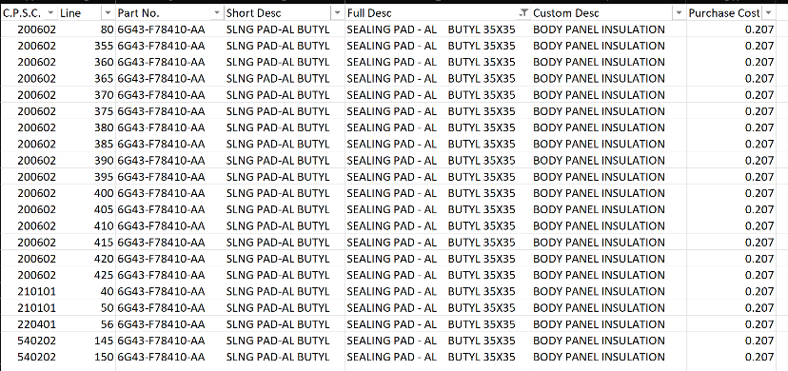

Appendix A-B: Betafill Sealer Cost (12 x 600ml)
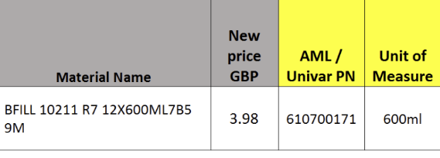

Appendix B: FMEA Guidelines (Aston Martin Lagonda Ltd, 2026)

Appendix B-A: Severity Ranking
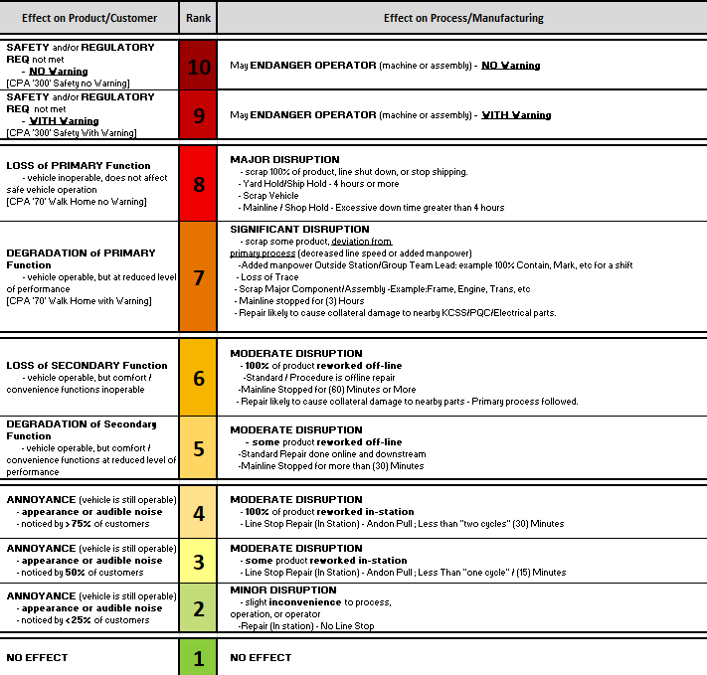

Appendix B-B: Occurrence Ranking
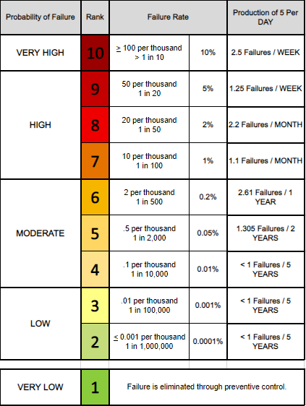

Appendix B-C: Detection Ranking
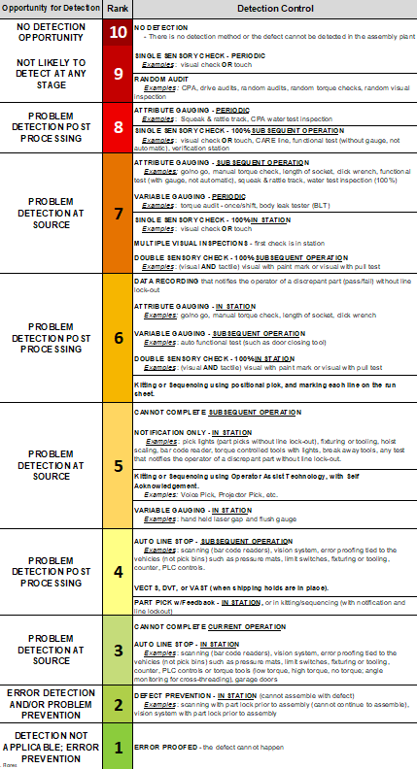

Appendix B-D: Risk Limiting Matrix Scoring
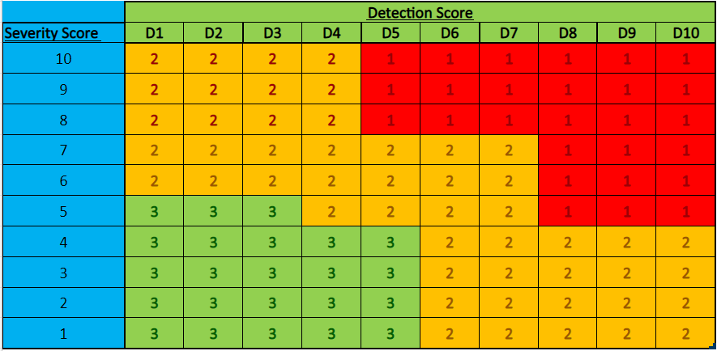

Appendix C: Gauge R&R Data

Appendix C-A: Metrology PVC Grommet Data Table
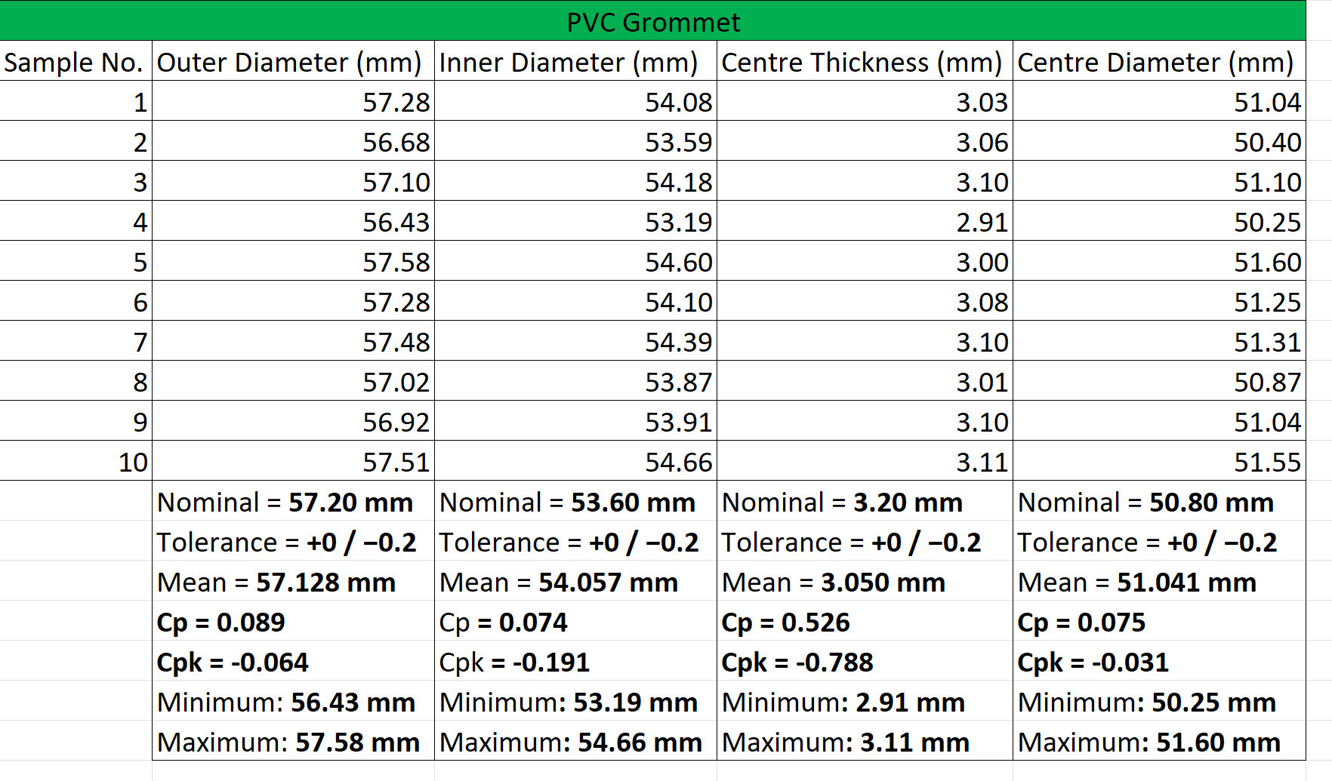

Appendix C-B: Metrology EPDM Grommet Data Table
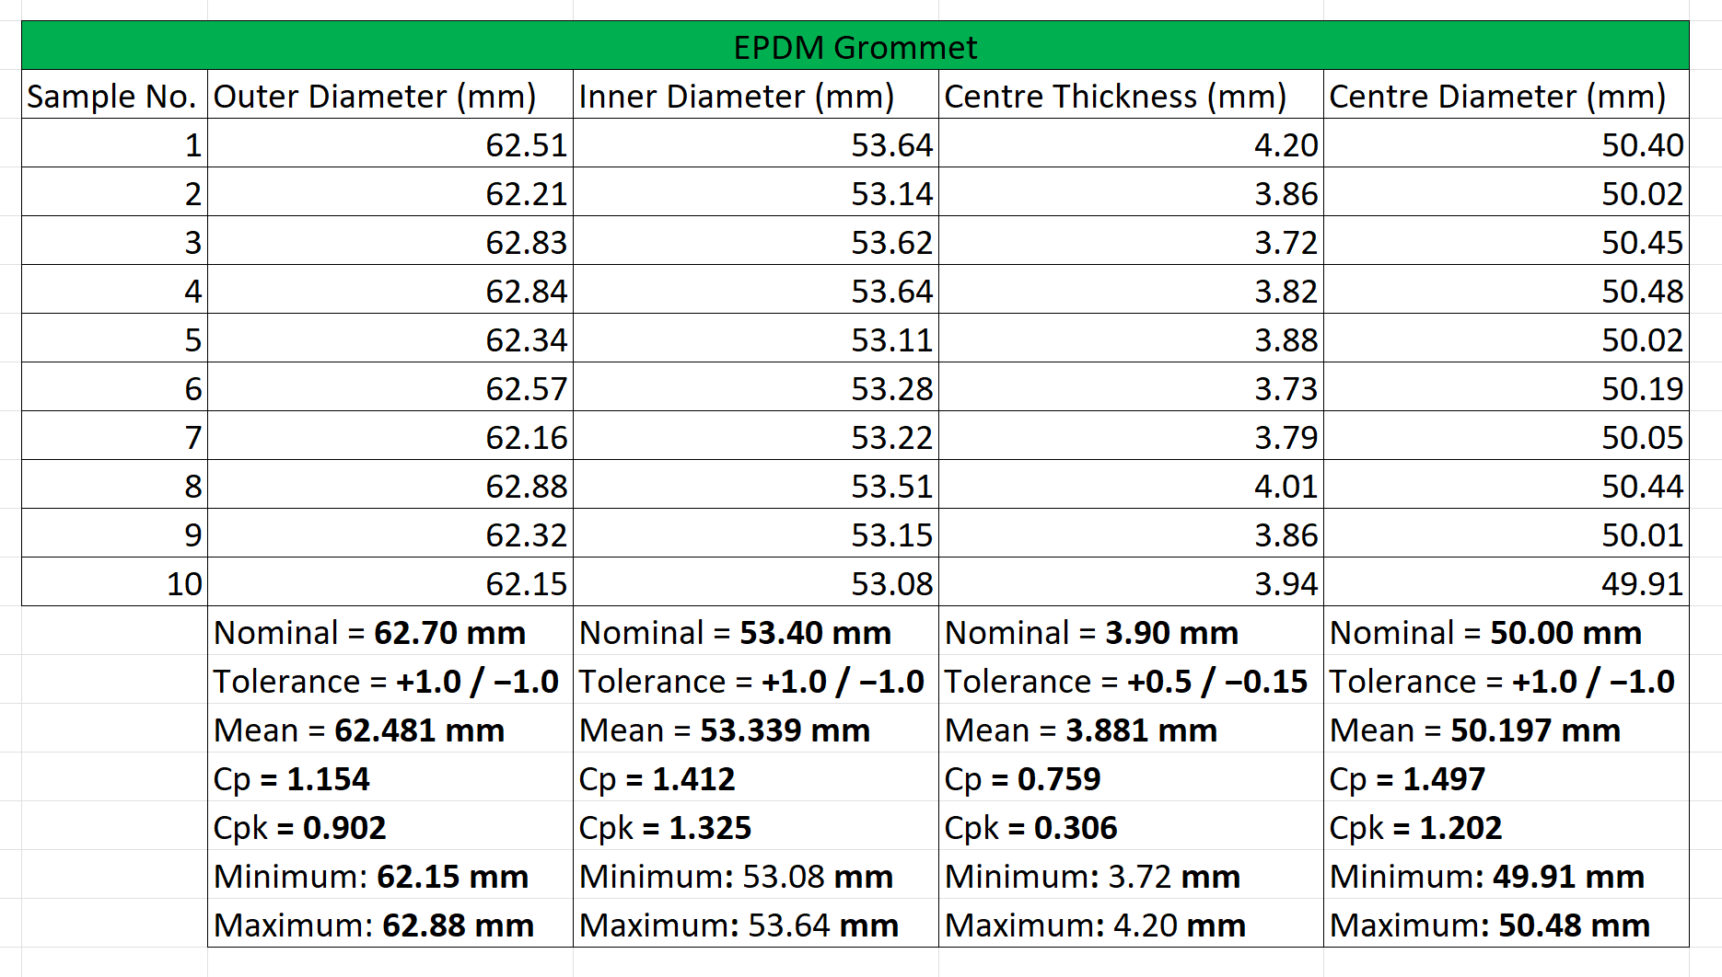

Appendix C-C: Metrology Tailgate Lid Data Table
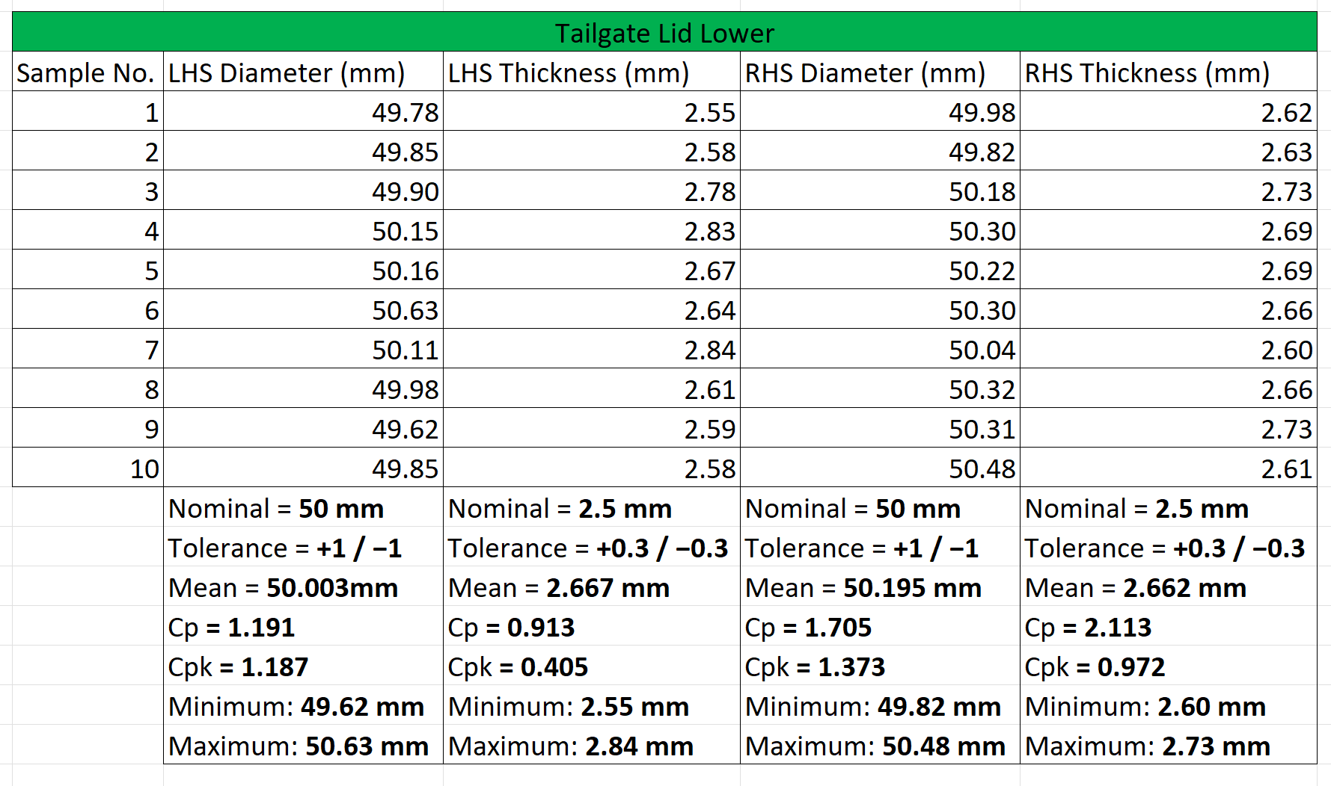

Appendix C-D: VLQ PVC Grommet Data Table
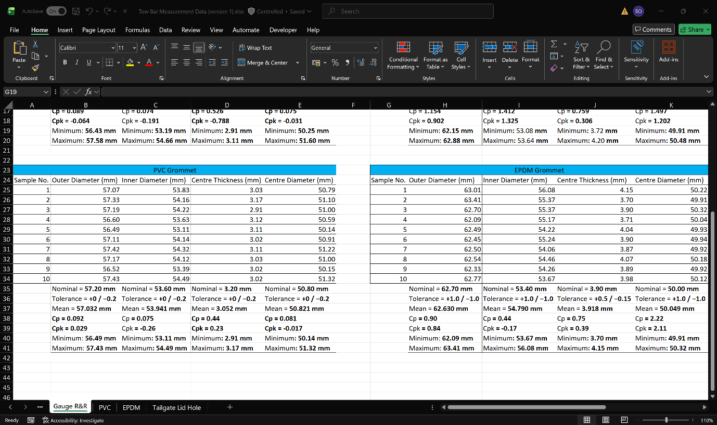

Appendix C-E: VLQ EPDM Grommet Data Table

Appendix C-F: VLQ Tailgate Lid Data Table
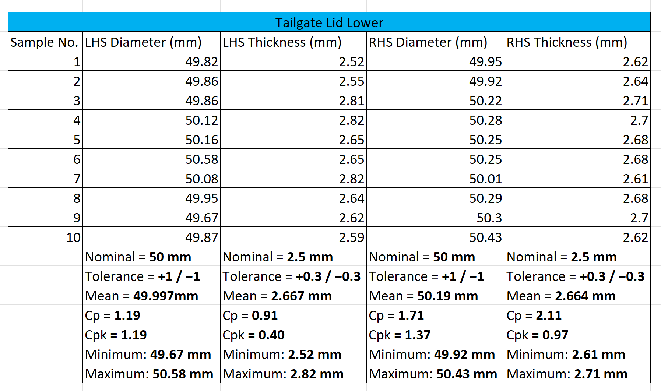

Appendix C-G: PVC Grommet Engineering Drawing
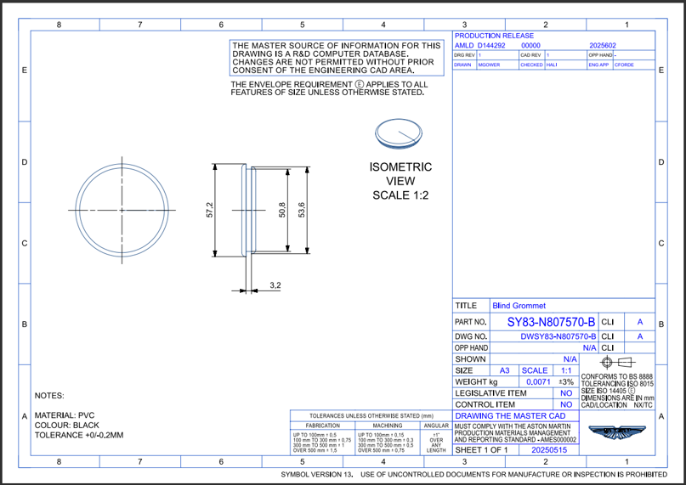

Appendix C-H: EPDM Grommet Engineering Drawing
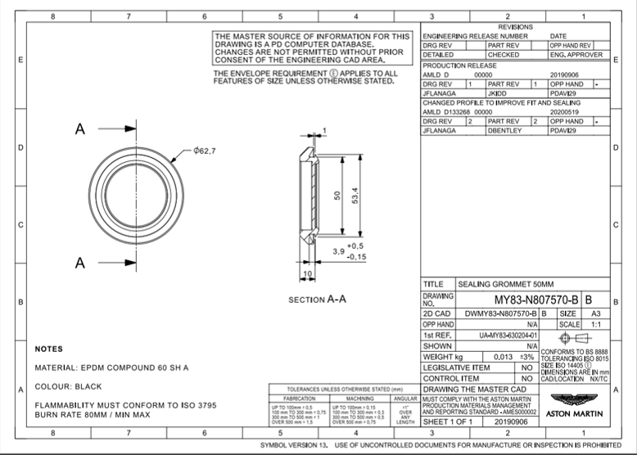

Appendix C-I: Tailgate Lid Engineering Drawing
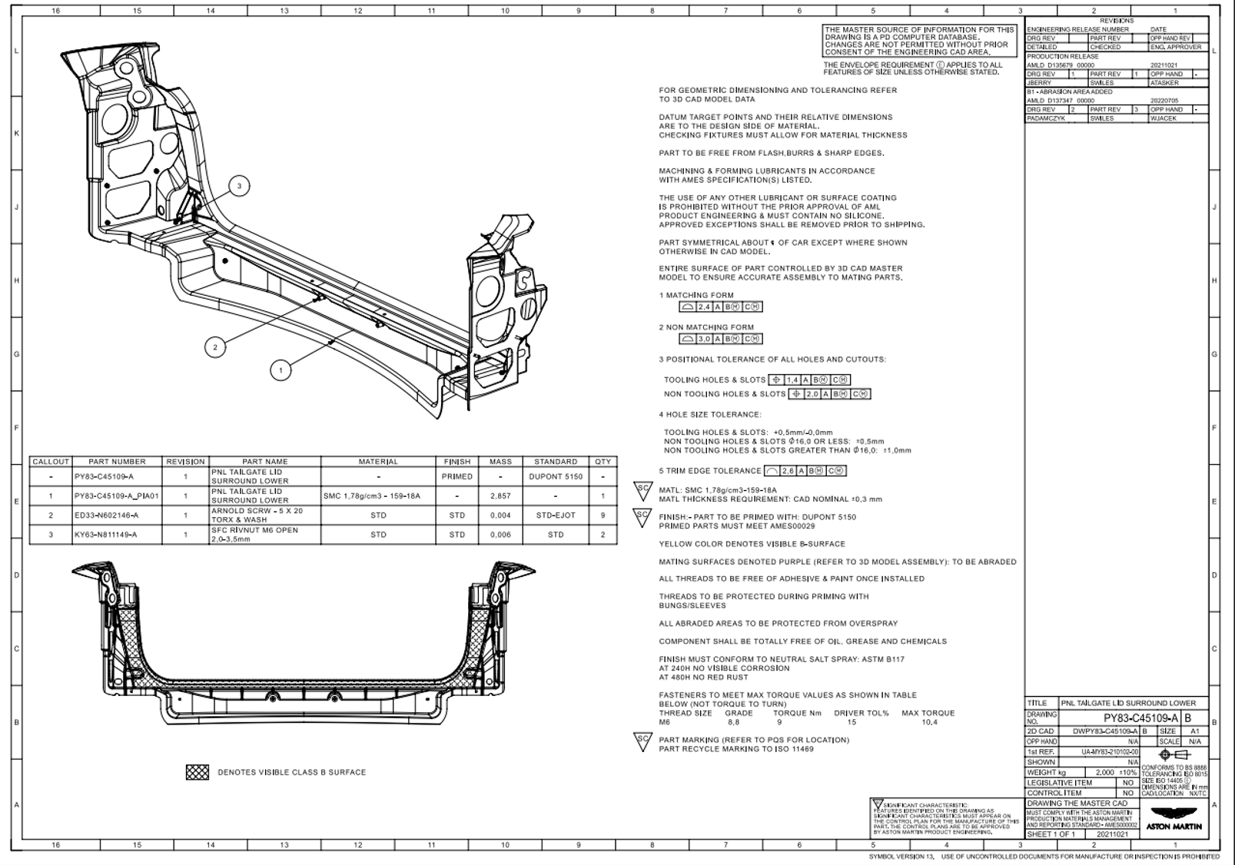

Appendix D: Cost Breakdown

Appendix D-A: Total Cost Breakdown
Stage | Detail | Cost/Save
Rework Cost | Average Rework cost for Tow Bar Grommet water leak | £20.24 per occurrence
Rework cost per vehicle | Applied 36.65% failure rate | £7.65 per vehicle
Containment cost | 1 minute technician rate and material cost | £0.583 per vehicle
Containment Saving | £7.65 - £0.583 | £7.07 per vehicle
Containment to Body | 54 second labour saving and 12p part cost save from PVC grommet | 64p per vehicle
Tailgate Variants | Remaining 6.3p labour saving and £1.20 part cost save | £1.263 per vehicle
Total Saving |  | £8.97 per vehicle

Appendix D-A: PVC Grommet Quotation
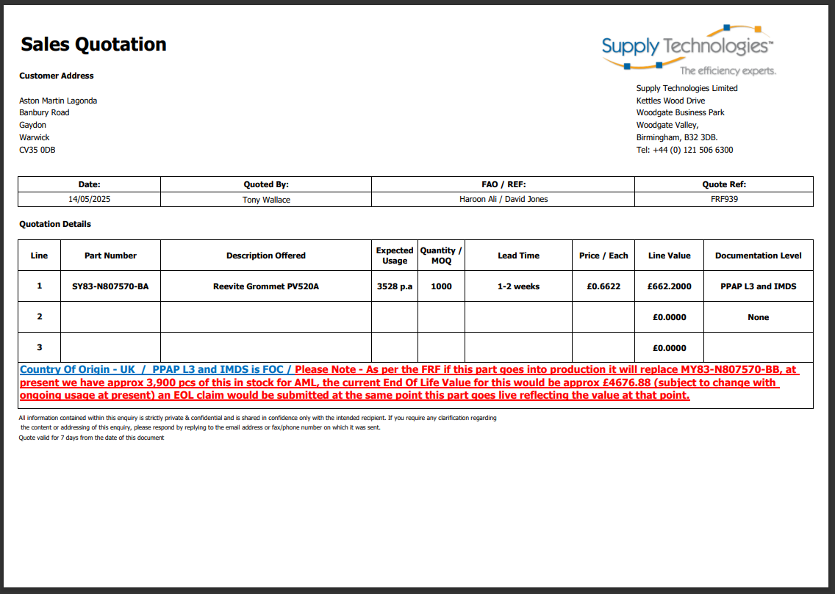

Appendix D-A: EPDM Grommet Quotation
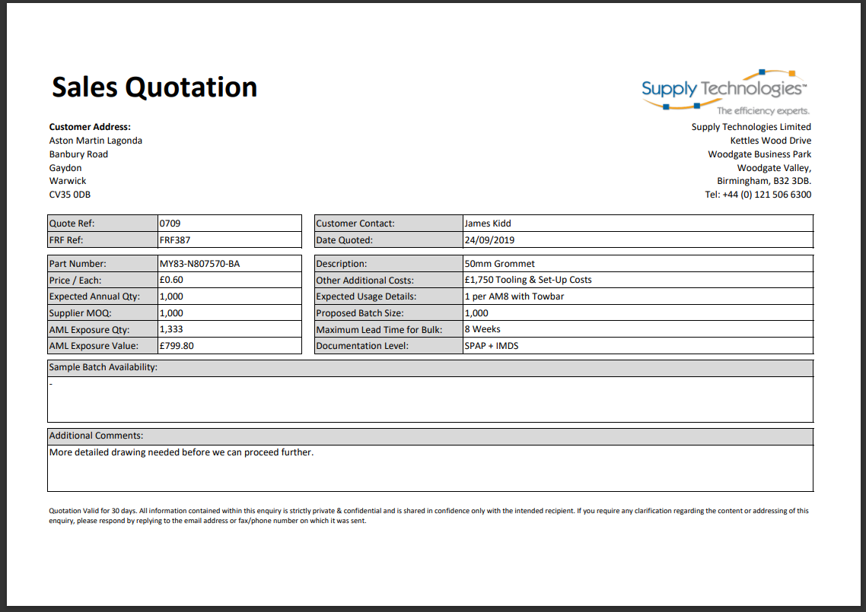

Appendix E: EPDM Grommet w/Containment FLAGs Data


