Final Project / Digital Forensic

Accessing the UFDR report
The Cellebrite report is accessible on here : Project_digital_forensic_said_chaoui
If the redirection is not working, please copy/paste the link bellow in your browser:
https://uowtsd-my.sharepoint.com/:f:/g/personal/2422745_student_uwtsd_ac_uk/Ek7csmcjViVKrhgkeS7eeykBsDxuoseKoSl516tlJjV3Nw?e=iXVEcB
There are 2 versions:
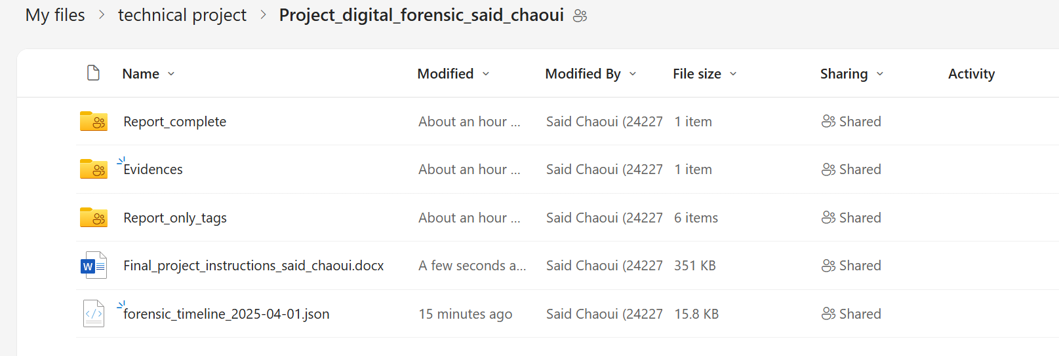
- The light version “Report only tags” where I did include only the files I tagged as evidence or important.
- The complete version which contains all the data from every phone and the tags too.
- Evidences contains the open.7z file which is important, it contains Emma account details.

Additional information
I have created a react web page to have a timeline of the events and gather all the information’s I need to understand what exactly happened and when. And most importantly to be able to identify which tag is about what event and what kind of information it holds.
To see my timeline, please access my website https://www.saiverse.fr/saidisik
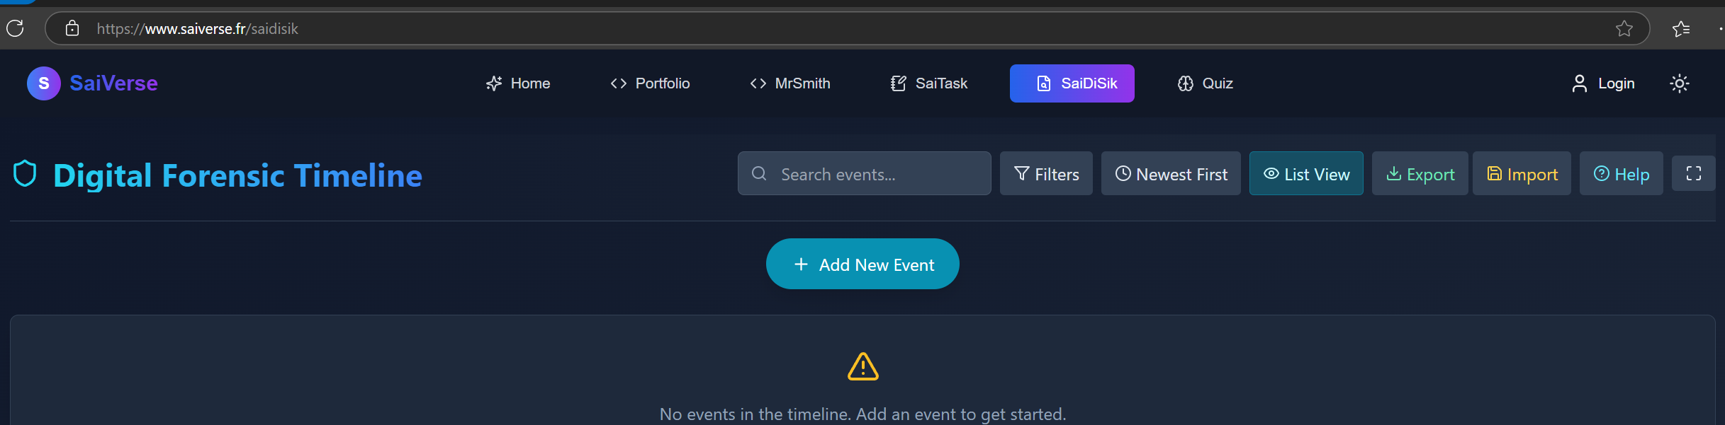
Click the yellow button “ Import “ and select the forensic_timeline_2025_04_1.json file.
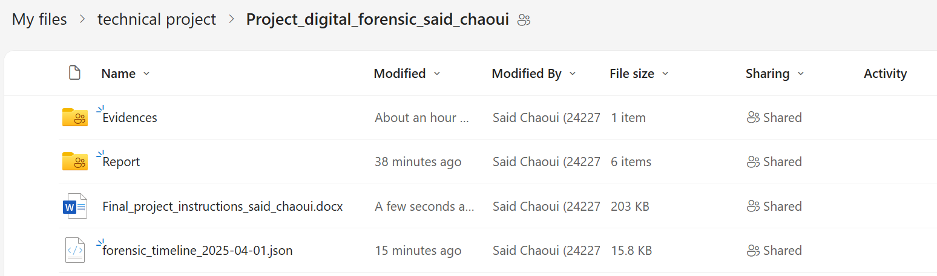
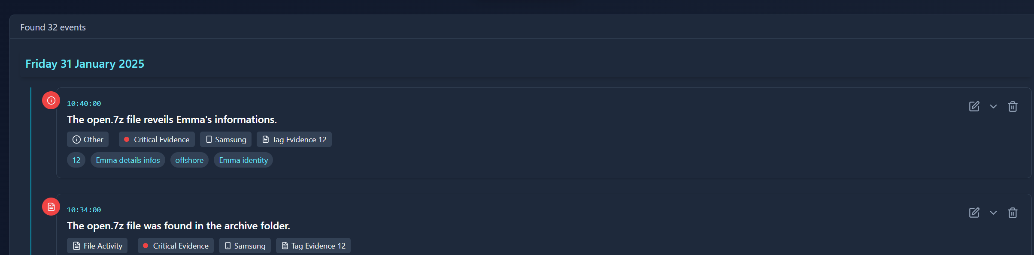

Conclusion
This investigation uncovered a sophisticated corporate espionage operation targeting ABC Technologies' proprietary "Neuro" AI project. Evidence from three devices (Samsung, Nokia, Huawei) reveals a coordinated conspiracy between Emma Blake/Johnson (lead engineer at ABC), Joe (middleman, date of birth: 10/09/1978), and Norman Smith (buyer).
Timeline shows methodical progression: initial planning (August 2024), negotiation (September 2024), development (October-November 2024), and transaction completion (January 2025). Communications across multiple platforms (WhatsApp, Instagram, Messenger) document explicit discussions of selling proprietary information.
Key evidence includes:
- Encrypted file "Open.7z" (password: "Neuro2023") containing Emma's offshore payment details
- Negotiated payment structure: $5M upfront, $10M after delivery
- Use of aliases ("Peter Dover" on Instagram)
- Suspicious international travel patterns by Emma (physically impossible movements between countries)
- Corroborating location data matching meeting schedules (Paris, Manchester, Glasgow)
- Direct communications about stealing and selling "the key algorithm on the neuro product"
- Cross-device evidence confirmation strengthening case validity
The collective evidence establishes intent, planning, execution, and completion of the intellectual property theft scheme worth $15M, constituting a serious corporate espionage case with potential criminal and civil liabilities.

