Digital Marketing

Name of the Student - Pendyala Bikshapathy
Student’s ID - 2128324
Module Code - LCMB7010
Lecturer – Md Sadeque Shaikh

Table of Contents
Introduction 3
Task 1 4
Part 1: Analysis of the global market 4
Digital representation of Tesco PLC 7
Digital assets of Tesco PLC 10
Indication of the balance between internal and external communication structural flows 13
Information Architecture used for Tesco PLC 15
Part 2 19
Machine Learning (ML) is an essential component of Artificial Intelligence. 19
The applications of Machine Learning in digital marketing to Maximize ROI 21
Conclusion 25
References 27
Appendix 32

Introduction
Digital marketing, often known as online advertising, seems to be the advertising of companies via the utilization of the computer and other types of digital communications to interact among prospective clients. These comprise texts and multimodal messaging as just a promotional strategy in addition to mail, social networks, and web-based advertisements. Most industry professionals think fundamental digital advertising abilities are not difficult to master. Nevertheless, getting such capabilities and effectively incorporating them into digital marketing initiatives could be difficult (Rukmani., 2021). Organizations may use online marketing to reach their targeted demographic and advertise their services or products. Whereas effective advertising campaigns have the same purpose, digital advertising allows firms to address a much more targeted or specialized demographic. Digital marketing, often shortened to online branding, seems to be the delivery providing advertisements via broadcast platforms to advertise companies and engage target users via the World Wide Web and other kinds of electronic technology, including Google search and Internet sites, and Social networking sites. Researcher describes multiple issues and challenges related to Digital marketing Of Tesco, issues are describes in main body of the report.
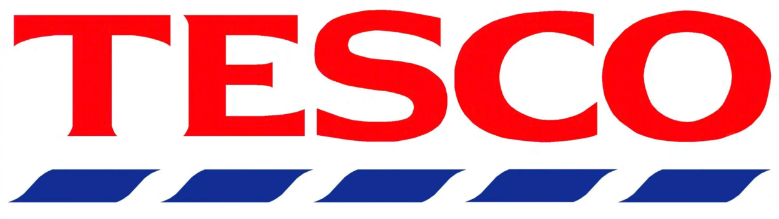
Figure 1: Tesco PLC logo
Source: (Rukmani., 2021).

In recent decades, the link between machine learning and advertising significantly flourished, resulting in a new collection of techniques and technologies that optimize the operation. To compete effectively and keep coveted technical skills inside the business, contemporary marketing seems to have no alternative but to hop mostly on-trend. Tesco Plc (Tesco) appears to be a U.K.-based worldwide generic goods store. The company operates in multi-format locations and online (Lara-Mejía et al., 2022). The company runs storefronts inside a variety of sizes as well as product choices, including big, mini, startup exclusively, and first. Tesco uses big data analytics, including computers, to adjust its distribution network and market presence towards changing purchase patterns, anticipate potential customer purchase behaviours and produce targeted both on- and offline promotions. The retailer claims to be employing temperature-detecting equipment to monitor checkout queues. They reportedly claimed upgraded scanning; self-service cashiers and checking webcams were already engaged in cutting down on lines. Tesco has stated that even self-service checkouts until now account for around one amongst total earnings.

Task 1

Part 1: Analysis of the global market
Tesco PLC is a British multinational grocery and general merchandise retailer headquartered in Welwyn Garden City, Hertfordshire, England (Dakhli et al., 2019). It is the third-largest retailer in the world measured by gross revenues and the ninth-largest retailer in the world measured by revenue.
Understanding the global market
The global market is a vast and complex place. To succeed in today's economy, businesses must clearly understand the worldwide market and how they fit into it. There are many factors to consider when understanding the global market, such as economic indicators, political stability, and cultural differences. Economic indicators are essential to consider when trying to understand the global market. These indicators can give insight into the health of a country's economy and how it is performing relative to other countries. Political stability is another essential factor to consider when understanding the global market. Countries with unstable governments or internal conflicts are often less attractive to foreign investors and can be more volatile.
Cultural differences must also be considered when doing business in a foreign country. What may be regarded as average or acceptable in one culture may be offensive or taboo in another (Rukmani., 2022). Researching and understanding these differences is essential before doing business in a new country. Tesco PLC must clearly understand each country's economic indicators, political stability, and cultural differences to succeed in the global market. By understanding these factors, Tesco PLC can make informed decisions about where to expand its operations and how to serve its customers best.
Conducting market research
Market research is critical for any company that wants to succeed in the global market. There are many ways to collect data and information about potential customers, but the most important thing is ensuring the research is valid and reliable. There are several ways to collect data about potential customers—the most common method is surveys. Surveys can be conducted online, by phone, or in person. Another standard method is focus groups. Focus groups are groups of people brought together to discuss a particular topic. A moderator usually leads the discussion, and the group members are encouraged to share their opinions and ideas. Data can also be collected through secondary sources, such as government reports, industry associations, and trade publications (Walsh., 2021). This type of research is often less expensive and time-consuming than primary research, but it can be less reliable because it is not based on first-hand information. Once the data has been collected, it is essential to analyze it carefully to ensure it is valid and reliable. This analysis can be done using various statistical methods, such as regression or factor analysis. After the data has been analyzed, it should be interpreted to conclude the market and Tesco PLC's place.
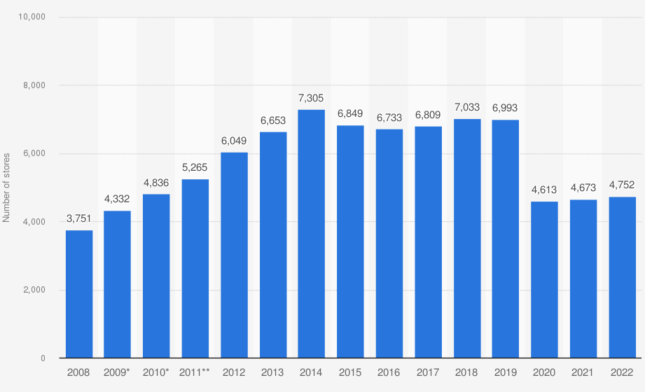
Figure 2: Global number of stores of Tesco 2022
Source: (Panwar et al., 2022).
Tesco PLC's place in the global market
Tesco PLC is one of the largest retailers in the world. The company “operates in over 30 countries and employs over 500,000 people”. Tesco PLC is a publicly traded company listed on the London Stock Exchange. The company's market capitalization is over £40 billion. Tesco PLC has a strong presence in the United Kingdom, Ireland, Poland, Hungary, the Czech Republic, Slovakia, Turkey, Malaysia, and Thailand. The company also has a significant presence in India through its joint venture with Tata Group. In 2013, Tesco PLC had revenues of £58.4 billion and profits of £3.9 billion. The global retail market is highly competitive. The top four retailers worldwide (Wal-Mart, Carrefour, Costco, and Tesco PLC) account for less than 20% of the total retail market. The remaining 80% of the market is fragmented among many small and medium-sized retailers. Tesco PLC has been successful by focusing on providing value to its customers through low prices and convenience. However, the company faces challenges in the future as it expands into new markets where it may not have the same competitive advantages. Additionally, Tesco PLC must continue to invest in its technology and logistics infrastructure to keep up with its larger competitors.
Issues facing by the Tesco PLC
The global market for Walmart is extremely competitive. In order to maintain its position as the world's largest retailer, Walmart must continually adapt to the ever-changing landscape of the retail industry. The company is currently facing several challenges, including the rise of e-commerce, the growth of Amazon, and the increasing popularity of discount retailers such as Aldi and Lidl. To stay ahead of these threats, Walmart must focus on its strengths, including its vast brick-and-mortar footprint, its low prices, and its strong relationships with suppliers. In addition to these internal challenges, Walmart must also contend with the political and economic environment in which it operates. In recent years, Walmart has come under fire for its business practices, including its treatment of workers and its impact on local communities. These criticisms have led to calls for stricter regulation of the company, which could hamper its ability to compete in the global market. Despite these challenges, Walmart remains the clear leader in the global retail market. The company has a proven track record of adapting to change and overcoming adversity. With a strong focus on its core strengths, Walmart is well positioned to continue its dominance of the retail industry for years to come.

Digital representation of Tesco PLC
Tesco PLC is represented digitally in a variety of ways. The company has an official website, which provides an overview of the company's history, products, and services. Tesco PLC also maintains active social media accounts on platforms such as Facebook, Twitter, and Instagram. These accounts promote special offers and deals and provide customer service (Monte., 2021). In addition, Tesco PLC has developed a mobile app that allows customers to shop online and access their account information. The benefits of a digital representation for Tesco PLC are numerous. A digital presence allows the company to reach a wider audience through marketing and advertising campaigns. A digital picture makes it easier for customers to find information about the company and its products or services.
Finally, a digital presence provides an additional layer of customer service, as customers can quickly contact the company through its website or social media accounts. Some things could be improved in the digital representation of Tesco PLC. For example, the company is susceptible to negative reviews and comments online. Additionally, a digital presence requires ongoing maintenance and updates to remain relevant and accurate. Finally, a digital representation can be expensive to create and maintain. Tesco PLC also uses social media to connect with customers and promote its products and services. The company's online reputation is generally positive, with most news sources reporting on Tesco PLC's successes rather than failures. However, some competitors have a more robust online presence, offering more features and information to potential customers.
Tesco PLC's strategy of representing online
The company has a robust online presence, with a website that allows customers to shop for groceries and other items online. Tesco also has a mobile app that enables customers to access their accounts, view their shopping baskets, and find stores nearby. Tesco's online presence is designed to make shopping more accessible and convenient for customers. The website is easy to navigate, and the mobile app is user-friendly (Rukmani., 2022). Customers can create an account on the website or app to save their preferences and make future shopping trips quicker. The benefits of digital representation for Tesco PLC are numerous. Tesco can increase customer loyalty and repeat business by making shopping more accessible and convenient for customers.
Additionally, by having a robust online presence, Tesco can reach new customers who may have yet to shop at a Tesco store. There are some challenges associated with digital representation for Tesco PLC as well. One challenge is ensuring that customer data is secure. Another challenge is keeping the website and mobile app up-to-date with the latest products and offers. Additionally, Tesco must continually monitor its online reputation to ensure customers have a positive experience when shopping with the company.
Tesco PLC uses social media
Tesco PLC uses social media in a variety of ways. The company has an official Facebook page with over 2.5 million likes. Tesco PLC also has Twitter and Instagram accounts. The company uses these platforms to share news and information about products and services and engage with customers. Tesco PLC's social media presence is used to build brand awareness and create a positive image for the company. The company often posts pictures and videos that show off its products and services in a positive light. In addition, Tesco PLC's social media accounts provide customer service and address any negative comments or reviews about the company. When it comes to online news sources, Tesco PLC is widely represented. A simple Google search for the company name yields over 4 million results (Panwar et al., 2022).
These three results show that Tesco PLC is a company that is constantly in the news. This is likely because it is one of the largest retailers in the world. As such, anything that Tesco PLC does - whether investing in price cuts or reporting quarterly sales figures - is of interest to the general public. In terms of its digital representation, Tesco PLC fares quite well compared to its competitors (Moura., 2021). While its website may be more flashy and user-friendly than some of its rivals, it contains a wealth of information about the company. Its social media presence is also strong, with active Twitter and Facebook accounts regularly updated with news and information about Tesco PLC. Overall, Tesco PLC's digital representation is solid and informative, making it a good source of information for those interested in learning more about the company.
Strengths and Weaknesses of Tesco PLC's Digital Presence
Tesco PLC's digital presence is both a strength and a weakness. On the one hand, Tesco PLC has done an excellent job of creating a comprehensive online presence that includes a website, mobile app, and social media accounts. This allows customers to find information about the company and its products easily and makes it easy for them to purchase. However, on the other hand, Tesco PLC's digital presence makes it easy for customers to compare prices and find better deals elsewhere. This could lead to customers leaving Tesco PLC in favor of other retailers.
Issues regarding the digital representation
There are several issues that have been raised in regards to the digital representation of Tesco PLC. One of the main issues is that the website does not provide enough information about the company and its products. There is also a lack of transparency in terms of pricing, which makes it difficult for customers to know how much they are actually paying for products. In addition, the website is not user-friendly and navigation can be confusing. Lastly, there have been reports of technical difficulties with the website, which can make it difficult to use.

Digital assets of Tesco PLC
When analyzing the digital assets of a retail business organization like Tesco PLC, it is essential to focus on the website, as this is often the most visible and public-facing element of the company's online presence (Smith and Williams., 2022). One of the first things that stand out about Tesco's website is its clean and modern design. The homepage is easy to navigate and prominently links to the site's most popular sections, such as the online shopping area. This immediately gives visitors a good idea of what they can expect from the site and makes it easy for them to find what they are looking for. In terms of digital assets, Tesco's website contains valuable content, including product information, customer reviews, and recipes.
There is also a strong social media presence, with links to Tesco's various social media channels prominently displayed on the homepage. This allows visitors to connect with Tesco on their preferred platform and stay up-to-date with all the latest news and offers. Overall, Tesco's website is an excellent example of how a retail business can effectively represent itself online (Benghezal and Izadi., 2022). The site is well-designed, easy to navigate, and contains valuable content that helps promote the company's products and services.
Tesco PLC's digital presence
Tesco PLC's digital presence is vast and far-reaching. The company has a website with information on all aspects of the business, from products and services to news and events. In addition to the website, Tesco PLC also has an online store where customers can purchase items directly from the company. The online store offers various products, including groceries, household items, and electronics. Tesco PLC also has a solid social media presence, with accounts on all major platforms (Mogili and Natarajan., 2021). The company uses social media to connect with customers, promote products and services, and share news and events. Tesco PLC's digital presence is impressive and gives the company a powerful way to reach and engage with customers.
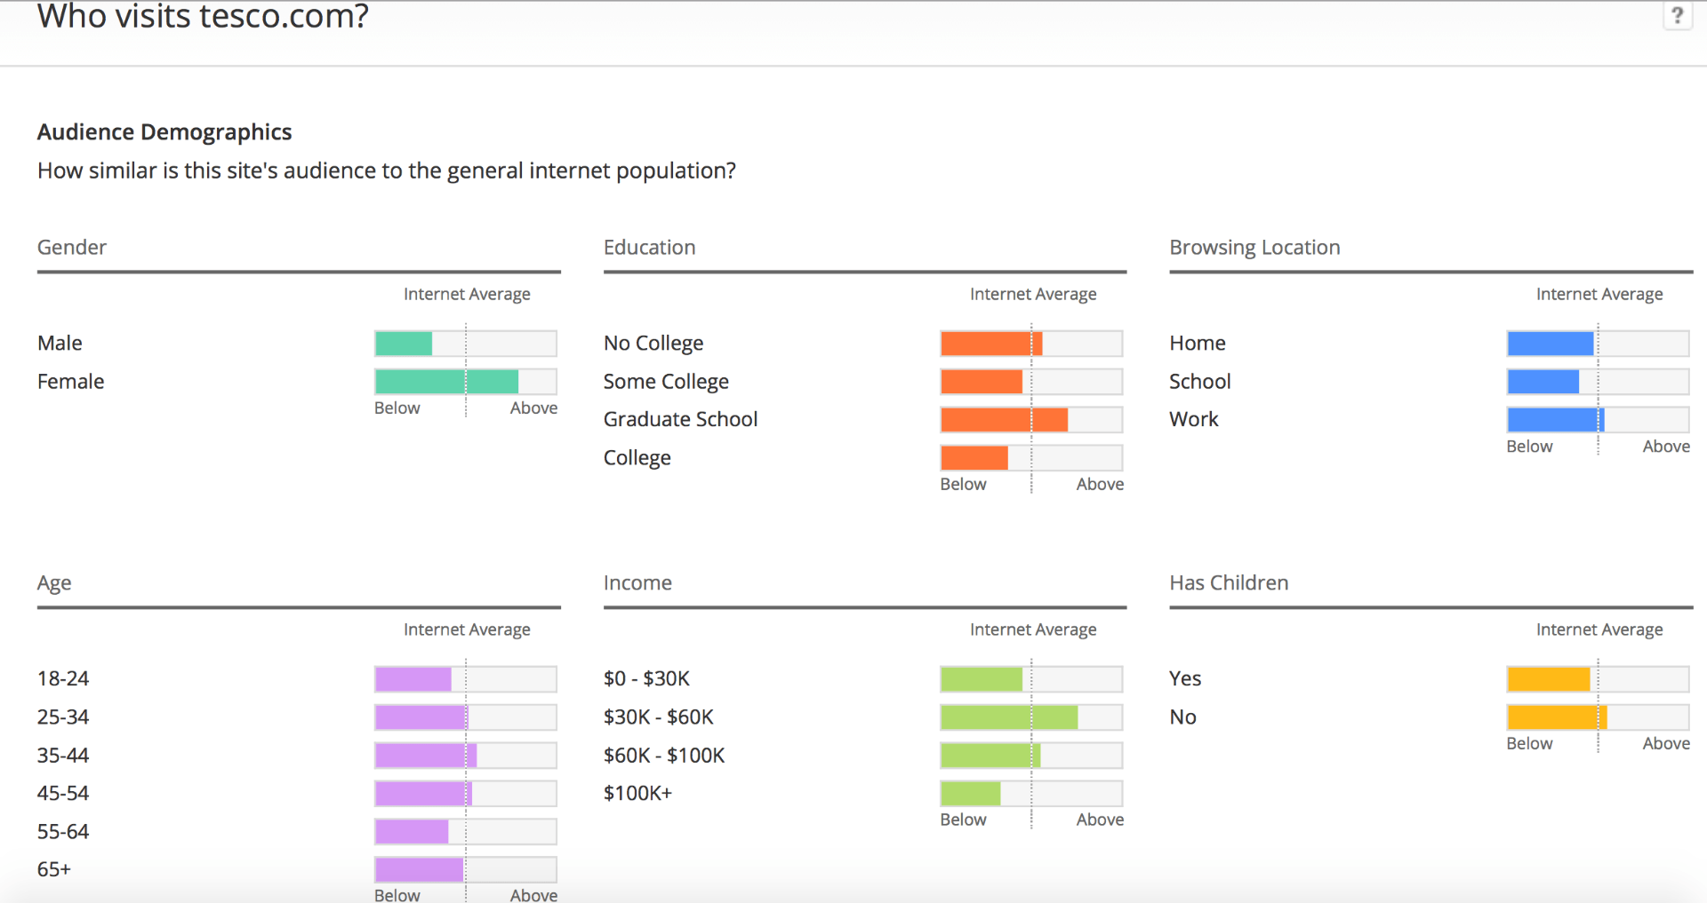
Figure 3: Audit of the website of Tesco
Source: (Smith., 2022).
Issues of the digital assets with the company
The digital assets of Tesco PLC are its website, online presence, and any associated online customer accounts. The issues with these assets are that they are not being used to their full potential and are not integrated with each other. The recommendation is for Tesco PLC to invest in a digital transformation strategy that will improve the customer experience and make better use of its digital assets.
Analysis of Tesco PLC's website
Tesco PLC's website is one of the company's most critical digital assets. The website is the primary way customers and potential customers interact with the company. It is also an essential marketing and sales tool (Utama et al., 2022). The website must be well-designed and easy to use to be effective. The website's home page is the first thing visitors will see. The home page should be visually appealing and give visitors a clear idea of what the website is about. The home page should also be easy to navigate so that visitors can find what they are looking for quickly and easily. The content on the website must be well-written and accurate. The content should be informative and helpful without being too salesy. The website should also be updated regularly with new content so that visitors have a reason to keep coming back. Overall, Tesco PLC's website is a well-designed and practical digital asset. The company should continue investing in the website to maintain its competitive advantage.
Recommendations
1. Increase the number of digital touchpoints: To better engage with customers, Tesco should increase the number of digital touchpoints across its website and mobile app. This will give customers more opportunities to interact with the brand and learn about new products and services.
2. Make it easier to purchase online: Tesco should make it easier for customers to buy products and services online. This can be done by streamlining the checkout process and offering more payment options (Frei et al., 2022).
3. Enhance customer service: Tesco should enhance its service offerings to improve customer satisfaction. This can be done by providing more self-service options and making it easier to contact customer service representatives.
4. Improve website design: To create a more user-friendly experience, Tesco should improve the design of its website. This can be done by simplifying the navigation and increasing the use of visuals.
5. Increase marketing efforts: To increase awareness of its digital assets, Tesco should increase its marketing efforts. This can be done by using targeted advertising and partnering with influencers.

Indication of the balance between internal and external communication structural flows
The role of internal communication is to ensure that employees are informed about company news and developments and that they understand the company's vision and values. Internal communication channels such as employee newsletters, intranet updates, and town hall meetings help to keep employees up-to-date with what is happening within the company. Tesco PLC has a robust internal communication structure. All employees can communicate with each other through a variety of channels, including email, instant messaging, and video conferencing (Monte., 2021). There is also an intranet system that allows for easy sharing of information and collaboration on projects. The company has a clear hierarchy, with each department having a designated manager responsible for communication between employees. This ensures that everyone knows what is happening within the company and that tasks are assigned appropriately. There is a strong emphasis on teamwork at Tesco PLC, reflected in how the internal communication structure is set up.
Teams are encouraged to work together to solve problems and develop creative solutions. This fosters a sense of camaraderie and helps to build morale within the company. The internal communication structure of Tesco PLC is exceptionally effective in ensuring that all employees can stay informed and collaborate effectively (Bravi et al., 2022). Tesco PLC has a very complex and diverse external communication structure. This is because Tesco PLC operates in many different countries and therefore has to communicate with various stakeholders. The main external communication channels of Tesco PLC are its website, its annual report and accounts, and its corporate social responsibility (CSR) report.
The balance between internal and external communication structural flows in Tesco PLC
It is essential to maintain a balance between internal and external communication structural flows to ensure the success of an organization. In Tesco PLC, the balance between internal and external communication structural flows is evident in how the company communicates with its stakeholders. Tesco PLC's strong focus on internal communication is clear in how the company communicates with its employees.
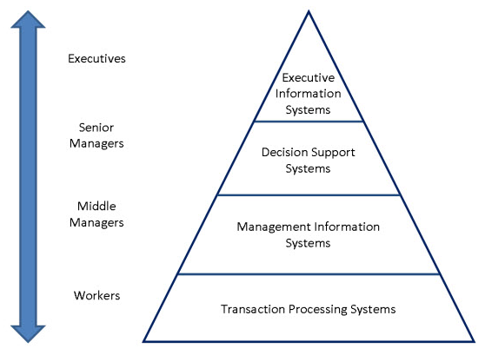
Figure 4: Information system of Tesco
Source: (Hovorushchenko and Pavlova., 2021).
Tesco PLC uses various communication methods with its employees, including face-to-face communication, email, and intranet. This focus on internal communication ensures that employees are kept up-to-date with company news and developments (Norton and Male., 2020). Tesco PLC also places a strong emphasis on external communication. The company uses various communication methods with its stakeholders, including press releases, website updates, and social media. This focus on external communication ensures that stakeholders are kept up-to-date with company news and developments. The balance between internal and external communication structural flows in Tesco PLC is evident in how the company communicates with its employees and stakeholders. This balance ensures that employees and stakeholders are kept up-to-date with company news and developments.

Information Architecture used for Tesco PLC
Information architecture can be effectively used for TESCO PLC by understanding how users interact with the site and designing the site accordingly (Treves., 2021). The goal is to make it easy for users to find the information they need while providing a rich experience. There are a few key things to remember when using information architecture for TESCO PLC. First, the site should be designed for the user rather than the company. This means that the user should always come first when making decisions about navigation and content. Second, the site should be designed to meet the user's needs. This means that all content should be well-organized and easy to find. Navigation should be intuitive, and search should be easy to use. Third, the site should be designed to be flexible. It should be easy to add or remove content and change how that information is presented.
The goal is to make it easy to keep the site up-to-date without completely redesigning it every time something changes. Fourth, the site should be designed with scalability in mind. This means that it should be able to grow as TESCO PLC grows (Moura., 2021). The goal is to ensure that the site can handle increased traffic and new content without breaking down. Finally, the site should be designed with security in mind. This means that all data should be stored securely and access controlled. The goal is to ensure that only authorized users can access sensitive information. TESCO PLC can use Information Architecture to its advantage by creating a well-organized website that is easy to navigate. By doing this, potential customers can find the information they are looking for quickly and easily. In addition, TESCO PLC can use Information Architecture to create a more efficient way of handling customer inquiries and complaints. With a well-organized website, TESCO PLC will save time and money while providing excellent customer service.
Common strategies used for promoting products and services
There are a variety of techniques that can be used for promoting products and services. Some common methods include:
- Creating a strong brand identity involves creating a unique and recognizable brand that consumers can easily identify. This can be done through effective marketing and advertising campaigns that generate awareness and interest in the product or service.
- Offering discounts and coupons: This common strategy encourages customers to purchase a product or service. Discounts and coupons can be provided through various channels such as online, in-store, or mailers.
- Creating loyalty programs: Loyalty programs are designed to encourage customers to return to purchase a product or service. These programs offer rewards such as points, discounts, or freebies for continued business.
- Offering free trials: This strategy allows potential customers to try a product or service before making a purchase. Free trials can be provided for a limited time or a specific number of uses.
- Creating an affiliate program: An affiliate program allows businesses to partner with other companies or individuals to promote their products or services. Affiliates are typically given a commission for each sale they generate.
- Sponsoring events is a great way to get exposure for a product or service by sponsoring events with a target audience interested in the product or service.
Effective Strategies for Promoting TESCO PLC Products and Services
There are many ways to promote products and services, but some strategies are more effective than others. For TESCO PLC, an integrated approach that combines online and offline promotion is the best way to reach potential customers and create brand awareness. Some of the most effective online promotion strategies for TESCO PLC include search engine optimization (SEO), social media marketing, and content marketing (Zhang et al., 2021). “SEO ensures that TESCO PLC's website appears as high as possible in search engine results pages (SERPs), making it more likely to be seen by potential customers.
Social media marketing involves creating and sharing content on social media platforms like Facebook, Twitter, and Instagram to engage with potential customers and build relationships.” Content marketing involves creating informative blog posts, articles, info graphics, and other content that can be shared online to educate potential customers about TESCO PLC's products and services.

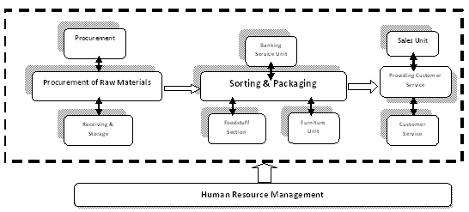
Figure 5: Operations Strategy and Management of Tesco
Source: (Zhao., 2021).
Offline promotion strategies for TESCO PLC can include print advertising, television commercials, radio ads, and direct mail. While offline promotion can be more expensive, it can still effectively reach potential customers who may spend less time online.TESCO PLC has several effective strategies for promoting and servicing its products and services. One such strategy is its focus on customer service (Treves., 2021). TESCO PLC has a team of dedicated customer service representatives available to answer any questions customers may have about the company's products or services. Additionally, TESCO PLC offers a toll-free customer service number that customers can call if they need assistance with any aspect of their purchase.
Another effective strategy that TESCO PLC uses to promote and service its products and services is its focus on providing a high level of quality (Chen., 2022). All of the company's products are backed by a satisfaction guarantee, and TESCO PLC offers a wide variety of product warranties to ensure that customers are satisfied with their purchases. In addition, TESCO PLC has a rigorous quality control process to ensure that all of its products meet the highest standards of quality. Finally, TESCO PLC offers several promotional discounts and deals to customers who purchase its products or services. For example, the company often runs special sales where customers can save money on purchases. Additionally, TESCO PLC offers coupons and discounts to customers who sign up for its email list or follow the company on social media (Bierganz., 2021). By providing these promotional discounts, TESCO PLC can attract new customers and keep existing customers coming back for more.

Part 2

Machine Learning (ML) is an essential component of Artificial Intelligence.
Machine learning (ML) seems to be a segment of A.I. that enables computer programs generally grow increasingly effective at making predictions while explicitly programming them for this purpose. Algorithms for machine learning estimate correct future output by using past information as input (Bag et al., 2021). Machine learning (ML), a subtype of (A.I.), seems to be a branch of computing sciences that concentrates on analyzing and comprehending patterns and relationships in information to facilitate understanding, understanding, and making decisions without human involvement. The Student represents the most critical element of such instruction since most actions and the confirmation system revolve around them. Active learning seems to be the emphasis of attempting to learn education. Machine learning is a discipline of ai technology that allows computers to autonomously learn from their mistakes and encounters to discover new and more efficient responses (Ullal et al., 2021). The more information and knowledge an algorithm possesses, the greater this will perform inside the upcoming. Machine learning algorithms are broadly classified into directed and unsupervised learning. Individuals provide large datasets and responses to controlled algorithms in the initial phase. Participants have been educated on certain characteristics to search towards initially and would gradually improve their ability to detect such features.
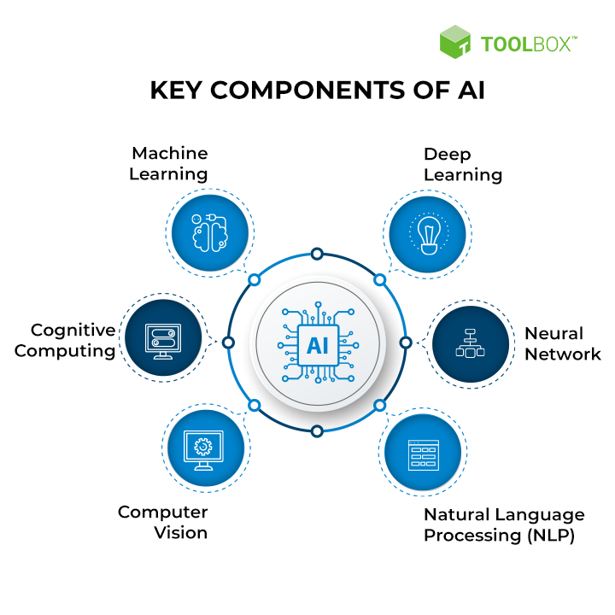
Figure 6: Key components of Artificial Intelligence
Source: (Ullal et al., 2021)
Algorithms trained using unsupervised learning are used in this sort of machine learning. The program examines data sources about any noteworthy connections. The information used to develop computers and the projections and suggestions they provide been predefined (Zhao et al., 2022). Computer scientists commonly employ the learning algorithm to educate a computer that executes a multi-step procedure with well-stated criteria. Computer scientists build an algorithm to perform a task and provide it with positive and negative signals to determine how to finish the job well. However, for most parts, the algorithms select whatever actions should be taken along the road.
Machine learning is an artificial intelligence specialization that uses algorithms to analyze information, detect patterns, and make choices without any or minimal human interference. Machine learning encompasses everything from reacting to voice instructions to Facebook identifying and categorizing the profile inside a photo (Verma et al., 2021). However, the true benefit of machine learning comes from its algorithms: the programs that assist mortal humans with solving complicated issues faster and efficiently, minimizing your dependency on third-party apps. Whilst advertisers have traditionally been hesitant to employ experimental technologies. Current applications have opened up the opportunity for various brand-new digital marketing methods to be implemented.

The applications of Machine Learning in digital marketing to Maximize ROI
Digital marketing ROI seems to be a calculation of such earnings or losses generated by business digital marketing activities. Based on the sum of income they've put in. In other respects, these metrics show customers if their marketing efforts provide a good return on investment. This successful return on investment indicates that marketing initiatives have been generating more revenue than what they're investing on such (Micu et al., 2021). It is critical to demonstrate online marketing ROI since, without it, companies have been simply advertising blind. Tesco often uses print and media advertising to reach out to certain populations. Companies frequently provide a "buy one, get one free" deal to maintain and acquire clients. Companies can give gift cards to their loyal consumers (Huang and Rust., 2021). Individuals may use their Loyalty scheme to cash back rewards for extra advantages. By embracing entrepreneurship and innovation, Tesco may separate its company from the marketplace and many other rivals. This might help Tesco stand out from the crowd and offer businesses an advantage against their competitors.
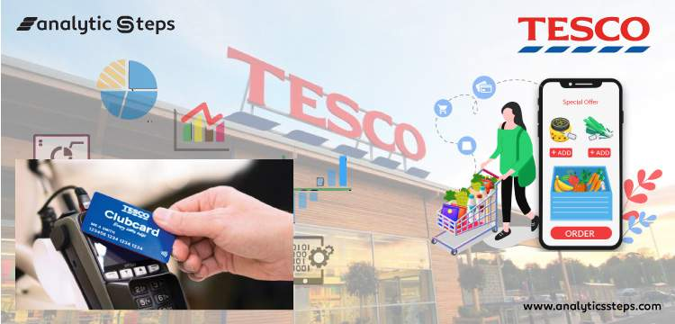
Figure 7: Tesco uses Big Data Analytics
Source: (Battisti et al., 2022)
Machine learning is based on enhanced data processing of patterns and dependence identification. Whenever algorithms examine additional data, ML posits that they can adjust autonomously and utilize this other knowledge to evolve through understanding from previous knowledge. Machine learning techniques can potentially improve almost every element of such an organization, including sales and advertising to management (Limna et al., 2022). DataArt has been selected as a reliable technological consultancy and solution provider, including over 20 years of knowledge in developing technology capabilities for such retail sectors as Tesco. They could assist the customer on its local farmers market with a cross-corporate match before spreading the worldwide influence of their Research and innovation locations (Battisti et al., 2022). They also collaborated with the client's sales and marketing departments to establish the B.I. specifications, documented everything, and began an incremental approach. These allowed the customer to utilize the application again from the start of such a design project.
The tool works with various databases, including social-economic, geographical, and POS geolocation, as well as other factors. Seasonality, buying behaviour data, customer soundness, and regional grocery socioeconomic aspects have all been considered. For information processing, designers employed virtualized architecture. Apache Spark technology is used to power the applications (Giroux et al., 2022). This renders the application very expandable as well as allows this one to operate and handle huge amounts of information. This also allows companies to incorporate sources of information such as web server logs, consumer comments through social networking sites, promotional messages, and much more (Behera et al., 2022). The solution is founded on tried-and-true free software elements, including data gathering libraries which give a fully prepared collection of machine learning techniques and the capabilities enabling model validation and testing. DataArt's application assists this customer in improving business marketing plans, mostly on the regional markets, by providing reliably accurate information on the amounts and where to participate in promotional activity and related advertising strategies (Mostaghel et al., 2022). This assists the customer in meeting overall sales objectives. Consequently, the program improves the marketing strategy for each company's point of purchase and increases the company's operational efficiencies, revenues, and customer base.
Quality Control: Machine learning has increasingly been applied to check and control products. Machine learning-based computer vision algorithms could adapt to discriminate the "good" again from "bad" with a group of examples. Semi-supervised anomalous detection methods, for instance, required just "good" examples in this training dataset, eliminating the need for a database containing probable flaws (Jain et al., 2021). Conversely, a technique that correlates specimens to common problem instances could be built. ML-based machine learning systems could also be used to watch dangerous locations within industries, recording if each employee is respecting safety rules and, maybe, even delivering a fast alarm to the supervisors with a complete explanation of what happened.
Marketing Optimization: Companies may enhance overall marketing ROI by using machine learning within existing consumer research. To make the greatest use of promotional campaigns, comprehensive computer modelling may assist in discovering clients who have the greatest ROI on commercials. Featuring sophisticated attributing algorithms, this also improves distribution channels. For a popular smartphone advertising network, A.I. created a model that predicted online adverts' number of likes (Figueiredo et al., 2021). The research analyzes previous data concerning site usage patterns to identify abnormalities and trends. This allowed customers to spot unusual behaviour amongst customers, which proved to be bots performing false browsing. The approach successfully recognized online bots that engage in advertisements, considerably improving CTR forecasts - over 90% of robots have been detected, and CTR forecasts increased by approximately 35% above previous algorithms.
Demand Forecasting: Demand forecasting could be employed to anticipate consumer spending in the domain of predictive modelling. Forecasting is generally accomplished by studying statistical information as well as searching for trends as well as relationships. Contemporary sales forecasting approaches extend far beyond simple empirical data processing, including machine learning elevating the profession (Apasrawirote et al., 2022). Newer strategies integrate perception and historical information. Modern retailers may explore company information-seeking themes and developments. Requirement prediction machine learning algorithms, such as gradient descent and artificial neural, are located at the absolute peak of such approaches, outperforming traditional statistics-based techniques.
Transactional data, again from the past, serves as the foundation for more modern demand forecasting methodologies. Companies gather as well as preserve this information because of fiscal as well as business issues. These statistics are the simplest to utilize since they are generally accessible. This contemporary method is quite successful (Faruk et al., 2021). One of Tesco's retail customers lost thousands of dollars annually because of out-of-stock. The company had a recommended limit to the number of different innovations that might be received in its warehouses. Their team created a demand forecasting algorithm for newly released items. This allows the corporation to utilize the caps better by buying more popular items and lesser, less popular ones.
The in-depth understanding of several parts of mathematical and computer science and the concentration of attention required in spotting inefficiency inside the algorithms makes complex challenges. Machine learning programs need meticulous attention to every detail to optimize algorithms. Another of the most critical challenges that computational intelligence specialists confront is a lack of high-quality information. Unclean as well as noisy elements may cause the entire procedure tedious. You wouldn't want their system to create incorrect projections. As a result, data quality is critical for improving performance. Machine Learning is self-sufficient even though it is prone to mistakes. Assume the user's training algorithms using large datasets that are too tiny to be comprehensive. As a result of a biased training dataset, individuals get prejudiced forecasts.

Conclusion
Large volumes of machine learning have become an essential aspect of such retail and industrial corporate landscapes. This had typically been done through specialists who've already developed their abilities through experience. Nevertheless, thanks to learning algorithms, this is currently feasible to integrate the incredible volume of big data well with the accuracy and intelligence of such a machine-learning algorithm. Whereas the business sector would have to be conscious of numerous such risks that computer vision may provide, this does equip corporate operations with incredible versatility and power. A.I. in retailing improves improving forecast accuracy. A.I. management information systems foresee industrial movements and enable preemptive adjustments to a marketing dept, retailing, and corporate strategy by extracting information through marketplaces, customer, and competition information.
Digital marketing collects important customer data. Tesco retailers must examine such information and utilize that to adapt messaging to potential customers. Personalized communications improve customer service as well as boost loyalty among customers. A.I. assists Tesco retailers to include improving demand forecasting, price choices, including positioning strategy. Consequently, customers engage well with the correct items at the appropriate locations and times. A.I. may be used to estimate market growth, create customer information, and programmatic purchase ads, among other things. The second is the consumer-facing side, in which advertisers employ A.I. to help enhance the user experience, reinforcing the branding and increasing sales. A.I. in marketing may assist in managing and anticipating customer behaviour, identifying cross-selling, increasing sales possibilities, and automating services to improve prediction performance.

References
Apasrawirote, D., Yawised, K. and Muneesawang, P., 2022. Digital marketing capability: the mystery of business capabilities. Marketing Intelligence & Planning.
Bag, S., Srivastava, G., Al Bashir, M.M., Kumari, S., Giannakis, M. and Chowdhury, A.H., 2021. Journey of customers in this digital era: Understanding the role of artificial intelligence technologies in user engagement and conversion. Benchmarking: An International Journal.
Battisti, S., Agarwal, N. and Brem, A., 2022. Creating new tech entrepreneurs with digital platforms: Meta-organizations for shared value in data-driven retail ecosystems. Technological Forecasting and Social Change, 175, p.121392.
Behera, R.K., Bala, P.K., Rana, N.P. and Kizgin, H., 2022. Cognitive computing based ethical principles for improving organizational reputation: A B2B digital marketing perspective. Journal of business research, 141, pp.685-701.
Benghezal, D. and Izadi, J., 2022. Exploring the impact of CSR strategy in food retail sector firms.
Bierganz, M., 2021. Delivering virtual value: the role of virtual value creation in e-grocery business models and resulting implications for today’s grocery retail firms (Doctoral dissertation).
Bravi, L., Gori, R. and Musso, F., 2022. Corporate Social Responsibility: A Longitudinal Analysis in the Retail Sector. In Managing Sustainability (pp. 9-31). Springer, Cham.
Chen, J.J., 2022. Tesco Plc. In International Cases of Corporate Governance (pp. 27-44). Palgrave Macmillan, Singapore.
Dakhli, M., Ketata, I., Lifang, W. and White, M.S., 2019. Tesco in China: How Could Things Go So Wrong?. In SAGE Business Cases. NeilsonJournals Publishing.
Faruk, M., Rahman, M. and Hasan, S., 2021. How digital marketing evolved: A bibliometric analysis on Scopus database. Heliyon, p.e08603.
Figueiredo, F., Gonçalves, M.J.A. and Teixeira, S., 2021, October. Information technology adoption on digital marketing: a literature review. In Informatics (Vol. 8, No. 4, p. 74). MDPI.
Frei, R., Jack, L. and Krzyzaniak, S.A., 2022. Mapping product returns processes in multichannel retailing: challenges and opportunities. Sustainability, 14(3), p.1382.
Giroux, M., Kim, J., Lee, J.C. and Park, J., 2022. Artificial intelligence and declined guilt: Retailing morality comparison between human and A.I. Journal of Business Ethics, pp.1-15.
Hovorushchenko, T. and Pavlova, O., 2021, September. Multi-Agent Technology for Assessing the Availability of Information at the Software Development Initial Stages. In 2021 IEEE 16th International Conference on Computer Sciences and Information Technologies (CSIT) (Vol. 1, pp. 353-356). IEEE.
Huang, M.H. and Rust, R.T., 2021. A strategic framework for artificial intelligence in marketing. Journal of the Academy of Marketing Science, 49(1), pp.30-50.
Jain, D., Dash, M.K., Kumar, A. and Luthra, S., 2021. How is blockchain used in marketing: a review and research agenda. International Journal of Information Management Data Insights, 1(2), p.100044.
Lara-Mejía, V., Franco-Lares, B., Lozada-Tequeanes, A.L., Villanueva-Vázquez, C. and Hernández-Cordero, S., 2022. Methodologies for Monitoring the Digital Marketing of Foods and Beverages Aimed at Infants, Children, and Adolescents (ICA): A Scoping Review. International Journal of Environmental Research and Public Health, 19(15), p.8951.
Limna, P., Siripipatthanakul, S. and Phayaphrom, B., 2021. The Role of Big Data Analytics in Influencing Artificial Intelligence (A.I.) Adoption for Coffee Shops in Krabi, Thailand. International Journal of Behavioral Analytics, 1(2), pp.1-17.
Micu, A., Micu, A.E., Geru, M., Căpățînă, A. and Muntean, M.C., 2021. The impact of artificial intelligence use on e-commerce in Romania. Amfiteatru Economic, 23(56), pp.137-154.
Mogili, R. and Natarajan, T., 2021. Online Retailing and Customer Engagement: The Changing Paradigm of Customer Relationship Management (CRM). In Insights, Innovation, and Analytics for Optimal Customer Engagement (pp. 184-195). IGI Global.
Monte, A., 2021. A study of value chain reconfiguration processes under Covid-19 pressures: the case of Tesco PLC in the United Kingdom.
Monte, A., 2021. A study of value chain reconfiguration processes under Covid-19 pressures: the case of Tesco PLC in the United Kingdom.
Mostaghel, R., Oghazi, P., Parida, V. and Sohrabpour, V., 2022. Digitalization driven retail business model innovation: Evaluation of past and avenues for future research trends. Journal of Business Research, 146, pp.134-145.
Moura, M.B.L.D., 2021. Equity Research in Food & Retail Industry-TESCO PLC (Doctoral dissertation, Instituto Superior de Economia e Gestão).
Moura, M.B.L.D., 2021. Equity Research in Food & Retail Industry-TESCO PLC (Doctoral dissertation, Instituto Superior de Economia e Gestão).
Nair, K. and Gupta, R., 2021. Application of A.I. technology in the modern digital marketing environment. World Journal of Entrepreneurship, Management and Sustainable Development.
Norton, P. and Male, L. eds., 2020. Promoting Property: Insight, Experience and Best Practice. Routledge.
Panwar, R., Pinkse, J. and De Marchi, V., 2022. The future of global supply chains in a post-Covid-19 world. California Management Review, 64(2), pp.5-23.
Panwar, R., Pinkse, J. and De Marchi, V., 2022. The future of global supply chains in a post-Covid-19 world. California Management Review, 64(2), pp.5-23.
Rukmani, R., 2022. Examining the modern ways of digital marketing and how they are affected by different cultures.
Rukmani, R., 2022. Examining the modern ways of digital marketing and how they are affected by different cultures.
Rukmani, R., 2022. Examining the modern ways of digital marketing and how they are affected by different cultures.
Smith, D., 2022. Retail. In Fraud and Corruption (pp. 283-293). Springer, Cham.
Smith, T. and Williams, T., 2022. Brand Fusion: Purpose-driven brand strategy. Walter de Gruyter GmbH & Co KG.
Treves, L., 2021. Business Models in the Digital Age: The Internet of Things. Contemporary Issues in International Business and Entrepreneurship.
Treves, L., 2021. Business Models in the Digital Age: The Internet of Things. Contemporary Issues in International Business and Entrepreneurship.
Ullal, M.S., Hawaldar, I.T., Soni, R. and Nadeem, M., 2021. The role of machine learning in digital marketing. Sage Open, 11(4), p.21582440211050394.
Utama, A.G.S., Verma, M., Ng, J.Y., Kee, D.M.H., Nga, C.S., Izzati, N.N., Ng, Y.X. and Khoiruwnia, F., 2022. A Research on Tesco's Consumer Purchasing Behavior towards E-Commerce during the Pandemic Period. International Journal of Accounting & Finance in Asia Pasific (IJAFAP), 5(1), pp.53-63.
Verma, S., Sharma, R., Deb, S. and Maitra, D., 2021. Artificial intelligence in marketing: Systematic review and future research direction. International Journal of Information Management Data Insights, 1(1), p.100002.
Walsh, G., 2021. Relationships among immigrant consumers' cultural orientation, innovativeness and opinion leadership. International Marketing Review, 39(1), pp.80-104.
Zhang, L., Wu, L., Huang, L. and Zhang, Y., 2021. Wield the power of omni-channel retailing strategy: a capability and supply chain resilience perspective. Journal of Strategic Marketing, pp.1-25.
Zhao, C., 2021. Research on Cost Management of E-commerce Enterprises Based on Value Chain——Taking Suning Tesco as an Example.
Zhao, H., Lyu, F. and Luo, Y., 2022. Research on the Effect of Online Marketing Based on Multimodel Fusion and Artificial Intelligence in the Context of Big Data. Security and Communication Networks, 2022.

Appendix
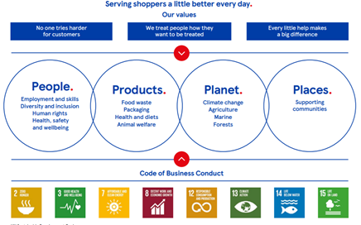
Figure 8: Business model of Tesco
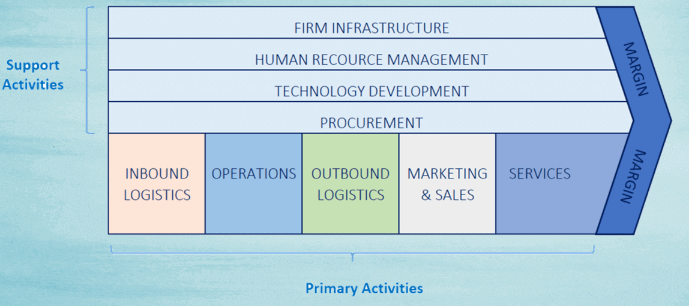
Figure 9: Value Chain Analysis of Tesco

additional Links:
https://www.google.com/url?sa=i&url=https%3A%2F%2Fwww.bstrategyinsights.com%2Ftescos-value-chain-analysis%2F&psig=AOvVaw1PWvyYciOo--iT2fLKCwD&ust=1672388195168000&source=images&cd=vfe&ved=0CBEQjhxqFwoTCIi9rtOxnvwCFQAAAAAdAAAAABAv

https://www.google.com/url?sa=i&url=https%3A%2F%2F15writers.com%2Fsamplereports%2Ftescopestelswotportersfiveforcesvaluechain%2F&psig=AOvVaw1PWvyYciOoiT2fLKCwD&ust=1672388195168000&source=images&cd=vfe&ved=0CBEQjhxqFwoTCIi9rtOxnvwCFQAAAAAdAAAAABA0

https://www.google.com/url?sa=i&url=https%3A%2F%2Fwww.hndassignmenthelp.com%2Ftesco-ansoff-matrix%2F&psig=AOvVaw1PWvyYciOo--iT2fLKCwD&ust=1672388195168000&source=images&cd=vfe&ved=0CBEQjhxqFwoTCIi9rtOxnvwCFQAAAAAdAAAAABA9

https://www.google.com/url?sa=i&url=https%3A%2F%2Fwww.statista.com%2Fstatistics%2F238667%2Ftescoplcnumberofoutletsworldwide%2F&psig=AOvVaw1PWvyYciOoiT2fLKCwD&ust=1672388195168000&source=images&cd=vfe&ved=0CBEQjhxqFwoTCIi9rtOxnvwCFQAAAAAdAAAAABBS

