Student Self Evaluation Form

This section repeats in brief the common assessment criteria detailed on previous pages. The extent to which these are demonstrated by you determines your mark. Using these criteria, tick the box that best indicates the level of achievement you feel you have achieved with regard to each of them.

Common Assessment Criteria Applied
Common Assessment Criteria Applied | REFER |  | D |  |  | C | B | A
 | OUTRIGHT FAIL | UNSATISFACTORY | SATISFACTORY |  | GOOD |  | VERY GOOD | EXCELLENT
1. Subject Knowledge and Understanding (which includes using research-informed literature and knowledge and understanding of the subject)
 |  |  |  |  | x
2. Intellectual Skills (Analysis)
2. Intellectual Skills (Analysis) |  |  |  |  | x
3. Pedagogic and Professional Applications (Practical Application and Deployment)
 |  |  |  |  | x
4. Key Transferable Skills
4. Key Transferable Skills |  |  |  |  | x
PLEASE COMMENT ON AREAS IN WHICH YOU FEEL THAT YOU HAVE PERFORMED WELL |  |  |  | PLEASE COMMENT ON AREAS you feel that you need TO DEVELOP
Coherent writing style and well presented. |  |  |  | Further external reading.

Supporting pupil progress: a detailed analysis of one child’s holistic development, with justification for the next steps in learning.

Word Count - 4937

Introduction

The focus of this assignment is to provide a detailed analysis of one pupil’s holistic development, with justification for the pupil’s next steps in their learning. Throughout the assignment the pupil shall be referred to as Pupil A.

Pupil A is a male child in a Year 2 class in a large, town school with approximately 600 pupils on roll. Around 33% of the school are eligible for free school meals, which is above the Welsh national average. Nearly all of the pupils in the school are of white British ethnicity and come from homes where English is the main language, a category that Pupil A falls into. Approximately 25% of pupils have been identified by the school as having additional learning needs (Estyn, 2016). Pupil A has not been identified as having additional learning needs and his current attainment levels and support presently being received are discussed in further detail later in the assignment.

There are three Year 2 classes in the school. Pupil A is in a class of 28 pupils which has two LSA’s supporting the class, one of whom provides one to one support for a child with a statement of special educational needs for a medical condition. Two further pupils in the class have Individual Educational Plans, one for medical reasons and the other for speech and language and behavioural issues.

The first section of this assignment will outline and critique the methods used to collect the relevant data with due consideration given to the ethical issues surrounding such data collection. The next section will provide an analysis of Pupil A as a learner referring to the data collected and providing an analysis of its strengths and limitations. The focus of the assignment will then turn towards justifying a range of strategies in order to develop the learning progress of Pupil A, with consideration given to a variety of pedagogical approaches. Finally, the assignment will conclude with a critical reflection in terms of personal knowledge of assessment for learning and how this will impact upon my own future teaching practices.

Data Collection Methods - the Mosaic Approach

The data was collected with due consideration of the Mosaic approach methodology, where data is collected through a wide range of means, referred to by Clark and Moss (2011) as pieces of the mosaic. It is then the responsibility of the researcher to place these individual pieces together to form a larger picture. Clark and Moss refer to a framework for listening to young children which underpins the philosophy of the Mosaic approach. The framework is one which is multi-method, participatory, reflexive, adaptable, focussed on children’s experiences and embedded into practice. As such, the voice of the child is recognised throughout the data collection process and the child is treated as an expert in their own life. Furthermore, the child and relevant practitioners, in this instance being the class teacher of Pupil A, are included in discussions. The framework therefore has the potential to be used not only as a means of evaluation but also to become embedded into early years practice.

Clark and Moss continue to identify three stages to the Mosaic Approach, the first being the gathering of relevant documentation by both the adult and the child. In terms of the information gathered for the purposes of this assignment, this was achieved through observations of pupil A as well as interviews with both Pupil A and his class teacher. Photographs taken by Pupil A of specific areas and resources that he considers important in terms of helping him with his learning also form part of this body of information as well as examples of Pupil A’s work. The photographs taken include displays, areas and resources within Pupil A’s classroom and other areas of the school. This information and documentation is referred to in greater detail in the next section of the assignment and is also evidenced in the appendices.

The second stage is the piecing together of the information in terms of establishing a dialogue for reflecting and interpreting the information. It is during this stage that a picture of Pupil A’s holistic development is formed through the piecing together of the different forms of information gathered in the first stage of the process. Again, this is explored in further detail in the next section of the assignment.

The final stage refers to the decisions made on areas of continuity and change in terms of creating a link between listening and action (Clark and Moss, 2005). This can be viewed with regards to the justifications for the next steps of learning for Pupil A as discussed later in the assignment.
The key strength of the Mosaic Approach is that children are able to choose from a number of diverse participatory tools, such as photography and as such, the quality of the interpretation of the research data is potentially increased. However, there are limitations to this approach in that it can be time consuming due to the layers of intricacy involved with using such a multi-method approach (Clark & Moss, 2011).
In terms of the data collection with regards to Pupil A, these limitations were mitigated to some extent through narrowing the focus of the data collected to specific areas of the Foundation Phase curriculum being mainly literacy and numeracy. Data on well-being was captured through observations, using the Leuven Scale of Wellbeing as a starting point. There are some limitations with regards to data collected through observation in that there could be an unintended bias by myself as observer. Papatheodorou et. al (2011) refers to the ‘observer effect’, maintaining that just by an observer being present, this can potentially influence the attitudes and actions of the person being observed. With regards to the observations of Pupil A, every effort was made to ensure impartiality throughout the observation process.
The observations and interviews with Pupil A were carried out with due consideration of the British Educational Research Association Ethical Guidelines for Educational Research (2011) with regards to pupil confidentiality and anonymity. The ethical requirements of the Education Workforce Council Code of Professional Conduct and Practice (2017) were also adhered to throughout the data collection process. For the purposes of this assignment, no photographs or filming of Pupil A was necessary.
Pupil A was informed at the start of the process that he did not have to participate and could withdraw at any point. Verbal assent was obtained from Pupil A and his response is noted in Appendix 1. No incentive was offered to him in order to reduce any potential impact of bias on the data and also to ensure that he did not feel any pressure in participating in the interviews and observations. Guidelines set out in the safeguarding policy of the school were also adhered to throughout the process.
In line with data protection regulations contained in the Data Protection Act 1998, all relevant data stored electronically was password protected and Pupil A’s anonymity was maintained throughout the data collection process.

Analysis of the Learner
The analysis of Pupil A as a learner was undertaken using Nottingham’s (2013) ASK Model as a tool to develop a coherent picture of achievement and attitudes to learning. Through exploring the attitudes, skills and knowledge of Pupil A as a learner it provides a starting point from which to develop these skills more effectively in order to provide the next steps in his learning. This is further illustrated by the diagram below.
Figure 1: ASK Model (Nottingham, 2013)
It is clear from interviews with Pupil A that he has a very positive attitude towards learning. His responses display a definite curiosity and a desire to succeed, especially with regards to numeracy. This is evidenced through his response that he likes to work out all the different methods when adding and taking away in maths and he likes ‘doing them in his head’ too. He shows himself to be open minded and resilient when he refers to his reading and the goals he needs to achieve in order to improve his spelling. He states that he likes to know what the words are and that this helps him to write them down and when he knows how to write it down, this then helps him with his spelling.
With regard to Pupil A’s skills, his intellectual skills are clearly developing. In numeracy, he identifies connections between ideas and can alter these to derive a different method for working out simple addition and subtraction. This is evidenced in Appendix 2 which illustrates his approaches to using both partitioning and column addition to calculate the correct answer. He is able therefore to compare and contrast his methods and demonstrates a logical approach when determining which method to use.
Pupil A’s communication skills are well developed as observed during class discussions and when doing group work. He listens to other speakers with increasing concentration and asks questions to clarify his understanding, a prerequisite for an oracy assessment at Foundation Phase of Outcome 5. He speaks clearly and was able to present his work orally about sloths in South America as highlighted in Appendix 3. During interviews he was able to communicate effectively and understood the questions being asked of him.
In terms of Pupil A’s social skills, these too are well developed. Through observation using Laevers’ (1994) Leuven Scale of Well-Being as a starting point, I noted that generally, he was happy and cheerful, relaxed and did not show signs of stress or tension. He seems to be well liked in class and has formed solid friendship groups. He responds well to others during group work and respects others’ view points. He works well both independently and as part of a team when working in cooperative groups, although he noted in one interview that he doesn’t like it when a certain pupil in his cooperative group ‘gets annoyed’. This potentially suggests that he is non-confrontational in character. Furthermore, from general observation in class, it appears that Pupil A is modest and shy when it comes to celebrating his own achievements. This can be illustrated through observing on several occasions his reluctance to accept ‘pom-poms’ for his pot as rewards for good effort, which would inevitably lead to him being rewarded in front of the class once his pot was full of pom-poms. However, he seemed perfectly happy to be rewarded with verbal praise. This suggests that he does not like to be at the centre of attention which could potentially result in him not putting himself forward for future events or activities that may be of benefit to him especially in terms of developing his confidence and resilience through being outside of his comfort zone.
In terms of using this information on Pupil A’s social skills in order to assess against the Foundation Phase Outcomes, it would seem appropriate to suggest that he has attained Outcome 5. He is able to associate, cooperate and communicate appropriately with peers and familiar adults and seek help when necessary. He is also able to recognise and express his feelings appropriately. Evidence of this occurred during an observation of a morning check-in when he reported that he was feeling sad because his baby sister had a cough and was poorly. This showed clear evidence of empathy and an awareness of others’ feelings.
With regards to Pupil A’s knowledge for learning, Nottingham refers to pupils being motivated to learn through having an interest in the subject. He contrasts this motivation to acquire knowledge against the current framework set out in the National Curriculum which identifies the knowledge that pupils should be taught. Nottingham’s view however needs to be considered against the current reforms taking place following the Donaldson Report (2015). Changes to the curriculum will enable schools to motivate their pupils more, allowing them to have a say in the topics they are taught as we move towards a broader curriculum.
In terms of Pupil A’s current knowledge as assessed against the Foundation Phase Outcomes (2015), through analysis of his work and after discussion with his class teacher, it would seem reasonable to currently assess him as attaining Outcome 5 in Numeracy and a mix of Outcome 4 and 5 in Literacy. His Personal Social and Emotional Wellbeing could also be assessed at Outcome 5.
The appendices show some examples of Pupil A’s numeracy work as evidence of an Outcome 5 assessment. In one example at Appendix 4, Pupil A clearly shows that he can partition 2 digit numbers and knows the value of each digit. This is further highlighted in Appendix 2 where different methods of addition and subtraction using 2 digit numbers are calculated. Indeed, when asked to photograph areas of the classroom, resources and displays that helped him to learn, it was interesting that Pupil A’s primary focus was on resources and displays relating to Numeracy, as shown in Appendix 5.
With regards to shape, there is a clear understanding of regular and irregular shapes up to 5 sides (Appendix 6). Further examples of Pupil A’s numeracy work which could be assessed at Outcome 5 identify his use of standard units to measure showing an awareness of different scales of units (Appendix 7). There is also evidence of comparing daily temperatures using a thermometer (Appendix 8). In addition to this, his end of term report completed by his class teacher highlighted several other strands of numeracy where he attained Foundation Phase Outcome 5.
With regards to literacy, in addition to the oracy assessment as outlined earlier in this section, it was also apparent from conversations with him that he used a range of appropriate vocabulary and could organise what he said, including the relevant details to make himself clear. An example of this was observed during a numeracy lesson when he was asked to explain the process and method needed to order a selection of numbers from smallest to largest. He started by writing an ‘S’ on the left side of his whiteboard and a ‘L’ on the right. He then proceeded to order the numbers and commented throughout the process on every step taken, in a clear and concise manner using appropriate vocabulary and relevant details to make himself clear, such as ‘the S stands for smallest and so I know that the number 9 goes here as this is the only number that doesn’t have any 10’s in it’. This further suggests that an assessment of Outcome 5 for oracy is an appropriate one.
In terms of Pupil A’s reading, this is an area where he currently receives additional support. At the end of Year 1, he scored 7 out of 36 in the end of year reading test. Whilst his reading has improved this year, resulting in a score of 13 out of 32, this is still an area where improvement can be made. At the moment, Pupil A receives support through attending a ‘letters and sounds’ intervention group in order to assist with his spelling, recalling and reading. In class, either the teacher or LSA aim to read daily with him. This seems to have had a positive effect so far as highlighted by the increased reading scores, however, this is still identified as an area for improvement as discussed in greater detail in the next section.
When listening to Pupil A read, he was able to sequence the events of the book in the right order. He could recall information contained in the text and did use personal experience to support his understanding when we spoke about a story that was set in a school. During one reading session, I observed that he was starting to read fluently with some expression developing, dependent on the punctuation used. He was tracking the print with both his eyes and his finger. In another reading session, I noted that he sounded out certain tricky words and had good self-correction when he had made a mistake. He is currently on the Oxford Reading Tree Blue Band which is levelled as being for year 1 readers. From these observations it would seem reasonable to suggest that Pupil A is attaining Foundation Phase Outcome 4 in his reading.
In writing, Pupil A is forming upper and lower-case letters accurately, with consistent size and orientation. He uses written language for different audiences, building on a form modelled by an adult, and can sequence and structure content correctly. He is beginning to use his knowledge of phonemes to spell high frequency words correctly although as noted above, he is receiving support in this area. Pupil A is also beginning to use a range of punctuation in his writing, but often needs reminding to do so independently. The best fit for pupil A in writing with regards to the data collected could be suggested to be a low Outcome 5 or a high Outcome 4. Evidence of assessment in writing can be found at Appendix 9.
It is interesting to note that Pupil A did not photograph any literacy resources or displays within the classroom or other areas. When questioned as to whether he used any of them to help him with his learning his reply was that he did not really use them. This possibly suggests that he has a different attitude to learning when it comes to literacy than with numeracy and is possibly less curious about the subject.
The strengths of the data collected are that there is a wide variety of examples of Pupil A’s work which together show a coherent picture of Pupil A’s attainment at different stages of his development. Through the observations and interviews with the pupil, a greater understanding is gained with regards to his learning interests and behaviour patterns. Discussion with his class teacher provides a beneficial professional view of the Foundation Phase Outcomes he is currently attaining and the next steps that need to be taken to progress him further.
However, there are some limitations with regards to the data in that the observations have been carried out over a short period of Pupil A’s school life and so are merely a snapshot of his attainment and do not provide any history as to his learning attitudes, skills and knowledge. There are also gaps in the data with regards to a range of curriculum activities such as PE, drama and music. There is no data with regards to extra-curricular activities or indeed with regards to any significant events that could have happened at home or family histories of learning behaviours that could all be analysed and viewed as additional pieces of the mosaic that make up the bigger picture of Pupil A.

Next Steps in Learning

In order to progress Pupil A in terms of his next steps in learning, for the purposes of this assignment, the focus will be on numeracy, literacy, personal and social skills and the development of an attitude to learning.

In terms of progression in numeracy, this is clearly a subject that Pupil A enjoys and connects with. His development in this academic year has been significant and therefore it would seem appropriate to ensure that this progress continues. The school have recently adopted the Singapore Approach to teaching numeracy and this seems to be working very well with regards to Pupil A’s improvement. The approach focusses on teaching mastery of maths topics for the year group the pupil is in as opposed to merely moving the pupil to working at the level of their next academic year or beyond. Askew at. al (2015) notes this and refer to challenge in maths being provided by going deeper into the subject as opposed to accelerating into new mathematical content.

Further research by the National Association for Able Children in Education (2017) provide guidance on how to implement a mastery approach in the classroom. They refer to teachers being able to anticipate and adapt in their teaching, understanding what answers their pupils may provide or the mistakes they will possibly make. Teachers can then build on this to provide tasks and challenges appropriate to the individual pupils. NAACE continue to state that mastery promotes a conceptual understanding of the subject and this can be achieved through skilful questioning of the teacher and their ability to set appropriate challenges to extend the learners who are more able. The beauty of maths is that there is no one way to solve most problems that are set. Mastery therefore requires the pupil to deepen their knowledge through understanding the various methods and ways that a problem can be answered. Mastery also allows time for pupils to explore, think and reflect, crucial skills in order to develop that deeper learning of a subject (NAACE, 2017).

In terms of Pupil A’s progress, he could be extended in his maths through developing his problem-solving skills. Challenge work could be, for example, to ask him to write a question based on a picture he can see or to write a question that has a mistake in it. There are many options that could be used to extend such mathematical tasks in order to provide and develop a robust foundation for mathematics which will enable Pupil A to continue to progress in this subject.

Another strategy that can be used in class is to use Pupil A as a ‘numeracy ambassador’ and encourage him to occasionally peer tutor others in his class on certain numeracy topics. This could potentially build up his social confidence in terms of receiving recognition in front of class members although it would need to be managed in terms of ensuring that Pupil A was comfortable with the process.

Displays and resources are also important in order to provide the necessary tools to provide points of reference and to assist Pupil A in his learning. Through the use of concrete pictorial and abstract representation this will support him as a more able learner to meet problems that are presented in different ways, in different contexts and with use of more varied vocabulary. So, for example, if Pupil A were to use marbles or counters to explain to a peer what 4 x 8 looks like this would enable him to articulate his mathematical thinking, an important skill that is also recognised by Donaldson (2015) when he refers to ambitious, capable learners who set themselves high standards, seek and enjoy a challenge, are questioning and enjoy problem solving.

In terms of Pupil A’s reading interventions, the Education Endowment Foundation (2016) recognises the importance of using high quality structured intervention programmes to help pupils who may be struggling with aspects of literacy. The EEF refers to targeted intervention as being where the pupil receives small group or one to one support, usually through programmes delivered by a Learning Support Assistant. At present, pupil A receives support in a small group ‘letters and sounds’ activity outside of normal lessons. In order for Pupil A to further progress, it will be essential to ensure that he can make the relevant links between his learning in these intervention sessions and his classroom-based literacy work. Through effective intervention, progress should be made not only in writing and spelling but also in reading as the decoding of tricky words becomes easier.

The EEF further highlight that there is widespread and consistently positive evidence from a variety of studies involving Foundation Phase age pupils of the impact small group and one to one structured interventions have on increasing pupil attainment.

In 2012, the Boys Reading Commission, a joint venture with the National Literacy Trust, published its findings in a report which revealed that 76% of UK schools are concerned about boys’ underachievement in reading. The report continued to raise the question as to why there had been no government strategy to address the issue. They maintain that a sustained approach is needed in order to increase motivation and engagement in boys when reading and make several recommendations to the government. One of their focuses is on getting fathers and other male role models involved in the reading process and ensuring that there is a sufficient selection of books that appeal to boys in both the classroom and the school library. The school also needs to promote reading for enjoyment both in the classroom and through links with home learning.
However, from observations of Pupil A, it could be argued that it is not his engagement with reading that is an issue but rather just the fact that he struggles with some of the strategies when reading unfamiliar texts in order to decode words and establish their meaning. After discussion with him about his interests, he stated that he did not really like football and rugby and found them boring. He enjoyed playing at home and spoke of his brothers and baby sister with fondness.
It would seem appropriate to consider parental engagement with regards to possibly discussing ways that Pupil A’s parents could further help with his reading through developing a home school link with specific strategies and targets communicated effectively from school to the parents so that they can provide the necessary support. Regular reading at home, including being read to, plus the use of apps such as Reading Eggs can all be used as an effective tool to help develop Pupil A’s reading skills further.
Literacy displays in the classroom, as discussed earlier, were not identified by pupil A as being of any assistance to his learning. As such, it would seem appropriate to survey the whole class to ascertain what resources and displays they all find useful with regards to literacy. Having more child orientated literacy displays based on topical cartoon characters or popular current themes could engage pupils more. Phonic mats could also be used on the tables when the pupils are developing their writing skills as well as modelling other pupils’ work where for example punctuation is of a high standard.
In terms of developing Pupil A’s attitude to learning further, through the use of Dweck’s (2008) Growth Mindset and Nottingham’s (2010) Learning Pit, there already exists a culture in the school and classroom where the ‘power of yet’ is central to developing pupils’ resilience. The promotion of these strategies for developing learning attitudes should be continued and they should also be referred to regularly to ensure that Pupil A’s attitude to learning remains positive.
With regards to increasing his confidence in whole class discussion situations, by working in cooperative learning groups where specific roles are allocated, Pupil A should be given the opportunity to rotate through a variety of roles within the group, including at times roles such as organiser, manager or motivator, which will mean that he will at times have the opportunity to provide relevant feedback to a whole class through a structured format. The Education Endowment Foundation (2018) suggests that teaching methods which encourage talk and interaction between learners tend to result in the greatest improvements. The EEF also highlight the importance of encouraging pupils to talk and communicate their thinking in cooperative tasks. Thus, through increasing cooperative learning opportunities in the class, there is the potential not only to further develop Pupil A’s confidence but also his oracy and thinking skills. Whilst Pupil A is relatively comfortable in speaking in class discussions, having a leadership role in a small group could potentially boost his confidence as he develops his people organisational skills.
It has been argued by Hattie (2012) that one of the most effective ways to improve a pupils learning is through providing quality feedback. Such feedback needs to be easy to understand and relate specifically to the success criteria of the learning intention. It also needs to be tailored to the individual pupil and provide advice on how the pupil can make improvements and so progress on their learning journey. With this in mind, through providing effective feedback to Pupil A with regards to his work and attitudes, this should enable further progression to be made.

Conclusion

Through the evaluation and analysis of Pupil A’s holistic development and next steps in his learning, a key conclusion that I have arrived at is that there is a no ‘one size fits all’ approach in ensuring that individual pupils achieve their full potential in learning. It is essential to understand the whole child, their interests and likes, family background etc. in order to fully appreciate what the child’s points of reference are. From this starting point, a programme can be put in place tailored to the individual child’s needs that will enable them to develop and progress at an appropriate rate. Promoting an ethos where equity as opposed to equality is encouraged will ensure that all pupils in the class are given the same opportunity to progress and develop.

A key factor in any child’s learning development is their attitude towards learning and this, if anything, is the message that as teachers we need to pay significant heed too. If a child wants to learn and is eager to learn then this is half the battle. Lessons therefore need to be engaging and stimulating and relevant to the child. With the introduction of a new curriculum for Wales on the horizon, teachers are being given the opportunity to become more creative through delivering a broader curriculum which should include the pupils’ voice in deciding the topics to be delivered and the big overarching questions that could be asked. By including the child in the learning process, this increases their curiosity and willingness to learn. Combine this with specific, targeted strategies for focussed areas of a child’s learning such as spelling and the possibility for every child to reach their full learning potential is increased.

References

Askew, M., Bishop, S., Christie, C., Eaton, S., Griffin, P. and Morgan, D. (2015) ‘Teaching for Mastery’. Available at: https://www.ncetm.org.uk/public/files/23305578/Mastery_Assessment_Y2_High_Res.pdf [Accessed: 26th May 2018].

British Educational Research Association (2011) ‘Ethical Guidelines for Educational Research’. Available at: https://www.bera.ac.uk/wp-content/uploads/2014/02/BERA-
Ethical-Guidelines-2011.pdf [Accessed: 24th May 2018].

Clark, A. and Moss, P. (2005) Spaces to play: More listening to young children using the Mosaic approach London: National Children’s Bureau.

Clark, A. and Moss, P. (2011) Listening to Young Children: The Mosaic Approach (2nd ed) London: National Children’s Bureau, [e-book]. Available at: https://www-dawsonera-com.ezproxy.uwtsd.ac.uk/readonline/9781907969423 [Accessed: 20th April 2018].

Dweck, C. (2008) Mindset: the new psychology of success. New York: Ballentine.

Education Endowment Foundation (2016). Improving Literacy in Key Stage One. London: Education Endowment Foundation. Available at: https://educationendowmentfoundation.org.uk/public/files/Publications/Campaigns/Literacy/KS1_Literacy_Guidance_-_Printable.pdf [Accessed 28th May 2018].

Education Endowment Foundation (2018) ‘Collaborative Learning’. Available at:

https://educationendowmentfoundation.org.uk/evidence-summaries/teaching-learning-toolkit/collaborative-learning/ [Accessed: 28th May 2018].

Great Britain: Data Protection Act (1998) London: The Stationary Office.

Hattie, J. (2012) Visible Learning for Teachers: maximizing impact on learning. Abingdon: Routledge.
Laevers, F. (1994) ‘The Leuven Involvement Scale for Young Children. Manual and video’ Experiential Education Series, 1.

National Association for Able Children in Education (2017) ‘5 ways to challenge more able learners using maths mastery’. Available at:
http://www.nace.co.uk/blog/5-ways-challenge-more-able-learners-maths-mastery [Accessed: 27th May 2018].

National Literacy Trust (2012) ‘Boys Reading Commission Final Report’. Available at:
https://literacytrust.org.uk/policy-and-campaigns/all-party-parliamentary-group-literacy/boys-reading-commission/ [Accessed: 27th May 2018].

Nottingham, J. (2010) Challenging Learning: theory, effective practice and lesson ideas to create optimal learning in the classroom. (2nd ed) London and New York: Routledge.

Nottingham, J. (2013) Encouraging Learning London: Routledge

Papatheodorou, T., Luff, P. and Gill, J. (2011) Child Observation for Learning and Research. Harlow: Pearson

Wales: Department for Children, Education, Lifelong Learning and Skills (Revised 2015) Curriculum for Wales: Foundation Phase framework. Cardiff: Welsh Assembly Government.

Wales: Education Workforce Council (2017) Code of Professional Conduct and Practice for registrants with the Education Workforce Council. Cardiff: Education Workforce Council. Available at: https://www.ewc.wales/site/index.php/en/fitness-to-practise/code-of-professional-conduct-and-practice-pdf/file.html [Accessed: 24th May 2018].

Wales: Her Majesty’s Inspectorate for Education and Training in Wales, Estyn (2016) A report on XXX School. Cardiff: Estyn. Available at: https://www.estyn.gov.wales [Accessed: 15th May 2018].

Wales: Department for Children, Education, Lifelong Learning and Skills, Donaldson, G. (2015) Successful Futures: Independent Review of Curriculum and Assessment Arrangements in Wales. Cardiff: Welsh Government.

Appendix 1: Consent Form
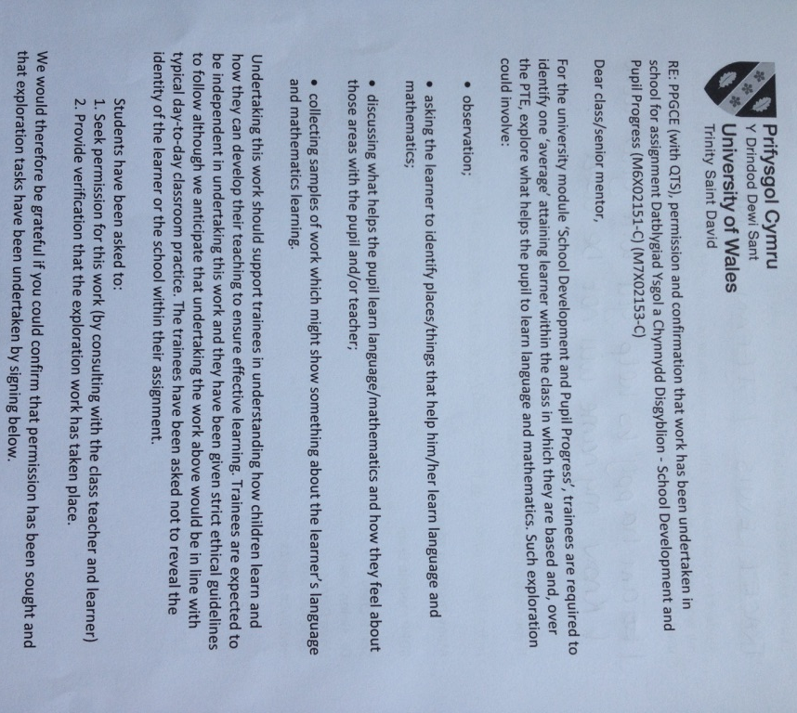
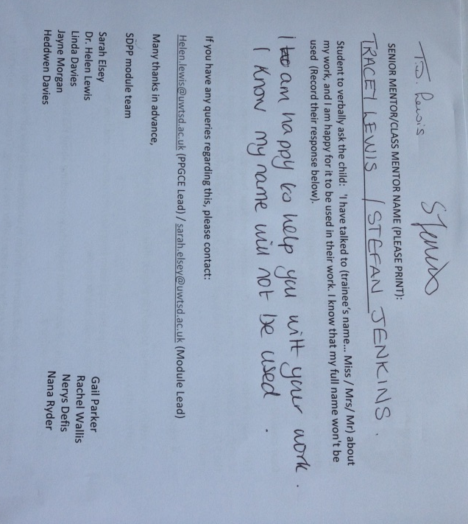
Appendix 2
Pupil A showing use of different methods to calculate addition and subtraction with 2 digit numbers.

- Addition using partitioning and column addition methods
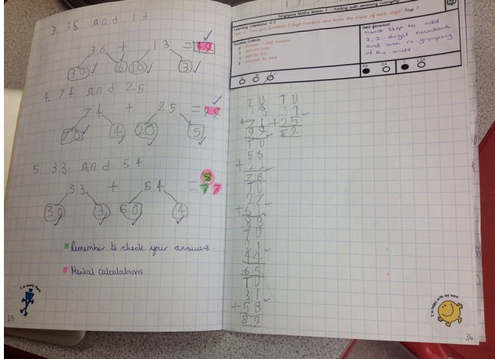

Appendix 2 (cont.)
- Column Subtraction Method – Note how Pupil A self corrects (red pen) after an incorrect answer is highlighted in green by the class teacher.
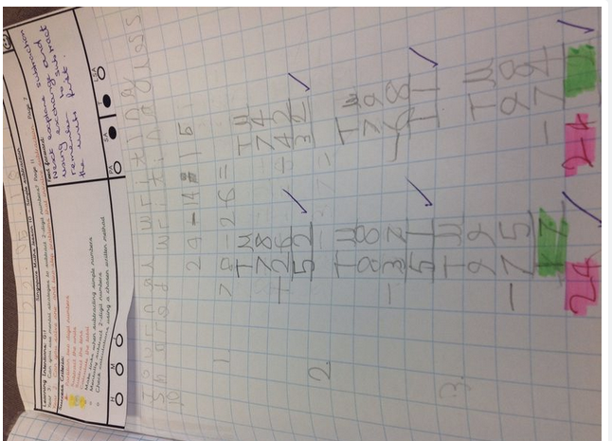

Appendix 2 (cont.)
- Subtraction using Partitioning Method
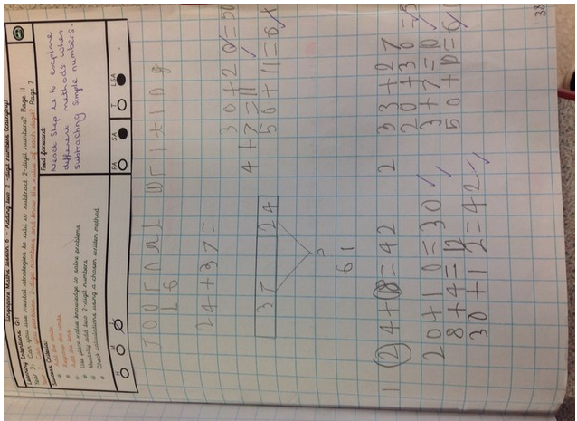

Appendix 3
In this sound clip, Pupil A demonstrates a clear speaking voice when he recalls facts about sloths in South America.

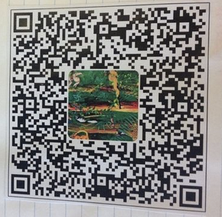

Appendix 4
Pupil A showing clear understanding of partitioning and adding 2 digit numbers, albeit the number 49 is written in reverse at the bottom of the whiteboard. This is not a misconception however but rather just an error.

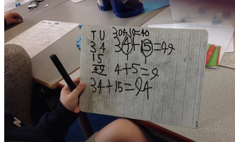

Appendix 5.
Photographs by Pupil A of resources and areas within the class and school that help him with his learning.

This photo showing methods generated by pupils during a Singapore maths lesson was the first one that Pupil A took. He stated that this really helps him when he is working out the calculations in maths.
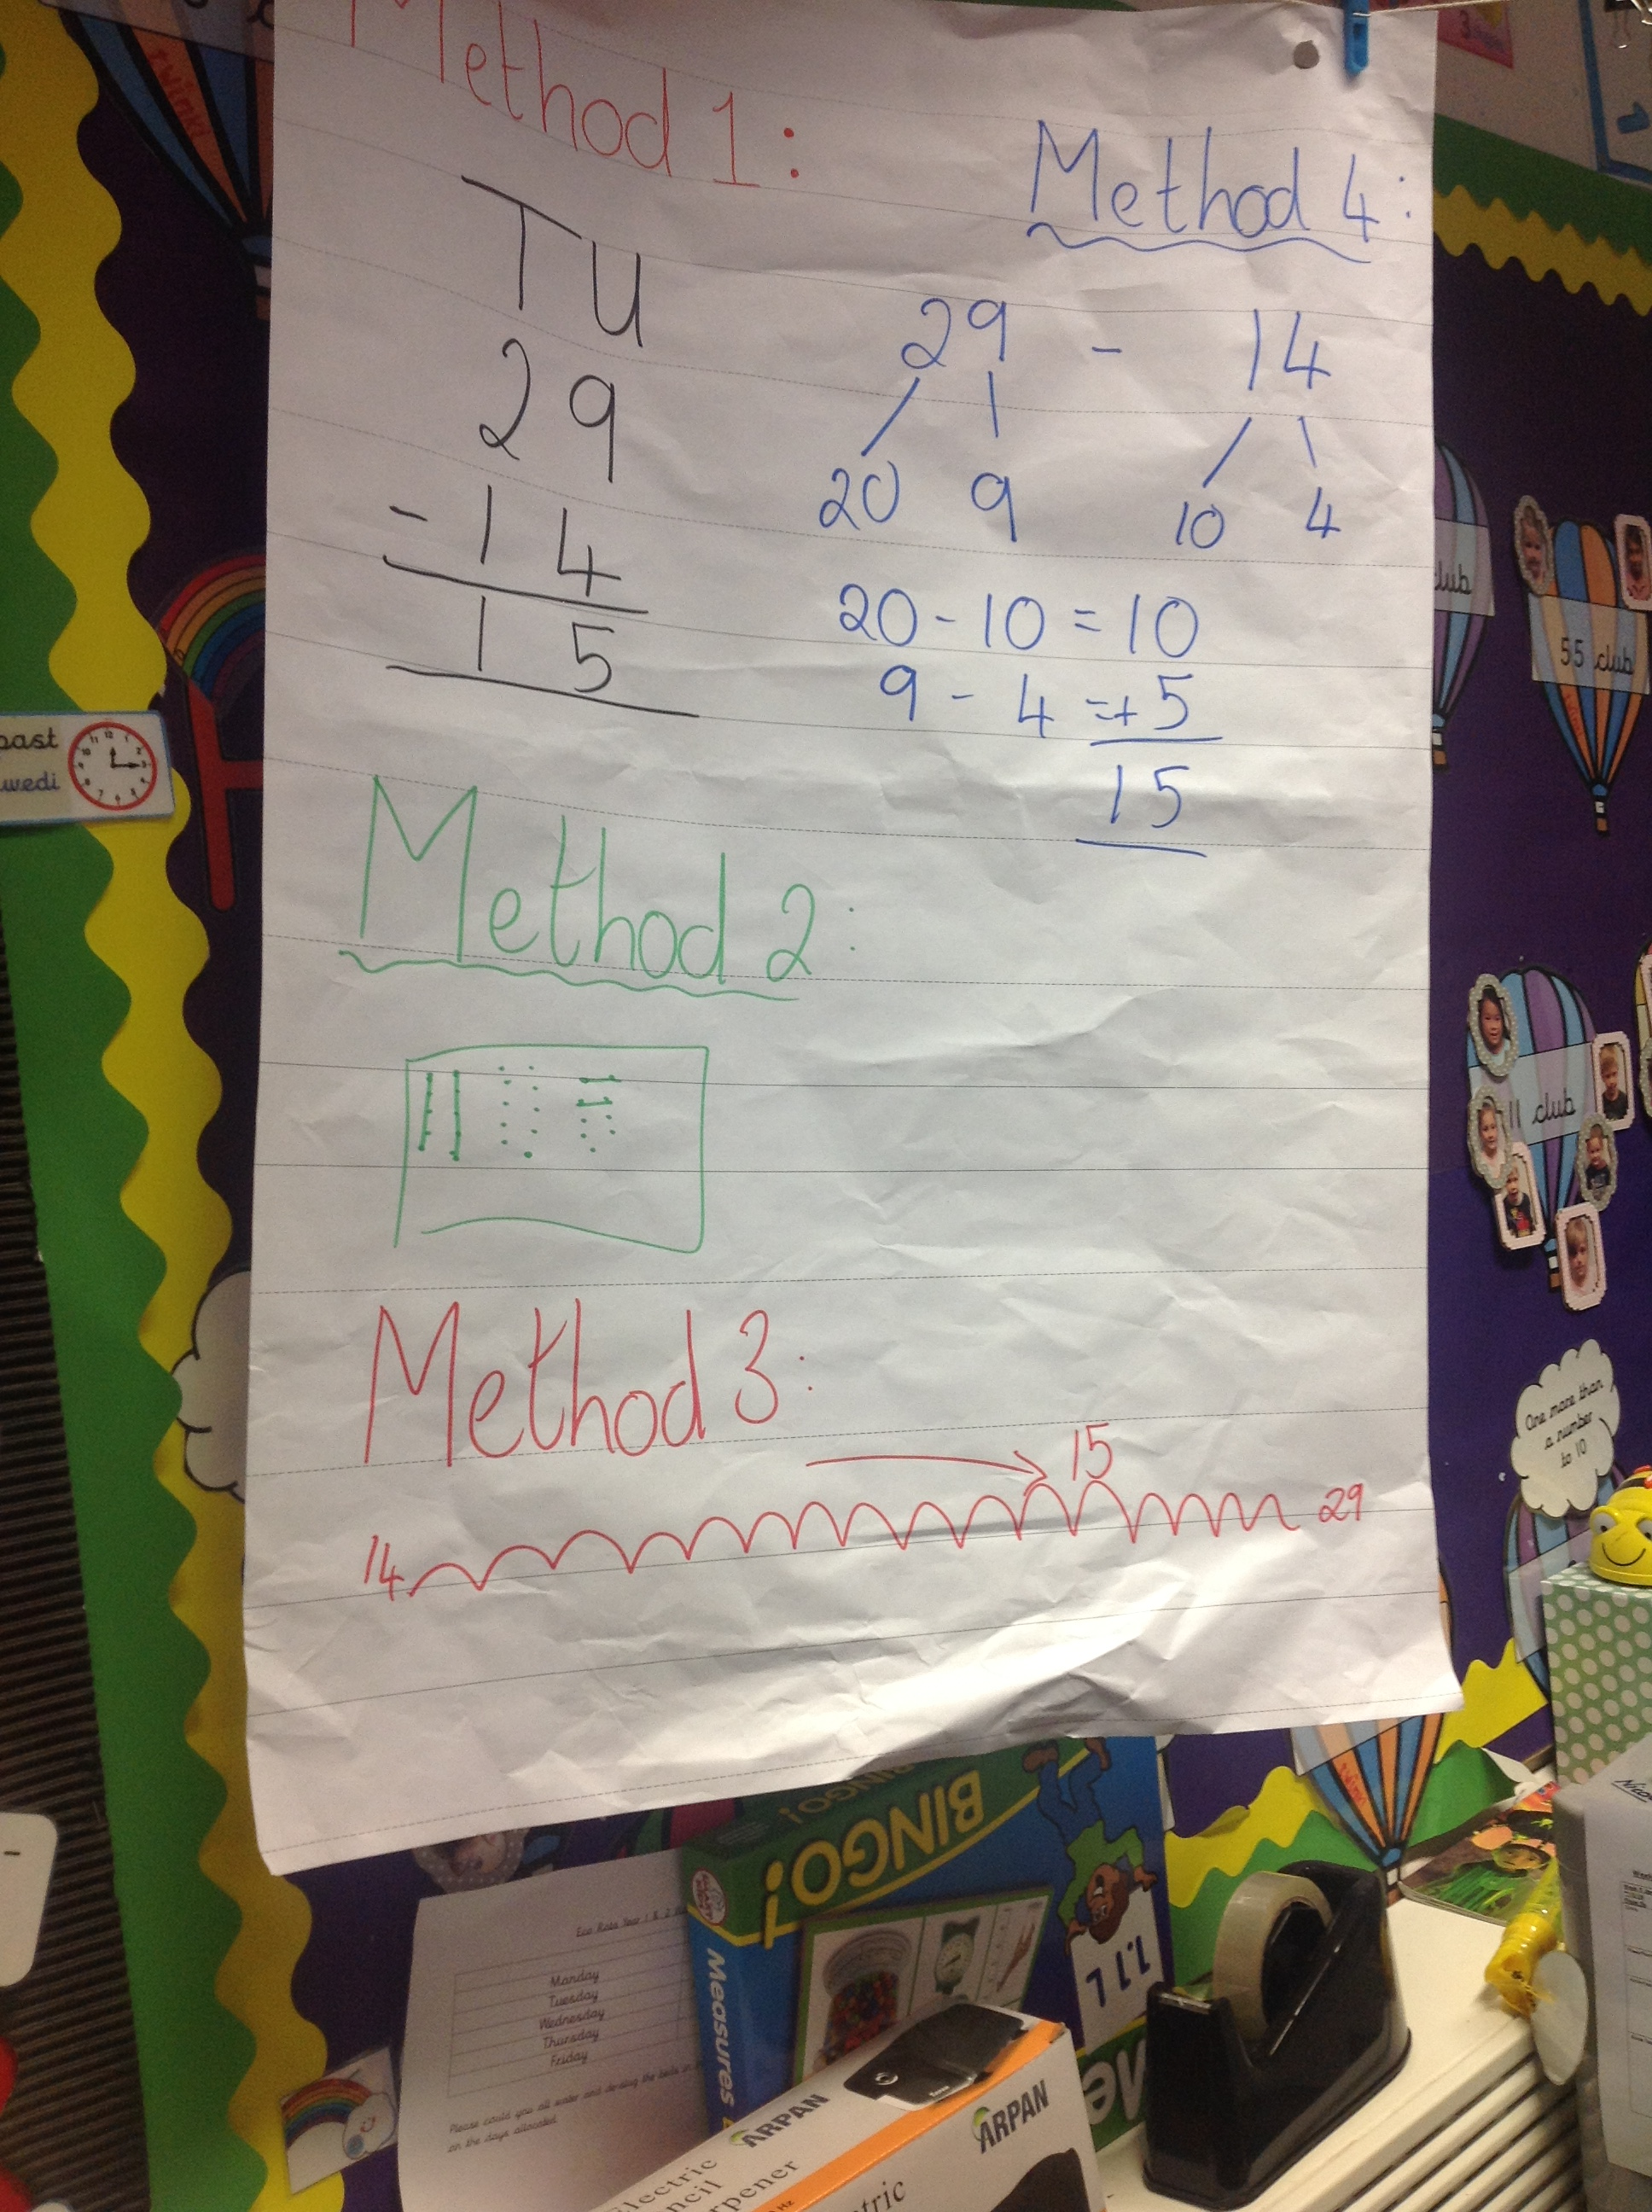

Appendix 5 (cont.)
Other photos taken by Pupil A show a 100 square in the corridor, numicon, a three times table counting stick and the times tables posters.

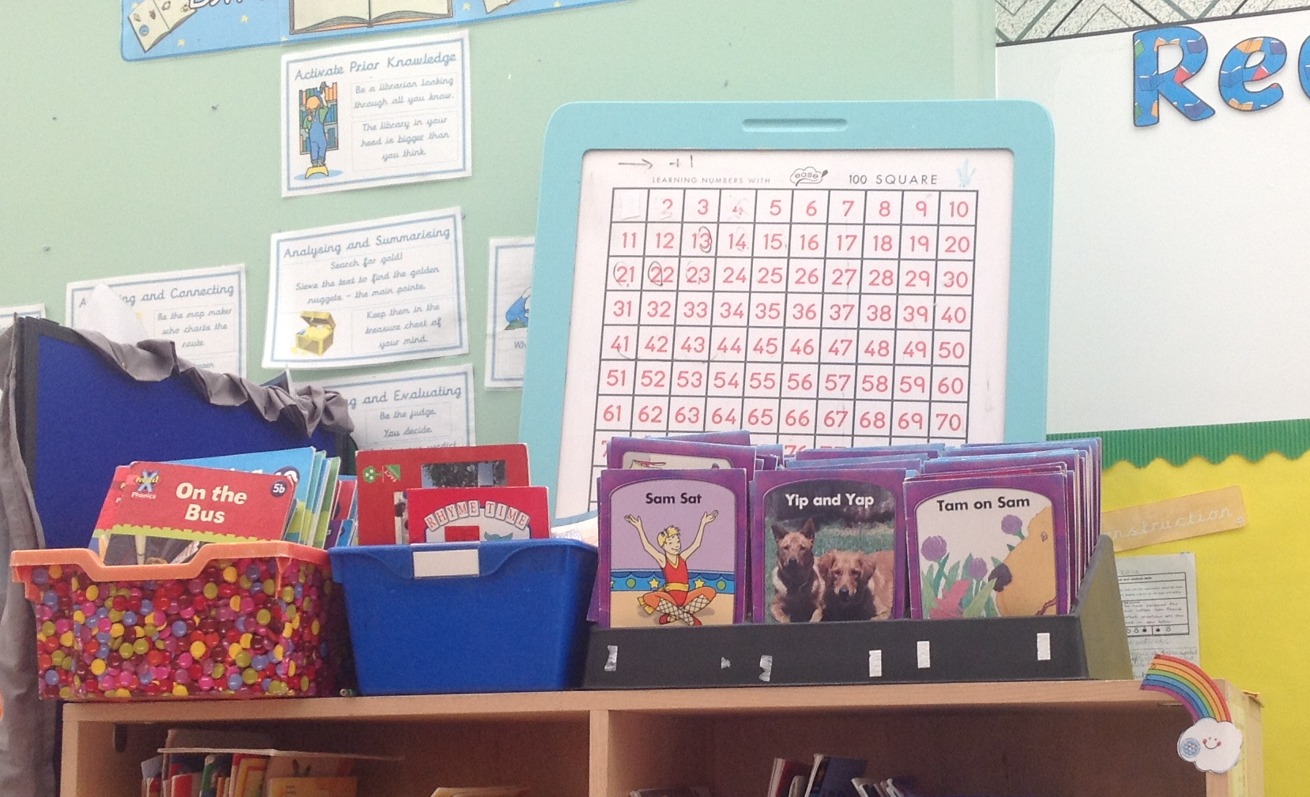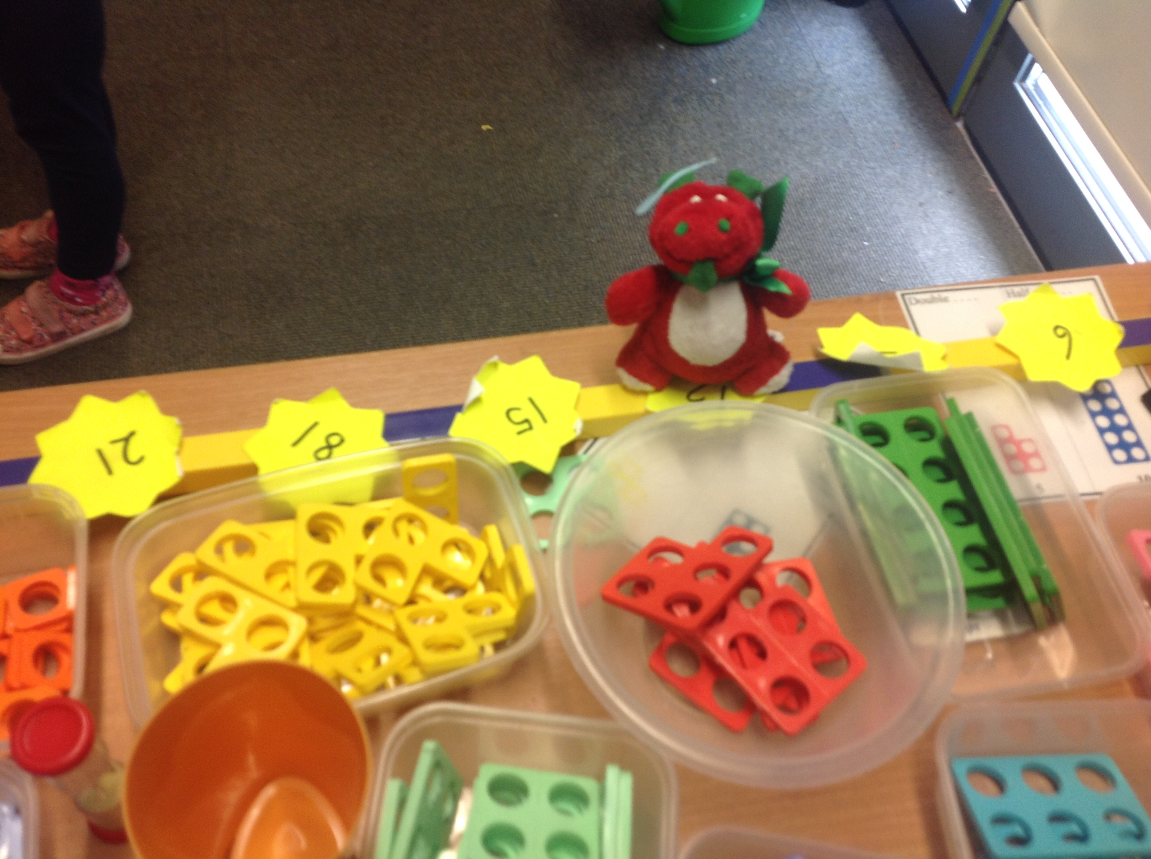

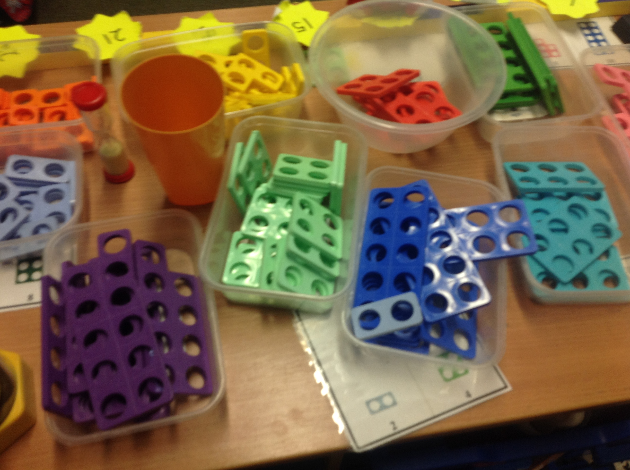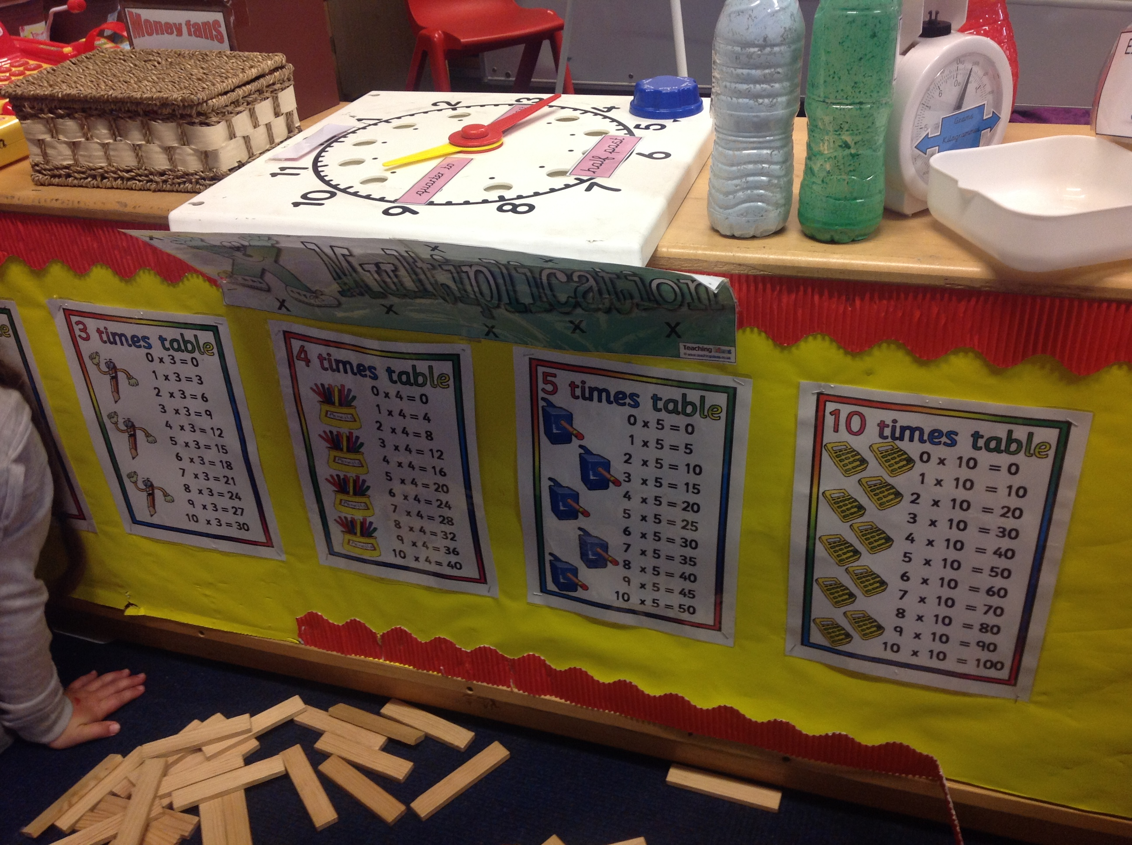

Appendix 6
Pupil A demonstrating knowledge and understanding of a range of regular and irregular 2D shapes.

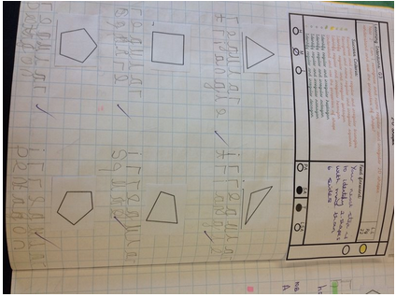

Appendix 7
Using standard units to measure, showing awareness of different scales of units.
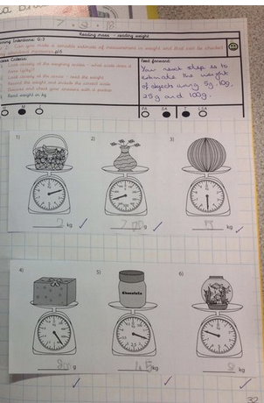

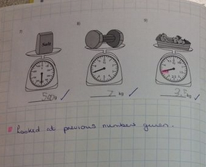
Appendix 8
Comparing temperatures using thermometers.

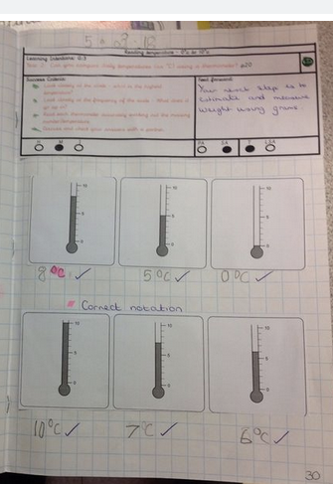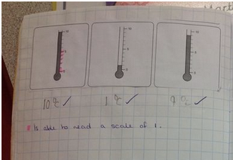

Appendix 9: Literacy Evidence
Evidence of Outcome 5. Pupil A was able to sound and spell dictated words using his knowledge of the phoneme ‘ue’ in his spelling. Pupil A also showing accurate formation of upper- and lower-case letters with consistent size and orientation.
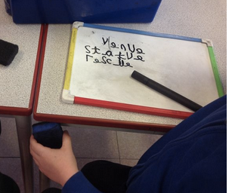

Evidence of Outcome 5. Pupil A used commas to separate a list of adjectives.
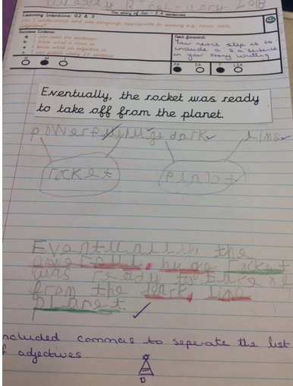

Appendix 9 (cont.)
Evidence of Outcome 5. Pupil A sequencing and structuring the content of his writing correctly and starting to extend his writing.
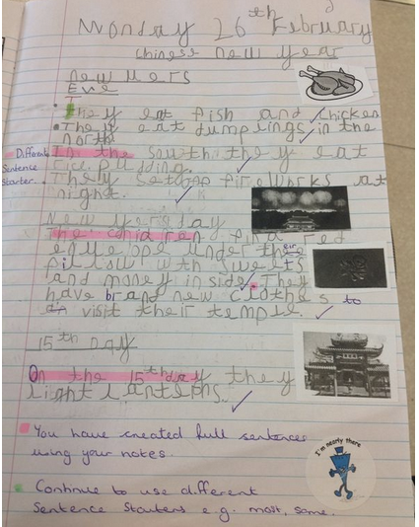

Appendix 9 (cont.)
Evidence of Outcome 4. Pupil A is beginning to use time connectives.
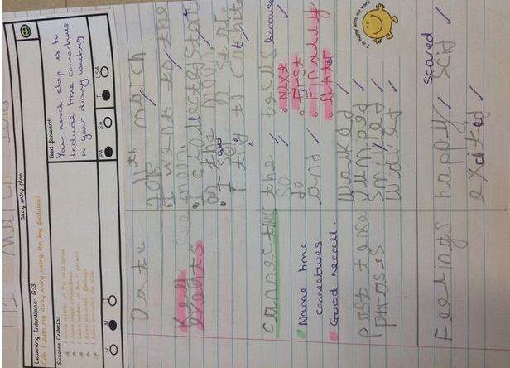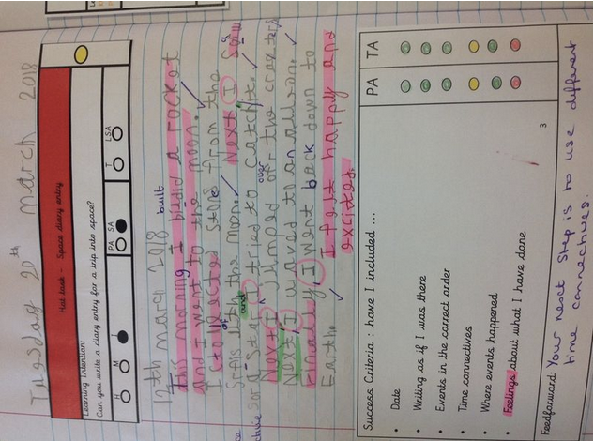

Appendix 9 (cont.)
Evidence of Outcome 4. Pupil A is reminded in these pieces of work to use capital letters and full stops in his writing.


