

Employee On-boarding System

by
Michael Simmonds

Supervisor: Gaynor Thomas

Project submitted as part of the requirements for the award of
BSc (Hons) Computing (Software Engineering)

July 2023

Abstract
This report presents the development and implementation of a digital self-service onboarding application for Bridgend County Borough Council (BCBC). The project's primary objective was to streamline the onboarding process for successful applicants, addressing challenges and inefficiencies in the council's traditional onboarding practices. The report begins with an introduction to digital transformation within BCBC and outlines the specific objectives of the HR onboarding phase.
A comprehensive literature review was conducted to explore what constitutes a great onboarding process and how technology can enhance it. The review identified key elements such as the 5 C’s compliance, clarification, confidence, connection, and culture, which served as the foundation for the new onboarding processes.
The development methodology employed for the project was the Waterfall Methodology, with its advantages and disadvantages discussed in detail. The design and implementation phase focused on project requirements, system models (including Use Case Diagrams and Data Flow Diagrams), and interfaces (prototypes and storyboards). Emphasis was also placed on ensuring accessibility for all users.
The report highlights the challenges and successes encountered during coding, including the use of HTML, PHP, and JavaScript in building the application. Testing, included system, usability, user acceptance and a pilot phase, was performed to validate the system's functionality and usability.
The report concludes with a summary of project achievements, highlighting the alignment with the literature review and identifying areas for improvement. Recommendations for further work are provided, offering potential avenues for future research and development. The report reflects on the overall success of the project, showcasing the positive impact of the digital self-service onboarding application on both BCBC and its new employees.

Declaration

I, Michael Simmonds declare that I am the sole author of this Project; that all references cited have been consulted; that I have conducted all work of which this is a record, and that the finished work lies within the prescribed word limits.

This work has not previously been accepted as part of any other degree submission.

Date: 01/05/2023

Form of consent

I Michael Simmonds hereby consent that my Project, submitted in candidature for the B.Sc. (Hons) Computing (Software Engineering) degree, if successful, may be made available for inter-library loan or photocopying (subject to the law of copyright), and that the title and abstract may be made available to outside organisations.

Date: 01/05/2023

Table of Abbreviations

Abbreviation | Meaning
BCBC | Bridgend County Borough Council
ASS | Applicant Self Service
LGA | Local Government Authority
ESS | Employee Self Service
HR | Human Resources
HRA | Human Resources Assistant
SST | Self Service Technology
API | Application Programming Interface
UAT | User acceptance testing
EDRM | Electronic Data Records Management

Contents
Abstract 2
Declaration 3
Form of consent 3
Table of Abbreviations 4
1. Introduction 7
1.1 Digital Transformation 7
1.2 Digital Transformation within BCBC 7
1.3 Phase 1 7
1.4 Phase 2 – HR On-boarding 8
1.5 Objective – HR On-boarding 8
1.5.1 Current On-boarding processes 9
1.5.2 New On-boarding processes 11
2. Literature Review 13
2.1 What makes a great onboarding process? 13
2.2 How can Technology improve the onboarding process? 15
2.2.1 Digital forms 15
2.2.2 Automation & Integration 16
2.2.3 Self Service Technologies 18
2.3 Current Onboarding Systems 19
2.4 Technologies to build Onboarding system. 21
2.4.1 HTML (Hypertext Markup Language) 21
2.4.2 PHP 21
2.4.3 JavaScript 21
3. Development Methodology 22
3.1 Waterfall Methodology advantages and disadvantages 24
4. Design & Implementation 26
4.1 Project requirements 26
4.2 System Models 27
4.2.1 Use Case Diagram 27
4.2.2 Data Flow Diagram (DFD) 29
4.3 Interfaces 30
4.3.1 Prototypes 30
4.3.2 Storyboards 31
4.3.3 Database Diagram 33
4.4 Accessibility 34
4.5 Challenges and Successes with coding 34
4.5.1 Successes 34
4.5.2 Challenges 35
4.6 Testing 38
4.6.1 System Testing 38
4.6.2 Usability Testing 41
4.6.3 Pilot 41
4.6.4 Acceptance Testing 42
5. Evaluation 43
5.1 Project achievements 43
5.2 Alignment with Literature Review 43
5.3 Areas for improvement 44
6. Conclusions and Recommendations 45
6.1 Project Summary 45
6.2 Contributions to Meeting Objectives 46
6.3 Further work suggestions 46
6.4 Recommendations 47
6.5 Further conclusion 47
8. References 49
9. Bibliography 51
Appendix 1 – Onboarding Questionnaire 52
Appendix 2 – Data Protection Impact Assessment 53

Introduction

Digital Transformation
The United Kingdom Government initiated a nationwide initiative for Local Authorities to adopt digital transformation, with the primary objective of enhancing work processes through the implementation of digital technology.

The Digital Transformation Programme was set up and is being run to help fund councils to develop digital solutions to support their wider work on national programmes of transformation including, the integration of health and social care, Troubled Families, Welfare Reform and Public Health. [1]

The initial nationwide digital transformation initiative encompasses three key objectives:

- Enhancing efficiency
The Local Government Association (LGA) will explore technological solutions to streamline processing time, enabling more focus on delivering improved services.

- Achieving financial savings
All LGAs will assess the potential of digital transformation, specifically technology, to generate cost savings, which is crucial given the budget constraints faced by LGAs.

- Enhancing service delivery
Digital transformation also seeks to enhance the quality of services provided by LGAs to their residents.

Digital Transformation within BCBC
The Digital Transformation initiative commenced at Bridgend County Borough Council in 2017. The first phase of the project had two primary objectives:
- Enhancing online public services
- Improving online human resources for employees
A business case was promptly established, and a project board was formed to oversee the initiative. Initially, the project was divided into two phases: Phase 1 and Phase 2.

Phase 1
To accomplish the objective of improving online human resources services for employees, a Self-service system was implemented. The Employee Self Service system enabled employees to access and modify real-time data managed by the Human Resources department. It introduced the following functionalities:
- Viewing Payslips
Employees can conveniently view and download previous payslips and P60 documents.
- Managing Qualification Data
Employees can view, add, and edit their qualification information.
- Booking Annual Leave
Employees can request annual leave for the upcoming year.
- Accessing and Editing Performance Reviews
Employees can view and modify their performance reviews.
The implementation of the new Employee Self Service system resulted in a reduction of over 50% in calls and inquiries directed to the HR department.

Phase 2 – HR On-boarding
When planning the second phase of the Digital Transformation project at Bridgend Council, the achievements of the Employee Self Service system implemented in phase one were considered. The project board examined other areas facing challenges and identified opportunities where Self-Service technologies could enhance processes.
Across the United Kingdom, Local Government Authorities are encountering challenges in recruiting new staff, as the private sector is able to offer more generous employment packages. Bridgend County Borough Council aims to enhance the entire recruitment process to attract and retain employees.
One of the most time-consuming and resource-intensive stages in the HR lifecycle is the recruitment process, particularly the transition from a successful interview to the applicant commencing their new job. According to research, the average time it takes to respond with a contract offer after a successful interview is 24 business days. [2]
BCBC strives to streamline and expedite the onboarding process within the organisation, ensuring that positions are filled as promptly as possible, thus creating a faster and smoother onboarding experience.

Objective – HR On-boarding
Recognising the difficulties and obstacles faced by local authorities in transitioning successful applicants into employees, the Digital Transformation board has decided to initiate a project. The objective of the project is to design and implement a digital self-service onboarding system that streamlines the transition process for successful applicants and minimises the time required to onboard them as employees, addressing the challenges faced by local authorities in this regard.

Current On-boarding processes

Once an applicant receives notification of their success in the interview stage, the onboarding process is initiated. After confirming the position offer verbally within BCBC, the council proceeds to make it official. The initial step involves HR sending a straightforward job offer via email, which requires the applicant to print, sign, and return the document. This process serves two purposes: confirming the applicant's ongoing interest in the position and initiating the broader onboarding process.
Following the return of the signed job offer, the onboarding process encompasses several steps, outlined as follows:
- New Starter Pack
A comprehensive package is sent to the successful applicant, containing various documents, some of which are quite extensive. These documents primarily serve the purpose of collecting necessary data to facilitate the transition from applicant to employee. The documents included are:
- New Starter Form
This form aims to gather personal information, including the National Insurance (NI) number, address, and ID documents.
- HMRC Start Checklist
This checklist ensures that the applicant starts their new position with the correct tax code, receives accurate payment, and has the appropriate amount of tax and national insurance deductions.
- Pension Form
All new starters are enrolled in the Local Government Pension Scheme, and the pension provider requires the relevant data to facilitate the process.
- Health Questionnaire
BCBC needs to ensure that the applicant's physical and mental health will not be adversely affected by taking up a new position within the council. This questionnaire serves the purpose of collecting relevant health-related information.
Once the council receives all the aforementioned documents, they should be printed, signed, and sent back. Upon receiving these documents, HR will proceed to enter all the information from the received documents into the Human Resources information system.
After conducting any required checks and coordinating a start date with the recruiting manager, HR will then issue a document called a Written Statement of Particulars (WOSP), which details the terms and conditions of the new position.
Overall, the current process is outdated and brings many disadvantages including:
- Delayed onboarding
The onboarding process experiences delays due to the extensive number of documents requiring printing, signing, and returning. Each document has its specific requirements, resulting in varying turnaround times. Even after the documents are returned, the process does not speed up significantly as the Human Resources Assistant must input the received information into the information system.
“The average response time after a successful interview to a contract offer is 24 business days” [3]
- Duplicated processing
The applicant fills in information on the documents that need to be returned, and then the HRA duplicates this effort by inputting the same information into the HR information system.
- Data accuracy
Similarly, to the previous point, since the successful applicant does not directly input information into the HR information system, errors can occur, whether it's due to poor handwriting or mistakes made by the HRA, leading to potential misinterpretation of the data.
The entire process, from beginning to end, is outdated and no longer suitable for the current job market, where numerous local authorities (LAs) and companies are in fierce competition to attract the limited talent available. Recognising this need, the digital transformation board initiated this project to address the outdated practices and bring about necessary changes.

New On-boarding processes
Recognising the issues of the current process, it was deemed necessary for the council to develop a new application that can effectively cater to the competitive job market.
If onboarding is conducted successfully, it has the potential to bring powerful results which support positive business outcomes. Indeed, research by Glassdoor found that good employee onboarding can boost retention by 82% and increase productivity by 70%. [4]
Primarily, this application should build upon the existing web recruitment site that the applicants utilised to apply for their positions. The applicants will be required to use the same username and password they used during the initial job application. Their account will be linked to an applicant record where certain personal information from the application process will already be stored.
In the existing onboarding process, the first step involves HR sending a basic job offer via email, the new application should replicate this step, providing a similar opportunity for the applicant to accept or reject the offer. This could be achieved through a pop-up notification or another suitable method, as long as the applicant is given the chance to indicate their acceptance or rejection. If the applicant accepts the offer, they will then gain access to additional functionalities within the system. On the other hand, if the applicant declines the offer, they should be presented with a message containing instructions on how to contact HR and provide an explanation for their decision.
The new application must be capable of gathering information from successful applicants, while also adhering to the General Data Protection Regulations (GDPR) to safeguard the sensitive nature of the provided information. This additional information will then be attached to the applicant record, preparing them for their transition into an employee role.
In addition to collecting various types of information, there are instances where the HR department needs to obtain copies of identification documents such as driving licenses or passports. Therefore, it is essential for the application to have the functionality that enables applicants to securely upload these documents.
The successful applicant, depending on the position within the organisation, should receive essential welcome messages from their new manager. These messages will include important information about the organisation as well as guidance on starting their new role as an employee. This could be information including:
- What to expect on their first day
- Access to eLearning that needs completing before start date.
- Rules and regulations for BCBC
In the final stage of the current process, the successful applicant is required to accept the terms and conditions outlined in their Written Statement of Particulars (WSOP). These WSOPs are specific to each position and are stored in a file-sharing system. The new application must be capable of accessing and displaying the WSOP from the file-sharing system, allowing the applicant to review and either accept or reject it.
To ensure compliance with GDPR principles, all the mentioned functionalities must be securely accessed through a unique login system. This measure aims to protect the privacy and security of sensitive data. In line with the practices in BCBC (Bridgend County Borough Council), developers are required to complete a Data Protection Impact Assessment, which is provided in Appendix 1.
By implementing the described system and adhering to the outlined process, the drawbacks associated with the current process will be alleviated:
- Accelerated onboarding.
By eliminating the need to print, sign, and physically return documents, the applicant can conveniently input all necessary data in one place. DocuSign, a prominent provider of e-signature systems, conducted research on the return time of HR documents. Their findings indicate that 56% of individuals return digital forms within the first hour of receiving them, and up to 85% return them within the first 24 hours [5]. This streamlined digital process significantly reduces onboarding delays.
- Streamlined processing.
The new application eliminates duplicated processing by allowing the successful applicant to directly input their data. This eliminates the need for the HRA to manually input the data. The information collected through the new application seamlessly transfers to the HR information system. As a result, data is entered at the source, reducing the need for redundant data entry.
- Improved data accuracy
With the new application, data accuracy is enhanced due to the direct input of information by the successful applicant. By eliminating the manual transfer of data from paper documents or reliance on HR to input information, the chances of errors or misinterpretations are significantly reduced. The applicant's direct input ensures that the data is accurately captured, improving the overall quality and reliability of the information stored in the HR system.

Literature Review

What makes a great onboarding process?
Prior to diving into application design, the initial step is to conduct thorough research on what constitutes a great onboarding process. This research aims to gain a comprehensive understanding of the essential elements that should be incorporated into the application.
Recognising the significance of first impressions, it is crucial for the application to provide a positive and impressive introduction to Bridgend County Borough Council for the successful applicant. While data collection is an important aspect at this stage, equally important is ensuring that the applicant feels welcomed and integrated as part of the team. Balancing both aspects will contribute to a successful onboarding experience and set the foundation for a positive relationship between the applicant and the council.
Doing too little during this crucial transition period can lead to higher turnover, lower engagement, and poor productivity, among other things. [6]
So, what makes for a great onboarding process, a great onboarding system should benefit both the applicant and the council. Most organisation use the 5 “C’s” created by Dr. Talya Bauer [7] in order to perform the onboarding process these are:
- Compliance
Organisations are required to meet various compliance standards when hiring a new staff member. Firstly, they need to ensure that the successful applicant has the legal right to work in the country where the job is located. Additionally, organisations are responsible for verifying the physical and mental fitness of the applicant for the intended role. Furthermore, they must fulfil their obligation to provide appropriate compensation to the new staff member. To comply with these compliance requirements, organisations, including the council, need to collect a considerable amount of data from the applicant.
- Clarification
A great onboarding process should clearly communicate the expectations and rules that the successful applicant needs to follow. While a more detailed induction will provide a comprehensive understanding of expectations and rules, it is essential to provide a basic understanding of their work location, working hours, and fundamental rules during the initial onboarding phase. This ensures that new employees have a solid foundation of information regarding their role and responsibilities from the start.
- Confidence
While closely related to the previous point, starting a new job can be an intimidating experience, and it is crucial to instil confidence in the applicant from the beginning. Providing a clear understanding of their new job responsibilities and all that it entails can greatly enhance and expedite the onboarding process. By ensuring that applicants have a solid grasp of their new role, tasks, and expectations, organisations can help them feel more comfortable and empowered, setting the stage for a successful transition into their new career.
- Connection
The process of meeting the hiring manager and teammates can be daunting, and a well-designed onboarding experience should address this aspect. It is beneficial for the successful applicant to have already established communication and familiarity with their hiring manager before their start date. This communication should outline mutual expectations between the applicant and the manager. By establishing this connection in advance, the need for extensive introductions during the onboarding process can be minimised.
A study conducted by Harvard Business School revealed that when new employees developed a strong relationship with their hiring manager within the first month, they were 58% more likely to be highly engaged in their work [8].
- Culture
The last aspect to consider within the 5 “C’s” is culture. It is crucial for a successful applicant to develop a sense of the environment they are joining. Understanding the vision and values of the organisation is essential. A great onboarding process aids the applicant in understanding these aspects by providing information about the organisation's history, policies, and more. By offering these insights, the onboarding process ensures that the applicant can arrive on their first day with a basic understanding of the organisation, including its history and its present state.

How can Technology improve the onboarding process?

Digital forms
In many organisations, the primary objective of onboarding is to have applicants fill out extensive HR forms for compliance purposes. This typically entails the applicant receiving a pile of repetitive paperwork.
While technology cannot entirely eliminate the need for paperwork, it can greatly assist applicants in various ways. The applicant will be able to access the data collection forms from anywhere with an internet connection on any device, including mobile devices, at any time of the day rather than having to wait for the forms to either come through the post or having to print an email attachment sign and scan back in.
This means increased efficiency for both the applicant and the council, with the applicant directly inputting the data into the system, with an integration into the main HR information system a HRA does not need to input anything, which they do need to do via a manual process. The improved process doesn’t stop with efficiency saving as the accuracy of the data will greatly improve.
Many browsers & phones now allow the use of an auto fill future. Autofill, also called autocomplete, is a software feature that automatically inserts previously entered personal information into web form fields for the user’s convenience [9], which can help with the tedious task of completing these forms.
A 2015 ADP survey of almost 1,500 employees and HR professionals found that fewer than 12 percent of new employees can access onboarding paperwork from their mobile device. [10]

Automation & Integration
Application integration is the process of enabling individual applications—each designed for its own specific purpose—to work with one another. By merging and optimising data and workflows between multiple software applications, organisations can achieve integrations that modernise their infrastructures and support agile business operations. [11]
One of the primary advantages offered by an onboarding system is the assurance of accuracy, accountability, and resource savings. Traditional paper-based onboarding processes are challenging to monitor and often result in user mistakes and inaccurate data collection. However, an onboarding system holds the new employee accountable for the accuracy of the collected data [12].
The most widely used integration system is an Application Programming Interface (API), which is a software intermediary that allows two applications to talk to each other. [13]
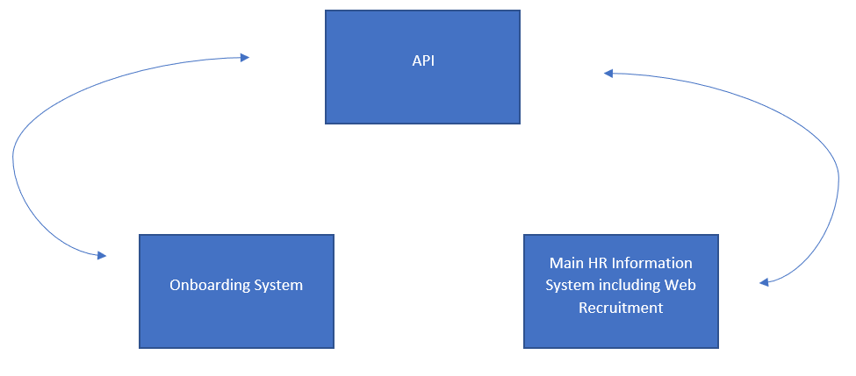
The new onboarding system is designed to follow the demonstrated flow above, providing a seamless user experience for applicants. As part of this process, the web recruitment system, functioning as a module of the main HR information system, requires applicants to create an account. This entails providing a unique username/email address and a secure password. Crucially, these login credentials are integrated with the new onboarding system, allowing successful applicants to access the onboarding portal effortlessly using the same username and password.
After creating an account in the web recruitment system, applicants proceed to fill out an application for the advertised position. During this stage, only essential information is collected, focusing on relevant training, experience, and basic personal details. This is done to make sure that the application applying is suitable for the job and is suitable to be moved on to the next stage.
To enhance efficiency and eliminate duplication, an integration between systems comes into play. When an applicant is successful and chosen for the position, this integrated system automatically transfers the essential information collected during the application phase to the new onboarding system. This seamless data transfer eliminates the need for the applicant to re-enter the same information, streamlining the process and reducing the risk of data entry errors.
One of the most significant advantages of API integration is its ability to output crucial information. Without this functionality, the data collected through the onboarding system would require manual entry into the HR information system by an HRA. This manual input introduces the potential for user errors and mistakes, leading to inaccuracies in the HR datbase. [14]
By utilising an API, the initial data entered by new employees through the onboarding portal is automatically and seamlessly transferred to the main HR information system. This integration plays a pivotal role in enhancing data accuracy, ensuring that the HR system is populated with precise and reliable data. Moreover, it brings about valuable resource savings for the HR department.
With the automated data transfer, HR administrators can allocate their time and effort more efficiently, focusing on other essential projects and strategic initiatives. This intelligent use of technology showcases how seamless integration between systems can lead to significant improvements in organisational processes and outcomes.

Self Service Technologies
Self Service Technology is changing the way people interact with organisations it lets users interact with an organisation independently without direct interactions.
Self-service technologies (SSTs) offer convenience, speed, and impeccable accuracy. They eliminate the need for service employees to handle face-to-face transactions, providing a streamlined and efficient two-way process that benefits both HR and Employee. [15]
Self-service technology offers numerous advantages, with its primary benefit lying in enabling users to independently assist themselves without the need for face-to-face interaction. Implementing self-service technology within an organisation can effectively free up resources. According to a study conducted by EasyVista, a company specialising in this field, an organisation that adopts a self-service technology solution for its Human Resources department can expect a 30% reduction in calls to the HR department compared to an organisation that does not employ such technology. [16]
Self-service portals are at the forefront of modern onboarding systems in the UK. These portals allow new hires to access essential onboarding resources and complete necessary tasks at their own pace and convenience. Through the portal, applicants can securely access onboarding documents, tax forms, benefits enrolment options, and other relevant information. They can also update their personal details and preferences, providing HR with accurate and up-to-date information.[17]

Current Onboarding Systems
The process of onboarding new employees has evolved significantly over the years, with the advent of technology transforming traditional approaches. In the UK, various onboarding systems have emerged, each offering unique features and capabilities to streamline the employee integration process. This part of the literature review examines the current landscape of onboarding systems available in the UK, exploring their functionalities and potential benefits.
Here are some of the systems that are on offer within the UK:
BambooHR – Onboarding
BambooHR are a company that we founded in 2008 and offer a wide range of HR and Payroll applications to help improve HR & Payroll as a whole. One of the solutions that BambooHR offer is an onboarding portal, which can be used as part of their fully integrated HR & Payroll information system or on its own. The onboarding system offers many features including:
- Paperless onboarding with digital document submission.
- Customisable workflows to tailor the onboarding experience.
- Onboarding checklist to track completed tasks.
- Electronic signatures for streamlined document signing.
- Personalised welcome page for new hires.
There are two ways to procure the BambooHR onboarding solution, the first being as part of a larger solution by incorporating it into their main Information’s system and the other on its own. Both options depend on how many applicants you’re going to onboard and with no exact prices on their website you would need to get in contact with the sales team. [18]

SageHR
SageHR is part of the sage group, Sage is the market leader for integrated accounting, payroll, and payment systems, supporting the ambition of the world’s entrepreneurs. Again, similar to BambooHR Sage offers a lot of different solutions in order to help with HR & Payroll processes. Sage is a little different to its competitors and only offer their onboarding portal as part of a package. The onboarding portal offers features including:
- Digital forms for streamlined data collection.
- Workflow builder to create efficient onboarding processes.
- Automation to reduce manual tasks.
- Digital signatures for secure document signing.
- Reporting for analytics and insights.
As briefly mentioned above to gain access to Sage’s onboarding solution you need to also buy its main application called ‘CORE HR + LEAVE MANAGEMENT’ this makes the solution very expensive and like most companies in this industry it depends on how many application/employees are going to use the system with 5000 users a year SageHR monthly fee is £20,150 which is £241,800 a year.[19]
Enboarder
Enboarder is a standalone solution which rare as most onboarding solutions are rolled up into a larger system which incorporates other systems like the core HR information system. It does however offer integrations into all you market leading HR information systems including the two examples above. As a standalone system the company was able to focus on onboarding and onboarding alone bring features that other companies haven’t thought of along with the normal features you might expect, some of these features are:
- Digital forms for efficient data collection.
- Automation and integration capabilities.
- Reporting for performance tracking.
- Data-driven manager coaching.
- Intelligent pulse surveys to gather employee feedback.
- Virtual bonding spaces for new hires and their teams.
Just like most solutions on the market an exact price is only known when a company requests a demo and an official quote but procuring a standalone system can be more expensive as the cost isn’t rolled up into a larger solution meaning that you’re paying for two solutions rather than one but it does bring the benefits of a better onboarding experience with the company only focusing on onboarding.[20]
Choosing the right onboarding solution depends on factors like the organisation's size, budget, and specific requirements. Companies should carefully evaluate each system's features, costs, and benefits to find the best fit for their onboarding process and overall HR needs. With the proper onboarding system in place, businesses can enhance employee experiences, streamline processes, and set the stage for long-term success.

Technologies to build Onboarding system.
In the digital era, web technologies play a crucial role in developing efficient and user-friendly onboarding systems. This section explores three key technologies utilised in building the onboarding application: HTML, PHP, and JavaScript.

HTML (Hypertext Markup Language)
HTML serves as the backbone of web development, providing the essential structure for creating web pages and applications. It is a markup language that defines the elements and content of a webpage, allowing developers to format text, images, and other multimedia components. In the context of the onboarding system, HTML was instrumental in designing the user interface and determining the layout of each page. [21]

PHP
PHP is a server-side scripting language that complements HTML in building dynamic and interactive web applications. As a server-side language, PHP processes data and generates dynamic content before sending it to the user's web browser. In the onboarding system, PHP played a critical role in handling data input from applicants and performing server-side validation and processing. [22]

JavaScript
JavaScript is a client-side scripting language that enhances the interactivity and responsiveness of web applications. It allows developers to add dynamic features to webpages, such as real-time form validation, interactive elements, and dynamic content updates. In the onboarding system, JavaScript played a vital role in improving user experience and providing instant feedback to applicants. [23]

Development Methodology
Bridgend County Borough Council employs a hybrid approach, combining elements of both Agile and Waterfall methodologies for application development. Whenever there is an unresolved issue that requires a more flexible approach to finding a solution, the Agile methodology is adopted. On the other hand, when faced with a set of well-defied requirements, the council chooses for the Waterfall method, as it offers a faster and more straightforward development process for the application.
Using the Waterfall methodology for developing a new onboarding application was the best option, especially as the project has well-defined and stable requirements which have been laid out from the beginning.
Here is overview of why BCBC applied the waterfall methodology for the development of a new onboarding application with the report going into most in more detail later within the report:
- Requirements Gathering
As previously mentioned in this report's introduction, the new HR Onboarding project is part of the larger Digital Transformation project, driven by the clear objective of reducing the time between a successful interview and the employee's start date. In the initial phase of the onboarding project, a diverse array of stakeholders, including HR professionals, managers, and employees, were consulted to identify and record detailed requirements for the onboarding application.
During this preliminary phase, it became evident what specific requirements were essential to achieve the project's objective. The majority of stakeholders highlighted the following areas where improvement was needed:
- Streamlining Data Collection
A key priority was to accelerate data collection by eliminating the cumbersome process of sending data collection forms via email attachments. The traditional method of printing, signing, scanning, and returning forms to HR was slowing down the overall process. As a result, it was imperative to enable the completion of these forms online.
- E-signing the Written Statement of Particulars (WOSP)
Similar to the previous point, stakeholders emphasised the need to eliminate the necessity for wet signatures on the Written Statement of Particulars (contract of employment). Instead, the system should facilitate viewing the contract and allowing candidates to accept or reject it electronically.
- Introduction
While not as unanimously popular as the first two requirements, stakeholders recognised the importance of introducing the successful applicant to both the council and the team. Therefore, it was crucial to include this as a logged requirement.
- Integration with Main HR Information System
To speed up the overall process, all HR stakeholders advised the significance of linking the new onboarding system with the main HR information system. This integration would ensure that the information collected during onboarding seamlessly replicates into the main HR system.
Other requirements were discussed including the design of the user interface as well as the security of the successful applicant’s personal data.
- System Design
With the clear reequipments documented in the first step the development team can move to the design phase. This stage is where the application starts to form with comprehensive designs to show stake holders designs including:
- Storyboarding
- User Case Diagrams
- Entity Relationship Diagrams
- Data base schema
The focus here is to define the application's structure and how different components will interact with each other.
- Implementation
Using the waterfall method, the implementation phase only starts once the design phase is fully complete. This phase is where the developer puts the designs in to action, the developer will look at the final designs and start turning them in to code to create the onboarding application. They will follow the technical specifications and ensure that the application meets the specified requirements. While doing this. stakeholders will be consulted to make sure the developer is steering the correct way.
- Testing
Arguably the most important phase within the waterfall mythology is the testing phase. It’s important for testing to make sure that the application is working as intended and more importantly making sure the application and the data within it is secure.
The developer will carry out a various type of testing techniques including:
- Unit testing to make sure that each feature works how it should.
- User interface testing to make sure that all components within the user interface work and are as accessible as it can be.
- System/Security testing to make sure that the whole system works as it should and is as secure as it can be.
Along with the testing completed by the developer and the development team the application needs to be tested by its future users in order to make sure the system is fit for purpose, this will be done under user acceptance testing (UAT), the user can feed back any issues that have been found along with any future ideas to develop the new onboarding application. UAT will be carried out by a select number of stakeholders, within BCBC there are normally a group called superusers who are first point of contact for any system issues within their teams.
UAT is important because it helps demonstrate that required business functions are operating in a manner suited to real-world circumstances and usage. If the expected outcome is not achieved during testing, the item will be documented and sent back to the developers for repair. [21]
- Deployment
Now that testing has been completed and any issues have been fixed the new onboarding application is now ready to be deployed. The application will now be moved to a production environment and made accessible to all HR users, managers, and successful applicants. Although most issue will be captured by the testing phase, some other minor issue might be identified at this stage normally due to performance when all stakeholders now have access to the application this is normally covered by stress testing but can never be covered 100% until all users have access to the application.
- Maintenance
After deployment, the maintenance phase begins. This involves providing ongoing support, bug fixes, and updates to the application as needed. The Waterfall methodology assumes that the requirements will not change significantly after deployment, but minor updates and maintenance will be part of this phase.
These updates arise either due to change requests demanded by the customer, or defects uncovered during the use of the product or software.[22]

Waterfall Methodology advantages and disadvantages
The waterfall methodology has many advantages over other methodology’s when creating an onboarding system including:
- Clear Requirements
Onboarding systems are developed for the sole reason of transitioning a successful applicant into a employees, this is backed up with the research into current systems available in the literature review section of this report where most features are supplicated over all applications. This sets clear requirements when developing a new onboarding application. The waterfall method is the perfect methodology when there is a set of clear requirements.
- Structured process
The waterfall mythology provides a ridged and structured process to follow, this allows for easy planning during the development where phases can be planned in advance to make sure that stakeholders are available to input into the project.
Teams must complete an entire phase before moving on to the next one. So, if there are obstacles to completion, they are immediately visible.[23]
- Stable Product Design
The design is finalised in the early stages of the Waterfall method, reducing the likelihood of significant design changes during development, which can be beneficial for projects with fixed budgets and timelines.
- Documentation
The Waterfall approach encourages comprehensive documentation of requirements, design, and other aspects, making it easier for future reference and maintenance.

As with every development methodology there are disadvantages if choosing the waterfall method here are a few and also how the council intends to word around them:
- Flexibility
The Waterfall methodology lacks the flexibility to accommodate changing requirements. Due to the structured process any changes during the development process will take the method back to the initial phase. To work around this limitation, it's essential to conduct a thorough and detailed requirements gathering phase to capture all necessary functionalities from the outset and making sure a wide verity of stakeholders are engaged throughout to get a wide array of opinions.
- Late user feedback
User feedback within the waterfall method does not come until the testing phase through user acceptance testing, users can sometime find issues with the application or its features that the developer can have missed. This can knock the development back to phase two which will hinder the speed of development. Bridgend County Borough Council make sure that stakeholders are involved in every phase within the development including the design phase and implementation phase this makes sure that of the development team misses something the stakeholders can advise them at the earliest stage to ensure their needs are adequately captured.
- Long development time
Waterfall projects can take longer to complete, especially for large and complex applications. This can be due to a number of factors, but the main factor is similar to the points above that when something is missed the whole development can be taken back steps. The council always ensure a well-defined project timeline is set and milestones and deadlines are adhered to.
The Waterfall methodology offers a structured and systematic approach to the new onboarding system development. While it has clear advantages, addressing its limitations through thorough planning, stakeholder involvement, and adherence to timelines can lead to successful implementation.

Design & Implementation
The development of the new onboarding system was driven by the objective of improving the transition time between a successful interview and the employee's start date. To ensure the system's effectiveness, we engaged in extensive consultations with HR professionals, managers, and employees to gather detailed requirements for the onboarding application. These requirements formed the foundation of our design decisions.
The council adopted the Waterfall methodology to structure our design process systematically. Each phase, including requirements gathering, design, implementation, testing, and deployment, was completed in a precise and documented manner. The comprehensive documentation throughout the Waterfall approach ensured that the development process remained complete, consistent, and correct.

Project requirements
To start the design phase of the project the requirement for the new onboarding system we carefully studied, and the development team came up with the following overview of what needed to be designed:
Overview of Project Requirements:
- The onboarding system should be a digital self-service platform accessible to successful applicants through the existing web recruitment site login details.
- It should securely collect, and store sensitive personal information and documentation required for the transition to employee status.
- The system should enable applicants to accept or reject Written Statement of Particulars (WSOP) digitally, reducing delays in the onboarding process.
- The platform should facilitate welcome messages and important information about the organisation.
- Compliance with GDPR principles should be ensured to protect the privacy and security of applicant data.
The initial project objectives were outlined by the Digital Transformation board at BCBC, aiming to address the challenges faced by local authorities in the recruitment process. To discover the specific requirements for the onboarding system, the project team engaged in extensive consultations with stakeholders, including HR professionals, managers, and potential users. The project team conducted interviews with HR professionals and managers to gather insights into the current onboarding process and identify pain points and areas for improvement. Surveys were also administered to potential users, such as successful applicants, to understand their preferences and needs in the onboarding experience.
After consulting with key stakeholders, a business case was established (Appendix) to outline the project's objectives and identify the key requirements. This document provided a starting point for understanding the scope and goals of the onboarding system.

System Models

Use Case Diagram
A Use Case diagram was created to visually represent the interactions between the system and its users. The primary actor identified in the Use Case diagram was an "Applicant". The Use Case diagram outlined the various use cases and functionalities that each actor could perform within the onboarding system.
Key use cases included "Accept Job Offer," "Upload Identification Documents," "View Written Statement of Particulars," and "Meet the team”. The Use Case diagram provided an overview of the system's functionalities and interactions, guiding the development process.
One of the goals of the onboarding site was to provide a simple user face, the use case diagrams below were created in conjunction with HR and applicant stakeholders and show that nothing in the application should be more than two clicks away.
The first use case was to show when an applicant logs in to complete the onboarding form. As you can see form the image below the applicant would need to log in to the application which will take them to the home page where they will be able to click through to complete the onboarding form.

The next use case was for an applicant who needs to upload identification documents which can be later acceded through the web server and could create a future enhancement to automatically move these documents in to our electronic data record management system (EDRM).
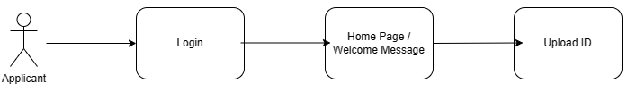
The third use case is where an applicant can view their offered written statement of particulars (WSOP) and either choose to accept or reject them, again this is only two clicks away from the login page.

The last use case is when an applicant logs in to the new onboarding application to meet their manager and team.
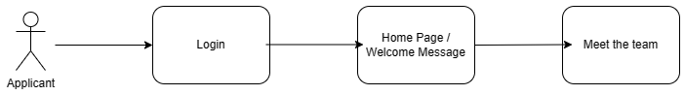
As you can see from all the use cases and again later from the data flow diagram all pages are just two clicks away with everything being able to be accessed via the home page. This makes the the application self-explanatory and hopefully if the application follows the use cases applicant shouldn’t have any issues find where they need to be.

Data Flow Diagram (DFD)
The Data Flow Diagram illustrated the flow of data and information within the onboarding system but also the to and from using a PHP API. It depicted the processes, data stores, and data flows between the applicant, HR staff, and the HR information system.
The DFD helped in understanding how data is collected, processed, and stored within the system, ensuring a clear understanding of data interactions and dependencies. It also helped to gain an understanding of where the applicant would need to be in order to carry out certain tasks.

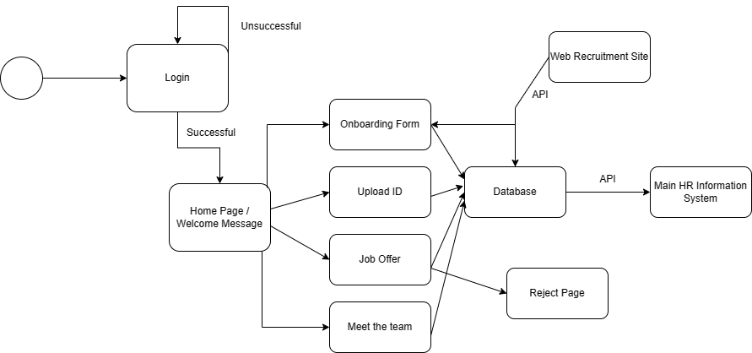

As you can see above the DFD further reiterates that every page is only two clicks away. It also shows the flow of login, and personal information into the system from a PHP API with the same being illustrated outbound via an API to the main HR information system.

Interfaces

Prototypes
Interactive prototypes were designed to showcase the user interface and user experience of the onboarding system. The prototypes were created using HTML pages with no processing behind them enabling stakeholders to experience the system's functionalities and navigation.
The prototypes included screens for different stages of the onboarding process, such as the job offer acceptance page, the personal information input form, document upload page, and the welcome message from the new manager and team.
User feedback from the prototypes was collected through user testing sessions, leading to interface improvements and refinements. One of the main changes from these sessions was the home page, as you’ll see from the storyboards below, within the home screen there is now a welcome message from Bridgend County Brough Council Chief Executive but before the forementioned change there was duplicated links with a brief explanation of each page, which HR felt that wasn’t needed.

Storyboards
Storyboards were utilised to visually represent the step-by-step user journey through the onboarding process.
The storyboard illustrates designed for each page and shows #the applicant's interactions with the system. Storyboards helped stakeholders comprehend the onboarding process flow and identify potential bottlenecks or areas for enhancement.
Additionally, the storyboards were valuable in presenting the system's functionality to non-technical stakeholders, facilitating a better understanding of the user experience.
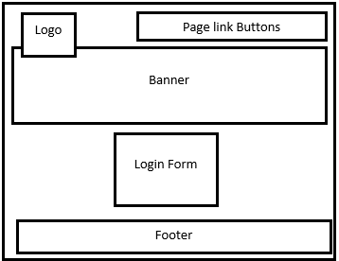
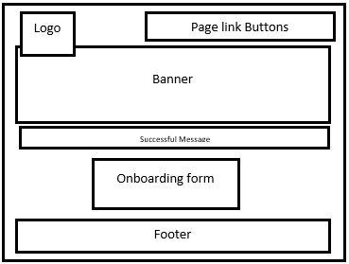
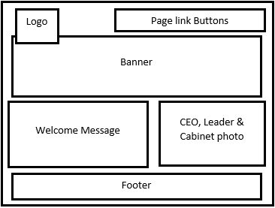
Onboarding form Page
Home Page
Login Page

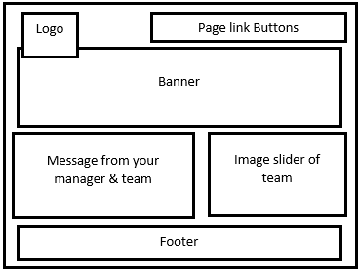
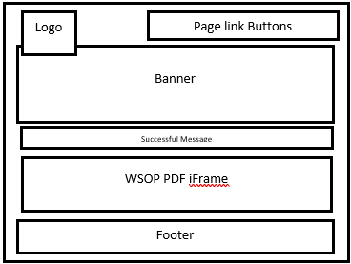
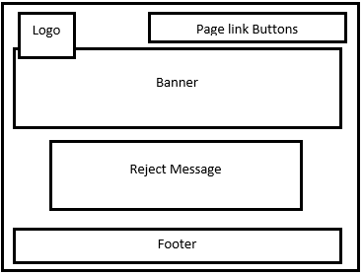
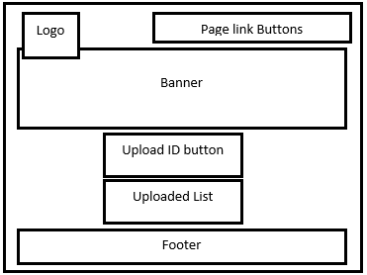
Meet the team Page.
Rejected Page
Job offers Page.
ID Upload Page

The storyboards offer an overview of the page layout and illustrates the simple design across the application will all pages having very similar banners and exactly the same footers, where the prototypes were designed in cohorts with the HR department the storyboards were created with previous applicants, both design methods were combined in order to take various opinions onboard.

Database Diagram

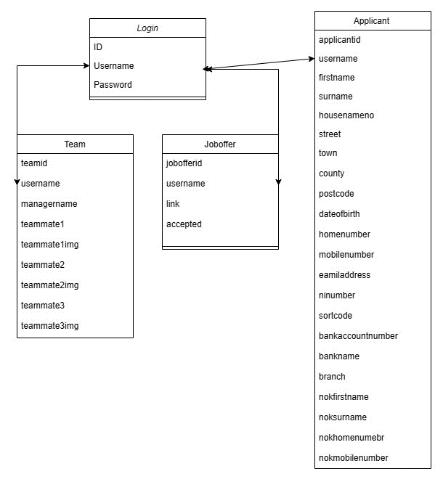

Accessibility
In the interface design, the developer has considered accessibility to ensure that the system is usable by individuals with disabilities. The developer followed Web Content Accessibility Guidelines (WCAG) standards, including:
- Proper Contrast
Ensuring clear and readable content by maintaining adequate contrast between text and background colours.
- Keyboard Navigation
Supporting keyboard navigation so that users can interact with the system using the Tab key and other shortcuts.
- Alternative Text
Providing descriptive alt text for images, allowing users with visual impairments to understand the content conveyed by the images.
By implementing these accessibility features, the system becomes more inclusive, offers an enhanced user experience, and complies with legal regulations. It also demonstrates a commitment to inclusivity and builds trust with users and stakeholders.

Challenges and Successes with coding
Here are some coding successes and challenges encountered during the development of the onboarding application:

Successes
- Front-End User Interface:
Using HTML, CSS, and JavaScript, the front-end user interface was successfully designed to provide an intuitive and visually appealing experience for applicants. The layout and design adhered to modern web development practices, ensuring responsiveness, cross-browser compatibility, and cross device compatibility.
- Integration with Existing Systems:
Successfully integrating the onboarding application with the existing web recruitment site using PHP allowed for seamless data transfer and account management. This integration minimised the need for duplicate data entry and streamlined the onboarding process. Although at the beginning of the process the developer hadn’t implemented an API using PHP with the developers skill set and research [24], the developer was able to develop an in put and out put API (please note although the code has been written and limiting testing had been carried out using postman the API will not actually work due to the nature of the systems they need to be connected to).
- Secure Document Upload and Storage
Implementing a secure document upload feature using PHP allowed applicants to upload identification documents securely. Future enhancements to the system could result in the documents automatically being uploaded to the councils EDRM system.
- Personalised Welcome Messages
Utilising PHP personalised welcome messages were successfully generated and displayed to new employees. Dynamic content generation allowed for a customised message, providing essential information about their role, and starting their journey with the organisation.
All these features relied on the logged in applicant’s username where all tables within the database used the logged in username as a secondary key, when the applicant first logs in the username is stored as a session variable, all PHP scripts then call upon the session variable to display and update the correct applicant’s data.
Here is a snippet of code that stores the username as a session variable:
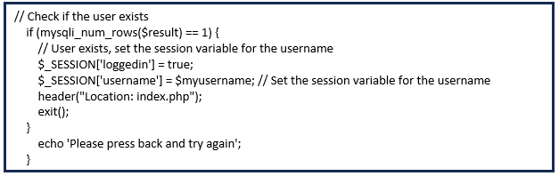
Here is a snippet of code which calls upon the session variable:
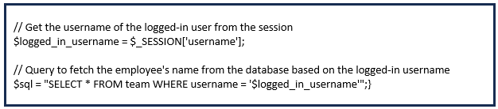

Challenges
- Onboarding form
As forementioned within this report, the applicant who is onboarding will have input basic information within the web recruitment system when completing an application for the advertises position, this information is then imported into the onboarding portal via the PHP API.
The developer encountered a significant hurdle while attempting to populate the onboarding form fields with the applicant's information that has been imported from the web recruitment system when the applicant clicks into the onboarding form page.
The applicant logs on to the onboarding system with their username, this username is the secondary key for all tables within the database, the developer planned to display the applicants information by matching the applicants username that they are logged in with to the username within the applicant table within the database, at first the information just would not display and the developer couldn’t find the issue with the code.
After many validation scripts the developer found that on logon the username wasn’t being stored into a session variable so the PHP script that was selecting the data from the database would never have worked.
Here is a snippet of code which brings back any data stored within the database for the applicant that is currently logged in:
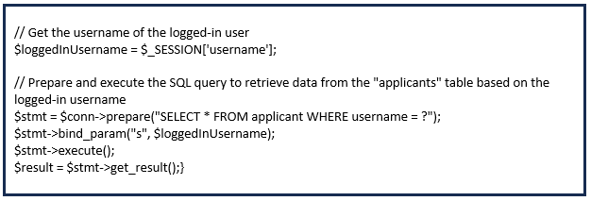
This code is using the session variable of ‘username’ that the developer added to the login PHP script and matched it to the username via a SQL statement within the applicant table to bring back the applicant’s information. Later within the PHP script all the information is then input into variables which is input as values into the form fields.
- ID document uploads
One of the requirements for the onboarding system was to enable the applicant to upload ID documentation, this posed a challenge, but the developer was able to overcome this by using the ‘move_uploaded_file’ function within PHP which saved the files uploaded to a location on the web server.
This function checks to ensure that the file designated by from is a valid upload file (meaning that it was uploaded via PHP's HTTP POST upload mechanism). If the file is valid, it will be moved to the filename given by to.[25]
Once this was complete the developer wanted to list the files that had been uploaded and provide a link to them so that the applicant could check what they had uploaded, the developer used the ‘scandir()’ function to check and list what files were within the file directory on the web server.
The scandir() function in PHP is an inbuilt function that is used to return an array of files and directories of the specified directory.[26]
- Success messages
Success messages are shown on two pages in the new onboarding application: the onboarding form page and the job offer page. On both pages, the messages should be displayed when specific buttons are clicked. However, the developer needed to keep the option open for the buttons to be clicked again, making it challenging to create the success messages directly in HTML.
As a solution, the developer opted to use PHP to verify whether the buttons were clicked. They created session variables that were set when the update or accept button was clicked. The PHP code then checked the existence of these session variables, and if they were present, a success message would be generated and displayed accordingly. This approach allowed for dynamic success messages to be shown based on user interactions without relying solely on static HTML.
This snippet of code shows the creation of the session variable:
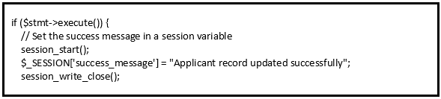
Here is the message being displayed if the variable exists:
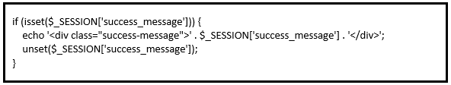
Overall, the successful implementation of the onboarding application using HTML, CSS, JavaScript, and PHP contributed to streamlining the onboarding process, reducing delays, and enhancing the overall efficiency of the HR department.
The application's design decisions and features directly aligned with the project's objectives, fulfilling the specified requirements, and providing a user-friendly experience for both applicants and HR staff.

Testing
Testing is a critical phase in the development process to ensure that the onboarding application functions as intended, meets the specified requirements, and provides a positive user experience. Here is an overview of the testing process for the software:

System Testing
System testing involves evaluating the entire application as a whole to assess its functionality and performance in a simulated environment. During system testing, the entire onboarding application was subjected to various test cases, including positive and negative scenarios. This testing phase ensured that all components integrated seamlessly, and data flow between different modules was accurate and consistent. System testing also validated the application's adherence to business logic and its overall compliance with requirements.
These tests were conducted after the initial testing showed that the username wasn’t being stored as a session variable which caused most of these tests to fail, this has now been corrected.
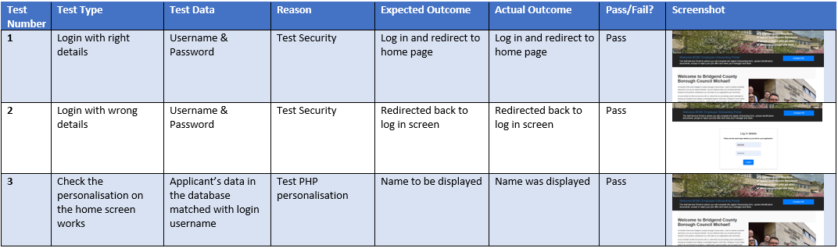
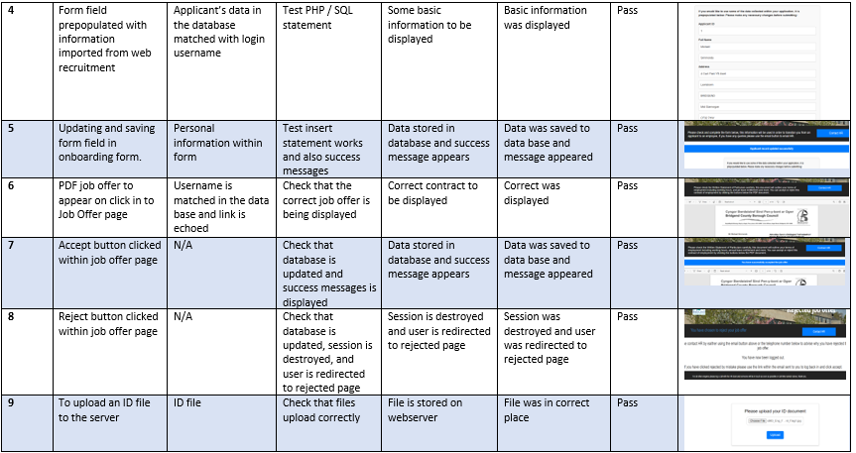
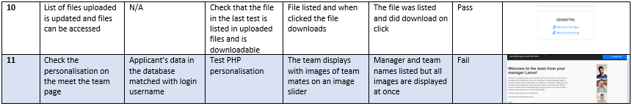
As you can see from the testing the system is working as it should be. There was one fail due to the images not being available via an image slider and were shown all at once, this was a problem with the JavaScript and was corrected and now that function works.

Usability Testing
Usability testing focused on evaluating the user interface and interaction design of the onboarding application. A group of representative users, including HR staff and applicants, participated in this testing.
This group of stakeholders were given each webpage as a HTML document with no PHP or JavaScript behind them, this was to just evaluate out the user interface only.
They performed specific tasks on the application while providing feedback on their experience. Usability testing aimed to identify any usability issues, such as confusing navigation, unclear instructions, or unintuitive layouts.
Based on user feedback, necessary improvements were made to enhance the user interface and overall user experience, one part of the feedback was regarding the home screen where its body of content included links to all pages with a small amount of information regarding them, the stakeholders found this not to be needed as all link were within the menu already, there were a number of idea on what to do with this page but the stakeholders agreed that there should be a personalised message from the Chief Executive of the council along with an image of BCBC’s cabernet.

Pilot
One of the advantages of conducting a pilot study is that it might give advance warning about where the main research project could fail, where research protocols may not be followed, or whether proposed methods or instruments are inappropriate or too complicated. [24]
The pilot included a selected group of 20 new employees who had been successful within an interview. The group of new jobs selected contained a wide variety of jobs from grade 1 positions to grade 16 positions.
The successful applicants were emailed a link to the new SST on-boarding system where they completed all paperwork electronically, the new system also included all information about the successful applicant’s team, so the new employees were introduced to Bridgend County Borough Council.
The success of the pilot was measured in two different ways.
The first measurement used a Quantitative approach, and a survey was sent out to the group which piloted the new system. The survey asked questions about the new onboarding application (Appendix) 85% thought that the new processes were excellent.
The second measurement was again a Quantitative approach, this measurement looked at the time the admin tasks conducted by the HR department were taken with the new digital process’s vs the old paper processes.
The measurements were taken over 5 jobs so an average could be found:
Paper Process | Digital Process | % of Time Saved
5 hours 32 minutes | 2 hours 18 minutes | 41.5%

Acceptance Testing
Acceptance testing is the final phase of testing, during which the onboarding application was evaluated against the agreed-upon acceptance criteria to determine if it meets the user's expectations and requirements.
This acceptance criteria were as followed:
- The successful applicant can login to the system with the same details as the web recruitment site
- The successful applicant can view and edit their personal information.
- The successful applicant can upload identification documents.
- The successful applicant can accept or reject a job offer.
- The successful applicant is introduced to their team.
Representatives from the HR department and applicants participated in this testing to assess the application's suitability for its intended purpose. The acceptance tests ensured that all functionalities, including account creation, document upload, and welcome messages, were fully functional and aligned with the project's objectives.
Feedback from users during acceptance testing was crucial in identifying any last-minute adjustments or improvements needed to make the application ready for deployment.
Overall, comprehensive testing of the software, including system testing, usability testing, and acceptance testing, played a pivotal role in validating the onboarding application's performance, reliability, and usability. It allowed the development team to identify and address potential issues proactively, ensuring a smooth and efficient onboarding process for successful applicants and enhancing the overall HR experience within the organisation.

Evaluation
The onboarding application developed for Bridgend County Borough Council (BCBC) has undergone extensive testing and evaluation to assess its effectiveness in streamlining the onboarding process and meeting the project's objectives.

Project achievements
- Achievement of Objectives
The onboarding application successfully achives its primary objective of expediting the onboarding process for successful applicant. As the new application seamlessly integrates with the existing web recruitment site, it allows applicants to conveniently accept job offers digitally, eliminating the need for manual paperwork and reducing administrative burdens. The functionalities, such as gathering personal information, uploading identification documents, and displaying the Written Statement of Particulars (WSOP), work to enhance the efficiency of the onboarding process.
The application effectively gathers all necessary information from successful applicants, such as contact details, next of kin details, and banking details, and stores it securely in the HR information system. This eliminates redundant data entry and significantly reduces the risk of data errors. The information is then used to transition the successful applicnt into a council employee.
- Fulfilment of Aim
The aim of the project was to enhance the entire onboarding process at BCBC to attract and retain employees more efficiently. The successful implementation of the onboarding application has directly contributed to achieving this aim. By reducing onboarding delays and streamlining the process, BCBC can now attract talent more effectively and provide a positive onboarding experience to new employees. As you can see form the pilot during testing phase the amount of time resources needed as been reduced by up to 41.5%.

Alignment with Literature Review
The literature review highlighted the benefits of technology in improving onboarding processes, particularly through digital forms, intergration, and self-service technologies.
The data confirmed that the digital onboarding application successfully integrated digital forms, enabling applicants to submit essential data conveniently and securely. The application's integration capabilities significantly reduced manual tasks, resulting in increased efficiency and data accuracy.
Moreover, the self-service technology provided applicants with greater control over the onboarding process, empowering them to access necessary resources and complete tasks independently.
The evaluation data supported the idea that the new onboarding system improved the overall onboarding experience for successful applicants, aligning with the findings from the literature review. It reduced delays in the onboarding process, expedited data collection, and enhanced data accuracy.
The new onboarding application was like a bridge connecting the applicants with the council. Its user-friendly design made it easy for the applicants to navigate through the process, and it felt like a natural extension of the web recruitment system they were already familiar with. It was like meeting an old friend who knew your preferences and made you feel comfortable.
The literature review also researched currently onboarding system offerings, the councils new onboarding system did take some of these features onboard but also create some new ideas including the option for successful applicants to upload identification documents.
Overall, the data aligned with the research findings from the literature review, confirming the effectiveness of the onboarding application in meeting the objectives of streamlining the onboarding process and enhancing the overall experience for new employees at Bridgend County Borough Council.

Areas for improvement
While the onboarding application met its overall aims and objectives there is always room for improvement and as a developer there is always thing you’d do differently if you were to develop the application again, some of these are:
- Error Handling
The developer would implement more robust error handling method which would not only make the user experience better but provide clear error messages and guidance in case of errors. The new onboarding application does use data validation when collecting information from the applicant such as using a date picker so there is always a valid date and limiting the phone number fields to 11 numbers so no extra digits are added but there is always room for improvement, this could be making sure the email address being entered it’s in the correct format or using a postcode look up to fill out the address.
- Scalability
Within the introduction of this report, it was advised that recruiting employees is currently one of the main risks to the council. This means that more positions than ever are currently being advertised. This could mean that a lot more applicants that first thought may need to use the councils new onboarding application. So going forward it is essential to consider the application's scalability to accommodate increasing numbers of applicants without compromising performance.
- Mobile Responsiveness
Although the application uses bootstrap in order to allow mobile device users to access the new onboarding application the use of mobile to access these types of applications is increasing massively.
Over 55% of website traffic comes from mobile devices with 92.3% of internet users access the internet using a mobile phone. [28]
Responsive design principles could be applied, and a dedicated mobile site developed to ensure seamless user experiences across different devices.
- File upload movement
Within the new application any identifications uploaded are stored securely on the web server, during the pilot the HR department would need to gain access to these documents and upload them into the councils EDRM system against the applicant’s applicant ID, we could improve this process by uploading these documents automatically against the applicant ID stored in the applicants table of the database.

Conclusions and Recommendations

Project Summary
The project aimed to design and implement a digital self-service onboarding application for Bridgend County Borough Council. The project sought to address the challenges and inefficiencies that existed in the council's traditional onboarding process. The application sought to streamline the onboarding process for successful applicants, reducing delays, enhancing data accuracy, and improving the overall onboarding experience. To achieve this, we conducted a literature review on what makes a great onboarding process and how technology can improve it.
In the initial phases, an extensive literature review was conducted to understand what makes a great onboarding process and how technology can be used to enhance it. The literature review highlighted the importance of the 5 C’s compliance, clarification, confidence, connection, and culture in onboarding new employees. These key elements formed the foundation of our design decisions, ensuring that our application aligned with best practices and industry standards.
The design phase involved creating a user-focused onboarding system, integrated with the existing web recruitment site. The user journey was carefully considered and incorporated features that would expedite the onboarding process while maintaining data accuracy and security. We made key design decisions to ensure a seamless user experience, with features like digital acceptance of job offers, data input by applicants, and secure document uploads.
The implementation of the application presented both successes and challenges. Utilising HTML, CSS, JavaScript, and PHP, we brought the design to life, creating a functional and efficient system. The developer encountered coding difficulties, but with perseverance and reseach, the developer overcame them and ensured that each individual bit of code worked effectively.
During testing, we performed unit testing to ensure individual code segments worked correctly, system testing to validate the application as a whole. Usability testing provided valuable feedback on the user interface and overall user experience. Additionally, acceptance testing allowed us to assess whether the application met the specified requirements and achieved its objectives.
The evaluation demonstrated the success of our application, confirming that it significantly improved the onboarding process for Bridgend County Borough Council. The system models and interfaces we created, along with the integration of self-service technologies, a sense of connection and familiarity between applicants and the council, leading to positive outcomes.
The new onboarding application has significantly improved the onboarding process for Bridgend County Borough Council. By adhering to the essential elements of a great onboarding process research and using the power of technology, our application has streamlined the onboarding experience for successful applicants. The reduction in delays, improved data accuracy, and enhanced efficiency have had positive outcomes for both the council and its new employees.

Contributions to Meeting Objectives
The development and implementation of the onboarding application successfully addressed the sims and objectives set in the introduction of this report. By using the research from the liture review including what makes a great onboarding process, how can technology improve onboarding and current onboarding systems on the market the developer ensured that the application provided a comprehensive and positive onboarding experience for successful applicants.
The seamless integration of the application with the existing web recruitment system and the main HR information system allowed for efficient data transfer and reduced delays in the onboarding process. This integration not only enhanced data accuracy but also showcased the benefits of automation and self-service technologies in HR practices.
Furthermore, the application's user-focused design and intuitive interface contributed to successful applicants ease in accepting job offers, inputting required data, and uploading necessary documents. The positive onboarding experience established strong foundations for the successful integration of new employees into the council.

Further work suggestions
While the onboarding application has significantly improved the council's onboarding process, there are opportunities for further research and development to enhance successful applicant’s experiences:
- Continuous User Feedback
Conducting regular feedback sessions with new employees can provide valuable ideas on how the council can make the onboarding application better, further improving the successful applicant experiences. Also, feedback sessions with the HR department will also provide idea on how we can further expedite the onboarding process.
- Enhanced Integration
Exploring the potential for deeper integration with other HR systems, such as performance management and learning platforms, can further streamline the employee lifecycle and improve overall HR efficiency. Allowing Successful applicants to complete training and set objectives before they start can reduce the time needs for their induction period.
- AI-Driven Onboarding
Exploring the use of Artificial Intelligence (AI) and machine learning to automate repetitive onboarding tasks and provide personalised guidance to new employees.
AI can be used for tasks such as creating employee profiles, sending welcome emails, and assigning access to systems. [29]
- Analytics and Reporting
Incorporating analytics and reporting features in the onboarding application would enable the council to monitor the onboarding process's effectiveness and identify areas for improvement.

Recommendations
Based on the outcome of the project as a whole a number of recommendations can be made to take the new onboarding application further and to use it to its full potential:
- Regular Updates and Maintenance
Ensure regular updates and maintenance of the onboarding application to address potential issues, incorporate user feedback, and stay aligned with industry best practices.
- Promotion and Training
Promote the application internally and provide training to HR staff and hiring managers to optimise its usage and maximise its benefits.
- Data Analysis and Insights
Use the application's reporting capabilities to analyse onboarding metrics and gain insights into process efficiency, applicant engagement, and employee satisfaction.
- Collaboration and User Involvement
Encourage collaboration between HR, IT, and employees to foster ongoing improvements in the application and its features.
- Continued Focus on User Experience
Maintain a strong focus on the user experience and continuously seek ways to make the onboarding process more engaging, efficient, and user-friendly.

Further conclusion
The onboarding application's contributions to meeting objectives were evident as it addressed the challenges identified in the traditional paper-based onboarding process. By adhering to best practices and using the power of technology, the application streamlined the onboarding experience, reducing delays and improving data accuracy. Successful applicants experienced an intuitive and user-friendly interface, enhancing their ease in accepting job offers and submitting necessary information.
Looking ahead, there are opportunities for further work and improvements. The application can be expanded to incorporate more advanced features. Additionally, continuous monitoring and feedback mechanisms could be implemented to gather insights and make iterative improvements to the onboarding process.
In conclusion, the onboarding application has successfully achieved its objectives, providing Bridgend County Borough Council utilising technology, we have significantly improved the onboarding experience for both the council and its new employees. The positive impact of this application sets a solid foundation for a strong and positive relationship between the council and its workforce, fostering a culture of engagement, productivity, and long-term success.

- Reflection
During the course of this project, I have undergone a learning experience that has not only enhanced my technical skills but also enriched my understanding of project management, problem-solving, and the value of user-cantered design. Reflecting on this journey, I have learned invaluable lessons that have shaped me as a person and a professional.
One of the key takeaways from this project is the importance of thorough research and analysis. Conducting an extensive literature review allowed me to gain an understanding of what constitutes a great onboarding process and how technology can be harnessed to improve it. This knowledge formed the of the project, guiding my design decisions and ensuring that the application aligned with industry best practices. It made me realise the significance of informed decision-making and the impact of evidence-based practices in delivering successful applications.
Throughout the development and implementation phases, I encountered various challenges, especially in coding and system integration. Although I had developed using PHP before, never for the features that needs to be within the application to meet the objectives. These obstacles taught me the value of perseverance, research, and the need to be resilient in the face of difficulties. Instead of being deterred by the coding issues and changing features to already known skills, I took a proactive approach, engaging in thorough research and seeking support from my team at work. This experience has improved my problem-solving skills, enabling me to approach challenges with confidence.
Furthermore, the project highlighted the criticality of user-focused design. By prioritising the applicants' experience and considering their needs and preferences, I was able to create an intuitive and efficient onboarding application rather than using the system analyst view of it works for me. This user-centric approach not only improved the usability of the application but also made a sense of connection and familiarity between the applicants and the council.
Undertaking this project has also underscored the significance of effective project management and time management. Balancing multiple tasks, from research and design to coding and testing, required planning and organisation. The experience has strengthened my project management skills, enabling me to set realistic goals, allocate resources effectively, and deliver within the established timelines because before this project I would always over stretch the goals and 9 times out of 10 didn’t hit them.
As a person, this project has shown me that every obstacle is an opportunity to learn and improve. Rather than being discouraged by setbacks, I now embrace them as steppingstones for development. This shift in perspective has not only positively impacted my work but has also influenced my approach to challenges in other aspects of life.
In conclusion, this project has been a learning journey, learning valuable lessons that extend beyond technical expertise. From research and problem-solving to user-centred design and project management, I have gained an understanding of the intricacies of software development. Moreover, I have developed a growth mindset, enabling me to view challenges as opportunities for improvement. Moving forward, I am eager to apply these newfound skills and knowledge to future projects, striving to deliver even better and more impactful solutions.

References
[1]"Digital Transformation programme", Local.gov.uk, 2021. [Online]. Available: https://www.local.gov.uk/digital-transformation-programme. [Accessed: 02- Jun- 2023].
[2] A. Richardson, "Major push to fill shortage of 'under-valued, under-appreciated' carers", Manchester Evening News, 2021. [Online]. Available: https://www.manchestereveningnews.co.uk/news/greater-manchester-news/major-staffing-push-councils-face-22191938. [Accessed: 02- Jun- 2023].
[3]"What Is the Average Response Time After an Interview? | Indeed.com", Indeed Career Guide, 2021. [Online]. Available: https://www.indeed.com/career-advice/interviewing/average-response-time-after-interview. [Accessed: 02- Jun- 2023].
[4] "How to Up Your Onboarding and Retention Game - TalentCulture." TalentCulture. https://talentculture.com/how-to-improve-onboarding-and-retention/ (Accessed May 6, 2023).
[5] "Streamline Human Resources agreements." DocuSign. https://www.docusign.com/solutions/departments/human-resources [Accessed: 03- Jun- 2023].
[6]"Sapling - 6 Benefits of Onboarding Employees the Right Way", Saplinghr.com, 2021. [Online]. Available: https://www.saplinghr.com/blog/6-benefits-of-onboarding-employees-the-right-way. [Accessed: 03- Jun- 2023].
[7] "The 5 C’s of Employee Onboarding - by Dr. Talya Bauer." Preppio — Employee Onboarding Software. https://www.preppio.com/blog/the-5-cs-of-onboarding (Accessed Apr. 10, 2023).
[8] J. Baldoni. "Employee Engagement Does More than Boost Productivity." Harvard Business Review. https://hbr.org/2013/07/employee-engagement-does-more (Accessed Jun. 6, 2023).
[9] T. Contributor. "What is autofill? | Definition from TechTarget." WhatIs.com. https://www.techtarget.com/whatis/definition/autofill#:~:text=Autofill,%20also%20called%20autocomplete,%20is,fields%20for%20the%20user's%20convenience. (Accessed May 6, 2023).
[10] C. Reilly, "4 Reasons Technology Is the Future of Onboarding", Entrepreneur, 2021. [Online]. Available: https://www.entrepreneur.com/article/276387. (Accessed Jun. 6, 2023).
[11]I. Education, "What is Application Integration?", Ibm.com, 2021. [Online]. Available: https://www.ibm.com/cloud/learn/application-integration. (Accessed Jun. 6, 2023).
[12]H. Schafir, "What Are The Benefits Of Onboarding Software? | ExactHire", ExactHire, 2021. [Online]. Available: https://www.exacthire.com/employee-onboarding-software/benefits/. (Accessed Jun. 6, 2023).
[13]"What is an API? (Application Programming Interface) | MuleSoft", MuleSoft, 2021. [Online]. Available: https://www.mulesoft.com/resources/api/what-is-an-api. (Accessed Jun. 6, 2023).
[14] Leveraging API Integration in HR Onboarding: A Comprehensive Guide (Get ref to Jern)
[15]H. Bhasin, "Self service technologies - Definition, Meaning and 10 Examples", Marketing91, 2021. [Online]. Available: https://www.marketing91.com/self-service-technologies/. (Accessed Jun. 6, 2023).
[16]K. Lyons, "15 Amazing Advantages of IT Self-Service Technology", Easyvista.com, 2021. [Online]. Available: https://www.easyvista.com/blog/15-amazing-advantages-of-it-self-service-technology/. (Accessed Jun. 6, 2023).
[17] "Valuable Self-service Software Helps New Hires Help Themselves." HR Software to Improve Employee Experience & Employee Engagement. https://www.hrcloud.com/employee-self-service-made-easy (accessed Jun. 13, 2023).
[18] "HR Onboarding Software for New Employees | Create Stellar First Days | BambooHR." BambooHR: The Complete HR Software for People, Payroll & Benefits. https://www.bamboohr.com/hr-software/employee-self-onboarding (accessed Jun. 14, 2023).
[19] "Employee Onboarding Software | Sage HR." Sage HR | HR Management Software | Start Your Free Trial Now! https://sage.hr/features/onboarding (accessed Jun. 14, 2023).
[21] "HTML: HyperText Markup Language | MDN." MDN Web Docs. https://developer.mozilla.org/en-US/docs/Web/HTML (accessed Jun. 14, 2023).
[22] "PHP: Hypertext Preprocessor." PHP: Hypertext Preprocessor. https://www.php.net/ (accessed Jun. 14, 2023).
[23] "Learn JavaScript Online - Courses for Beginners - javascript.com." Learn JavaScript Online - Courses for Beginners - javascript.com. https://www.javascript.com/ (accessed Jun. 14, 2023).
[24] "Onboarding." Enboarder. https://enboarder.com/onboarding/ (accessed Jun. 14, 2023).
[25] "The Value of User Acceptance Testing." https://www2.stardust-testing.com/en/the-value-of-user-acceptance-testing#:~:text=UAT%20is%20important%20because%20it,to%20the%20developers%20for%20repair. (accessed Jun. 21, 2023).
[26] "The different types of testing in software | Atlassian." Atlassian. https://www.atlassian.com/continuous-delivery/software-testing/types-of-software-testing (accessed Jun. 21, 2023).
[27] "4 Advantages and Disadvantages of the Waterfall Model." appvizer.co.uk. https://www.appvizer.co.uk/magazine/operations/project-management/advantages-of-waterfall-model (accessed Jun. 21, 2023).
[28] K. Hristozov. "Build a Simple REST API in PHP." Okta Developer. https://developer.okta.com/blog/2019/03/08/simple-rest-api-php (accessed Jun. 27, 2023).
[29] "PHP: move_uploaded_file - Manual." PHP: Hypertext Preprocessor. https://www.php.net/manual/en/function.move-uploaded-file.php (accessed Jul. 4, 2023).
[30] "PHP scandir( ) Function - GeeksforGeeks." GeeksforGeeks. https://www.geeksforgeeks.org/php-scandir-function/ (accessed Jul. 5, 2023).
[31]
[32] J. Howarth. "Internet Traffic from Mobile Devices (July 2023)." Exploding Topics. https://explodingtopics.com/blog/mobile-internet-traffic (accessed Jul. 22, 2023).
[33] J. Howarth. "Internet Traffic from Mobile Devices (July 2023)." Exploding Topics. https://explodingtopics.com/blog/mobile-internet-traffic (accessed Jul. 22, 2023).

Bibliography
[1] J. O. Graybill, M. Taesil Hudson Carpenter, J. Offord, M. Piorun, and G. Shaffer, "Employee onboarding: identification of best practices in ACRL libraries," Library Manage., vol. 34, no. 3, p. 200–218, Feb. 2013. Accessed: May. 01, 2023. [Online].
[2] J. Said, "Using HR automation to attract stronger construction candidates and simplify remote onboarding challenges," Strategic HR Rev., Mar. 2023. Accessed: Jun. 10, 2023. [Online]. Available: https://doi.org/10.1108/shr-01-2023-0009
[3] O.C.Joo “Exploring Digital Onboarding for Organisations: A Concept Paper” Volume 13, Issue 9, 2020 Accessed: Jun. 10, 2023. [Online].

Appendix 1 – Onboarding Questionnaire
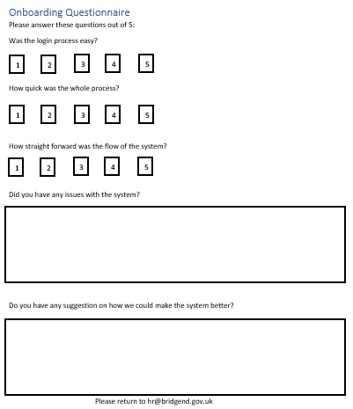

Appendix 2 – Data Protection Impact Assessment

Data Protection Impact Assessment
E-Signature System “Signable”

Version No: 1
Status: Draft

Authors: Michael Simmonds
Approver:

Date: 21/06/2023

Table of contents

Document history 3
Introduction 3
Process 5
Data Protection Impact Assessment Toolkit 7
Data Types 8

Document history

Date | Version | Author | Revision Summary
21/06/2023 | 1.0 | Michael Simmonds | First Draft

Introduction
A Data Protection Impact Assessment (DPIA) is a process which helps to identify and minimise the data protection risks of a project. You must do a DPIA for certain types of processing, or any other processing that is likely to result in a high risk to individuals. It is also good practice to do a DPIA for any other major project which requires the processing of personal data.
An effective DPIA helps to identify and fix problems at an early stage, demonstrate compliance with data protection obligations, meet individuals’ expectations of privacy and help avoid reputational damage which might otherwise occur.
The DPIA should consider not just compliance risks but also broader risks to the rights and freedoms of individuals, including the potential for any significant or economic disadvantage. The focus is on the potential for harm – to individuals or to society at large, whether it is physical, material or non-material. It does not have to eradicate the risks altogether but should help minimise risks and assess whether or not remaining risks are justified.
“The risk to the rights and freedoms of natural persons, of varying likelihood and severity, may result from data processing which could lead to physical, material or non-material damage, in particular: where the processing may give rise to discrimination, identity theft or fraud, financial loss, damage to the reputation, loss of confidentiality of personal data protected by protected secrecy, unauthorised reversal of pseudonymisation, or any other significant economic or social disadvantage; where data subjects might be deprived of their rights and freedoms or prevented from exercising control over their personal data…”
(Recital 75 EU GDPR)

A DPIA must be carried out before you begin any type of processing which is “likely to result in a high risk”. This means that although you have not yet assessed the actual level of risk you need to screen for factors that point to the potential for a widespread or serious impact on individuals. You will also need to consider a DPIA if you:
- Use systematic and extensive profiling with significant effects
- Process special category or criminal offence data on a large scale; or
- Systematically monitor publicly accessible places on a large scale
- Use new technologies (in the world at large rather than technology new to you)
- Profile individuals on a large scale
- Process biometric data
- Process genetic data
- Match data or combine datasets from different sources
- Collect personal data from a source other than the individual without providing them with a privacy notice (invisible processing)
- Track individuals’ behaviour or location
- Process data that might endanger the individual’s physical health or safety in the event of a security breach
- Profile children or target marketing or online services at them
- Use profiling or special category data to decide on access to services.
- A major new project involving the use of personal data
- Process data on a large scale
- Process data concerning vulnerable data subjects
- Prevent data subjects from exercising a right or using a service or contract
Please note this list is not exhaustive.
Any systems which do not identify individuals in any way do not require a DPIA to be performed. However, it is important to understand that what may appear to be “anonymised” data, could in fact be identifiable when used with other information, so anonymised data should be considered very carefully before any decision is made that it will not identify individuals.
The Data Protection Officer will advise any services regarding whether a PIA needs to be completed and support them through the assessment process. If a high risk is identified that cannot be mitigated then the Information Commissioner must be consulted before starting the processing.
All assessments will be public documents and will be published into the public domain.

Process
Send the completed Data Protection Impact Assessment for an initial review of risks and compliance by the DPO
Approval of Data Protection Impact Assesment and notification to Information Asset Owner
If necessary an action plan will be produced by the DPO and provided to the lead officer
If necessary a Cloud Impact Assessment will be undertaken by the service and ICT Security
Lead officer will be asked to provide assurances that the agreed actions have been implemented
You may be asked to supply supporting information. E.g system specification, contract, consent etc..
Send Toolkit answers to Information Team. If Yes to any questions, complete Data Protection Impact Assessment
Data Protection Toolkit – Screening Questions
Are you implementing a new service, system, or changing the way you work?

Data Protection Impact Assessment Toolkit
Screening Questions - To be completed by the project/business change lead
Please complete the table below. Answering “Yes” to any of the screening questions below represents a potential Information Governance risk factor that will have to be further analysed to ensure those risks are identified, assessed and mitigated through a Data Protection Impact Assessment.

Category | Screening Question | Yes/No
Identity | Will the project/process/business change include the processing of personal data? | Yes
Identity | Will the change involve the collection of new information about individuals? | Yes
Identity | Will the project require individuals to provide information about themselves? | Yes
Identity | Does the change involve a new technology or new company holding personal data? | Yes
Multiple  organisations | Will information about individuals be disclosed to organisations or people who have not previously had routine access to the information? | Yes
Data | Are you using information about individuals for a purpose it is not currently used for, or in a way it is not currently used? | No
Data | Does the change involve using new technology which could be perceived as being privacy intruding for example biometrics, facial recognition or use of IP address data? | Yes
Data | Will the change result in the way personal information is stored or secured being changed? For example on a new system, with a new supplier | Yes
Data | Will the change result in you making decisions or taking action against individuals in ways which could have a significant impact on them? | Yes
Data | Does the information involved include sensitive data? For example health records, criminal records, or other information that people are likely to consider as private? | Yes
Data | Does the change involve changes to your premises involving private spaces where clients or customers may disclose their personal information (reception areas, for example) | No
Data | Does the change involve surveillance, tracking or monitoring of movements, behaviour or communications | No
Approval | Has this project/process already been started as a pilot without a Privacy Impact Assessment being undertaken? | No

Data Types

In order to understand the potential risks to individual’s privacy, it is important to know the types of data that will be held and/or shared. Even if exact detail is not known and initial indication will assist in the assessment.

Personal | Tick  (All that Apply) | Sensitive | Tick  (All that Apply)
Name | Y | Racial / ethnic origin
Address (home or business) | Y | Political opinions
Postcode | Y | Religious beliefs
NHS No. |  | Trade union membership
Email address | Y | Physical or mental health | Y
Date of birth | Y | Sexual life
Employee number | Y | Criminal offences
Driving Licence [shows date of birth and first part of surname] |  | Biometrics; fingerprints
IP Address | Y | National Insurance number | Y
Additional data types (if relevant): |  | Bank, financial or credit card details
 |  | Mother’s maiden name
 |  | Tax, benefit Records
 |  | Health, adoption, employment, school, Social Services, housing records
 |  | Child Protection
 |  | Safeguarding Adults
 |  | Pension Records
Comments

DPIA Template
This template is an example of how you can record your DPIA process and outcome. It follows the process set out in our DPIA guidance, and you should read it alongside that guidance and the Criteria for an acceptable DPIA set out in European guidelines on DPIAs.

Start to fill out the template at the beginning of any major project involving the use of personal data, or if you are making a significant change to an existing process. Integrate the final outcomes back into your project plan.

Step 1: Identify the need for a DPIA
Explain broadly what the project aims to achieve and what type of processing it involves. You may find it helpful to refer or link to other documents, such as a project proposal. Summarise why you identified the need for a DPIA.
As part of a digital transformation project, the process of onboarding successful applicants is undergoing changes. The implementation of new procedures aims to enhance the efficiency of Bridgend CBC's applicant onboarding process.

Currently, there are three forms within the scope of the new onboarding application usage. These forms include:

- New Starter Form: This form captures essential information such as emergency contact details, next of kin details, Welsh language information, HMRC checklist, student loan information, and an ID card photo.

- Workplace Health Declaration: This form requires the provision of full name, date of birth, national insurance number, contact details, and responses to health-related and adjustment-related questions.

- WSOP (Written Statement of Particulars): This form entails an outline of the job offer and requires the employee's signature and date.

By implementing new onboarding application usage and utilising these forms digitally, Bridgend CBC aims to expedite the process of integrating new applicants into the organization.

Step 2: Describe the processing
Describe the nature of the processing: how will you collect, use, store and delete data? What is the source of the data? Will you be sharing data with anyone? You might find it useful to refer to a flow diagram or another way of describing data flows. What types of processing identified as likely high risk are involved?
All documents shall be generated exclusively through the Electronic Data Records Management (EDRM) system employed by the council. Subsequently, these documents will be uploaded to the new onboarding application

Upon completion, the applicant/employee will receive an email containing a hyperlink leading to the new onboarding application, where the document will be available for completion. The specific information collected during this stage may vary, as indicated in the aforementioned documentation.

Once the applicant/ employee has completed the signing and submits the document, the document then goes two down two channels, the first process just saves the document back on to the new onboarding application for viewing, the second process saves the document to the web server.

Documents that are saved within the new onboarding application will be periodically deleted after a predetermined period of time, ensuring that the document has been securely archived within the EDRM system.

Describe the scope of the processing: what is the nature of the data, and does it include special category or criminal offence data? How much data will you be collecting and using? How often? How long will you keep it? How many individuals are affected? What geographical area does it cover?
The purpose of collecting the data is to facilitate the recruitment process by assessing the suitability of applicants for employment at Bridgend CBC. The collected data serves to ensure that the applicant meets the necessary requirements for the position and is capable of working legally within the United Kingdom.

Data collection occurs only after an applicant successfully completes the initial phase of the recruitment process and receives a verbal offer of employment from Bridgend CBC.

The information gathered encompasses various aspects, including emergency contact details, next of kin information, Welsh language proficiency, HMRC checklist, student loan details, full name, date of birth, national insurance number, contact information, health-related inquiries, adjustment-related questions, and the employee's signature with date.

As previously mentioned, the collected data will be stored in two different locations. The first is the Electronic Data Records Management (EDRM) system utilised by the council, which adheres to the current HR retention policy. The second location is the new onboarding application, where the data will be held temporarily and periodically deleted after a predetermined period of time. This ensures that the document has been securely archived within the EDRM system.

Describe the context of the processing: what is the nature of your relationship with the individuals? How much control will they have? Would they expect you to use their data in this way? Do they include children or other vulnerable groups? Are there prior concerns over this type of processing or security flaws? Is it novel in any way? What is the current state of technology in this area? Are there any current issues of public concern that you should factor in? Are you signed up to any approved code of conduct or certification scheme (once any have been approved)?
The commencement of an individual's relationship with Bridgend County Borough Council (BCBC) occurs when they submit a job application. Upon successful completion of the interview process, the Signable system comes into play by sending the necessary forms to the applicant for completion and signature.

The successful applicant retains full control over the information provided within the Signable forms. These applicants anticipate that Bridgend CBC will process their data in a manner conducive to their transition into an employee role.

It is important to note that some successful applicants may be below the age of 18, as it is legally permissible within the United Kingdom for individuals aged 16 and over to be employed, albeit subject to different terms compared to applicants over the age of 18. Bridgend CBC, as a disability-confident employer, acknowledges that certain applicants may belong to vulnerable groups. However, the processing of their data will be handled in the same manner as that of applicants who do not fall into such categories.

All data processed by Bridgend CBC adheres strictly to the principles of data protection and aligns with the regulations set forth by the General Data Protection Regulation (GDPR).

Onboarding application utilises the following technologies:
- Amazon Web Services (AWS) – The data centre is located within the United Kingdom (London).
- SSL Encryption - SSL represents the standard security technology employed to establish an encrypted connection between a web server and a browser. This connection ensures the privacy of all data transmitted between the server and the browser.
- Vulnerability Scanning - Signable employs vulnerability scanning techniques to identify potential security weaknesses in its system. This proactive approach ensures prompt detection and resolution of any suspected vulnerabilities, thereby safeguarding the security of your data.
- Penetration Testing - The Signable infrastructure undergoes daily scanning against the OWASP top 10 security issues. Any identified issues are promptly reported to the Signable development team, who address them accordingly. Additionally, the infrastructure is subjected to quarterly scanning to maintain compliance with the Payment Card Industry Data Security Standard (PCI-DSS) certification.

Describe the purposes of the processing: what do you want to achieve? What is the intended effect on individuals? What are the benefits of the processing for you, and more broadly?
The project encompasses several objectives, which are as follows:

- Enhancing the Applicant Experience: The primary aim is to improve the experience of successful applicants after interview stage. This entails creating a more seamless and efficient process for them as they transition towards becoming employees.
- Streamlining the Onboarding Process: Another objective is to optimise the onboarding process, reducing the time it takes for an applicant to progress from being hired to becoming an employee. The intention is to make this transition smoother and more time effective. This object will benefit both applicant and HR department.

To achieve these objectives, the new onboarding application will play a pivotal role. Its functionality enables the attainment of the aforementioned goals through the following means:

- Expedited Document Processing: The new onboarding application enables the swift sending of documents for data collection and signature. This expedites the overall process, saving time for both the recruitment team and the successful applicant.
- Seamless Return of Documents: The application allows the successful applicant to effortlessly return the completed documents with a simple click of a button. This eliminates the need for physical printing, manual filling out, and signing of documents, followed by scanning for their subsequent submission to the recruitment team.

By leveraging the capabilities of the new onboarding application, the project aims to enhance the applicant experience by providing a more efficient and user-friendly process upon successful interview outcomes. Additionally, it seeks to streamline the onboarding process, reducing the time required to transition an applicant into an employee role.

Step 3: Engagement process
Consider how to engage with relevant stakeholders: describe when and how you will seek individuals’ views – or justify why it’s not appropriate to do so. Who else do you need to involve within your organisation? Do you need to ask your processors to assist? Do you plan to consult information security experts, or any other experts?
During the implementation period, the key stakeholders involved would include:

- Digital Transformation Team: This team is responsible for driving the digital transformation initiatives within the organisation and ensuring the successful implementation of the project.
- ICT: The ICT department plays a vital role in providing technical expertise and support for the implementation of the project, particularly regarding the integration and operation of the Signable system.
- Human Resources: The HR department is a crucial stakeholder as they are directly involved in the recruitment and onboarding processes, and they will be utilising the implemented system to streamline their operations and manage employee data.

The Digital Transformation Project oversees the overall management of the project, and stakeholders from the aforementioned departments regularly convene to gather input and insights. This collaborative approach ensures that the project aligns with the requirements of all involved departments and operates smoothly. The actions and outcomes of these stakeholder meetings are subsequently reported to the main project board, which oversees the project's progress and decision-making.

Step 4: Assess necessity and proportionality
Describe compliance and proportionality measures, in particular: what is your lawful basis for processing? Does the processing actually achieve your purpose? Is there another way to achieve the same outcome? How will you prevent function creep? How will you ensure data quality and data minimisation? What information will you give individuals? How will you help to support their rights? What measures do you take to ensure processors comply? How do you safeguard any international transfers?
The data to be processed by the system pertains to individuals who have successfully applied for a position within Bridgend County Borough Council (BCBC). The processing of this data is based on a lawful foundation aimed at facilitating the transition of applicants into employees. The primary objective of collecting this data is to ensure the suitability of the applicant for employment within the United Kingdom and to fulfill other legal obligations.

Currently, Bridgend CBC employs an email-based method for gathering this information, wherein the applicant is required to print out the necessary forms, complete them manually, scan the completed forms, and subsequently return them via email. By implementing new onboarding application, an improved approach will be adopted, enabling applicants to digitally complete and sign the required forms. This transition will not only enhance the quality of data but also minimize errors arising from illegible handwriting and redundant data entry.
Step 5: Identify and assess risks

Describe the source of risk and nature of potential impact on individuals. Include associated compliance and corporate risks as necessary. | Likelihood of harm | Severity of Harm | Overall risk
Data loss – Data loss can occur either during the transmission process or while being stored within the application.  Unauthorised viewing – Making sure that the data is only viewed by employees who need to view it.  Data retention – Making sure that data is deleted from the signable app after a certain period and when the data has been moved to BCBC’s EDRM system. The new onboarding application does not have an automatic function. | Remote, possible or probable  Remote  Remote  Remote | Minimal, significant or sever  Significant  Minimal  Significant | Low, medium or high  Medium  Low  Medium

Step 6: Identify measures to reduce risk

Identify additional measures you could take to reduce or eliminate risks identified as medium or high risk in step 5
Risk | Options to reduce or eliminate risk | Effect on risk | Residual Risk | Measure approved
Data Loss  Unauthorised Viewing  Data retention | The new onboarding application has implemented several robust measures to mitigate the risk of data loss, which include the following:  - SSL Encryption: Signable utilizes SSL (Secure Socket Layer) encryption to secure data transmission, ensuring that sensitive information remains protected during transit.  - Penetration Testing: conducts regular penetration testing to identify potential vulnerabilities in its systems and infrastructure. This proactive approach helps to detect and address any security weaknesses, thereby reducing the risk of data loss.  - Vulnerability Scanning: employs vulnerability scanning tools to regularly assess its systems for potential security vulnerabilities. By identifying and addressing any weaknesses promptly, Signable ensures a higher level of protection against data loss.  Moreover, all data is stored within an Amazon data centre located in London. This selection of a reputable cloud service provider enables Signable to adhere to stringent data protection regulations, such as the Data Protection Act (DPA) and the General Data Protection Regulation (GDPR). By complying with these regulatory frameworks, Signable upholds the necessary privacy standards to safeguard the confidentiality of user data.  The new onboarding application implements stringent user access controls to ensure that only authorised individuals, as established by the system administrator, are able to log in to the application.  While the new onboarding application usage does not possess an automated feature for data deletion after a specific duration, a mutually agreed time period will be established following implementation, aligning with HR's existing data retention policy. In accordance with this agreed-upon timeframe, the system administrator will manually access the new onboarding application to identify and delete data that has surpassed the designated retention period. This process ensures compliance with HR's data retention guidelines and maintains data integrity within the system. | Minimises the risk of data loss  Minimises the risk of Unauthorised Viewing  Implements data retention | Low  Low  Low

Step 7: Sign off and record outcomes

Item | Name/date | Notes
Measures approved by: |  | Integrate actions back into project plan, with date and responsibility for completion
Residual risks approved by: |  | If accepting any residual high risk, consult the ICO before going ahead
DPO advice provided: | Charlotte Branford  11/07/2023 | DPO should advise on compliance, step 6 measures and whether processing can proceed
Summary of DPO advice: Satisfied with the mitigating measures put in place to overcome the risks. Agree the processing can proceed.
DPO advice accepted or overruled by: |  | If overruled, you must explain your reasons
Comments:
Consultation responses reviewed by: |  | If your decision departs from individuals’ views, you must explain your reasons
Comments:
This DPIA will be kept under review by: |  | The DPO should also review ongoing compliance with DPIA

