1.Pepsico

In 1965, Pepsi-Cola CEO Donald Kendall and Frito-Lay CEO Herman Lay saw what they dubbed "a marriage made in heaven," a single firm offering precisely salty snacks served alongside the best cola on the planet. PepsiCo, one of the world's biggest food and beverage companies, was born from their ambition.
In more than 200 countries and territories throughout the world, PepsiCo products are consumed more than one billion times per day. PepsiCo's complementary food and beverage portfolio, which includes Frito-Lay, Gatorade, Pepsi-Cola, Quaker, Tropicana, and SodaStream, produced more than $70 billion in net revenue in 2020. PepsiCo's product portfolio encompasses a wide range of tasty foods and beverages, including 23 brands with estimated annual retail sales of more than $1 billion each.
Co-operatives
The International Co-operative Alliance is a non-profit organisation that represents cooperatives all around the world. A co-operative is defined as "...an autonomous association of persons united voluntarily to achieve their common economic, social, and cultural needs and ambitions through a jointly owned and democratically governed firm." 'Co-operatives employ more than 100 million women and men and have more than 800 million individual members around the world, ranging from small-scale to multi-million dollar firms,' it continues.
Businesses do not operate in isolation; they are always interacting with elements that influence and are influenced by their actions.
The company is made up of seven divisions: PepsiCo Beverages North America; Frito-Lay North America; Quaker Foods North America; Latin America; Europe; Africa, Middle East and South Asia; and Asia Pacific, Australia/New Zealand and China. Each of these divisions has its own unique history and way of doing business.
Structures that are based on an area
In some circumstances, the organisation is organised by geographical regions. Aside from the arguments for local expertise, the area structure may give cost savings when goods and services must be close to the client.
Structure of divisions
There are firms that are part of a larger corporation but operate independently in many ways. Each company division may have a slightly distinct focus, yet there may be some common ground.
Corporations with a Global Reach (MNCs)
MNCs are businesses that operate on a wider scale, with headquarters in one nation but activities in several others.
MNCs typically do this to be able to access different markets (especially where trade barriers exist), better meet production needs for that local market, expand their brand, exploit the availability of resources such as labour and raw materials, take advantage of tax or investment allowances, and lower transportation and distribution costs.
Strategy
The way a company looks to the future and determines how to make goals a reality is referred to as strategy .
The business must examine three primary questions while developing a strategy:
1. At X point in the future, where do we wish to be? For the sake of long-term planning.
2. What are our current circumstances? Strategy necessitates a review of the company's current situation in order to determine its strengths, weaknesses, opportunities, and threats, as well as how far it is from its long-term objectives.
3. How will we attain our objectives? The company can come up with a strategy or set of broad objectives to assist it achieve its goals and track and evaluate progress.
PepsiCo can expand into new markets in a variety of nations and territories by making direct foreign investments (DFI). Franchising, joint ventures, international subsidiaries, and mergers and acquisitions are some of the DFI techniques it employs.
Exporting is the process of creating final items in order to send them abroad and sell them in foreign markets. The most significant difficulty in this strategy is foreign exchange risk. PepsiCo can enter a foreign market through established distribution networks with this strategy, and the initial expenditure is modest.
PepsiCo has employed this strategy to get into the restaurant and industrial sectors of a number of international markets. It is the acquisition of a controlling interest in a company. This method enables them to take control of the firm while rapidly increasing market share in the territory they occupy. One example is their purchase of The Quaker Oates Company, which already owned Gatorade, the world's most popular sports energy drink... Please show more material...
Which theories best explain why a multinational corporation (MNC) engages in worldwide trade? Describe the agency challenges and limits that the MNC encounters in attempting to achieve their objectives, as well as how they attempt to overcome them, in the specific nations where the MNC does business.
Certain countries are known for their expertise in the manufacturing of specific commodities and services. In addition, labour or materials in the MNC's home country may be more expensive than if they produced the identical commodity or service in another country. As a result, country specialisation can improve both the speed with which a product is produced and the efficiency with which money is used. As a result, PepsiCo benefits from cost savings in production, allowing them to generate a bigger profit margin when items are sold.
Firms like PepsiCo can benefit from the immobility of means of production such as labour and other resources in a foreign country. They can enter and exploit these markets since they are a major company with more information and resources.

2. The subject of economic supply and demand.
Increased demand in the presence of constricted or poor supply tends to drive prices up.
The link between price and amount supplied is represented by the market supply curve. Firms are willing to sell more things at greater prices than they would at lower ones. The price and quantity of goods delivered have a positive relationship.
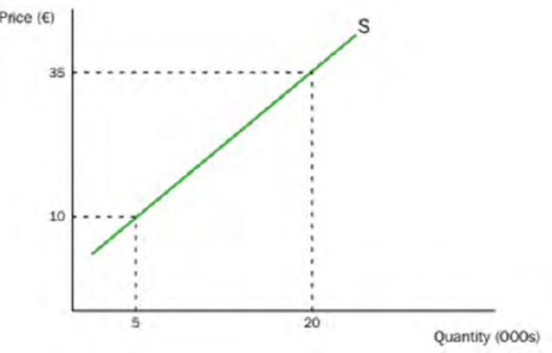
Changes in any of the factors impacting supply other than price might induce a change in supply, as seen in the graph.
The supply curve shifts to the left due to factors that negatively influence producers, such as an increase in production costs.
At any price, suppliers will now be ready and able to provide the market less than they did previously. The supply curve shifts to the right as conditions that affect producers positively alter.
Suppliers are now eager and able to provide more for sale at any price.
The initial supply curve S is depicted in the picture, along with a price of €20. A change in the supply curve to the left causes a drop in supply at €20 of 7000 to 5000 units, whereas a rise in supply at €20 causes an increase in supply to 20 000 units, an increase of 8000 units.

An overabundance of an item or service with stagnant or weak demand, on the other hand, might cause prices to fall. According to the World Gold Council, gold demand increased by 4% to 4,345 tonnes in 2018, with investment demand falling by 7%. However, gold supply increased by only 1% in 2018, the slowest pace of growth since 2008. Gold prices have been trending higher since mid-August 2018, owing to rising demand and limited supply.
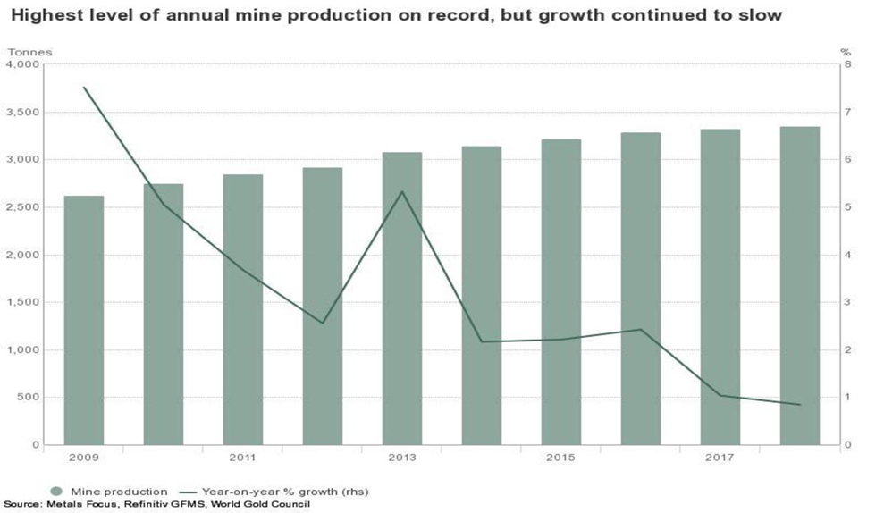
The Market Demand Curve
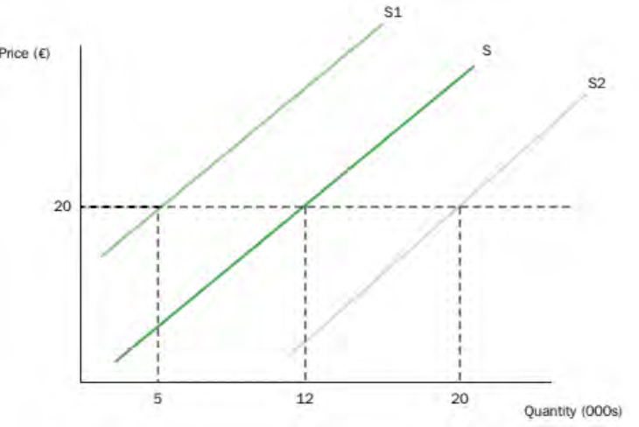
It depicts the connection between price and quantity demanded. At higher costs, there are fewer purchasers wanting and able to acquire the goods, whereas at lower prices, considerably more people are willing and able to purchase the good.
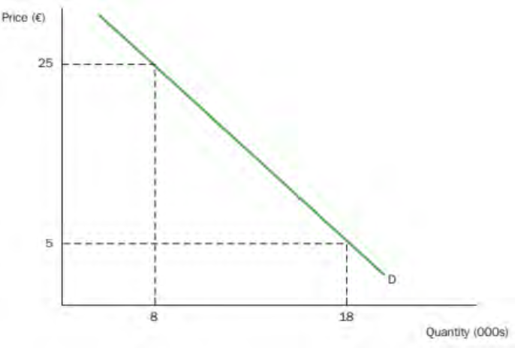

Price is influenced by a number of factors.
Other goods – substitutes and complements – prices
Income – the amount of money earned and how it is distributed.
Fashions and tastes
The population's size and composition
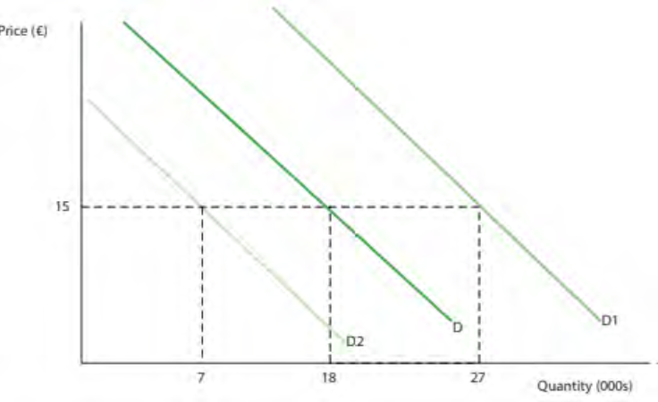
It demonstrates how demand is affected by shifts in the demand curve. If the demand curve shifts to the right, there will be an increase in demand (from D to D1) Demand would increase from 18 000 to 27 000 at a price of €15. Demand would fall if a change in a factor caused demand to shift from D to D2. Demand would be 7000 at a price of €15, down from 18000 before the shift in demand.

ELASTICITY
Price elasticity of demand refers to how responsive a quantity demanded is to a change in price.
Price elasticity of supply refers to how responsive a quantity supplied is to a change in price.
The more elastic the relationship is, the more responsive the quantity demanded and supplied are to price changes.
The relationship is described as inelastic when the quantity demanded and supplied is not very responsive to price changes.
Elasticity Determinants
The time frame that is being considered.
The longer the time period under consideration, the more price elasticity the demand and supply for a product tends to be. This is because consumers and producers can adjust their behaviour and price swings more effectively over time. The availability of resources and production factors. The ease with which suppliers can adjust supply may be determined by their ability to access resources to expand production. Limitations of the plant The percentage of income that the product consumes. Substitutes' availability and proximity. The product's definition is as broad as it gets.
People will buy fewer items if the price of most items is raised. When one airline raises its fare, for example, passengers may choose to fly with a competitor.
The term "price elasticity of demand" refers to how changes in a product's or service's cost affect a company's revenue. For some products, a small price change can have a big impact on how many units a customer buys. Price changes have little impact on demand in other cases. As a result, maximising profit requires an understanding of each offering's price elasticity. The price elasticity of products can be influenced by a number of factors. If substitute goods are readily available, for example, when the price rises, the customer will immediately reduce purchases. And if the item accounts for a significant portion of the buyer's total spending, he or she is more likely to shop solely on price. For any business, knowing how customers value a product is critical. Raising prices is one of the simplest ways to increase profits, but only if customers are willing to pay the higher price.
Because the amount of bread purchased changes little with price, demand for basic goods such as bread is thought to be inelastic. People have little choice but to pay if the price rises, but they are unlikely to eat more bread if the price falls. Luxury goods, on the other hand, are price elastic.

3. THE MARKET FAILS
Market failure happens when the demand for a product exceeds the supply of that product.
When a market fails, someone will intervene to try to remedy it. Consider the government. Positive discrimination (which is unlawful in the UK) and income distribution through welfare programmes may be regulated or prohibited.
When external costs and benefits are factored into decision-making, it is called social efficiency.
When society provides things and services at a low cost that people want, this is known as allocating efficiency.
When goods and services are produced with the smallest amount of resources possible, this is referred to as technical efficiency.
The production of goods and services at the lowest factor cost is referred to as productive efficiency.

