TRAINING AND DVELOPMENT NEEDS FOR A HR OFFICER /MANAGER

Table of Contents
Assessment 1 4
Slide 1 4
Slide 2 4
Slide-3 5
Slide-4 6
Slide 5 7
Slide 6 8
Slide 7 9
Slide 8 10
Slide 9 11
Slide 10 12
Appendix B 15
Personal Skills Audit 15

Assessment 1

Slide 1

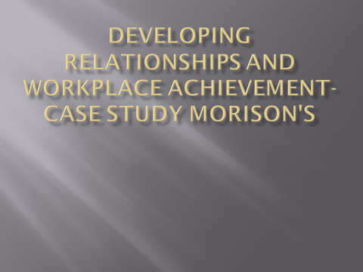

Slide 2
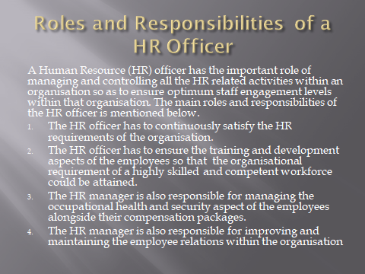
The HR officer is responsible for administering all the HR related functionalities which helps in ensuring that an organisation is making the most efficient use of their staffs. The role and responsibility of the HR officer assumes critical significance from the fact that it helps in ensuring an optimum organisational performance and enables an organisation to retain their competitive edge over their industry rivals (Hussain, 2016). This helps in the creation of a highly performance workforce that allows an organisation to ensure their future business growth and success.
The HR officer is responsible for satisfying and meeting the HR requirements of an organisation. In doing so, he/she must thoroughly plan the recruitment and selection strategies of the organisation. The HR officer must match the job requirements with the skills, talents and qualifications possessed by deserving job applicants and this would allow them to select and recruit the most suitable and deserving candidates for their organisation (Wright et al., 2011).
The HR officer is responsible for developing and retaining a highly competent and skilled workforce that could satisfy the growing business needs and requirements of an organisation. They take care of the training and development aspect of the employees and this helps in improving the skills and competencies of their employees. The HR officer also has to ensure that all the employees have equal career growth and development opportunities based on their available skills and talents (Welch and Welch, 2012). Furthermore, the HR officers are also responsible for appraising the yearly performance of their employees and providing them with a reasonable salary hike that the employees are entitled to receive.
The HR officers are also responsible for maintaining the health and safety of the employees at the workplace. They have to ensure that the employees have a safe and secure work environment that does not pose a threat to their personal safety ever. The HR officer has to look after the employee benefits and making sure all employees get access to all the job benefits that they are entitled to (Wright et al., 2011). The HR manager manages the employee compensation paid to the employees on a monthly basis. They calculate the monthly salaries by considering the amount of working days attended by the staffs and transfer the salaries to the employees.
Lastly, HR officers are responsible for improving the employee relations. They must make sure that all employees are treated with respect and dignity and the employees are not subjected to any kind of discrimination. Furthermore, the aspect of collective bargaining and contract administration is also looked after by the HR officer (Hussain, 2016).
The HR department of Morison's is a strong well coordinated team that is well aware regarding the open position that are to be filled up any different areas of the business and accordingly attracts the best talent and put them in to work along with the required support so that they can deliver their best performance
The HR team assess each of the employees who has been put in to work and accordingly offers a wide range of training to them so that they can achieve their highest level of operational efficiency.
The organization considers is of the employees as their valuable asset who is most capable of adding value to the business. ( Morrisons. 2020).
Attracting and training the best talent is the primary job being carried out by Morison's. The organization is capable of offering a wide range of training as per the need of the resources so that they can raise their potential and can offer the best possible performance to the organization. The best performer are being talented so that all the employees can be kept motivated and energized. Every employee of the organization has the opportunity to talk with their immediate superior regarding the growth and shaping of their career. The employees are free to raise to raise their voice and the management of the organization is ready to hear from them. Every manager of the organization are well trained regarding the process of dealing to the employees to be followed for the best interest of the organization. The employees are eligible to different kind of benefits so that they can avail the best work life balance. The organization has the policy to take care of their retired employees through the different employee benefit schemes. [[ morrisons 2020)

Slide 5
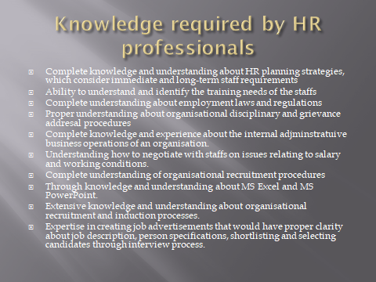
The knowledge of the HR professionals largely determines their capability and competency to contribute to the organisational growth and success. The aspect of knowledge largely comes from experience and this experience can only be obtained by spending time at the workplace and acquiring all the practical knowledge and understanding that comes through working in specific functional roles and responsibilities (Furnham, 2008). Over time HRM has become a highly dynamic and challenging organisational functionality and modern day HR professionals require a wide set of knowledge and skills in order to be successful in their job roles and responsibilities.
The HR professionals must have high level of knowledge and understanding about HR planning strategies and this would greatly help them in addressing the future staff requirements of their organisation (Cohen, 2015). The HR professions must have adequate knowledge and understanding about employment laws and regulations and this would greatly help them to satisfy the interest of both their staffs as well as their organisation. The HR professionals must have the innate capacity to understand and realise the training and development needs of their staffs and this would greatly help them to create a highly competent and professional workforce. The HR professions must have complete clarity about organisational recruitment procedures and this would help them to select and recruit the best talents for their business (De Mauro et al., 2018). They must also be proficient in the use of MS Excel and MS PowerPoint which are required for everyday administrative jobs.

Slide 6
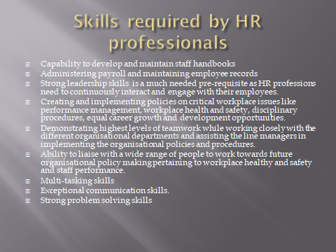
The skills and competencies of the HR professions would largely determine their success in their respective job roles as HR professionals. The HR professionals must have effective multi-tasking skills as this would enable them to perform multiple tasks at the same time, thereby helping them to improve their performance and efficiency at the workplace (Ashkezari and Aeen, 2012). The HR professionals must have exceptional communication skills because that is the main pre-requisite for any modern day HR professional. The HR functionality of modern day organisations requires continuous communication and interaction with employees to realise their problems and challenges that they are facing and that is compromising their workplace performance. Exceptional communication skills goes a long way in ensuring prompt solution to the workers’ problems and issues and this provides greater motivation and job satisfaction to the employees (De Mauro et al., 2018). The HR professionals must have the capacity to maintain employee payroll records. The HR professionals must be strong team players as they would require to work in teams while creating future policy making pertaining to employee performance and workplace health and safety. Additionally, the HR professionals must be effective problem solvers as their job roles and responsibilities require them to tackle and solve the workplace problems and issues faced by their staffs in a prompt and effective manner. This helps them to ensure the normal and smooth workflow process that is crucial for maintaining optimised organisational performance (Kramar and Steane, 2012).

Slide 7
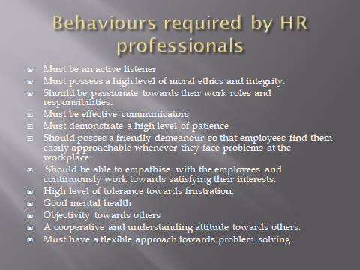
HR professionals must be an active listener and this would allow them to clearly understand the problems and issues faced by the employees. This would help them to address those issues and problems in a prompt and effective manner (Cohen, 2015).
The HR professionals must have high level of moral ethics and this would help them to serve the interest of both the employees and the organisation in an efficient manner.
The HR professionals must demonstrate a high level of passion towards their work roles and responsibilities and this would help them to perform their job roles and responsibilities in a perfect manner. They would be able to create and maintain a highly committed and capable workforce that would help them to ensure the future growth and sustainability of their business (Kramar and Steane, 2012).
The HR professionals must also be effective communicators and this would really help them to manage their employees in a more effective manner. They would be able to understand the needs and aspirations of different employees based on their individual personality types and this would enable them to motivate and inspire their staffs. They would be able to develop team spirit among the staffs by building up team cohesiveness and this would really enable them to foster job satisfaction and corporate loyalty among their employees (Furnham, 2008).
A cooperative and understanding attitude would help the HR professionals to solve the problems of their staffs in a more comprehensive manner and this would really increase the job satisfaction level of the employees (Kramar and Steane, 2012). –u|
HRM is a highly complex and challenging functional domain and so the HR professions must have a high tolerance level towards frustration and this would really enable them to survive the stress and anxiety that comes with their job roles (Cohen, 2015).

Slide 8
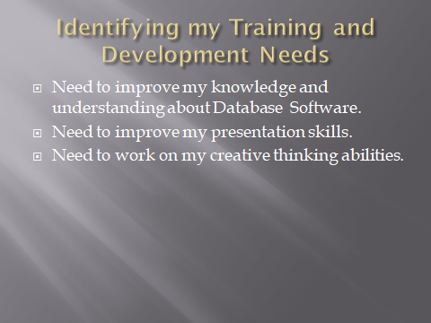
I need to work on my Database knowledge and skills as this is one area where I do not posses adequate knowledge and understanding. This is mainly attributed to the fact that I do not belong to a computer programming background and so I do not have the exposure and expertise in this domain. The database management is an academic field that is considered to be a stronghold of computer programmers and this has become a much needed skills in the modern day workplace. I need to enrol in professional Database Management courses that are aimed at modern day IT professionals and this would really help me to improve my knowledge and understanding about the intricacies associated with database management. I also need to access online video tutorials in order to make myself more adept in Database management. This would really help in improving my overall capabilities and competence as an HR professional.
Presentation Skills is another area where I need to seriously work on. I possess below average presentation skills and this really acts as a hindrance to my career growth and development as a HR professional. It is a well-known fact that presentation skill is an important and much sought after skill in the modern day workplace and HR professionals often have to undertake presentations in order to explain and describe the long term impacts and implications resulting from their HR policies and practices. Lacking in presentation skills really undermines my overall capacity as an HR professional. I need to really take the help of professional experts in order to improve my presentation skills and this world really help in increasing my bargaining power as an HR professional and help me to guarantee my career growth and success in my organisation.
Creative thinking ability is another area where I need to work on. I need to improve my creative thinking abilities by dedicating more time towards solving puzzles and riddles. This would really help me to find unconventional and out of the box solutions to the workplace problems and issuers faced by the employees and as a result I would be able to perform my roles and responsibilities as an HR professional in the best possible manner.

Appendix B

Personal Skills Audit

Name Mercy oscar Adah
Job role: Human Resource Officer

Please tick as appropriate to indicate how you would rate your skills in relation to the following work / functional areas.
 | Very good | Good | Adequate | Little or no
Information Technology
Use Microsoft Office Word |  | Yesssssssssssssssseseeeess
Use Excel spreadsheet |  | Gghhhggghhhhhhhhhhhhhhh
Use a Database |  |  |  | Hhjjjnnnnnnbbbbbbbbbbbbb
Use specialist HR software |  |  | Hhhjjjjjkkkkkkkkkkkkkgg
Use the internet |  | Gghhhhhhhggggggghhgghhh
Use e-mail |  | Gyhhhhjjjjjjhhhgttrrrtrrtttttttt
Use PowerPoint |  |  | Gggghhhhhhhyyyyyyyttyy6y

 | Very good | Good | Adequate | Little or no
Communication Skills
Drafting contracts of employment |  | Yyhhhhhjjjjjhhhhhhhhhhh
Taking notes of disciplinary |  |  | Hhhhhhhhhhhhhhhhhhhhhhhhhhhhhhhhhhhhhhhhhh
Write reports |  | Hhhhhhhjjhhhhhhhhhhhhhhh
Produce material to support |  |  | Hhhhhhhhhhhhhhhhhhhhhhhhhhhhhjjjhhhhhhhhhhh
Delivering a training session |  | Hhhhhhhhhhhhhhhhhhhhhhhhhhhhhhhhhhhhhhhhhh
Resolving disputes/complaint |  | Hhhhhhhhhhhhhhhhhhhhhhhhhhhhhhhhhhhhhhhhhh
Interviewing |  | Jjjjjjjjjjjjjjjhhhhhhhhhhhhhhh
Advising on HR issues |  | Gghhhhhhhhhjjjjjvhhhuhhugughhjhjjjjhhhhhhhhhhhhhhh

10

 | Very good | Good | Adequate | Little or no
Problem solving skills
Make good use of verbal reasoning skills, able to handle complex data and make selective use of information |  | Ghhhhhhhhhhhhhhhhhjjjjjhhhhhjhhhhhhhyyyyyyyyyyyyyyyhhhhhh
Explore more than one solution in order to solve a problem |  | Hhhhhhhhhhhhhhhhhhhhhhhhhhh
Consider the ideas of others to help solve problems |  | Hhhjjjjhhhhhhjjjjjjjjjjjjjuuuuuuuu

Supervisory Management
How much experience have you had in your role? |  |  | < 1 month | 1-3 hhmonthsbgggggggggggggggggggggggggghhhhhhhhhhhh | > 3 months
How many people have you managed at any one time? |  |  | None | 1-5hhhhjjjjjjhhhhhjjjjjjjjjjjjjjjjjjjjjjjjjjjjjjh | Above 5

I declare that the information given in this form is true
Signed 
Date 25/8/20

Reference:
De Mauro, A. Greco M., Grimaldi M. and Ritala, P., 2018. Human resources for big data professions. A systematic classification of job roles and required skills sets. Information processing & management 54(5),pp.807-817
Cohen, D,j.,2015. HR past, present and future: A call for consitent practices and a focus on competencies. Human Resource management Review 25(2),PP. 205-215.
Burnham,A.,2008. HR professionals beliefs about, and knowledge of assessment techniques and psychometric tests. International journal of selection and Assessment 16(3),pp. 300-305
Wright,P.M Boudreau, J.W., pace D., sartain, L., McKinnon, P. and Antonie, R, 2011. The chief HR officer Defining the new role of human resources leader John Wiley &Son.
Kramar,R. and steane, P.,2012 emerging HRM skills in Australia. Asia Pacific journal of Business Administration.
Ashklezari, M. J.,and Aeen M.N 2012. Using competency models to improve HRM, Ideal type of management, 1(1)pp.59-68.
Hussiain, F., 2016. The chief HR officer Defining the new role of human resources leader, South Asian journal of management, 23(1),p.226.
Welch, C.L. and Welch, D. E., 2012. What do HR manager really do? Management International Review, 52(4),PP.597-617
Morrison. Jobs , 2020 HR At Morrisons/Morrisons careers( online Available.
https://www.Morrisons .jobs/our-team/teams head-office/HR(Accessed 19 August 2020)

