Student Name: Dale Griffiths, Student P Number: P146062, Module Code: M7X01697, Module: Emerging Network Technologies, Lecturer: Dr Carlene Campbell

Design, Simulation and Evaluation of a potential real life Communication System
Abstract— A large increase in the number of internet of things services (IoT) and smart cities have given developers a challenge on what different modulation schemes can be used to ensure connectivity is kept. The first section of the report included researching modulation schemes and then creating three different modulation schemes. The second section of the report investigated wireless communication systems, IoT and security imaging technology. This then allowed the author to build a wireless monitoring system.

Index Terms— Amplitude Shift Keying (ASK), Phase Shift Keying (PSK), Quadrature Amplitude Modulation (QAM), Bit Error Rate (BER), Signal-to-Noise Ratio (SNR), Satellite, Cellular, Internet of Things (IoT), Smart City, Security imaging technology

Contents
I. INTRODUCTION 1
II. Research & evaluation of modulation schemes 1
A. What is modulation 1
B. What is the function of modulation in a communication system? 1
C. How the concepts and principals of computer networks relate to communication systems? 2
D. Analog Modulation 2
E. Digital Modulation 2
F. Amplitude Shift Keying (ASK) 2
G. Phase Shift Keying (PSK) 2
H. Quadrature Amplitude Modulation (QAM) 2
I. Comparison of the three modulation schemes 3
J. Provide examples of implementations 3
1) Amplitude Shift Keying (ASK) 3
2) Phase Shift Keying (PSK) 5
3) Quadrature Amplitude Modulation (QAM) 8
K. Design and test performance of simulations 9
1) Amplitude Shift Keying (ASK) 9
2) Phase Shift Keying (PSK) 10
3) Quadrature Amplitude Modulation (QAM) 10
III. Wireless network design & evaluation 11
A. Long Range (LoRa & LoRa1) 11
B. Short Range 11
1) Wireless Local Area Network (WLAN) 11
2) ZigBee 11
C. Satellite 11
D. Cellular 11
E. Internet of Things and Smart City 11
F. Security imaging technology for the detection of concealed weapons 11
IV. Wireless monitoring system 11
V. Results & findings 13
A. NetSim Wireless Monitoring System 13
1) Delay 13
2) Throughput 13
3) Packet Loss 14
VI. Best modulation scheme for the networks 14
VII. Conclusion 15
VIII. Recommendations for future work 15
IX. References 15

Figure 1 - Comparison of Modulation Schemes 4
Figure 2 – ASK Implementation 4
Figure 3 - ASK Bernoulli Binary Generator 4
Figure 4 – ASK Sign Wave (1) 5
Figure 5 - ASK Sign Wave (2) 5
Figure 6 - ASK Switch 5
Figure 7 - ASK AWGN Channel 5
Figure 8 - ASK Product 5
Figure 9 - ASK Digital Filter Design 5
Figure 10 - ASK Constant 5
Figure 11 - ASK Add 6
Figure 12 - ASK Sign 6
Figure 13 - ASK Scope 6
Figure 14 - ASK Error Rate Calculation 6
Figure 15 - ASK Display 6
Figure 16 - ASK Modulation 6
Figure 17 – PSK Implementation 7
Figure 18 - PSK Random Integer Generator 7
Figure 19 - PSK Integer to Bit Converter 7
Figure 20 - PSK Demux 7
Figure 21 - PSK Unipolar to Bipolar Converter 7
Figure 22 - PSK Sine Wave (1) 7
Figure 23 - PSK Sine Wave (2) 7
Figure 24 - PSK Product 8
Figure 25 - PSK Sum 8
Figure 26 - PSK AWGN Channel 8
Figure 27 - PSK Digital Filter 8
Figure 28 - PSK Sign 8
Figure 29 - PSK Saturation 8
Figure 30 - PSK Mux 8
Figure 31 -Bit to Integer Converter 8
Figure 32 - PSK Error Rate Calculation 9
Figure 33 – PSK Display 9
Figure 34 - PSK Modulation 9
Figure 35 – QAM Implementation 9
Figure 36 - QAM Random Integer Generator 9
Figure 37 - QAM Modulator 9
Figure 38 - QAM Diagram 9
Figure 39 - QAM AWGN Channel 10
Figure 40 - QAM Demodulator 10
Figure 41 - QAM Display 10
Figure 42 - QAM Error Rate Calculation 10
Figure 43 - PSK Modulation 10
Figure 44 - ASK Data 11
Figure 45 - ASK Data (Graph) 11
Figure 46 - PSK Data 11
Figure 47 - PSK Data (Graph) 11
Figure 48 - QAM Data 11
Figure 49 - QAM Data (Graph) 12
Figure 50 - NetSim Implementation 13
Figure 51 - NetSim Application (1) 13
Figure 52 - NetSim Application (2) 14
Figure 53 - NetSim Application (3) 14
Figure 54 - Netsim Delay 14
Figure 55 - Netsim Delay (Graph) 15
Figure 56 - Netsim Throughput 15
Figure 57 - Netsim Throughput (Graph) 15
Figure 58 - NetSim Packet Loss 15
Figure 59 - NetSim Packet Loss (Graph) 16
Figure 60 - Comparison of Modulations (Graph) 16

INTRODUCTION
T
HIS report is split into two separate sections. The First section of the report is utilized to investigate different modulation schemes. The first section of the report is focused on Amplitude Shift keying (ASK), Phase Shift Keying (PSK) and Quadrature Amplitude Modulation (QAM). It consists of research and then implementations of each of the three different modulation schemes. The second section of the report is utilized to conduct research into different wireless communication systems, IoT and security imaging technology. This then will support the author in crating a wireless monitoring system to reduce the number of farmers devastated by robberies on their farms. The wireless monitoring system will additionally help to reduce violent robberies within cities and on public transport with security imaging technology included in the design.

Research & evaluation of modulation schemes
This section of the report will be used to document the research that will be conducted by the author. The first part of this will be to cover different modulation techniques. The second part of the research will be used to cover research on wireless networks and communication systems.

What is modulation
Modulation is the process in which data is converted into electrical or optical signal to be transmitted over an electronic medium. When the modulated signal is received, the signal must be demodulated to convert the data into its original form.

There are three different categories of modulation the first is amplitude modulation. Amplitude modulation (AM), this is when the carrier’s amplitude is modified to transmit the data. The next type of modulation is Frequency modulation, this is when the carrier’s frequency is modified to transmit the data. The final type of modulation is Phase modulation, this is when the carrier’s phase is modified to transmit the data.

What is the function of modulation in a communication system?
The function of modulation in a communication system is to transmit information. This is done by mixing the constant carrier signal with a second signal that contains the information required to be transmitted. This then creates a modulated signal allowing the message to be sent across a communication system such as a computer network. A message needs to be modulated to have the ability to be sent and then demodulated to obtain the original information. Without modulation there would be no way of transmitting data over communication systems, this would limit the ways to communicate with others.

How the concepts and principals of computer networks relate to communication systems?
A computer network is essentially a communication system, it allows users to send and receive information between devices. When data is being sent, the information is added to the carrier signal to create a modulated signal. The modulated data can then be transmitted across the networks to the destination. This is when the data then needs to be demodulated, this will remove any noise that the message has and restore the original message that was sent across the computer network. Without modulation a computer network would not be able to send or receive data.

Analog Modulation
Analog modulation is used when transmitting analog low frequency baseband signal over higher frequency carrier signals. Modern devices tend to use digital modulation however, some older systems use an analogue signal. There is one issue with analogue modulation and that is that it cannot deal with interference as well as what digital modulation can. Analog modulation is used in the transmission of TV and audio transmissions. There are three different analog modulation techniques, Amplitude Modulation (AM), Frequency Modulation (FM), and Phase Modulation (PM) [1], [2].

Digital Modulation
Digital modulation is like analog modulation however; the baseband signal has a discreet amplitude level. Binary signal has only two levels, these are known as high or low and can additionally known as logic 1 or logic 0. Digital modulation helps to eliminate noise and reduces signal interference compared to analog modulation however, digital modulation can introduce a slight time delay. There are several digital modulation techniques, Amplitude Shift Keying (ASK), Frequency Shift Keying (FSK), Phase Shift Keying (PSK), and Quadrature Amplitude Modulation (QAM) [3], [4].

Amplitude Shift Keying (ASK)
Amplitude Shift Keying (ASK) is an amplitude modulation. Amplitude modulations use variations in the amplitude of the signal to represent the value of 0 or 1. ASK uses a continuous high frequency carrier signal, the unipolar signal that is added to it as high or low. A low signal is represented by the switch being left open giving a low output of 0. A high signal is represented by the switch being closed allowing a high carrier signal to be output giving the high output of 1. ASK is used in fiber optical transmissions for both the transmitter and receiver, it is also commonly used in infrared remote controls. Amplitude shift keying is expressed as the formula.$C\left(t\right)=a_{c}∙cos⁡(2π∙F_{c}∙t)$. The advantage of ASK is how easy the modulation scheme is to modulate and demodulate. This means it is cheap to implement and is commonly used over optical fiber. The disadvantage of ASK is that the signal is very sensitive to noise and is not power efficient [5][6].

Phase Shift Keying (PSK)
Phase Shift Keying (PSK) is a phase modulation. Phase modulations use a process of changing the carrier wave by modifying the sine and cosine inputs at different times to represent the values. The modified signal can then be used to represent a value e.g. 1, the original carrier signal can then be used to represent the other value of 0. In PSK a binary value of 0 is equal to 180-degree phase, a binary value of 0 is equal to a 0-degree phase. PSK is very commonly used in wireless local area networks (WLAN). PSK is additionally used in RFID, Bluetooth, Bio-metric and contactless communications. The advantages of PSK modulation are it has good utilization of bandwidth, less susceptible to noise and errors than ASK and has a high data throughput. The disadvantages of PSK are low bandwidth efficiency and demodulation is very complex[7][8].

Quadrature Amplitude Modulation (QAM)
Quadrature amplitude modulation (QAM) is a mixture of both amplitude and phase modulation schemes, this allowing QAM to utilize the spectrum and provide excellent efficiency. This type of modulation signal utilizes two carriers that are shifted by a 90-degree phase, these are then modulated and combined into a single signal. The first signal is known as the I signal, and this stands for in-phase, the second signal is known as the Q signal and stands for the quadrature signal. In the past QAM has been utilized for AM stereo analogue transmissions. However, due to its high efficiency in data applications it is utilized in many high-speed communication devices including Wi-Fi and mobile phones. The advantages of QAM are increased efficiency of transmission and utilizes both amplitude and phase modulations[9][10].

Comparison of the three modulation schemes
This section of the report will be used to compare the three different modulation schemes. The author will look at several parameters to conclude what is the better modulation scheme. The research that has been conducted has been utilized to fill the table below, this allowing the author to compare the different modulation schemes. Different modulations schemes work better in different scenarios. If there is a lot of noise then PSK would be recommended however, if throughput is more important then, QAM would be better. The author would overall recommend QAM, but this is the most complex modulation scheme discussed.

Parameter | ASK | PSK | QAM
Complexity | Low | Moderate | High
Error Rate Chance | High | Moderate | High
Modulation Type | Amplitude Modulation | Phase Shift Modulation | Amplitude Modulation
Bit Rate | Low | Moderate | High
Figure 1 - Comparison of Modulation Schemes

Provide examples of implementations

Amplitude Shift Keying (ASK)
An example of ASK can be seen in the figure 2 below. The figure shows the blocks that are required to produce an ASK signal in Matlab. This section of the report will document why each block has been used and the reason for the block being included within the simulation.
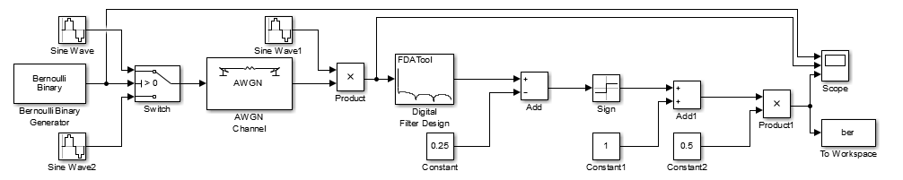
Figure 2 – ASK Implementation
The Bernoulli binary generator is utilized to produce a value of either 0 or 1. The author has configured the probability of this to 50% meaning roughly half the values should be 0 and half should be 1. Figure 3 shows the configuration of the Bernoulli binary generator.
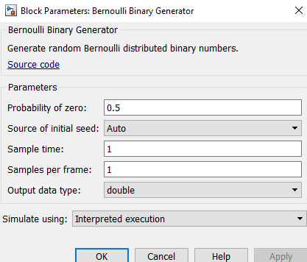
Figure 3 - ASK Bernoulli Binary Generator

The sign wave, this simulation utilizes three different sign-waves. The two sign waves at the start of the ASK modulation are used to produce the signal, these are controlled by a switch that is explained next. Figures 4 and 5 show the different frequencies used within the simulation, depending on the value the switch then utilizes one of the signals.
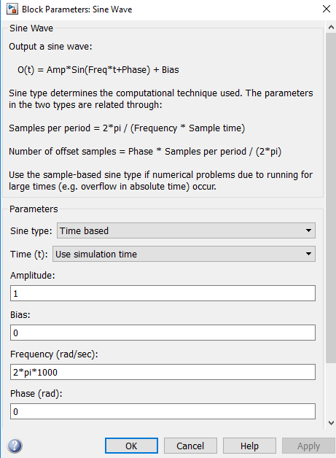
Figure 4 – ASK Sign Wave (1)
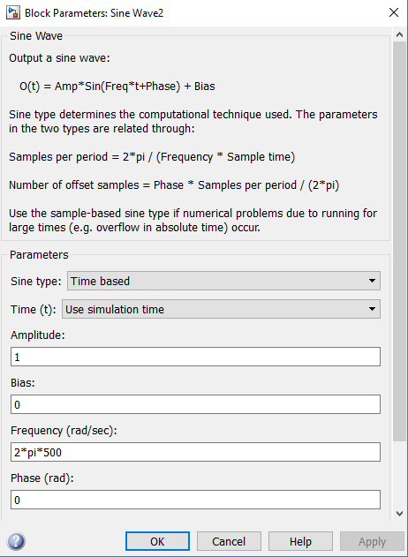
Figure 5 - ASK Sign Wave (2)
The switch, the author utilizes a switch to change the frequency of the signal depending upon the Bernoulli binary generator value. A value of 1 will utilize the sign wave seen in figure 4, with a frequency of 2*pi*1000. A value of 0 will utilize the sign wave seen in figure 5, with a frequency of 2*pi*500. Figure 6 shows the configuration of the switch; it has a threshold of 0.
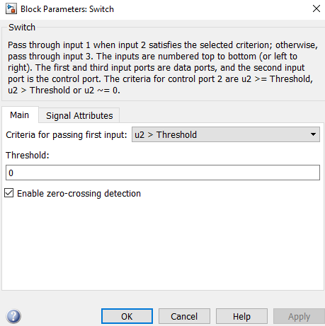
Figure 6 - ASK Switch
The AWGN channel, the author utilizes this block to add noise into the simulation. This block allows the simulation to be tested with different amounts of noise within it. This is done by changing the signal to noise ratio (SNR). Figure 7 shows the configuration of the AWGN channel, the SNR is set to 10.
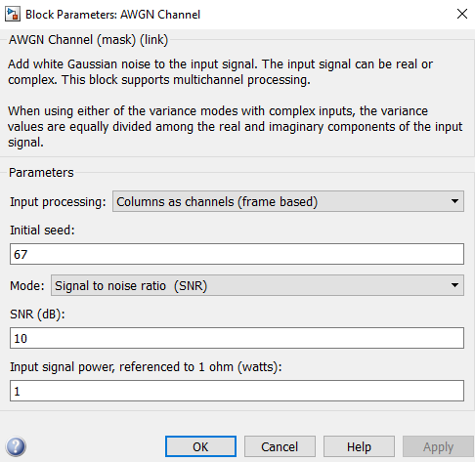
Figure 7 - ASK AWGN Channel
The product, this is utilized within the modulation to multiply the signal with the third sign wave, once multiplied the signal is fully modulated. Figure 8 below shows the configuration of the product with number of inputs set to 2[11].
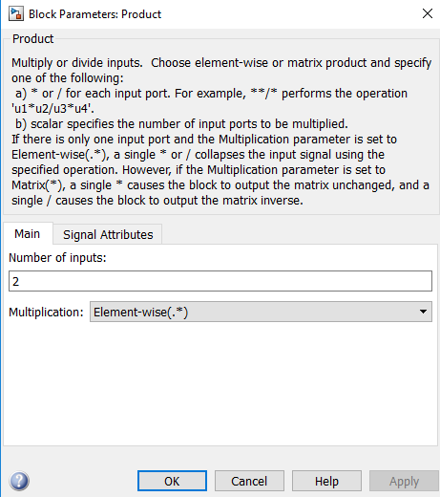
Figure 8 - ASK Product
The digital filter design is utilized to start the demodulation process. It is used to filter the signal; this then removes any unwanted frequencies. Figure 9 shows the configuration of the digital filter to demodulate the ASK signal.
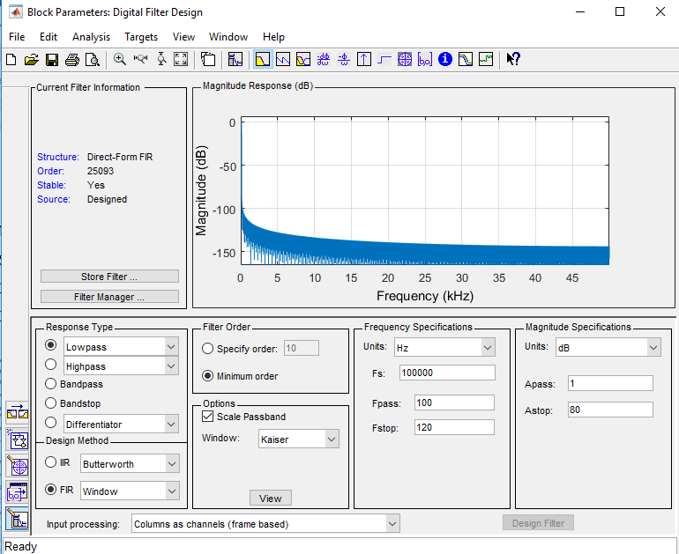
Figure 9 - ASK Digital Filter Design
The constant, the author utilizes three of these within the ASK modulation. A constant can be used to multiply, add or subtract a value from the signal. Figure 10 shows the first constant is set to a value of 0.25.
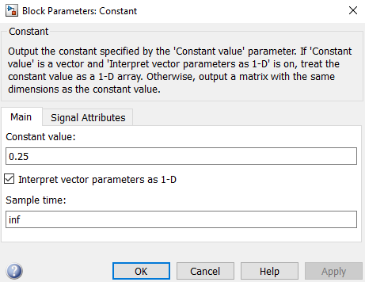
Figure 10 - ASK Constant
The add, the author utilizes the add block to both add and subtract constant values to the signal in the demodulation process. Figure 11 shows the configuration of the first add block, it subtracts the constant value (0.25) from the signal as part of the demodulation process.
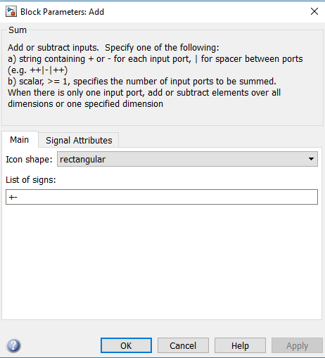
Figure 11 - ASK Add
The sign block, this is the next step in the demodulation process. This block is used to identify if the signal value is positive or negative. A positive value will output 1 and a negative value will output -1 however, if the value is 0 then it will output 0. Figure 12 shows the configuration on the sign block.
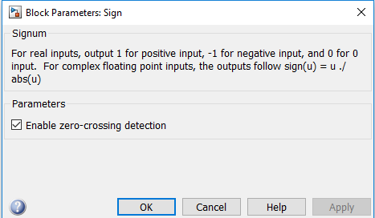
Figure 12 - ASK Sign
The scope, the author utilizes this to display three sections of the signal. The author has selected the original signal, modulated signal and then the demodulated signal. This gives the author the ability to ensure the modulation is working correctly. Figure 13 is utilized to show the settings that have been used on the scope within the ASK modulation.
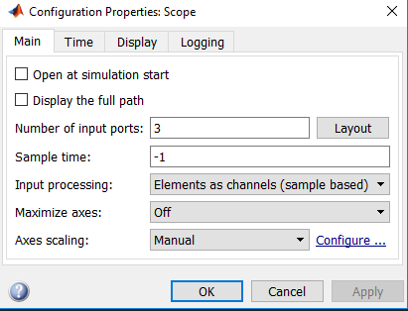
Figure 13 - ASK Scope
The error rate calculation is utilized to calculate the number of errors that occur during the transmission. Figure 14 below shows the configuration that is used within the modulation. The settings show that if there are 100 errors the simulation should stop.
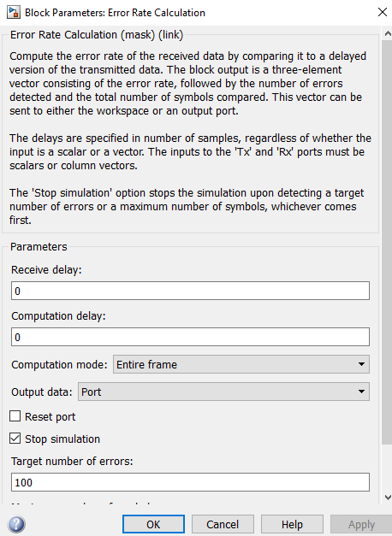
Figure 14 - ASK Error Rate Calculation
The display, this is utilized to display the error rate calculation. Figure 15 shows that the author has configured the display in a short format with a decimation of 1 within the modulation.
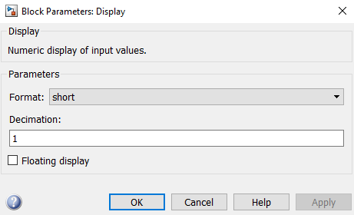
Figure 15 - ASK Display
The ASK modulation, figure 16 below is used to show the output from the scope after the modulation has been run. The top scope shows the original signal, this is the information being sent. The middle scope shows the modulated signal with noise, this is what would be transmitted. The bottom scope shows the demodulated signal. The signal is restored, however there is a slight delay.
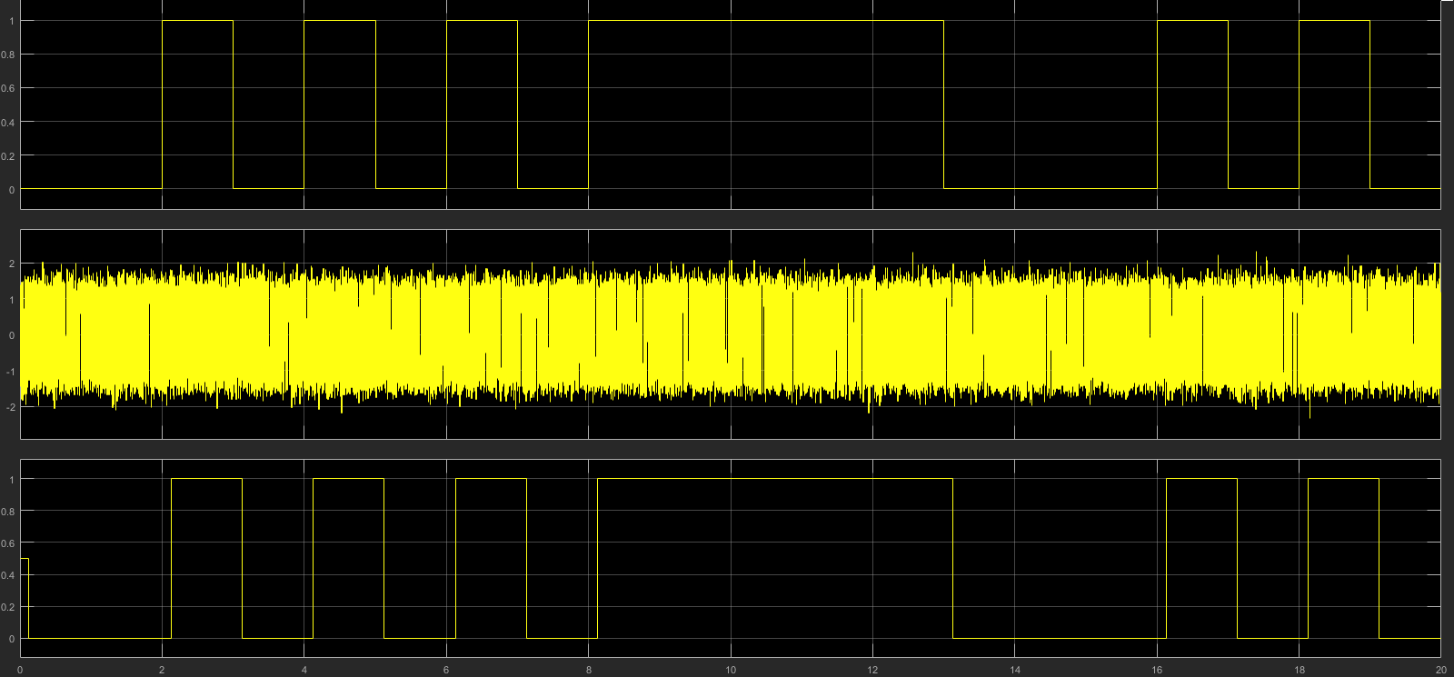
Figure 16 - ASK Modulation

Phase Shift Keying (PSK)
An example of PSK can be seen in the figure 17 below. The figure shows the blocks that are required to produce an PSK signal in Matlab. This section of the report will document why each block has been used and the reason for the block being included within the simulation.
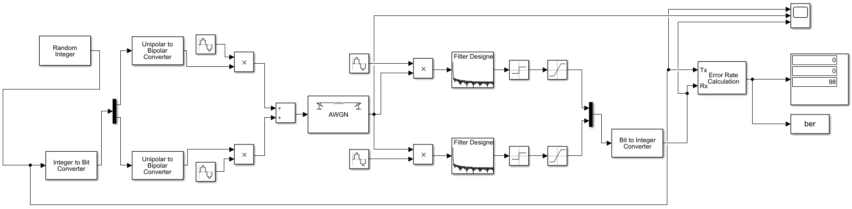
Figure 17 – PSK Implementation
The Random integer generator, this is utilized to generate random numbers between certain values. Figure 18 shows the configuration that has been utilized for the modulation. There is a set size of 4, this means that the values will be randomly between 1 and 3.
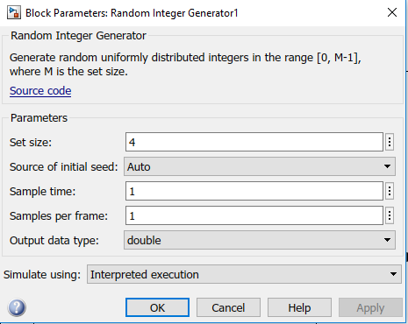
Figure 18 - PSK Random Integer Generator
The Integer to bit converter, this is utilized to convert the randomly generated integers into bits so that they can be transmitted. Figure 19 shows the configuration that has been utilized for this modulation. It shows that a value of 2 has been input within the number of bits per integer.
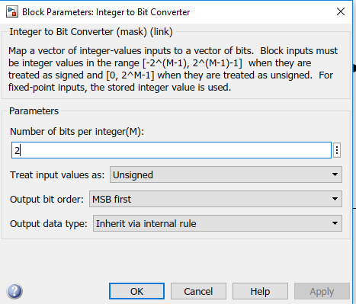
Figure 19 - PSK Integer to Bit Converter
The Demux, this is utilized to split a signal into more than one output. Figure 20 shows the configuration of the Demux that has been used within the modulation, it has two outputs.
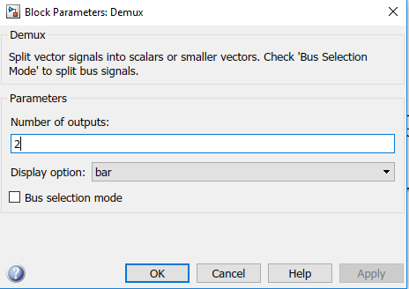
Figure 20 - PSK Demux
The Unipolar to Bipolar Converter is utilized to convert unipolar values into bipolar values. Figure 21 shows the configuration that is utilized within the modulation scheme.
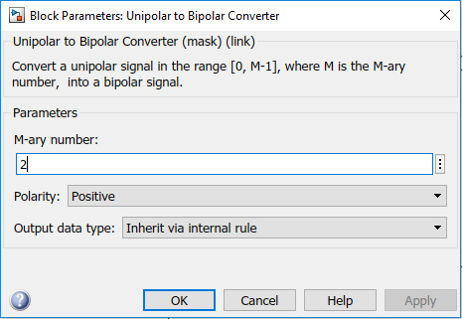
Figure 21 - PSK Unipolar to Bipolar Converter
The sign wave, this simulation utilizes two different sign-waves. The two sign waves at the start of the PSK modulation are used to produce the signal. There are additionally two sign waves utilized within the demodulation process. Figures 22 and 23 show the different frequencies used within the simulation.
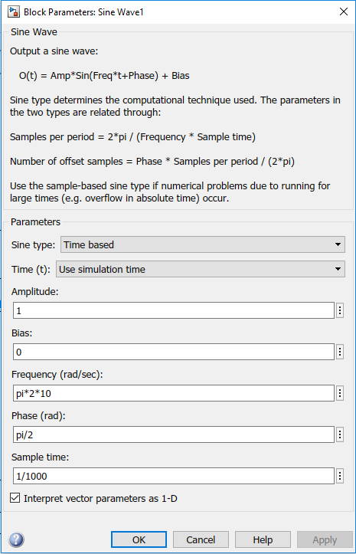
Figure 22 - PSK Sine Wave (1)
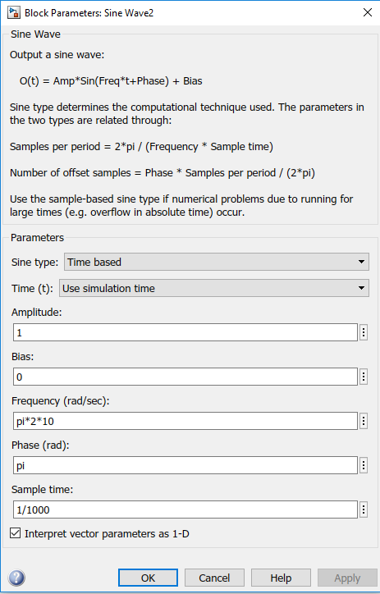
Figure 23 - PSK Sine Wave (2)
The product, there are four products utilized within the modulation to multiply the signal with sign waves. Figure 24 below shows the configuration of the product with number of inputs set to 2.
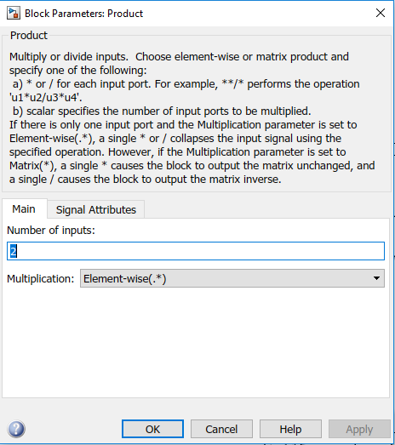
Figure 24 - PSK Product
The sum, this is utilized to add the two signals together to create one modulated signal. Figure 25 below shows the configuration that is utilized within the simulation, it is used to add both signals together.
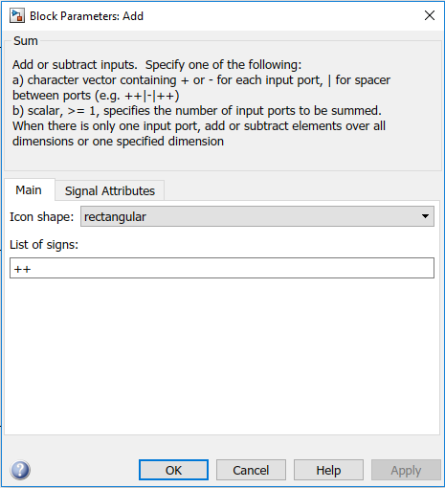
Figure 25 - PSK Sum
The AWGN channel, the author utilizes this block to add noise into the simulation. This block allows the simulation to be tested with different amounts of noise within it. This is done by changing the signal to noise ratio (SNR). Figure 26 shows the configuration of the AWGN channel, the SNR is set to 50.
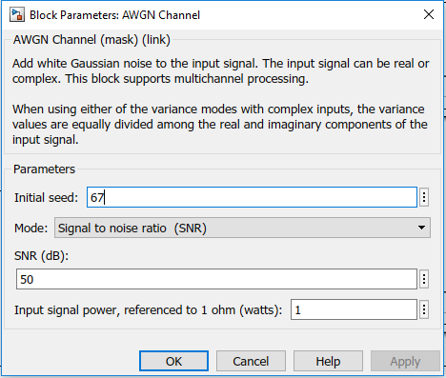
Figure 26 - PSK AWGN Channel
The digital filter design is utilized to start the demodulation process. It is used to filter the signal; this then removes any unwanted frequencies. Figure 27 shows the configuration of the digital filter to demodulate the PSK signal.
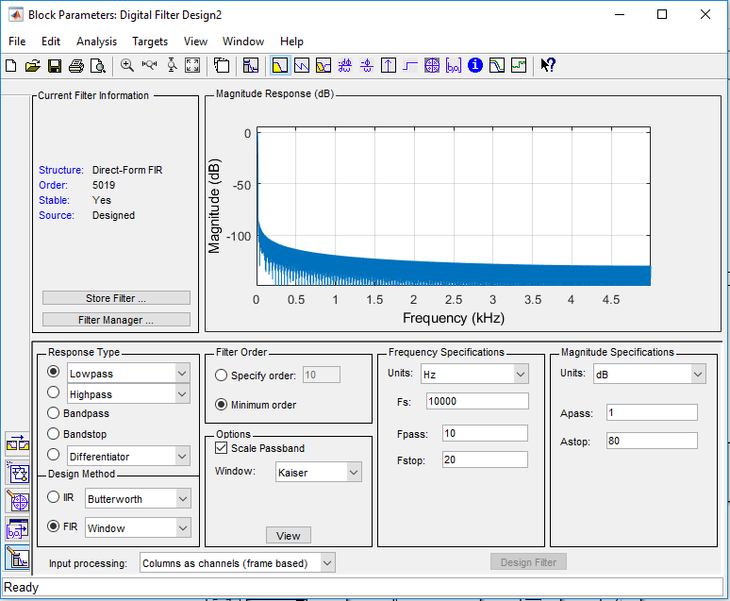
Figure 27 - PSK Digital Filter
The sign block, this is the next step in the demodulation process. This block is used to identify if the signal value is positive or negative. A positive value will output 1 and a negative value will output -1 however, if the value is 0 then it will output 0. Figure 28 shows the configuration on the sign block.
Figure 28 - PSK Sign
The saturation block, this was utilized to limit the lowest and highest values that can be used within the signal. Figure 29 shows the configuration utilized within the modulation. It shows an upper limit of 1 and a lower limit of 0. This means anything above 1 will be set to 1 and anything below 0 will be set to 0.
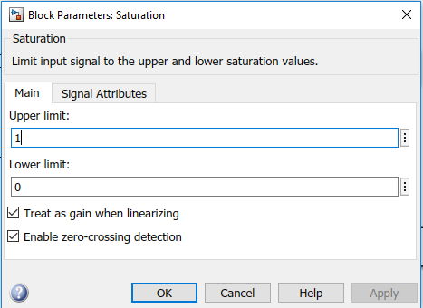
Figure 29 - PSK Saturation
The mux, this block is utilized to combine more than one signal together. Figure 30 shows the configuration utilized within the modulation. It shows that two inputs have been selected meaning that two signals can be combined to form one signal.
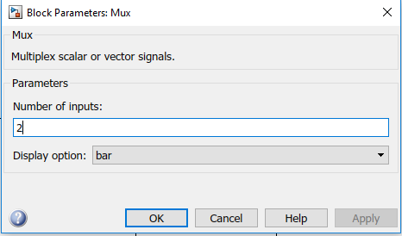
Figure 30 - PSK Mux
The bit to integer converter, this is the final step in the demodulation process. This is the process of converting the bits back into integers. Figure 31 shows the configuration utilized within the modulation process.
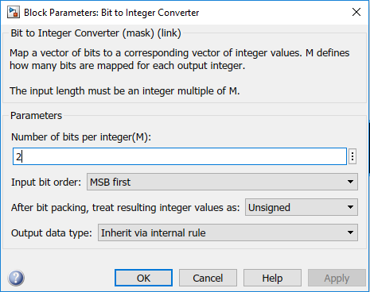
Figure 31 -Bit to Integer Converter
The error rate calculation is utilized to calculate the number of errors that occur during the transmission. Figure 32 below shows the configuration that is used within the modulation.
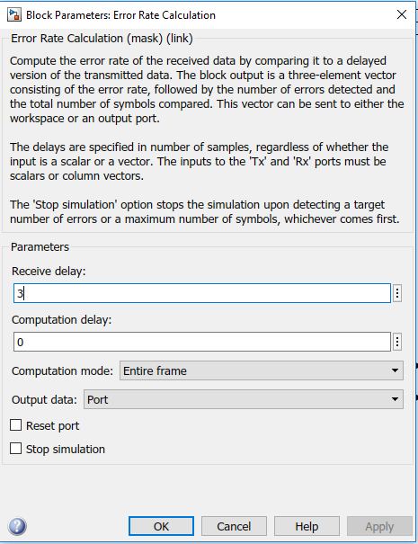
Figure 32 - PSK Error Rate Calculation

The display, this is utilized to display the error rate calculation. Figure 33 shows that the author has configured the display in a short format with a decimation of 1 within the modulation.
Figure 33 – PSK Display

The PSK modulation, figure 34 below is used to show the output from the scope after the modulation has been run. The top scope shows the original signal, this is the information being sent. The middle scope shows the modulated signal with noise, this is what would be transmitted, this additionally shows the phase shifts within the modulation. The bottom scope shows the demodulated signal. The signal is restored, however there is a delay.
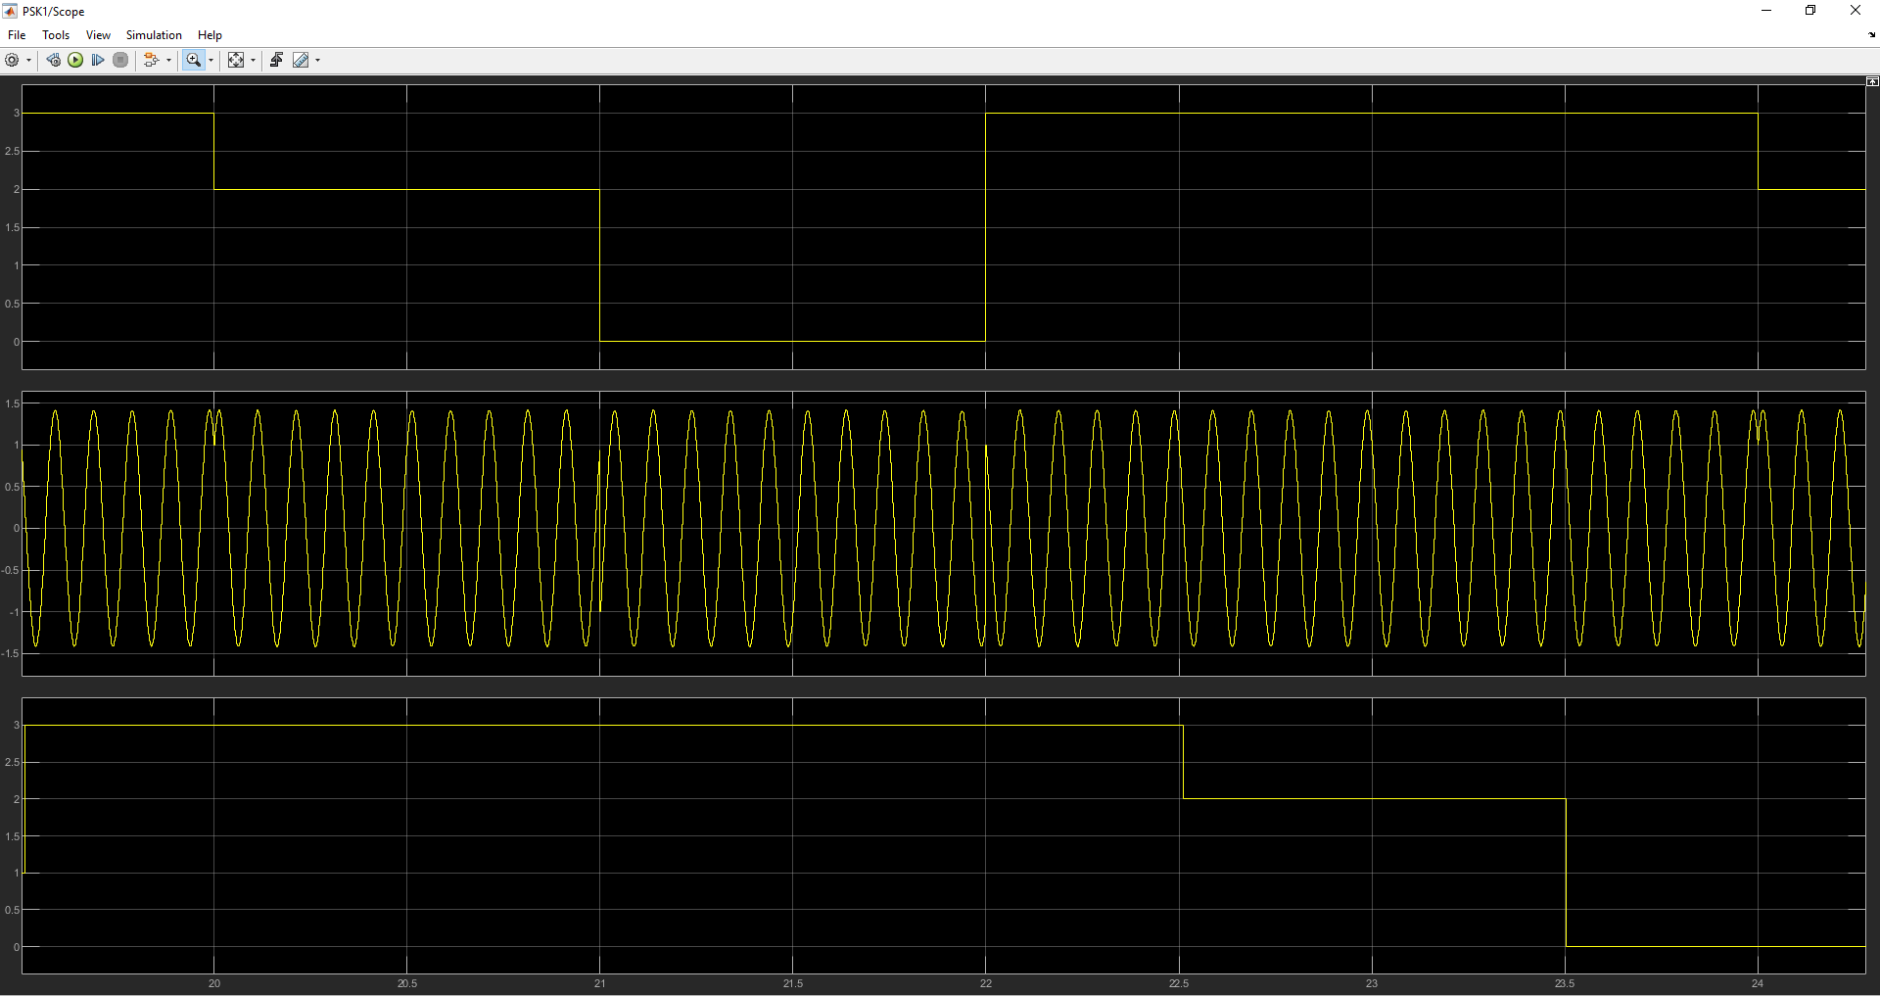
Figure 34 - PSK Modulation

Quadrature Amplitude Modulation (QAM)
An example of QAM can be seen in the figure 35 below. The figure shows the blocks that are required to produce an QAM signal in Matlab. This section of the report will document why each block has been used and the reason for the block being included within the simulation.
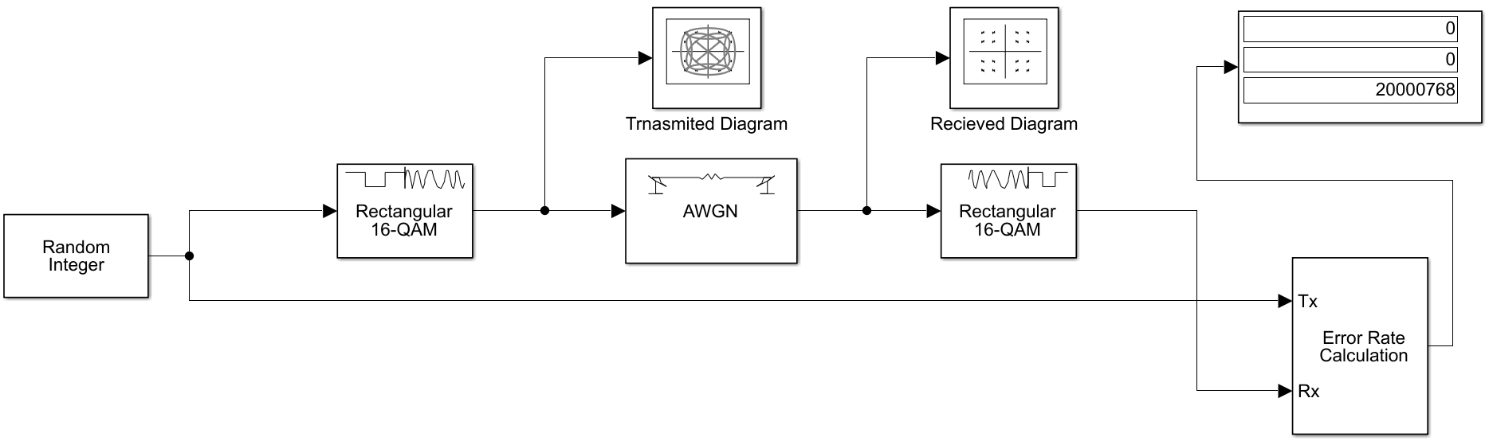
Figure 35 – QAM Implementation

The Random integer generator, this is utilized to generate random numbers between certain values. Figure 36 shows the configuration that has been utilized for the modulation, it shows a set size of 16.
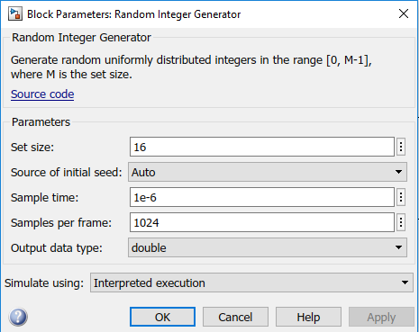
Figure 36 - QAM Random Integer Generator
The rectangular QAM modulator baseband is used to create a QAM signal. Figure 37 shows the configuration utilized within the modulation.
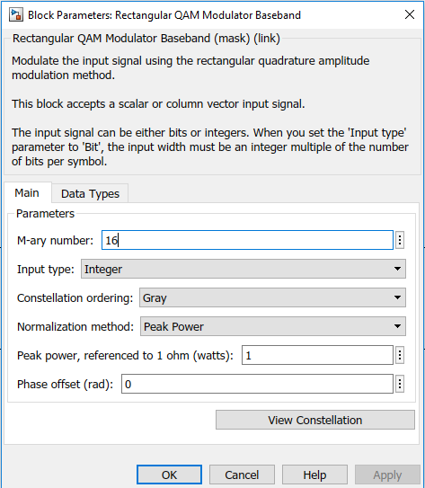
Figure 37 - QAM Modulator
The diagram block is utilized to show the transmitted and the received signal within the modulation. Figure 38 shows the block before data is transmitted.
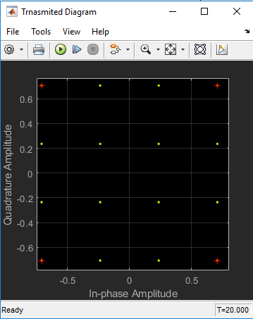
Figure 38 - QAM Diagram

The AWGN channel, the author utilizes this block to add noise into the simulation. This block allows the simulation to be tested with different amounts of noise within it. This is done by changing the signal to noise ratio (SNR). Figure 39 shows the configuration of the AWGN channel, the SNR is set to 50.
Figure 39 - QAM AWGN Channel
The QAM demodulator is utilized within the modulation to demodulate the QAM signal. This restores the signal to what was originally sent before noise was added to the modulation.
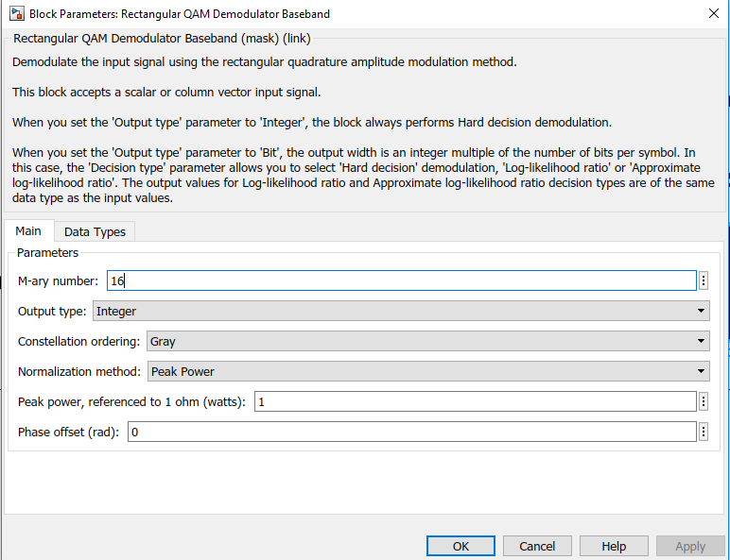
Figure 40 - QAM Demodulator
The display, this is utilized to display the error rate calculation. Figure 41 shows that the author has configured the display in a short format with a decimation of 1 within the modulation.
Figure 41 - QAM Display
The error rate calculation is utilized to calculate the number of errors that occur during the transmission. Figure 42 below shows the configuration that is used within the modulation.
Figure 42 - QAM Error Rate Calculation
The QAM modulation, figure 43 below is used to show the output from the display after the modulation has been run. The display shows the 16 bits and how they transmit data, the author has added some noise to show the data, otherwise it would show just 16 dots as seen in figure 38.
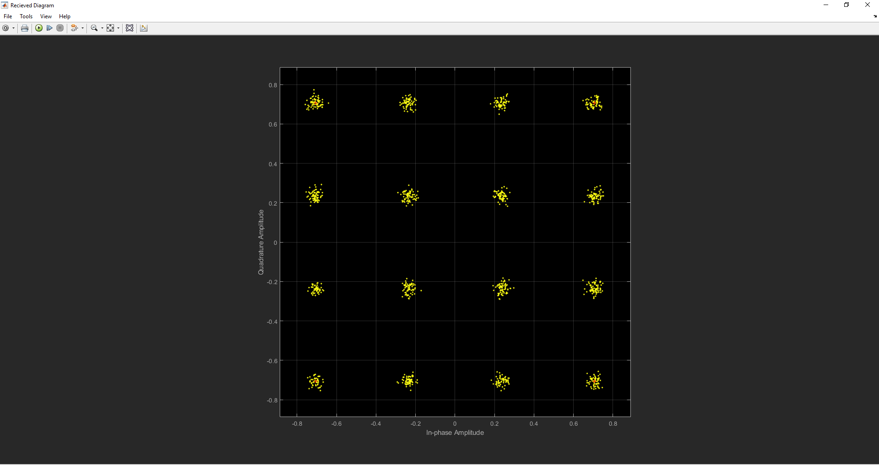
Figure 43 - PSK Modulation

Design and test performance of simulations
This section of the report is utilized to test the three different modulation techniques with different levels of channel noise. This will allow the author to compare the findings from the results to the research conducted.

Amplitude Shift Keying (ASK)
The ASK modulation has been tested with channel noise (SNR) from -50 to 50. Figure 44 shows the results from the modulation being run. It shows clearly the less noise the less packets are lost. When run with a SNR of -50 there was a 50% packet loss, however when run with a SNR of -10 there was no packet loss.
AWGN SNR (dB) | Packet loss (%) | Packets Lost | Packet Sent
-50 | 0.50% | 10 | 20
-40 | 0.35% | 7 | 20
-30 | 0.30% | 6 | 20
-20 | 0.15% | 3 | 20
-10 | 0.00% | 0 | 20
0 | 0.00% | 0 | 20
10 | 0.00% | 0 | 20
20 | 0.00% | 0 | 20
30 | 0.00% | 0 | 20
40 | 0.00% | 0 | 20
50 | 0.00% | 0 | 20
Figure 44 - ASK Data
Figure 45 below shows the data from the modulation plotted on a graph. It again shows a clear link that the less noise the lower the packet loss. The packet loss with a SNR of -30 does not seem to have as much of an impact in the packet loss as the other SNRs that have been tested. The results of the testing on ASK modulation are exactly as expected from the research.

Figure 45 - ASK Data (Graph)

Phase Shift Keying (PSK)
The PSK modulation has been tested with channel noise (SNR) from -50 to 50. Figure 46 shows the results from the modulation being run. It shows clearly the less noise the less packets are lost. When run with a SNR of -50 there was a 75% packet loss, however when run with a SNR of -10 there was no packet loss.
AWGN SNR (dB) | Packet loss (%) | Packets Lost | Packet Sent
-50 | 0.75% | 752 | 998
-40 | 0.70% | 695 | 998
-30 | 0.55% | 546 | 998
-20 | 0.17% | 174 | 998
-10 | 0.00% | 0 | 998
0 | 0.00% | 0 | 998
10 | 0.00% | 0 | 998
20 | 0.00% | 0 | 998
30 | 0.00% | 0 | 998
40 | 0.00% | 0 | 998
50 | 0.00% | 0 | 998
Figure 46 - PSK Data
Figure 47 below shows the data from the modulation plotted on a graph. It again shows a clear link that the less noise the lower the packet loss. The packet loss with a SNR of between -30 and -20 has a huge impact on the packet loss with a reduction of 38% of packet loss. The research conducted by the author stated that PSK was good at dealing with interference however, when dealing with a SNR below -20 PSK seems massively effected by noise. The results of the modulation were very similar to what was expected from research however, not exactly as the high levels of noise

Figure 47 - PSK Data (Graph)

Quadrature Amplitude Modulation (QAM)
The QAM modulation has been tested with channel noise (SNR) from -50 to 50. Figure 48 shows the results from the modulation being run. It shows clearly QAM can be affected by channel noise with a huge percentage of packet loss until the SNR is greater than 20. When run with a SNR of -50 there was a 94% packet loss, however when run with a SNR of 30 there was no packet loss.
AWGN SNR (dB) | Packet loss (%) | Packets Lost | Packet Sent
-50 | 0.94% | 18745437 | 20000738
-40 | 0.94% | 18729584 | 20000738
-30 | 0.93% | 18686456 | 20000738
-20 | 0.93% | 18543577 | 20000738
-10 | 0.90% | 18042862 | 20000738
0 | 0.80% | 16025572 | 20000738
10 | 0.39% | 7798846 | 20000738
20 | 0.001% | 25543 | 20000738
30 | 0.00% | 0 | 20000738
40 | 0.00% | 0 | 20000738
50 | 0.00% | 0 | 20000738
Figure 48 - QAM Data
Figure 49 below shows the data from the modulation plotted on a graph. It shows that there is a huge impact by channel noise. The packet loss with a SNR of between -50 and -0 is above 80% however after this it drops dramatically. The research conducted by the author stated that QAM has a high throughput and could not deal with noise very well. The results of the modulation link to the research and confirm it was correct.

Figure 49 - QAM Data (Graph)

Wireless network design & evaluation

Long Range (LoRa & LoRa1)
LoRa is a wireless data communication channel that covers a long range, LoRa can reach distances in excess of 10km. LoRa might have the ability to cover a large distance however, it is slow with data rates of 50kbps. LoRa is very commonly used within wireless internet of things (IoT) networks due to its range and low cost. LoRa is very good for long distance wireless communications that do not require a fast connection as it utilizes a low power consumption[12][13].

Short Range

Wireless Local Area Network (WLAN)
A WLAN a wireless network that allows devices to connect to it wirelessly. A WLAN is also known as Wi-Fi and is very common, it is utilized in homes, offices and on public transport. A WLAN is usually fast with the 802.11ac standard supporting speeds up to 1,300 megabits per second (Mbps). However, a single access point on a WLAN can only support ranges of 46 meters indoors and 92 meters outdoors. This means this type of connection is excellent for short range communications. A WLAN can utilize 2.4G or 5G frequency depending on the age of the access point and devices connected.

ZigBee
ZigBee is a wireless personal area network (PAN). ZigBee is very common within home automation as it is a low power, low cost network that can be used within close proximity. ZigBee can operate at distances of between 10 and 100 meters with a data rate of 250kbits/s. ZigBee utilizes the IEEE 802.15.4 standard and uses the 2.4G frequency[14].

Satellite
A satellite can cover a huge surface of the earth; however, they have a large initial cost. A satellite offers high bandwidth and sometimes can work out cheaper than other communication methods over long distances. A satellite can offer data rates of 1000 Gigabits per second (Gbit/s), it can cover a range of between 100 and 6000km[15].

Cellular
A cellular network is a wireless mobile network. The network is made up of areas that are called cells, each cell has a transceiver. Cellular networks can be utilized for both voice and data communications. Cellular communications use the 3G, 4G and are moving towards the 5G frequencies. However currently the 4G frequency can offer speeds of up to 50Mbps. Cellular coverage can reach up to 45 miles however, the terrain can interfere with this and dramatically reduce the range. Connectivity can be kept after the 45 miles however a cellular handover is completed, and the user is connected to the next cell tower automatically without knowing anything has happened[16].

Internet of Things and Smart City
The internet of things (IoT) is a network of smart devices. Nearly all devices can be connected as IoT devices to create smart devices and smart homes. The idea of being able to remotely control a home or car is great however, security and privacy is a massive concern when dealing with IoT devices[17].

A smart city is a city with IoT devices that can be utilized to manage users, devices, traffic and transportation systems to provide a better service to the end users. Smart cities can find parking spaces, provide Wi-Fi to users and support cities residents all making their lives easier.

Security imaging technology for the detection of concealed weapons
Security imaging technology for the detection of concealed weapon detection is utilized within airports, it can consist of metal detectors to x-ray machines that can scan a person to ensure they are not concealing a weapon. This technology is utilized to ensure that anyone carrying a weapon is found and then the weapon can be removed to keep people safe[18].

Wireless monitoring system
Figure 50 below shows the wireless monitoring system that has been created to protect the farmers, crops and their livestock. It additionally shows how the sensors would be connected that will be utilized to detect concealed weapons. The simulation includes two farms, these both have cctv cameras and motion sensors and a smart lighting system around the perimeter to deter thieves. All data is both stored locally and forwarded to the nearest local police station and all other police stations.

The city and its train station have smart lighting system linked to motion sensors and cctv cameras, the train station additionally has a sensor to detect concealed weapons to reduce robbery with both linked to the police station based within the city. The town and its bus have the same systems as the city and its train station however are linked to the town police station. The simulation has been created utilizing only one of each device to demonstrate how its system would connect however, the real implementation would include hundreds of sensors and devices to protect each area of the network. The network additionally did not allow the author to implement redundancy as in the real world there would be more than one internet service provider however, the simulation software would now allow this to be implemented.
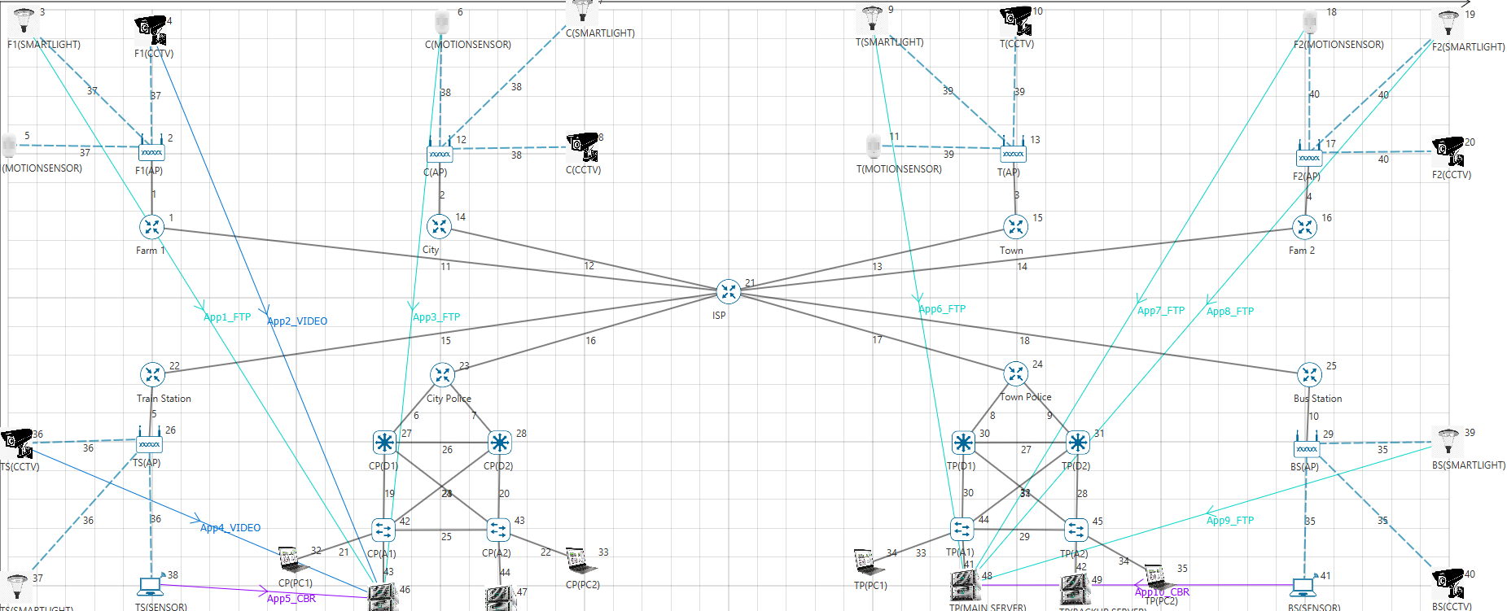
Figure 50 - NetSim Implementation
Figure 51 below shows the file transfer protocol (FTP) application settings configured for each of the FTP applications. It shows there is a unicast FTP link between the farm smart lighting system and the city police station. The connection is encrypted utilizing advanced encryption standard (AES), ensuring data is kept secure. A random startup has been created on this application as data would be sent at periodic intervals. This is an FTP communication so there is no need for a high priority link, for this reason the quality of services (QoS) was set to NRTPS which from research is recommended for FTP applications.
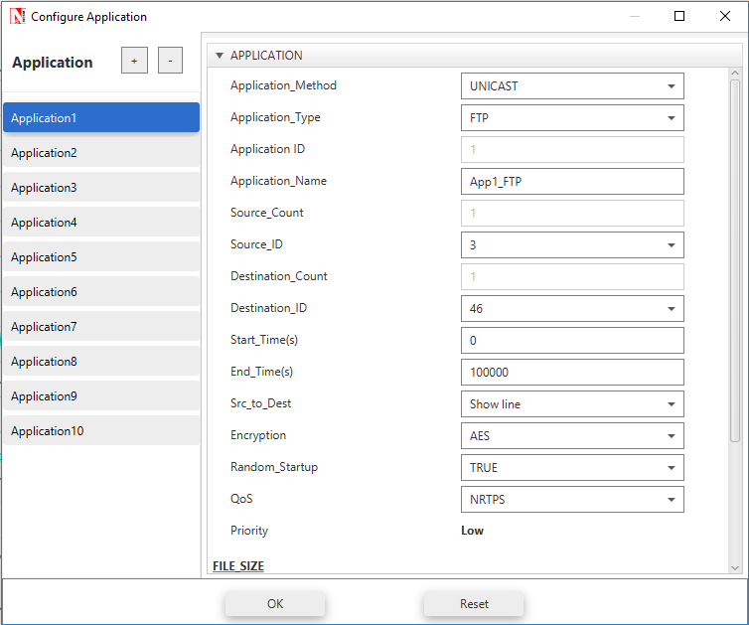
Figure 51 - NetSim Application (1)
Figure 52 below shows the video application settings configured for each of the video applications. It shows there is a unicast video communication link between the farm camera system and the city police station. The connection is encrypted utilizing advanced encryption standard (AES), ensuring data is kept secure. There is no random startup configured as there would be a live stream of data sent to the police station. This is an video communication so there is need for a high priority link, for this reason the quality of services (QoS) was set to UGs which from research is recommended for video applications and gives high priority.
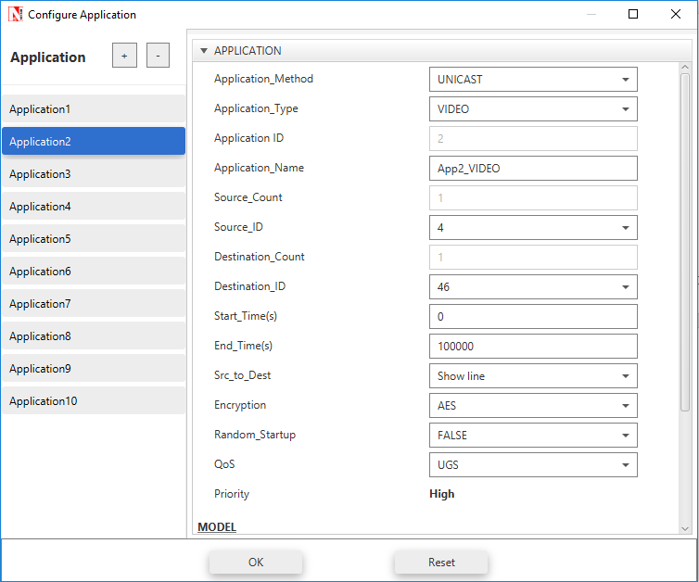
Figure 52 - NetSim Application (2)

Figure 53 below shows the constant bit rate (CBR) application settings configured for the CBR applications. It shows there is a unicast CBR link between the concealed weapon detection system the city police station. The connection is encrypted utilizing advanced encryption standard (AES), ensuring data is kept secure. This sensor requires a low priority link, for this reason the quality of services (QoS) was set to NRTPS which from research is recommended for CBR applications.

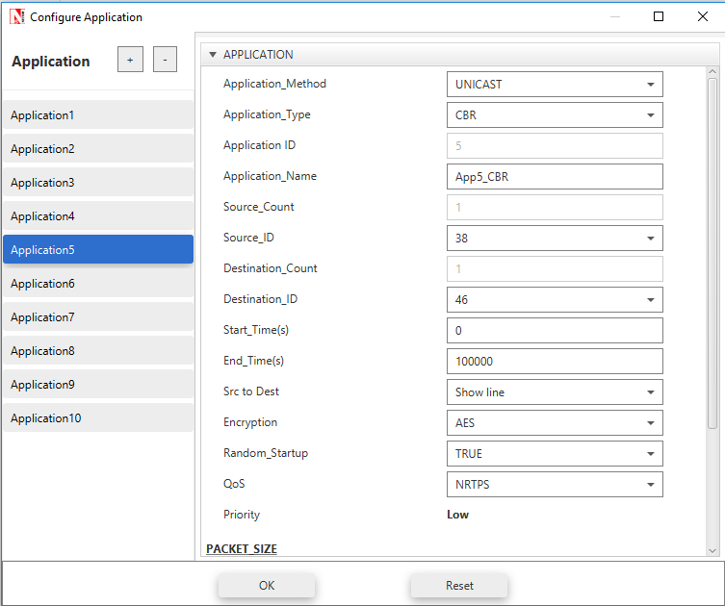
Figure 53 - NetSim Application (3)

Results & findings

NetSim Wireless Monitoring System

Delay
The results from the simulation being run have been added into the table below. This shows the delay for each of the different applications. The results show that video appears to have the lowest delay with 1321 and 1312 microseconds. It additionally shows that CBR gives a mixed result with one low delay of 1538713 microseconds and one quite high delay of 1314017 microseconds. The FTP connection appears to stay the same except for in application 8, where it has a low delay of 874699 microsec.

Application Name | Source Id | Destination Id | Delay(microsec)
App1_FTP | 3 | 46 | 1272866.108
App2_VIDEO | 4 | 46 | 1321.562178
App3_FTP | 6 | 46 | 1355386.745
App4_VIDEO | 36 | 46 | 1312.260065
App5_CBR | 38 | 46 | 1539713.15
App6_FTP | 9 | 48 | 1252000.555
App7_FTP | 18 | 48 | 1317403.526
App8_FTP | 19 | 48 | 874699.8769
App9_FTP | 39 | 48 | 1145818.933
App10_CBR | 41 | 48 | 1314017.521
Figure 54 - Netsim Delay
Figure 55 shows the results from table in figure 54 plotted onto a graph. The graph does not show much of a difference in FTP and CBR data transmission however, it shows clearly that video traffic has been created with the highest priority as the delay is much shorter than the other application types that have been utilized within the simulation.

Figure 55 - Netsim Delay (Graph)

Throughput
The results from the simulation appear to show that CBR traffic has the greatest throughput with both links having 0.58327Mbps. FTP is the next best throughput with its slowest being application 3 with a throughput of 0.157665. Video has the worst throughput that has been tested within the simulation with the fastest throughput being application 2, this had a throughput of 0.048685.

Application Name | Source Id | Destination Id | Throughput (Mbps)
App1_FTP | 3 | 46 | 0.155329
App2_VIDEO | 4 | 46 | 0.048685
App3_FTP | 6 | 46 | 0.157665
App4_VIDEO | 36 | 46 | 0.047641
App5_CBR | 38 | 46 | 0.58372
App6_FTP | 9 | 48 | 0.14571
App7_FTP | 18 | 48 | 0.145055
App8_FTP | 19 | 48 | 0.142067
App9_FTP | 39 | 48 | 0.140573
App10_CBR | 41 | 48 | 0.58372
Figure 56 - Netsim Throughput
Figure 57 shows the results plotted onto a graph. It clearly identifies that CBR traffic has the best throughput. This is as CBR is the lowest file size, FTP has the second-best throughput with a larger file size and video the worst throughput with the largest file size.

Figure 57 - Netsim Throughput (Graph)

Packet Loss
The results from the simulation show that CBR traffic has the lowest packet loss with both applications loosing 0 packets. FTP gives a mixed result with between 26 and 215 packets lost. Video gives a result of between 95 and 112 packets being lost making it the second-best application tested with FTP being the worst application tested.

Application Name | Source Id | Destination Id | Packets Lost
App1_FTP | 3 | 46 | 51
App2_VIDEO | 4 | 46 | 95
App3_FTP | 6 | 46 | 26
App4_VIDEO | 36 | 46 | 112
App5_CBR | 38 | 46 | 0
App6_FTP | 9 | 48 | 158
App7_FTP | 18 | 48 | 164
App8_FTP | 19 | 48 | 198
App9_FTP | 39 | 48 | 215
App10_CBR | 41 | 48 | 0
Figure 58 - NetSim Packet Loss
The graph in figure 59 clearly identifies the CBR traffic has the lowest packet loss, it shows video traffic additionally does not have a huge packet loss. However, it shows FTP has a mixed result with some applications like number 3 having low packet loss and application 9 having a huge packet loss.

Figure 59 - NetSim Packet Loss (Graph)

Best modulation scheme for the networks
Figure 60 shows that ASK has the lowest packet loss from the SNR testing performed. It additionally shows that PSK has the second lowest packet loss during the testing, and that QAM has the highest data loss at nearly 100% until an SNR of 0. ASK was clearly the best option within this test however it suffers with a low throughput as identified within the research conducted, so for this reason the author would not choose ASK for the modulation scheme for the network. QAM is a very fast modulation scheme that can run high throughput where there is little interference. However, the author would recommend utilizing PSK for the modulation due to it not being over complicated, and lower costs than QAM. It doesn’t have the same amount of bandwidth however research identifies that it will be the best choice for a modulation scheme for the different networks created.
Figure 60 - Comparison of Modulations (Graph)

Conclusion
In conclusion, the author believes that the assignment was very successful. The Matlab section of the report was very good learn how different modulation schemes work. The research that was conducted was as expected with the results of the modulation schemes. The NetSim network was additionally very important to allow the author to conduct testing to ensure that the correct modulation scheme was selected to be utilized within the networks. The modulation scheme that was selected was PSK due to it having a high enough throughput with a low enough SNR to run the network.

Recommendations for future work
- Further research to identify more modulation schemes
- Implementations of more modulation schemes to allow a better comparison
- Further research to identify more information on wireless monitoring systems and communication systems
- Testing of the simulation in different simulation software to allow a comparison to be made against the different simulations.

References
[1] T. Golonek, “Analog testing stimulus optimization for generating by means of Sigma-Delta modulation,” in Proceedings of the 22nd International Conference Mixed Design of Integrated Circuits and Systems, MIXDES 2015, 2015, pp. 521–524.
[2] V. V. Shcherbakov, A. F. Solodkov, and A. A. Zadernovsky, “Analysis of intensity modulation response of analog fiber-optic links,” in Conference Proceedings - 2016 IEEE 13th International Conference on Laser and Fiber-Optical Networks Modeling, LFNM 2016, 2016, pp. 24–26.
[3] P. S. Crovetti, “All-Digital High Resolution D/A Conversion by Dyadic Digital Pulse Modulation,” IEEE Trans. Circuits Syst. I Regul. Pap., vol. 64, no. 3, pp. 573–584, Mar. 2017.
[4] P. P. Sotiriadis and C. Basetas, “Single-bit all digital frequency synthesis with homodyne sigma-delta modulation for Internet of Things applications,” in 2017 IEEE International Symposium on Circuits and Systems (ISCAS), 2017, pp. 1–4.
[5] F. Mazzilli and C. Dehollain, “184 μW ultrasonic on–off keying/amplitude-shift keying demodulator for downlink communication in deep implanted medical devices,” Electron. Lett., vol. 52, no. 7, pp. 502–504, Apr. 2016.
[6] N. Liu, J. Cheng, and J. F. Holzman, “Undersampled differential phase shift on-off keying for optical camera communications with phase error detection,” in 2017 13th International Wireless Communications and Mobile Computing Conference, IWCMC 2017, 2017, pp. 916–921.
[7] Wei Li, Ming Li, and Ning Hua Zhu, “All-optical generation of ASK, PSK, and FSK radio-frequency signals,” in 2016 Progress in Electromagnetic Research Symposium (PIERS), 2016, pp. 2362–2362.
[8] J.-W. Lee, M. Kim, J. Park, G.-M. Hong, and S. Kim, “Phase shift keying demodulator with decision feedback phase-locked loop,” in 2016 IEEE International Symposium on Circuits and Systems (ISCAS), 2016, pp. 1550–1553.
[9] H. S. Khallaf, H. M. H. Shalaby, J. M. Garrido-Balsells, and S. Sampei, “Performance Analysis of a Hybrid QAM-MPPM Technique Over Turbulence-Free and Gamma–Gamma Free-Space Optical Channels,” J. Opt. Commun. Netw., vol. 9, no. 2, p. 161, Feb. 2017.
[10] B. T. Vo, H. H. Nguyen, and H. D. Tuan, “Constellation Design for Quadrature Spatial Modulation,” in 2017 IEEE 86th Vehicular Technology Conference (VTC-Fall), 2017, pp. 1–5.
[11] B. Chirag, A. Lohith, and H. S. Prashantha, “Comparative performance analysis of various digital modulation schemes in AWGN channel,” in 2017 Innovations in Power and Advanced Computing Technologies (i-PACT), 2017, pp. 1–5.
[12] Association for Computing Machinery and IEEE Computer Society, 2017 16th ACM/IEEE International Conference on Information Processing Conference on Information Processing : IPSN 2017 : proceedings : 18-2 April 2017, Pittsburgh, Pennsylvania, USA. .
[13] A. Lavric and V. Popa, “Internet of Things and LoRaTM Low-Power Wide-Area Networks: A survey,” in 2017 International Symposium on Signals, Circuits and Systems (ISSCS), 2017, pp. 1–5.
[14] G. Pan, J. He, Q. Wu, R. Fang, J. Cao, and D. Liao, “Automatic stabilization of Zigbee network,” in 2018 International Conference on Artificial Intelligence and Big Data (ICAIBD), 2018, pp. 224–227.
[15] J. Huang, Y. Su, L. Huang, W. Liu, and F. Wang, “An Optimized Snapshot Division Strategy for Satellite Network in GNSS,” IEEE Commun. Lett., vol. 20, no. 12, pp. 2406–2409, Dec. 2016.
[16] J. Cai, “A time-threshold-based priority hopping scheme for vertical handoff in cellular/WLAN interworking,” in 2017 3rd IEEE International Conference on Computer and Communications, ICCC 2017, 2018, vol. 2018–Janua, pp. 429–432.
[17] D. C. Bogatinoska, R. Malekian, J. Trengoska, and W. A. Nyako, “Advanced sensing and internet of things in smart cities,” in 2016 39th International Convention on Information and Communication Technology, Electronics and Microelectronics, MIPRO 2016 - Proceedings, 2016, pp. 632–637.
[18] S. Agarwal, B. Kumar, and D. Singh, “Non-invasive concealed weapon detection and identification using v band millimeter wave imaging radar system,” in RAECE 2015 - Conference Proceedings, National Conference on Recent Advances in Electronics and Computer Engineering, 2016, pp. 258–262.

