

Assessment 1 – Reading Task Template
Upload your photo of your A3 in-class notes here:
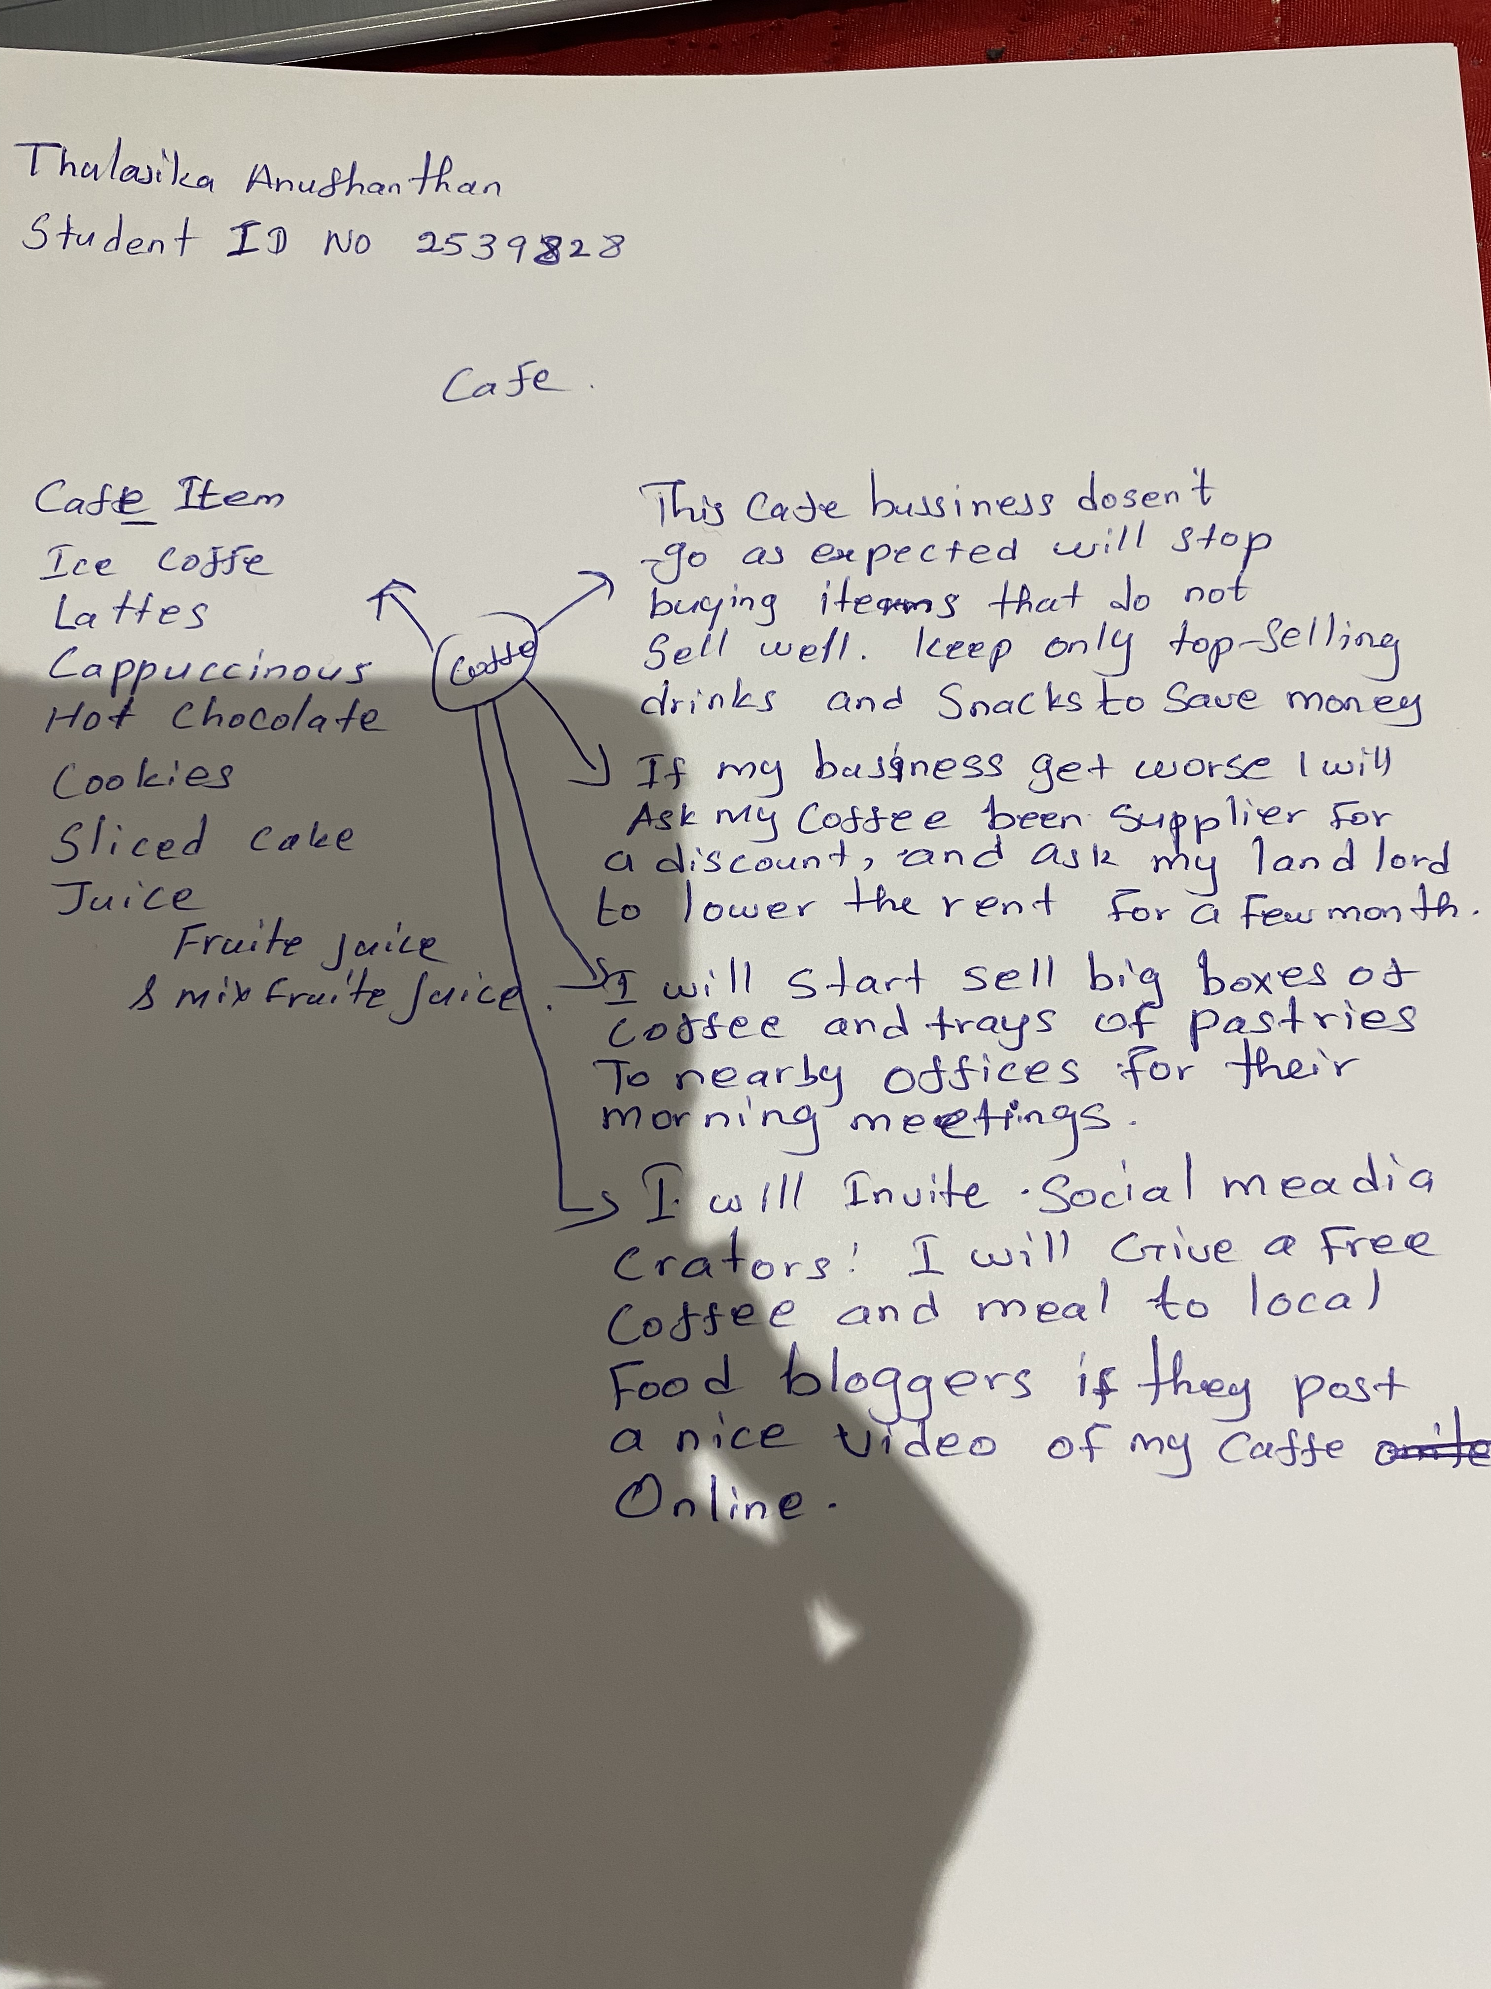

1. Answer these questions using the sentence starters below
a. What is the main idea of the text?
The main idea is that café owner is planning ways to improve the business by reducing cost, focusing on popular items, and using new strategies to attract customers.
b. What are two key points?
One key point is that the owner will stop buying items that do not sell well and keep only the TOP – Selling drinks and snacks.
Another key point is that the owner wants to promote the café by working with social - media creators and offering free food in exchange for online posts.
c. What part of the text did you find most important? Why?
The most important part is the plan to sell boxes of coffee and trays of pastries to nearby offices because it shows a smart way to increase sales and reach new customer.
d. Was anything unclear or difficult to understand?
I was not sure about how the owner will decide which items are ‘‘Top-Selling’’, because the text does not explain how they measure sales or track customer preferences.
e. How did your group help you understand the text better?
My group helped me by understand the text better by discussing each idea and explaining why certain strategies would help the café succeed. They also helped me think about how the owner could improve the business in different ways.
2. One sentence reflection
Question: What did you find challenging about this task?
The hardest part was carefully reading each idea in the text and explaining it in full sentences while making sure my answer matched the sentence starters and stayed connected to the café business plan.

