

An investigation into the ‘current state’ as the Approaching of Brexit of Food Retailers in the UK Market – with Specific Reference to Aldi

Date: 21st September 2018
Author: Yu Zhang (1704411)
Supervisor: Sarah Peasley
DECLARATION
This work has not previously been accepted in substance for any degree and is not being concurrently submitted in candidature for any degree

Signed……………………………………………

Date………………………………………………

STATEMENT 1
This dissertation is being submitted in partial fulfilment of the requirements for the degree of BA.

Signed…………………………………………….

Date………………………………………………

STATEMENT 2
This dissertation is the result of my own independent work/investigation, except where otherwise stated.
Other sources are acknowledged by footnotes giving explicit references. A bibliography is appended.

Signed……………………………………………

Date………………………………………………
STATEMENT 3
I hereby give consent for my dissertation, if accepted, to be available for photocopying and for interlibrary loan, and for the title and summary to be made available to outside organisations.

Signed………………………………………………

Date…………………………………………………

STATEMENT 4
I hereby give consent for my dissertation, if accepted, to be available on the university’s IT system to those who have consent to use the system.

Signed………………………………………………

Date…………………………………………………

Abstract
The aim of this dissertation is to investigate the current operation state of food retailers in the UK market as the approaching of Brexit, take Aldi as an example. The researcher divided the dissertation into five chapters to consequently display the critical and logical analysis of this research.

Chapter 1 is the introduction, which sets the tone and specifies the direction for the research by providing the background information on this topic, clarifying the aim of this project, listed the objectives of obtaining the aim of this research and display the important terminologies relate to this project.

Chapter 2 is the literature review, a critical review about the topic-related previous research is been displayed. Studies on food retailers’ current situations, impacts brought by the imminent Brexit situation is been clarified in this chapter. Strategies relating to solutions towards the crisis the approaching of Brexit will bring, which includes strengthen human resource management, customer retention and supply chain enhancement is included in this chapter.

Chapter 3 is the research methodology. In this chapter, research paradigm is been explained, which includes the research philosophy and research methods. This research applied both qualitative research and quantitative research, specific ways and gist of conducting the methods are been displayed. The ethical consideration and limitation of this research are also been expounded in this chapter.

Chapter 4 is data analysis, which presents the raw data and results of this research from the online questionnaire, interview and case study. The discussion is based on the findings exhibited in this chapter.
Chapter 5 is conclusions and recommendations, which systematically summarize the findings and outcomes of this research and provide answers to the objections set in the beginning of this dissertation. Justifiable recommendations based on the facts are propounded in this chapter.

Acknowledgements

The dissertation presents the findings of my research and will lead to the completion of the Master in Business Administration at the Faculty of Business, University of Wales Trinity Saint David.

Firstly, I would like to thank my family for providing me with continuous support throughout my one year in the UK. Without their support, I would not have been able to complete my master degree.

I would also like to express my deepest appreciation to my supervisor Sarah Peasley for her patience, guidance and supported me throughout the research. I am very grateful of her willingness in providing advice and guidance at short notice.

I would like to staff members of the Aldi store in Carmarthen Road, Swansea for their willingness in participating in my research interview. Lastly, I would like to thank everyone who participated in the questionnaire survey crucial to my research.

Contents
Abstract 4
Acknowledgements 6
Chapter 1 Introduction 11
1.1 Introduction 11
1.2 Background of Aldi under the approaching of Brexit 12
1.3 Important terminologies 14
1.3.1 Human Resource Management 14
1.3.2 Customer Retention 15
1.3.3 Supply Chain Management 15
1.3.4 Discount Chain 16
1.4 Rationale, Aim and Objectives 16
Chapter 2 Literature Review 18
2.1 Introduction 18
2.2 Food retailer’s current situation in the UK 19
2.3 Under the context of the approaching Bexit 21
2.4 Human Resource Management 23
2.4.1 Definition and Role of Human Resource Management 23
2.4.2 Human Resourcing and Talent Planning 24
2.4.3 Human Resourcing in Raising Performance 26
2.5 Customer retention 27
2.5.1 Customer experience and customer relationship 27
2.5.2 Customer lifecycle 29
2.6 Supply chain 32
Chapter 3 Research Methodology 36
3.1 Introduction 36
3.2 Research paradigm 37
3.2.1 Research philosophy (Pragmatism) 37
3.2.2 Research methods 38
3.3 Research strategy and design 40
3.3.1 Sample size 40
3.3.2 Questionnaire design 40
3.3.3 Piloting the questionnaire 41
3.3.4 Sending the questionnaire 42
3.4 Data collection and analysis methods 42
3.5 Ethical consideration 43
3.5.1 Research limitations 43
3.5.2 Reliability and validity 44
3.6 Qualitative research 45
3.7 Interview 45
3.8. Case study 47
Chapter 4 Data Analysis 49
4.1 Introduction 49
4.2 Quantitative analysis – food purchasing preference survey 50
4.3 Qualitative analysis – an interview with Aldi’s manager 58
4.4 Qualitative analysis – Aldi’s supply chain case study 60
4.4.1 Introduction 60
4.4.2 Challenges 60
4.4.3 Proposed solution 61
4.4.4 Results 61
4.5 Discussion 62
4.5.1 Question 1 The UK customers’ food purchasing preferences and Aldi’s advantages and disadvantages in the UK’s food retailers market as Brexit approaches. 62
4.5.2 Question 2: Aldi’s human resource management, especially in relation to their vocational training 71
4.5.3 Question 3: As the imminent of Brexit started casting negative influences on retailer industry, Aldi’s supply chain will be affected or not? 72
Chapter 5 Discussion, Conclusion and Recommendation 74
5.1 Introduction 74
5.2 Conclusions 75
5.2.1 Objective 1: The influences brought by the approaching of Brexit to the UK food retailers and the three ways to augment food retailers to resist the crisis the imminent Brexit situation casted on. 75
5.2.2 Objective 2: Strengthen the human resource management especially talent planning (take Aldi as an example). 75
5.2.3 Objective 3: Understanding customer’s food purchasing preferences (take Aldi as an example). 75
5.2.4 Objective 4: Adjusting supply chain to adapt the existing circumstance (take Aldi as an example). 75
5.2 Recommendation for Aldi under the context of the approaching of Bexit 75

List of figures

Figure 1: Result for questionnaire Q1- What is your gender? 49
Figure 2: Result for questionnaire Q2 - What is your age group? 49
Figure 3: Result for questionnaire Q3 – Where do you normally go for your weekly food shop? 50
Figure 4: Result for questionnaire Q4 – What is your first consideration when going to a food store to buy food for weekly shopping? 51
Figure 5: Result for questionnaire Q5 – What do you think of own brand items? 52
Figure 6: Result for questionnaire Q6 – Do you like to purchase food online? 52
Figure 7: Result for questionnaire Q6a – What type of shop do you complete when shopping online? 53
Figure 8: Result for questionnaire Q6b – Talking about online shopping delivery fee, which one you would prefer? 54
Figure 9: Result for questionnaire Q7 – Do you prefer to go to the food retailer which you have a membership card with? 55
Figure 10: Result for questionnaire Q8 – What sort of benefit would you like to see from a membership card? 55
Figure 11: First consideration of respondents who selected Aldi as their weekly food shop store. 58
Figure 12: Under 25 age group, weekly food shop preference. 61
Figure 13: 25-65 age group weekly food shop preference. 61
Figure 14: Over 65 age grop weekly food preference. 62
Figure 15: First consideration of respondent who selected Aldi as their weekly food shop store. 63
Figure 16: Preference of shopping method of the respondents who selected Aldi as their weekly food shop store. 64
Figure 17: Preference of own brand item among the respondents who selected Aldi as their weekly food shop store. 65
Figure 18: Food retailer’s preference of the respondents who selected food quality. 66
Figure 19: Food retailer’s preference of the respondents who selected food price. 66
Figure 20: First consideration of respondents who selected Tesco as their weekly food shop store. 67

Chapter 1 Introduction

1.1 Introduction
The purpose of this dissertation was to investigate under the approaching of Brexit, UK food retailers' tactics towards imminent Brexit. Firstly, this dissertation is going to analyse the context of Brexit and UK’s food retailers, especially food retailers in discount chains ‘operation states under this context. Secondly, UK food retailer’s human resource management under the changing situation, as the raising performance of HR, talent planning is of vital importance for a company’s vitality and activating employee’s contribution. The researcher completed an interview with the Aldi’s manager in Carmarthen Road, Swansea to obtain more information about Aldi’s human resource management. Thirdly, this research investigates customer’s preference and behaviour when carrying out weekly food shopping. Through the extensive data gathering exercise, the researcher is able to understand more about the customers and explore more appropriate methods in order to acquire new customers, retain customers and develop customers. Fourthly, this dissertation analyses the current supply chain of the UK food retailers and the threat they face under the imminent Brexit situation that the food price and any variation that would potentially have an effect. The researcher utilises a case study to investigate food retailers’ supply chain and Aldi has been chosen as company for the case study.

1.2 Background of Aldi under the approaching of Brexit
According to the latest data on Kantar Worldpanel, 2018, German company Aldi has dominated 7.3% of the total UK market share with the “Big Four (Tesco, Sainsbury’s, ASDA, Morrisons)” taking the biggest share. Due to the relatively small market share, this manifests a bright prospect for Aldi to grow as a company in the food retail industry. Several food retail analysts predicted that discount chain companies will continue to exert influences on the food retailers market based on the market data (Chapman, 2018). Given the decision of the British people for leaving the European Union (EU), the food retailers has been affected by especially the sterling depreciation and has increased the cost of importing materials, which made grocery price higher. New research has shown that in the year 2017 alone, nearly 75% of food are imported from the EU and the food retailer industry will be most affected than any other sectors by ultimate to 80% tariffs on food imported from the EU (Musaddique, 2018). Alongside with the recession and growing unemployment, customers turn to cheaper options other than the Big Four, gave more rooms for discount chain like Aldi to accelerate its pace (Tsang, 2017).
Aldi has undergone a third consecutive drop in profit but a leap in sales. According to Barns, the chief executive of Aldi, providing a competitive price to consumers is always what Aldi has been pursuing since its establishment. Aldi has targeted UK market as a long term project since 1990 when they first entered the UK food industry, so plans like cutting prices and expansion for more branches will still be progressing (Butler, 2017). Barns also pointed out that as Brexit dent profits for food retailers, Aldi could stick to its previous policy of buying British which the statistics show that 77% of their products are from British (Craven, 2017). In that way, Aldi can retain its price gap over other food retailers who import from the EU as Brexit approaches. The food retailers never stop their steps of scrambling for bigger markets share, this year ASDA announced the major merger with Sainsbury’s. This significant merger between two Big Four supermarkets will snatch the majority of the market share and easily overtakes Tesco becoming the biggest retailer in the UK. The newly merge company is likely to cause 10% reduction on the popular food price. The newly merged giant company is likely to pose pressure on Aldi who always want to keep the low price gap in food retailer market, to slash their price further.
Facing with these changes and challenges, it could be both threat and opportunity for Aldi to grow by continuing with implementing smart strategies to keep its price advantage. Based on a recent current survey Aldi has successfully beaten Waitrose and ranked top as customer’s favourite retailer which give Aldi another advantage to increase its market share. It is obvious that the customers are satisfied with Aldi’s good value of money as well as the quality its own labelled products (Rodionova, 2018).

1.3 Important terminologies

1.3.1 Human Resource Management
The Human Resource Management (HRM) was defined by Armstrong in his book as “activities encompass all scopes of people employment and administration”. The human resources include strategy and planning that align with corporate strategy. Pilbeam et al (2010) emphasizes that there are five significant HRM philosophies. The first one is the integration of HR management with corporate strategy. The second one is to delegate HR activities to line managers. The third one is to encourage employee’s commitment and engagement. The fourth one is to promote worker flexibility and the last one is to propaganda active management in corporate culture. Kumar et al (2018) listed key HRM programme includes recruiting, retention and engagement, compensation, wellness and training and development. A success of a company is also dependant on how staff members within the organisation are being managed. The success of the program can be measured by the return of investment (ROI) on human resource program. It is vital to measure the effective of these program via ROI in order to develop, implement and improve these HR program. Kumar et al (2018) also pointed out the importance of strong workplace culture (i.e. leadership and resulted in attractive employee proposition and increase the organisation’s ability to attract top talent achieve its objectives.

1.3.2 Customer Retention
Customer retention is the ability to sustain existing customers for a product or services over a defined period. In order for an organisation to be successful in this day and age, organisation is required to strive to provide at the very least a satisfactory service to customer so they are retained and loyal to the organisation (Kaura et al, 2015; Su et al., 2016; Kumar and Dash, 2017). When the customer is satisfied with the experience of the services and products provided, the customer is likely to become loyal to the organisation (Chiu et al., 2016; Padila et al., 2017). Econsultancy refers that more companies consider innovative strategies to satisfy customer comes top of their consideration (Perking, 2017). In the high changing food retailer market, customer’s decision can be easily changed. Malcolm (1995) pointed out that companies should categorize their customers to make different strategies. The cost of winning new customer is much higher than retain old customers. To cultivate loyal customer and figure out ways to retain them is cost effective.

1.3.3 Supply Chain Management
Supply chain management is management of movement of goods and service between suppliers, producers, distributors and customers for the purpose of sustain and enhancing existing competitive position of the organisation in the current market (Chopra and Meindl, 2001). There are numerous definition of supply chain management (SCM) presented in various literature. Donlon (1996) states that supply chain management consists of partnership with suppliers, outsourcing, compression in cycle time, continuous flow in process, and sharing information technology. Tan et al (2002) emphasised six elements of supply chain management practice including integration of supply chain, information sharing, characteristic of supply chain, the management of customer service, geographical distance and the ability JIT (just in time). Min and Mentzer (2004) pointed out supply chain management includes vision and goals, effective information exchange, sharing of risk and rewards, collaboration, effective integration and streamlining of processes, long term connection and SC stewardship.

1.3.4 Discount Chain
Discount chain or sometimes also known as discount store/shop is a retailer who often sells products at a cheaper price than the typical retail price. Discount chain commonly has a prime objective of providing product at the lowest cost for customer and often the quality of the products are not compromise despite the low price. Discount chain may retail own brand or brand items at low cost. Discount chain organisation often purchase branded items in a large bulk so the price can be negotiated a lower rate so products can be retailed at a better value. Discount chain is a growing industry in the UK, Jordan, D, 2018 states that the food discounter is expecting to grow by almost 12% in year 2018 alone.

1.4 Rationale, Aim and Objectives
As a Germany Retailer, Aldi has been witnessed an aggressive growth in UK food retail industry by providing low price but good quality products. As the approaching of Brexit, the four major food retailers have been affected by numerous impacts, however retailers on discount chain like Aldi and Lidl thrived in this trend. Hence the researcher’s curiosity has been triggered by such phenomenon that how food retailers can hinder the impact brought by the approaching of Brexit. Therefore, the topic of this dissertation has been settled as “An investigation into the ‘current state’ as the approaching of Brexit of food retailers in the UK market- with specific reference to Aldi”. To achieving the goal of this dissertation according to the topic, the researcher has set several objectives. There are:
1. Status quo of UK food retailers’ operation as Brexit approaches
2. How food retailers in UK can defeat the impacts brought by the approaching of Brexit
3. UK food retailers’ human resource management under the impact of the imminent Brexit situation (take Aldi as an example)
4. Customer retention management under the impact of the approaching of Brexit (take Aldi as an example)
5. Supply chain management as the Brexit is impending (take Aldi as an example)
6. Providing valid recommendations to Aldi

Chapter 2 Literature Review

2.1 Introduction
This chapter will focus on literature review and the sources of relevant theories on the topics investigated in this report. The literature review aims to enhance and improve understanding theories utilised in the research. The enhanced understanding will allow the research to be more academic and robust. The sources of this research will derive from the related books, journals, articles, E-books and authorized websites.
All literatures are organized logically into five parts: Previously, related studies of a brief overlook on the UK food retail will be presented. Then the correlated up-to-date studies of the threat facing by food retailers in UK presented, mainly based on the approaching of Brexit. The latter three chapters focused on the three important aspects to resist the risks brought by the approaching of Brexit. The third part will concentrate on studies about the significant role played by human resource management. Next, this chapter will focus on related studies of customer retention. Finally, the supply chain will be discussed.

2.2 Food retailer’s current situation in the UK
According to the report written by Nicholson, Julie Vasquez(2016), the UK can provide 60% of the demand for food domestically, however with the rising customers’ requirements, the UK is increasingly reliant on imported food. In the year 2017 alone the UK has imported 54% of agricultural food from EU, in which 15% from Netherlands, 11% from Ireland, 10% from Germany, 10% from France, 8% from Spain and 7% from Italy. The food retailer markets are competing fiercely nowadays, the five major retailers owns around 70% of the market shares which other companies struggled for the remainder shares, while online food sales is displaying a tendency of growing which gained 10.4 billion pound in the year of 2017. At the same time, the discount chains are gaining popularities from consumers. The three major forms (grocery stores, discount stores and online stores) of food retailers are expanding exponentially. The distribution of stores are changing slightly recently, with the opening of larger stores becoming less common and the number of in town smaller stores are rising. The bombshell announcement this year that Sainsbury’s and Asda (ranked 2nd and 3rd ) are committed to merge which will arouse a huge sensation in food retailer industry, which the total market share will surpass the biggest one(Tesco). It is estimated that discount and convenience stores are set to continue to grow rapidly and be the fastest growing area. The total market value of the UK Grocery Market is predicted to grow by 15% by 2022 to the total of £213 billion, with discounters taking a share of £30.1 billion. These discount stores are projected to claim one in every nine pounds spent on grocery items. At the same time, the discount chains keep providing low costs which has made the competition fierce and the food prices become lower. Consumers’ buying habits have adapted as convenience stores keep providing better quality food and a greater variety of food now, they enjoy top-up shops nowadays more than previous years. By the year of 2022, it is believed that the convenience stores will occupy 15% of the food retailer market. Convenience stores are focusing on selling everyday items to satisfy the top-up shopping trend. The growing trend and public consensus of being more health conscious, customers are tending to buy different kinds of food like ethnic foods, “free from” food(gluten or lactose free) and organic food. The fast-paced society of today is making people prefer more convenient products such as ready meals and pre-packed foods.
As the approaching of Brexit, changes will happen for food retailers. Armstrong Ashley(2018) in her report has estimated that though Aldi and Lidl has taken their price advantage to keep making expansion last year, under the context of ‘no deal’ Brexit, their expansion process will go slower. However Aldi still ranked top in their services to customers’ satisfaction(BBCNEWS,2018). For senior groceries M&S’s food hall and Waitrose, the future may become even uncertain. They still focus on providing high quality but at the same time lessen the variety and supply niche products. In Rayner Jay’s (2018) article, says the Brexit will hinder the free floe of food for 30% from the border of UK. Helen Dickinson from British Retail Consortium said the supply chain is no longer strong. Morris Chris(2018) also maintain that the Brexit may cause the problem for food stockpiling at the UK border for logistics. Then for frozen food, the scenario is worse.

2.3 Under the context of the approaching Bexit
The electorate of leaving the EU is on the horizon, which experts in various walks of life made prophecy about the changes it will bring. Amaro(2018) from CNBC predicted that it will be a hard time for food retailers in UK due to the uncertainty of the future in this area. She believes that EU won’t build a new relationship with UK because the prime minister has pronounced to leave the EU single market. Floyd and David (2016) maintained that from the perspective of macro-economy, the withdrawal from the EU would potentially bring uncertainty to labour markets. Considering of the achieved benefits with EU, restrictions will be cast on migrant’s benefit, welfares, child educations and Schengen policy. The hiring policy of talents from EU may also need to re-stipulate.
Musaddique(2018) believes that the approaching of Brexit would be a grim milestone for food retailers in UK. According to the statistics provided by Squire Patton Boggs(2018 ), based on the fact that UK haven’t reached an agreement with the EU which means the food retailers will face a higher tariff than any other industries. In 2017 alone, UK imported 30 billion pounds from EU, which have accounted to 75% of the total food and drinks (Musaddique, 2018). Apart from the increasing of tariff, according to Willis Towers Watson (2017), there are three other risks may occur to food retailers brought by the approaching of Brexit. The first one is the likely abolishment of free movement will impact the cost base of food retailers, although the EU workers in food retailers only account for a small percentage (4%) in all EU migrant workers(Caroline, 2016). The second one is there will be some changes on the aspect of supply chain. In order to minimize the import costs, some retailers are already switching suppliers to those who got a stronger treaty network (Dentons, 2016). The third one is that for online retailers, it would be a time for them to suffer because rules and regulations may need to change (WLTW, 2017). What’s more, food retailers hesitated to invest in new market or expand their business, they would rather take a wait-and-see attitude till the regulations and rules become more clear (Dhonota, 2017).
As the voting to leave the EU has undermined UK’s economy, plus the declining of sterling rate, customers turn to discount chains to save money (Tsang, 2017). The two major discounters from German- Aldi and Lidl seized the opportunity and kept expanding their branches in UK market, while UK’s ‘big four’ are less likely to open new stores, on the contrary they even trimmed their staffs to compete with low price provided by discount chains(Looveren, 2018). UK’s biggest and traditional food retailer Tesco is launched a new discount stores in this autumn to gain more market share and fight back to discount chains like Aldi and Lidl (Ahmed, 2018). Besides, several days ago, Tesco’s new discount chain Jack’s is open, the manager announced that Jack’s objective is to providing lower prices than Aldi ad Lidl but more variety of food (Dearbail, 2018). The second and third supermarket Sainsbury’s and Argos are merged and decided to implement a “dual-brand strategy” and reduce their price around ten percentage in order to attract more customers(Hammett, 2018). Fraser McKevitt from Kantar forecasts that discount chain company will continue to exert influences on the food retailers market based on the data (Chapman, 2018). New research has shown that in the year 2017 alone, nearly 75% of food are imported from EU and the food retailer industry will be most affected than any other sectors by ultimate to 80% tariffs on food imported from EU (Musaddique, 2018). Together with the recession and growing unemployment, customers turn to cheaper options other than the Big Four, gave more rooms for discount chain like Aldi to accelerate its pace(Tsang, 2017).
The approaching of Brexit brings changes and uncertainties, food retailers need to enhance human resource management to hire talented employees and trained them properly; understanding customers and customer’s lifecycle in order to satisfy customer’s raising requirement in this fierce competitive food retailers market; figuring out new solutions towards the changes the approaching of Brexit will bring.

2.4 Human Resource Management

2.4.1 Definition and Role of Human Resource Management
The definition of HRM has been developed and improved by adding new insights over the years. Beer et al (1984) defined HRM, as the activity of human resource in which will influence the relationship between the company and its employees. HRM activities can be traced back to human relations movement of the 1930s, following the discovery of social needs for worker to provide job satisfaction, motivation and leadership (Pilbeam et al, 2010). The term HRM and the method of managing people is originated from the USA in response to emerging global competitive pressure. Guest (1987) later delineated the definition more vividly as he expanded the role of HRM to policy formulation, which serves to improve the performances and outcomes of employees. Legge (1989) pushed forward the policy design to the layer of cultivating a proper corporate culture, which in the end will form a mutual recognized pursuit between the workforce and the organization. Storey (1995) maintained that HRM is a unique method to manage workforce by applying a comprehensive structure in line with the company’s culture, structure and personnel strategy, which in the end will stimulate employees highly committed to work. Based on the above studies, Armstrong defines HRM in his book as “activities cover all areas of people employment and administration”. He also believes that HRM have overlapped with other studies and been improved more refined by building up on the basis of these studies, like behavioural science, strategic management, industrial relations and human capital (Armstrong, 2009). Pilbeam et al (2010) emphasized on 5 key HRM philosophies including (1) integration of HR management with corporate strategy, (2) delegating HR activities to line managers, (3) encourage employee commitment and engagement, (4) promote worker flexibility and (5) encourage active management in corporate culture.

2.4.2 Human Resourcing and Talent Planning
According to Tansley et al (2007), talent comprises of individuals who are able to make significant contribution to organizational performance demonstrating the highest levels of potential. Talent management requires to consideration of cooperate strategy to ensure that talents are acquire based on both quantitative and qualitative HR information in which identified talent requirements and business needs. Tansley et al (2007) pointed out that the success talent planning dependent on the development and communication of a common understanding of talent within an organization. Two approaches which determine the size of talent pool has been stated, namely the inclusive and exclusive approaches. The inclusive approach involve accept wider talent pool from employees at all levels who have talent, not just senior management. Inclusive promotes development of a more diverse work force. The exclusive approach identifies high performers for succession planning. This approach resulted in a smaller talent pool in which financial and non-financial resources can be focused on. Talent can be acquired from out the organisation. However, the organisation will have to attract these talents through creating a strong brand and multiple employee value propositions (EVPs), Pilbeam et al (2010). In times of changing economic, the competition for labour and the shortage of experienced staff can be fierce. The development of talent planning initiatives supported by talent management activities of attracting talent, developing talent and rewarding talent are vital to recruit and retain talented employees.
The recent political surprises particularly rise in populism and anti-establishment resulting in the UK voted to leave the EU, the way in which organizations attract and retain talent are significantly affected. CIPD (2017) carried out a survey where sample of UK-based HR professional from a wide range of organization (in total 1,068 people responded to the survey). The survey concluded that large majority of the organization is experiencing difficulties in recruiting well-qualified talent in the last year. The finding stated in CIPD (2017) suggests an increased focus on talent management in general. Over half of the organization has started upskilling and developing talent in-house to overcome recruitment difficulties following the UK’s decision to leave the EU and the possibility to restricting labour mobility.

2.4.3 Human Resourcing in Raising Performance
Kew and Stredwick (2013) have pointed out that in the operation of a company, it is the people that make a difference. A company should always put HR in first consideration place and let HR management be in part of strategy formulation, in that way HR’s policy can exert huge impact on the performance of the company. According to Ramsey et al (2000), a company’s success relies on the evolution of HR and how much their employees made their contributions, they even gave this method a name called ‘the high road’. Mark Huselid (1995) did a survey in higher class companies to measure the power of HR towards these companies’ performance. In the aspect of market value growth, companies who apply beyond average HR policy has generated extra market value, approximately 10 thousands to 40 thousands per employee, which the good outcome happens instantly (Guest, 1998). While in the aspects of profitability and productivity, when applying effective HR policy, we will also witness notable increase. Surveys and evidences show that a company should put the management of people in the first place. Aldi (2018) claims that their biggest asset is its employees and they never stop creating a harmonious environment and platform for employees development and coordinate operation. By no means Aldi’s HR had a strict recruitment and selection as well as well-organized training and development for employees. The core issue for recruit new people and make the selection is to absorb the right people and put them in the right position, normally this people should own the suitable skills and personality, a proper testing system and physiological test is necessary. A good training can inspire the employee to better serve for the company, the ultimate ideal outcome for employee’ training is employees can learn by themselves and willing to take a lifelong learning under the company’s learning organization (Kew, 2013). Performance appraisal is a important element of managing performance of employees. The primary aim of performance appraisal is measured and assessed individual’s achievement against predetermined goals agreed by both the employees and their line managers. Aldi implements a top-down scheme performance review system where immediate line manager normally undertake the formal appraisal of the employees.

2.5 Customer retention

2.5.1 Customer experience and customer relationship
In this day and age, business is becoming more and more competitive and organisations are required to increase their competitive advantage in order to survive in the market. Shaw and Ivens (2002) once depicted customer services as ‘the next competitive battleground’ since organisations are more dedicated on managing and providing better customer experience in contemporary market. Kotler & Keller (2006) suggested in order for company to be competitive, customer experience and relationship should be the main focal point. Holbrook & Hirshman (1982) interestingly pointed out that elements of pleasure, beauty, symbolic, meaning, creativity and emotion can enhance understanding consumer behaviour. Twenty years later, concept of customer experience becomes an important element in understanding consumer behaviour. Joseph Pine and James Gilmore(1998) first gave birth to the idea of customer experience that customers could add value in the process of enjoying services. According to Francis, B (2010), customer experience is the overall impact on customer cognition of their interaction with an organisation’s employees, products and services. Customer services is of paramount importance that in the end it will affect deeply on customer’s future buying behavior, customer loyalty and their brand image (Buttle, 2010). Francis, B (2010) emphasized three key concepts of enhancing customer experience through touchpoint, moment of truth and engagement. Customers are interacting with company’s people, processes and technologies via touchpoints such as call centres, shop front or vending machines. Moment of truth (MOT) is identified as any occasion where customers are forming first impression towards the company during their interactions with the touchpoints. MOT is a crucial moment where customers form evaluative judgements which could be either positive of negative about their experience. Francis, B (2010) pointed out that the definition of engagement can be considered as the customer’s emotion and rational response, despite there is no agreed definition of term during the time of publishing. In order to achieve positive customer engagement, customer service experience can be designed to exert sense of confidence, integrity, pride, delight and passion in customers. Francis, B (2010) indicates six ways to determine a company’s performance on delivery customer experience. The six ways included implementing mystery shopping, experience mapping, process mapping, ethnographic methods, participant observation and non-participant observation.

2.5.2 Customer lifecycle
According to Stern(2018), the customer lifecycle stems from customer relationship management, which begins at the instance the customer plans their purchase, the time covering the customers’ buying behavior, ending at the period after the customers’ buying. Crothers(2013) believes that the customer lifecycle management is significant for company, owing to the function of breaking down the activities to help the company to seize the current existing customer, foster the loyalty of the customer and create value from the customer. In UK food retailer market, consumers have stronger connections to Tesco and Sainsbury’s than discount chain Aldi and Lidl, they will only start loyalty scheme when they do market expanding(Netimperative, 2017). Buttle (2010) divided activities of customer lifecycle into three parts, namely customer acquisition, retention and development.

2.5.2.1 Customer acquisition
Acquisition is the first step of customer lifecycle. Other activities such as retention and development are dependent on acquiring new customer and built valuable customer base. The concept of acquiring of new customers presented in Francis, B (2010) is based on 3 major decisions namely (1) customer group target, (2) method of communication and (3) incentives for customer of such communication. Ultimately the goal is to acquire new customer which will generate more profit than the cost of acquiring and retaining them. Francis, B (2010) also pointed out business to business (B2B) is a way to acquire new customer base. Meire et al (2017) explained customer acquisition in B2B environment is very complex as it involves marketers to search for leads for salesperson to follow up. Leads are companies or individual who potentially need the offered product and are able to pay promptly. Customer relationship management (CRM) is used to define the process of creation and maintain relationship with customers. It is another useful process to acquire new customer base. CRM facilitates the process of identifying, attracting, differentiating and retaining customer (Hassan et al, 2015). Operational CRM processes can be described as coordination between sales, customer service, marketing, field’s support and other customer touching functions.

2.5.2.2 Customer retention and development
Following to the acquisition of new customer base, it is important for organisations to retain and develop new customers. Weinstein, A (2002) points out that measurement of customer retention varies across industry. However Weinstein, A (2002) suggests a simple measurement by measuring the number of customers doing business with an organisation at the end of the trading period, also known as raw customer retention. Francis, B (2010) states positive retention and negative retention concept. Positive retention is a strategy where rewards are given to customers who stay with the organisation. On the other hand, negative retention imposes switching cost to customers who decided to leave. There are several ways to implement positive retention strategy including achieving and exceeding customer expectation, finding way to add value, promoting social bonds and encourage customer engagement. Loyalty schemes, customer clubs and discount vouchers to name a few are ways to add value to customer’s shopping experience.
The concept of growing the value of retained customer base is referred to as customer development. Customer development can be implemented through cross-sell and up-sell activities. Francis, B (2010) defines cross selling as an activity where additional product and service are being sold to existing customer. Up selling is being defined as higher priced or higher margin products are being sold to existing customer. There are number of CRM technologies that facilitate customer development activities including campaign management, event-based marketing, data marketing, customisation, channel integration, integrated customer communications and marketing optimisation.
Inevitably there will be times where organisation is required to terminate relationship with customer who shows no sign of profitability, for example, fraudster, persistent late payers, serial complainants, customer who constantly change their mind with cost consequence to the organisation and customer who constantly searching for better deals (Helm et al, 2006). As a result, it is crucial for organisation to constantly review their customer base in order to identify potential customer for dismissal.

2.6 Supply chain
According to Dani (2018, P2-P6), food supply chain consists of five factors twining and affecting each other, namely producers, processor, retailer and distributors, hospitality sector and consumers. The food supply chain starts from food producers, through the traders and caters (hospitality sectors), then arriving at the food processors, who manufacture food to satisfy customers’ demands. The next stage is retailers and distributors, in which distributors seek the source of food from the processor then distribute them to customers, while retailing displays products on shelves from express shops to hypermarkets. The end stage is the customers. The affecting factors for food supply chain can be complex, except for parameters like agriculture production, new models of business, city density caused by the movement of people, innovations in technology, changes in market, Dani (2018) focused more on the influencing factors like value chain, legislation, the choice of customer, the food supply sustainability and collaboration among producers and processors.
A report from NFU shows that although UK food supply chain is always aiming at supplying high quality and affordable food, the approach of Brexit poses challenges to UK consumers in aspects of food access, variety and price (NFU, 2018). A fairly up-to-date news article on The Guardian in July 2018 also reported that the no-deal Brexit would put UK in food crisis, on account of currently 30% of the food are imported from Europe and only 49% of food grown in Britain (Rayner, 2018). Thomas Kwansniok, Peter Guarraia and Michael Garstka (2017) said a hard brexit will disrupt the supply chains of UK’s five major industries and cut their profits by GBP3 billion, which accounts for 30% of the total net profit. Another chart in the article shows that a moderate scenario of Brexit will decrease in profits of GBP6.18 billion (if the prices stay the same), while a hard Brexit could be even worse, which would make the profits drop to GBP19.8 billion. Though the final confirmation of the UK-EU governments has not been settled yet, formulating a strategy to anticipate the changes and markets is paramount for suppliers. Fearne and Hughes(2000) classify the UK fresh food industry has the features of excessive production, and is commodity driven and also has a a significant slow rate of growth. Food retailers are endeavoring to minimize the unknowns for the future markets by economizing the overall quality of supply chain, ensuring a better consumer product, minimizing liabilities and streamlining the scale of the supply chain (Hogarth-Scott, 1999). The supermarkets are maintaining their relationship with the same wholesalers for longer and with a smaller variety of them (Dorsch, Swanson, and Kelly, 1998). This kind of cooperative relationship offers many benefits, firstly it will guarantee the quality of product, secondly, it will make the commodity traceable, thirdly it will add value during the process from origin place to consumers (Fearne and Hughes, 2000; Hughes, 2000).
From the perspective of market share, BBC news(2017) states that currently Tesco accounted for the biggest portion of market share, followed by Sainsbury’s, ASDA, Morrisons, Aldi and ect. Given that the various food retailers has dissimilar supply chains, the impact for them of the approaching of Brexit is likely to be different. For UK’s biggest grocery store Tesco, Conrad Amanda (2017) said Tesco will suffer from the isolationist Brexit. According to an article written by Blod Ben(2017), researches show that Tesco ranked first been affected by Brexit. Since the referendum, a number of manufactures failed to reach an agreement on the new deal with Tesco, which is due to the following reasons: the rise in costs, the drop of the value of the pound and the increase of the fuel cost. Failing to negotiate with the supplier’s raising prices, 45% of the products from Heineken company have been taken down from the shelves of Tesco, another brand- Unilever also has been affected by the unpleasant deal with Tesco (Davies, 2017). The chief executive from Sainsbury’s argues that custom control has significant impact to its food supply chain. Food could be left rotting if strict and time consuming custom control and inspection are to be implemented after Brexit (Sembhy, 2017). ASDA’s CEO claims that the current food supply chain would be demolished by the hard Brexit and cast huge impact to ASDA(Jahshan, 2018). Verdict (2017) states that Morrisons is consider to have a better prospect in comparison to other food retailers due to its vertical supply chain. Thanks to Morrisons’ long-term good relationships with suppliers(most of them were UK based suppliers), it may not face the problem caused by the Brexit. German company Aldi has been analyzing and thinking countermeasures to the negative impact Brexit may bring to food retailers. Aldi has categorized the supply chain into food composition, food packaging and employees they have hired from EU, to be better prepared for the Brexit (Jahshan, 2018). What’s more, Aldi’s existing strategy may help Aldi go further compared to other food retailers in the fierce competition of Brexit due to their lower price and UK based food supplier (Allen, 2016).

Chapter 3 Research Methodology

3.1 Introduction
In this chapter, the research methodology explains how the data has been collected in order to achieve the aims and objectives set at the beginning of this dissertation.
Firstly this chapter will elaborate the paradigm of the research which includes the chosen research philosophies and research methods. It will explain what the chosen philosophy is and why this philosophy should subsequently be applied, in addition to the advantages and disadvantages relating to the methods. Secondly, this chapter will discuss the research design, including the design of the questionnaire, the interview questions and the case study. Also the piloting of the questionnaire will be discussed in this part. Furthermore, the intentions of sending the questionnaire to respondents will be discussed and the outcome data will be analysed. Lastly the chapter will discuss the ethical issues, including the research limitations and reliability and validity of this study.

3.2 Research paradigm

3.2.1 Research philosophy (Pragmatism)
The research philosophy of this investigation into the effect of Brexit on UK for retail market will be in line with the pragmatism approach. According to Saunders and Thornhill (2012), pragmatics “believes that there is no sole answer to analyse the whole situation for exploring the world and doing research because the truth reality is various.” Wilson (2010) describes that pragmatist apply diverse methods together to search for the answers to the research. The method does not need to be multiple but the way the research use should best push forward the specific study. The main advantage of approaching research with the pragmatism philosophy is the ability to use a combination of research methods in order to aid answering the research question. It is believe that pragmatism is the most appropriate philosophy for the research, largely due the convenience and versatility of the Internet and online surveys, of which features heavily in gathering the research. Pragmatism avoids metaphysical tendencies of other paradigms, which can be seen as superfluous (Tashakkori, Teddlie, 1998) and in adopting pragmatism, the research gathered aids conclusions more effectively.
Pragmatism gives way to the use of qualitative and quantitative research in the form of mixed methods. Due to the nature of the research topic, both qualitative and quantitative methods are appropriate, allowing discussion of the (human) source of the data ultimately collected.

3.2.2 Research methods
In order to respond the aim defined at the beginning of this dissertation, qualitative method has been applied by doing an interview with Aldi’s deputy manager to get a deeper understanding of Aldi’s competitive HR policy, quantitative method has been applied to do a questionnaire among consumers to better understand them and take better advantage of the consumer lifecycle, also another qualitative method has been applied by doing a case study about Aldi’s supply chain.
All the methods applied in this research is aiming at obtaining impartial data set for final analysis (Sekaran. U, 2003). Quantitative survey utilizes measurable data to formulate facts and describe patterns in research. Quantitative survey is regarded to be more structured than qualitative data collection approach. The quantitative survey consists of survey questionnaires that will be distributed to consumers from all walks of life. The target group size will be 100 people and been divided into three groups containing respondents under 25, respondents whose age between 25 to 65 and also senior respondents over 65. A small group of pilot study will be done to test the validity and reliability of the research before sending the questionnaires to respondents online. DeFranzo (2012) believes that the online survey is one of the most effective method to do a survey in contemporary world. This survey will be implemented using online survey tool such as SurveyMonkey to distribute the questionnaires to respondents and collecting raw data. Microsoft Excel spreadsheet is created to do the data analysis including the basic data analysis and cross data analysis. The aim of the survey questionnaires is to understand and gather consumer’s food purchasing preferences and behaviour towards Aldi as one of the UK supermarket chain. The questions for the survey will be designed with the aim to gather opinion and view from consumers and will subsequently be quantified and generalized.
Advantages for online survey including conveniently getting access to individuals in distant locations, the ability to reach difficult to contact participants, and the convenience of having automated data collection, which reduces researcher’s time and effort. Indeed, the questionnaire design is of higher feasibility and flexible and more convenient for respondents (Cvent, 2016). Online survey platform such as Survey Monkey also allows data to be exported in text format and to be processed in Microsoft Excel.
According to Wright (2005), the disadvantages of online survey research includes uncertainty over the validity of the data and sampling issues, and concerns surrounding the design, implementation, and evaluation of an online survey. Despite the fact that the survey is carried out in a fully confidential manner, there is no guarantee that the participants or respondents will provide genuine answer that is representative to their own view. There is also a possibility that the respondents may understand the question incorrectly and may resulted in a misrepresent analysis.

3.3 Research strategy and design

3.3.1 Sample size
According to Simplepsychology (2014) the definition for sample is referred to a group of individuals who participate in the process of the survey, known as “respondents”. Sampling method is the procedure of choosing a representative group of respondents under the subject (Simplypsychology, 2014). The sample size of this dissertation is 100 individuals. The 100 individuals participated in this survey through online questionnaire. The survey data were gathered and processed in order to investigate the customer preference and behaviour on food purchasing.

3.3.2 Questionnaire design
Questionnaire is required to be well designed and structured to collect the up-to-date precise data. Before sketching the questionnaire, the research should consider clearly the main objective, the way to apply the data and the method to analyse the data (DeFranzo, 2012). The questionnaire of this research is to understand the current customers’ food purchasing behavior including their opinions about the store location, food prices and varieties, online stores and physical stores, personal information includes their gender and age group which is been protected.
According to Burgess (2001), he divided the questionnaire design process into three phase, the first step is to design the question content, then choose the proper way to raise the question, at last well organize the sequence and layout of the questionnaire. Later he proposed that all the questions in questionnaire should be concise and explicit, in that way the respondents can answer the questions easily. The questions also should not be misleading or it will influence the respondent’s’ real opinion towards the question that will affect the authenticity of the result. Moreover, questions should be raised in a formal way; the selection of words in the questionnaire design is significant.
Farrell (2016) defines “closed-ended questions are the questions can be simply response as “Yes” or “No”, or been providing several concise questions (e.g. A, B, C, D or Above).” Closed-ended questions will normally get higher responds than open-ended questions. The researcher applied ten closed-ended questions in this research based on the nature of quantitative and the pragmatism paradigm of this research. All the 10 closed-ended questions will be easy for respondents to answer and for the researcher to gather primary data, as well as it is a way that can save time and energy to go through the whole process. By using the closed-ended questions, the researcher got the established amount of responses from all respondents.

3.3.3 Piloting the questionnaire
A pilot study is of great significance in conducting a research, that it examines the inconspicuous problems and drawbacks under the research protocols and implementation (Lancaster GA, 2004). Also by piloting study, the researcher can have acquaintance with the whole procedure of the research in that gradually aware of the advantages and disadvantages and also the feasibility of the investigation. Still, the researcher can decide under the certain aim of the research, to apply the interactive interview method or by the autonomous questionnaire (Kraemer,2006). The researcher has done pilot study (to three people) to test the feasibility of this research before sending out the questionnaire.

3.3.4 Sending the questionnaire
The questionnaire was implemented using Survey Monkey, an online source which distributes the survey by sharing the URL via social media and online messaging platforms. The disclaimer will also be included to specify the objective of the research as well as how the collected data been applied for. The URL was distributed to respondents via social media (Facebook Messenger, WhatsApp and Wechat) from 25th of July 2018 to 13th of August 2018, providing twenty days for respondents to complete the survey, which the sufficient time frame guaranteed the quality of this investigation. Among all the 100 respondents in this research, only one question in one questionnaire was missed out and all the other respondents answered accordingly. Basically all the respondents have fulfilled the researcher’s objection and provided a reliable result.

3.4 Data collection and analysis methods
The questionnaire data were collected over 19 days and 100 individuals have responded to the survey request. The data were extracted from Survey Monkey and processed in Microsoft Excel. In order to improve efficiency in analysing large amount data, an excel spreadsheet has been setup as such that the each question can be analysed individually or concurrently with other questions. The excel spreadsheet is capable in generating results in a percentage format showing the amount of respondents for each answer. The spreadsheet is also capable in analysing two questions concurrently. For example, the spreadsheet can analyse question Q1 and question Q3 and generate result for percentage of female respondents who selected Tesco as their preferred weekly food shop destination. In essence, the analysis was undertaken in order to determine consumers behaviour and preference in food purchasing in order to draw conclusion and fulfil the objective of this research.

3.5 Ethical consideration
The survey was undertaken in a strictly confidential manner and the raw data were made available only to the author and supervisor of this dissertation. The raw data were not intended in anywhere to release to the general public or to anyone other than the supervisor of this dissertation. The survey provides a platform for participants to express their view anonymously and contribute to the research. The participation of this survey was undertaken in a complete voluntary fashion and the participant was free to withdraw from the questionnaire at any stage of the survey.

3.5.1 Research limitations
For the questionnaire part, limitation can be concluded in mainly two parts, the age group imbalance and the geographic imbalance.
Firstly, it is the limitation of geographical range. Due to the reason that the researcher is using online questionnaire to do the research (sending questionnaire to friends through Facebook Messenger and Whatsapp), the majority of the respondents are from Wales (mainly from Swansea). Food retailers in different ranges of the UK has different distributions, so the investigation of customer’s shopping preference may be affected by the geographical limitation and can only represent the Swansea region.
Secondly is the imbalance of the age group is another limitation of this research. The respondents in “under 25” accounts for 37%, the respondents for the group “25-65” is 55% and the respondents in “over 65” is only 8%. The researcher cannot get approaches to the senior respondents through online questionnaire, therefore the amount for senior group is not adequate.

3.5.2 Reliability and validity
Prior to questionnaire survey, the researcher has applied a pilot study to a small group of people comprises of a combination of students and teaching professionals to test the validity of this research before sending the revised questionnaire to all respondents to gather the final data of this research. By applying a pilot study before gathering the final data ensures that all the questions within the research can cover the objectives set by the research and at last acted in accordance with the face, content, criterion-related and construct validity. The pilot study is capable in evaluating whether the participants can easily understand the questions and effectively capture the topic under surveyed. In order to test the reliability, the pilot study also contributes to the consistency of the research.

3.6 Qualitative research
Qualitative survey is an exploratory research, which will also be undertaken primarily to uncover any possible trends and to gain understanding in underlying reason and motivation of the conclusion drawn from the quantitative survey (Saunder, M et al, 2009). The survey will uncover any gaps that require further investigation. It is anticipated that the outcome of the qualitative survey would help to develop idea and hypothesis for the quantitative research. Hence, the qualitative survey will be implemented initially and in parallel with the quantitative survey. The qualitative survey involves extensive research on available literature relating to Aldi’s human resources management and their supply chain under the context of the approaching of Brexit.

3.7 Interview
According to Kvale (1996), the interview is a kind of qualitative research in research methodology that the core objection is to understand and interpret the interviewee’s response. The qualitative research intends to investigate the fact of the interviewee’s answer and also the implied meaning beneath the word, though it is difficult to reach to the latter layer. McNamara (1999) indicates that the interview is aiming at dig deeper into the interviewee’s experiences as the interview could conceive proper questions to acquire further information around the research topic. There are various ways of collecting information for a qualitative research, the face-to-face interviews are taken the dominant position in contemporary qualitative research.
Opdenakker (2006) has summarized that “the face-to-face interview is a synchronous communication of time and place”. Advantages of the face-to-face interview are abundant. Firstly, by face-to-face interview, the researcher can get the interviewee’s social cues (intonation, facial expressions, body gestures, etc) directly, extra information can be obtained other than just verbal response. Secondly, as it has been mentioned that the face-to-face interview is an synchronic method, the synchronous communication provides a direct reaction of the interviewee which the interviewer can get a spontaneous answer. However the nature of this method requires the researcher owns the ability of “double attention”. Wengraf (2001) indicates “the interviewer should do the parallel task of understanding what the interviewee’s saying and preparing the next question which should be logical and relate accurately with the research objection”. Also, it is important for interviewer to take notes. Thirdly, compared to other interview methods, the face-to-face method is more convenient and less cost if well organized (Opdenakker, 2006).
In this research, the researcher choose to make a face-to-face in-store interview with the manager in Aldi (located in Carmarthen Rd, Gendros, Swansea, SA5 8LL). The researcher has designed five questions before doing the interview with Aldi’s store manager, which the first two questions is relate to the big context of the approaching of Brexit, planning to know get information correlated to Aldi’s future outlook and food supplier. The latter two is about Aldi’s current human resource management policy and policy implementation, basically the employee training and employee’s feedback towards current vocational training. The last question is about whether Aldi will open new services in the future like online food shopping. All five questions is aiming at answering the objectives set in the beginning of this research. After the researcher conveyed the questions to the manager, the researcher commenced taking notes to what the manager’s words while thinking how to pose the next question in line with the manager’s speaking habit. The researcher also interpreted the question more specific to the manager when needed.
The limitation of the face-to-face interview in this research is that the interviewee is not familiar with questions related to specific professional roles (i.e. HR department, etc) and can only offer limited information to the interviewer. Therefore in the data analysis part of this research, the researcher is required to reference some of the information presented on Aldi’s official website in order to further investigate and response to the objective set in the beginning of this research.

3.8. Case study
Schramm (1971) highlighted that case study specified the reason for the purpose of the research, the method the research has been taken and the result of the research. Ying (2003) agreed that the core issue of a case study is answering “how” and “why” at the beginning of the research. Ying believes that “The case study is and empirical investment”, which the research objection and the real situation has an ambiguous boundary. As a research method, the case study contains logical sketch and data accumulation. Hence, the case study is an all-round research method that combines data accumulation and logical design process (Stoecker, 1991).
The case study of this research is aiming at answering the supply chain questions set in the beginning of this research. The researcher is managing to design the case study explaining Aldi’s current supply chain management and whether there will be any changes as the approaching of Brexit situation. Also the research is trying to figure out the reason behind their current and future supply chain management strategy. All the references is based on the online information including files on Aldi’s official website and articles relating to Aldi’s supply chain management. The limitation of this research is all the information is the researcher collected online and the researcher have not visit Aldi’s headquarter to do the research. Hence the information is limited.

Chapter 4 Data Analysis

4.1 Introduction
This chapter will exhibit the facts of both qualitative research and quantitative research and will also make a further discussion based on the aforementioned data conclusion. The primary data of the quantitative research aiming at understanding customers’ food purchasing behaviour is presented using pie chart. The data of the interview qualitative research aiming at understanding Aldi’s human resource management and the case study about Aldi’s supply chain management are both presented in a narrative way. In the discussion part of this chapter, through the application of the spreadsheet of Microsoft Excel, any two questions were able to analyse concurrently to provide more possibilities to make the research outcome fruitful and answer the objective questions to the utmost extent. The cross analysis will be displayed in the form of histogram and pie chart providing a vivid visual cognition. All the questionnaire samples, and outcome analysis charts will be included in the appendices. This part of ths research is planned to solve the following problems:
1. The UK customers’ food purchasing preferences and Aldi’s advantages and disadvantages in Uk’s food retailers market as Brexit approaches.
2. Aldi’s human resource management, especially in relating to their vocational training.
3. As the imminent of Brexit started casting negative influences on retailer industry, Aldi’s supply chain will be affected or not.

4.2 Quantitative analysis – food purchasing preference survey
As part of this thesis, a detailed analysis has been undertaken on the data collected from the questionnaire survey between 25th of July 2018 and 13th of August 2018. The questionnaires were randomly distributed to 100 respondents residing in the United Kingdom regardless of profession and income. Despite the majority of the respondents were from Swansea, Wales, the outcome of the survey is considered robust in providing a basic overview of consumer’s behaviour towards food retail industry. The 10 questions were carefully structured in order to draw various conclusion to support the hypothesis. The survey questionnaires were distributed via SurveyMonkey and Microsoft Excel was used to carry out data processing of the collected results.
The result of the first question – “What is your gender?” revealed the gender distribution among the respondents were fairly equivalent with 51% of the respondents were male and 49% were female. Therefore, the outcome of the survey is considered representative of both genders.
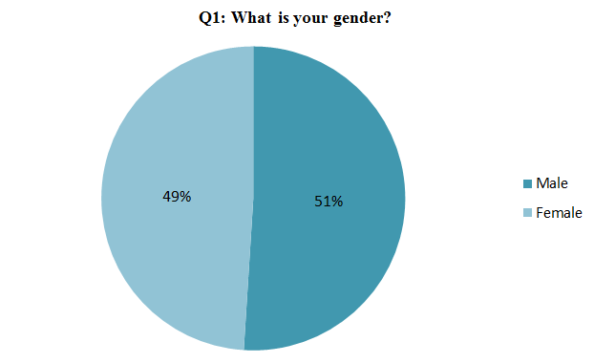
Figure 1: Result for questionnaire Q1- What is your gender?

The result of the second question – “What is your age group?” indicated that the majority of the respondents fall under the age group 25-65 years old. The chart below shows 37% of the respondents were under 25 years old, 55% of the respondents were between 25 and 65 years old and 8% were over 65 years old. The spread of age group of the respondent is considered uneven where predominant of the respondent are between 25 and 65 years old. As a result, the outcome of the survey may not be representative of other age group (i.e. under 25 and over 65).

Figure 2: Result for questionnaire Q2 - What is your age group?
The result of the third question – “Where do you normally go for your food shop?” indicated that the majority of the respondents have selected Tesco. 46% of the respondents selected Tesco, 12% selected Lidl, 11% selected Morrisons, 6% selected Aldi, 6% Waitrose, 6% Marks & Spencer, 4% Sainsbury’s, 3% others, 3% ASDA, 2% Ocado and 1% Iceland. The outcome of this question may be affected by the location of the respondents as majority of the respondents reside in Swansea. Tesco superstore in Swansea is strategically located in the town centre which may have a significant influence on the result.
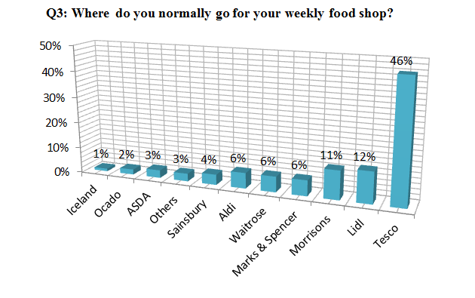
Figure 3: Result for questionnaire Q3 – Where do you normally go for your weekly food shop?
The result of the fourth question – “What is your first consideration when going to a food store to buy food for weekly shopping?” shows 33% of respondents selected store location, 28% selected food price, 22% selected quality of food, 11% selected variety of food, 3% selected others, 2% selected promotions and 1% selected services. Based on the result, the location of store, price, quality and variety of food are the primary considerations of consumer when carrying out weekly food shopping.

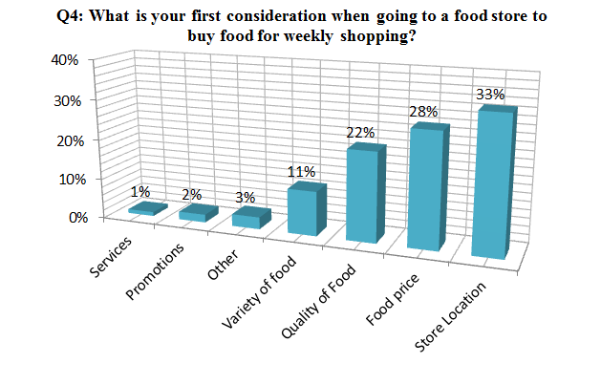
Figure 4: Result for questionnaire Q4 – What is your first consideration when going to a food store to buy food for weekly shopping?
The result of the fifth question – “What do you think of own brand items?” indicated the majority of respondents have no preference between brand items and own brand items. 39% of respondents selected no preference, 32% of respondents selected own brand items and 29 % selected brand items. The result shows no conclusive and clear indication of the predominant consumer’s behaviour in regards to brand items.
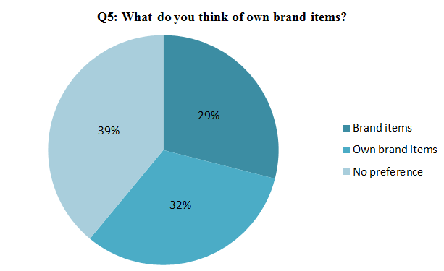
Figure 5: Result for questionnaire Q5 – What do you think of own brand items?
The result of the sixth question – “Do you like to purchase food online?” indicated that the majority of respondents prefer to shop in store. 63% of the respondents indicated prefer shopping in store and 37% of the respondents prefer online shopping. The result indicated that online food shopping is a popular method of the shipping among the respondents.
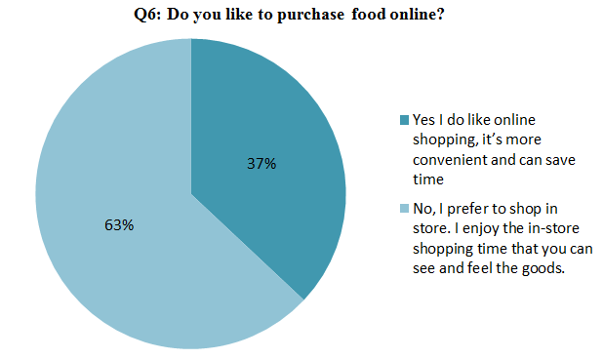
Figure 6: Result for questionnaire Q6 – Do you like to purchase food online?

Question 6a is follow-on question from Question 6 - “What type of shop do you complete when shopping online?” The result indicated 42% of respondent carry out online shopping for weekly shopping, 21% for top-up shopping and 7% for weekly and top shopping.
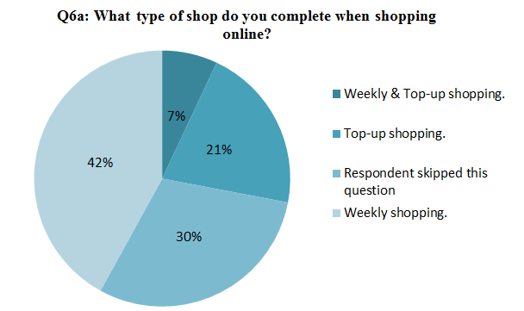
Figure 7: Result for questionnaire Q6a – What type of shop do you complete when shopping online?

Question 6b is follow-on question from Question 6a - “Talking about online shopping delivery fee, which one you would prefer?” The result indicated 80% of respondent prefer free delivery with minimum spending and 10 % prefer a small delivery fees regardless of spending. Free delivery with minimum spending appears to be the predominant consideration of online food shopper.
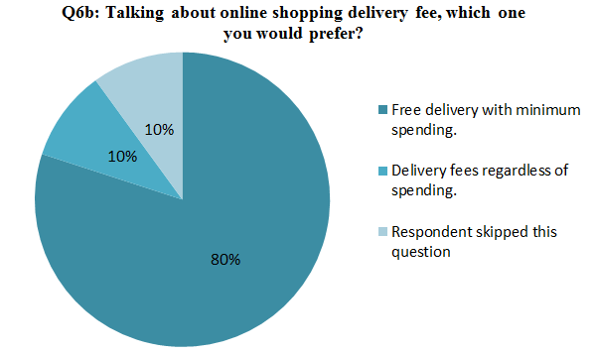
Figure 8: Result for questionnaire Q6b – Talking about online shopping delivery fee, which one you would prefer?

The result of the seventh question – “Do you prefer to go to the food retailer which you have a loyalty card with?” indicated that the majority of respondents have no preference and 45% of respondents would always go to food retailer where they have a loyalty card with. The analysis show relatively small difference between the answers (i.e. 55% and 45%) and the unable draw a robust conclusion from the result.
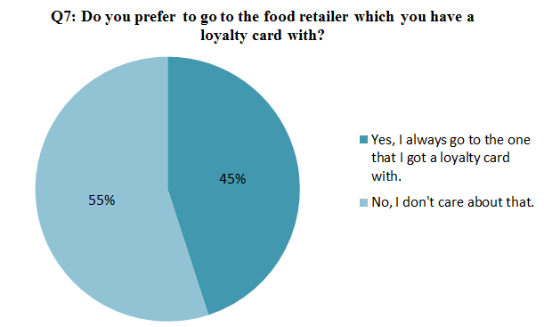
Figure 9: Result for questionnaire Q7 – Do you prefer to go to the food retailer which you have a loyalty card with?

The result of the final question – “What sort of benefit would you like to see from loyalty card?” revealed that the majority of respondents (55%) prefer to collect points and use the points to pay for shopping next time, 31% of the respondents prefer to collect points and exchange the points for discount coupons and 7% of the respondents prefer to utilise the points to win appointed items.
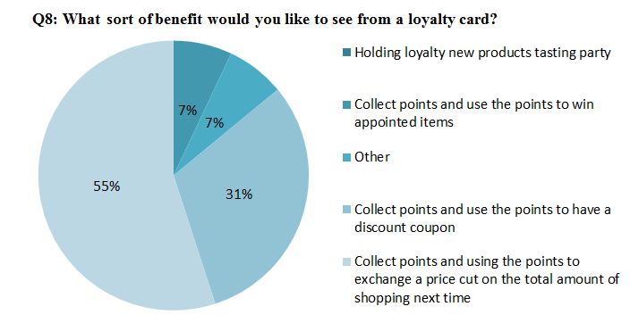
Figure 10: Result for questionnaire Q8 – What sort of benefit would you like to see from a loyalty card?

4.3 Qualitative analysis – an interview with Aldi’s manager
The researcher paid a visit to Aldi(on Carmarthen Rd, Gendros, Swansea, SA5 8LL) to do an interview with the in-store manager to discuss Aldi’s current human resource management and the development under the approaching of Brexit. During the interviewing time, the researcher has transcripted all the answers while raising the questions. Five questions are included within the interview and the respondent’s response is as follow:
The first two questions are relate to Aldi’s status quo under the imminent of Brexit situation and an outlook under this context. The first question the researcher have asked is “What challenges do you think the approaching of Brexit has for Aldi in the UK food retail market?”, while the respondent said,”I think it will bring Aldi some opportunities.” The second question posed by the researcher is “Under the context of the approaching of Brexit, do you think Aldi will import food or use the UK based fresh food?”, while the respondent answered “I think we will still use UK produced food.”
The next two questions are about Aldi’s human resource management. The third question posed by the researcher is “What do you think of Aldi’s recruitment policy? Are there any differences to other food retailers?”, while the respondent said “It is good. I think there are no big differences. One notable difference is we hire less employees than other food retailers, which means every employee has more priorities. We hire less people so we can save on cost. This enables us to provide competitive prices to our customers.” The fourth question asked by the researcher is “Do you have an employee training program? What do you feel about the position of HR in your company?” The respondent answered ”Yes we have an employee training program. The deputy manager will train the employees in store.”
The last question is about the outlook of Aldi’s future and services. The researcher asked “What is the reason that Aldi does not have the option to purchase food online? Do you think Aldi would consider providing online food services like the already existing ones like Wines, Specialbuys, Garden shop and Everyday Collections?” while the respondent answered, “I am unsure why we do not have an online option. We only started the online option for Wine in 2016 and more recently specialbuys, garden shop and everyday collections. So I think we will have the online food service in the near future.”

4.4 Qualitative analysis – Aldi’s supply chain case study

4.4.1 Introduction
The “No deal” Brexit agreement will put UK food supply chains at risk. Current convenient free flow of food products between European and the UK will vanish(Kapadia,2018). Suppliers and food retailers in UK are planning to do a further negotiation towards the Brexit, however it seems the initiative is in supplier’s hand(Doherty, 2018). As the “big four” was affected by the deal, Aldi and Lidl benefit from the Brexit approaches(Allen, 2016). By providing competitive prices, Aldi wins its market share. As the approaching of Brexit, Aldi’s manager Barnes(2017) claims that Aldi will continue to utilize the UK produced products and remain the price gap to other food retailers(Craven, 2017). Applying UK based food products contribute Aldi to maintain the competitive advantage under the context of the approaching of Brexit.

4.4.2 Challenges
According to Quinn(2018), as the imminent Brexit situation, food suppliers started to stockpiling food and plan to change previous manufacturing relations. The “big four” are already step to stock for the products having over ten days’ stock for fear of the increase of price in food and the limited amount (Quinn, 2018). The ‘No Deal’ Brexit has put most food retailers in the blur.

4.4.3 Proposed solution
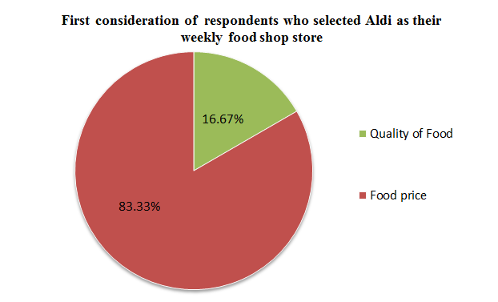
Figure 11: First consideration of respondents who selected Aldi as their weekly food shop store.
This pie chart is one of the analysis of the questionnaire, which shows that the respondents who favour Aldi is because they are more interested in the food price(83.33%) and the quality of food(16.67%). We can draw the conclusion from this pie chart that people are attracted by Aldi majorly due to the reason that Aldi provide competitive price. Hence for Aldi, it is pivot to keep offering lower prices to other competitors. Currently, under the context of the approaching of Brexit, Aldi keep applying the UK based food is the ideal solution for Aldi. The end-to-end supply chain save cost for each product, which is also beneficial for Aldi to offer good value of money products.

4.4.4 Results
As the ‘No deal’ Brexit threatened food retailers in UK, food prices have the potential to rise which put food retailers in dilemma to negotiate with their suppliers and figuring out the possibility of changing new suppliers. However, Aldi has benefit from this trend and remain its price advantages. Aldi’s competitive position in UK food retailer market can not be detached by the relationship between UK based suppliers and keep delivering UK based fresh, which enable Aldi to attract customers by their competitive price.

4.5 Discussion
In this part, the results of the above three outcomes were mixed to better fulfil the tasks set in the beginning of this chapter.

4.5.1 Question 1 The UK customers’ food purchasing preferences and Aldi’s advantages and disadvantages in the UK’s food retailers market as Brexit approaches.
The survey results presented in Chapter 4.1 show the analysis undertaken on each individual question in isolation. An Excel spreadsheet was created to analyse two questions or three questions concurrently. This will allow further analysis undertaken on specific group and establish consumer’s behaviour for that group. For example, question Q3 and question Q4 can be analysed concurrently to determine primary consideration of customer who carry out their weekly shopping at Aldi or any other retailer listed in the answer choices.
The following three histograms show respondents’ food retailer preference for the 3 different age group, namely under 25, 25 to 65 and over 65. The first histogram indicates that the majority of respondents fall within the under-25 age group prefer Tesco followed by Lidl as their weekly food shopping destination.
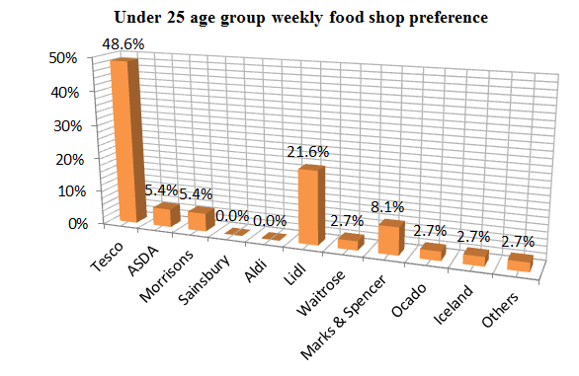
Figure 12: Under 25 age group, weekly food shop preference.
The results from question Q2 revealed that 55 respondents are between 25 and 65. Based on the histogram below, a large majority (49.1%) of the 55 respondents from this age group selected Tesco as their preferred food retailer and 10.9% of the respondents from this age group selected Aldi.
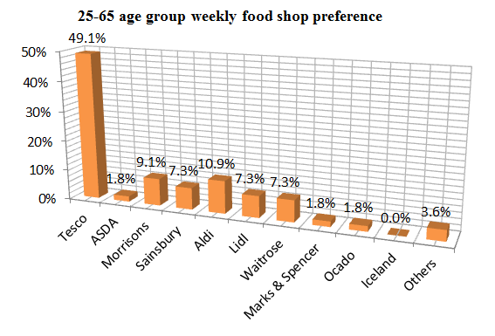
Figure 13: 25-65 age group weekly food shop preference.
Interestingly, the result depicted in the histogram below shows the majority of the respondent in the over-65 age group selected Morisons as their weekly food shopping destination. There were 8 respondents who are in this age group. In comparison to other age group, the histogram below revealed a significant increase in preference of Waitrose and Marks and Spencer as weekly food shop destination. It is understood from the literature review that both Marks and Spencer and Waitrose are not discount stores and both stores appears to appeal to consumer over 65 years old.
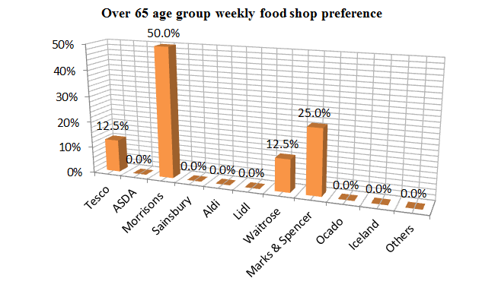
Figure 14: Over 65 age grop weekly food preference.
Based on the analysis of question Q3, there were 6 respondents who selected Aldi as their preferred supermarket for weekly food shopping. Given that this research focused on Aldi as a food retailer, further analysis was undertaken to establish the behavior of this particular group of consumer. Based on the analysis, the respondents who selected Aldi as their preferred food retailer for their weekly food shopping, 83.3% selected food price and 16.7% selected food price. According to the result, the respondents who selected Aldi as weekly food shopping destination are more interested in food price and quality food instead of other consideration such as store location or promotions.
Figure 15: First consideration of respondent who selected Aldi as their weekly food shop store.
The following chart shows the result of further analysis of the respondents who selected Aldi to understand preference of shopping method (i.e. online shopping or in store shopping). The chart indicated that 83.3% of Aldi’s customers prefer in store shopping and 16.7% prefer online shopping. The finding correlates with the fact that Aldi does not provide online food shopping, hence the majority Aldi’s customer prefers in store shopping.
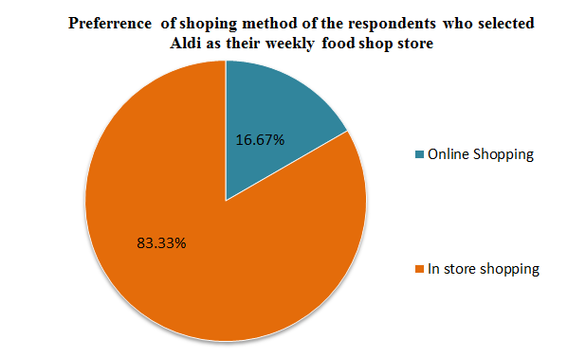
Figure 16: Preference of shopping method of the respondents who selected Aldi as their weekly food shop store.
The information depicted in the chart below shows the view of the respondents who selected Aldi as their weekly food shopping store towards own brand items. It is understood from the literature review that the items retailed in Aldi’s store are predominantly products manufactured for Aldi (i.e. own brand items). According to the result below, a large majority of the respondents who selected Aldi (i.e. 66.7%) prefer own brand items, 25% have no preference and 8.3% prefer brand items.
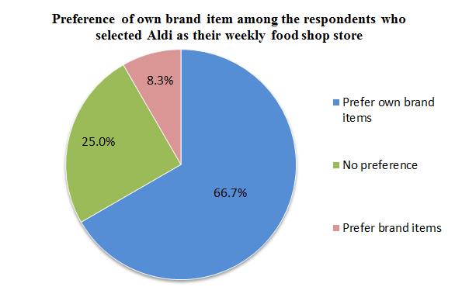
Figure 17: Preference of own brand item among the respondents who selected Aldi as their weekly food shop store.
From the above analysis, it is understood that food price and food quality are the main consideration of respondents who selected Aldi as their preferred weekly shopping supermarket. Further analysis was undertaken to determine Aldi’s key competitors who also provide desirable food price and food quality to the consumers. This was done by identify the preferred food retailers of the respondents who selected food price and food quality using the aforementioned spreadsheet. According to the analysis, there were 22 respondents selected food quality as their main consideration when choosing food retailer for weekly food shop. Out the 22 respondents, 27.3% selected Tesco, 18.2% selected Waitrose, 18.2% selected Marks and Spencer and only 4.5% selected Aldi, to name a few. Based on the result, it is understood in terms of food quality, Aldi’s main competitors are Tesco, Waitrose and Marks & Spencer. Waitrose and Marks and Spencer are not discounted stores and therefore may be unable compete in providing better value for money product in comparison to discount stores.
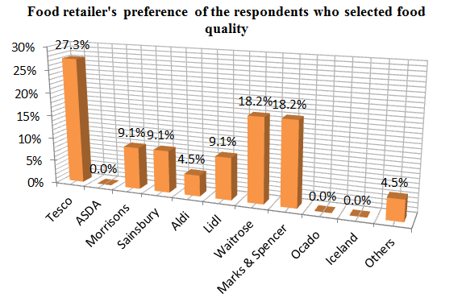
Figure 18: Food retailer’s preference of the respondents who selected food quality.
There were 22 respondents selected food price as their main consideration when undertaking weekly food shopping. The histogram below shows analysis undertaken on the 22 respondents and confirms that their preferred weekly shopping stores are Tesco (32.1%), Lidl (28.6%) and Aldi (17.9%) (top three). Based on the survey, Tesco and Lidl are considered the top competitors to Aldi in terms of food price.
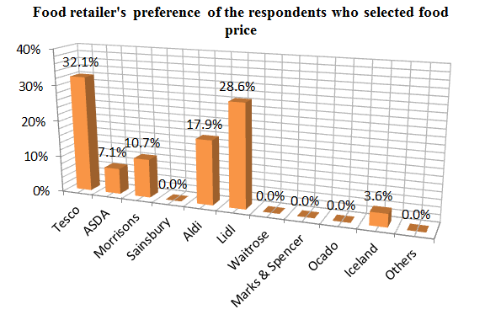
Figure 19: Food retailer’s preference of the respondents who selected food price.
From the above analysis, it is understood that Tesco is one of Aldi’s main competitors. Besides, the majority of the respondents selected Tesco as their weekly food shopping supermarket. Further analysis was undertaken to understand their consideration of selecting Tesco for their weekly shopping. The following chart depicted that out of the 46 respondents who selected Tesco, 43.5% selected store location as their first consideration when going to a food store to buy food for weekly shopping, 19.6% selected food price, 17.4% selected variety of food and 13% selected quality of food.
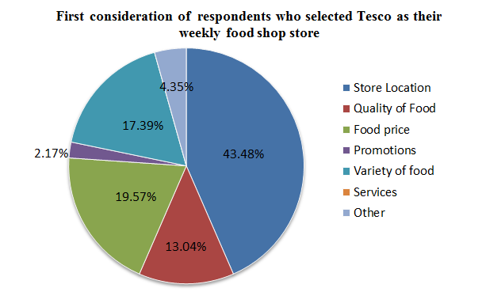
Figure 20: First consideration of respondents who selected Tesco as their weekly food shop store.
From the analysis above, it can be concluded that Aldi’s customers are attracted by the price of food and the quality of food offered by Aldi as a food retailer. The majority of Aldi’s customers prefer to shop in store instead of online shopping for their weekly food shopping. In order to retain existing customer, Aldi as a discount food retailer could maintain and improve existing pricing strategy and provide quality products that are value for money. The analysis indicates that Waitrose and Marks and Spencer are Aldi main competitors when it comes to providing quality food product. However, both Waitrose and Marks and Spencer are not discounted stores and consumers may find their price tag attractive. The analysis reveals that Tesco and Lidl are Aldi’s competitors when it comes to food pricing. The analysis indicates that over 91% of the respondents who selected Aldi as their weekly shop destination have no preference or prefer own brand items. It can be concluded that good quality and good value for money own brand products are the main factor of consumer selecting Aldi as their weekly shop destination.
Based on the analysis, Tesco appears to be the main competitor of Aldi on food pricing and food quality. The analysis indicates store location is the first consideration of the majority of the respondents who selected Tesco as their weekly food shop destination. To attract new customer, Aldi could also pick a more strategic location for their new stores in order to be more competitive. 17.39% of respondents who selected Tesco as their weekly food shop store also selected variety of food as their main consideration when choosing food retailer for weekly food shopping. Aldi could also expand in the variety of food in order to attract more customers.

4.5.2 Question 2: Aldi’s human resource management, especially in relation to their vocational training
In the response of the store manager, he replies that compared to other food retailers, the most distinguishable feature of Aldi is that Aldi’s employee shoulders more tasks than the employees in the same position of other food retailers. Aldi hire less employee but training them to handle multiple tasks. The deputy manager organizes employee training activities to strengthen employee’s vocational skills and impart new skills, which provide employees an opportunity to improve themselves and become more competitive at the same position in food retailer industry. To Aldi, strengthen employees’ ability contribute to the accomplishment for the company’s current mission and future plans. Aldi’s official website has the brochure about their requirement and training program for the new ones to Aldi. In this brochure, a specific whole year training context has been shown to all candidates. After the one year’s job skill training, the following year is for company culture grasp and finding the employee’s own working pace. Moreover, Aldi also providing international career expanding. The meticulous and comprehensive employee training program made employee self improvement possible and in turn push forward the develop pace of Aldi, that enable to figure out effective strategies coping with changes and stay the competitive state in the food retailer industry.

4.5.3 Question 3: As the imminent of Brexit started casting negative influences on retailer industry, Aldi’s supply chain will be affected or not?
According to the case study that as the Brexit approaches, Aldi signed additional new contract with a UK based meat supplier. As a result, Aldi has successfully secured UK based food supplier for 77% of its products including fruits, vegetables, milk and meat. Therefore, in general, it is unlikely that Aldi will be affected significantly should there is a ‘No Deal’ Brexit situation. However, products such as condiments, fizzy drinks, candies, household products, etc will require raw materials to manufacture and some of these raw materials may not be readily available in the UK. Aldi may be affected by a “No Deal’ situation indirectly, where its suppliers are requiring to import raw materials from the European Union and those raw materials will incur custom duties when transported across international borders. As a result, the “No deal” Brexit situation may increase the price of manufactured products and subsequently increase the retail price in Aldi. Based on the analysis, food price is one the main reason for consumer to shop at Aldi and the increase in food price may have a negative impact to Aldi’s revenue. In general, for other food retailers who are relying on suppliers based in the EU not only would face potential risk of food price increase but also delay in food transportation. A “No Deal” Brexit situation will manifest hard border situation where all goods in transit crossing international border control will require strict regulatory checks. A poor implementation of border control and regulatory checks could result in significant delay and fresh food will be damaged (rotten) if not stored appropriately. The haulage companies may charge a higher rate of transportation for their investment in a better transportation storage facilities and the additional border control administration (not including custom duties). The current potential “No deal” Brexit situation has created various uncertainties in the food supply chain as mentioned above

Chapter 5 Discussion, Conclusion and Recommendation

5.1 Introduction
In this chapter, the analysis of the research findings and outcomes in response to the aim and objectives set in the beginning of this research will be displayed. Further suggestions and recommendations of this research will be provided. The primary goal for this dissertation is to investigate UK food retailers’ current state under the impending Brexit situation, which take Aldi as the research object and providing valid recommendations to Aldi’s further development in the future. Through the previous researches, implementing effective human resource management, building a strong connection to customers and transforming supply chain agilely will be propitious to the risks brought by the changing situations for a company. The answers to each objective are listed in the following chapter.

5.2 Conclusions

5.2.1 Objective 1: The influences brought by the approaching of Brexit to the UK food retailers and the three ways to augment food retailers to resist the crisis the imminent Brexit situation casted on.
As the approaching of Brexit, the grocery prices is keep soaring which has been influenced sterling depreciation, the possibility of the previous contracts with the EU. Among all the industry, food retailer has been affected the most serious (Musaddique, 2018). There is a tendency for customer to choose cheaper products along with the reason of recession and uprising unemployment (Tsang, 2017). Under this circumstance, food retailers can enhance their human resource management to hire the most proper employee to put on the suitable position and organizing effective and interactive training to improve the talents which in turn will contribute to the company’s competitiveness. The understanding of customer can help food retailers to adjust strategy to acquire new customers, retain old customers and develop potential customers. Strengthen the supply chain is also of vital importance under the approaching of Brexit, since keep the old contracts with suppliers from the EU or using the UK produced products has made a difference on price. These three ways help food retailers to resist the risk brought by the imminent of Brexit condition.

5.2.2 Objective 2: Strengthen the human resource management especially talent planning (take Aldi as an example).
Storey (1995) believes that HRM can stimulate employees’ commitment to work via the refined structure of the colourful organization culture, structure and personnel strategy. Within all the tasks of human resource management, talent planning is of significant under the changing pace of economic market. Kew and Stredwick (2013) pointed out that among all the task of operating the company, it is the people that make a difference. Ramsey et al (2000) even give a name to the HR’s obligation- ‘the high road’ that a company relies its success on. From the outcome of the interview to Aldi’s manager and files on Aldi’s employment files, Aldi put high attention on employment training, that Aldi have a clear and specific career training plan and employment training activities were undergoing every week, which made Aldi have a strong employment commitment to this company and the company keep it’s characteristics and advantage among all the food retailers in UK food retailer market. In addition Aldi gained market share in the approaching of Brexit among other food retailers can not detached from their strong human resource management.

5.2.3 Objective 3: Understanding customer’s food purchasing preferences (take Aldi as an example).
The analysis investigates customer’s behaviour and food purchasing preferences and concluded that the majority of the respondents would consider store location as priority when deciding where to carry out their weekly food shopping. Store location appears to be the first consideration by most respondents, followed by food price, food quality and variety of food. The analysis shows the majority of the respondent selected Tesco as the weekly food shopping destination and their first consideration when choosing a food retailer is store location. Further investigation has been carried out on the respondents who selected Aldi as their weekly food shopping destination, to understand their reason as to why they selected Aldi. The result indicates food price and food quality are the first consideration of all respondents who selected Aldi. It appears that Aldi customers are satisfy with the quality and value for money product offered by Aldi despite the majority of its product are own brand items. The respondents who selected Aldi find brand items are not their priority consideration and the majority have no preference or in favour of own brand products.

5.2.4 Objective 4: Adjusting supply chain to adapt the existing circumstance (take Aldi as an example).
In consideration of the imminent Brexit situation, there are various uncertainties especially the potential “No Deal” Brexit situation on the food supply chain prospect in the UK. The food retailers who heavily rely on suppliers based in the European Union may experience severe negative impact as a result of a “No Deal” Brexit situation. The “No Deal” Brexit situation is likely to manifest increase in food cost due to implementation of custom duties and delay in food transportation due to the introduction of a hard border with custom border control and regulatory checks. Based on the research, Aldi as one of the major discount chain is expected to have minimal direct negative impact from the potential “No deal” Brexit situation. This is due to the fact that Aldi has successfully secured suppliers based in the UK for approximately 77% of its product. However, products such as condiments, candies and fizzy drinks to name a few require raw materials to manufacture. The raw materials may not be readily available in the UK and require to be sourced in the EU region, consequently increased the cost of the certain food product. Aldi is likely to be affected indirectly by the “No Deal” Brexit situation due to the increase cost of manufactured products.

5.2 Recommendation for Aldi under the context of the approaching of Brexit
- Aldi should remain and strengthen its price advantage in the future development. According to the histogram chart (Figure 15), the respondents who prefer Aldi as their weekly food shopping food retailer is mainly been appeal by Aldi’s food price. Also 16.67% choose Aldi because they trust Aldi’s quality, in this point, Aldi should holding these two favourable advantages and at the same time improve these to cater for customer’s preference. 83.33% of the Aldi shopper prefer to do the in-store food shopping rather than online shopping. Better organizing of the layout of commodities in store may contribute to Aldi’s attractiveness to loyalty customers as well as new customers. However, Tesco’s discount chain Jack’s opened recently, its will be a huge threat to Aldi as they are aiming at providing lower price but more variety of food than Aldi. This new discount store is based on UK’s biggest food retailer.
- If Aldi consider a strategic store location, larger amount of customers will be reachable. In addition, implementing express stores (similar to Tesco Express) may increase the total market share. As from the figure 15, customer chooses Aldi as their weekly shopping store due to their food price and quality. However from the perspective of food price (Figure 19) and food quality (Figure 18), Tesco ranked top among all the provided food retailer provided in the questionnaire. In addition to people’s preference of food retailer, Tesco is most favoured as the results of this questionnaire shows. And from the 46 respondents who choose Tesco as their weekly shopping store, of which 43.5% selected store location as their major consideration, followed by food price(19.6%), the variety of food (17.4%) and quality (13%). For Aldi, Tesco seems to be a very strong competitor. Tesco got a smart consideration of store location, usually Tesco super store located off-city within urban area and Tesco express distributed in residential area. This provides customers more approaches to shopping in Tesco. It is understood that Aldi’s store are mainly located off-city (i.e. not located in town centre). For the purpose of weekly shopping, if Aldi provides better price and quality, customer may drive far to do the weekly shopping there. However, for top-up shopping, customer may rather choose the better location store for them. As the new discount store Jack’s of Tesco, Aldi should strengthen its price advantage to stay competitive in market.
- Aldi should provide various variety of food in the future. From the result of the questionnaire that Tesco is most favoured by the respondents in this research, so the advantages of Tesco is worth for Aldi to learn from. As Figure 20 shows the first consideration for customers who have choose Tesco is the store location (43.48%), followed by food price (19.57%) and the variety of food (17.39%). Since the location factor and food price factor have been analysed above, the variety of food should also been emphasized. In Aldi, the products is mainly its own brand products and merely see branded items. The loyalty customers who shop in Aldi may favour their own brand food but when they need other brand items, they need to switch to other food retailers. Also since the existence of Jack’s, who provided not only own brand food but also branded food and Tesco exclusives, which is more competitive than Aldi. Aldi need to take the variety of food in store into consideration in the future.
- Aldi need to enhance the relationship to UK fresh suppliers. As in the previous analysis of Aldi’s supply chain, Aldi can survive from the imminent of Brexit situation and won bigger market share is due to the reason that Aldi use the UK produced food and have signed contracts with a lot of UK suppliers other than other food retailers signing contracts with the EU suppliers. However, the newly established food retail Jack’s is also using UK produced fresh and also provide good value of money products. Aldi need to strengthen their relationship with their food suppliers to keep the price advantage.

