

LOCATION: Swansea | LLEOLIAD: abertawe
LEVEL 6 | LEFEL 6
EXAMINATION PERIOD | CYFNOD ARHOLIADAU
may 2020 | mai 2020

MODULE CODE: ACDA6004
Power Electronics and Drives
TIME: 2 HOURS
answer all questions

Equipment or materials required – Calculator
Adnoddau neu ddefnyddiau sydd eu hangen - cyfrifiannell

This is an online open book exam

Instructions to students:

Answer all questions.

Answer your questions in a word document and upload it to TurnItIn at the end of the examination – this will act as a delivery mechanism and also a plagiarism check. An upload link will be provided next to the one for this file.

If a question requires a drawn diagram, either use a sketching/drawing program (don’t worry if you have to draw with a mouse and it’s a bit rough – you aren’t marked on your graphic ability!), or draw the diagram freehand on a piece of paper, then scan it, or take a photo of it using your phone etc. and insert it into your word document.

If you run into problems doing the transfer, email the photos to your lecturer as soon as you can at the end of the exam.

Note that the upload link will have a cut-off time, so ensure you don’t miss the deadline.

ANSWER ALL QUESTIONS

- In the context of variable frequency drives, compare and contrast the use of Diodes, thyristors (SCRs) and IGBTs for rectification of the incoming mains.
[20 Marks]

Any persuasive argument accepted, although answer must include a discussion on the following points: complexity of circuit required, use of variable angle timing to change average voltage for SCR, use of IGBT for feeding back recovered energy from regenerative breaking back onto grid. Must also consider electrical noise and harmonics produced by each of the different methods.

- Compare and contrast the operation of unipolar and bipolar stepper motors.
[20 Marks]
Bipolar configuration is the simplest. Four wires are used to connect the motor to the controller. The coils are internally connected inside the motor either in series or parallel.
The motor has 4 terminals. Two terminals are for powering the one set of coils, while the other two terminals are for powering the other set of coils. The problem with this configuration is that, if someone wants to change the magnetic polarity, the only way to do this is by changing the current direction. This means that the driver circuit will have to be complicated, for example with a H-bridge.

In a unipolar motor, a common wire is connected to the center point of the two coils.
Using this common wire, the magnetic poles can now easily be changed. Suppose for example that we connect the common wire to the ground. By powering the first end of the coil and the other end, the magnetic poles are changed. This makes the circuit for a bi-directional motor application very simple, usually with only two transistors per phase. A major drawback is that, on each occasion, only half of the available coil windings are used. This is similar to the motor only being driven with single-coil excitation. Therefore, the torque generated is always about half the torque that would have be generated if both coils were powered. In other words, uni-polar motors needs to be double the size of a bipolar motor, to provide the same torque. The uni-polar motor can be used as a bipolar motor, simply by leaving the common wire unconnected.

- Explain the benefits of using a micro-stepping drive for positioning a robot arm using a stepper motor. You may want to use a coil switching timing diagram of the phases to aid your answer.
[20 Marks]

Micro-stepping is the most common method to control stepper motors. The operation of micro-stepping, is achieved by powering the coils of the motor NOT with pulses, but with a waveform similar to a sine waveform. This way, the transition from one step to the next is smoother, making the stepper motor suitable to be used for high accuracy applications such as CNC positioning systems. Also, the stress of the parts connected on the motor, as well as the stress on the motor itself is significantly decreased. With micro-stepping, a stepper motor can rotate almost continuous, like simple DC motors.

The waveform that the coils are powered with, is similar to an AC waveform. Digital waveforms can also be used.

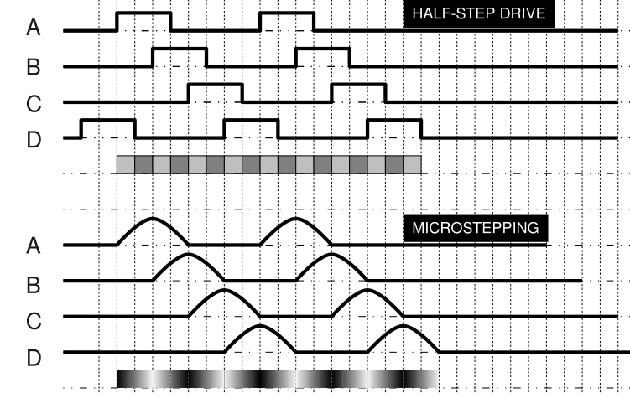

- A six-pole alternator is required to operate at 50Hz. What is the required rotation speed in r.p.m?
[2 marks]
6 poles = 3 pole pairs
$$\frac{50}{3}=16.66667 Hz$$
$$16.66667×60=1000 rpm$$

- A coil of 1600 turns with a coil of width 150mm and active depth of 250mm rotates in a uniform magnetic field between the poles of a magnet with an air gap flux density of 0.75T. If the coil rotates at a speed of 3000rpm calculate:

- The maximum e.m.f. induced in the coil.
[4 Marks]
$$A=150×{10}^{-3}×250×{10}^{-3}=0.0375 m^{2}$$
$$f=\frac{rpm}{60}=\frac{3000}{60}=50 Hz$$
$$E_{Max}=1600×0.75×0.0375×2×π×50=14137.16694 V$$

- The maximum amount of flux cutting the coil.
[4 Marks]
Maximum flux cuts coil when coil is at 90°
$$Φ_{Max}=BA=0.75×0.0375=0.028125 Wb$$
$$=28.125 mWb$$

- Describe the working principles of a dynamo
[15 Marks]
Description of a dynamo to include:
- Stator field produced by usually permanent magnets
- Rotor coil rotated inside stator by prime mover
- Rotor coil cuts magnetic field produced in stator inducing voltage in rotor coils
- Current in rotor coils transferred from rotor via commutator and brushes
- Current drawn from brushes not true DC – smoothness depends on number of coils in rotor / segments on commutator.

- Describe the working principles of a shell type single phase transformer
[15 Marks]
Description should include:
- Core made from iron or other ferrous material in E & I sections
- Two coils – Pri & Sec wound on top of each other to increase magnetic coupling efficiency
- Current in Pri creates Mag field which is transferred through the core to the Sec.
- Mag field around Sec induces voltage in sec
- Negating all losses, voltage on Sec is controlled by voltage on Pri and turns ration of two coils.
$$V_{Sec}=V_{Pri}×\frac{N_{Sec}}{N_{Pri}}$$

$$I_{Sec}=I_{Pri}×\frac{N_{Pri}}{N_{Sec}}$$

- Electrical power out is (slightly) less than power in – high (but not perfect) efficiency

Diwedd/End

