Fundamentals of Construction Technology
New Build Dwelling: Technical report with drawings
ACBA4001
Keaton Davies
(2320042)

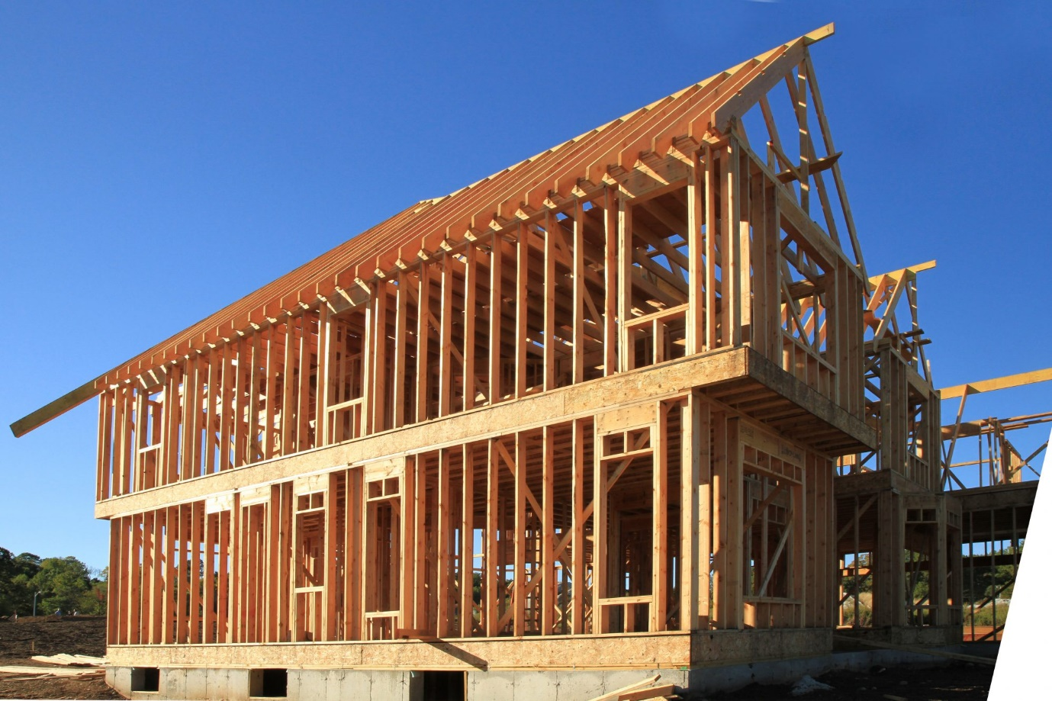

Contents
Clearly define the term Offsite Construction. 3
Describe the four main categories of offsite construction giving an example of how each method could be incorporated into the proposed house. 4
The Ground floor Construction, detailing and junctions with external walls 5
A detailed section and plan detail showing a window opening in the external wall 6
Eaves detailing & main roof structure – indicating appropriate weathering, fixing and laps. 7
The Client wishes to compare the wall construction of brick and block v’s the new proposed construction. Draw a typical wall section for each making comparisons on thickness, thermal performance and structure. 8
The Client wishes to compare the wall construction of brick and block v’s the new proposed construction. 9
References 10

Clearly define the term Offsite Construction.

Offsite construction is a method for creating structures where the majority of the construction work is done in a factory or offsite location rather than on the project site itself. It is sometimes referred to as prefabrication or modular construction. Under this method, building modules or components are produced using cutting-edge technology in controlled conditions before being delivered to the construction site and installed. This method is different from typical onsite construction techniques, in which the majority of the building process takes place on the site where the project is intended to be built.
Offsite construction usually has a number of important phases. To determine the project's requirements and specifications, comprehensive design and planning are first conducted. Following that, off-site fabrication is used to create construction components, frequently employing standardised materials and procedures to guarantee uniformity and quality. Depending on the project's complexity, these parts can be anything from wall panels, floors, and roof trusses to whole room modules.
After manufacturing, the parts are often delivered to the building site by trucks or other means of transportation. As the modules or components arrive, they are put together and built into the building's structure in line with the planned design. Since this assembly approach depends on the precise production of components in a controlled environment, it is frequently quicker and more effective than traditional onsite building methods.
Compared with traditional onsite building techniques, offsite construction has a number of benefits. One of the main advantages is faster construction since more work can be done at once, cutting down on project schedules. Offsite construction can also enhance quality control since it allows for careful monitoring and regulation of production processes, which reduces errors and modification. Since most building operations take place offsite, this strategy also reduces waste and onsite disturbances while also reducing the influence on the surrounding environment, noise, and dust.
Additionally, since many hazardous projects may be completed in a controlled factory setting rather than on a busy construction site, off-site construction can improve worker safety. Offsite construction is also well suitable for a variety of projects, from large-scale commercial structures and infrastructural improvements to residential residences, due to its flexibility and scale. All things considered, offsite construction is a cutting edge method of constructing that has several advantages in terms of effectiveness, durability, and quality.

Describe the four main categories of offsite construction giving an example of how each method could be incorporated into the proposed house.
Offsite construction refers to a variety of techniques that entail assembling building components offsite before transporting and installing them at the construction site. It is sometimes referred to as prefabrication or modular construction. Sub-assemblies, panelised systems, hybrid systems, and volumetric modular construction are the four primary types of offsite buildings.
The process of creating complete rooms or portions of a structure in a factory is known as volumetric modular construction. After that, these modules are sent to the building site where they are put together to create the structure. For instance, volumetric modular construction may be used to create prefabricated bathroom pods in the proposed home. These pods would be ready to be lowered into position within the house's framework, replete with finishing, plumbing, and fixtures.

Prefabricated panels are manufactured offsite and assembled onsite to create the building envelope in panelised systems. Wall, floor, and roof panels are a few examples of these panels. Panelised systems might be used in the construction of the outside walls of the proposed house. To swiftly and effectively enclose the building, prefabricated wall panels with insulation and cladding may be produced offsite and assembled on location.

Panelised and volumetric modular construction components are used in hybrid systems to provide flexibility in both design and construction. In the instance of the proposed house, a hybrid approach could use volumetric modules for some elements of the structure, including the living sections and kitchen, combined with prefabricated floor and roof panels. With this method, customisation is still possible and the advantages of offsite building are retained.

Smaller parts or assemblies that are produced off-site and subsequently included into the building process are referred to as sub-assemblies. These could consist of things like window assemblies, precast concrete steps, or mechanical and electrical systems. Sub-assemblies for the proposed house could potentially be connected through pre-assembled window components or precast concrete foundation parts, which would speed up the onsite building process and require less labour.

With unique benefits to efficiency, quality control, and construction speed offered by each of these categories, offsite building is becoming a more and more appealing choice for UK residential projects.

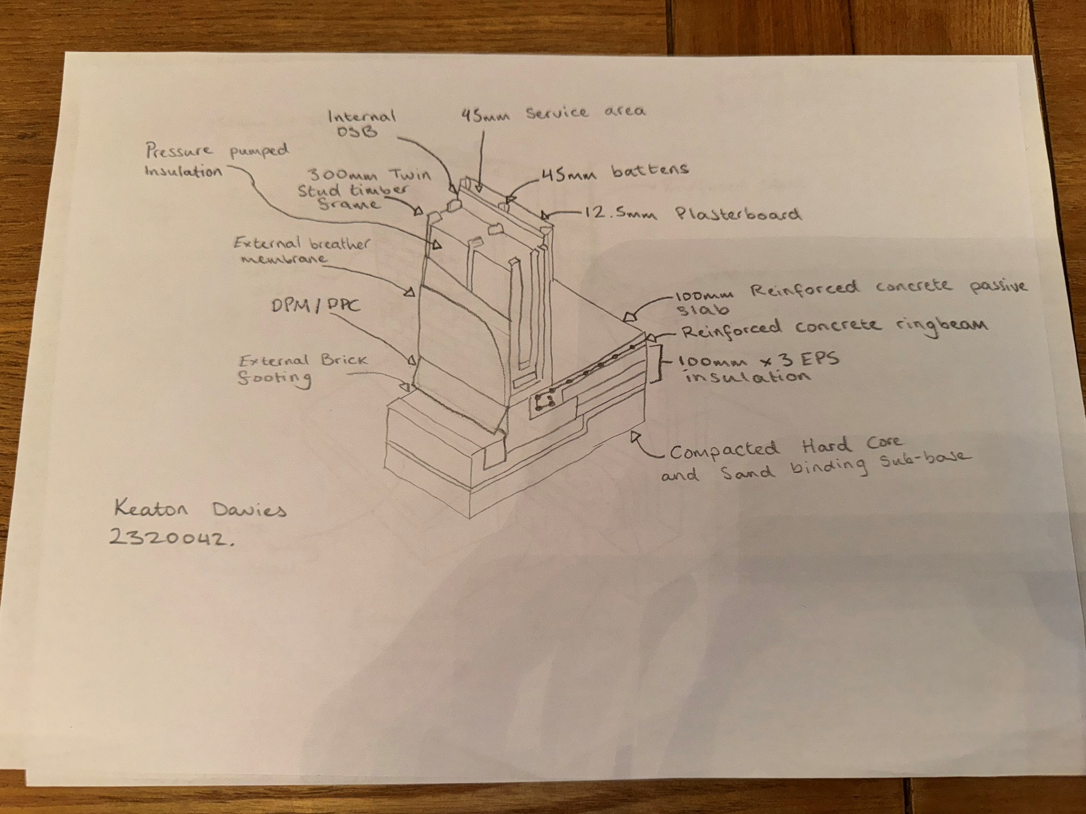
The Ground floor Construction, detailing and junctions with external walls

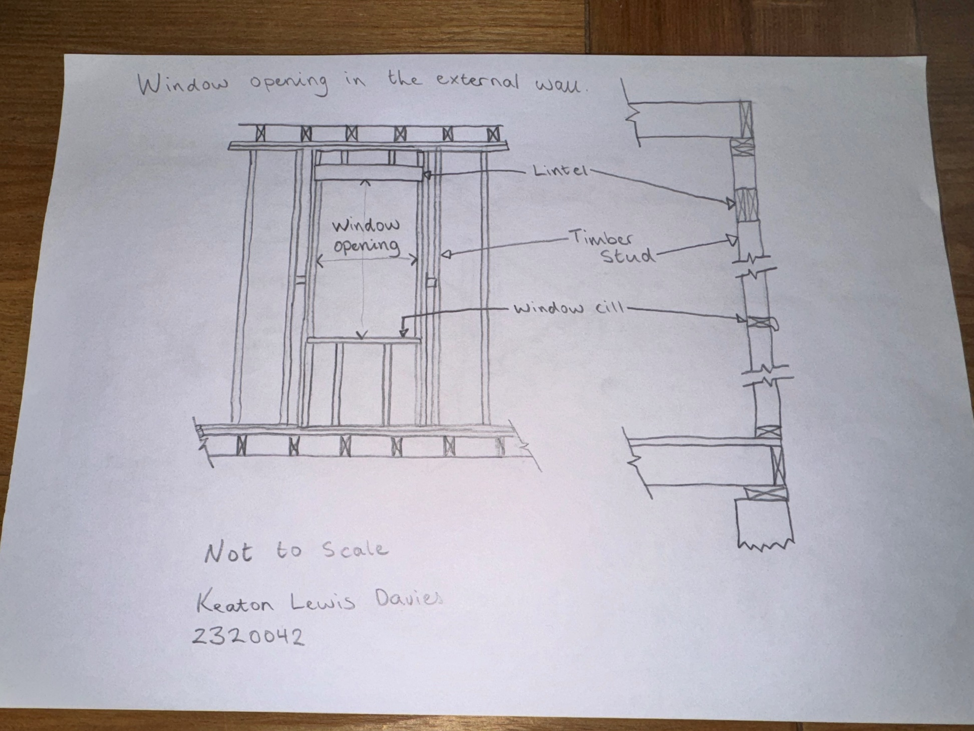
A detailed section and plan detail showing a window opening in the external wall

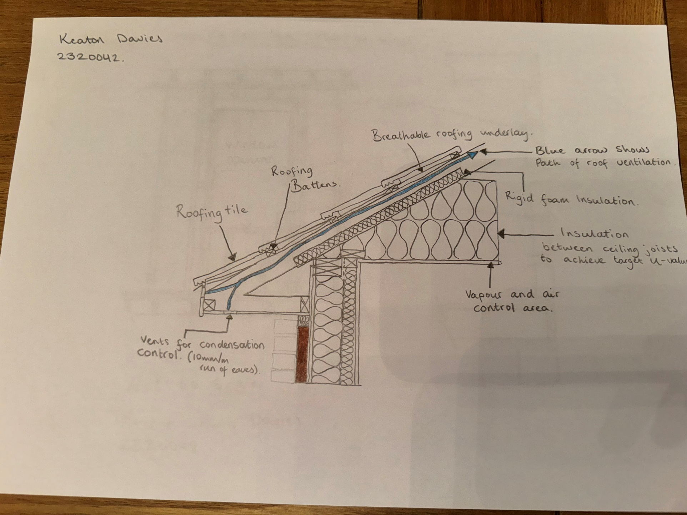
Eaves detailing & main roof structure – indicating appropriate weathering, fixing and laps.

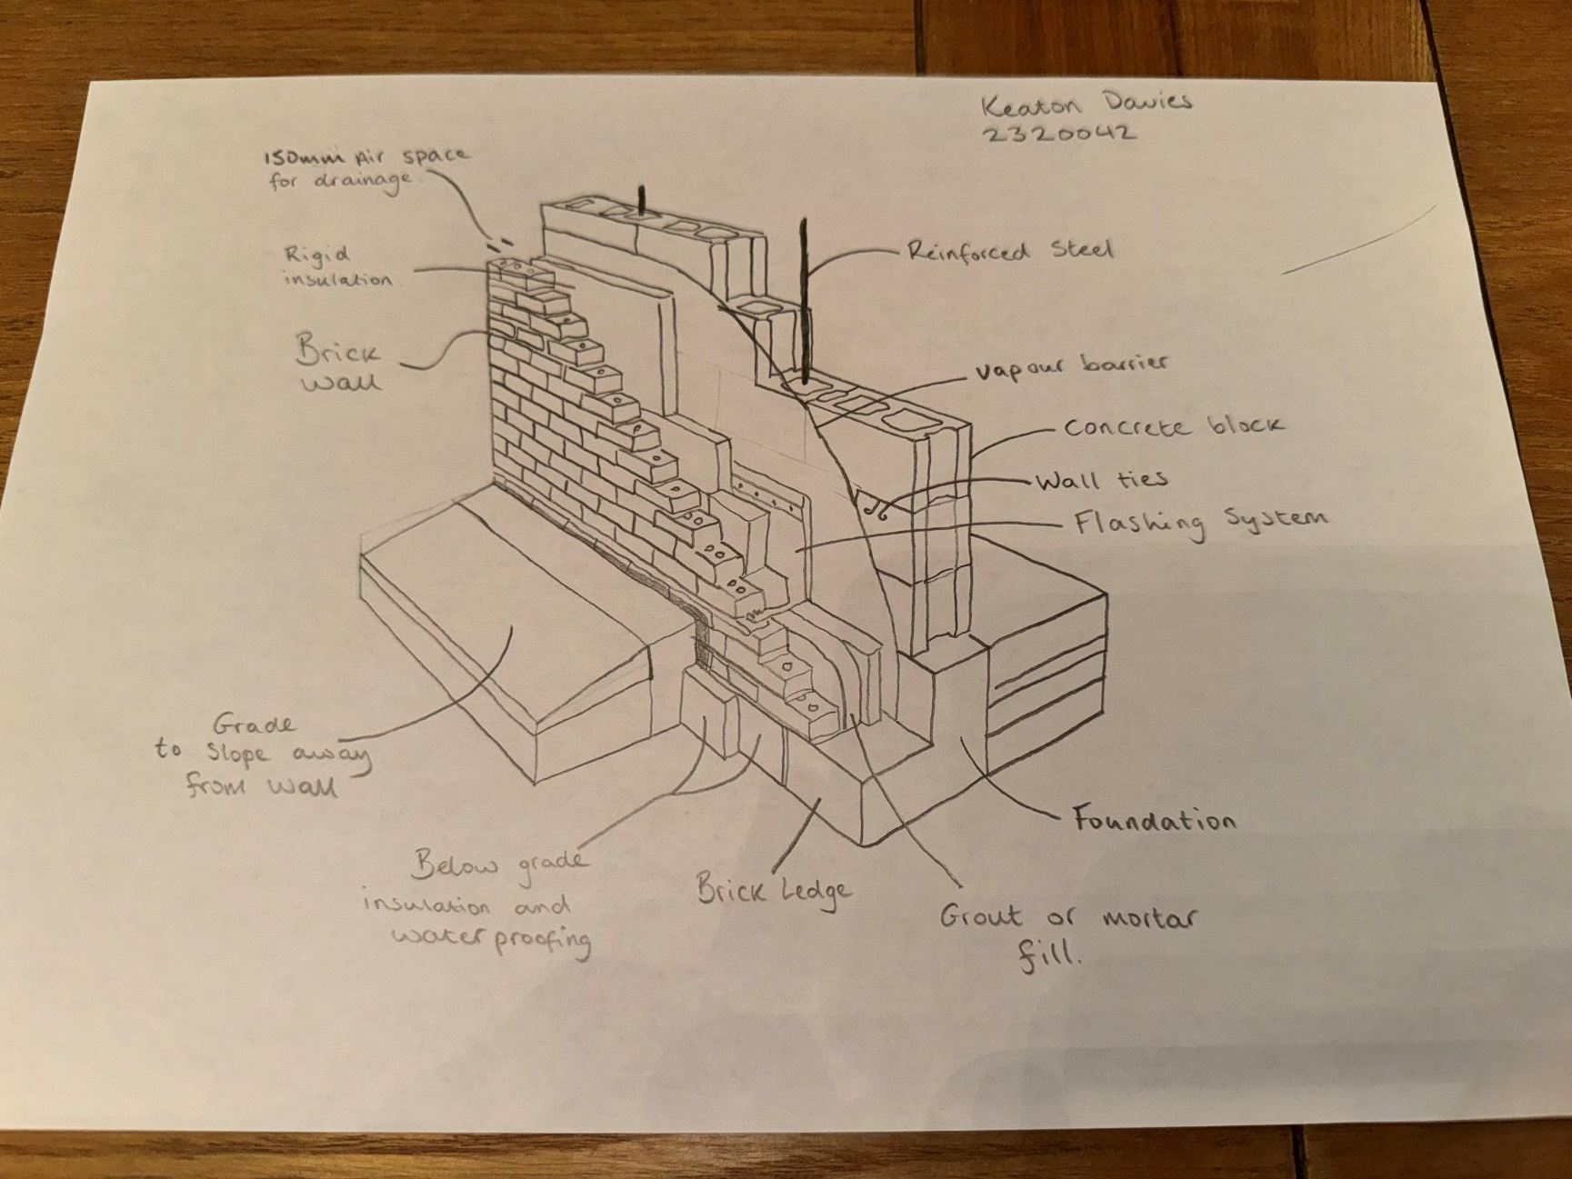
The Client wishes to compare the wall construction of brick and block v’s the new proposed construction. Draw a typical wall section for each making comparisons on thickness, thermal performance and structure.

The Client wishes to compare the wall construction of brick and block v’s the new proposed construction.
It's important to look at each aspect of each layer and how they affect thickness and thermal efficiency when comparing a unique twin frame timber off-site construction with the traditional brick and block wall construction.
Traditional brick and block buildings usually consists of multiple layers, with courses of bricks or concrete blocks placed on top of a concrete base. The components are joined together using mortar, which offers structural support. These walls' thickness can vary based on load-bearing specifications and architectural style, although it often varies from 150mm to 450mm or more. However, depending on the precise materials and design decisions, the thickness may vary.
The twin frame timber off-site building method, on the other hand, provides a more efficient and effective option with separate layers. Similar to brick and block construction, this approach starts with a foundation but uses prefabricated wood panels that are made off-site in place of heavy masonry sections. Usually, these panels are made up of many layers: an outside layer of cladding to protect against weather, a structural timber frame for support, and layers of insulation to improve thermal performance. Depending on the particular design and insulation needs, the thickness of these wood panels is typically significantly thinner than that of standard brick and block walls.
The twin frame timber off-site construction performs exceptionally well in terms of heat efficiency because of its precise engineering and insulating layers. The airtight design of prefabricated panels combined with premium insulation materials reduces thermal bridging and efficiently controls interior temperatures. Compared to standard brick and block walls, which could need more insulation to get the same outcomes, twin timber frame out performs brick and block construction in thermal performance.
All things considered, twin frame timber off-site building offers an up-to-date, energy-efficient substitute with slimmer profiles and better thermal performance, while traditional brick and block construction gives durability and a classic design.

References
Batesmith, C. (2018). The Pros and Cons of Building with Timber Frame. [online] Build It. Available at: https://www.self-build.co.uk/pros-cons-building-timber-frame/
Blundell, S. (2020). Offsite construction and pre-manufacture. [online] Planning, Building & Construction Today. Available at: https://www.pbctoday.co.uk/news/mmc-news/offsite-construction-landscape/80122/#:~:text=The%20construction%20value%2Dadded%20on [Accessed 18 April 2024].
Doherty, T. (2018). Choosing Insulation for a Timber Frame Home. [online] Build It. Available at: https://www.self-build.co.uk/choosing-insulation-timber-frame-home/
Lassetter, K. (2023). Off-site manufacturing –– methods and benefits. [online] Streif. Available at: https://streif.co.uk/the-different-types-of-off-site-manufacturing-methods-for-sustainable-building-systems/ [Accessed 20 April 2024].
Shaw, K. (2024). Timber vs Brick Construction in Modern New Build Homes. [online] Brickkickers. Available at: https://brickkickers.co.uk/snagging-advice/timber-vs-brick-construction-in-modern-new-build-homes/ [Accessed 14 April 2024].
Team, I. (2022). Offsite construction methods and their benefits | IKO Group UK. [online] ikogroup.co.uk. Available at: https://ikogroup.co.uk/news-advice/offsite-construction-methods-and-their-benefits/#:~:text=Offsite%20construction%20refers%20to%20structures
Williams, H. (2023). What is Offsite Construction? [online] Hardiman - Williams LLC. Available at: https://offsiteconstructionnetwork.com/what-is-offsite/

