TASK 2 - Illustrated Book Project Proposal Task
500 words, due 5pm Feb 12th, submitted via moodle.
Formatting: please use the headings below making use of the advice and resources provided. References should be made using the Harvard format.

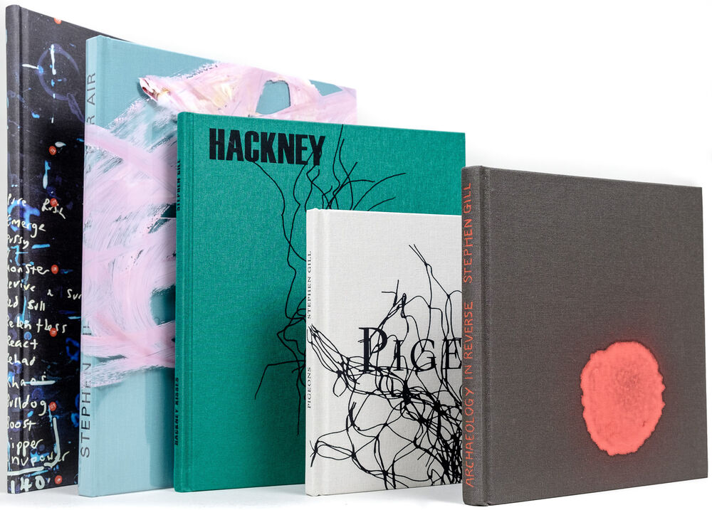
Name:

Theme/Context
Provide a brief summary of the theme or subject you want your work to focus on. You might include details about the impact you hope to achieve, how the book format will help you connect with your audience, and what will make your work stand out. (300 – 500 words)

Influence
Highlight the work of a photographer who currently inspires your work. Analyse an image of theirs and explain your interest in their work. Consider style, theme, context, practical technique. (300 – 500 words)

Book Form
Referencing the session PowerPoint on Moodle (or another relevant source), discuss at least one book that has influenced you. Explore its visual and aesthetic qualities, social or historical context, impact, or practical methods relevant to your theme. You may also evaluate its overall effectiveness. (300 – 500 words)

