

Task 1 – Reading Task Template
Upload your photo of your A3 in-class notes here:
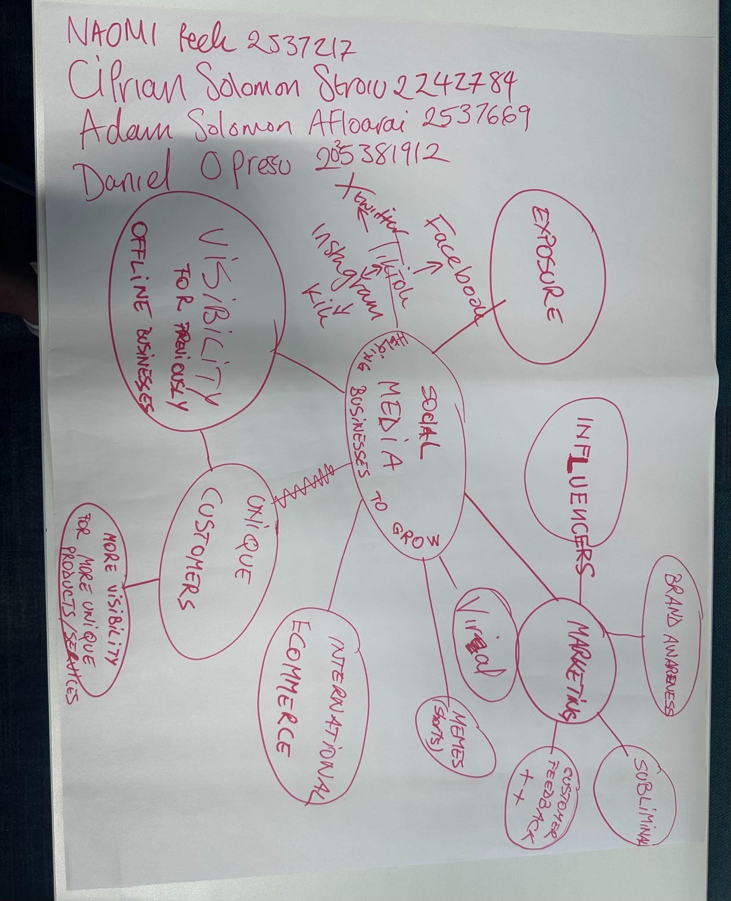

1. Answer these questions using the sentence starters below
a. What is the main idea of the text?
The main idea is that you document yourself on social media and take what is good so that you can improve the smooth running of your business and marketing.
b. What are two key points?
One key point is to use social media to advertise your business and promote it to attract customers.
Another key point is that customers can give you advantageous feedback through social networks that promote your products and can increase your income.
c. What part of the text did you find most important? Why?
The most important part is customer feedback and the quality of the products you have, this helps the business run well and increase sales.
d. Was anything unclear or difficult to understand?
I was not sure about how to use social media to attract customers and promote my business.
e. How did your group help you understand the text better?
My group helped me by discussing the advantages of a business and sharing good and bad ideas for a business and how we can keep a business running smoothly.
3. One sentence reflection
Question: What did you find challenging about this task?
The hardest part was finding the most important information in a business and making a summary to write it short and clear so it would be understandable.

