11/05/2026

Buildability and Sustainability Analysis:
Medium-high rise Swansea Bay hotel proposal

Produced by Louis James (2415463)
Construction Technology 2 (ACBA5019)
Table of Contents
1.0 Introduction 5
2.0 Environmental Impact 5
2.1 Building Orientation 5
2.2 Life Cycle 7
2.2a Current proposed Development 7
2.2b Potential Alternative use 8
2.2c Demolition and end of life considerations 9
2.3 Aesthetics 9
3.0 Façade Greening and SuDS 10
3.1 Façade Greening strategy 10
3.2 SuDS Strategy 11
4.0 Buildability 14
4.1 Preferred construction method 14
4.2 Site logistics, materials and labour 15
4.3 Structural complexity and programme of works feasibility 15
4.4 Safe and sustainable construction process and sequence of works 15
5.0 Conclusion 16
6.0 References 17

Figure List
Figure 1: Sun path of site location. [Online] Available at: https://www.suncalc.org/#/51.5527,-4.1832,3/2026.05.05/15:47/1/3 [Accessed 11/05/2026]
Figure 2: Solar radiation received depending on orientation and inclination of superstructure. [CIS] Available at: https://products.ihserc.com/tmp_stamp/00283321362/GVCOWGAAAAAAAAAA.pdf?sess=00283321362&prod=CIS1 [Accessed 11/05/2026]
Figure 3: Drained and ventilated rainscreen cladding. [Online] Available at: https://morson-nexus.com/news-articles/what-is-rainscreen-cladding-and-what-are-the-benefits/ [Accessed 11/05/2026]
Figure 4: Embodied carbon in materials. [Online] Available at: https://www.concretecentre.com/News/2020/Specifying-Sustainable-Concrete.aspx [Accessed 11/05/2026]
Figure 5: Proposed site's surrounding urban environment. [Online] Available at: https://www.google.com/maps/@51.6082153,-3.9832237,1016m/data=!3m1!1e3?entry=ttu&g_ep=EgoyMDI2MDUwNi4wIKXMDSoASAFQAw%3D%3D [Accessed 11/05/2026]
Figure 6: Proposed hotel design. [ChatGPT]
Figure 7: Benefits of Green Facade systems. [CIS] Available at: https://products.ihserc.com/tmp_stamp/00910234696/SYAWRGAAAAAAAAAA.pdf?sess=00910234696&prod=CIS1 [Accessed 11/05/2026]
Figure 8: Four pillars of SuDS design. [CIS] Available at: https://products.ihserc.com/tmp_stamp/00910234696/UZAASGAAAAAAAAAA.pdf?sess=00910234696&prod=CIS1 [Accessed 11/05/2026]
Figure 9: Geocellular Soakaway. [Online] Available at: https://aquarainwater.com/attenuation-tank-vs-soakaway/ [Accessed 11/05/2026]
Figure 10: Outline sketch of proposed site layout. [Online] Available at: https://www.google.com/maps/@51.6060494,-3.9865133,395m/data=!3m1!1e3?entry=ttu&g_ep=EgoyMDI2MDUwNi4wIKXMDSoASAFQAw%3D%3D [Accessed 11/05/2026]

Glossary Of Terms
CFA - Continuous Flight Auger
GGBS – Ground Granulated Blast Furnaced Slag
H&S – Health and Safety
MMC – Modern Methods of Construction
PPE – Personnel Protective Equipment
SuDS – Sustainable urban Drainage Systems
WDR – Wind Driven Rain

Introduction
This report presents the buildability and sustainability analysis of the proposed medium-high rise hotel development located at Sketty Lane, Sketty, Swansea SA2 8QB. The proposed location is situated along the Swansea coastline and in a close proximity to Singleton Hospital.
The report follows on from the proposed technical building design established in Construction Technology: Medium-high rise Swansea bay hotel proposal (James, L. 2026) which establishes the continuous flight auger (CFA) pile foundations, steel frame structure with a reinforced concrete core, composite floor system and a drained and ventilated rainscreen envelope. These systems were selected as they provide a stable structural superstructure, efficient construction time and increased resilience to the expected coastal conditions.
This report evaluates whether the proposed design is durable, buildable and appropriate for the site’s location, this will be assessed based on key factors such the site’s local environment, building orientation, Life cycle and material durability, Aesthetics in relation to the coastal setting, Green Facades and sustainable urban drainage systems (SuDS) and buildability, to determine if the proposed design can provide a sustainable, maintainable and practical superstructure that is suitable in relation to the challenges expected of a urban coastal location.

Environmental Impact

2.1 Building Orientation
The orientation of the development is a vital passive design strategy that significantly affects the energy consumption and performance, human comfort and long-term durability of the hotel. The building’s orientation is not only for providing coastal views but also for managing solar gain, overheating risk, ventilation and exposure to wind driven rain (WDR).
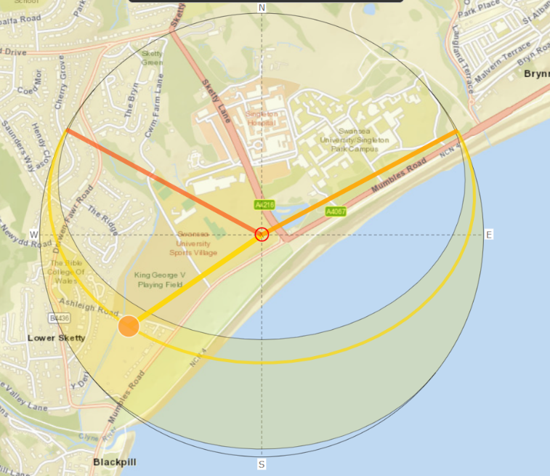
Guidance from (Littlefair, P. 2006) highlights the use of effective orientation and fenestration design is vital for managing heat gain and losses throughout the year. The proposed hotel is to be south facing optimising natural daylight received, reducing the need for artificial lighting which minimises the building operation energy use contributing to Wales’s target of Net Zero. Additionally, maximising daylight improves the occupant’s comfort which is beneficial for a hotel.
Figure 1: Sun path of site location.

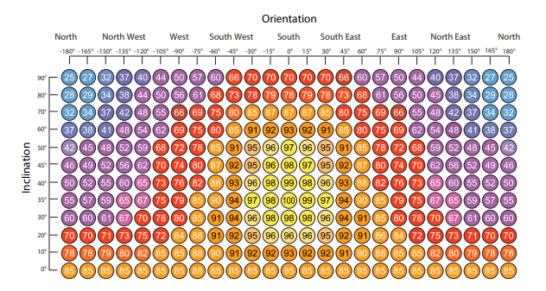
Figure 2: Solar radiation received depending on orientation and inclination of superstructure.
However, daylight lighting must be adequately controlled to mitigate the risk of overheating especially during the summer months where solar radiation is higher. In order to mitigate this, glazing is to be selectively positioned and combined with solar shading devices to regulate the superstructures solar intake.
The building’s orientation has an impact on the ventilation strategy. Due to the height of the proposed hotel and the coastal environment, it is not practical to completely rely on natural ventilation. A cross ventilation system consisting of natural and mechanical is proposed to maintain indoor air quality and temperatures to reduce overheating in summer months (Littlefair, P. 2006).
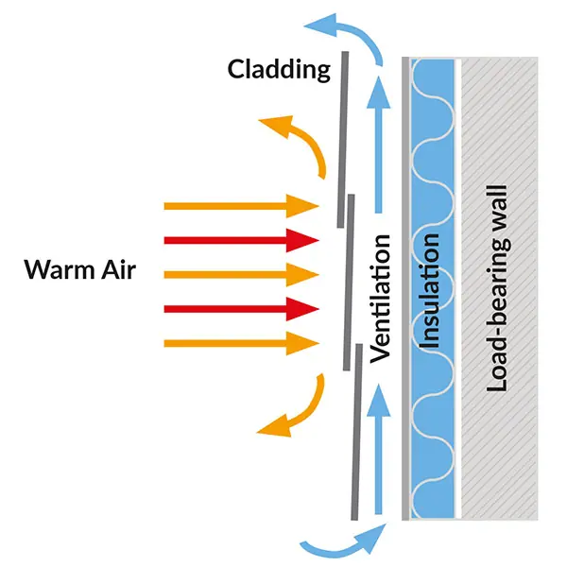
In relation to (James, L. 2026), the drained and ventilated rainscreen cladding supports this strategy as it minimises thermal bridging and protects insulation reducing energy consumption in the winter. As visualised in figure 3 because of the open cavity, there is a continuous airflow that removes solar heat before it transfers to the superstructure which will reduce the potential for overheating in the summer months.

Figure 3: Drained and ventilated rainscreen cladding

2.2 Life Cycle
The whole life cycle of the proposed hotel is to be considered, guidance from (RICS, 2023) state the whole life carbon of the development is the assessment of the carbon impacts from the construction period to its end of use, therefore the hotel structure must be durable and adaptable to reduce future costs and carbon emissions.

2.2a Current proposed Development
The selected CFA pile foundations, reinforced concrete core, steel frame, composite floor and drained and ventilated rainscreen cladding remain appropriate for the proposed medium-high rise hotel development because they provide a stable, durable structure that has a high resistance to fire which is essential for a hotel development. However, the structure contains a high embodied carbon particularly in the concrete piles, core and composite slabs. As shown in figure 4, materials such as ground granulated blast furnaced slag (GGBS) or fly ash should be alternatively used if possible (Concrete Centre, 2020).
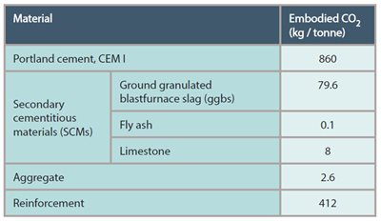
Figure 4: Embodied carbon in materials
As a result of the coastal location, the exposed steel framework, brackets and fixtures must be suitably coated with a marine grade coating to mitigate the risk of corrosion.

2.2b Potential Alternative use
Guidance from (BSI Standards Publication, 2022) highlights the requirements to consider the potential of future adaptability of the building’s design and use. The building is currently proposed to be a hotel which will contain open communal areas, a restaurant and provide accommodation. As shown in figure 5, the surrounding urban environment includes a hospital and a university, due to the close proximity to the proposed site, student accommodation or new hospital wards are best suited and require fewer structural and non-structural adaptations improving the long term sustainability of the building’s life and reducing the embodied carbon footprint.
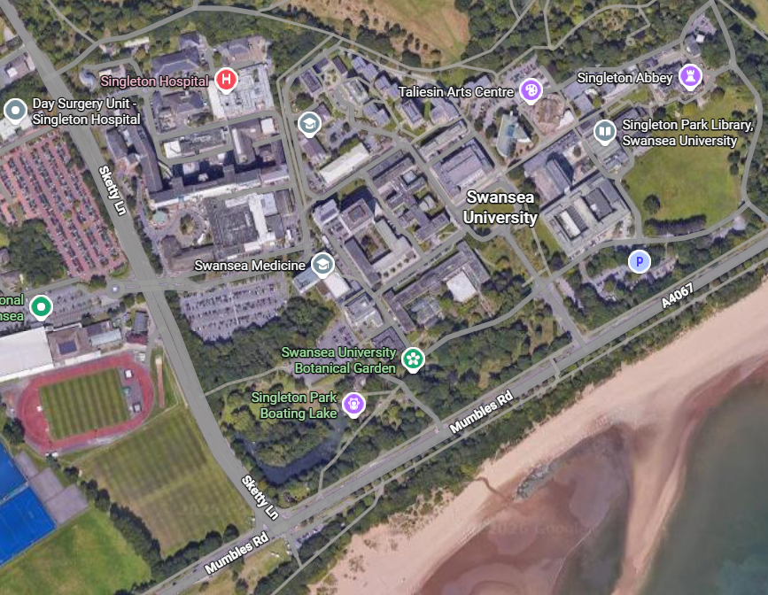
Figure 5: Proposed site's surrounding urban environment

2.2c Demolition and end of life considerations
If future demolition is unavoidable, the design should support selective deconstruction which is a sustainable method of dismantling designated specific parts of the building, such as the steel framework, glazing, doors and the drained and ventilated rainscreen cladding. The use of this method ensures all materials are recycled or re-used reducing the carbon and environmental impact (ReBuild Green, 2026), although this method is suitable for the steel framework, external cladding and façade the composite flooring is not as straightforward. As noted in (ECCS, 2025) the steel and concrete bonding is permanent therefore unable to be re-used however, as both materials are recyclable it allows for an environmentally responsible disposal method.

2.3 Aesthetics
The aesthetic design of the proposed hotel is vital as the appearance will influence the character of the Swansea bay coastline. The surrounding infrastructure primarily consists of low-medium rise non-residential buildings, therefore the hotel should not be designed as a landmark object. As shown in the drawings below, a vertical form with a recessed upper level would appear slimmer and less dominant suiting the local environment.
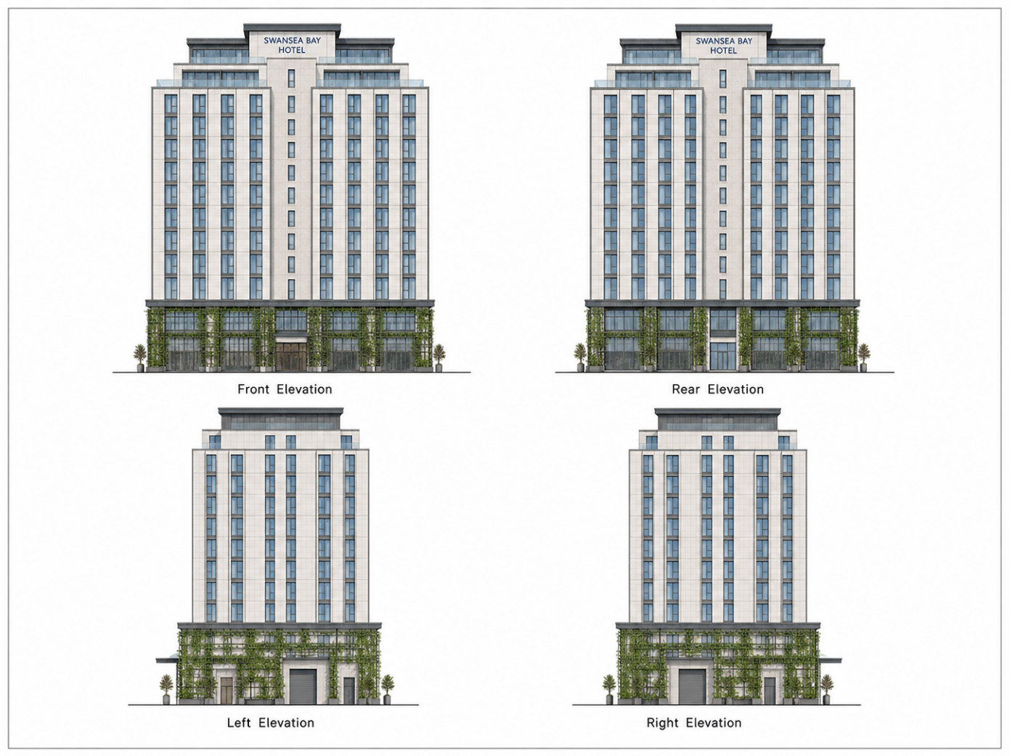
Figure 6: Proposed hotel design.
The appearance of materials should also be chosen to relate to the coastal environment. Light colours such as a pale or cream cladding, powder coated steelwork and controlled ratio of glazing are suitable for the setting, whereas if dark coloured cladding would be incorporated it would make the hotel appear heavier and dull and increase the solar gain (Karina, 2025). The ground floor contains a high ratio of glazing, so the hotel connects with the pedestrian environment.

Façade Greening and SuDS

3.1 Façade Greening strategy
The incorporation of a green façade system to the proposed hotel development has the potential to improve the environmental performance and overall aesthetic, however the suitability of these systems must be critically assessed in relation to the building being medium-high rise, coastal environment and long-term maintenance requirements. As mentioned in (Williams, H. 2026) there are three main categories of façade greening systems:
- Extensive systems
- Plants grown and remained in soil climb up the building fabric which can be assisted through the use of trellis.
- Intensive systems
- Plants placed and supported in modular panels or lightweight substrates fixed directly to the building’s façade.
- Zero-infrastructure systems
- Man-made walls designed to mimic nature and allowed for natural colonisation of vegetation.
Each of these systems provide benefits such as a reduction in surface temperature, protection from solar radiation, thermal and sound insulator and provide an aesthetically pleasing view.
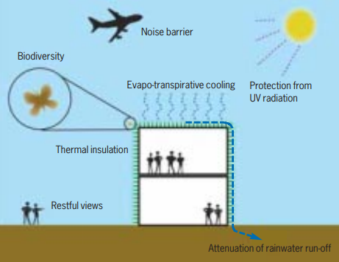
Figure 7: Benefits of Green Facade systems.
As the proposed hotel development is medium-high rise, the most suitable approach is a partial extensive green façade system applied to the lower levels of the building. This system requires simpler support structures such as a trellis framework and requires less demand on potential maintenance.
Additionally, this approach provides environmental benefits at a pedestrian level such as improved aesthetics, shading and enhancing local biodiversity whilst avoiding risks if placed at high levels. During the design phase it is essential that the detailing of the trellis framework is separated from the drained and ventilated rainscreen cladding to prevent moisture ingress which will cause a loss of durability and thermal performance (CWCT, 2020) furthermore, maintenance access routes are not to be blocked which can result in unneeded costs for removing and reinstating the façade system. Finally, the façade system must comply with (Welsh government, 2010) to ensure fire safety.

3.2 SuDS Strategy
The use of SuDS maximises the benefits available from adequate surface management, (Woods Ballard, B. et al. 2015) highlights SuDS should manage four main categories water quantity, water quality, amenity and biodiversity rather than purely acting as an underground drainage system. As the proposed site is located within Swansea bays coast heavy rainfall is expected throughout the year, resulting in rapid water surface runoff rather than infiltrating into the ground increasing pressure on the site’s drainage.
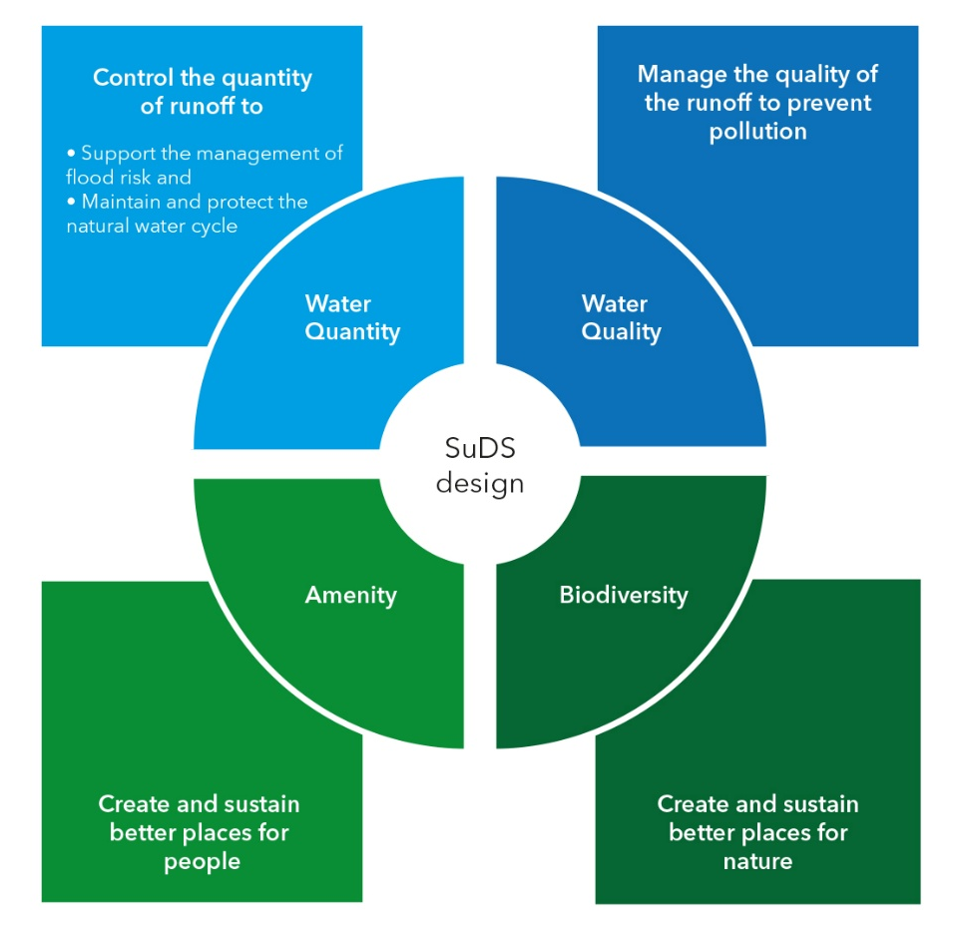
Figure 8: Four pillars of SuDS design.
Legislation from (Welsh Government, 2018) state that as of 7th January 2019, all new developments are required to include SuDS that are compliant with national standards. The strategy is to follow the Welsh statutory standards priority levels.
- Priority Level 1 - Surface water runoff is collected for usage.
- Priority Level 2 - Surface water runoff is infiltrated into the ground.
- Priority Level 3 - Surface water runoff is discharged into a surface water body.
- Priority Level 4 - Surface water runoff is discharged into a water sewer or another drainage system (Only to be used in exceptional circumstances).
- Priority Level 5 - Surface water runoff is discharged into a combined sewer (Only to be used in exceptional circumstances).
Prior to infiltrating surface water into the ground, a soil infiltration test is to be conducted in accordance with (Garvin, S. 2016), to confirm that the ground can safely absorb water.
Following infiltration testing, if the ground conditions are confirmed suitable, the proposed SuDS design is permeable paving and an underground geocellular soakaway, visualised in figure 9. This allows for the surface water to be treated and slowed before entering the soakaway.
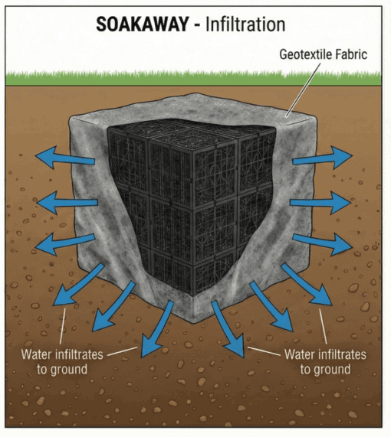
Figure 9: Geocellular Soakaway.
The proposed site is approximately 2.6ha and a QBAR greenfield runoff rate of 13.5 l/s, which should be used as the maximum controlled discharged rate (hr Wallingford, n.d.). The developed peak runoff can be estimated using the following calculations:
Q = Design event peak rate of water runoff.
C = Non-dimensional runoff coefficient.
I = Rainfall intensity for the design return period.
A = Total catchment area being drained.
Therefore:
Q = 2.78 x 0.75 x 17 x 2.6 = 92.2l/s.
92.2l/s – 13.5l/s = 78.7l/s (requiring runoff storage).

For a 60 minute storm duration:
Storage required = 78.7 x (60x60 = 3600) = 283, 320 litres = 283m3.

The geocellular soakaway system can be used with a porosity of 95% or higher void ratio (CivilWeb spreadsheets, n.d.). Required soakaway volume:
283m3 / 0.95 = 298m3.
A suitable arrangement would be 20m x 10m x 1.5m = 300m3, providing 285m3 of water storage, ensuring that excess surface water can be temporarily stored and released into the ground reducing the risk of flooding during heavy rainfall.
As shown in figure 10, the geocellular soakaway and is to be placed under the designated area of the car park.
Key:
Red – Hotel (South facing)
Yellow – External communal space.
Purple – Permeable paving slabs.
Blue – Car Park.
Brown – Underground geocellular soakaway.
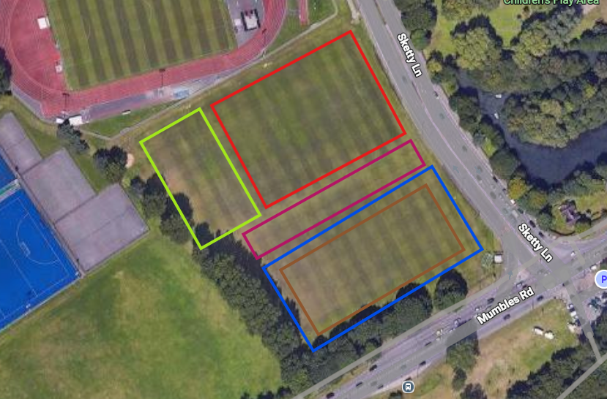
Figure 10: Outline sketch of proposed site layout.

Buildability
Buildability is a critical stage during the pre-construction phase that assesses how efficient and straightforward it is to construct the development based on the locations, environment, design, materials and site constraints in order to achieve the desired quality (Designing Buildings, 2020).

4.1 Preferred construction method
The preferred construction method will consist primarily of a modern method of construction (MMC) whilst using a traditional methods approach for certain elements. A primary method of MMC is suitable for the hotel development as it improves accuracy, quality control, productivity, health and safety (H&S) and reduces on-site disturbances and weather related delays (Government Commercial Function, 2022), this is beneficial as the surrounding urban environment contains a university and hospital which may be disturbed by the noise, vibrations and congestion as a result of the construction works.
The proposed MMC strategy will include an offsite prefabricated steel frame, bathroom pods, composite flooring and panelised drained and ventilated rainscreen cladding. This approach is viable as the hotel layout will be repetitive with similar size bedrooms and bathrooms.
A fully modular building is not recommended, as the proposed development is medium-high rise and is expected to experience high coastal winds the CFA pile foundations and reinforced concrete core should remain in-situ providing a robust lateral stability system capable of resisting the wind loads and transferring them into the ground (Collum, B. 2017).

4.2 Site logistics, materials and labour
Site logistics must be carefully controlled because large components such as the steel framework, rainscreen cladding and modular pods require co-ordinated delivery, unloading and heavy machinery access. Therefore, a traffic management plan should be prepared prior to construction, this plan is to include delivery time slots, identification of traffic marshals and highlight the designated delivery and access routes to mitigate pedestrian interference (HSE, n.d.).
The material availability is primarily suitable as steelwork, concrete, reinforcement, composite flooring, rainscreen cladding and soakaways are commonly available throughout the UK however, due to the site’s coastal environment there is an increased risk of corrosion reducing the materials durability. Exposed steelwork is to be protected with an adequate marine grade coating to maximise the materials life cycle ensuring durability (SWJ, 2026).
The labour required includes trained competent professionals such as crane operators, piling specialists, drainage specialists and a variety of tradesmen such as electricians and carpenters. The use of MMC reduces the number of tradesmen on-site and at a specific time as majority of construction will be fabricated within large open warehouses reducing congestion and improving H&S.

4.3 Structural complexity and programme of works feasibility
The structural design is moderately complex because the building is medium-high rise, exposed to coastal wind and relies on co-ordination between CFA foundations, reinforced concrete core, steel framework and composite flooring. The main buildability risk is temporary structures such as scaffolding as the expected coastal weather conditions can result in delays due to being unsafe for work, as highlighted by (HSE, n.d.) all temporary structures must be designed, installed and maintained to withstand expected loads. To ensure compliance is met, it is essential all temporary structures are installed through competent and qualified personnel and all members working off the structure is adequately trained and provided with the correct personnel protective equipment (PPE).
The programme of works is feasible as the hotel layout is repetitive across the floor levels, allowing tradesmen to improve efficiency as the project progresses (Davenport and Partington, 2021). Once the lower levels are installed and weather-tight, internal works and decoration can begin while upper floors are still being constructed. However, the programme of works should account for possible delays that can be caused from late deliveries and weather conditions.

4.4 Safe and sustainable construction process and sequence of works
The construction process must comply with the construction design and management (CDM) regulations. As highlighted in (CDM, 2015) it is required that all works are to be planned, documented, managed and monitored throughout the project. Identified key risks include working at height, crane operations, piling operations, steel framework and cladding installation, temporary structures and traffic management. The identified risks are to be adequately assessed and controlled through site inductions, tool box talks, lifting plans, segregated pedestrian routes and exclusion zones.
The hybrid MMC approach supports sustainability, this claim is supported by (BRE Group, n.d.) as off-site fabrication reduces material waste and improves accuracy and quality mitigating potential errors that may result in being unusable increasing the embodied carbon of the development. Furthermore, if applicable replacing the concrete mixes with a lower carbon material such as GGBS or fly ash will improve the overall environmental impact of the proposed development. Overall, the proposed design is buildable because it combines robust traditional construction with efficient MMC elements.
Stage | Construction activity
1 | Site setup, access arrangements, welfare facilities.
2 | Location of services, site clearance and excavation to allow construction works to begin.
3 | CFA Piling and reinforcement installation.
4 | Drainage runs and soakaway installation.
5 | Reinforced concrete core construction, including walls, lift shafts and stair cores.
6 | Prefabricated steel frame, delivery and erection.
7 | Composite floor installation delivery and installation.
8 | Drained and ventilated rainscreen cladding installation and external works.
9 | Modular pods installation and internal decorations.
10 | External works, landscaping, snagging and handover.

Conclusion
The proposed medium-high rise Swansea bay hotel is considered buildable, durable and sustainable when the appropriate design considerations and controls are applied. The use of CFA piles, reinforced concrete core, steel framework, composite flooring and drained and ventilated rainscreen cladding provides a suitable structurally strong building that can withstand the coastal environment. However, it is essential all exposed steelwork is adequately protected with marine grade coating to reduce the risk of corrosion and ensure the materials last the expected life cycle. To improve the environmental impact of the development, where possible lower carbon concrete alternatives are to be used. The south facing orientation, partial green façade and SuDS strategy improves the environmental impact and increases human comfort. The hybrid MMC approach supports efficiency, accuracy, quality and site safety. Therefore, the proposal is suitable for the coastal environment and the desired building use.

References
BRE Group. (n.d.). Offsite Modular Construction. [Online] Available at: https://bregroup.com/expertise/innovation/modular-construction [Accessed 11/05/2026]
BSI Standards Publication. (2022). Sustainability in buildings and civil engineering works — Framework for methods of assessment of the environmental, social and economic performance of construction works as a basis for sustainability assessment. [CIS] Available at: https://products.ihserc.com/tmp_stamp/00348605306/YMNTWGAAAAAAAAAA.pdf?sess=00348605306&prod=CIS1 [Accessed 11/05/2026]
CDM (2015). The Construction (Design and Management) Regulations 2015. [Online] Available at: https://www.legislation.gov.uk/uksi/2015/51/regulation/13 [Accessed 11/05/2026]
CivilWeb spreadsheets. (n.d.). Soakaway Fill Material. [Online] Available at: https://civilweb-spreadsheets.com/drainage-design-spreadsheets/soakaway-size-calculator-spreadsheet/soakaway-fill-material/ [Accessed 11/05/2026]
Collum, B (2017). Nuclear Facilities. [Online] Available at: https://www.sciencedirect.com/science/chapter/monograph/abs/pii/B9780081019382000052 [Accessed 11/05/2026]
Concrete Centre. (2020). Specifying Sustainable Concrete. [Online] Available at: https://www.concretecentre.com/News/2020/Specifying-Sustainable-Concrete.aspx [Accessed 11/05/2026]
CWCT. (2020). FACETS. [Online] Available at: https://www.cwct.co.uk/pages/facets#!articles/1222-9011-0204-drained-and-ventilated [Accessed 11/05/2026]
Davenport and Partington. (2021). Modern methods of construction. [Online] Available at: https://www.nhbc.co.uk/kontentdocuments/a4a6e18b-f84e-4c42-87c5-ee3f8da2137a/modern-methods-of-construction-2.pdf [Accessed 11/05/2026]
Designing Buildings. (2020). Buildability in construction. [Online] Available at: https://www.designingbuildings.co.uk/wiki/Buildability_in_construction [Accessed 11/05/2026]
ECCS (2025). Recommendations for Reuse of Steel Products Volume 1: Reusing existing steel products and buildings. [Online] Available at: https://www.terasrakenneyhdistys.fi/wp-content/uploads/2025/10/ADVANCE-Recommendations-for-Reuse-Vol-1.pdf [Accessed 11/05/2026]
Garvin, S. (2016). Soakaway design. [CIS] Available at: https://products.ihserc.com/tmp_stamp/00348605306/USZZRGAAAAAAAAAA.pdf?sess=00348605306&prod=CIS1 [Accessed 11/05/2026]
Government Commercial Function. (2022). Modern Methods of Construction. [Online] Available at: https://assets.publishing.service.gov.uk/media/631222468fa8f5423fb0c7c0/20220901-MMC-Guidance-Note.pdf [Accessed 11/05/2026]
hr Wallingford. (n.d.). Greenfield runoff rate estimation – members. [Online] Available at: https://www.uksuds.com/tools/members/greenfield-runoff-rate-estimation-members [Accessed 11/05/2026]
HSE. (n.d.). Safety Hazards. [Online] Available at: https://www.hse.gov.uk/construction/safetytopics/index.htm [Accessed 11/05/2026]
HSE. (n.d.). Temporary Works. [Online] Available at: https://www.hse.gov.uk/construction/safetytopics/temporary-works.htm [Accessed 11/05/2026]
James, L (2026). Construction Technology 2 – 2415463. [Unpublished Assignment]. ACBA5019: Construction Technology 2. UWTSD. [Accessed 11/05/2026]
Karina. (2025). What are the Disadvantages of Black Composite Cladding? [Online] Available at: https://www.solidexwood.com/black-composite-cladding-7-disadvantages-homeowners-should-know/ [Accessed 11/05/2026]
Littlefair, P (2006). Design for improved solar shading control. [CIS] Available at: https://products.ihserc.com/tmp_stamp/00348605306/MRTVRGAAAAAAAAAA.pdf?sess=00348605306&prod=CIS1 [Accessed 11/05/2026]
ReBuild Green. (2026). Selective Deconstruction. [Online] Available at: https://www.rebuildgreen.net/services/selective-deconstruction [Accessed 11/05/2026]
RICS. (2023). Whole life carbon assessment for the built environment. [Online] Available at: https://www.rics.org/content/dam/ricsglobal/documents/standards/Whole_life_carbon_assessment_PS_Sept23.pdf [Accessed 11/05/2026]
SWJ (2026). Protecting Steelwork in Coastal Environments: Remedial Structural Solutions for Seafront Properties. [Online] Available at: https://swjconsulting.co.uk/portfolio-items/protecting-steelwork-in-coastal-environments/ [Accessed 11/05/2026]
Welsh government. (2010). Approved documents B: Volume 2 – Buildings other than dwellinghouses. [Online] Available at: https://www.gov.wales/sites/default/files/publications/2021-12/building-regulations-guidance-part-b-fire-safety-volume-2-buildings-other-than-dwellinghouses.pdf [Accessed 11/05/2026]
Welsh Government. (2018). Statutory standards for sustainable drainage systems – designing, constructing, operating and maintaining surface water drainage systems. [Online] Available at: https://www.gov.wales/sites/default/files/publications/2019-06/statutory-national-standards-for-sustainable-drainage-systems.pdf [Accessed 11/05/2026]
Williams, H. (2026). Lesson 9: Green Facades. [Powerpoint presentation]. ACBA5019: Construction Technology 2. UWTSD. [Accessed 11/05/2026]
Woods Ballard, B. et al. (2015). The SuDS Manual. [CIS] Available at: https://products.ihserc.com/tmp_stamp/00348605306/UZAASGAAAAAAAAAA.pdf?sess=00348605306&prod=CIS1 [Accessed 11/05/2026]

