Introduction to Health Research
Module Number: BMNS 4005
Lucy Morgan
Student Number: 2115422

Written Assessment
Screening during pregnancy: Do you know the impact Group B streptococcus (GBS), can have on pregnant women during labour?

Contents Page
Introduction Page 3
What is GBS Disease? Page 4
Age range of GBS Page 5
How GBS affects labour and new-born babies? Page 6
What promotion of Health is offered to Mothers Page 7
Conclusion Page 8
References Page 9 & 10

Introduction
Leeuwenhoek (1676), was the first to identify microscopic one-celled organisms, which he called ‘animalcules’ also know today as GBS. He described bacteria of the genus Selenomonas as a crescent shaped bacteria from the human mouth in 1676. However it was the work of Billroth (1894), who coined the term Streptococcus to describe this particular group of bacteria, this came from working with severe infections in cattle as GBS would cause mastitis. The first formal screening guidelines for GBS in pregnancy were released in 1992, based on the joint efforts of The American College of Obstetricians and Gynaecologists (ACOG) and the American Academy of Paediatrics (AAP). Group B Streptococcus (GBS) is a common bacterium that is commonly found in the intestines or lower genital tract. In most cases, the bacterium is not harmful to healthy adults. Doran and Nizet (2004) maintains that in neonates, it can cause a deadly condition known as GBS disease. Within this report there will be a comparison of age ranges to see if GBS affects only certain ages, along with what happens to new-borns who encounter the bacteria during the labour process. Lastly What promotion of Health is offered to Mothers. The World Health Organisation (WHO, 2021) has recognised, that GBS is far higher than previously thought, it is linked to over half a million preterm births annually.

What is GBS Disease?
Group B Streptococcal Disease is a type of bacteria. It is very common with more than 20,000 cases in the UK per year. GBS is not known to be contagious nor is it known how it is transmitted, there is no vaccine available and is only treatable with antibiotics which can take several days or weeks depending on the severity of infection. It is fairly frequent in both men and women and typically resides in the rectum or vagina. GBS is usually innocuous, and most people are unaware they have it. In a study conducted by Oxford clinical infectious diseases (2004) it found eighty-two (34%) of 241 women had GBS and forty-three (20%) of 211 men had GBS in urine samples taken. However a review by UK National Screening Committee (UNSC, 2016) does not recommend that screening should be introduced in the UK, this is due to the research available currently does not know whether giving antibiotics during labour to women with a positive GBS screening test actually reduces the number of babies dying from Early Onset Group B Streptococcal (EOGBS).
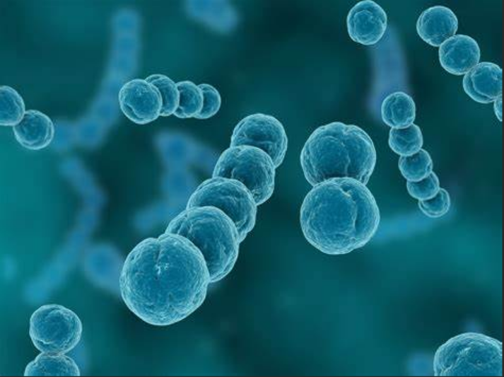

Picture of GBS Bacteria courtesy of Infectious Disease Hub (Powell, 2017)

Age Range of GBS
GBS has lately been identified as a significant and seemingly increasing source of invasive illness in older adults, the annual increase reported by Farley (2012) has estimated 4.4% per 100,000 adults and is highest among over 60 years of age. GBS in over 60 years of age if left untreated it can cause pneumonia, bone and joint infections and infection of the heart valves. The majority of healthy adults with GBS have no underlaying symptoms of the infection, bacteria may come and go in adults’ bodies without symptoms. The Centre of Disease control (CDC, 2020) states that the rate of serious GBS disease increases with age saying there are 25 cases in every 100,000 each year with 10 of those adults dying from GBS infections. Among babies there are two types of GBS, early onset (EOGBS) means within the first week of the baby being born and late onset (LOGBS) is anything after the first week and up to 3 months after birth. According to CDC about 930 babies get EOGBS and around 1,050 get LOGBS, with 3 in every 50 babies (4-6%) who develop GBS dying. Mortality rates from this invasive disease is particularly high in the young and elderly. Public Health Wales (PHW, 2022) observes there is an importance of the collection and interpretation of data about the levels of GBS disease in the Welsh population, PHW are constantly undertaking surveillance to detect trends and evaluate prevention and control measures against such infectious diseases.

How GBS affects labour and new-born babies?
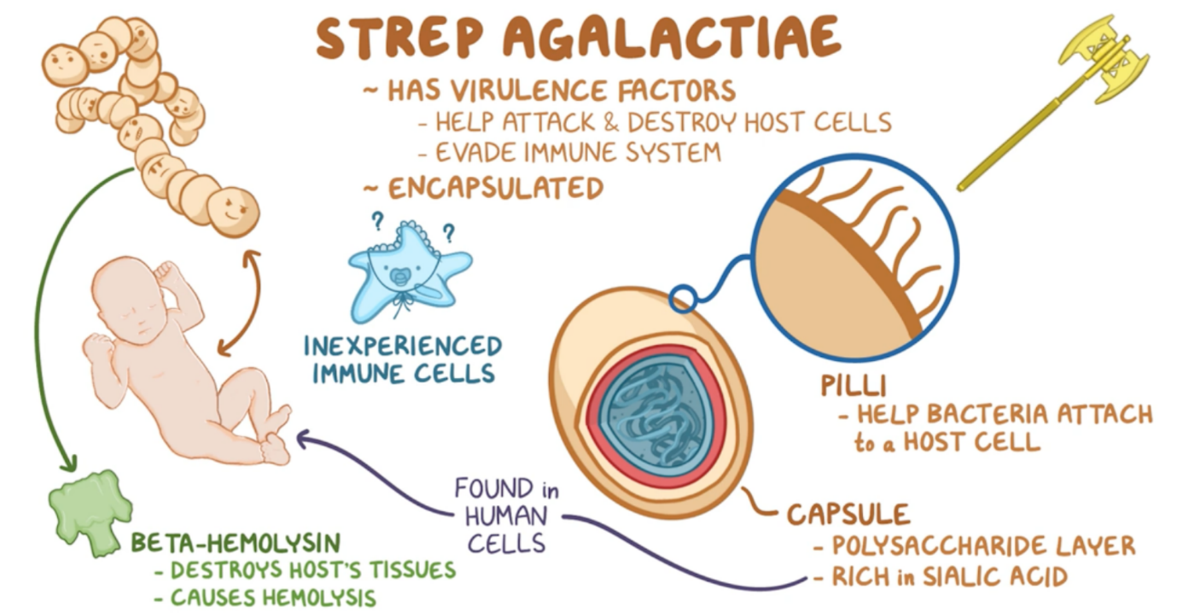
NHS (2021) points out if GBS is present the baby will most likely be exposed to it during labour and delivery. While many new-borns will not be affected, there is a very small possibility that your new-born will get extremely unwell. In some cases, GBS infection can cause miscarriage, early labour or stillbirth. EOGBS in new-borns will develop within the first 6 days of life, this can cause blood poisoning, pneumonia or meningitis. Although even with the best possible care a small number of new-borns die and some who recover have after effects of EOGBS like deafness or brain damage. There is normally only a concern if a woman is pregnant and carrying the bacteria GBS, because during labour this is when it can spread to the baby via ingestion. GBS will make new-borns extremely ill this will happen 1 in 400 pregnancies without antibiotics. However, if antibiotics are given this will decrease the rate of transmission to 1 in 4,000 chance of the baby being exposed to GBS. Currently in Wales there is no routine testing for GBS as the NHS argues that testing is not accurate enough and can lead to false positives and overuse of antibiotics. NHS (2022) believes the overuse of antibiotics in recent years means they are becoming less effective to treat superbugs. There are strains of bacteria that have developed resistance to many different antibiotics, the main concern is a new strain of bacteria comes along and can not be treated by current antibiotics.

What promotion of Health is offered to Mothers
GBS is a leading cause of serious neonatal infection and disease. Most neonatal GBS infections can be prevented through the use of intrapartum antimicrobial prophylaxis in women who are at increased risk for transmitting the infection to new-borns. Despite clinical trials demonstrating the efficacy of intrapartum antibiotic prophylaxis, preventative techniques have not been extensively or consistently used, and the frequency of newborn GBS illness has not decreased. The National Library of Medicine (2022) champions this view by stating Generation Surveillance System and shows that 295 babies developed early onset GBS in 1996. This figure rose to 520 in 2020 – a rise of 77% and that is unacceptable in this day and age. There are more natural promotions of health by a charity called Gentle Midwife services (GMS 2009), this charity believes prevention is better than cure and to starting a course of probiotics during pregnancy can be beneficial in more ways than one, when dealing with GBS its recommended to start supplementing orally at 28-32 weeks and steadily increase the oral dose when closer to the due date, then within the last 2-4 weeks consider using a vaginal probiotic to counter act the bacterium of GBS. Whilst this charity suggests the probiotics work there is no statistical evidence to back this claim.

Conclusion
In conclusion to this report GBS in still a key factor in new-borns being born prematurely, still born, miscarried or left with life changing disabilities due to a seemingly harmless bacteria that is carried in the intestines or lower genital tract. The GBS disease is fairly common in healthy young adults and most adults are totally unaware of the dangers GBS may cause when pregnant, the NHS does not routinely test for GBS due to issues with accuracy of the testing process. However GBS in adults over 60 years of age can create unprecedented infections in the bones, cardiac infections along with pneumonia if left untreated. More than one health care department has recognised, that GBS is far higher than previously thought and cases are still rising in Wales due to lack of testing.

References
Billroth, T. (1894) ‘Science Direct’, Journal of Gynecology and Obstetrics, 252(12), pp.526-533.
Centres for Disease Control (2020) Saving Lives Protecting People: Rates of serious group B strep (GBS) infections are higher among newborns but anyone can get GBS disease. Available at: https://www.cdc.gov/groupbstrep/about/fast-facts.html (Accessed 23 March 2022).
Doran, K. and Nizet, V. (2004) ‘Molecular pathogenesis of neonatal group B streptococcal infection: no longer in its infancy’, Molecular Biology, 54(1), pp. 23-31.
Farley, M. (2012) ‘Group B Streptococcal Infection in Older Patients’, Journal of Drugs & Aging, 6(2), pp. 293-300.
Gentle Midwife Service Charity (2009) Preventing Group B Strep Colonisation in Pregnacy: Gentle Midwife Services. Available at: https://gentlemidwife.com/2021/07/31/preventing-group-b-strep-colonization-in-pregnancy/ (Accessed 31 March 2022)
Leeuwenhoek, A. (1676) ‘European Journal of Obstetrics & Gynecology and Reproductive Biology: Group B Streptococcal Disease in the Mother and Newborn’, 252(12), pp. 526-533.
National Health Service (2021) Health A-Z: Group B Strep in pregnancy. Available at: https://www.nhs.uk/conditions/group-b-strep (Accessed 17 March 2022).
National Health Service (2022) Antibiotic Antimicrobial Resistance. Antibiotics and Superbugs Resistance. Available at: https://www.nhs.uk/conditions/antibiotics/antibiotic-antimicrobial-resistance/ (Accessed 28 March 2022).
Powell, M. (2017) ‘Clinical Infectious Disease Hub’, Journal of Future Science Group, 39(3), pp.380-388.
Public Health Wales (2022) Infectious diseases caused by group B streptococcus. Who Gets it and How Serious Is It. Available at: https://phw.nhs.wales/topics (Accessed 24 March 2022).
The National Library of Medicine (2022) Group B Strep Support: Preventing Group B Strep in Babies in the UK – Past, Present and Future. Available at: Https:/preventing-group-b-strep-infections-in-babies-in-the-uk-past-present-and-future/ (Accessed 29 March 2022)
UK National Screening Committee (2016) Universal antenatal culture-based screening for maternal Group B Streptococcus (GBS): Carriage to Prevent Early-Onset GBS Disease. Available at: file:///C:/Users/loopy/Downloads/Evidence_summaryGroup_B_Streptococcus_2017_compressed.pdf (Accessed 20 March 2022).
World Health Organisation (2021) Urgent need for vaccine to prevent deadly Group B streptococcus: The global burden of Group B streptococcus. Available at: https://www.who.int/news/item/02-11-2021-urgent-need-for-vaccine-to-prevent-deadly-group-b-streptococcus (Accessed 15 March 2022).

