Title

Exploring the difference in anxiety before and after a CBT short course.

Anxiety is a common feeling. It is the brain's mechanism for handling stress and alerting us to impending danger.
Anxiety disorders, however, are distinct. They are a set of mental conditions that produce unrelenting, intense anxiety and worry. Overwhelming anxiety may cause us to avoid social situations that could set off or exacerbate symptoms, such as work, school, family gatherings, and others.
For the past ten years, anxiety levels in Britain have "exploded."
Analyzing UK anxiety statistics reveal the number of people in need of assistance as well as the severity of anxiety's impact on various demographic groups.
The study demonstrates that almost 8 million people in the UK are dealing with anxiety disorders right now (Mental Health UK). (Pindar, 2023) Nonetheless, everyone's experience with anxiety disorders varies. Both mental and physical signs of not anxiousness can exist. The symptoms of an anxiety disorder are the same for everyone who has them. Anxiety disorders come in a variety of forms.
The five major of anxiety disorders are: Generalized Anxiety Disorder (GAD), Obsessive-Compulsive Disorder(OCD), Panic Disorder, Post-Traumatic Stress Disorder (PTSD), Social Phobia or Social Anxiety Disorder.
Both medicine and psychotherapy are used to treat anxiety disorders.

Psychotherapy is a type of counselling that teaches you how emotions affect your behaviour. It is sometimes referred to as talk therapy. A licenced mental health expert converses with us about our thoughts and feelings and makes recommendations for understanding and managing our anxiety disease.
Cognitive behavioural therapy (CBT), a common type of psychotherapy, teaches patients how to transform unfavourable or anxiety-provoking thoughts and behaviours into favourable ones.It is a dialogue-based treatment that teaches coping skills for various issues while emphasising how thoughts, beliefs, and attitudes influence feelings and behaviour. It is the preferred treatment for anxiety disorders. The NHS in England recommends CBT as an effective treatment for depression and anxiety. Patients can learn the skills needed to deal with their immediate problems and support their long-term health by enrolling on a course of CBT. (Reynolds, 2023).
According to a study report, the treatment group improved more post-test than the control group in all dependent variables when generalised anxiety disorder was treated with cognitive-behavioural therapy. Several trials proved that CBT is effective in treating GAD.
Social anxiety disorder significantly negatively affects people's lives because it is persistent and essentially unrelenting.( Dugas et al. ,2003)
Social anxiety disorder is another name for social phobia., affects 7% of the population (Fehm et al., 2008) and, untreated, develops into a chronic and incapacitating condition. Particularly according to the research published in the article "Psychological and pharmacological approaches for social anxiety disorder in adults," individual CBT therapy is more effective than psychodynamic psychotherapy and other psychological therapies. CBT is used in many psychological treatments that had significant results, indicating that it can be successful in a number of settings. (Wilson et al., 2014)
The purpose of our research is to exploring difference in anxiety levels before and after a CBT short course. It is hypothesised that levels that levels of self-reported anxiety will be significantly lower following the completion of a six-week CBT short-course.

Method
Participants
There were 13 females and 11 males in the sample (N = 24). The sample's mean age was 27.93, standard deviation was 11.24, and the age range was 63–19=44.
In contrast to the other 17 participants, seven of the 24 participants had received a clinical diagnosis of an anxiety illness.
Design
The design = within-subject; all participants completed the Anxiety Symptoms Questionnaire (ASQ) (see Appendix 3) before and after taking part in a six-week CBT short-course. The independent variable was the completion of the ASQ ( before and after the CBT course) and the dependent variable was the intensity of anxiety symptoms reported.
The test used to analyse data will be the Wilcoxon Signed Ranks Test.
Materials
The Anxiety Symptom Questionnaire (ASQ; Baker et al., 2019) was used to collect information on the severity of anxiety symptoms reported by participants. Both symptom severity and frequency were intended to be assessed using the entire questionnaire, but for the purposes of this study, only severity data were used in the analysis. There were 24 questions in the ASQ. One of the questions was 'attention and concentration problem'. Instructions on how to complete the questionnaire were included. The respondent was instructed to read each item and, after reading each item, to write in each box the number from the scale that best reflected his perception of the severity (A) and frequency (B) of these symptoms. He used a scale with a range of 10 to complete the box.
O meant no anxiety, while 10 meant extreme anxiety.
Procedure
A volunteer sample of members of the public were notified of the research study via a study advertisement poster placed within a self-help group for individuals experiencing symptoms of anxiety. Interested participants were prompted to contact the lead researcher to receive further information about the requirements of the study.
Full study information was sent via email to each interested participant. Participants were informed that they would be required to take part in a six-week short-course of CBT aimed a helping them manage their anxiety symptoms, and that they would be asked to complete a short anxiety questionnaire before and after taking part in the CBT course.
On the first day of their CBT sessions, each participant completed the ASQ to assess the intensity of their anxiety symptoms prior to taking part in the course. Following the completion of the final session after the six-week period, participants were again asked to complete the ASQ.
Participants were thanked for their participation and provided with the opportunity to ask questions. A debrief form (see Appendix 2 ) was provided outlining the aims of the study.

Results
A Wilcoxon Signed Ranks Test ( see table 1) was conducted to determine whether the intensity of anxiety symptoms reported by participants reduced following the completion of a six-week short course of CBT. The value of W was calculated as the smaller of W+ and W-, and therefore W was equal to 81.5. ( see Table 2) .The critical value of W as indicated by the critical values table for 24 participants was 91, and so it has been observed that there is significant difference in participants anxiety symptom intensity. The median scores indicate that intensity of symptoms was lower following the completion of the CBT short-course (median before = 52.5 and median after = 49). ( see Table 3).

References

1.Dugas, M. J., Ladouceur, R., Leger, E., Freeston, M. H., Langlois, F., Provencher, D., & Boisvet, J. M. (2003). Group Cognitive Behavioral Therapy For Generalizes Anxiety Disorder: Treatment Outcome and Long-Term Follow-Up. Journal of Consulting and Clinical Psychology, 71, 821-825.
2. Fehm L, Beesdo K, Jacobi F, Fiedler A. Social anxiety disorder above
and below the diagnostic t hreshold: prevalence, comorbidity and impairment in the general population. Soc Psychiatry Psychiatr Epidemiol 2008; 43: 257–65.
3. Pindar, J. Champion Health. (2023). Anxiety Statistic UK 2023. https://championhealth.co.uk/insights/anxiety-statistics/.
4. Reynolds, S. (2023). Fundamentals of CBT: An introduction to the CBT model. https://www.futurelearn.com/info/courses/anxiety-depression-and-cbt/0/steps/14736.
5. Wilson, E. M., Dias, S., Mavranezouli, I., Kew, K., Clark, D. M., Ades, A. E., & Pilling, S. (2014). Psychological and pharmacological interventions for social anxiety disorder in adults: a systematic review and network meta-analysis in. Lancet Psychiatry, 1, 368-76.

Appendices
Consent form
Debrief form
Anxiety Symptoms Questionnaire
Wilcoxon Calculation

Appendix 1
Study Consent Form
I understand that this research study is being carried out to assess the effectiveness of a six-week short course of CBT in assisting in reducing symptoms of anxiety, and I understand that taking part in this study will involve me completing a short assessment of my anxiety symptoms at two time points, and that I am required to take part in the six-week course of CBT.
The questionnaire will be completed before the first session of CBT and following the completion of the final CBT session in week 6. I understand that my participation, therefore, will last for six weeks but that I am giving my time voluntarily, and therefore I understand that I am free to withdraw participation at any time during or at the end of the study without providing a reason.
I understand that after the end of the six weeks, I will be asked to allow for the submission of my anxiety symptoms data and that, if I agree to this, my data cannot be withdrawn after that point as it will be anonymized in preparation for analysis.
I am aware that if I have any concerns about the study, I can contact the researcher and discus these at any time during or after the study. I understand that I will be provided with the contact details of the lead researcher at the bottom of this consent form and again at the end of the study.
I understand that the information provided by me will be held confidentially, with a code assigned in place of my name. These data will be stored indefinitely in accordance with the Data Protection Act. Any information I provide during the CBT sessions will be held confidentially with the counsellor and will not be shared with the research team or anyone else, unless there is a risk of harm to myself or others.
I also understand that at the end of the study I will be provided with a debrief form and the opportunity to discuss any issues with the researcher.

I, ___________________________________(NAME) consent to participate in the study conducted by [NAME],Centre forPsychology and Counselling, University of Wales Trinity Saint David, under the supervision of [SUPERVISORS NAME]

Participant Signature:________________________________________________
Date:___________________
Name and signature of researcher taking consent
___________________________________________________________________

Appendix 2


Centre forPsychology and Counselling

Study Debrief Sheet
(words underlined and in italics should be changed to fit your specific study)
Exploring differences in anxiety levels pre- and post-CBT short-course.

Thank you for taking part in the study.

The aim of this study was to assess the effectiveness of a six-week short course of CBT in assisting in the reduction of anxiety symptoms. We specifically aimed to find out whether self-reported anxiety symptoms, as recorded by participants at the beginning of their first CBT session, reduced when the same questionnaire was completed for a second time following the completion of the six weeks of CBT. We expect to find that taking part in the course of CBT significantly reduces symptoms of anxiety in participants.

If you wish to withdraw your data from the study, you must tell the researcher now. After this point, all of your data will be anonymised and we will not be able to trace it back to you.

If taking part in this study has raised any questions, please speak to the researcher on put your name and student email address here or contact the academic supervisor insert supervisor contact here, name and email.

Thank you once again for taking time to participate in this study.

Put your name here

Put your programme of study here
(BSc Applied Psychology, or BSc Psychology, or BSc Psychology and Counselling)

University of Wales Trinity Saint David

Appendix 3
Anxiety Symptoms Questionnaire
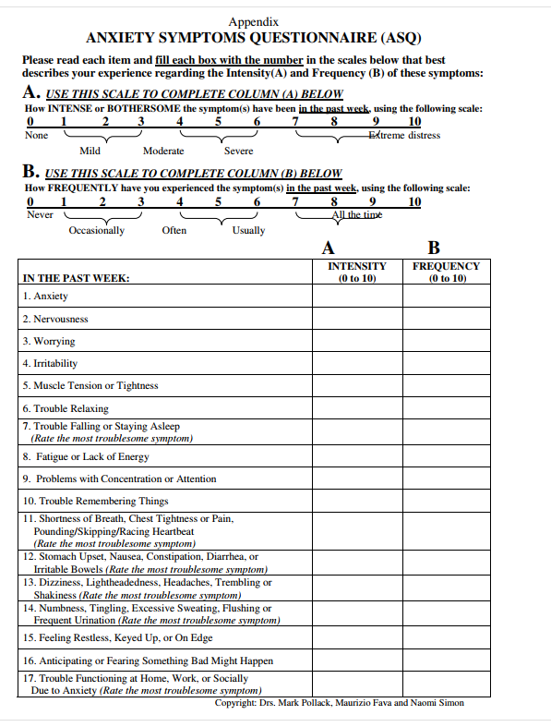

Table 1
Data: Wilcoxon Signed Ranks Test
P | Anxiety BEFORE CBT | Anxiety AFTER CBT | Difference | Order | Rank | Sign
1 | 100 | 80 | 20 | 1 | 3 | 3
2 | 56 | 46 | 10 | -1 | 3 | -3
3 | 111 | 110 | 1 | 1 | 3 | 3
4 | 80 | 84 | -4 | 1 | 3 | 3
5 | 54 | 50 | 4 | -1 | 3 | -3
6 | 40 | 41 | -1 | -2 | 7 | -7
7 | 21 | 23 | -2 | -2 | 7 | -7
8 | 35 | 29 | 6 | 2 | 7 | 7
9 | 34 | 30 | 4 | 3 | 9 | 9
10 | 45 | 25 | 20 | -4 | 12.5 | -12.5
11 | 81 | 74 | 7 | 4 | 12.5 | 12.5
12 | 64 | 60 | 4 | 4 | 12.5 | 12.5
13 | 27 | 31 | -4 | 4 | 12.5 | 12.5
14 | 58 | 60 | -2 | -4 | 12.5 | -12.5
15 | 51 | 50 | 1 | 4 | 12.5 | 12.5
16 | 101 | 81 | 20 | -5 | 16 | -16
17 | 49 | 48 | 1 | 6 | 17.5 | 17.5
18 | 84 | 80 | 4 | 6 | 17.5 | 17.5
19 | 29 | 39 | -10 | 7 | 19 | 19
20 | 40 | 45 | -5 | 10 | 20.5 | 20.5
21 | 68 | 65 | 3 | -10 | 20.5 | -20.5
22 | 27 | 28 | -1 | 20 | 23 | 23
23 | 12 | 10 | 2 | 20 | 23 | 23
24 | 56 | 50 | 6 | 20 | 23 | 23

Table 2
W+ | W-
3 | -3
3 | -3
3 | -7
7 | -7
9 | -12.5
12.5 | -12.5
12.5 | -16
12.5 | -20.5
12.5
17.5
17.5
19
20.5
23
23
23
Total 218.5 | Total 81.5
W + the sum of all positive ranks
W- the sum of all negative ranks
W+ =218.5
W- = 81.5
So W = 81.5
Critical value W = 91

Table 3
Median anxiety before and after CBT
P | Anxiety BEFORE CBT | Anxiety AFTER CBT
1 | 12 | 10
2 | 21 | 23
3 | 27 | 25
4 | 27 | 28
5 | 29 | 29
6 | 34 | 30
7 | 35 | 31
8 | 40 | 39
9 | 40 | 41
10 | 45 | 45
11 | 49 | 46
12 | 51 | 48
13 | 54 | 50
14 | 56 | 50
15 | 56 | 50
16 | 58 | 60
17 | 64 | 60
18 | 68 | 65
19 | 80 | 74
20 | 81 | 80
21 | 84 | 80
22 | 100 | 81
23 | 101 | 84
24 | 111 | 110

Median before (51+54):2=52.5
Median after (48+50):2=49

