

TITLE: DISCOUNT FOR LACK OF MARKETABILITY IN HONG KONG

ABSTRACT

The Discount for Lack of Marketability (DLOM) is "an amount or percentage deducted from the value of an ownership interest to reflect the relative absence of marketability," as stated in the International Valuation Standard (2024), and is commonly used by valuation experts when evaluating the stock of privately-owned businesses. International Valuation Standard (2024) states that "Discounts for Lack of Marketability (DLOM) should be applied when the comparables are deemed to have superior marketability compared to the subject asset.". A valuer is required by RICS (2024) to search for material differences between the subject asset and comparable sales, as well as differences in the marketability of the subject asset and similar sales.
The United States and Europe have produced the vast majority of the empirical research on DLOM in the last several decades. We provided and reviewed a large number of empirical studies using qualitative and quantitative approaches in our thesis's literature review part. Within the Qualitative Approach, we found multiple flaws in the Pre-IPO Method. There is often an excessively long period between a pre-IPO transaction and a public offering, according to Z. Christopher Mercer et al. (2011). Also, in order to ensure complete subscription, pre-IPO deals are usually undervalued, according to Z. Christopher Mercer et al. (2011). Hence, our argument does not include the Pre-IPO Method. We also found that the Restricted Stock Method has some flaws, such as the fact that it doesn't take into account up-to-date market data and that issuer characteristics aren't stable. So, we won't be using the Restricted Stock Method in our calculations. The main limitation of the Quantitative Approach's Option Pricing Model is that it does not take illiquidity's qualitative features into consideration. The monetary advantages of owning the genuine liquidity option are also under-represented in some option pricing models. The lack of solutions to mitigate the price risk associated with nonmarketable assets is another reason why these models aren't ideal for privately owned companies, according to their detractors. Hence, we will not be considering the Option Pricing Model. The Shareholder Cash Flow Adjustment Model uses a Quantitative Approach to determine the DLOM, but it relies on a number of complex assumptions that make the model unreliable. These assumptions include expected cash flows, dividends, risk, and long-term growth rates. Hence, it is not a part of our thesis either.

Despite the extensive utilization of DLOM by various professionals, such as lawyers, accountants, and actuaries in Hong Kong, there is an absence of comprehensive or well-established research validating DLOM for the Hong Kong market. All professionals in Hong Kong are required to employ DLOM data and findings from studies conducted in the United States and Europe. Various elements affecting the DLOM calculation and results, including the economy, government policy, and investment climate, vary between the USA, Europe and Hong Kong. The direct use of DLOM results from the USA market is inappropriate for the Hong Kong market. To furnish suitable and accurate DLOM data and outcomes for daily use across diverse industries in Hong Kong, it is essential to conduct a comprehensive DLOM study exclusively using Hong Kong data.

Keywords: Discount for Lack of Marketability, DLOM, Value, Liquidity, Marketability, Valuation.

LITERATURE REVIEW

The notion of marketability pertains to the liquidity of the interest. It pertains to the speed and certainty with which it can be liquidated into cash at the owner's discretion.
Marketability is highly valued by investors, who are even ready to pay a premium for it. On the flip side, investors are willing to pay a premium for assets that aren't as liquid as comparable but more liquid ones. The disparity in value between interests that are easily marketable and those that are not is more than most people think. In the International Glossary of Business Valuation Terms, Lucas Parris (2022) defined Marketability as the capacity to swiftly and easily turn an investment, asset, or business into cash with minimal outlay of capital, reflecting the property's transferability and saleability. Regarding the investment attributes of assets, the terms marketability and liquidity are frequently used synonymously. In the International Glossary of Business Valuation Terms, Lucas Parris (2022) defines liquidity as “the ability to quickly convert property to cash or pay a liability” which basically share a similar meaning with the marketability. When discussing company valuations, the words marketability and liquidity are frequently employed in a broad sense. James R. Hitchner (2024) indicated that majority of analysts include both liquidity and marketability when calculating the marketability discount for closely held corporations, without distinguishing between the two. Therefore, marketability and liquidity will be used alternatively with the same meaning in this study.

Shannon P. Pratt (2022) and Lucas Parris (2022) defined Marketability as how quickly and easily an investment or product may be bought and sold. He also indicated that the terms “Marketability” and “Liquidity” are often used interchangeably. As most researchers have similar definitions about Marketability and Liquidity, this study adopt the meaning of Marketability from Shannon P. Pratt (2022) and Lucas Parris (2022).

According to the International Valuation Standard (2024), the Discount for Lack of Marketability (DLOM) is an amount or percentage deducted from the value of an ownership interest to reflect the relative absence of marketability. There is a value difference between privately held equities, which often do not have a functional marketplace, and publicly listed stocks,. Divesting from a privately owned corporation is unequivocally a more costly, uncertain, and lengthy process than liquidating a position in a publicly traded entity. An investment that enables the owner to achieve liquidity swiftly is more valuable than one that does not permit rapid selling. The extra expenses, higher levels of uncertainty, and longer timescales associated with selling unusual assets should force privately held enterprises to trade below their true intrinsic value.

DLOM is commonly used by valuation experts when evaluating the stock of privately-owned businesses. International Valuation Standard (2024) states that DLOM should be applied when the comparables are deemed to have superior marketability compared to the subject asset.". A valuer is required by RICS (2024) to search for material differences between the subject asset and comparable sales, as well as differences in the marketability of the subject asset and similar sales. Therefore, valuers must understand and apply the DLOM in valuation in their daily professional work. The degree to which a particular firm ownership interest's marketability differs from that of assets sold freely in active markets depends on a number of factors. Shannon P. Pratt, (2012) revealed that those factors include put rights, dividends or distributions, the size of the prospective buyer's market, the likelihood of an IPO or acquisition, restrictions on transfers, the company's size and financial soundness, and the proportion of the stake in question to the total number of shares outstanding.

Equity interest markets in the US and the Europe are among the world's most liquid. The U.S. and the Europe stock market is the gold standard for marketability; you may sell your shares over the phone in an instant at or near the public price and get the money in three business days. Anything that doesn't meet that liquidity criteria is discounted because it isn't marketable. Multiple methodologies within both the Qualitative and Quantitative Approaches have been employed to substantiate the DLOM in previous studies in the US and the Europe. Those methodologies and studies include Restricted Stock Studies; Pre-IPO Studies, Acquisition Studies, Option Pricing Models, and Shareholder Cash Flow Adjustment Models. The table below encapsulates the methodologies and findings of prior research concerning the DLOM.

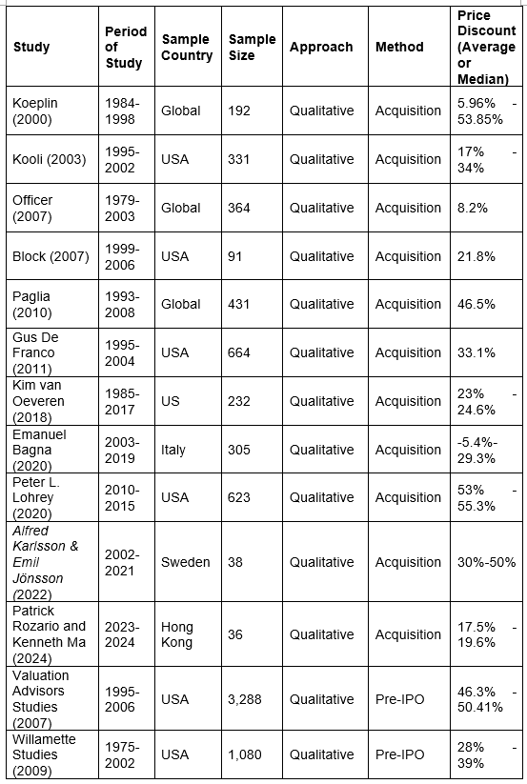
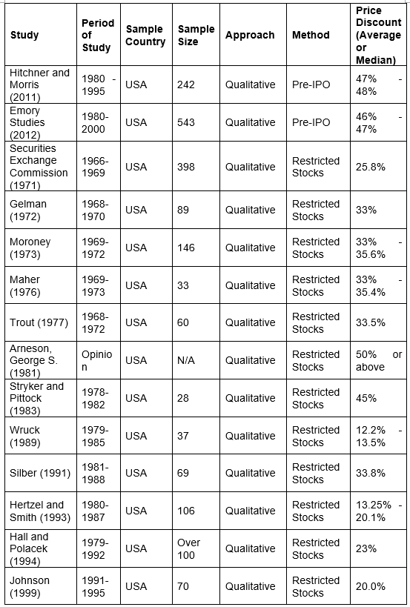

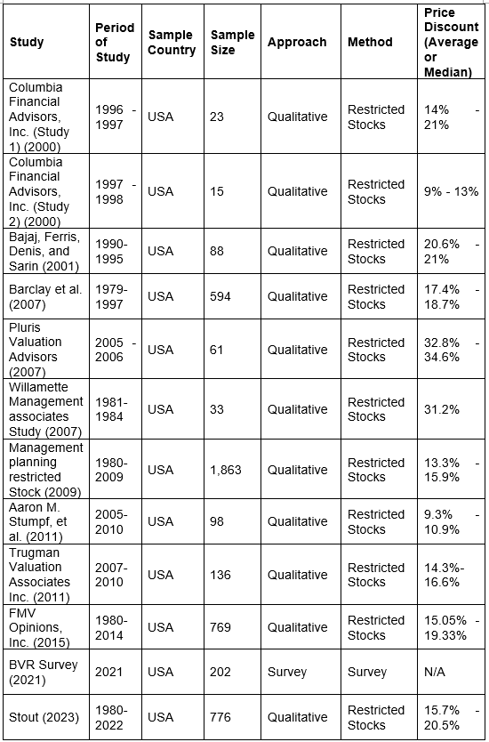
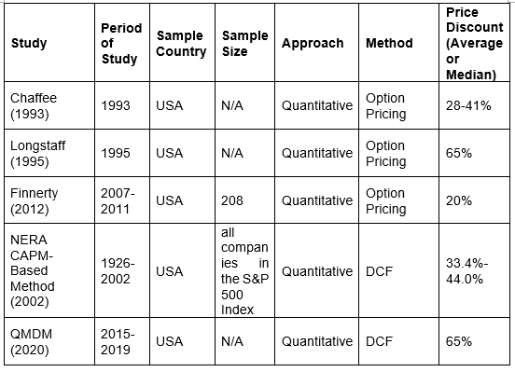

Below we will analyse the technique and results of both the Qualitative Approach and the Quantitative Approach utilized in previous researches to support the DLOM.
Qualitative Methodology
According to John W. Creswell (2024), qualitative research is a way to learn about people's social realities, like their beliefs, attitudes, and motivations, through collecting and evaluating descriptive data that isn't numerical. Extensive interviews, focus groups, or field observations are common methods used in this study to gather material that is rich in depth and context. When trying to understand complicated phenomena or people's unique viewpoints and experiences, qualitative research is generally the way to go. In studies aiming to decipher people's intrinsic motivations or the significance people ascribe to their experiences, this is especially helpful. There are two well-known studies that show how much of a gap there is between the prices of publicly traded stocks and stocks that are same or nearly identical but cannot be traded publicly at the valuation date. Restricted stock studies and pre-IPO studies are the names given to these two sets of research. Acquisition Studies are also another well recognised qualitative approaches for DLOM calculation.

Studies on Restricted Stock
To assess the impact of limited marketability, restricted stock research compares the sale price of publicly traded shares to restricted shares from the same company.
These shares are identical but for their marketability. The studies presented here are convincing because restricted stock allow for the comparison of shares of the same firm that are otherwise freely traded, sometimes at the same time.

Since 1969, the U.S. Securities and Exchange Commission (SEC) has mandated that registered investment organizations publicly disclose their internal valuation methodology for restricted securities and transaction data (SEC Accounting Series Release No. 113, dated October 21, 1969, and Accounting Series Release No. 118, dated December 23, 1970). The accessibility of the records enabled analysts to ascertain the absence of a marketability discount on assets acquired by investment firms and utilize it as a benchmark for the discount on a tightly held stake. Significant research on restricted stock includes the SEC institutional investor (1971), Gelman (1972), Moroney (1973), Maher (1976), Trout (1977), Arneson (1981), Stryker and Pittock (1983), Wruck (1989), Silber (1991), Hertzel and Smith (1993), Hall and Polacek (1994), Johnson (1999), Columbia Financial Advisors, Inc. (Study 1 & Study 2) (2000), Bajaj et al. (2001), Barclay et al. (2007), Pluris (2007), Willamette Management Associates (2007), Management Planning, Inc. (2009), SRR (2011), Trugman Valuation Associates Inc. (2011), FMV Opinions (2015), BVR Survey (2021), and Stout (2023).
There have been a lot of complaints about how restricted stock studies are used to justify non-marketability discounts for privately held company stakes. However, the main drawbacks of relying on sales are: (1) Outdated market data; (2) unsteady issuer traits; (3) abnormally high returns indicated by discounts; (4) economic variables beyond simple lack of marketability represented by discounts; and (5) Hedging methods would yield lesser discounts compared to those indicated by restricted stock analysis. So, we didn't use this method in our thesis.
Pre-IPO Analyses
Evaluations of DLOM have made use of pre-IPO investigations since the 1970s. To do this, they compare the equity interest valuation from a company's SEC filings with the common stock market price after the IPO. The idea behind the IPO is that shares sold before the offering are not marketable, but those sold after the IPO are completely liquid and can be bought and sold. There must be a percentage difference between the two prices to show that there are changes in marketability. We looked at four major pre-IPO studies, including one by Valuation Advisors (2007) and two by Willamette Management Associates (2009). Emory (2012) and Hitchner and Morris (2011).
Some limitations are shown by the pre-IPO approach. The time it takes to go from a pre-IPO deal to an IPO is often overly drawn out, according to Z. Christopher Mercer et al. (2011). If we look at the private deals that happened between five months and three years prior to the IPO, we can see that there were other, unconnected reasons for the price increase. Pre-IPO studies, unlike limited stock studies, possess the deficiency of lacking contemporaneous price comparisons between the two stocks. Consequently, price variations significantly influence not only marketability but also the company's fundamentals. Conversely, Z. Christopher Mercer et al. (2011) asserts that Pre-IPO transactions are generally undervalued to ensure complete subscription. In summary, criticisms against the use of the pre-IPO studies include: (1) Assess elements unrelated to marketability; (2) Rely on non-contemporaneous pricing comparisons; (3) Inflated owing to the elapse of time; (4) Represent remuneration for insider services; (5) Exaggerated owing to self-selection and survivorship bias; (6) Suggest implausibly substantial returns; (7) Manifest IPO price speculation; (8) Indicate that IPOs coincide with increasing profitability; and (9) Contain data inaccuracies. So, we didn't use this method in our thesis.
Acquisition Research
An alternative method to assessing DLOM entails comparing the acquisition price multiples of private firms with those of benchmark public companies. This methodology is referred to as the acquisition method for discount computation and is based on research concerning discounts in private firms. This technique contrasts the acquisition multiples of private firms with the market multiples of similar publicly traded corporations. The primary premise of the studies asserts that private firms are transacted at lower pricing multiples than public corporations, suggesting that this pricing discrepancy may reflect illiquidity. Certain analysts employ these investigations to validate a Discount for Lack of Marketability, whereas others use the analyzes for the selection and adjustment of market multiples in the market approach. The Historical Acquisition Studies include the following works: Koeplin Study (2000), Kooli (2003), Officer (2007), Block (2007), Paglia (2010), Gus De Franco (2011), Kim van Oeveren (2018), Emanuel Bagna (2020), Peter L Lohrey (2020), Alfred Karlsson & Emil Jönsson (2022), and Patrick Rozario and Kenneth Ma (2024).
While some analysts often use assessments for selecting and adjusting market multiples in the market method to valuation, others frequently use the Acquisition Method to support a Discount for Lack of Marketability. Therefore, our thesis makes use of the Acquisition Method. Although Patrick Rozario and Kenneth Ma (2024) conducted quarterly and annual analyses of the DLOM in Hong Kong, their study only provided quarterly figures and analysis but did not cover a longer time frame or provide results. As DLOM is usually used in valuations that include long-term cash flow estimates, experts and consumers would find a three- or five-year DLOM outcome more relevant and useful. We therefore apply the acquisition method to investigate the DLOM using data from the past five years so that we can give a more thorough study and result.
Quantitative Approach
Quantitative research is defined by Alan Bryman et al. (2021) as a methodology that places an emphasis on the quantification of data collection and analysis. It stems from a positivist and empiricist-influenced deductive methodology that places an emphasis on theory evaluation. The use of different quantitative methodologies and approaches allows for this to be achieved, showcasing its wide-ranging research strategy in numerous academic domains. Two quantitative methods exist for calculating the DLOM: shareholder cash flow adjustment models and option pricing models.
Option Pricing Models
Over the years, many different option pricing models have emerged, each predicated on a different set of assumptions about the opportunity costs that investors face. It appears that nonmarketable investments may need to be sold at steep discounts. Investors incur opportunity costs due to regulatory limitations on stock resale, which worsen the price penalty associated with illiquidity. Within the context of option pricing, these reductions make sense when one thinks about the underlying investment's intrinsic volatility, risk, holding term, and, on occasion, dividend yields. Opportunity cost, often known as the concept of foregone alternatives, is an economic principle that can be used by option pricing models to assess DLOM. The ability to diversify one's portfolio, take advantage of new and attractive investment opportunities, and earn returns with little outlay of capital is a hallmark of fully marketable asset owners. On the other hand, there is an opportunity cost for investors in nonmarketable assets since they do not have access to these positive liquidity options. To make up for the lost opportunities caused by not being able to resell unmarketable stock because of market frictions, investors need steep discounts. In a made-up scenario, a shareholder might buy a put option to sell their untradeable shares. By utilizing the option's price, which is obtained from option pricing models, one can evaluate the opportunity costs linked to missed financial gains during the security's restriction period. Some notable option pricing models include those proposed by Longstaff (1995), Chaffe (1993), and Finnerty (2012).
But there are a lot of problems with the Option Pricing Model. If anything, Chaffe's model implies that DLOM should go up when interest rates go down, which goes against DLOM theory. Limiting the model to corporations that pay dividends, distributions undermine the premise of DLOM by boosting the value of put options and inferred DLOM. For DLOM assessments over long time periods, the model may not be enough because the Black-Scholes put value falls with increasing option term after reaching its peak. That approach "should be utilized solely as a proxy" because it doesn't take into account other qualitative factors that affect DLOM. Analysts using Longstaff's method are unable to assume that the underlying security will pay dividends. Since distributions should theoretically reduce marketability discounts, the model frequently overestimates the discount on dividend-paying assets. The real liquidity selection differs from the economic alternative given by the model. According to the Longstaff model, the holder has the opportunity to repurchase the shares at its peak price during the option term. Under no circumstances throughout the duration of the option may the holder sell shares at the then-current market price. Any qualitative elements that can impact the marketability discount are ignored by the model. The actual liquidity option's expiration payouts might be higher in Longstaff's model. If you own an average-strike put option and the option period ends, you can sell your shares at the average realized price from the past. Because of the high liquidity, the holder can sell it at any time at the market rate. Assuming a high enough dividend yield, the sensitivity analysis of the model shows that the expected DLOM decreases with increasing holding period. This finding is at odds with the DLOM theory. When calculating the marketability discount, the model ignores all qualitative variables. Therefore, our argument does not make use of the Option Pricing Model.
Shareholder Cash Flow Adjustment Models
The Quantitative Marketability Discount Model (2020) (QMDM) and the NERA CAPM-Based Method (2002) are two notable shareholder cash flow adjustment models. Based on the correlation between shareholders' valuations of a company and its intrinsic worth, the QMDM theory postulates a marketability discount. The value to shareholders is often lower than the value to the company itself. In privately owned companies, the QMDM's discounted cash flow inputs account for the interests of minority shareholders. Since business estimates are strongly related to shareholder expectations for cash flows, risk, and growth, the QMDM uses a concurrent enterprise valuation with the nonmarketable minority stake appraisal.
Nonetheless, numerous deficiencies exist in Shareholder Cash Flow Adjustment Models. In evaluating the number of assumptions necessary for the comprehensive evaluation process, critiques regarding the model's assumption requirements appear trivial. Numerous complex assumptions are necessary to determine the enterprise value, or equity value prior to discounts, which underpins the DLOM process. Regardless of the method used, there are a number of assumptions that are inherent to valuation. For example, if you want to use discounted future cash flow analysis, you'll need to make a long list of cash flow, growth, and risk assumptions. If you want to use a market approach, you'll need to find similar transactions and/or publicly traded entities that are related to your interest. Therefore, criticizing the QMDM for over-reliance on assumptions seems narrow-minded. On Mercer's book page 225, you may see a matrix of possible discounts from 5% to 100%. The NERA CAPM-Based Method's valuation approach, regardless of the value estimate, involves certain assumptions. In addition, the Tabak model's equity risk premium is up for debate. As a result, our argument does not make use of the Shareholder Cash Flow Adjustment Model.

ANNOTATED BIBLIOGRAPHY

- Aaron M. Stumpf, et al. (2011), The SRR Restricted Stock Study, Business Valuation Review (2011), 30 (1), pp. 7–19.

SRR determined the discount for the sample of 98 transactions by comparing the transaction price to the price one day before the announcement.

- Alan Bryman, et al. (2021), Social Research Methods, 6th edn. Leicester: Oxford University Press

It is clear, comprehensive, and pays equal attention to both qualitative and quantitative methods, while offering practical, step-by-step advice to students through all stages of the research process. This includes formulating questions, choosing methods, recruiting participants, analyzing the data, and writing up the results.

- Alberto Crisostomo (2020), The Discount for Lack of Marketability: An Investigation of Privately Held Companies in North Italy, Master Thesis, Ca' Foscari University

Alberto Crisostomo provides a thorough analysis of the DLOM's concept, outlining the aspects that have the greatest impact on its computation as well as how it has evolved over time. He finds that the discount for lack of marketability ranges from 23,96% to 32,44%.

- Alfred Karlsson & Emil Jönsson (2022), The Private Company Discount: An acquisition study of public and private companies on the Swedish market, Bachelor Thesis, Linnaeus University

The study will be performed on the Swedish market and all data have been collected through Thomson Reuters Eikon Refinitiv. A minimum of one million US dollars must be the reported deal value for each deal that is offered, and at least 50% of the company's shares must be acquired.

- Arneson, George S. (1981), Non-marketability Discounts Should Exceed Fifty Percent, Taxes (January), pp. 25–31.

Arneson assessed research on investment firms' acquisitions of letter stock. He cited research by Maher and Moroney, which suggested that a closely held company's DLOM should be approximately 35 percent.

- Block, S. (2007), The Liquidity Discount in Valuing Privately Owned Companies, The Journal of Applied Finance, 17(2), pp, 33-40.

Private company discount indications of 14% based on enterprise value to book value pricing multiple analyses and 24% based on enterprise value to revenue pricing multiple analyses were reported by the Block study, as published in 2007.

- BVR Survey (2021), Methods Used for Estimating a Discount for Lack of Marketability, July 2021, Business Valuation Resources, LLC. Available at: https://sub.bvresources.com/pdfs/BVR-2021-DLOM-Survey-Results.pdf [Visited at September 2024]

BVR Survey questioned 202 interviewees whether they would apply a DLOM to a 100% interest in a private company. Among the 202 interviewees, 67 (33.17%) answered “Yes”, 54 (26.73%) answered "No”, and 81 (40.10%) answered "Maybe”.

- Chaffe III, D. B. (1993), Option pricing as a proxy for discount for lack of marketability in private company valuations, Business Valuation Review, pp. 182-188

Chaffe proposed that a Black-Scholes option pricing model at-the-money European put option might be used to replicate the marketability discount. An ATM European put option is a financial instrument that gives the holder the choice, but not the duty, to sell shares at the option's expiration date in accordance with the stock's strike price.

- David Tabak (2002) , A CAPM-Based Approach to Calculating Illiquidity Discounts, NERA Economic Consulting (Marsh & McLennan Companies), listed on www.nera.com, November 11, 2002.

It integrated the two assumptions into an excess required rate of return that can be objectively evaluated, whereas the QMDM requires separate assumptions for the expected growth rate of the asset and the investor's necessary rate of return.

- De Franco, Gus and Gavious, Ilanit and Richardson, Gordon D. and Jin, Justin Y., Do Private Company Targets that Hire Big 4 Auditors Receive Higher Proceeds (June 22, 2009). Available at SSRN: https://ssrn.com/abstract=1640496 or http://dx.doi.org/10.2139/ssrn.1640496

It contrasted purchases of public corporations in 2006 with private acquisitions of 100% ownership stakes in privately owned U.S. companies. There were 2,249 public enterprises and 673 private companies in the sample. According to the survey, marketability reductions ranged from 21% to 37% when purchasing private businesses.

- DONG Jichang, JIAO Danxiao, and SUN Xilong (2017), Acquisition Discount and Valuation Effect of Private M&As in China, Journal of Systems Science and Complexity, 2017, № 6, pp. 1364-1381

The authors came to the conclusion that unlisted companies in China are sold at a lower price than listed companies after deciding to use an acquisition strategy to create an acquisition discount for unlisted targets. The liquidity demand and the properties of the bilateral trading components are the primary determinants of the deeper discount.

- Espen Robak (2007), Discounts for Illiquid Shares and Warrants: The LiquiStat Database of Transactions on the Restricted Securities Trading Network, Pluris Valuation Advisors White Paper (January, 2007), pp. 22–32.

The Pluris Valuation Advisors’ Database of private sales transactions provided the 61 transactions used in this analysis. The transactions were facilitated by Restricted Stock Partners of New York, who established the Restricted Securities Trading Network.

- Ezra Angrist, Harry Curtis III, and Daniel Kerrigan (2011), Regression Analysis and Discounts for Lack of Marketability, Business Valuation Review (2011), 30 (1), pp. 36–48.

It conducted an analysis of the discounts on restricted stocks as compared to their openly traded counterparts. Numerous updates have been made to this study, the most recent of which examined data from 1980 to 2009.

- Finnerty, J. D. (2012), An Average-Strike Put Option Model of the Marketability Discount. The Journal of Derivatives, 9 (24), pp. 53–69.

Finnerty created a model to estimate DLOM using an average-strike put option. Asian options, such as average-strike put options, are a sort of exotic option where the holder has the choice—but not the obligation—to sell the stock at the average realized price during the option's term.

- FMV Opinions (2015), Determining Discounts for Lack of Marketability, A Companion Guide to the FMV Restricted Stock Study, 2015 edn, FMV Opinions, Inc.

Recurrent examinations of the restricted stock transactions in its exclusive transaction database were first published by FMV Opinions Inc. in 2001. The studies have been released annually in more recent years.

- Francis A. Longstaff (1995), How Much Can Marketability Affect Security Values, The Journal of Finance (December 1995), pp. 1767-1774.

Using a lookback put option, Longstaff offered an alternative approach for calculating DLOM. The right, but not the responsibility, to "look back" and sell the stock for the highest realized price during the option's term is granted to the holder of a lookback put option.

- Gelman, M. (1972), An Economist Financial Analyst’s Approach to Valuing Stock of a Closely Held Company, The Journal of Taxation, 36(6), pp. 353-354.

Gelman examined four investment corporations' 1968–1970 purchases of restricted securities. According to Gelman, investment firms purchase the equities straight from the business or, occasionally, from stockholders who are selling their holdings. Restricted securities are typically acquired for a significant discount to freely-marketable securities of the same class as the firm because their transferability is restricted.

- Hall, Lance S., and Timothy C. Polacek (1994), Strategies for Obtaining the Largest Valuation Discounts, Estate Planning, January/February 1994, pp. 38-44.

It reviewed actual Tax Court cases where a DLOM was allowed. The research conducted by Hall and Polacek affirms that the extent of the discount is frequently determined by the amount of the subject company's earnings, revenues, and the exchange on which the unrestricted stock was sold.

- Hertzel, M., and Smith, R. L. (1993), Market Discounts and Shareholder Gains for Placing Equity Privately, The Journal of Finance, 48(2), pp. 459-485.

In order to determine the causes of discounts on private placements and the ensuing aberrant returns, Hertzel and Smith conducted a study on private placements. "While the illiquidity of unregistered shares offers some insight, it is unclear why investors want such significant discounts and why companies are prepared to grant them.

- Hitchner, et al. (2017), Financial Valuation Applications and Models, 3rd edn. New Jersey: John Wiley & Sons, Inc., pp. 387-389.

In order to ascertain whether the DLOM was higher for transactions that were the furthest from the IPO date, Hitchner/Morris conducted an analysis on the Emory Study data for the period January 1980 through June 1995.

- James R. Hitchner (2024), Financial Valuation – Applications and Models, 4th Edn., Canada: John Wiley & Sons, inc., p.412

Defensible and suitable methods for preparing and presenting company values are laid out in this authoritative guide. This new edition, which is a must-have for anyone looking for the latest advice with a focus on models and applications, is compiled with the help of thirty of the best specialists in the area.

- John W. Creswell (2024), Educational Research: Planning, Conducting, and Evaluating Quantitative and Qualitative Research, 7th edn. Nebraska: Pearson Plc.

It first examines the general steps in the research process and then details the procedures for conducting specific types of quantitative, qualitative and mixed methods studies. Direct guidance on reading research is offered throughout and helpful features provide opportunities for you to practice and apply what you have learned.

- John D. Emory (1997), The Value of Marketability as Illustrated in Initial Public Offerings of Common Stock (Eighth in a Series), November 1995 through April 1997’, Business Valuation Review 16, no. 3 (September 1997): pp. 123–124.

Emory examined the prospectuses for nearly 4,000 transactions to find transactions that happened little more than five months before the IPO for studies spanning the years January 1980 to December 2000.

- Johnson, B. A. (1999), Restricted Stock Discounts. Shannon Pratt's Business Valuation Update, 5(3).

It examined seventy-two private placements that took place between 1991 and 1995. The five years that followed the relaxation of Rule 144 restrictions under Rule 144A, which let eligible institutional investors to trade unregistered securities without registering them, were represented by this era.

- James R. Hitchner (2017), Financial Valuation Applications and Models, 4th Edn, New Jersey: John Wiley & Sons, Inc. pp. 392-493.

It gives an overview of research that supports discounts for unmarketability and talks about what kinds of underlying income streams these discounts would apply to.

- James R. Hitchner (2017), Financial Valuation Workbook, 4th Edn, New Jersey: John Wiley & Sons, Inc.

This book includes valuation techniques that professionals can use to prepare business valuations and discount for lack of marketability, as well as educational exercises that walk the reader through a thorough business valuation.

- Johan Van den Cruijce (2022), Determinants of the Discount for Lack of Marketability, The European Business Valuation Magazine, 1 (2), pp. 4-11

He provide evidence of factors that contribute to a more accurate approach and demonstrate how the industry practice of using average DLOMs to value any private company produces inaccurate results.

- Karen H. Wruck (1989), Equity Ownership Concentration and Firm Value, The Journal of Financial Economics, 23(1989), pp. 3–28.

Dr. Wruck looked into the impact of ownership concentration on the value of the company as well as the reasons behind the typical anomalous return that comes from the news of a private equity sale as opposed to the negative

- Kathryn F. Aschwald (2000), Restricted Stock Discounts Decline as Result of 1-Year Holding Period – Studies After 1990 “No Longer Relevant” for Lack of Market ability Discounts, Shannon Pratt’s Business Valuation Update 6, no. 5 (May 2000), pp. 1-5.
For the indicated periods, only private equity placements were analysed in the two studies. The value of the stock swapped in acquisitions is determined by the two studies using long restriction periods and economic variables unique to the Company.

- Kim van Oeveren (2018), The Private Company Discount- An acquisition study on private firms within the US, Master Thesis, Tilburg University

The sample takes into account all domestic M&A deals that were done in the US between 1985 and 2017. The SDC Platinum database is where the data came from. All completed deals up to 31/12/2017 are included. It only took into account deals that have disclosed value.

- Koeplin, J., Sarin, A., & Shapiro, A. C. (2000), The Private Company Discount, The Journal of Applied Corporate Finance, 12(4)

It shows matching pairs of transactions for acquisitions made between 1984 and 1998. These are made by finding a public business transaction for every purchase made by a private company during that time frame.

- Kooli, M., Kortas, M., & L'Her, J.-F. (2003), A New Examination of the Private Company Discount: The Acquisition Approach, The Journal of Private Equity

A study conducted in 2003 by Kooli was based on a sample of 331 private firm transactions that occurred between 1995 and 2002 and were found through a search of the SDC and Done Deals databases. It's interesting that Kooli did not leave out financial firms.

- Leslie Rodríguez-Valencia, Prosper Lamothe-Fernández, and David Alaminos (2023), The market value of SMEs: a comparative study between private and listed firms in alternative stock markets, Annals of Finance, 2023, vol 19, issue 1, No. 4, pp.95-117

Through the use of a comparable multiples technique and a private discount approach that incorporates value estimates derived from discounted cash flow predictions, this study seeks to compare the market values of small and medium-sized enterprises (SMEs) that are publicly listed and those that are privately held in alternative stock exchanges.

- Lucas Parris (2022), International Valuation Glossary – Business Valuation, American Society of Appraisers.

The Glossary aims to provide a common understanding of technical terms used within the various sub-practice areas of business valuation, and for those operating in different markets. Users of valuation services are encouraged to familiarize themselves with the appropriate context, as not all terms are applicable to every use.

- Maher, J. Michael (1976), Discounts for Lack of Marketability for Closely Held Business Interests, Taxes – The Tax Magazine, pp. 562-571.

It conducted a further well-researched analysis, which was published in Taxes, on the lack of marketability discounts for closely held business ownership interests. Maher's analytical approach was comparable to Moroney's in that it contrasted the market prices of limited equities with the prices paid for stocks that were not restricted.

- Mercer (2020), Business Valuation: An Integrated Theory, 3rd edn, New Jersey: John Wiley & Sons, Inc. pp. 175-176

Mercer’s QMDM is a shareholder-level cash flow model. All the discounted cash flow inputs in QMDM, however, are customized to take into account the interests of private company owners, such as the long-term growth rate, discount rate, and distribution of dividends.

- Michael Gregory (2024), Gregory Reveals What’s Going on With the IRS and Tax Valuations, Business Valuation Update, Business Valuation Resources, LLC, August 2024

Gregory provided a helpful chart about debt liability management (DLOM) that illustrates appropriate DLOM approaches for different kinds of organizations and circumstances, as per the IRS's input.

- Michael J. Barclay, Clifford G. Holderness, and Dennis P. Sheehan (2007), Private Placements and Managerial Entrenchment, The Journal of Corporate Finance, 13 (2007), pp. 461–484.

To find out why purchasers and sellers of private placements of stock do such, Barclay et al. conducted an extensive study on private placements of large-percentage blocks of stock. From 1979 to 1997, a sample of 594 private placement deals were found by searching the Dow Jones News Service database.

- Moroney, Robert E. (1973), Most Courts Overvalue Closely Held Stocks, Taxes: The Tax Magazine, pp. 144-155.

Moroney analysis the price of 146 acquisitions of restricted stock by 10 investment companies. Moroney compares the evidence of the real cash deals with the lower average price reductions determined by most previous court rulings on gift and estate tax issues due to lack of marketability.

- Mukesh Bajaj, Stephen P. Ferris, David J. Denis, and Atulya Sarin (2001), Firm Value and Marketability Discounts, The Journal of Corporation Law

Bajaj located every private placement that was finished between January 1, 1990, and December 31, 1995, and that was recorded in Securities Data Corporation's electronic database. Information from the Dow Jones News Retrieval Service was compared to the data.

- Officer, M. S. (2006), The price of corporate liquidity: Acquisition discounts for unlisted targets, The Journal of Financial Economics, pp. 571-598.

Officer compared "acquisition multiples for unlisted targets to acquisition multiples for portfolios of comparable (industry- and size-matched) publicly-traded targets" in a study that employed a methodology akin to that of Koeplin and Kooli.

- Paglia, J. K., & Harjoto, M. A. (2010), The Discount for Lack of Marketability in Privately Owned Companies: A Multiples Approach, The Journal of Business Valuation and Economic Loss, 5(1), pp. 1-26.

An analysis of 674 private firm transaction multiples in comparison to publicly traded guideline market trading price multiples was released by Paglia in 2010.

- Patrick Rozario and Kenneth Ma (2024), Control Premium & Discount For Lack of Marketability Study, Issue 3, Moore Hong Kong

It quarterly summarised the circulars included valuation reports with the adoption of discounts for lack of marketability in Hong Kong Stock Exchange.

- Peter L. Lohrey (2020), The Dodd-Frank Act and the Private Company Discount: An Empirical Investigation, American Accounting Association, The Journal of Forensic Accounting Research, 5(1), pp. 298–318

This study uses acquisition data to perform an empirical investigation into value of private companies. It reviews the literature that examines whether unlisted target companies are acquired at a discount compared to the prices paid for publicly traded target companies.

- Pittock, William F., and Charles H. Stryker, Revenue Ruling 77-276 Revisited, SRC Quarterly Reports, Spring 1983, pp. 1-3.

It examined 28 restricted stock purchases following the format of the SEC Study on letter stock. They discovered that the median discount at which limited stocks sold was 45 percent by comparing their value to public equities issued by the same corporation.

- SHANNON P. PRATT (2012), Business Valuation Discounts and Premiums, 2nd Edn., New Jersey: John Wiley & Sons, Inc.

Shannon Pratt skilfully and logically explains the various discounts or premiums that may be applicable, depending on the basic valuation approach used, and how the valuation approaches used affect the level. Shannon Pratt addresses the three basic approaches to conducting a valuation: the income approach, the market approach, and the asset approach.

- Shannon P. Pratt (2022), Valuing a Business: The Analysis and Appraisal of Closely Held Companies, 6th edn, New York: McGraw-Hill, pp. 425.

The purpose of the study was to present more recent data on DLOM for restricted stock transactions. Shannon Pratt (2012) claims that the report was initially created to bolster his claims in a Tax Court case. He eliminated all the blatant insider trades, corrected the price to reflect the date's difference from the IPO's pricing, and took industry P/E ratios into consideration.

- Securities and Exchange Commission (1971), Discounts Involved in Purchases of Common Stock Institutional Investor Study Report. Do. No. 92-64, Part 5, pp. 2444- 2456.

It compared the prices at which transactions of restricted securities were made to the prices of publicly traded stocks from the same companies in a study that was published in March 1971 and reviewed purchases of restricted securities by investment companies for the period of January 1, 1966, through June 30, 1969.

- Stout Risius Ross (2023), The Stout Restricted Stock Study Companion Guide, 2023 edn, Stout Risius Ross, LLC

Searches conducted across multiple sources, such as 10K Wizard, Security Data Corp., EDGAR and EDGAR Pro, Dow Jones News Retrieval, Disclosure CompactD, and S&P Corporate Transactions Records, yielded the majority of the transactions included in the study.

- T. Koller et al.(2020), Valuation: Measuring and Managing the Value of Companies, 7th Edn., New Jersey: John Wiley & Sons, Inc.,

This book provides useful information including complete, detailed guidance on every crucial aspect of corporate valuation, explanation of the strategies, techniques, and nuances of valuation that every manager needs to know, and details on both core and advanced valuation techniques and management strategies.

- Trout, R. R. (1977), Estimation of the discount associated with the transfer of restricted securities. Taxes, 55, pp. 381–385..

Robert Trout conducted research on mutual fund purchases of limited stocks, just like Gelman. His period of time was 1968–1972. He made use of three additional fund in addition to the three Gelman had studied.

- Valuation Advisors (2007), Lack of Marketability Discount Study—DLOM Database (Discount for Lack of Marketability), Business Valuation Resources

It conducts a comparative analysis between the pre-IPO prices of common stock, convertible preferred stock, and common stock options and the IPO stock price.

- William Harris (2011), ‘Trugman Valuation Advisors, Inc. (TVA), Restricted Stock Study’, Business Valuation Review (Winter 2011): pp. 132–139.

It examines stock discounts that occurred between January 2007 and December 2008, a time of intense financial market volatility and widespread investor concern. In the first study, 80 transactions were examined to see if greater indicated DLOM was a direct result of the economic downturn.

- William L. Silber (1991), Discounts of Restricted Stock: The Impact of Illiquidity on Stock Prices, The Financial Analysts Journal, pp. 60–64.

The study's objective is to present proof of the influence of liquidity on restricted stock pricing. It's interesting to note that Silber included marketability as a variable in his formulas. Silber used the block size expressed as a percentage of the total number of outstanding shares to determine marketability.

- Z. Christopher Mercer et al. (2011), Buy-Sell Agreements for Closely Held and Family Business, New York: Peabody Publishing, LP

It provides you a guide for understanding what your agreement says from business and valuation perspectives. The book includes a comprehensive and yet understandable roadmap for business owners and their advisers.

