DS 1 Template

My Screenshots/Photos
- Please add 4–6 screenshots or photos of your digital life.
- You can use your phone or laptop.
- For each screenshot, write one or two sentences explaining what it shows.
- Outlook email, calendar, WhatsApp, LinkedIn, social media, ChatGPT

Screenshot/Photo 1
[Insert Photo/Screenshot below]
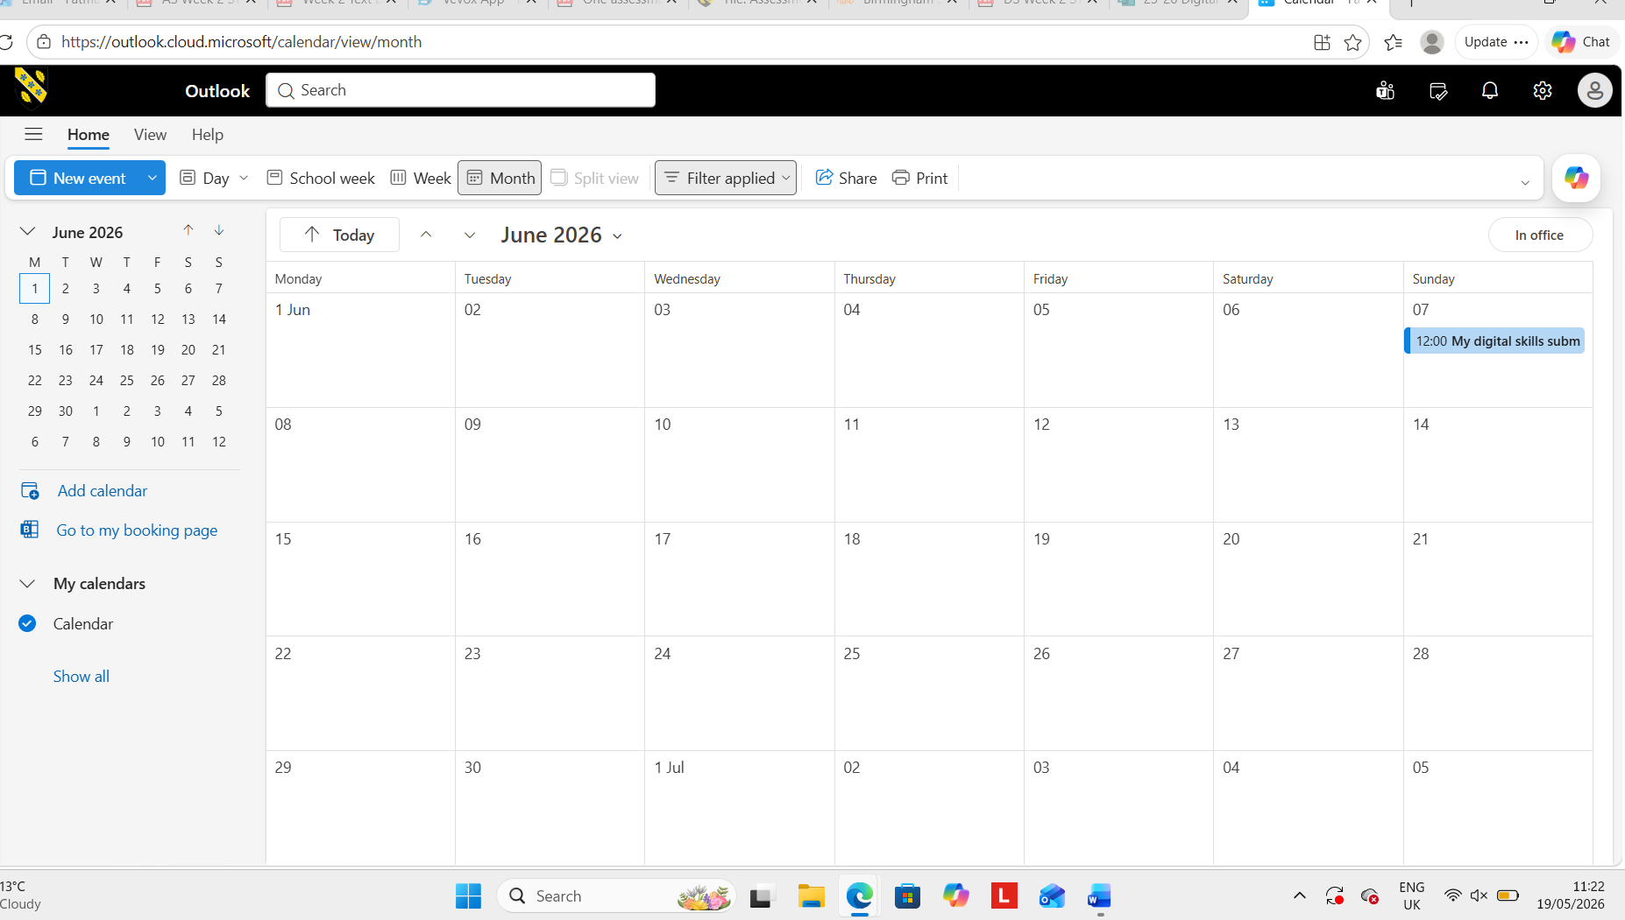
(calendar)
I intend to use the calendar to schedule my appointments, meetings and deadlines.
It will give me daily and weekly notifications to remind me of upcoming schedules.
It helps me manage my time effectively and make sure I don’t miss events.

Screenshot/Photo 2
[Insert Photo/Screenshot below]
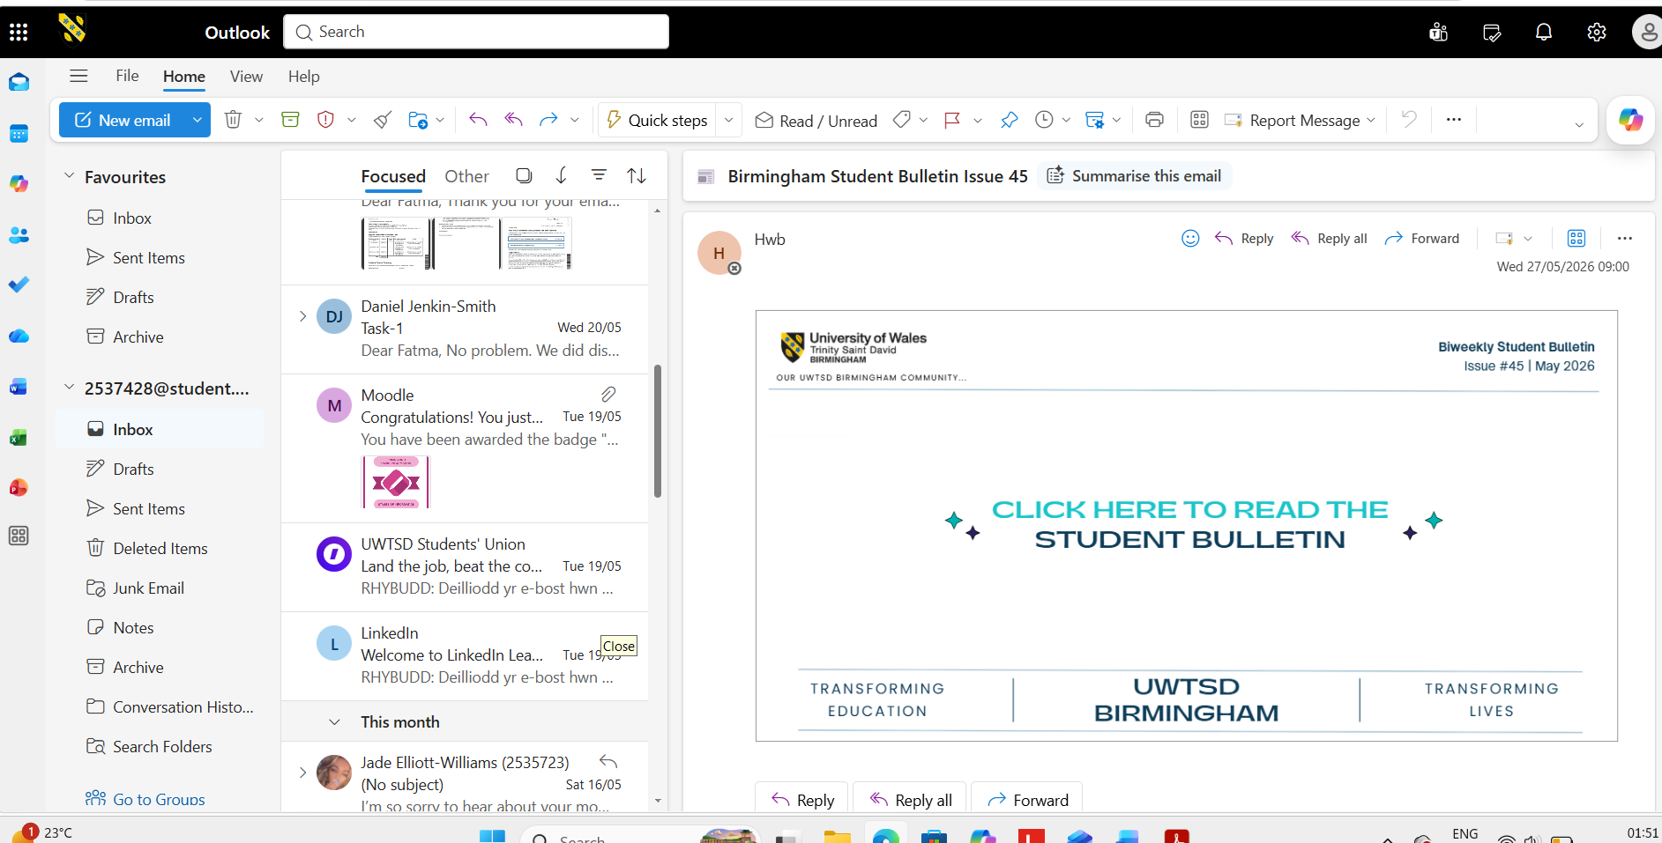
(email)
I use email daily to communicate professionally. Also, it helps me connect to service providers such as shopping, receipts, appointments, and keeping evidence.

Screenshot/Photo 3
[Insert Photo/Screenshot below]
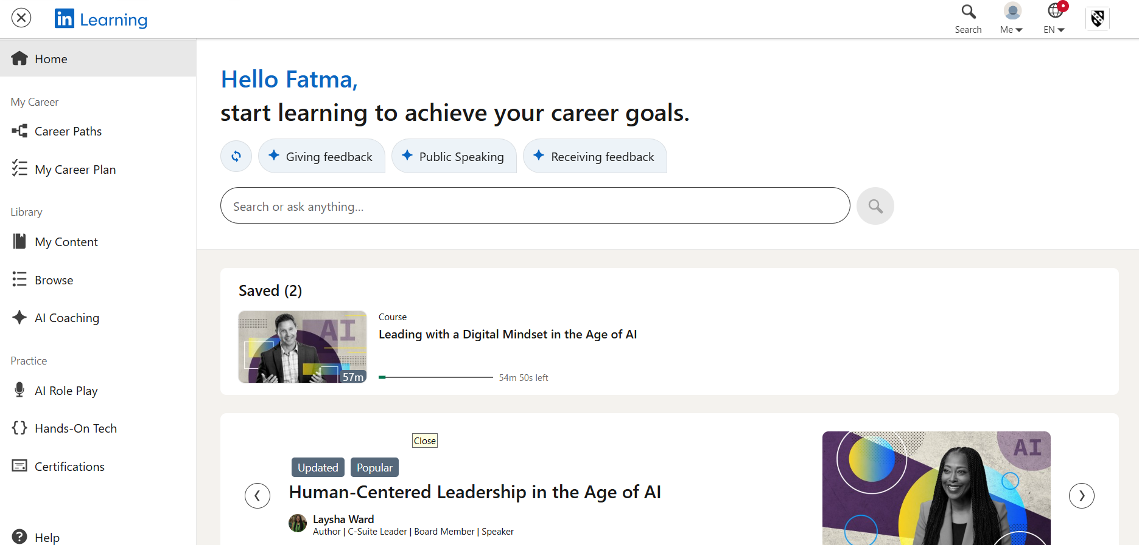
(LinkedIn)
I use LinkedIn daily to search for careers and connect with professionals and companies.
It helps me build my career skills by learning about which companies have achieved what and how it can help me in the future. I can also track developments in my industry to help me stay informed.

Screenshot/Photo 4
[Insert Photo/Screenshot below]
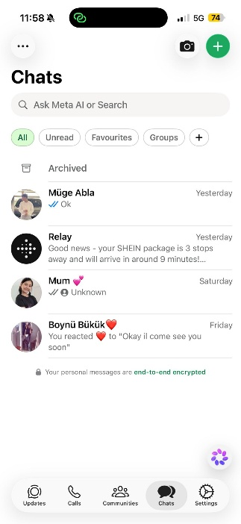
(whatsapp)
Using WhatsApp daily for communicating with friends and family via phone call or video from anywhere around the world.
I can share memories, files and many others.
Also, I can join multiple groups within my contact list or community groups to be able to catch up with new updates.

Screenshot/Photo 5
[Insert Photo/Screenshot below]
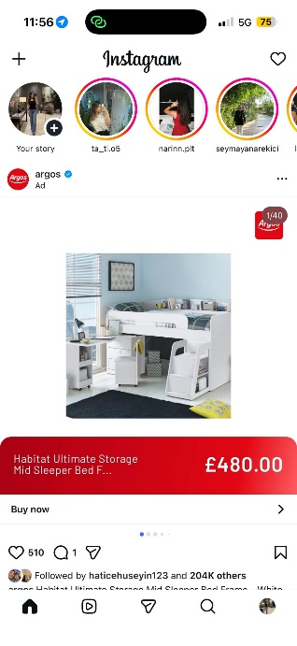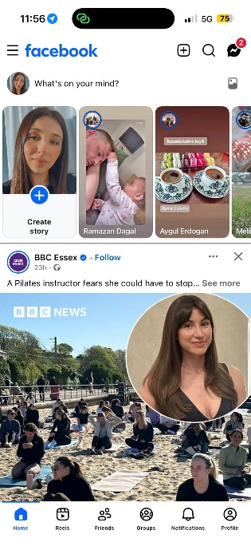
(social media)
Social media makes it easy for me to follow businesses, family, friends, and news about the world.
I also share content for my friends and family to see on my own profile.
It also allows me to see trending information sooner.

Screenshot/Photo 6
[Insert Photo/Screenshot below]
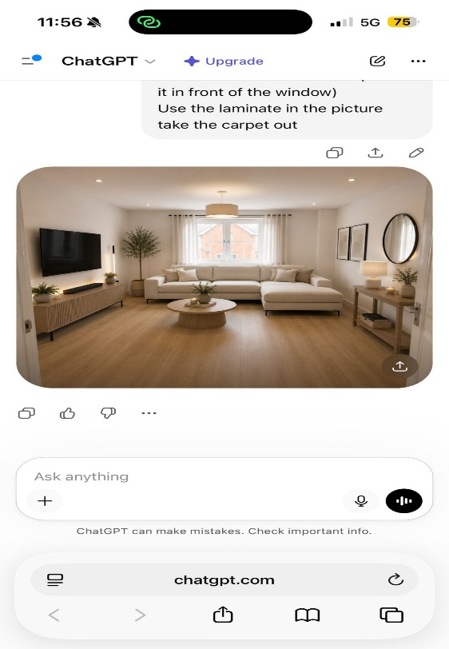
(AI)
I use AI online to help me find information I can't access from some websites or books.
Very useful to generate ideas, such as designing my living room, editing my images and checking my spelling and grammar.

My Short Reflection
- Write 5–8 simple sentences about your digital life.
- You can use the sentence starters below if helpful.
I use digital tools to have a good quality of life by using Outlook and the calendar it helps me track and keep up with my schedule.
I want to improve my use of LinkedIn since I have very little knowledge of how the website works.
I often use tools to help me to correct my spelling and grammar since I can email and text professionally.
Digital skills are important to me because business and life largely rely on technology, so I need to improve them.
I sometimes feel nervous about security online, such as phishing emails or scam websites, so my goal is to get better and keep safe online.

Sentence starters
- I use digital tools to …
- I feel confident when I …
- I want to improve …
- I often use these tools: …
- I sometimes feel nervous about …
- I hope this module will help me …
- Digital skills are important for me because …
You can write more if you want.

Submission Checklist
Before you submit, please check:
​​​ ☐ I added 4–6 screenshots
☐ I wrote short sentences for each screenshot
☐ I wrote my short reflection
☐ My work is my own
☐ My file opens correctly
​​☐ My file opens correctly

