4/24/2026
Introduction to Web and Database Concepts

REPORT TEMPLATE

Module: Introduction to Web and Database Concepts (ACCA4023)
Assignment: HTML & CSS Web Development
Student Name: Fernel Ramirez Espinal
Student ID: 2508572
Course: Introduction to Web and Database Concepts (ACCA4023_LON)
Submission Date: 24/04/2026

Table of Contents
Automatically generated if possible
List all sections and subsections with page numbers

1. Introduction (Abstract)
The purpose of this project was to design and hand-code a responsive, multi-page website following modern web standards. The chosen website, Dominican Republic Guide,
The website consists of four main pages: a Home page, providing an overview of the guide and its key offerings; an About page, describing the tourism’s history, mission, and services; and a Contact page, allowing visitors to send messages and access location details. The design emphasizes usability, accessibility, and responsiveness, ensuring that the site functions effectively across desktops, tablet, and mobile devices.
This report documents the requirements, design decisions, implementation process, and evaluation of the website. Validation of HTML and CSS is included to demonstrate compliance with web standards. Additionally, the report evaluates the site in terms of usability, accessibility, and search engine optimization (SEO), with references to relevant academic studies. The overall aim is to showcase both practical web development skills and an understanding of key web design principles. [1]

2. Requirements
The Dominican Republic Guide website was developed to provide a clear, informative, and visually appealing online presence for a fictional local guide. The main purpose of the website is to promote the guide’s offerings, including tourism and the friendly atmosphere, while providing users with relevant information about the business and ways to contact it.
Purpose
- Introduce visitors to the guide and its services.
- Provide a platform for users to contact the guide for inquiries or reservations.
Subject Matter
- The website focuses on guide experience, including guide, gallery photo, ambiance, and staff.
- Each page provides specific information:
  - Home Page: Overview of the guide.
  - About Page: Background, mission, and philosophy of the guide.
  - Gallery page: Has a few photos so you can see what we offer.
  - Contact Page: Form to send messages and display location/contact information.
Target Audience
Tourists are looking for a guide to relax or socialize.
tourist enthusiasts seeking high-quality, ethically sourced guide.
Potential customers who want to find information about the guide’s offerings and contact options.
Users of all devices, including desktops, tablets, and mobile, require a responsive and accessible design.
Key Requirements
- Responsive Design: The website must adapt to different screen sizes using CSS Grid or Flexbox.
- Usability: Navigation should be simple and intuitive; content should be easy to read.
- Accessibility: Include all text for images, readable font sizes, and sufficient color contrast. [2]
- SEO Considerations: Proper page titles, headings, and meta descriptions to improve search visibility.
- Standards Compliance: HTML and CSS should validate according to W3C standards.
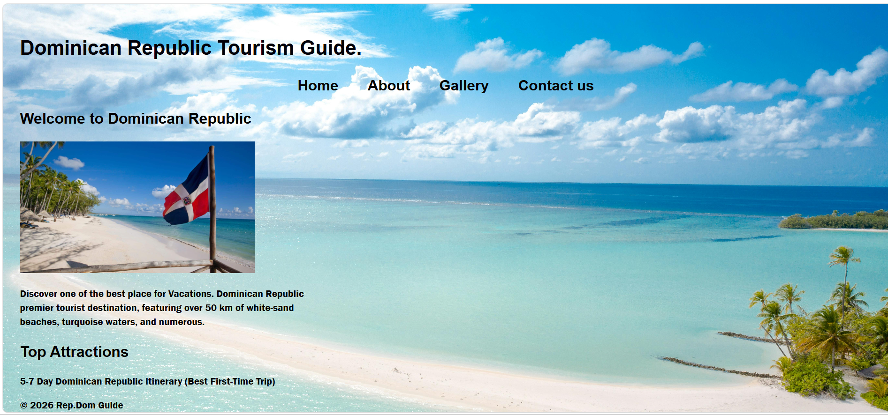
This image is a screenshot of a webpage titled “Dominican Republic Tourism Guide.” It appears to be a simple travel website displayed in a browser on a Windows computer.
At the top of the page, there is a large heading with the title, followed by a vertical navigation menu on the left with links such as Home, About, Gallery, and Contact us. Below that, there is a welcoming section labeled “Welcome to Dominican Republic.”
The main visual feature is a bright, tropical beach scene. On the left, there is a smaller rectangular image showing a sandy beach lined with palm trees and clear turquoise water. A Dominican Republic flag is mounted on a wooden pole in the foreground. The same flag and beach scene also appear enlarged as a background image on the right side of the page, filling most of the screen.
At the bottom of the visible section, there is a short paragraph describing the Dominican Republic as a popular vacation destination, mentioning its white-sand beaches and tourist attractions.
The browser interface is visible at the top, showing multiple open tabs and a local file path, suggesting the webpage is being viewed from a file saved on the computer rather than a live website.

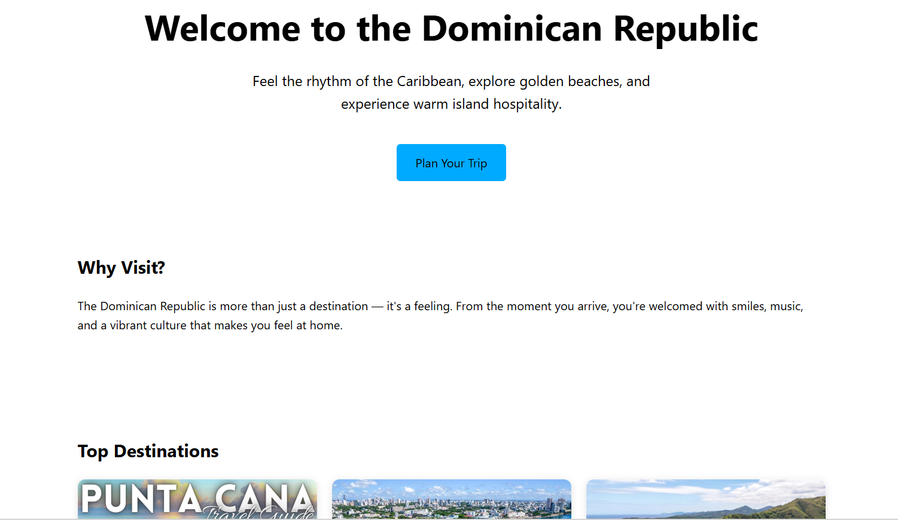
Home page screenshot, At the top center of the page, there is a large, bold heading that reads “Welcome to the Dominican Republic.” Directly underneath, a short tagline invites visitors to “feel the rhythm of the Caribbean, explore golden beaches, and experience warm island hospitality.” Below this text is a blue button labeled “Plan Your Trip,” which stands out as a call-to-action.
Further down the page, there is a section titled “Why Visit?”. It contains a paragraph explaining that the Dominican Republic is more than just a destination—it’s an experience filled with welcoming people, music, and vibrant culture.
Below that, the page begins a “Top Destinations” section. Part of this section is visible, showing image thumbnails—one clearly labeled “Punta Cana,” with other scenic images beside it that likely represent popular locations.

The browser interface is visible at the top, including multiple open tabs and a file path indicating the page is being viewed from a local file (homepage.html). At the bottom of the screen, the Windows taskbar is visible, showing system icons, the time, weather (light rain, 19°C), and several pinned applications.

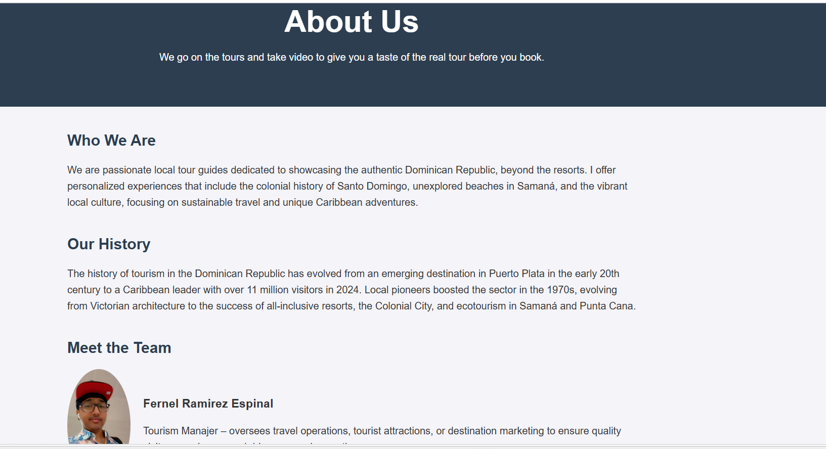
This image shows an “About Us” page from a Dominican Republic tourism website.
At the top, there is a wide dark-blue banner with a large heading that reads “About Us.” Beneath it is a short sentence explaining the purpose of the site: they go on tours and record videos to give customers a preview of the experience before booking.
Below the banner, the page is divided into sections:
- “Who We Are”: This section describes the team as passionate local tour guides who focus on showcasing the authentic Dominican Republic beyond resorts. It mentions personalized experiences, including the history of Santo Domingo, hidden beaches in Samana, and local culture, with an emphasis on sustainable travel.
- “Our History”: This part explains how tourism in the Dominican Republic has grown—from early development in Puerto Plata to becoming a major Caribbean destination with millions of visitors. It highlights growth in the 1970s and mentions attractions like the Colonial City, Punta Cana, and ecotourism areas.
- “Meet the Team”: At the bottom, there is a team member profile. It includes a circular photo of Fernel Ramirez Espinal and a brief description of their role as tourism manager.
Overall, the page has a clean, structured layout with headings, paragraphs, and a professional, informative tone focused on travel and tourism.

The layout is organized in a grid of cards, each displaying a scenic photo along with a location name. The design uses rounded image tiles, soft shadows, and a neutral background to make the images stand out.
What’s shown in the gallery:
- A natural pool surrounded by rocks and wooden stairs at Hoyo Azul
- A tropical island with white sand and turquoise water at Cayo Levantado
- A historic government building in Santo Domingo
- A monument and horse carriage scene in Santiago de los Caballeros
- A beach view labeled Puerto Plata
- A coastal resort and cruise port in La Romana
Overall impression:
The page looks like a travel-themed gallery or portfolio, likely created for a website project or personal showcase. It highlights some of the most popular tourist destinations in the Dominican Republic, combining vibrant nature, beaches, and urban landmarks in a visually appealing way.
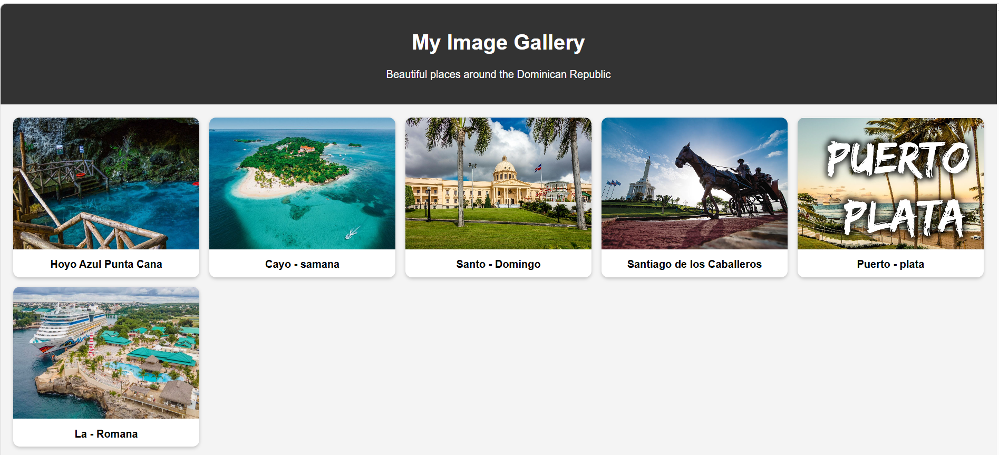

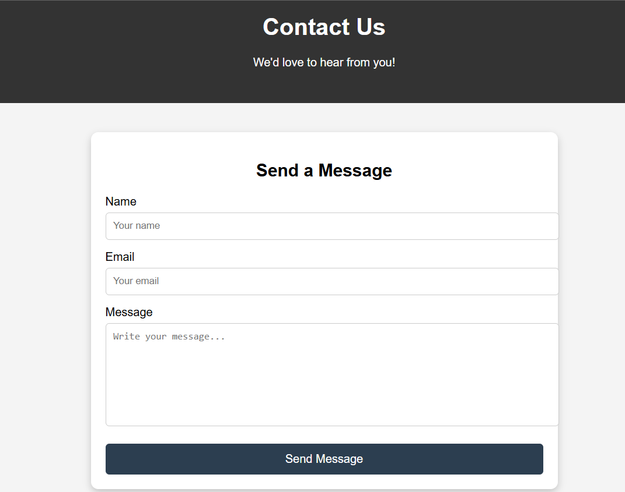
“Contact Us” webpage section with a clean, user-friendly design focused on collecting messages from visitors.
Key elements in the layout:
- Header section:
At the top, there’s a dark banner with the title “Contact Us” and a friendly subtitle: “We’d love to hear from you!” This creates a welcoming tone.
- Contact form card:
Centered on the page is a light-colored card with rounded corners and a soft shadow, making it stand out from the background.
- Form fields:
The form includes three main input areas:
  - Name – a text field for the user’s name
  - Email – a field for entering an email address
  - Message – a larger text area for writing a message
- Call-to-action button:
At the bottom, there’s a prominent “Send Message” button, styled in a dark color to attract attention and encourage submission.
Overall impression:
The design is simple, modern, and functional, typical of a website contact page. It emphasizes usability and clarity, making it easy for users to quickly fill out and send a message. The layout would fit well in a business website, portfolio, or travel site (like the gallery you showed earlier).
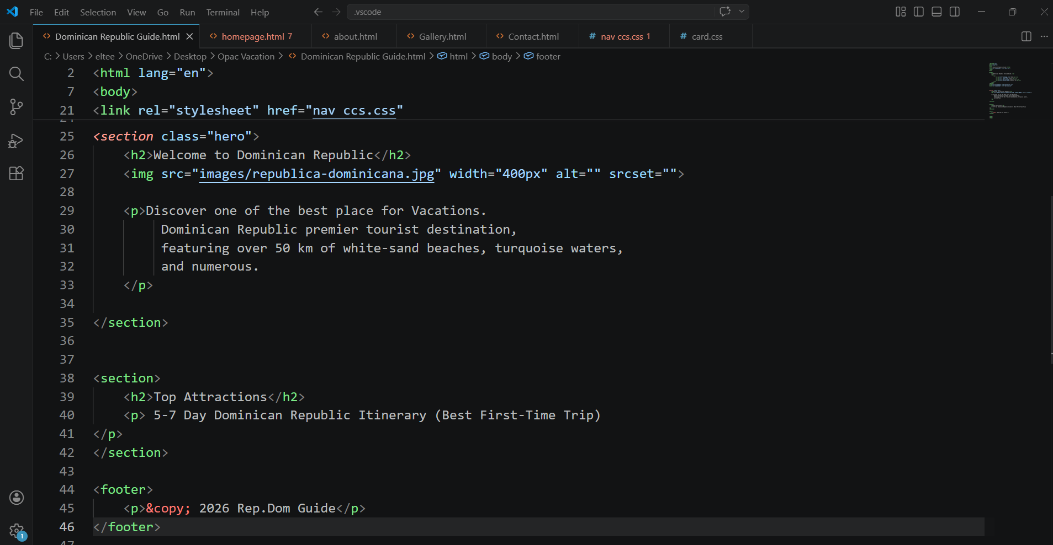
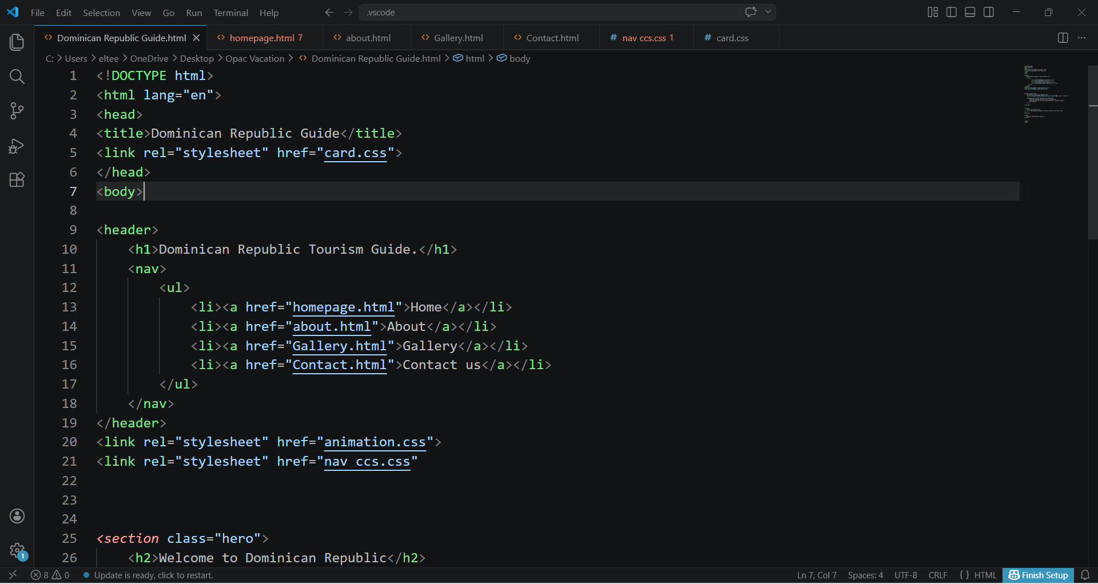
Dominican Republic Tourism Guide HTML CODE.

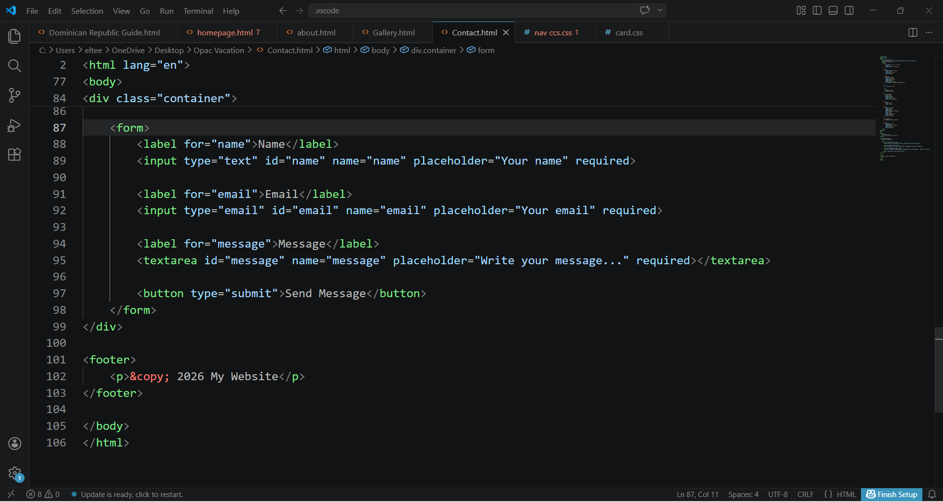
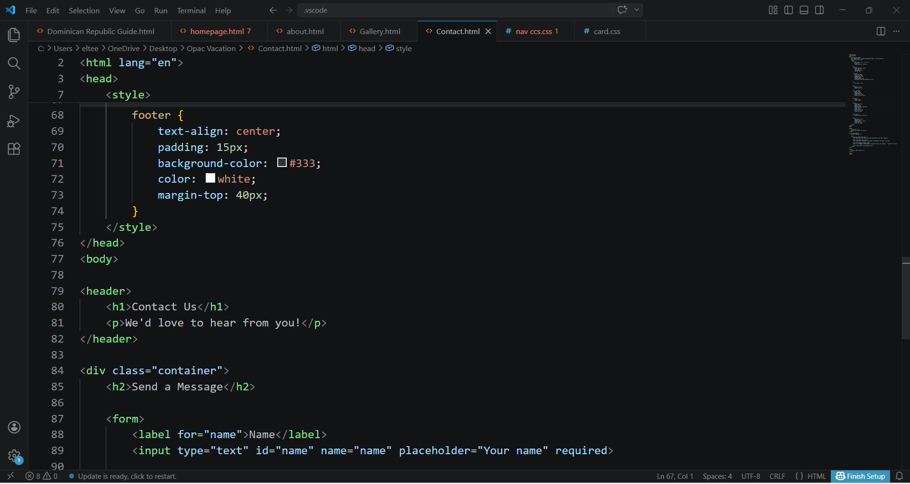
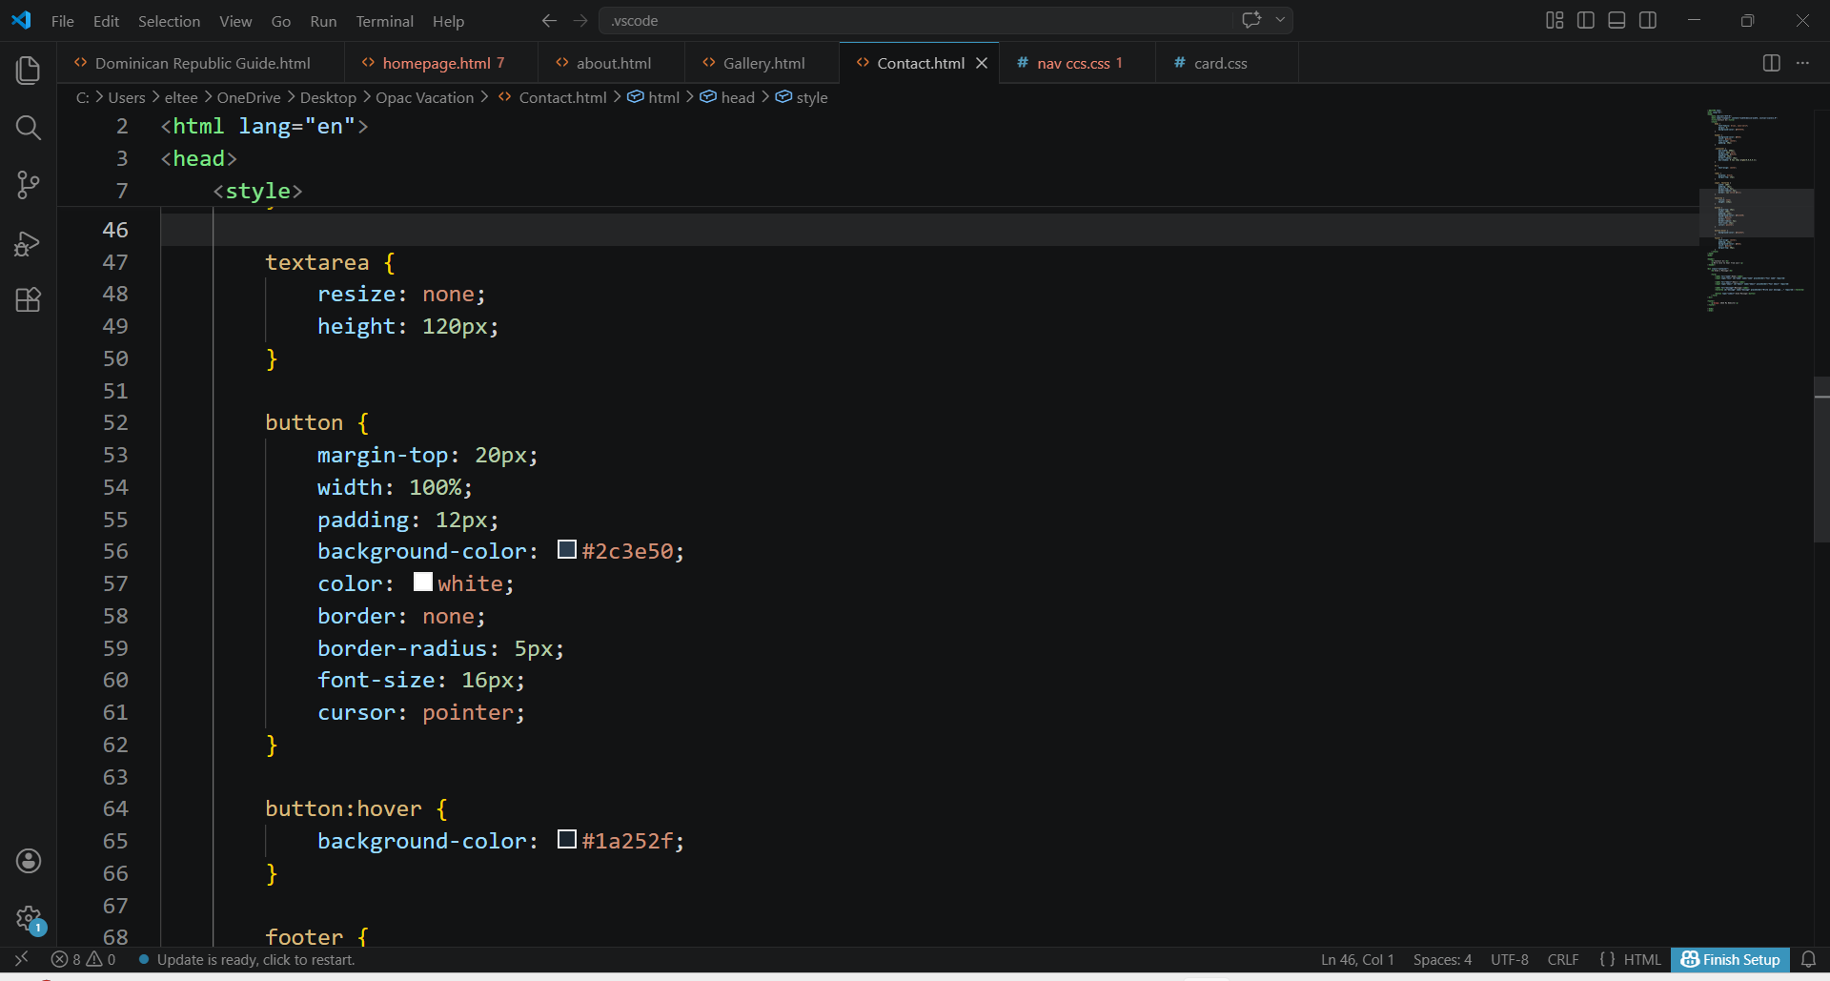
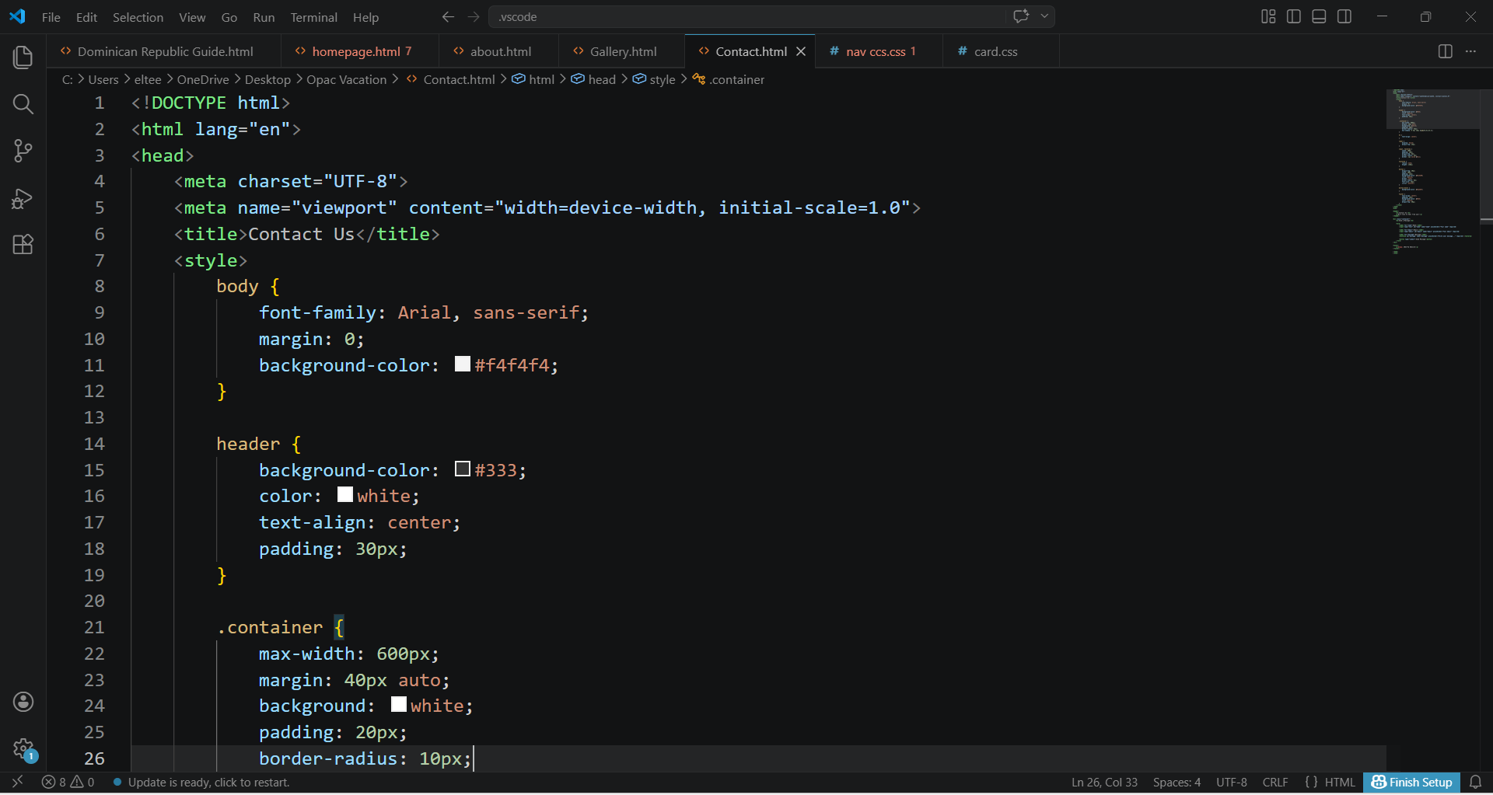
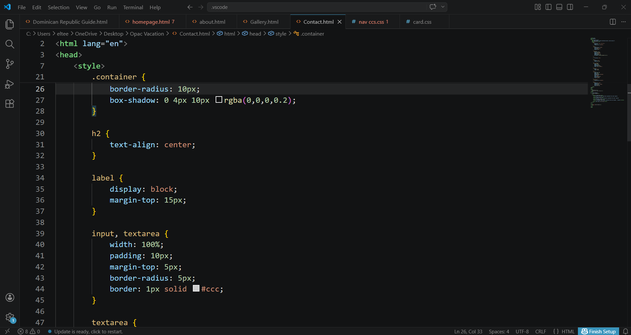
HOME PAGE HTML CODE.
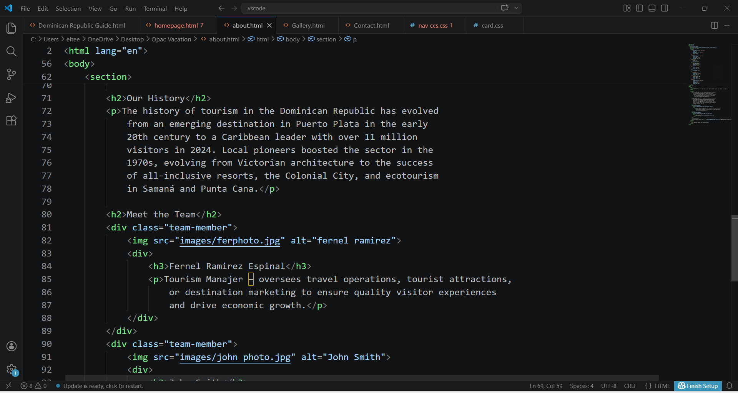
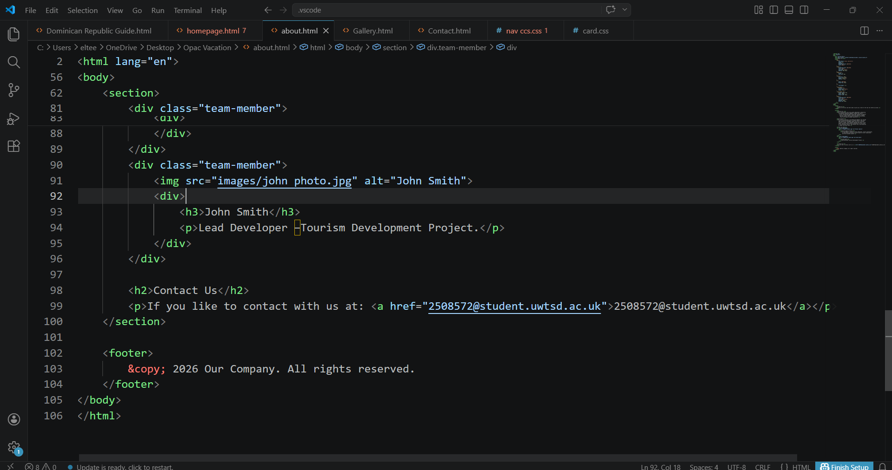
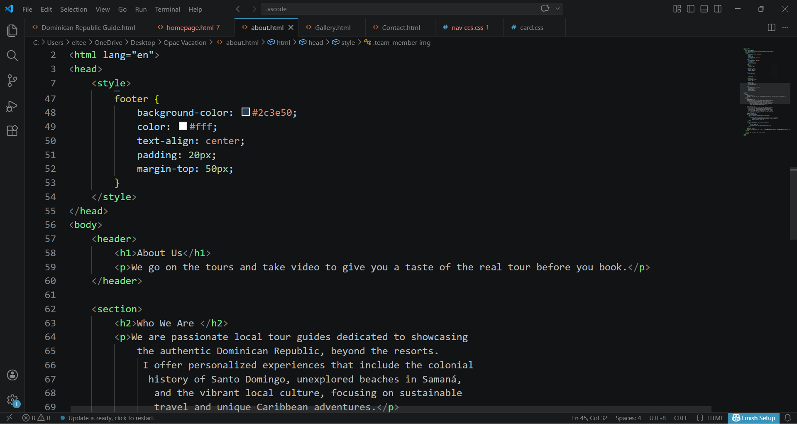
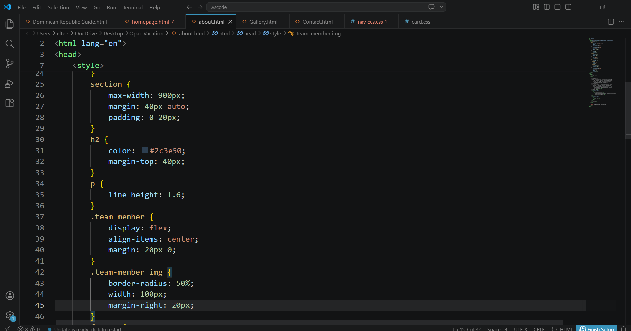
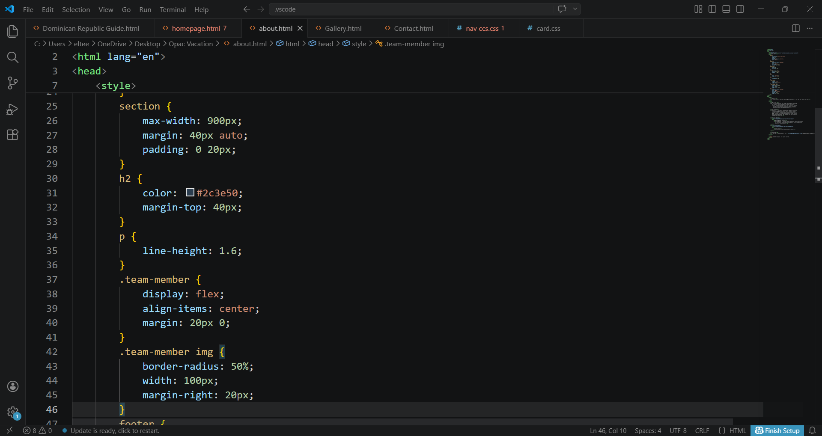
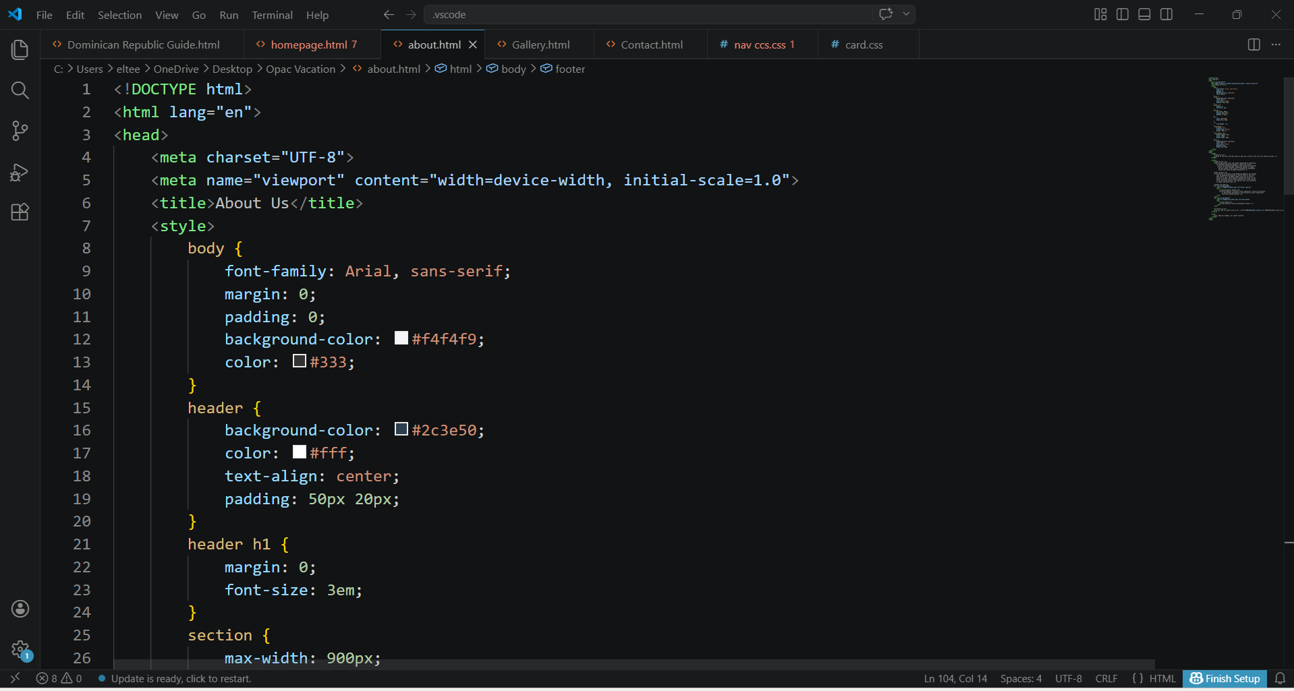
ABOUT US HTML CODE.

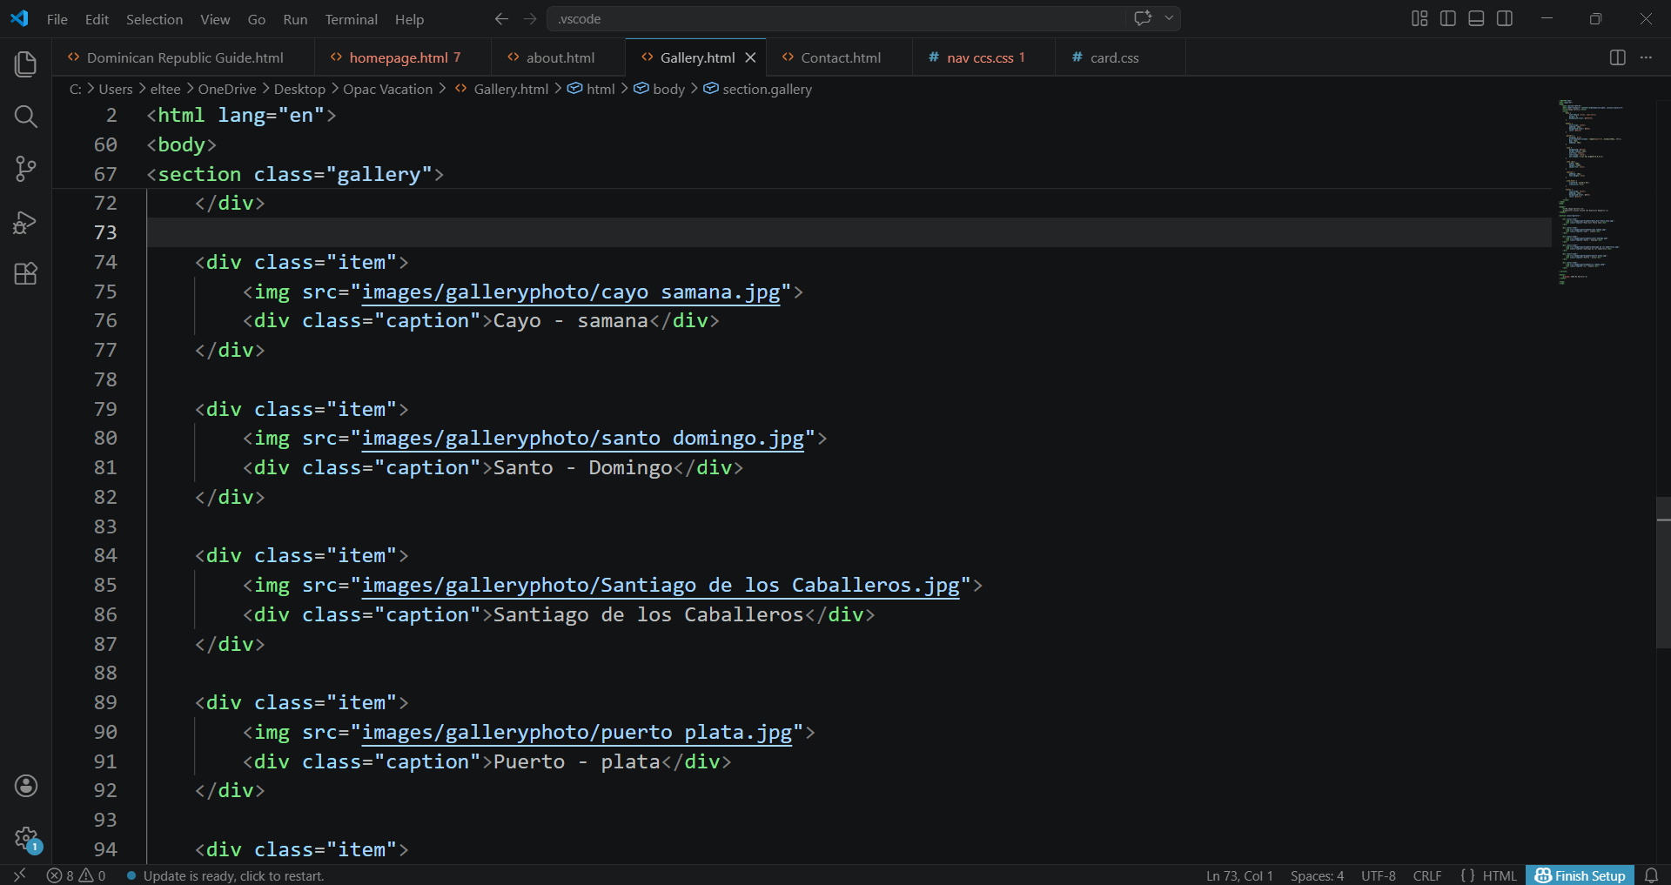
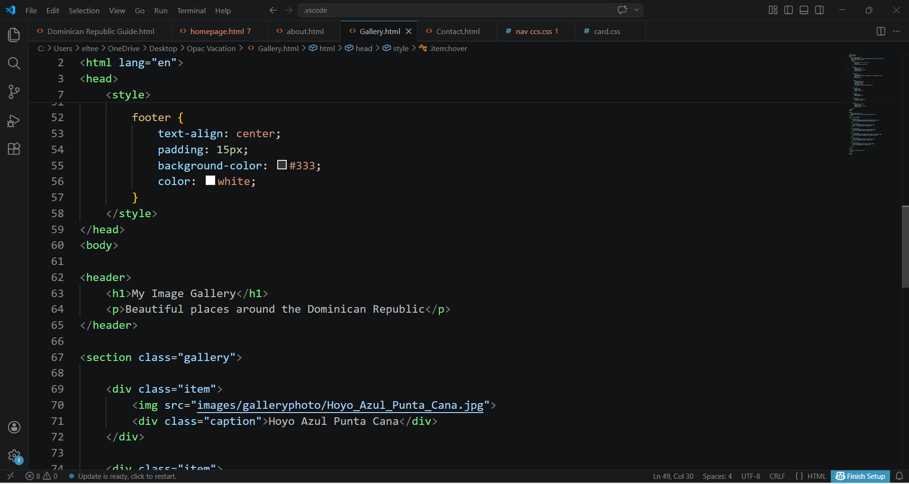
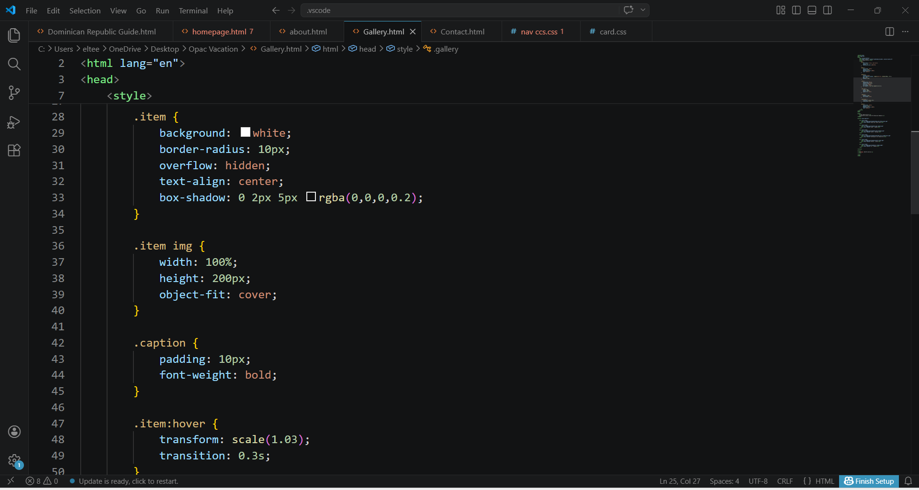
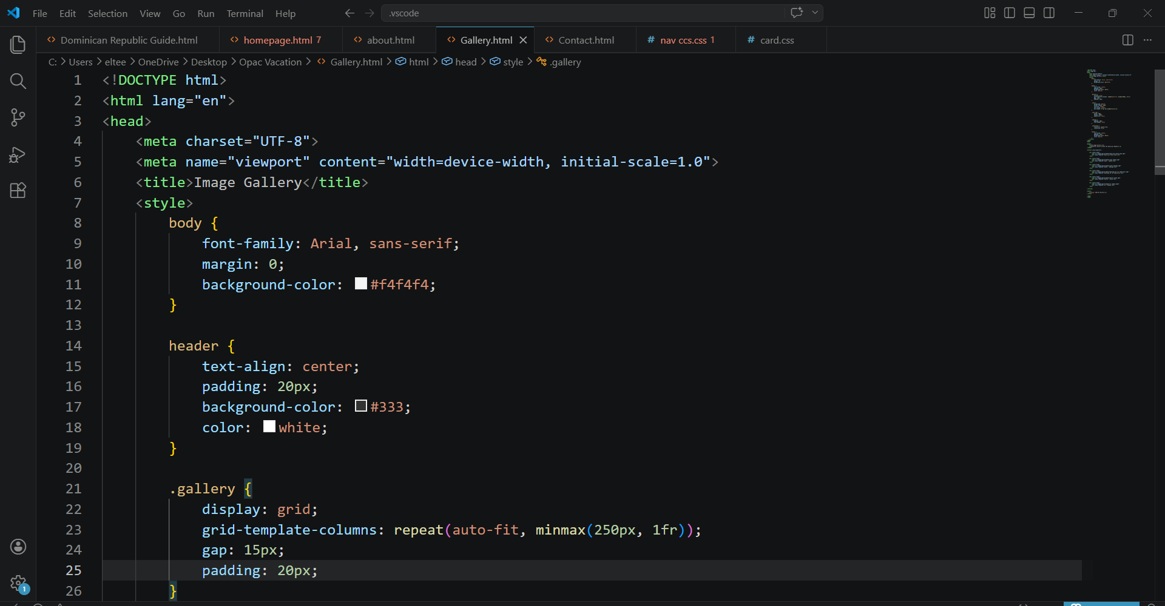
GALLERY HTML CODE.
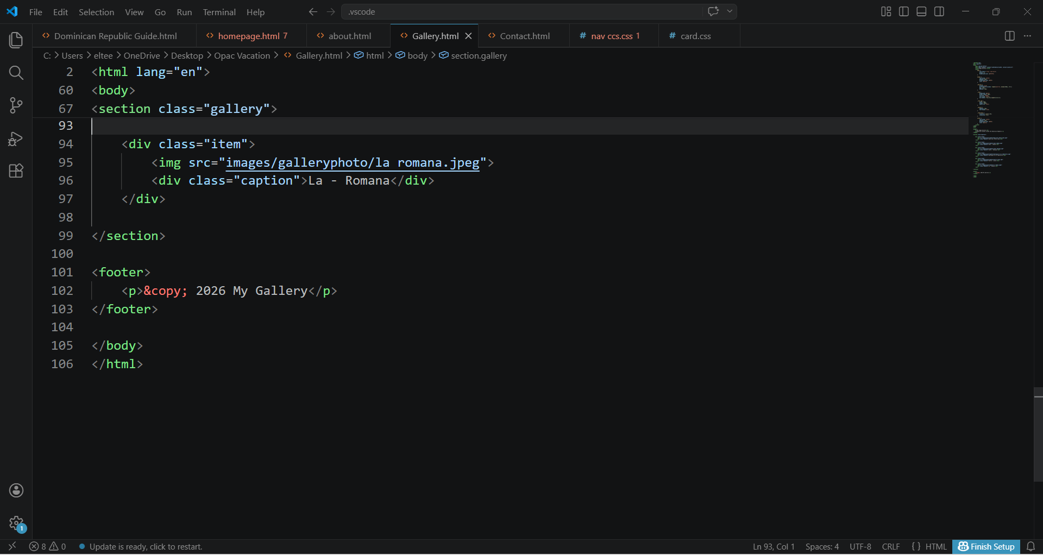

CONTACT HTML CODE.

CSS HTML CODE.

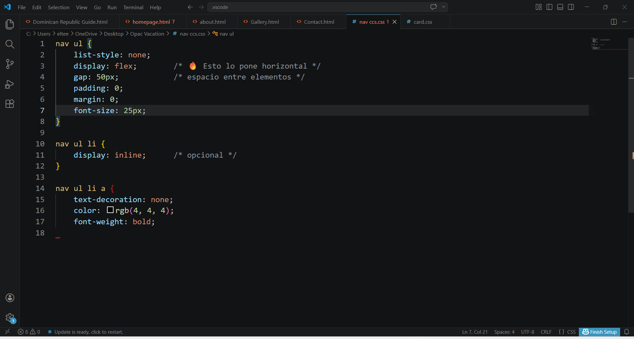

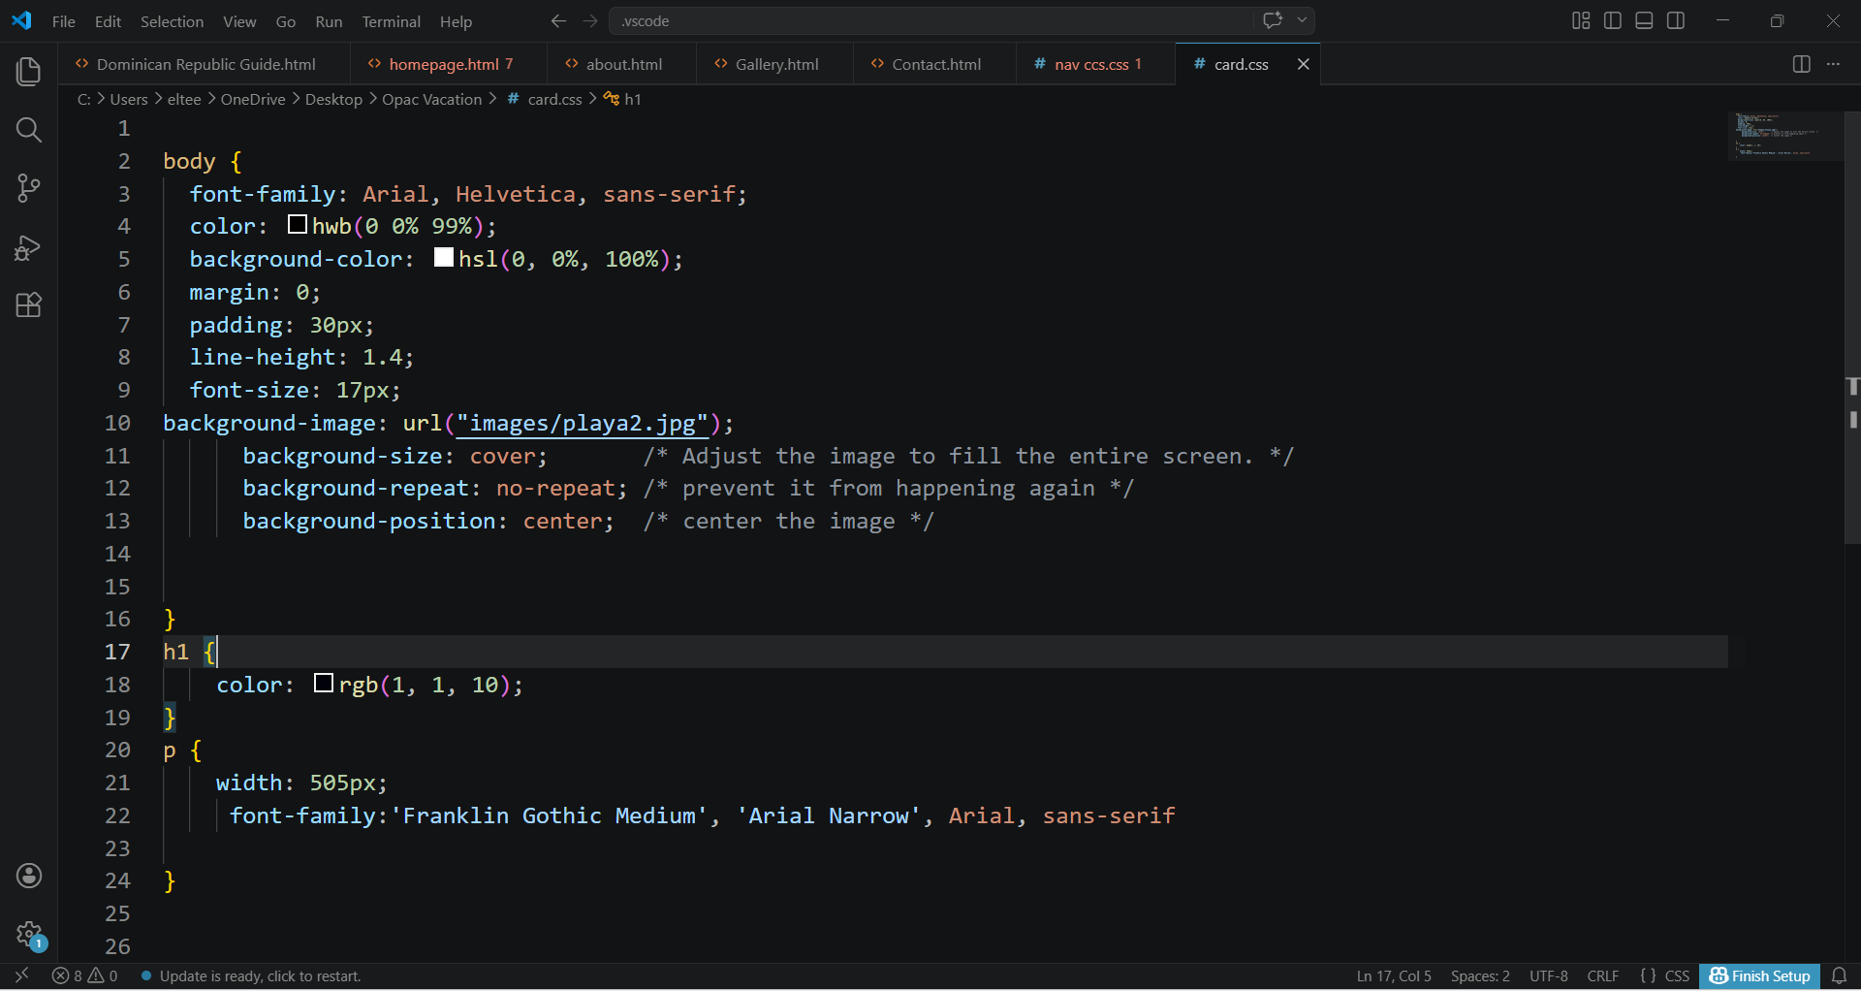
CARD CCS HTML CODE.

Usability is about how easy and pleasant a website is to use. A good website should allow users to find information quickly, understand the layout, and complete tasks without confusion. According to Matera, Rizzo and Carughi (2008), usability includes factors such as how easy it is to learn, how efficient it is to use, and how satisfied users feel.

In practice, this means clear navigation menus, readable text, and a logical structure. If a website is difficult to use, users are more likely to leave, which negatively affects the overall success of the site.

Accessibility focuses on making sure that everyone can use a website, including people with disabilities. The Web Content Accessibility Guidelines (WCAG 2.1) explain that websites should be perceivable, operable, understandable, and robust (W3C, 2018).

For example, images should include alternative text, websites should be usable with a keyboard, and colors should have enough contrast. Accessibility is important because it promotes inclusion and ensures equal access to information for all users.

SEO is the process of improving a website so that it appears higher in search engine results. This helps more users find the site. SEO includes using relevant keywords, having clear headings, and ensuring the website loads quickly.

Research shows that SEO is closely linked to usability and accessibility. A well-structured and user-friendly website is easier for search engines to understand and rank.

Usability & Utility
The website is generally easy to use, with a clear navigation menu that allows users to move between pages such as Home, About, Gallery, and Contact. The layout is simple and helps users understand the purpose of each section.
However, usability could be improved by adding more interactive features and ensuring consistency in design (for example, spacing, font sizes, and alignment). [3]

SEO Techniques Used
The website uses basic SEO techniques such as:
- Clear page titles
- Navigation links
- Relevant content about the Dominican Republic
To improve SEO further, the website could include:
- Meta descriptions
- More keyword-focused headings
- Image alt text
- Faster loading times

Accessibility (WCAG 2.1)
Some accessibility features are present, such as simple navigation and readable text. However, there are areas for improvement:
- Images may not include alt text
- Color contrast could be checked
- Keyboard navigation may not be fully supported
To meet WCAG 2.1 standards, the website should ensure it follows all four principles (perceivable, operable, understandable, robust).

Usability
The professional website has a more advanced design, with interactive features, search options, and a more polished layout. This makes it easier for users to explore information.
In comparison, your website is simpler, which is good for clarity, but it lacks advanced features that improve user experience.

Accessibility
The professional website is more likely to follow accessibility standards, including proper alt text, structured content, and compatibility with assistive technologies.
Your website meets some basic accessibility needs but would benefit from improvements to fully meet WCAG 2.1 guidelines.

SEO
The professional website uses strong SEO strategies, including:
- Optimized keywords
- High-quality content
- Metadata and structured pages
Your website uses basic SEO, but it could be improved by adding more technical elements and optimizing content.

Mobile Friendliness
The professional website is fully responsive, meaning it works well on mobile devices and tablets.
Your website may not yet be fully responsive, which can affect user experience on smaller screens. Adding responsive design (CSS media queries) would improve this. [4]

Conclusion
Overall, your website provides a clear and simple introduction to the Dominican Republic, with good basic usability. However, compared to a professional website, it still needs improvement in accessibility, SEO, and mobile responsiveness.
By improving these areas, the website can become more inclusive, easier to find on search engines, and more enjoyable for users.

References

[1] | M. Matera, F. Rizzo and G. Carughi,, "Web Usability: Principles and Evaluation Methods,” Web Engineering," 2008. [Online].
[2] | W. W. W. Consortium, "World Wide Web Consortium," Web Content Accessibility Guidelines (WCAG) 2.1, 2018. [Online]. Available: https://www.w3.org/TR/WCAG21/.
[3] | AccessibleEU, "Accessibility," Usability and SEO Study, 2020. [Online].
[4] | Search Engine Journal, "SEO and Accessibility," 2020. [Online].

