Portfolio
Component 1.
Activity Plan.
Activity Plan
Activity: Shapes on the sea shore

Number of children: 8 | Age of children: 3-4 years | Number of adults:  2 x qualified nursery practitioners  1 x Student volunteer
Location: Llanrhystud Beach | Preparation time: 10 Minutes to complete a visual check of the area. | Activity time: 5 minutes for story. Flexible activity time thereafter.
Resources:
- Shapes on the seashore book
- Natural resources found at the beach
- Picnic blanket
- Suitable clothing- wet weather suits, wellies, waterproofs
- Change of clothes/ towel
- First aid kit including any medications needed for known allergies or conditions
- Emergency contact details including parental information and details of the nearest hospital.
- Mobile phone
- Class camera
- Drinking water
- Snacks
- Register
Aim/s of activity:
The aim of the activity will be to promote children’s knowledge and understanding of the natural environment. Encouraging children to explore their surroundings while looking for objects of different shapes. Children will discuss their findings at the end of the activity asking questions and demonstrating their current knowledge.

Links to outcomes:
- Physical development- gross and fine motor skills through exploring and playing at the beach.
- Language and communication skills- listening to instruction, communicating with their peers, listening and discussing the story and follow up activities.
- Creative development- Imaginative play, movement, construction.
- Mathematical development- learning about shapes, size, spatial awareness, numbers, volume.
- Knowledge and understanding of the world- exploring a new environment, respect for living things, understanding weather, understanding tides.
- Social development- working with others, communication.
- I.T skills- use of the class camera.
- ESDGC- links to themes including the natural environment, choices and descisions, consumption and waste, health.

Differentiation: When going onto the beach, there is a concrete ramp which may be used for any persons with additional needs, for example, wheelchair access. The story and activity are appropriate for all children, extra support may be given to those in need.

Health and safety: A full risk assessment will be completed.

Role of adult/adults:
The role of the adult will be to support the children to explore the environment confidently and safely. During the story, at the beginning of the activity, one adult will complete a visual check on the area ensuring it is safe and marking out the boundaries of where the children can go. As soon as they arrive at the beach the lead practitioner will explain the boundaries and rules clearly so that children know what is expected of them. Following the story, the children will be allowed enough time to explore the area to find their shapes and bring back to the group, the adults will be close by to supervise and help if needed. Children with any additional needs will have adequate support but are also encouraged to explore independently or with their peers. During show and tell the adults in the group can ask questions to promote further discussion while also allowing sufficient time for the children to talk amongst themselves. The final part of the activity will be predominantly child led, the lead practitioner can suggest a few activities for them to do, for example, use their shapes to make a picture as a group activity, however it will ultimately be the children’s choice to use their time as they wish. All adults to be supervising, reminding children of health and safety rules when needed and assisting when asked or deemed appropriate.

The activity:

The children will visit the beach where they will first have a story, shapes on the seashore. The children will then be given the task of individually finding their own shapes, pebbles, sticks, seaweed and bringing them back to the group. As a group the children can then discuss their findings- show and tell activity with opportunities for sustained shared thinking.
Following this the children will then be asked what they would like to do with their shapes. Children may work in groups or individually to create anything they want with their chosen items along with others. They could build giant shapes, make people or animals, pictures or simply play. The children will also have the use of the class camera to take photos of their findings.

The activity plan can be altered to follow the children’s lead. The story will be the focused task of the outing, however following that the children can initiate games and further learning based on their own interests. Children will be allowed as much time as they need to explore their surroundings.

Component 2.
Risk Assessment.

Activity | Hazard  (potentially  dangerous activity,  occurrence or  physical item) | Risk  (incident / accident that MAY happen) | Benefit | Action to remove or reduce risk  (The whole group can learn to take their own precautions guided by the forest school leader) | Who? | When? | Risk  Level (when actions observed)  1-5  Low-High
Travelling to the beach location. | Vehicle accident | In the event of a collision or accident children may incur injury or harm | Children get to continue with their trip and explore an unfamiliar environment. | Regular maintenance checks on the vehicle. All children to travel in their own highbacked booster car seats that Parents/Carers will fit themselves. Staff to check all seats are secure before letting children on the bus. Children reminded of appropriate behaviour. Driver of the bus will have a full clean drivers license for a minimum of two years and attend an inhouse training course for the vehicle. | Staff and Parents/Carers | Ongoing maintenance checks and training.  On the day of the trip Parents/Carers to fit car seats. | 1
Arriving and departing the beach. | Other moving vehicles while walking to the beach location | Persons may incur injury or harm. | Children get to continue with their trip and explore an unfamiliar environment.  Promote knowledge on road safety. | All persons to be aware of moving vehicles, children to line up in pairs alongside the bus until staff confirm it is safe to cross the car park. Use walkways where possible and all persons to take care while walking. A member of staff to be at the front and rear of the group to ensure children stay together. | Staff and children | Arriving and departing the beach. | 1
Walking along the stones to get to the sand area. | Persons may slip or fall. | Persons may incur injury or harm | Children will be able to assess their own risk based on their own abilities.  Promote physical development and balance. | Children reminded to take care when walking onto the beach front. Children to walk individually. Staff to support children when appropriate. There is a concrete ramp which can be used by those who wish to. All staff to have up to date first aid training and a first aid kit. | Staff and children | Arriving and departing the beach. Throughout the activity. | 2
Beach trip | Known allergies and/or conditions | Staff and children may have allergies or conditions that may be triggered and need treatment. | Promote children’s independence in recognising and identifying different allergens. | All staff to be aware of any medical conditions within the group and what treatment may be required. All staff to have up to date first aid training and first aid kit. Ratios exceeded in case of an emergency. | Staff | Medical information obtained prior to the trip. | 1
Beach trip | Adverse weather conditions | Severe storms, strong winds, lightening. | Promote children’s knowledge and understanding of the world. Encourage independence when choosing appropriate clothing and footwear. | Children to be reminded of appropriate clothing and footwear for all weather conditions. Children to have a change of clothes also.  Trip will be postponed/cancelled in the event of dangerous weather. | Staff and children | For the duration of the trip. | 1
Beach trip | Hot weather | Sun exposure, sun burn and/or dehydration | Promote children’s knowledge and understanding of the world. Encourage independence when choosing appropriate clothing and footwear. | The trip will take place at the beginning of autumn so sever hot weather is unlikely. Staff to research weather forecast daily leading up to the trip. In the event of a temperatures rising then children will be reminded to wear appropriate clothing including sun hats and sunscreen. Sun screen to be applied as needed. Water to be available to all persons with regular breaks to encourage drinks. | Staff and children. | Leading up to the trip and during the day. | 1
Exploring the sight | Missing child | A child may go missing or get lost during the trip | Developing listening and communication skills by children understanding and following the rules and boundaries set out for the activity and trip. | Staff to clearly explain the rules and boundaries of where the children may go.  Staff to carry out regular headcounts. | Staff | On arrival and reminded during the trip | 3
Exploring the sight | Uneven ground, debris on the beach | Children may trip and hurt themselves | Children will be able to assess their own risk based on their own abilities.  Promote physical development and balance. | Ensure children are wearing appropriate clothing and footwear. Staff to have up to date first aid training and a first aid kit. Contact emergency services and Parents/Carers in the event of a serious injury. Visual checks to be made. | Staff and children | Throughout the trip. | 2
Exploring the sight | Sand coming into contact with eyes | Eye irritability and/or injury. | Children will be able to explore the beach and experience the texture of sand, experimenting with wet and dry sand and making sculptures. Promotes listening and communication skills as well as creative development and science. | Children to be reminded not to throw sand. If sand does come into contact with eyes, they will be rinsed with fresh water immediately. | staff | On arrival and reminded during the trip | 1
Toilet facilities | Child needing the toilet | Wet or soiled child, child in distress. | Promote children’s independence in being able to toilet independently. | Toilets to be assessed prior to trip. Children encouraged to use the toilet at regular intervals.  Staff to take a travel potty and spare clothing. | Staff | Throughout the trip. | 1
Beach trip | Public area, strangers. | Child may be abducted or be a victim of assault. | Developing listening and communication skills by children understanding and following the rules and boundaries set out for the activity and trip. Children to develop an awareness of their surroundings and unfamiliar persons. | Children to be reminded not to talk to strangers or to leave the designated area. Staff to be vigilant of strangers and carry out regular headcounts. | Staff | Throughout the trip. | 3
Exploring the sight, collecting materials. | The sea | Risk of drowning, being taken out to sea. | Children will be able to explore the area within the guidelines of the staff. Children to risk asses for themselves and demonstrate they understand the safety rules put in place, for example, to only paddle up to their knees and with adult supervision. | Staff to research the times of high tide and to plan the activity for a minimum of two hours after. Children to be reminded that they must only paddle and to go no deeper than their knees. Staff to supervise at all times. | Staff | Research high tide prior to trip.  Safety reminders throughout the day. | 2
Exploring the sight, collecting materials. | Animal droppings | Children to come in contact with animal feces | Promote an understanding for the natural environment and living things. Practice good personal hygiene. | Staff to carry out visual check of the sight. Children reminded not to touch feces. If a child does come in contact with feces their hand s to be wiped immediately with antibacterial wipe and taken to a hand wash facility. | Staff | Throughout the trip | 1
Exploring the sight, collecting materials. | Animals, dogs in particular | Persons may be bitten or scratched | Promote an understanding for the natural environment and living things. Understand that some animals/creatures can be harmful so to be aware of them but not frightened. | All persons to not touch animals. Staff to research dog friendly beaches during certain months of the year and choose destination appropriately. | Staff | Prior to the trip and during. | 2
Exploring the sight, collecting materials. | Insects and other living things including crabs and jellyfish | Bites and stings from wasps, bees and other living things | Promote an understanding for the natural environment and living things. Understand that some animals/creatures can be harmful so to be aware of them but not frightened. | All persons to wear appropriate clothing and footwear. Children reminded not to handle insects that may harm. First aid given when needed. | Staff | Throughout the trip | 2
Exploring the sight, collecting materials. | Children may find sharp or hazardous objects | Cuts | Promote children’s independence and trust in their ability to risk asses and communicate with staff anything they feel may be a hazard. | Children to be reminded not to handle any sharp objects, for example glass and to notify a member of staff immediately fi they find something hazardous. First aid given when appropriate. | Staff | Throughout the trip. | 2

Component 3.
Environmental Audit.
Environmental feature | Damage that could occur | How to lessen negative impact | Resources needed | Who is responsible
The beach | Litter to the environment. | All persons encouraged not to litter and to use the bin provided. Children encouraged to check they have all their belongings before leaving the sight. | A collection bin for after snack. | Practitioners and children.
Natural resources: Rocks, sand, pebbles, shells and more. | Resources and materials could be taken from the sight damaging the natural habitat. | Encourage children to put resources back where they found them and explain the reasons why. | None | Practitioners and children.
Living things | Living creatures could be disturbed or incur injuries from being handled | Children taught about respect for living things, encouraged not to handle living creatures but only to observe. Children to demonstrate care when investigating habitats such as rock pools. | None | Practitioners and children.
Natural habitats | Natural environments could be altered leaving them unhabitual. | Discuss with children the variety of creatures that may be present at the beach. Encourage care and understanding of all living things. | None | Practitioners and children.

Component 4.
Academic piece of writing.
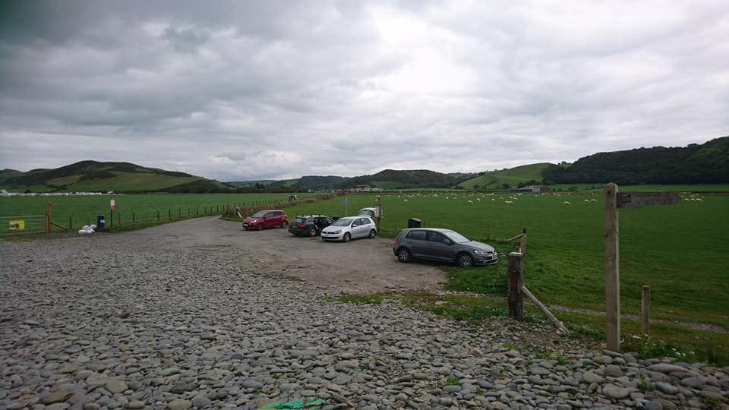Picture of the car park leading onto the beach.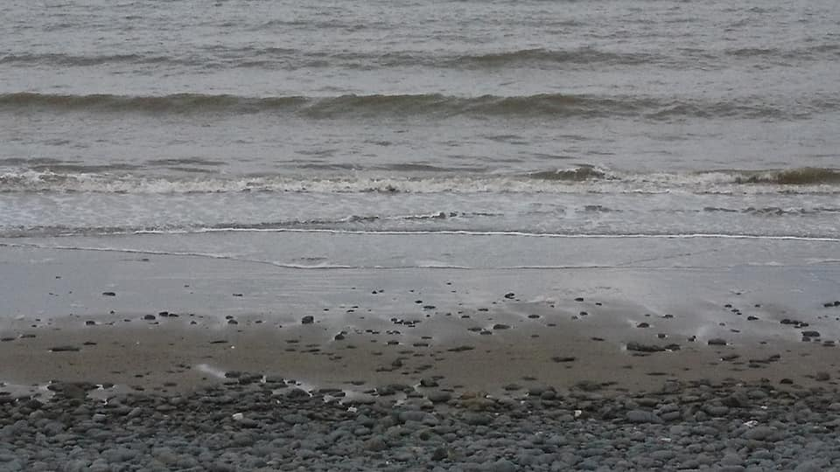Picture of the beach shore. 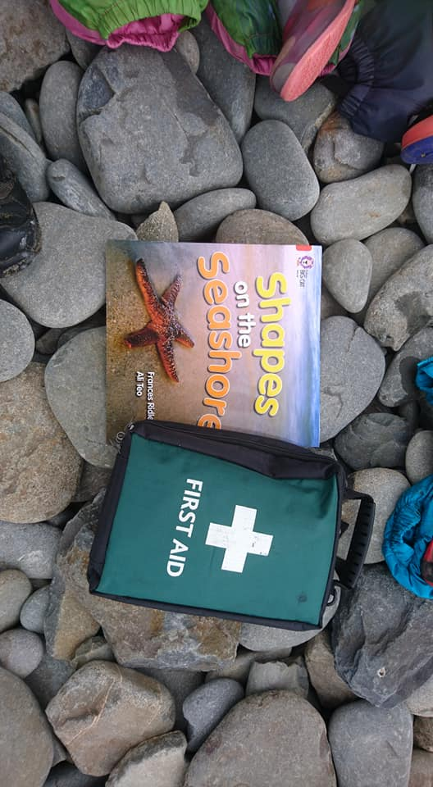The book that was read and a first aid kit. 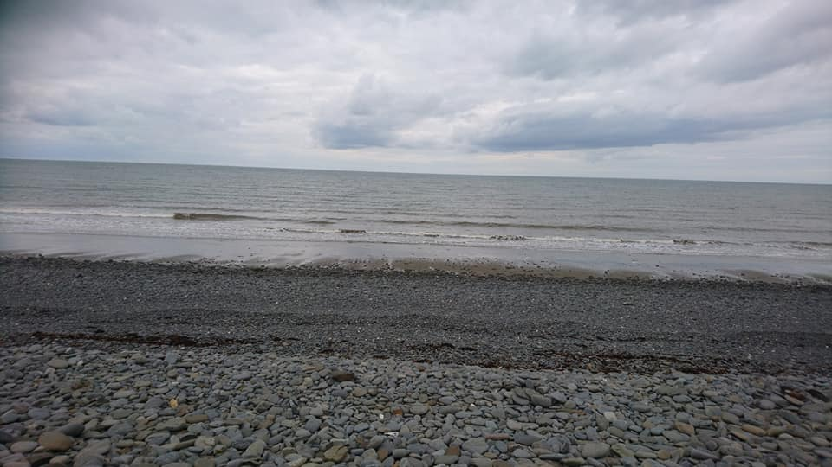The rocks slopping down to the beach. 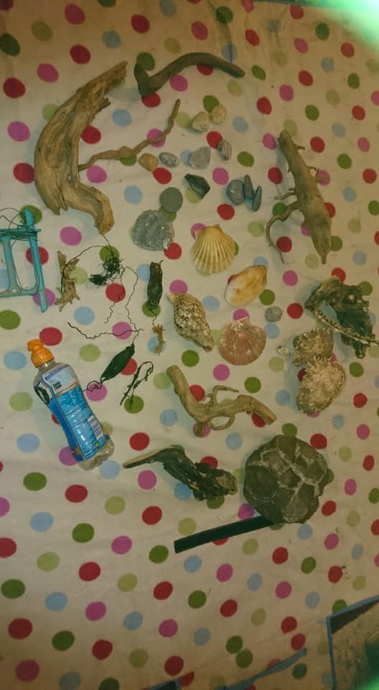What the children found. 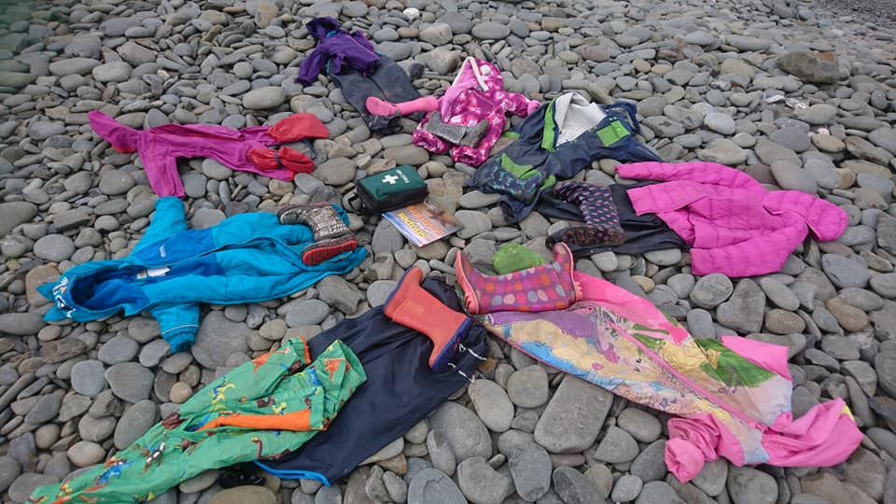8 pairs of wellies and wet weather suits.

It is thought that children today are offered fewer opportunities for outside learning and play (Gill, 2010; Ernst and Tornabene, 2012; Smith, 2013; Little, 2015) and seem to have a stronger connection to electronic devices than they do to nature (Smith, 2013). Several authors discuss the endless opportunities for outdoor learning environments along with the holistic development and health benefits for the child (Thornton and Brunton, 2007; Warden, 2007; Louv (2010); Ernst and Tornabene, 2012; Duncan, 2013; Goodenough, 2013; Smith, 2013; Wilson, 2013; Little, 2015; Tinney and Hirst, 2017). In some cultures, outdoor play is recognised as a crucial part of early years education. Arlemalm-Hagser (2010) talks about Swedish preschool programs where children spend up to three hours on the playground and participate in weekly forest school sessions. Being outdoors allows children the opportunity to be free, to engage in activities that are of an interest to them and explore their surroundings using all of their senses. A natural environment not only encourages children’s physical development but also promotes social skills, problem solving, resilience and offers children the chance to take responsibility for their own well-being. Goodenough (2013) adds that outdoor activities and play also reduces childhood obesity and stress; along with suggesting that the natural environment can help decrease symptoms of attention deficit disorder.
The beach location offered children an abundance of space, within the boundaries set out by the Nursery leader, to explore their surroundings, use all of their senses, work alongside their peers and be creative in a way that they wanted. The activity set was open ended allowing the children to investigate the area and find shapes, what they did with their findings was up to them. Some children chose to work in small groups while others worked alone. The beach was full of natural resources including stones, driftwood and shells, many of which were seen being used by the children demonstrating Simon Nicholson’s Loose parts theory (Fox and Wirth, 2015). For example, two children had collected shells, they used the shells to scoop up sand and then pour it over each other’s hands and watched as the sand slipped through their fingers. Other children used their props as fishing rods, pirate swords and kites.
According to Fox and Wirth (2015) when children use loose parts in their play they can try out their own ideas, initiating their own learning as they explore and discover things for themselves. These hands-on experiences with natural resources provide opportunities for problem solving, creativity, critical thinking and imagination that may not happen in more structured, manmade play spaces. Warden (2007) supports this by saying that it is when children are engaged in stimulating outdoor environments that they thrive through the real experiences offered. Some suggest that children who lack outdoor experiences are deprived and are at risk of nature deficit disorder (Warden, 2007; Louv, 2010; Learning through landscapes, no date). Research conducted by Ernst and Torabene (2012) discussed different outdoor learning spaces and what was perceived as the most beneficial for achieving educational outcomes. In the study it was found that early years educators were more inclined to use maintained outdoor settings such as parks as opposed to natural spaces, even though they agreed that spending time in the natural environment was important for children’s health and wellbeing. The reasons discussed were due to a number of barriers including lack of access to natural spaces, insufficient training for the practitioner and safety concerns.
One factor affecting the amount of time children spend in outdoor play spaces would be societies fear of risk taking. Children today are not necessarily given the same freedom as their parents and are encouraged to take part in more structured activities with more adult control (Gill, 2010; Little, 2015). Gill (2010) continues to say that this is not always the case, a minority group of children could be seen to have too much freedom where their parents may not apply rules and boundaries as necessary and have little control.
Being exposed to risk could be suggested as an inevitable part of childhood, and in learning how to manage risk, a lifelong skill that needs to be developed continuously in preparation for adult life. Children who are exposed to risk learn how to manage it for themselves, they become competent and are able to take responsibility for their own safety and of others (Thornton and Bruton, 2007; Warden, 2007; Gill, 2010; Little, 2015). As practitioners it is our role to ensure the child’s safety but also to observe and offer help when appropriate. To remove all aspects of risk from a play space eliminates challenge, a challenge that a child would have tried to overcome, and in doing so develop a great sense of self. If a situation appears too risky, the adult could offer an alternative, thus allowing the child to continue with the activity (Curtis, 2013). Warden (2007) states that ‘children are seriously disadvantaged if they do not learn how to approach and manage physical and emotional risk’ (Warden, 2007: 15). She continues to say that children need to be able to challenge themselves to become aware of their own abilities, in doing this they will be able to push their limits and learn how to be competent when mistakes are made. Completing a challenge will inevitably leave the child feeling confident and capable.
The beach environment offered opportunities for risk, there were rock pools for walking across, stones leading from the carpark to the beach, the sea to investigate and the possibility of discovering living things like jelly fish and crabs. The children were encouraged to explore and given the task of finding shapes within their surroundings. The practitioner’s role was to observe the children, promote their safety but also offer help when needed. For example, if a child wanted to explore the rock pools which can be slippy, the adult could then offer support but only if the child was willing. Feez (2010) explains that Montessori educators view the child as saying to the adult ‘help me to do it by myself’ (Feez, 2010: 15), practitioners should be there to scaffold a child’s learning and encourage their independence. She goes on to say that an adult who is trying to help could be the very obstacle in the child’s learning because the adult is interrupting them.
Research undertaken by Maynard et al. (2013) discusses the foundation phase for Wales and the emphasis on holistic, first hand play based experiences that are both practitioner initiated and child led. These activities should be inside and out. The foundation phase was created following evidence of good practice from Te Whariki, Scandinavia and Regio Emilia and it was decided that formal education and learning for young children could result in some children underachieving in the future. The framework highlights the need to build on children’s current knowledge and previous learning experiences promoting an environment that encourages independence and discovery with an importance placed on using the outdoors (Maynard et al., 2013; Department for Children, Education, Lifelong Learning and Skills, 2015; Tinney and Hirst, 2017).
One aspect of the activity was to allow the children as much time as possible to explore their environment and find items that were of interest to them. According to Feez (2010) Montessori children participate in their own chosen work, with objects that interest them and for as long as they want. Allowing the children this freedom, without interruption, means they are more focused and demonstrate a deeper control over their thoughts and movements; furthermore, they appear to be calmer and happy. This is because children can be immersed in what they are doing and have the opportunity to return to a project or object of interest repeatedly thus developing their concentration (Thornton and Bruton, 2007). At the end of the activity children were invited to share their findings and discuss with the group what it is they had found and what they played. The children would be encouraged to ask questions and make suggestions with the adult using sustained shared thinking techniques.
Some of the principles between the Foundation Phase and Education for Sustainable Development and Global Citizenship are alike in the sense that both documents outline holistic learning and development for the child through experiential activities that build on the child’s previous knowledge and experiences (DCELLS, 2015; Tinney and Hirst, 2017). In the ESDGC (DCELLS, 2008) there are seven core themes, these themes should not be seen as separate subjects but as a way of thinking as a whole, promoting positive attitudes and values incorporated into the curriculum and everyday life. During the beach trip these themes were incorporated and discussed. For example, consumption and waste, children were offered a drink and snack during the trip, the children were encouraged to pour their own drinking water while being made aware to only use what they wanted and share with their peers. Any waste or packaging from snacks were disposed of in the correct bin, general waste and/or recyclable products. This also links into choices and decisions and the natural environment. The children would make a choice about how to dispose of their own litter, how they would maintain the environment and treat living creatures, they would develop an understanding of how their actions could have consequences.
A collaboration between Scotland’s Woodland Trust and Forestry Commission Scotland meant an Outdoor Learning pack was produced for primary school teachers. Within this pack there are a number of suggestions for outside learning and bringing the classroom to nature. There are case studies, articles and examples of activities along with their links to curriculum and further reading. The booklet states that learning is a journey and one way to interest children, at the beginning of a topic or trip, is to send a mystery parcel. This parcel could be filled with interesting items to prompt discussion within the setting prior to venturing out (Woodland Trust Scotland and Forestry Commission Scotland, no date). An exercise like this would have enhanced the children’s beach activity. For example, if the children had opened a mystery parcel prior to the trip they could have speculated about all the different things they may have found. Some may have gone to look for specific things or thought about where to find them along with discussing with their peers. If the box contained a crab shell, the group may have discussed where to find crabs at the beach meaning the children may have looked for them in the rock pools.

Reference List.
Arlemalm-hagser, E. (2010) ‘Gender Choreography and Micro-structures- Early Childhood Professionals’ Understanding of Gender Roles and Gender Patterns in Outdoor Play and Learning’, European Early Childhood Education Research, Volume 18, Issue 4, December, pp. 515-525.
Department for Children, Education, Lifelong Learning and Skills (2008) Education for Sustainable Development and Global Citizenship- A Common Understanding for Schools. Cardiff: Welsh Assemble Government.
Department for Children, Education, Lifelong Learning and Skills (2015) Foundation Phase Framework for Children’s Learning for 3-7-year-olds in Wales. Cardiff: Welsh Government.
Curtis, D. (2013) ‘Risk’ in The Wisdom of Nature- Out my Backdoor. UK. Community Products LLC, pp. 20.
Duncan, S. (2013) ‘Gift of Nature’ in The Wisdom of Nature- Out my Backdoor. UK. Community Products LLC, pp. 12.
Ernst, J. and Tornabene, L. (2012) ‘Preservice Early Childhood Educators’ Perceptions of Outdoor Settings as Learning Environments’, Environmental Education Research, Issue 1, January, pp. 1-22.
Feez, S. (2010) Montessori and Early Childhood. London: SAGE Publications Ltd.
Fox, H. and Wirth, S. (2015) ‘The Learning in Loose Parts’ https://www.communityplaythings.co.uk/learning-library/articles/the-learning-in-loose-parts [Accessed: 20 September 2018].
Gill, T. (2010) Nothing Ventured: Balancing Risks and Benefits in the Outdoors. The English Outdoor Council. Available at www.englishoutdoorcouncil.org. [Accessed: 12 September 2018].
Tinny, G. and Hirst, N. (2017) ‘Early Childhood Education for Sustainability within Wales’, in D. Boyd; N. Hirst and J. Siraj-Blatchford (eds) Understanding Sustainability in Early Childhood Education. London: Routledge, pp. 104-138.
Goodenough, E. (2013) ‘Nature as a Healer’ in The Wisdom of Nature- Out my Backdoor. UK: Community Products LLC, pp. 16.
Learning Through Landscapes. (No date) Early Years Outdoors- Vision and Values for Outdoor Play.
Little, H. (2015) ‘Mothers Beliefs About Risk and Risk-taking in Children’s Outdoor Play’, Journal of Adventure Education and Outdoor Learning, Volume 15, Issue 1, pp. 24-39.
Louv, R. (2010) ‘Do our Kids have Nature-deficit Disorder’, Educational Leadership, Volume 67, Issue 4, January, pp. 24-30.
Maynard, T.; Waters, J. and Clement, J. (2013) ‘Child Initiated Learning, the Outdoor Environment and the ‘Underachieving’ Child’, Early Years: An International Research Journal, Volume 33, Issue 3, January, pp. 212-225.
Smith, R. (2013) ‘Memories of Childhood’ in The Wisdom of Nature- Out my Backdoor. UK: Community Products LLC, pp. 18.
Thornton, L. and Brunton, P. (ed) (2007) Bringing the Reggio Approach to Your Early Years Practice. London: Routledge.
Warden, C. (2012) Nurture Through Nature: Working with children under 3 in Outdoor Environments. UK: Mindstretchers.
Wilson, R. (2013) ‘Wonder’ in The Wisdom of Nature- Out my Backdoor. UK: Community Products LLC, pp. 8.
Woodland Trust Scotland and Forestry Commission Scotland (no date) Outdoor Learning Pack for Primary School Teachers.

