Fundamentals of Electrical and Electronic systems
Module code - ACDA4018
Electrical and Electronic system log book
Connor Hamill
2224953

Contents

Abstract
Introduction
Background/theory
Task 1
Task 2
Results
Discussion
Conclusion

Abstract

The aim of this report is to gain knowledge in both theoretical and practical fundamentals of electronics. Through using the software proteus and also the fundamental equations we are able to see how both theoretical and practical electronics work alongside each other to help us gain an understanding from both viewpoints. This module has allowed me to be able to perform electronic and electrical measurements, record and analyse data and as well as being able to produce a report from these newly learned skills. Within the report part one was based on trying to calculate various factors of resistance, current and power within a circuit, as well as being able to read and draw tables and graphs. Task 2 was focussed on calculating a voltage within the a circuit and also giving skills such as graph reading and table drawing which will be beneficial not just to this module but ones to come in the future. The results from the various circuits were on point and realistic which made the analysis easier and more understandable to write about

Introduction

This report allows us to challenge ourselves in both the theoretical and practical aspects of electronics, this course is both interesting and currently relevant as electronic circuits are a major factor when producing modern technology, circuits are created through various components which come together to create the overall circuit that can be used on a day-to-day basis. Creating circuits can both be done hands on, through computer software structures or through engineering drawings. The creation and consumption of electrical creations (power and energy) is crucial as it makes the modern world functionable and sustainable. The aim of this report as a whole is to help improve and develop practical measurement skills and data analysis, achieving this by performing a laboratory exercise on the software systems called proteus. In the end the skills expected to be shown are data recording and graph reading. Proteus as a whole the tester is to be able to produce functioning electric circuits and be able to read and take away the key results from the circuits making sure these are reasonable and functionally correct. By applying both already known skills of graphs and tables and as well as academically gained knowledge the tester should be able to apply all of this to both sections of the report. The factors key to success within an electronics module is an understanding of the various component’s equations and equipment and how they function/contribute to the overall task and use their knowledge of electronics. Through the lectures the tester will have been able gain an understanding into eat the task at hand is and how they can gain the right requirements to complete this module, Overall the knowledge and understanding gained from these should enhance the confidence of dealing with electronics as they will be able to understand the purpose of the circuit

Electronics Background and theory

Firstly, what is electricity? It is a type of energy that happens due to the motion of electrons or protons in an oscillating pattern. It is the energy transferred by the motion of electrons. Electricity is not created but it is in fact converted from one form of energy into electrical energy

And what is electronics? Electronics = Electron + Mechanics, it is a research of the flow of electrons under the influence of outward applied magnetic or electric fields.
Branch of Engineering which deals with current conduction through a vacuum or gas or semiconductor is known as Electronics

Voltage?

Voltage (also known as electric potential difference, electromotive force emf, electric pressure, or electric tension) is defined as the electric potential difference per unit charge between two points in an electric field. Voltage is expressed mathematically (i.e. in formulas) using the symbol “V”(1)

Resistance?

Resistance (R) is a measure of how difficult it is for current to flow. Resistance is measured in units called ohms (Ω). The amount of current flowing in a circuit is affected by the resistance of that circuit. Each component in a circuit has a resistance. Resistance can be calculated using the equation: Resistance = potential difference / current (2)

Current?

Current is the rate at which electrons flow past a point in a complete electrical circuit. At its most basic, current = flow. An ampere (AM-pir), or amp, is the international unit used for measuring current. It expresses the quantity of electrons (sometimes called "electrical charge") flowing past a point in a circuit over a given time. A current of 1 ampere means that 1 coulomb of electrons—that's 6.24 billion (6.24 x 1018) electrons—is moving past a single point in a circuit in 1 second (3)

Frequency?

frequency, in physics, the number of waves that pass a fixed point in unit time; also, the number of cycles or vibrations undergone during one unit of time by a body in periodic motion. A body in periodic motion is said to have undergone one cycle or one vibration after passing through a series of events or positions and returning to its original state
If the period, or time interval, required to complete one cycle or vibration is 1/2 second, the frequency is 2 per second; if the period is 1/100 of an hour, the frequency is 100 per hour. In general, the frequency is the reciprocal of the period, or time interval; i.e., frequency = 1/period = 1/(time interval) (4)

Power?

The word “work” has a different meaning in the world of Physics. In Physics, work done is given by force applied on an object to move a distance (d), and its formula is: W = F * d. Even after applying a lot of force, if an object does not move, then in the eyes of a physicist, no work is done. The word “power” is also used differently by physicists. Power is the ratio of work and time, i.e. the time taken to complete a work gives the power of an entity. It is expressed mathematically as: Power = Work/Time or P=W/T. Power is the rate at which energy (heat and electrical) is transferred. While studying electricity, you would find the power is defined as: Power = V * I, where V is the voltage within the circuit, and I is the current through the circuit. (5)

Task 1

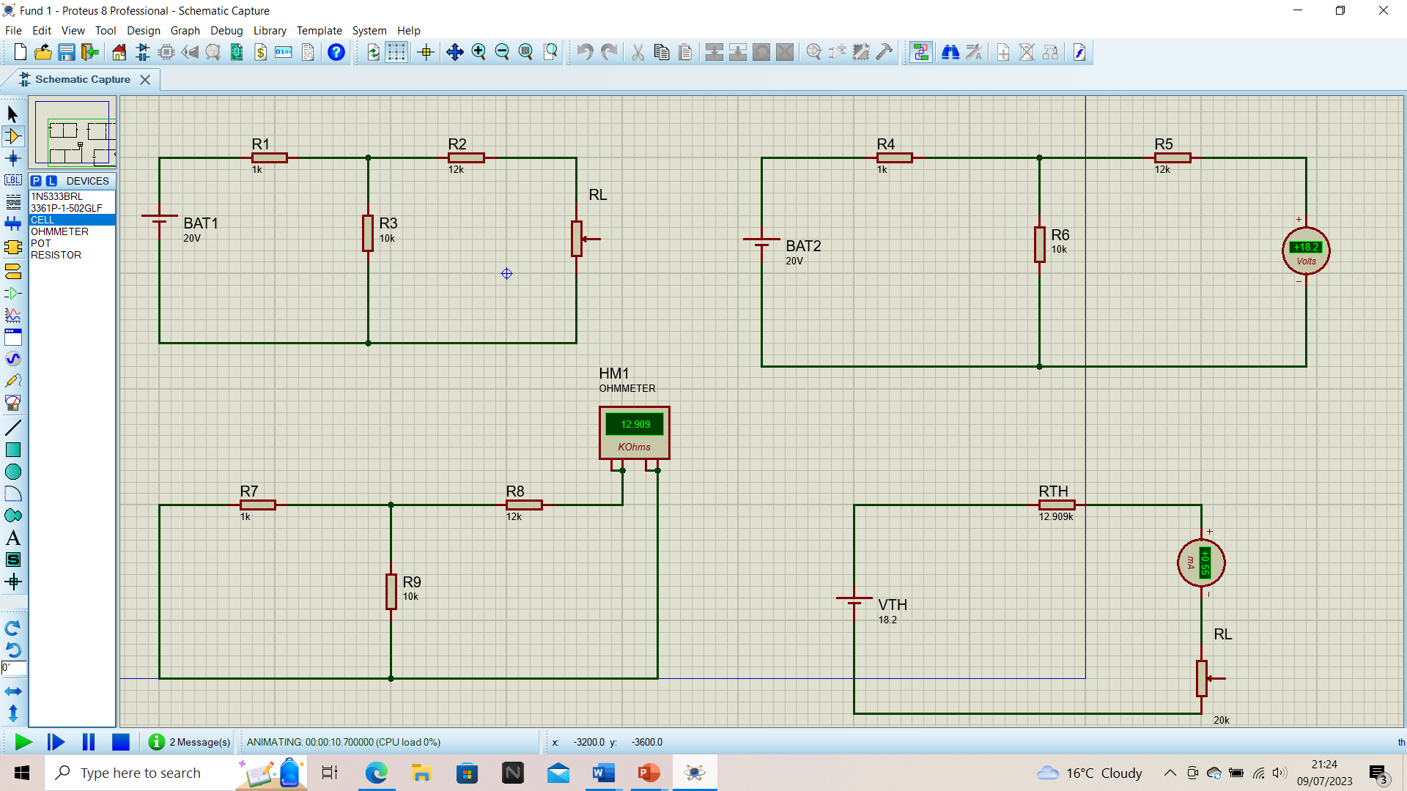
Figure 1

Using the formula( P = I²_{L} R_{L} )We were able to calculate the following values of power, needed for this were various circuits shown above as figure 1 to be able to calculate a voltage, resistance and current:
value | power | resistance | current
1K | 3.905 w | 12.909 | 0.55
5k | 4.637 w | 15.33 | 0.55
10k | 5.143 w | 17.00 | 0.55
20k | 5.647 w | 18.667 | 0.55

From the graph shown below we can see with increased resistance the power value will increase as well as with increased power the resistance value will also increase

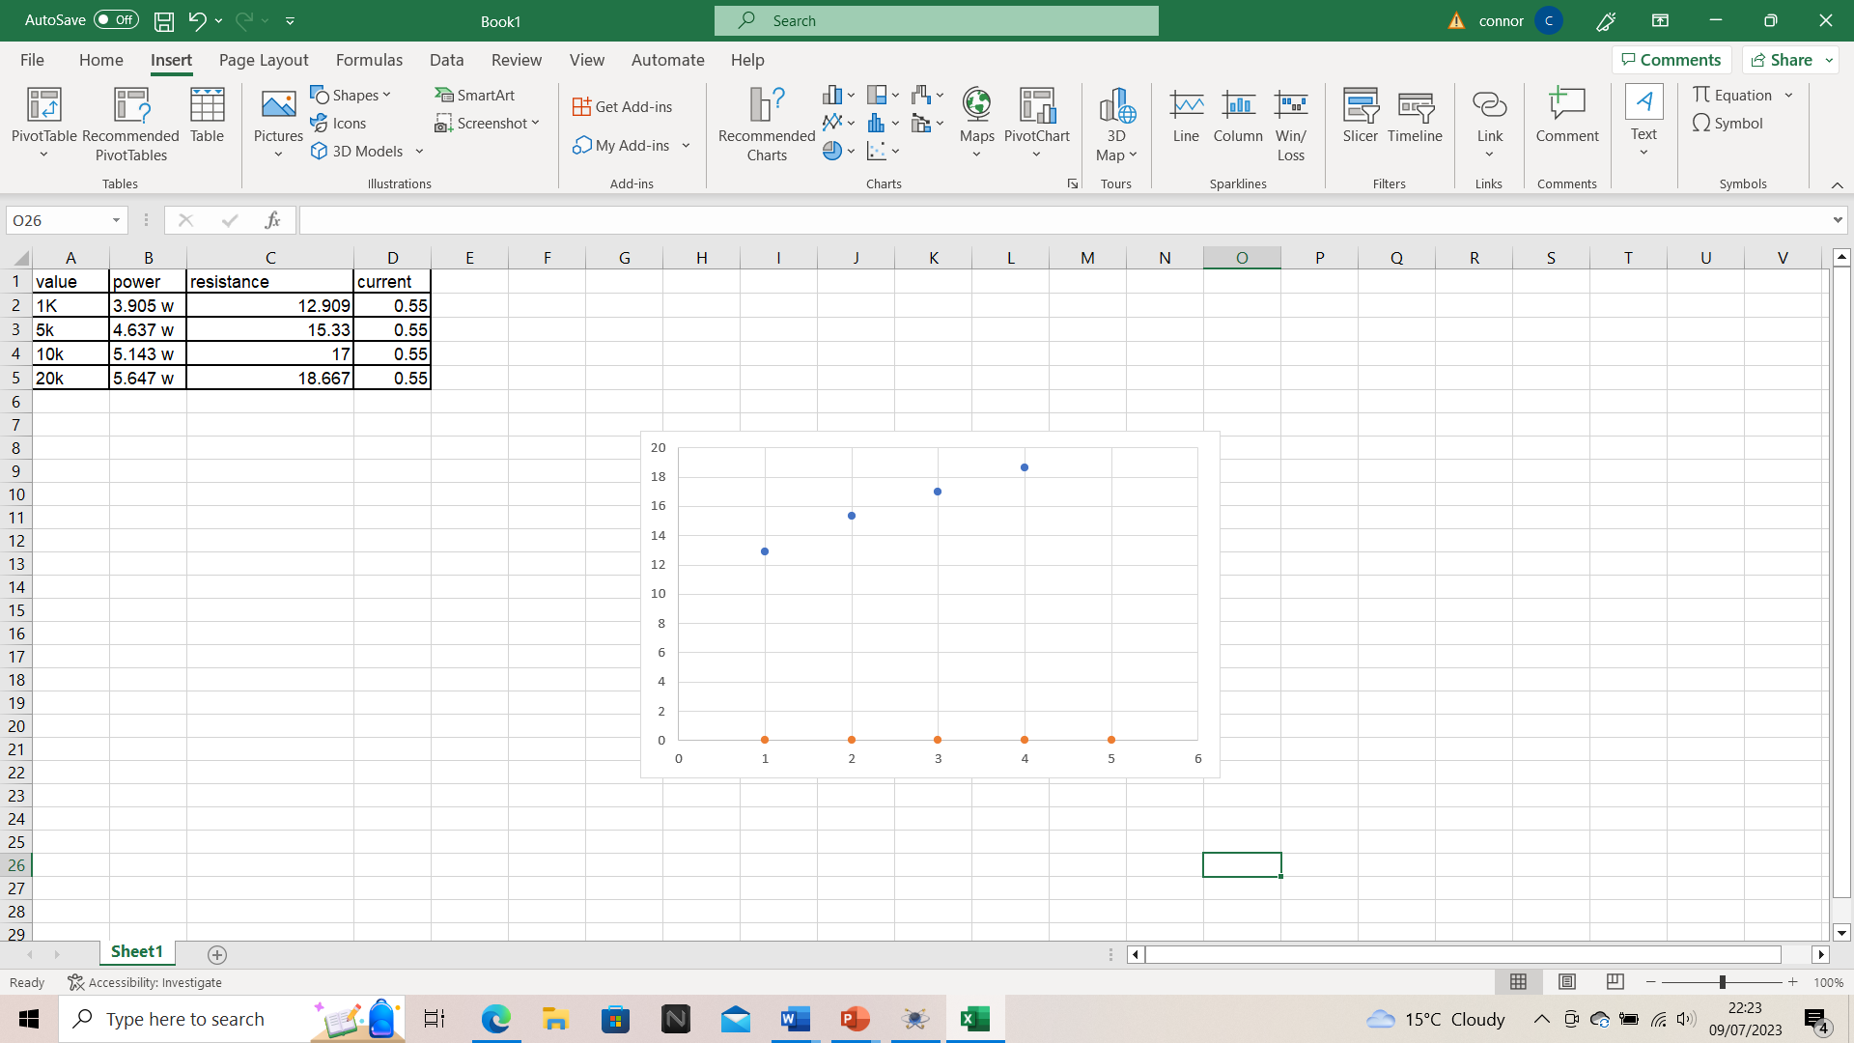

Figure 2

Results Overall

Using proteus to first off all build and understand what goes into making a circuit and after how it operates was both important for gaining knowledge and understanding of the fundamentals of electronics but also eye opening to see the circuits that people come across in day to day life and how simple circuits are what keep the world flowing and operating, Secondly to be able to create our own circuits and be tasked with making them fully operational was a fun but challenging task, by mixing both theoretical and practical learnings together to create our own individual circuits. As well as using these circuits to create things such as graphs, tables and to make calculations including power, frequency resistance and current. Overall from this module some main learning points and takeaways are firstly learning that There are two types of circuit we can make, called series and parallel.
The components in a circuit are joined by wires. If there are no branches then it's a series circuit. If there are branches it's a parallel circuit. Series circuits In a television series, you get several episodes, one after the other. A series circuit is similar. You get several components one after the other. If you follow the circuit diagram from one side of the cell to the other, you should pass through all the different components, one after the other, without any branches. In parallel circuits different components are connected on different branches of the wire. If you follow the circuit diagram from one side of the cell to the other, you can only pass through all the different components if you follow all the branches.
In the engineering world where his module targets its aim, tolerances are always taken into consideration. All available to use components have different tolerance, the component will have an initial tolerance that will overtime be changed due to all different factors some of these are as follows, stress, vibration, ageing and temperature stored, the stress that can be experienced can not always be physical sometimes this can include electric stress. When resistors come into play the tolerance should initially doubled, for example if someone is designing a circuit with a 10 percent tolerance resistor, they should e fitting a 5 percent tolerance resistor when physically installing one compared to in a circuit so that there is a guarantee for it to work better and longer than initially thought, It has been thoroughly established that within a factory setting the values of the components used is not the same as when building a circuit these are down to factors such as stress damage and age

Conclusion
Within completing this module I found out things such as proteus is a very accurate form of building circuits and determining their values as they run at one hundred percent valuation. When running a computer simulated software capable of running a simulated circuit there is no error but when people have to physically build circuits for various reasons there is the chance for inaccurate results compared to proteus, these errors can be within wires, components or human error. The most common types of errors found within circuits are faulty equipment, physical damage, poor circuit design and failure of the power. The results from this module overall provided with good points and learning challenges but overall taught a lot about future endeavours into electronic, there wasn't any certainty about how and what the results produced would be and how accurate they would be, but using proteus this reassured the results would be accurate if done so correctly .

Voltage: What is it? (Definition, Formula And How To Measure Potential Difference) | Electrical4U (1)
Resistance - KS3 Physics - BBC Bitesize - BBC Bitesize (2)
What is Current? | Fluke (3)
Frequency | Definition, Symbols, & Formulas | Britannica (4)
Unit of Power - Introduction, SI Units, and FAQs (vedantu.com) (5)

