What is colour and colour theory and how does it affect behaviour, emotion and feeling?
A comparison of illustration, animation, brand, and advertisement.
Dissertation by Keiran Protheroe

Contents.

- Title Page
- Contents
- Illustrations
- Illustrations
- Illustrations
- Illustrations
- Introduction
- Chapter One – What is Colour Theory.
- C1. Sub Chapter 1 – What emotions & feelings do colours trigger
- C1. Sub Chapter 1– What emotions & feelings do colours trigger
- C1. Sub Chapter 2– Colour Psychology
- C1. Sub Chapter 2– Colour Psychology
- Chapter Two – Psychology of colour in design + Sub Chapter 1 Illustration
- C.2 Sub Chapter 1 – Illustration
- C.2 Sub Chapter 2 – Animation
- C.2 Sub Chapter 2– Animation
- C.2 Sub Chapter 2– Animation
- C.2 Sub Chapter 3– Logos
- C.2 Sub Chapter 3– Logos
- C.2 Sub Chapter 4– Advertising
- C.2 Sub Chapter 4– Advertising
- C.2 Sub Chapter 4– Advertising
- Conclusion
- Bibliography

Illustrations.
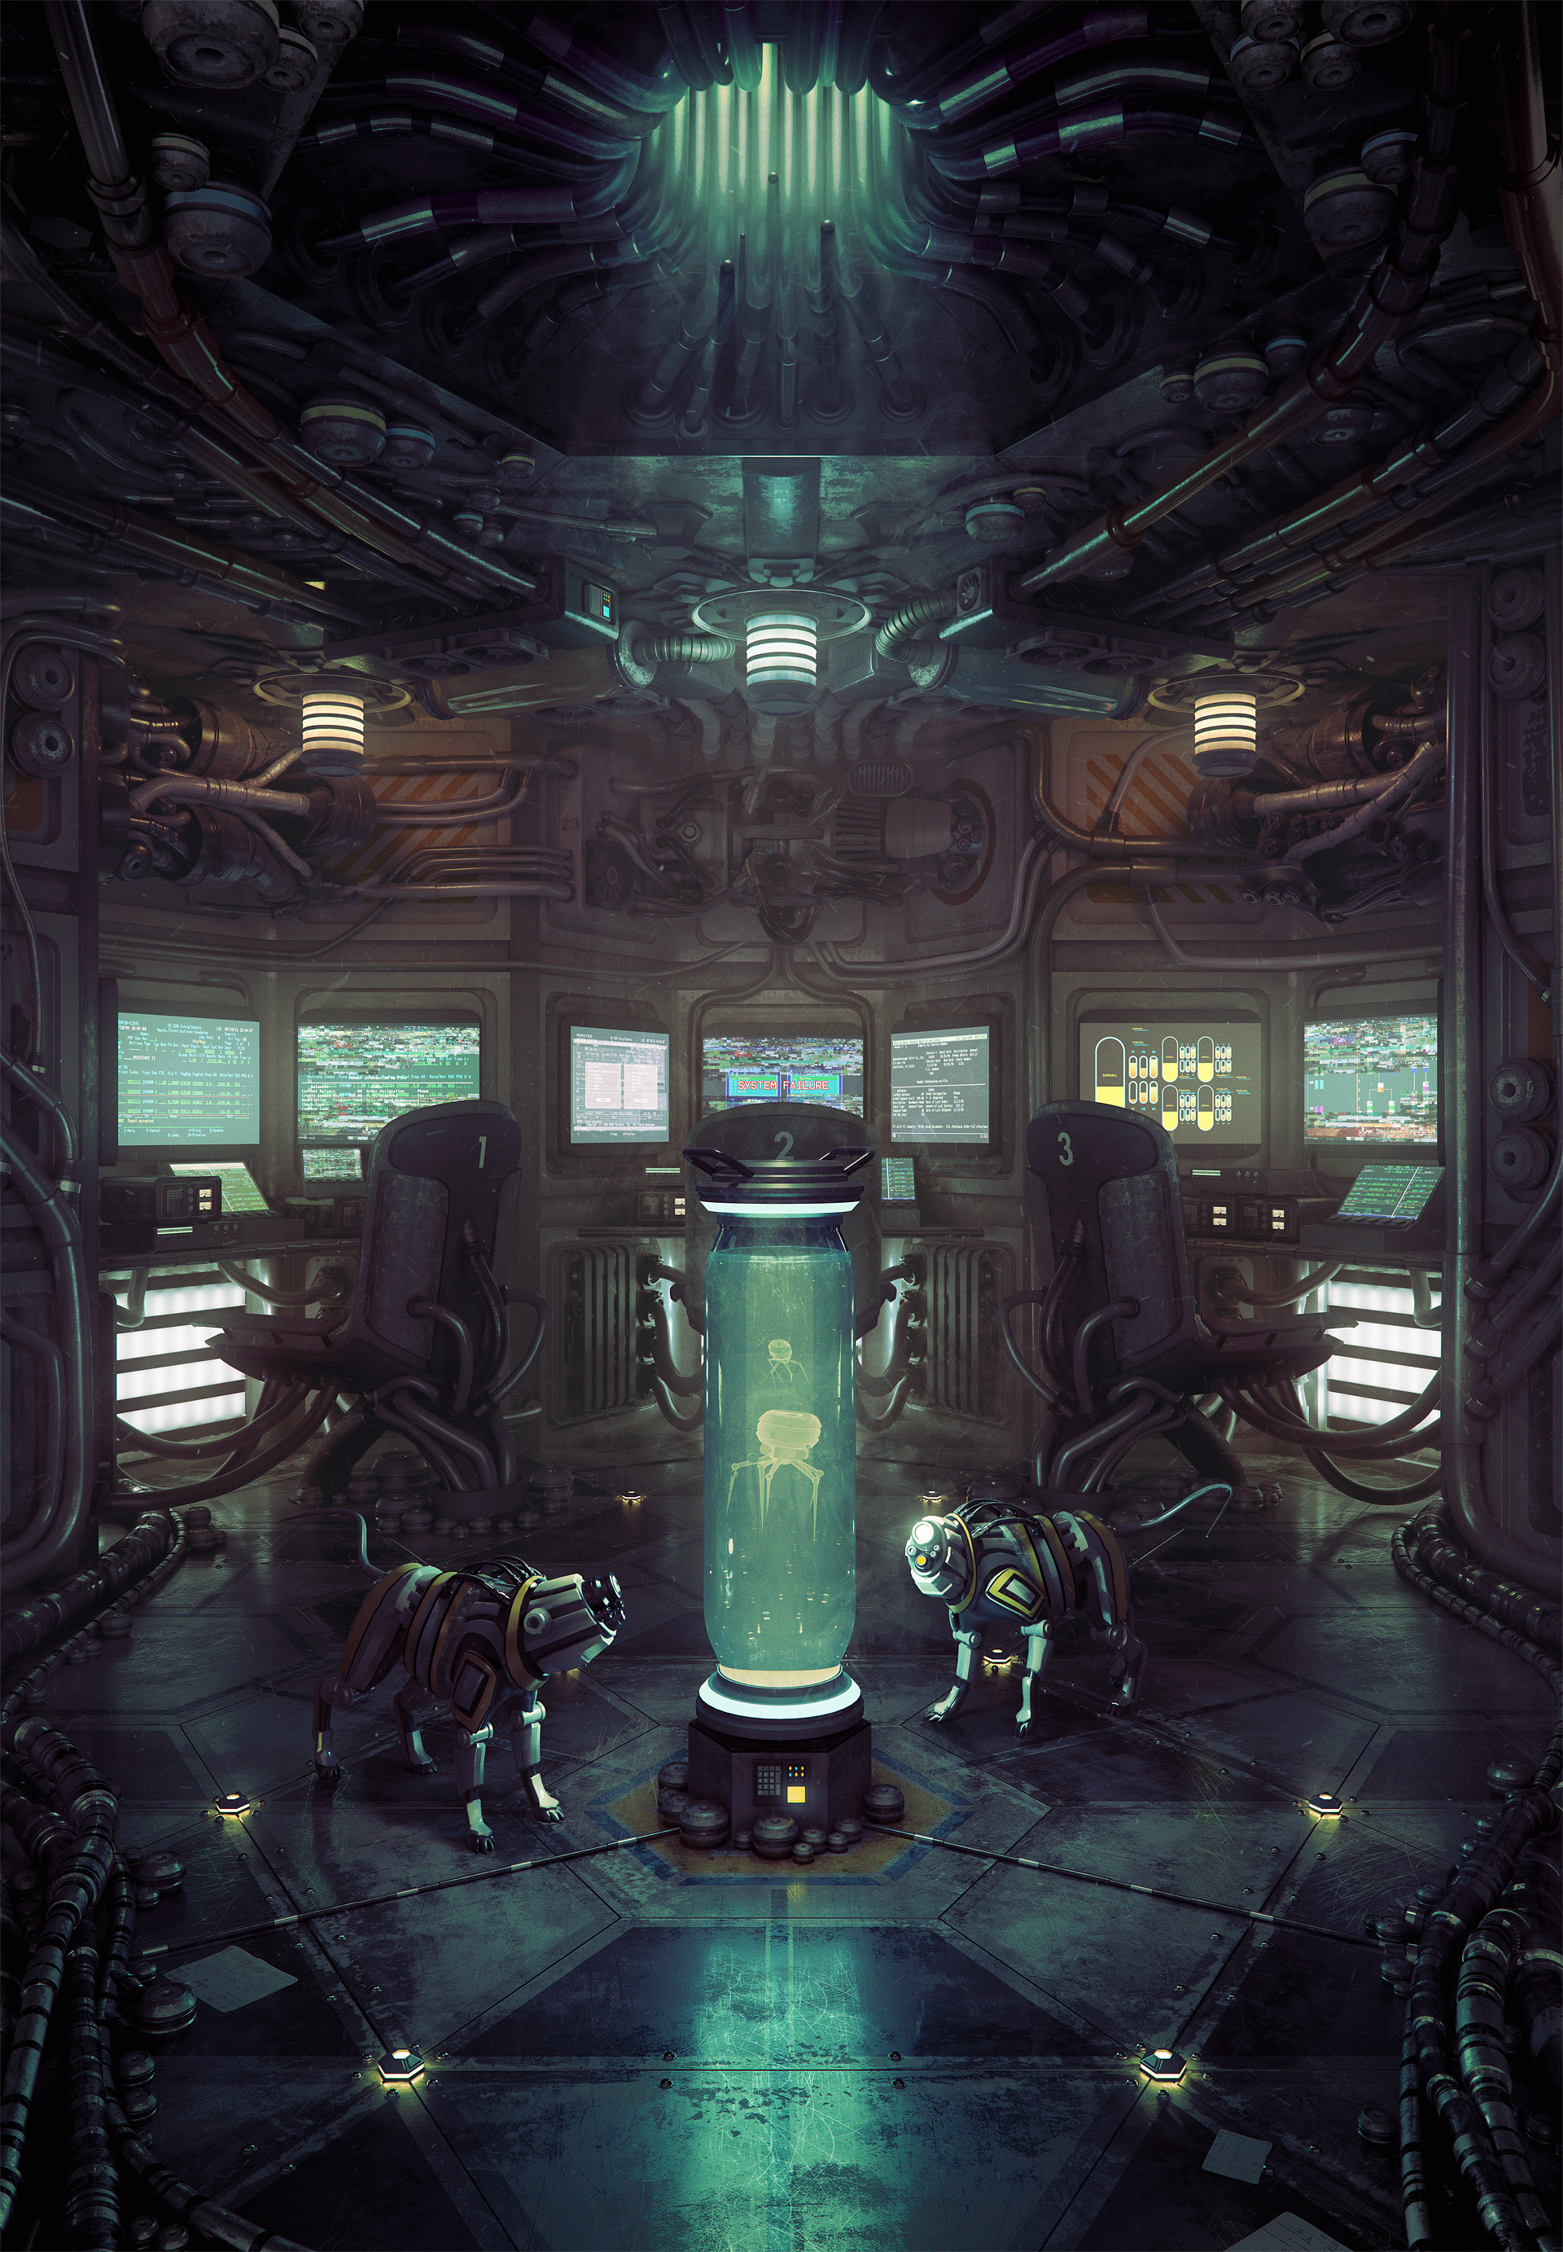
Fig.1
Artist – Cornelius Dammrich.
Title – Until the light takes us
Date Published – 2012

Fig.3
Artists – Pixar Animation Studios.
Title – UP
Date Published –2009
Fig.2
Artists – Anders Ehrenbord
& Bill Presing.
Title – Banana Girl
Date Published – 21.08.2012
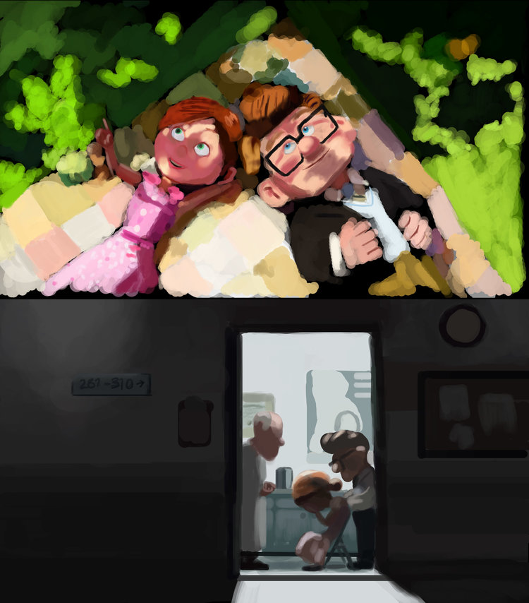

Fig.4
Artists – Pixar Animation Studios.
Title – Toy Story
Date Published –1995

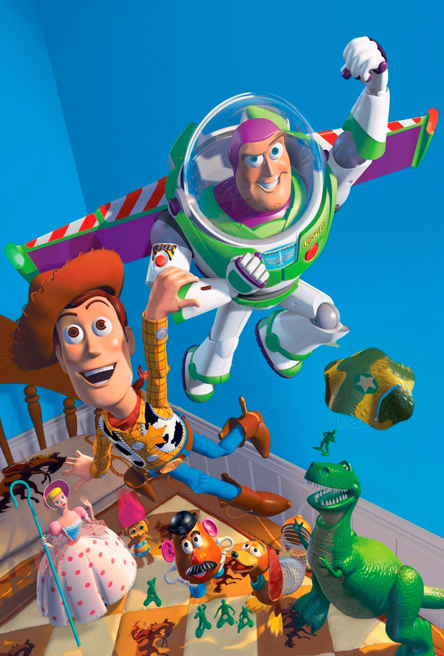
Fig.5
Artists – Pixar Animation Studios.
Title – Toy Story
Date Published –1995


Fig.6
Artists – William Murray Hill.
Title – Barclays Bank
Date Published –2004

Fig.7
Publisher: Coca Cola GB.
Title – The 2017 Coca-Cola Christmas Truck Tour
Date Published –01.11.17

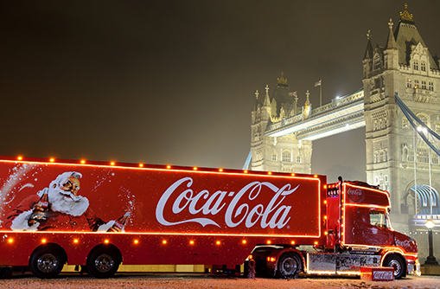
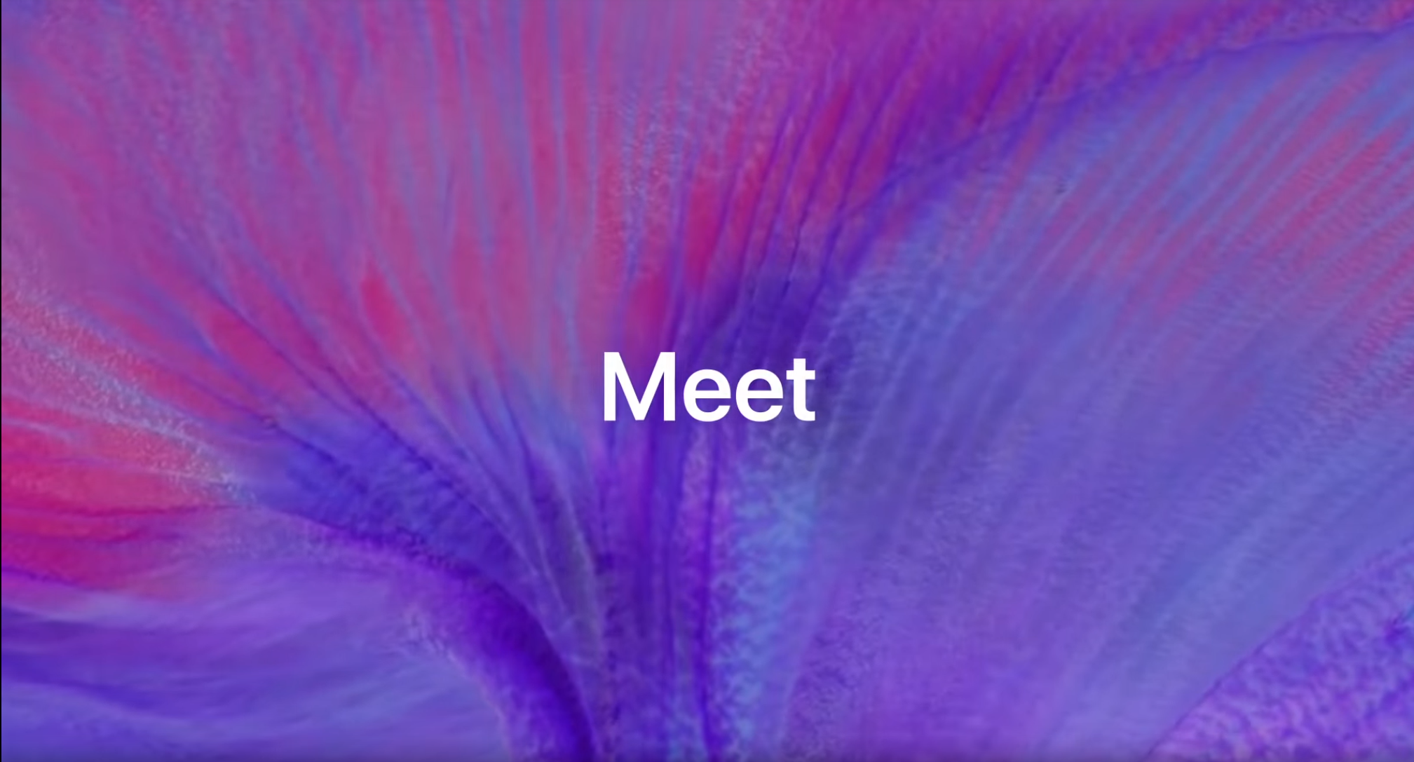
Fig.9
Publisher: Apple
Title – Meet iPhone X - Apple
Date Published –12.09.2017

Fig.8
Publisher: Apple
Title – Meet iPhone X - Apple
Date Published –12.09.2017

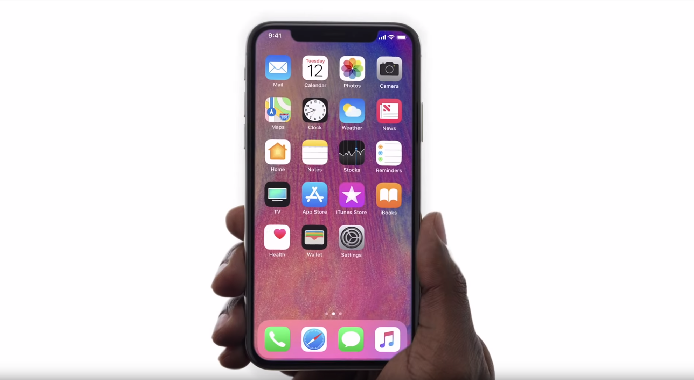

Fig.10
Publisher: McDonalds
Title – McDonalds Logo
Date Published –

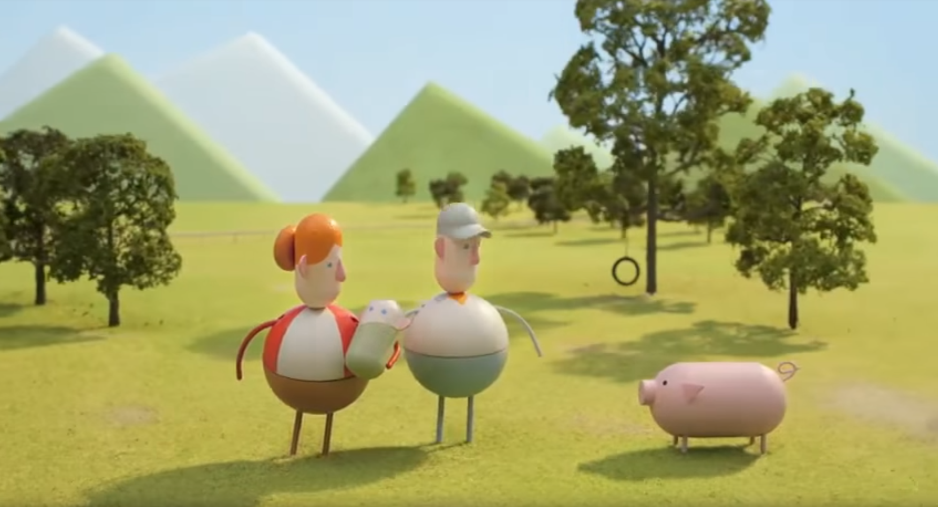
Fig.11
Publisher: Chipotle & Creative Artists Agency
Title – Back to the start
Date Published – 2012

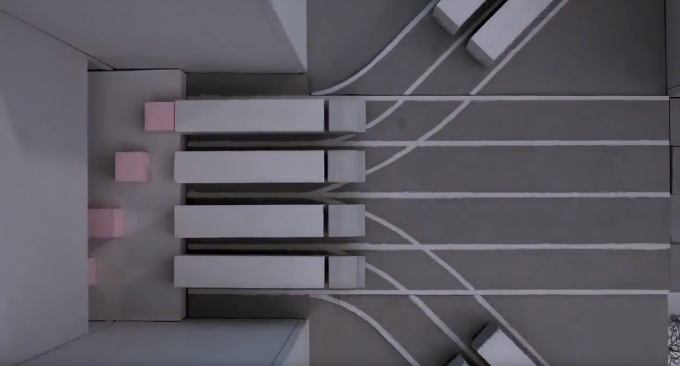
Introduction.
Fig.12
Publisher: Chipotle & Creative Artists Agency
Title – Back to the start
Date Published – 2012

This dissertation is an attempt to address the argument that there is a direct correlation between visible light (Colour) and human behaviour, emotion and feeling. This Dissertation will also compare as it whether Colour Theory and Colour Psychology is fused into design.
The research committed throughout this thesis will primarily explore and focus on the application of colour in aspects of design, such as: illustration, animation, brand, and advertisement. Upon review of design examples, it will be noted as to whether the design is successful in achieving the creators desired outcome to the viewer’. The media examples listed have been chosen due to the broad nature of colour theory & psychology.
I chose to explore and learn this subject as it directly links with my study of graphic design, graphic design & design is a completely subjective topic, however there are specific choices that a designer can make to evoke a specific reaction, feeling or emotion from the viewer. Baring great responsibility regarding colour, there are certain factors which determine the potential success of a piece’. This varies from cultural appropriation to target audience needs and wants. With no set guarantee that a final piece may achieve the same desired effect in every person there are measures that can be taken to raise success. For example, a basic understanding of colour theory may increase those statistical odds of achieving a likely consistent chance of getting the viewers to feel the same.
Each form of graphic media: Illustration, Animation, Brand, and Advertisement individually aspire to achieve a unique result from their target audience.

In Chapter One I will explore, introduce, and briefly explain the fundamentals of colour and its characteristics. I will also research and provide case studies in support of how colour theory may influence or alter behaviour, feeling or emotion.
Chapter Two will further my findings by providing examples of the listed graphic media, to then annotate and review as to what the desired outcome may be, and whether its is successful. Factors which determine desired outcome and its success are atmosphere, mood, and reaction.

Chapter 1: What is Colour Theory?
Sub Chapter: What is Colour?
There are two primary colour system methods by which colour is reproduced, additive and subtractive, both of which we use daily. Simply put, anything that emits light uses additive for example television, smartphones and computer displays. Subtractive is any object that reflects light e.g. paper, paintings, walls, wood, metal, cotton.
Additive colour breaks down into three colours: Red, Green, Blue (RBG). Using different wavelengths of these colours allows for reproduction of other colours. Subtractive is simplified into CMY: Cyan, Magenta, Yellow. It works based on reflecting light, more specifically the way a pigment reflects different wavelengths. Black is also included into this formula being the combination of CMY however it isn’t perfect. Due to this, a fourth pigment is introduced as “KEY”, completing the formula as (CMYK).
“Colour is the aspect of things that is caused by differing qualities of light being reflected or emitted by them”. [1]
Visible & invisible light is formulated in a spectrum. We primarily see the colours with a wavelength that our eyes are capable of processing. Each different colour in the rainbow has a unique wavelength (speed) of which is travels. The longest visible wavelength is red, the shortest being violet.
To understand colour harmony, it’s important to understand the basics of colour theory. Light is part of a huge range of vibration energies which is called electromagnetic spectrum. This includes gamma waves and radio waves. Only a small portion of this is visible to human eyes, this is the visible colour spectrum. The most sensitive colours we see in this spectrum are green & yellowish green (lime).
The visible spectrum is broken down into primary, secondary & tertiary colours. Primary colours consist of red, blue & yellow. Whilst secondary colours are an equal 1:1 mix of primary hues forming purple, green & orange. Tertiary colour is an unequal mix of 2:1 forming Red-Orange, Blue-Green etc. You can further break down the basic colours hue, brightness & intensity. Hue is the principal colour of white light. Essentially a primary, secondary, or tertiary colour. Brightness is the range from light to darkness, based within that hue.
Intensity is the range of any pure hue to the point of grayscale. Intensity can also be split into three sub-categories: Tints, Shades & Tones. Tints are the range of pure hue to white. Shades are the range from pure hue to black. A tone is the range of pure hue to any grey. Using the basic colour wheel, a designer can form a palette of harmonic colours, this is defined as: a satisfying arrangement of colours.
“A harmonic colour pallet aims to engage its viewer and create a sense of order. The human brain often rejects un-harmonic colours leading to a feeling of boring or even chaotic, which may cause a person to feel uncomfortable. Extreme cases of unity in colour leads to under-stimulation, oppositely, extreme complexity leads to over stimulation. A harmony is a dynamic equilibrium of colour.” [2]
Knowing this in basic form, using a complimentary colour palette results in opposing colours on a colour wheel e.g. green & purple. A great example of this would be natural flowers, harmonising colours effectively to achieve the purpose of that plant.
Sub Chapter: What emotions and feelings do colours trigger?
Scientists have committed a great deal of research into understanding the philosophy as to why colour can affect our mood, whether it be instinct or taught through culture. There’s a lot of various meanings behind colour in different cultures. This section is split into two sub-sections: universal colour application & cultural application.
Universal colour application to emotion/ meaning is a fundamental idea that most societies associate with said colour. For example, there are two basic colours ‘Red & Green’. Typically, red is known to represent “STOP” and green “GO”. This is a basic example however it gives some insight into the concept. Cultural Application to colour, there are hundreds of colour blends, shades, tones which can be interpreted differently throughout society. For simplicity we will focus on three: Red, Green, Blue (RGB). Red for example in most western societies represent: warmth, excitement, passion, desire and even danger, evil or anger. Green can be paired with nature, organic, growth, balance, peace, fertility & positivity. Blue also pairs with trust, honesty, authority, intelligence, calmness as well as sadness, gloominess and cold.
Interestingly, these colours can also represent more sensitive subjects. For example, South Africa associates red with mourning, the section of red in their countries flag represents violence & sacrifice.
“In Chinese culture red is traditionally worn on New Year as well as during funerals and weddings, it can also mean celebration or good luck. Green is often associated in western culture as life, however some South American cultures associate green with death. (Particularly those near forests.) Blue in western society is known to a masculine colour, however Chinese culture pairs it with feminine.” [3]
Aside from media, colour has been a very controversial topic in science, with relation to behaviour and even therapy it’s still not completely known as to what is entirely reliable. The study of how colour affects these attributes is known as photobiology, researchers have committed a great amount of experiments in search of finding solid evidence in support of this.
It seems that colour association is a complex topic, hue, value, intensity each determine a variety of emotions. Past research in this subject has surfaced a variation of results thus causing un-reliability. However, through some exploration there is a shared factor between conclusions. For example, Lynda Adler quotes:
“Associations may relate to how we view our environment and may stimulate our other senses. For example, colour suggests warmth and coolness. Persons in a blue-green room in one study felt that 4 59 degrees F. was cold, but in the red-orange room, the temperature had to fall from 52 to 42 degrees F. before people reported being cold. In another study, people tended to set the thermostat four degrees higher for comfort in a blue room than in a red room.” [4]
The evidence in support of examples surrounding colour psychology is un-reliable due to too many uncontrollable factors. It seems however that through discovering research in support of this hypothesis that there is a similarity between conclusions and how colour alters a person’s psychological state. Another example would be ‘Audrey K. Pahmer conducted an experiment in 2003 where 30 participants sat in a large cardboard box, each box being coloured. Everyone would sit in the box for up to 2 minutes whilst Audrey recorded the subjects blood pressure. The results are as follows:
“As I had hypothesized, red and yellow increased blood pressure, while green decreased it. However, my hypothesis was incorrect for blue. Blue did not decrease the blood pressure. It only went up or down few units but remained the same as the control most of the time. I also did a hypothesis test of significance comparing the mean of each colour to my control to see if my results were significantly significant. I found out that red, green, and yellow were all significant, (at the .05 alpha level), but, blue was not statistically significant in the difference of means.” [5]
Comparing experiments supplies us with somewhat a formidable foundation of support as towards how colour potentially alters a person’s feelings and emotion.

Sub Chapter: Colour Psychology
that the use of colour can significantly help increase the cognitive function of the brain:
“Clinical intervention for patients with dyslexia using colour have been proven to be effective in reducing patient difficulties in reading. The same approach is also used to help autistic patients. An improvement of reading speed up to 35% was reported for autistic patients reading using a coloured overlay compared to autistic patients reading without using a coloured overlay.” [7]
Using the fundamental ideology of applying colour to education in aid of increasing pupil efficiency to learn has been a well-endowed subject, as researched by Margie Meacham. She writes that:
“In 2002, researchers discovered that subjects performed 5-10% better on standardized pattern recognition tests when they were administered in colour rather black and white. The effect also boosted memory over time. The advantage of using colour was only demonstrated when the colour was “realistic.” When the objects were depicted in random colours, it appeared to have no effect on memory or pattern recognition.” [8]
Colour theory co-joins with colour psychology, the understanding as to how and why colour can alter behaviour. There has been a great deal of research, experiments, and practical application of colour psychology in effort to help change people’s behaviour for the better. For example:
“When children under detention at San Bernardino County Probation Department in California become violent, they are put in an 8-foot by 4-foot cell with one distinctive feature - it is bubble gum pink. The children tend to relax, stop yelling and banging, often falling asleep within 10 minutes, said Paul E. Boccumini, director of clinical services for the department.” [6]
Another example of how colour has been utilized in attempt to help benefit people is London’s Blackfriars bridge:
“re-painted blue to reduce the number of people who commit suicide by jumping from it.” [6]
A study committed by Mariam Adawiah Dzulkifi & Muhammed Fiaz Mustafar explores the influence of colour on memory performance. Their conclusion states
Colour, theoretically has limitless implications on everyday life, sub-consciously as humans we determine the quality of our food based on three senses: sight, smell, touch. It’s believed that visualisation of our food is perhaps the most vital. Understanding that colour can influence or even appetize an individual is a powerful tool for marketing.
In a science experiment, an individual set to understand as to whether a unique colour would influence for a squirrel to eat more nuts daily. This involved placing squirrels in coloured boxes and observing their daily intake of food. The conclusion is as follows:
“The hypothesis that the squirrels in the red box will eat the most nuts is proven to be correct. Squirrels are affected by colour in the same manner as we are.” [12]
Although a basic experiment, it provides some insight into how our behaviour can changes based on the colour of our surroundings. This topic however is controversial as for other experiments have proven opposite results. For example, Benjamin Caro found from extracts that people were less appetising when eating off a red plate.
“Regardless of enjoyment, testers ate less and tried less hand cream when they were handed red plates. Because of the earlier pasta party experiment, study author Nicola Bruno expected to see the results contingent upon differences in colour intensity, "but they did not. It's really related to the colour red compared to the food and cream colours." [13]
This case study contradicts the evidence of [12]. However, it supports the argument that not every individual will have the same depicted result from a set experiment.
The research obtained through this chapter provides more understanding into the context of how colour theory isn’t entirely conclusive. The results vary from case studies, a great example of inconclusive results is how colour influences appetite. Although somewhat unreliable, the results do show that colour perception is unique to the individual and that colour appropriation is a valid factor to consider.

Chapter 2: Psychology of colour in design,
how it evokes feelings & emotion.
Colour psychology is everywhere. Artists consider an array of variables on which they want their work to achieve, whether it be a painting, illustration, story book, television, marketing, or advertising. This chapter explores and explains various examples of design pieces and how they have successfully or unsuccessfully incorporated colour psychology to achieve its intended purpose.
Sub Category: Illustration
Fig.1 - Until the light takes us.
Attention is focused initially on the bluey-green ‘tube’ in the centre of the scene. Once your attention is caught you start to explore the scene out of curiosity, to understand the context. The contrast of dark gloomy shades to a light colour draws the eye. Achieving viewer attention for longer than a couple seconds is a difficult task, executed effectively in this piece through the colour palette. The gloomy use of greys, blues, and blacks all give an immersion of loneliness, whilst the highlight of lighter green-blue brings life into the illustration. A contrast between seclusion and the idea of seeking other life/ energy.
Fig.2 - Banana Girl.
The first impression of this illustration would be that it’s bright and colourful. At the centre of the image is the character, this draws in attention immediately not only due to positioning but also that the characters and banana stack are the two brightest (most vivid) coloured objects in the image. The backgrounds/ surrounding scene is using slightly washed out colours to create depth. The utilisation of colours creates an emotion of happiness in the scene, perhaps even tranquillity. This is done through successful application of harmonic colouring creating a satisfying balance between intensity and hue. Expanding on how the colours imply happiness, the use of yellow and green are two of the primary colours, both of which are as mentioned the most sensitive wavelengths of visible light thus creating the mood.

Sub Category: Animation
Fig.3 – UP.
Context:
“Up proves its power within the first ten minutes. With just a few lines of dialogue, an eye-opening montage introduces us to the main character, Carl and shows us the story of his life and love with Ellie – from their meeting as children, to their marriage, to their inability to have children and to her death.” [9]
Pixar use an intense application of colour to materialise these raw emotions and share them with the viewers. The colour palette in the early stages of the dialogue are filled with bright, vibrant greens, blues, pinks, yellows and so on. This symbolises the joyous and happy life that Carl & Ellie share. They also represent the characters passion and youth. Further into the dialogue we see a more dark, saddened time of Carl & Ellie’s relationship from Ellie’s inability to have children and even her unfortunate demise. This half of the sequence is painted with more colour neutral/ cold tones, representing the sadness, grieving and loss of life. This is a great example of effective application of colour theory & psychology as the colours give us more of a connection to the story and its characters.

Fig. 4 – TOY STORY.
Context:
“The world that Toy Story inhabits, where toys have secret lives unbeknownst to their owners. Everything that Andy’s toys think about and desire revolves around being played with and remaining relevant. Playtime is a thing to revel in. Selection for bedtime and trips away from home are special treats. Birthday and Christmas are wrought with anxiety for fear of being replaced.” [10]
Here we are exploring the difference in colours used through the film between the introduction of Buzz lightyear to the other toys, then further in the film for when he has accepted his place as toy and for the other toys and himself are happy.
“Buzz’s arrival at Andy’s birthday party is the precise contrast the film needs to know the world it depicts. Buzz doesn’t know (or care) he is a toy. His values are different from Woody’s or the other toys”. [10]
Here we see a slightly darker tone of colour, despite being set at night the film has used a very bright and vibrant range of hues until this point. Reason being that it’s to immerse us into the idea of reality as Buzz (at this point) is a spaceman sent to earth to fight his enemy. This application of more realistic tones allows us to step into the concept of what Buzz feels, being that he’s trapped on an alien planet and there’s imminent danger, Buzz hasn’t realised who or what he is.
Fig. 5 – TOY STORY.
The colour palette is much brighter and there’s a significant amount more of contrast. Here we see that Buzz has accepted his place as a toy and shares the same values as the other toys. There’s more happiness and excitement. A step back from reality. Using different tones of colour throughout the film helped the audience subtly distinguish reality as well as what the toys felt. Another great example of effective colour application.
Using colour, the film allows for the audience to develop emotional attachment to characters, it also allows for viewers to understand how the toys feel throughout the film. Toy story understands that children will be more energetic when a great adventure takes place during the film but using colour to express it, using the more natural life like colours it allows for a neutral approach to atmosphere and mood where as un-natural brighter colours steps into the toys reality and perception of the world.

Sub Chapter: Logos
Fig. 6 – Barclays Bank.
Barclays is a public bank organisation that has millions of customers internationally. This business and its identity logo was chosen for its simplicity in symbolism and message through colour. Barclays like any other business has targets of which to achieve, being a bank, its foundation relies on customer trust and loyalty as for it manages money. Understanding the basic criteria of what the business wants consumers to perceive of the brand likely helped influence the colour choice for branding. The iconic ‘Barclays blue’ symbolises strength, integrity, trust & clarity which people seek in a bank. Although simple, the colour choice has likely helped people choose whom of which they trust to store their money.
Fig. 7 – The 2017 Coca-Cola Christmas Truck Tour.
Coca Cola is an international business pronounced for its soft drinks, every year Coca Cola run an advertising campaign where they employ people to drive large red lorries with their logo (and a picture of Santa Claus) around and throughout the Nation. This campaign is very successful as it marks the nearing holiday of Christmas. What Makes this so effective is the use of the colour ‘Red’, a colour in western culture widely remembered and associated with Christmas. This concept of associating red (and green) with Christmas is normally seen in the winter.
“Coca Cola decided to go down a new marketing route in 2001, they created an uproar not unlike their new coke fiasco. By 2007 their famed commercials returned after customers phoned in demanding they bring back their childhood nostalgia. Repeat that for a second and comprehend how crazy it is. This is a company that sells soft drinks, a product that has as much to do with Christmas as a palm tree does.” [11]
Interestingly, the campaign has become so widely accepted and known with the holiday it now runs every year, and has done so since 1995. Despite the reality that Coca Cola’s soft pop has virtually nothing in relation with Christmas’ festive holiday. However, the marketing campaign has grown into the likes of people’s memories thus leading to its success.
This is a very effective example of utilising colour psychology as Coca Cola have built their brand into being associated with one colour. Using that colour to then create a story of which people become connected to. Symbolising an event and emotions.
Fig.10 – McDonalds Logo
McDonalds and its infamous golden arches is an icon in modern history, being more than just a rendition of the letter ‘M’. Its simplicity distinguishes the logo whilst being both characteristic and clean. The two-prominent colour used is bright red and yellow, the colour pair matches the company’s objectives perfectly, as mentioned by Gorilla Studio:
“Primary colours like red and yellow are the most eye-catching of the colour wheel and appeal to everyone, from children who associate bright colours with toys to commuters who are in a hurry to find something quick and convenient to eat.” [11]
The two colours represent a personality and trust form factor within the business. As for red can appetize an individual but also who strength and energy, whilst yellow represents happiness and satisfaction. Supporting the idea that McDonalds should be your choice for a meal.
Sub-chapter: Advertising
Fig. 8 – Meet iPhone X
Apple is a tech giant in the modern world, manufacturing and selling a variety of products ranging from smartphones, tablets, desktops, laptops, watches, and software. In a world of mass marketing it’s argued that somehow Apple still manages to avoid the saturation of marketing and brings fresh fun products to customers without being dull. This all boils down to methodology in how they push their product across.
Using their most recent product iPhone X is their newest flagship smartphone. What makes the device so interesting is not the facts surrounding it, but rather the vibrancy and exciting display of colours that shows off the phone. Fig. 8 for example is the first frame of one of their many advertisement videos for the device, instantly you are greeted with an explosion of colour which catches attention, the gradient isn’t overwhelming and suggests energy/ passion. This first impression is important as it’s ensuring that the viewer is caught with that fun energy of “here’s something new”. This first frame fundamentally changes your behaviour as it keeps your interest.
Fig. 9 – Meet iPhone X
Fig.9 is a separate frame screenshot from a few seconds later in the same video ad as fig. 8. Analysing this frame feeds an idea into our mind about the device, with white space there’s a sense of cleanliness and virtue as to suggest ‘for if you have this device there is creativity and perhaps a sense of purity or clarity’. This concept is supporting the idea with a bright colourful background on the device keeping the fun energy and curiosity of the viewer. The contrast allows for the colour to have a larger voice.
Fig. 11 – Back to the start
Chipotle, an American Mexican fast food chain is a thriving business in the United States. It’s 2012 advertising campaign labelled: ‘Back to the start’ took to fame due to the beautiful yet clear message portrayed in the two-minute animation. Taking viewers through the change of heart of a farmer running an industrialised farming compound to one with a more sustainable and humane method.
Not only does the animation and its narrative make the ad gripping, but it’s visual communication of colour does this just as affectively. Quite simply the ad starts with a short pan through an organic farm, every colour in this short sequence is bright, vivid, and natural, representing a healthy farm [Fig.11]. Further through the ad we see the farm starts to industrialise, thus leading the colour gradient to dim and become more neutral. This clearly represent the negative narrative of the story. [Fig. 12]
The application of colour in this advertisement helps materialise a connection between the viewer and the narratives meaning. For if there wasn’t a colour gradient change there likely wouldn’t be as strong of an emotional connection or behavioural change towards the matter. A very simple and efficient application of colour theory in advertising.
Fig. 12 – Back to the start
It’s clear that through all the provided examples of graphic media there is a consistency in objective. The creators each set to achieve a reaction from their audiences, when broken down it’s clear that each sample does effectively use colour in favour of pushing the message or idea across. The illustration samples provided don’t seem to have as much as an emotional connection to viewers, however they do bring attention to detail. Whereas material such as advertisement and animation use colour to bond the viewer with the narrative.

Conclusion.
In chapter one I found that there is cultural appropriation towards colour theory, that certain colours represent unique meanings to certain cultural societies. This was important as it allows for a more specific conclusion as to whether an experiment or media example is successful in achieving an evoked feeling based on culture and target audience.
Sub-chapter: Colour Psychology explored case studies for experiments regarding application of altering behaviour based on colour. It’s found that colour was used to calm misbehaving children at San Bernardino County Probation Department [6], as well as aiding individuals in achieving higher efficiency rates at learning with disabilities [7]. Colour has been seen to somewhat improve cognitive memory functionality through patterns in [8] which supports the ideology of colour theory, same as for all other case studies.
Through researching various forms of graphic media, illustration, animation, brand, and advertisement were my four choices as they each aim to evoke or suggest a unique feeling in their audiences. I found that currently, modern design utilises colour affectively in achieving a connection with their target audience. For example, Pixar Animation Studios are great at creating an atmosphere and emotional bond between the viewer and the characters using colour (fig. 3 & fig. 4). I also noted that brand identity heavily relies on its design colours just as much as the logo. McDonalds for example is a great example for this, as the two key colours are red and yellow. Each representing the brand as much as the ‘M’. The colours attract customers through sub-conscious decision making based on that individual, and their perception of what the red and yellow means. Overall McDonalds achieve their targets goal of wanting customers to believe in the brand as a strong and reliable provider in fast food. This depiction of logo has been built from other controlling factors, as mentioned in sub-chapter – colour psychology, colour perception is unique to the individual.
Through all the media forms compared and reviewed its clear that colour embeds a conscious and sub-conscious idea into us that essentially changes our behaviour and mood. Whether a graphic piece achieves an affect in altering emotion isn’t always clear, as it objectively depends on the individual viewing it, however there is a consistency in which colour is the controlling key factor of altering mood. My overall conclusion is that colour simply does affect our behaviour, emotions, and feelings.
Throughout the dissertation there has been some interesting case studies in support as to how colour does influence behaviour, emotion, and feelings. A note that I have taken throughout this experience is that some studies or experiments aren’t always reliable when resourced online.

Bibliography
- [4] Adler, L. (1999). Responding To Colour. Cooperative Extension Service, (HF-LRA.151).
- [12] All-science-fair-projects.com. (n.d.). Colour & Apetite. [online] Available at: http://www.all-science-fair-projects.com/print_project_1385_92 [Accessed 5 Dec. 2017].
- [13] Caro, B. (2014). Color Psychology: Red Plates Make You Eat Less. [online] L.A. Weekly. Available at: http://www.laweekly.com/restaurants/color-psychology-red-plates-make-you-eat-less-4421683 [Accessed 10 Dec. 2017].
- [1] crayola.co.uk. (2017). What is Color?. [online] Available at: http://www.crayola.co.uk/for-educators/resources-landing/articles/color-what-is-color.aspx [Accessed 1 Sep. 2017].
- [7] Dzulkifi, M. and Mustafar, M. (2013). The Influence of Colour on Memory Performance: A Review. The Malaysian journal of medical sciences, (PMC3743993).
- [10] Epic Brand Storytelling. (2014). How Coca Cola Uses Christmas To Tell a Story Nobody Forgets. [online] Available at: http://turndog.co/2014/12/02/coca-cola-tell-a-story-nobody-forgets/ [Accessed 7 Dec. 2017].
- [11] Gorillastudio.co.uk. (n.d.). Gorilla - What makes McDonald’s logo design so successful?. [online] Available at: http://gorillastudio.co.uk/branding/what-makes-mcdonalds-logo-design-so-successful/ [Accessed 9 Dec. 2017].
- [6] GRUSON, L. (1982). COLOR HAS A POWERFUL EFFECT ON BEHAVIOR, RESEARCHERS ASSERT. [online] Nytimes.com. Available at: http://www.nytimes.com/1982/10/19/science/color-has-a-powerful-effect-on-behavior-researchers-assert.html?pagewanted=all [Accessed 7 Dec. 2017].
- [2] Guru, B. (2014). Understanding Color. [video] Available at: https://www.youtube.com/watch?v=Qj1FK8n7WgY [Accessed 2 Sep. 2017].
- [3] HuffPost. (2016). What Colors Mean in Other Cultures. [online] Available at: https://www.huffingtonpost.com/smartertravel/what-colors-mean-in-other_b_9078674.html [Accessed 3 Sep. 2017].
- [8] Meacham, M. (2015). How colour can affect learning. Association for talent development. [online] Available at: https://www.td.org/insights/how-color-can-affect-learning [Accessed 7 Dec. 2017].
- [5] Pahmer, A. (2003). How Does Color Affect Blood Pressure? CALIFORNIA STATE SCIENCE FAIR, (S0317).
- [10] Vardenega, J. (n.d.). Toy Story. [online] PIXAR. Available at: http://pixar-animation.weebly.com/toy-story.html [Accessed 7 Oct. 2017].
- [9] Vardenega, J. (n.d.). Up. [online] PIXAR. Available at: http://pixar-animation.weebly.com/up.html [Accessed 7 Oct. 2017].

