Rebecca Porter
2320044
Module 3
BMPF7326D

Vocal Health Within the Cruise Ship Entertainment Industry

Index

Proposal - pg. 3
Report - pg. 5
- Introduction - pg. 6
- Literature Review - pg. 7
- Methodology - pg. 9
- Findings - pg. 12
Conclusion - pg. 24
Reference List - pg. 26
Appendices
- Appendix A: Interviews - pg. 29
- Appendix B: Questionnaires - pg. 57
- Appendix C: Consent Forms - pg. 68

Proposal

Context
This project is dedicated to the area of vocal health within the working environment in entertainment onboard cruise ships.
The aim is to define the vocal demands of a cruise ship entertainer role within the entertainment team onboard such as vocalists, guest entertainers, hosts, guest speakers and cruise directors onboard.
Justification
There is little literature available when trying to investigate the vocal impact of those working on cruise ships within entertainment. As a professional singer with 16 years of experience within the cruise industry, I have witnessed and experienced the extremes in how the voice is affected by the cruise environment and believe it important to raise awareness of how to protect your voice and upkeep professional standards within this workplace.
Simberg and Gustafsson (2015), as part of the Pan European Voice Conference Abstract Book by Manfredi, performed a study on vocal health for all crew members with many different job roles but all sharing the same environmental factors. It revealed there was no difference between men or women, and there was also no difference between those who smoked and those who did not. Vocal health in general was much poorer, showing more frequent vocal symptoms than on land, and reported it was due to poor air quality and higher noise exposure, resulting in higher accounts in vocal and general health due to background factors on cruise ships.
Aarnio (2022) explains how the air onboard a modern cruise as we see today is dehydrated and circulated to save energy consumption, and although they advertise 100% fresh air, it is not actually the case.
Satalhoff (2017) describes how lack of humidity in the air creates a drying effect on the voice through mucosal irritation. Black & Black (2018) also prove that recirculated dry air spread pathogens much faster and also remain in the air for up to three months, putting the voice and respiratory health more at risk than on land.
Work agencies and cruise lines do not provide this information and is only found through on-the-job experience.

The intended impact
The aim of this project is to address and gain more insight into vocal distress some cruise entertainers might have encountered during their career.
The World Health Organization (2007) provides a medical guide for ships covering upper respiratory issues such as the common cold, where it states, “No treatment is needed”. This is the closest research found to any voice protection or workload decisions made by entertainment management or medical team onboard- leaving a large field of research to be explored.
Mishler (2009) explains how the interview method is a definite way to achieve understanding of beliefs, feelings and experiences through question and answer, therefor non-bias, open-ended questions will be asked to three participants with different job roles to gain depth of data.
Questionnaires will then be distributed to as many cruise entertainers as possible to collect a greater range of data utilising choice answers, as Patten (2016) stated that this type of format allows participants to reply fast to questions that can be assessed objectively and aids in the number of responders as it takes less time.
Bradburn et al (2015) make aware how intrusive this type of research can be and therefore informed consent, confidentiality of companies and entertainers names will remain anonymous as to not compromise career opportunities for the participants.
Learning outcomes
I hope to achieve proof and reason for importance of this type of research to help protect the future of entertainers in this professional workspace. Williams (2020) makes apparent the attractive nature of this career where entertainers find their dream job singing, dancing, being a big personality and have almost fame-like status onboard a ship whilst exploring the world. But are these professional artists receiving profession-safe protection of workload or vocal health awareness for this specific type of workspace?

Rebecca Porter
2320044
Module 3
BMPF7326D

Report

Vocal Health Within the Cruise Ship Entertainment Industry

5876 Words

Introduction

Since the 1970’s the popularity of cruise ships has grown along with capacity of people and berth to include more activities onboard (Dorigatti et al, 2022). By the mid-20th century, it was claimed the fastest-growing globally renowned part of the travel industry (Koncar,2017). The current world’s largest cruise ship is 1,196 feet long, 20 decks, can accommodate up to 7,600 passengers and 2,350 crew members (Shine Cruise, 2025). The current world’s smallest cruise ship is 98.3 feet long, can accommodate 16 passengers and 12 crew (Tunney, 2023).
No matter the size of the ship, entertainment plays a critical role not just in enhancing the guest experience but also in driving revenue. Cashman (2016) illustrates how entertainment is strategically used to draw guests to specific venues, which, in turn, generates significant onboard revenue. Whether it’s enticing passengers to the theatre for specialised shows, the top deck for a sail away party with a live band, or a cocktail bar for piano performances, these activities are integral to creating the cruise atmosphere and keeping passengers engaged.
What’s particularly interesting is Cashman’s (2016) point that a considerable proportion of cruise line profits are derived from onboard revenue, not from ticket sales. This means that the entertainers, performers, musicians, and other staff are key players in this revenue-generating mechanism. The demand for high-quality entertainment is high, and it drives the commercial side of the cruise business. In many ways, entertainers are directly contributing to the financial success of the cruise, even though, there’s a lack of substantial literature focusing on their needs and challenges.
With 17 years of experience in cruise ship entertainment, I have observed the evolving demands placed on performers and the significant impact the cruise ship environment has on vocal health and performance. Firsthand experiences, along with concerns raised by colleagues, highlighted a lack of vocal health support within the industry. This gap in resources and awareness motivated the need for research into the realities of vocal health challenges at sea.
Given the limited literature on vocal health in the cruise entertainment industry, this study adopts a qualitative approach, incorporating semi-structured interviews with three participants from different entertainment sectors, alongside questionnaires to assess broader trends. The goal was to determine the extent to which vocal strain is more prevalent at sea compared to on land and to explore how performers manage these challenges.
As a subjective research project, this study aims to illuminate cruise entertainment culture, working conditions, and the environmental factors affecting vocal health, identifying gaps where existing vocal health literature may not fully address the needs of performers. By analysing participant experiences, this research serves as a foundation for industry-wide recognition of vocal health concerns and calls for improvements in working conditions, management decisions, and tailored vocal health training for cruise entertainers.

Literature Review

The Overlooked Social and Professional Realities of Cruise Ship Entertainers
Lütkenhaus (2020) highlights a significant gap in research, particularly when it comes to social studies in the context of life at sea. The lack of literature on the social dynamics and well-being of cruise ship crew members, including entertainers, is striking given the complexity of the environment they work in. The scarcity of literature on cruise ship entertainment is certainly surprising, especially when considering the vast amount of research available on land-based professional singers and the music culture that exists within those contexts. As Cashman and Hayward (2020) point out, the contrast is striking: there is a wealth of scholarship focused on musicians' vocal health, performance practices, and professional challenges on land, but little exploring the same issues for those working on cruise ships.
Vocal Health Challenges at Sea
Benninger and Murry (2008) and Davies et al (2005) make significant contributions to our understanding of vocal health for professional voice users, highlighting the importance of addressing vocal health challenges and understanding the factors that impact voice performance. Their work underscores the necessity for initiative-taking vocal care, especially for those in high-demand professions like singers, actors, and public speakers, where vocal strain and injury can jeopardise their careers. The insights of Davies et al (2005) work on the effects of travel on vocal health, particularly their focus on flying, is a critical part of this literature. They highlight how factors such as dry air circulation systems and background noise contribute to a vocally challenging environment- conditions that are equally relevant to the air filtration systems and noisy environments found on cruise ships.
A study by Simberg and Gustafsson (2015) offers insight into the vocal health challenges faced by crew members on cruise ships. Overall vocal health was worse, with more frequent vocal complaints than those typically reported for land-based professionals. The fact that there was no distinction in vocal health between males and females or between smokers and non-smokers suggests that the environmental conditions aboard cruise ships have a pervasive impact on all crew members, regardless of their personal habits or gender.
The issues of poor air quality and increased noise exposure identified in the study are particularly concerning. These factors are like the challenges associated with air travel, but with the added complexity of the cruise ship being a long-term living and working environment. On a plane, the exposure to such conditions is transient, usually lasting just a few hours, but on a cruise ship, crew members are exposed to these potentially damaging factors for much longer periods, even months at a time.
Sataloff's (2017) emphasis on understanding the current state of the voice to prevent injury highlights the importance of making informed decisions about vocal care. Personal strategies- like adjusting the length of rehearsals, selecting appropriate song choices, and ensuring adequate vocal rest- are all critical elements of maintaining vocal health, especially for those who rely on their voices professionally. However, the cruise ship environment presents unique challenges that complicate the implementation of these strategies. The historic hierarchy aboard cruise ships, particularly the power dynamics between officers and management and the performers, often restricts the autonomy of entertainers to make decisions that could protect their vocal health (Dennett 2018). In a typical workplace, performers can control aspects like rehearsal schedules, the type of material they perform, or when they need rest. However, on a cruise ship, these decisions are often dictated by management or operational needs, which can take precedence over individual health concerns.

Hierarchical Challenges at Sea
Dennett (2018) as well as Cashman and Hayward (2020) both emphasise how the naval hierarchy on cruise ships has a direct impact on the autonomy of crew members, particularly entertainers. The fact that management makes decisions regarding all aspects of life on board- such as cabin assignments, salary, working hours, and even who can interact with passengers- leaves performers with very little agency when it comes to decisions that directly affect their vocal health and overall well-being.
This kind of rigid structure makes it difficult for performers to voice concerns about their well-being, especially if they feel pressured to adhere to a packed performance schedule without considering the strain on their vocals. The pressure to perform consistently, multiple times a day, in less-than-ideal conditions (with dry air, noise, and travel-related fatigue) creates a situation where vocal health is often sacrificed for the demands of the job.
This study really underscores the need for more targeted research and guidelines for vocal health specifically for cruise ship entertainers and other long-term crew members. While much of the current literature focuses on land-based environments or short-term travel, the unique, extended nature of life aboard a cruise ship demands more specific attention.

Methodology

Exploring Vocal Health in Cruise Entertainers
This study aims to explore how cruise entertainers perceive the impact of their job roles on their vocal health. By adopting a subjective research approach, this study gathered insights directly from participants, focusing on their subjective experiences, emotions, and challenges within the cruise environment. This method allows for a deeper understanding of the lived realities of performers and the unique demands placed on their vocal well-being (Levers, 2013).
Ethical Considerations and Participant Anonymity
Protecting participant anonymity was a key ethical priority in this research. Hammersley and Traianou (2012) emphasise that maintaining confidentiality helps mitigate potential risks to participants’ careers, reputations, and personal lives. By ensuring that neither the participants’ identities nor the industry names were disclosed, the study upheld ethical research standards. This approach also fostered trust, encouraging participants to share their experiences openly without fear of repercussions (Lincoln 1985).

Potential Impact and Practical Applications
Hennink et al. (2020) highlight that qualitative research does more than just gather data- it can drive meaningful change. The insights derived from this study could inform industry policies and interventions aimed at improving vocal health and overall well-being for cruise entertainers. For instance, identifying the relationship between environmental conditions and vocal strain may lead to new vocal care protocols. These findings could be shared with industry leaders, health professionals, and cruise ship management to enhance working conditions for performers.
Connecting Land-Based and Onboard Vocal Health Practices
To gain comprehensive insights, a mixed-method approach combining interviews and questionnaires was used to collect open, honest, and anonymous perspectives from cruise entertainers. O’Cathain et al. (2007) emphasise that mixed methods strengthen research by balancing in-depth qualitative insights with broader quantitative data, making it an effective approach for understanding complex work environments. By comparing land-based vocal health resources with the realities of working at sea, this study aims to bridge the gap between these two environments and contribute to better strategies for preventing vocal injuries among cruise ship performers.

Research Methods: Justification for Data Collection Approaches
Use of questionnaires:
Questionnaires offer structured yet flexible data collection, making them ideal for the demanding cruise entertainment industry (Ruel et al., 2015). Patten (2016) emphasises the importance of concise, direct questionnaires, which was crucial given performers' limited availability. A streamlined format encouraged participation while minimising disruption.
The study aimed to assess vocal strain prevalence among cruise ship entertainers and determine whether issues were more pronounced at sea than on land. It also explored awareness of vocal health risks within the industry.
As an insider researcher, prior knowledge of vocal care practices and industry experiences informed the multiple-choice framework, allowing for structured analysis of how performers manage vocal strain in a challenging work environment. However, as the industry is known for being studied by insider researchers, there is a significant chance of bias within this research field. To mitigate this, measures were taken to avoid influencing participants and ensure objectivity in data collection and analysis.

Interview Method:
King et al. (2020) discuss how qualitative interviews are widely used and easily accessible for both researchers and participants. This familiarity helps create a comfortable environment, allowing individuals to express their thoughts candidly. Given the sensitive nature of vocal health, interviews provided an opportunity for in-depth exploration in a safe, conversational setting, where participants felt at ease discussing their challenges.
As Svend (2022) suggests, face-to-face interviews enable participants to convey emotions more effectively. The emotional aspects of vocal health- such as the frustration of vocal strain, performance pressures, or the vulnerability of being unwell while constantly in the public eye- can be difficult to express through written or remote methods. Face-to-face interactions, such as the one conducted onboard, provided a richer, more nuanced understanding of these experiences. Vocal health is not just a physical concern; it is deeply connected to a performer’s mental and emotional well-being (Castillo-Allendes, 2024).
To accommodate participants' schedules and accessibility, two interviews were conducted via Zoom, while one took place in person onboard a cruise ship. This combination of virtual and face-to-face meetings provided flexibility while maintaining the depth and quality of engagement. No noticeable difference in interview quality was observed, as clear audio and visual communication allowed for effective interaction in both formats.
Barsky (2019) emphasises the importance of allowing participants to shape the conversation, ensuring that findings reflect their authentic experiences. Semi-structured interviews offered the flexibility to explore issues beyond predefined questions, reducing bias and capturing a wider range of perspectives. This approach was particularly valuable in an under-researched area like vocal health in cruise ship entertainment, where rigid survey structures might not fully encapsulate the depth of participants' experiences.
Given the niche nature of this study and the limited existing literature on cruise ship entertainers, open-ended, semi-structured interviews facilitated a more organic exploration of participants' lived experiences without imposing preconceived assumptions (Mashuri, 2022). This method was key to uncovering unique challenges and strategies for maintaining vocal health that may not be present in broader research on theatrical or musical performance settings.

Participant Selection: Insights from Diverse Roles
The decision to include three distinct job roles within cruise ship entertainment - A guest entertainer/ Agent, Resident Vocalist/Multi-Instrumentalist and Assistant Cruise Director/Crew Staff- was made to examine differences in job expectations, skill demands, and vocal usage. By selecting roles with varying degrees of vocal strain- such as singers and speakers- the aim was to assess whether the cruise environment impacts’ vocal health, rather than focusing solely on one aspect of voice use (Pretorius, 2024). This diverse sampling approach provided a more comprehensive exploration of the factors influencing vocal health, helping to separate environmental impacts from individual voice-damaging behaviours (Stratton, 2024).

Findings

Interviews
With limited literature on cruise entertainment roles (Lütkenhaus, 2020), this section presents participants' job experiences, responsibilities, and demands in their own words. It also examines onboard living conditions, which vary by role and cruise line, impacting comfort, privacy, and well-being. These firsthand accounts help bridge knowledge gaps and provide a clearer view of life at sea.

Introduction to Participants
Participant 1 - Guest Entertainer Vocalist
Experience & Role: With 23 years in the industry, Participant 1 transitioned and has combined performing as a Guest Entertainer Vocalist and working as an agent for guest entertainers. Despite extensive industry experience, they had no formal training in vocal health before starting their career.
Guest Entertainers: Comedians, magicians, dancers, and singers, including performers from West End and Broadway productions, tribute artists, and independent artists who have gained industry recognition, are highly skilled professionals booked through agencies to perform on various cruise lines. Some have also been featured on television shows such as American Idol, Britain’s Got Talent, and the Eurovision Song Contest. Unlike resident entertainers, they travel between ships weekly, often navigating demanding air travel schedules.
“ At the peak of my career, I was doing between 30 and 40 cruises every year. I was out of the country upwards of 200 days, traveling between 80 and 90 flights a year. I worked for eight different cruise lines on over 40 different vessels during that time.” (Participant 1).
Performance & Living Conditions: Guest entertainers are typically required to perform two distinct 45-minute shows on separate days, often delivering two performances per evening to accommodate different audiences. Their accommodations vary depending on availability and cruise line policies. While some may receive passenger-grade cabins, occasionally with windows, others are assigned officer-standard cabins. However, high-demand passenger cabins, particularly those with balconies, are usually prioritised for paying guests, making premium accommodations for entertainers rare.

Participant 2 - Resident Multi-Instrumentalist & Vocalist
Experience & Role: Participant 2 has completed multiple long-term contracts, ranging from 20 days to five months, as a resident multi-instrumentalist and singer. They have formal training in their craft, including vocal technique and health, which supports their professional performance career:
" I did four years at university at Grant MacEwan and came out with two diplomas- a diploma in vocal jazz performance and a diploma in music merchandising, minoring in recording." (Participant 2)
Resident Entertainers: These musicians, including soloists, duos, party bands, and orchestra players, work as full-time crew members, performing across various venues onboard. In addition to their entertainment duties, they also serve as safety workers, assisting passengers in case of emergencies.
Performance & Living Conditions: Resident entertainers typically perform four 45-minute sets per day, with no guaranteed days off for the duration of their contract.
“You sign a contract that states you will work every single day. Some music managers might give you one day off every two weeks” (Participant 2).
Unlike guest entertainers, resident entertainers primarily perform in casual settings such as lounges and bars, requiring continuous audience engagement. However, if they have the necessary skills and repertoire, they may occasionally be asked to cover a theatre show. Accommodation is typically shared, windowless crew cabins, whereas officer-status crew members are provided with cabins that include windows.

Participant 3 - Assistant Cruise Director
Experience & Role: Participant 3 started as resident Cruise Staff before being promoted to Assistant Cruise Director, overseeing passenger entertainment. With four years of experience and a degree in performance, they have some vocal health awareness training.
Role & Responsibilities: The Assistant Cruise Director supports the Cruise Director, who serves as the primary face and voice of the ship’s entertainment, overseeing entertainment schedules and hosting activities, game shows, and theatre productions. Cruise Staff play a key role as hosts and facilitators, ensuring guest engagement, assisting with various events, and managing essential operational tasks such as embarkation, disembarkation, and safety drills.
Performance & Living Conditions: Crew Staff work long shifts, covering early mornings to late evenings, constantly interacting with passengers. While most share cabins, Participant 3 has a private cabin as part of their contract, though without a window:
" I have my own cabin, which I’m very lucky to have—it’s part of my contract. But there are no windows.” (Participant 3)

Common Themes in Vocal Health Challenges
To identify recurring patterns, coding was used to highlight key similarities across participants. While each participant experienced these issues differently due to the nature of their specific roles, common themes emerged. These core topics, as reflected in their subjective experiences, include:
- Lack of rest
- Air quality
- Hydration
- Lack of institutional support

Lack of Rest:
The Importance of Rest for Vocal Recovery
Sleep and adequate rest are essential for vocal recovery, as insufficient recovery can lead to vocal fatigue, hoarseness, and soreness (Josh, 2023). Icht et al. (2018) found that sleep deprivation increases fundamental frequency and vocal intensity, further straining the voice.

Effects of Travel Fatigue on Vocal Health
Participant 1, a guest entertainer with 23 years of experience, described how extensive travel significantly impacted their voice, often leaving it feeling “strained and tight”. While they performed less frequently than resident entertainers, the physical toll of travel had a substantial effect on their performance ability:
“Tiredness was another big factor. My voice was always affected when I didn’t get enough rest. Sometimes, you’re required to perform the day you arrive after flying long-haul. They try not to do that, but it happens. That’s the hardest part—when you’re tired or when you’ve been jumping between ships and time zones.” (Participant 1)

Workload-Related Exhaustion and Emotional Toll
Participant 2, a solo singer, faced significant challenges due to the demanding workload, including the absence of days off and the expectation to perform multiple times per day. Unlike party bands or duos, where multiple singers share the performance load, solo performers bear the full responsibility of covering sets, often due to their flexibility in adapting to different performance needs. This heightened vocal demand required more rest, impacting both their overall well-being and vocal health.
“I remember so many times—maybe not in the first couple of months, but after halfway through—just sleeping like 10 hours a day or longer because I needed the rest. And feeling so lonely.” (Participant 2)

Long Hours and Persistent Vocal Strain
Participant 3, a crew staff member, described how their working hours consisted of late nights and early mornings, allowing little time for sleep or rest. When interviewed mid-contract, they exhibited noticeably poor vocal health, describing their voice as raspy and strained. They emphasised that this was not their natural vocal quality, underscoring the impact of their demanding schedule:
“! When I’m at home and on leave, my voice isn’t raspy at all. There’s no huskiness. But on the ship, this happens.” (Participant 3)

The Toll of Continuous Voice Use Without Recovery
This acute and apparent vocal strain highlights the toll of continuous voice use and insufficient recovery time, making fatigue a major contributing factor to vocal issues among cruise ship performers.

Air Quality:
Lack of Fresh Air and Respiratory Challenges
All participants identified poor air quality as a major contributor to vocal strain while working onboard. Without prior knowledge of its effects on the respiratory system- and due to a lack of readily available literature- entertainers were unprepared for these conditions. As a result, they were eager to discuss how these factors impacted their vocal health.

Strategies for Managing Air Quality
- Participant 1 prioritised spending as much time outdoors as possible to maintain respiratory health and attempted to increase cabin humidity by placing bowls of water around the room and hanging wet towels.
- Participant 2 relied on frequent hydration to maintain moisture in the larynx and struggled with the inability to control cabin temperature, which made vocal health maintenance difficult. They stayed warm by using extra layers and blankets.
- Participant 3 reported that the ship’s air filtration system was not regularly cleaned, leading to persistent respiratory issues due to dust allergies, which they believed contributed to their vocal struggles.

Humidifier Use and Ship Regulations
While humidifiers could help combat dry air, they were either unavailable or prohibited onboard:
- Participant 1 noted that humidifiers were not commonly available during their 23-year career.
- Participants 2 and 3 confirmed that ship regulations classified humidifiers as fire hazards, preventing their use in cabins.
- Participant 2 chose to use a humidifier despite regulations, hiding it during routine cabin inspections.

Disparities Between Crew and Passenger Cabin Air Quality
Participants also noted a difference in air circulation between crew and passenger cabins:
- Participant 1, having experienced both, observed poorer air quality in crew accommodations.
- Participant 3 had a temperature gauge and actively adjusted their cabin environment, believing it helped their vocal health, whereas Participant 2 had no way to monitor or regulate temperature.

Research on Cruise Ship Air Quality
- Aarnio (2022) explains that despite cruise ships advertising 100% fresh air, modern cost-saving measures prioritise air recirculation rather than continuously bringing in outdoor air. This dehydrated, recirculated air creates a drier environment that affects both passengers and crew.
- Black & Black (2018) found that dry, recirculated air spreads pathogens faster, lingering in ventilation systems for months due to cleaning activities like mopping, dusting, and changing sheets. This supports Participant 3’s experience with worsening dust allergies and suggests an increased risk of respiratory illnesses onboard.
These findings emphasise the need for performers to find ways to hydrate the air in their cabins, as this could help alleviate some of the respiratory and vocal challenges they face compared to when they are on land.

Hydration:
The Importance of Hydration for Vocal Performance
Picard (2019) highlights how hydration enhances vocal quality by lubricating the vocal folds, producing a clearer, more resonant sound. Jana (2014) explains that hydration also improves oxygen flow, which in turn enhances vocal performance. Reid (2022) emphasises that well-hydrated vocal folds allow singers to control their voices more effectively, while Jacobs (2024) identifies dehydration as a major contributor to vocal fatigue.

Increased Hydration Demands in the Cruise Environment
All participants reported experiencing vocal strain due to dehydration, noting that they required greater hydration efforts onboard compared to performing on land.

Impact of Frequent Travel on Hydration Levels
Participant 1 admitted struggling with maintaining hydration, finding it difficult to drink enough water to counteract the dehydrating effects of frequent travel. They described the intensity of their travel schedule:
“I went from the far east of Asia to South America and Dubai. So, I literally went everywhere in 12 weeks. I think for me, the thing I found that affected my voice more than anything, like it might seem inevitable, but it's like the lack of hydration.” (Participant 1)
AirplaneTees (2023) highlights that airplane cabin humidity levels- typically below 20%- lead to dryness in the skin, eyes, larynx, and mucous membranes. The combination of high altitude and reduced air pressure accelerates moisture loss, further contributing to dehydration.
This aligns with Participant 1’s experience, where extensive travel made it difficult to maintain hydration levels necessary for vocal health. While participants understood hydration’s importance, the full extent of dehydration caused by air travel was not always considered, highlighting a gap in awareness and education among performers.

Challenges of Hydration in the Cruise Environment
Beyond air travel, the ship’s dry, recirculated air further exacerbates dehydration, compounding the challenges performers face in maintaining hydration levels. Unlike airplanes, the ship’s environment lacks the added factor of altitude, but still depletes moisture from the body, creating an ongoing challenge for vocalists.
This issue is further compounded by a lack of consideration from entertainment management when scheduling performances immediately after long-haul travel. Implementing recovery and hydration time could be critical in reducing vocal strain and preventing long-term damage.

Balancing Social Culture and Vocal Health
Participant 2 reported needing significantly more water per day than average to meet their vocal demands, stating:
“I drank like three litres of water. I had the humidifier and face steamer. So, that kind of counteracted the abuse that maybe I would put my body and my voice through by going to the crew bar.” (Participant 2)
This highlights the delicate balance between hydration, alcohol consumption, and vocal health.
Similarly, Participant 3 noted that the loud, sociable crew-bar environment, often involving alcohol and late nights, contributed to dehydration and vocal strain. These findings underscore how cruise ship social culture often conflicts with the needs of performers, requiring important levels of discipline and self-care to maintain vocal health amidst the challenges of onboard life.

Lack of Institutional Support:

Vocal Health as a Low Priority
Findings indicate that vocal health is not adequately recognised or prioritised within the cruise ship entertainment industry. Despite unmistakable evidence of vocal strain and dysphonia, there appears to be systemic disregard for performers’ well-being. The primary focus remains on maintaining entertainment volume, often at the expense of vocal health. This lack of consideration increases the risk of long-term vocal damage and neglects the immediate needs of performers.

Medical Neglect and Lack of Vocal Health Awareness
Participant 2 described a concerning yet common issue within the cruise industry- entertainment managers, often lacking knowledge of vocal health, make scheduling decisions that push vocalists to emotional and physical distress. Seeking medical support onboard proved ineffective, as the ship’s doctor failed to recognise the necessity of vocal recovery and refused to grant necessary rest:
“The first time I got sick, the doctor said to me, he can't put me off work because he doesn't know anything about my voice. He doesn't know singers.” (Participant 2)
Even when the doctor acknowledged the participant’s vocal impairment, their lack of understanding of professional voice use left the participant in a difficult position, forcing them to advocate for themselves.
“I had no support from the doctor. I had to go to my manager and say, ‘I can’t actually sing.’ And he was like, ‘Well, it’s the doctor that has to put you off singing.’
“So, it was this back-and-forth thing that I had. And finally, I just broke down, bawling, and said to the doctor, ‘I can’t sing.’ So, the doctor got together with the manager, they discussed it, and they put me off for two days.” (Participant 2)
This lack of medical and managerial understanding of vocal health reveals a significant gap in industry support structures. The requirement to display extreme emotional distress before being granted accommodations suggests an unsustainable and harmful working environment for vocalists.

Financial Decisions Prioritised Over Performer Well-being
Participant 1, drawing from their experience as an agent for guest entertainers, noted a decline in how cruise lines manage travel and accommodation for performers, especially post-COVID. Financial considerations now dictate decision-making, often at the expense of entertainers' health and working conditions.
- More demanding travel schedules are enforced to minimize costs, leading to longer, more exhausting journeys, often involving multiple flight connections.
- Accommodation quality has declined, with high-quality cabins previously allocated to entertainers now reserved for paying passengers, forcing guest entertainers into lower-standard crew accommodations.
Over the past 23 years, respect for performers has diminished, as Participant 1 described:
“The bookers are now doing the jobs of three or four people compared to pre-pandemic times. They’re booking entertainers and handling travel at the same time, so they just don’t have the capacity to make these more thoughtful considerations. It’s understandable, but it’s also unfortunate.
In an ideal world, all entertainers would be given outside cabins with balconies, so they could get fresh air every day. Twenty years ago, that was common. Most entertainers were given suites with balconies. In the very early days, they were even flown business class! Can you imagine? Flying business class everywhere would make this a completely different job.” (Participant 1)

Call for Industry Reform
The interviews highlight a significant gap in the industry's consideration for performers' health, particularly vocalists. These concerns underscore the urgent need for industry-wide reforms, ensuring that entertainers' well-being and working conditions are not sacrificed for financial efficiency.

Questionnaires

Why Only Eight Participants?

Despite initial enthusiasm, online questionnaire distribution had a low response rate, reflecting the challenges of conducting research within high-demand, transient professions (Clark et al., 2021). Although designed for ease with a tick-box format (Patten, 2015), email proved ineffective, and while WhatsApp engagement was slightly better, responses remained limited. This underscores the difficulty of securing participation from performers with unpredictable schedules and suggests the need for alternative data collection methods. Future research should explore paper-based questionnaires, administered in real time, allowing for quick completion without disrupting schedules.

While the small sample size is a limitation, this study still offers useful insights into research methods for those facing similar challenges in the cruise entertainment industry.

Vocal Health Strategies Among Participants

Figure 1

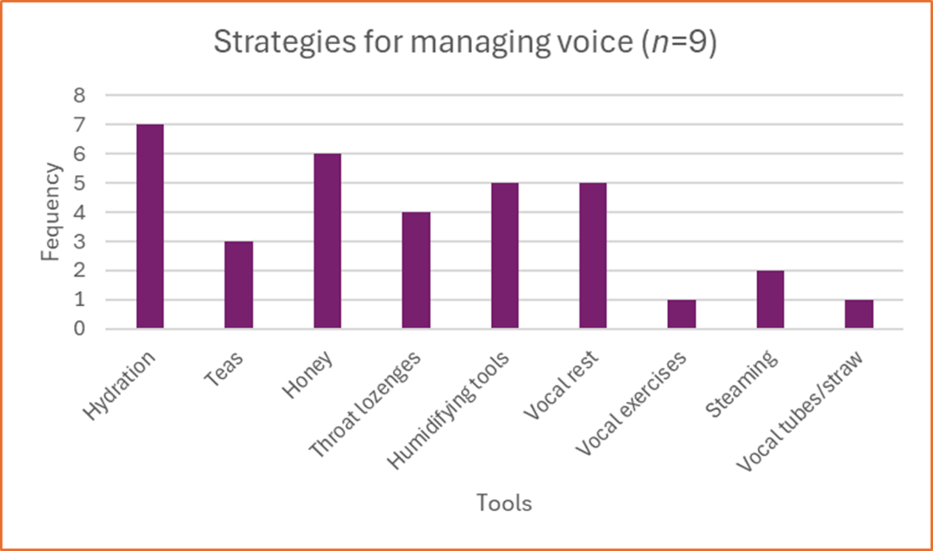

Figure 1 presents the tools used by the eight participants, displaying the most commonly relied-upon methods for vocal health onboard.

Hydration and Vocal Health Support Among Cruise Ship Performers
Questionnaire results indicate hydration as the most essential factor in protecting vocal health, reinforcing both existing literature and participant interview insights. Honey also emerged as a commonly used remedy, despite not being explicitly mentioned in interviews, suggesting a need for further research into its perceived benefits.
Adesina & Adetola (2021) identified honey as a frequently used remedy among professional voice users, linking its popularity to its soothing and healing properties. This finding warrants further investigation into both the physiological and psychological benefits of honey for vocal health.
Humidifying tools and vocal rest were also among the most relied upon strategies, suggesting their importance in mitigating the effects of the cruise environment on vocalists’ health.

Awareness of the Cruise Environment’s Effects on Vocal Health
Five out of eight participants reported experiencing more vocal issues onboard than on land, highlighting the significant environmental challenges affecting vocal health in this setting. Notably, only one participant claimed to have received formal training on how the cruise environment impacts vocal health.
This raises concerns regarding the accessibility and prioritisation of vocal health training within the industry. Future research should investigate why only one participant received training, assessing its source and effectiveness to develop best practices that could be more widely implemented.
The absence of standardised vocal health education reveals a critical gap in professional development for cruise entertainers. Further research should focus on integrating structured training programmes that equip performers with essential education and preventative measures. Phyland and Miles (2015) emphasise the importance of workplace voice protection, reinforcing the need for improved vocal health support in performance-based professions.

Conclusion
This study highlights the significant impact of the cruise ship environment on vocal health, exposing a lack of formal support, education, and protective measures for entertainers. Despite unmistakable evidence of vocal strain and fatigue, operational efficiency is prioritised over performer well-being, leaving entertainers to manage their vocal health independently. The findings indicate that performers experience increased vocal strain at sea due to factors such as poor air quality, dehydration, excessive workload, and lack of rest. Given the unique environmental challenges of cruise ship work—such as constant exposure to air conditioning, limited fresh air circulation, and demanding performance schedules- a more extreme effort in hydration and adequate rest are essential to maintaining vocal health. These findings align with Simberg and Gustafsson (2015), who identified that cruise ship crew members report more frequent vocal complaints than land-based professionals, suggesting that environmental conditions have a pervasive impact on vocal health.
A key issue identified is the absence of standardised vocal health training within the cruise industry. With only one participant having received any formal education on the topic, there is a clear gap in industry awareness. Phyland and Miles (2015) emphasise that occupational voice training should be taken more seriously in professional environments, reinforcing the need for targeted education within the cruise entertainment industry. Sataloff (2017) also stresses the importance of proactive vocal care to prevent long-term damage, particularly in high-demand performance settings. This study supports the need for industry-wide implementation of structured vocal health programmes to ensure all performers receive essential training and preventative measures.
Additionally, systemic barriers to vocal recovery were identified, including a lack of consideration from onboard medical teams and entertainment management when scheduling performances. Participants reported difficulty obtaining adequate rest or time off when experiencing vocal strain, a reality echoed in Dennett (2018), who discusses the hierarchical structure of cruise ship employment, which often restricts performers' autonomy in managing their health. The industry's reliance on continuous performances, despite the risks of vocal fatigue, nodules, or haemorrhages (Rodman, 2023), raises ethical concerns regarding performer welfare.
As an insider researcher who has also experienced being forced to perform despite vocal injury, there was a possibility of bias. However, neutrality was maintained by approaching participants as if unaware of these issues, ensuring responses were uninfluenced. The small sample size of the questionnaires was a notable limitation, proving disappointing in terms of data collection. For further study, paper-based questionnaires conducted in-person within the cruise ship work environment would likely yield more accurate and representative responses, though logistical challenges remain due to contract scheduling and access to performers during their employment.
For immediate actionable measures, while it is unrealistic to expect cultural and hierarchical shifts within the industry overnight, raising awareness through word of mouth and direct engagement with current cruise performers can serve as an initial step. Educating entertainers on the effects of their environment and sharing practical guidance—such as the importance of hydration, the use of noise reduction methods (e.g., earplugs in crew social areas), and balancing well-being with performance demands- may help mitigate vocal health risks. Given the challenges of prolonged voice use without sufficient recovery time, performers should be encouraged to prioritise hydration, schedule vocal rest strategically, and adopt practices that support long-term vocal resilience. Further research should continue exploring ways to support vocalists working in this uniquely demanding setting, ensuring that industry expectations do not come at the cost of long-term vocal damage.
By shedding light on these challenges, this research calls for industry-wide reforms to improve working conditions, protect vocal health, and promote career longevity for cruise entertainers. Recognising and prioritising vocal health is not only beneficial for performers but also essential for maintaining the high-quality entertainment that cruise lines depend on for guest satisfaction and revenue generation (Cashman, 2016).

Reference List
Aarnio, M. (2022). Cruise Ship Handbook. Springer Nature.
Adesina, S. and Adetola, A. (2021). On the Effect of Honey, Bitter Kola, Ginger, and Alligator Pepper for Voice Care: A Case Study on the Perception of Undergraduate Actors. Voice and Speech Review, 16(1), pp.1–11. doi:https://doi.org/10.1080/23268263.2021.1959012.
AirplaneTees (2023). How to Avoid Dehydration When Flying: 5 Tips to Combat It. [online] AirplaneTees. Available at: https://airplanetees.com/how-to-avoid-dehydration-when-flying/?utm_source=chatgpt.com [Accessed 6 Mar. 2025].
Barsky, A.E. (2019). Ethics and Values in Social work: an Integrated Approach for a Comprehensive Curriculum. 2nd ed. New York, Ny: Oxford University Press.
Benninger, M.S. and Murry, T. (2008). The Singer’s Voice. Plural Publishing.
Black, J.G. and Black, L.J. (2018). Microbiology : principles and explorations. Hoboken, Nj: Wiley.
Bradburn, N.M., Wansink, B. and Sudman, S. (2015). Asking Questions : the Definitive Guide to Questionnaire Design -- for Market research, Political polls, and Social and Health Questionnaires. [online] San Francisco, Calif.: Jossey-Bass. Available at: https://www.google.co.uk/books/edition/Asking_Questions/jbhUCgAAQBAJ?hl=en&gbpv=0 [Accessed 30 Jan. 2025].
Brinkmann, S. (2022). Qualitative Interviewing. 2nd ed. Oxford University Press.
Cashman, D. (2016). Tequila! Social Control of Guest Movement by Live Music Performance on Cruise Ships. Tourism in Marine Environments, 11(2), pp.89–100. doi:https://doi.org/10.3727/154427315x14513374773328.
Cashman, D. and Hayward, P. (2020). Cruisicology. Lexington Books.
Castillo-Allendes, A., Cantor-Cutiva, L.C., Vidal, V. and Hunter, E.J. (2024). Voice as a Working Tool for Teachers: a Qualitative Study of Work-Related Perceptions and Impact. Journal of Voice. doi:https://doi.org/10.1016/j.jvoice.2024.09.021.
Clark, T., Foster, L., Sloan, L. and Bryman, A. (2021). Bryman’s Social Research Methods. 6th ed. [online] Oxford: Oxford University Press. Available at: https://read.kortext.com/reader/epub/974675?page=.
Cloonan, M. (2021). Cruisicology: The Music Culture of Cruise Ships. By David Cashman and Philip Hayward. London: Lexington Books, 2020. 104 pp. ISBN 978-1-7936-0202-2. Popular Music, 40(3-4), pp.511–513. doi:https://doi.org/10.1017/s0261143021000489.
Davies, D.G., Jahn, A.F. and Keidar, A. (2020). Care of the Professional Voice. 2nd ed. Routledge eBooks. Routledge. doi:https://doi.org/10.5040/9781350054851.
Dennett, A. (2018). Identity Construction in Transient Spaces: Hospitality Work On-Board Cruise Ships. Tourism in Marine Environments, 13(4), pp.231–241. doi:https://doi.org/10.3727/154427318x15438502059120.
Dorigatti, J., Perić, T. and Mrčelić, G.J. (2022). Cruise Industry Trends and Cruise Ships’ Navigational Practices in the Central and South Part of the Adriatic East Coast Affecting Navigational Safety and Sustainable Development. Applied Sciences, 12(14), p.6884. doi:https://doi.org/10.3390/app12146884.
Hammersley, M. and Traianou, A. (2012). Ethics in Qualitative Research : Controversies and Contexts. Los Angeles I.E. Thousand Oaks, Calif.: Sage Publications.
Hennink, M., Hutter, I. and Bailey, A. (2020). Qualitative Research Methods. 2nd ed. London: Sage Publications.
Icht, M., Zukerman, G., Hershkovich, S., Laor, T., Heled, Y., Fink, N. and Fostick, L. (2018). The ‘Morning Voice’: the Effect of 24 Hours of Sleep Deprivation on Vocal Parameters of Young Adults. Journal of Voice, 34. doi:https://doi.org/10.1016/j.jvoice.2018.11.010.
Jacobs, J. (2024). Why Vocal Hydration Is Essential for Singers – Vibrant Vocals. [online] Vibrantvocals.com. Available at: https://vibrantvocals.com/why-vocal-hydration-is-essential-for-singers/?utm_source=chatgpt.com [Accessed 6 Mar. 2025].
Jana (2024). The Importance of Proper Hydration for Singers - StrongMocha. [online] StrongMocha. Available at: https://strongmocha.com/beginners-guides/singing/the-importance-of-proper-hydration-for-singers/?utm_source=chatgpt.com [Accessed 6 Mar. 2025].
Josh (2023). Vocal Health 101: the Path to a Healthy Voice. [online] Voicescience.org. Available at: https://www.voicescience.org/articles/post/vocal-health-101-the-path-to-a-healthy-voice?utm_source=chatgpt.com [Accessed 5 Mar. 2025].
King, N., Horrocks, C. and Brooks, J. (2019). Interviews in Qualitative Research. 2nd ed. London: Sage Publications Ltd.
Koncar, L. (2017). Community on a Cruise ship: the Contribution of an Ethnographic Research in Studying the Cruise Ship Industry. Bulletin De l’Institut Etnographique, 65(1), pp.207–221. doi:https://doi.org/10.2298/gei1701207k.
Levers, M.-J.D. (2013). Philosophical paradigms, Grounded theory, and Perspectives on Emergence. SAGE Open, 3(4), pp.1–6. doi:https://doi.org/10.1177/2158244013517243.
Lincoln, Y.S. and Guba, E.G. (1985). Organizational Theory and Inquiry : the Paradigm Revolution. Beverly Hills: Sage Publications.
Lütkenhaus, C. (2020). Work-Life Balance On-Board Cruise Ships a Survey on Crew Members’ Wellbeing. Tourism in Marine Environments, 15(2). doi:https://doi.org/10.3727/154427320x15833169859482.
Manfredi, C. (2015). Pan European Voice Conference Abstract Book. Firenze University Press.
Mashuri, S., Sarib, M., Rasak, A., Alhabsyi, F. and Ruslin, R. (2022). Semi-structured Interview: a Methodological Reflection on the Development of a Qualitative Research Instrument in Educational Studies Ruslin. IOSR Journal of Research & Method in Education, [online] 12(1), pp.22–29. doi:https://doi.org/10.9790/7388-1201052229.
Matuszewski, I. and Blenkinsopp, J. (2011). ‘New Kids on the Ship’: Organisational Socialisation and Sensemaking of New Entrants to Cruise Ship Employment. Journal of Hospitality and Tourism Management, 18(1), pp.79–87. doi:https://doi.org/10.1375/jhtm.18.1.79.
Mishler, E.G. (2009). Research Interviewing : Context and Narrative. [online] Cambridge, Mass.: Harvard University Press. Available at: https://www.google.co.uk/books/edition/Research_Interviewing/ZSH5uqJyLyAC?hl=en&gbpv=0 [Accessed 30 Jan. 2025].
Musicians Union (2023). Vocal Health Advice for Musicians. [online] Musiciansunion.org.uk. Available at: https://musiciansunion.org.uk/health-safety-wellbeing/health-and-safety/key-health-and-safety-issues/vocal-health?utm_source=chatgpt.com [Accessed 5 Mar. 2025].
O’Cathain, A., Murphy, E. and Nicholl, J. (2007). Why, and how, Mixed Methods Research Is Undertaken in Health Services Research in England: a Mixed Methods Study. BMC Health Services Research, 7(1). doi:https://doi.org/10.1186/1472-6963-7-85.
O’Reilly, M. and Kiyimba, N. (2015). Advanced Qualitative Research. SAGE.
Oppenheim, A.N. (2000). Questionnaire Design, Interviewing and Attitude Measurement. [online] London: Continuum. Available at: https://www.google.co.uk/books/edition/Questionnaire_Design_Interviewing_and_At/6V4GnZS7TO4C?hl=en&gbpv=0 [Accessed 31 Jan. 2025].
Patten, M.L. (2016). Questionnaire Research : a Practical Guide. 4th ed. Glendale, Ca: Pyrczak Publishing.
Phyland, D. and Miles, A. (2019). Occupational Voice Is a Work in Progress. Current Opinion in Otolaryngology & Head and Neck Surgery, 27(6), pp.439–447. doi:https://doi.org/10.1097/moo.0000000000000584.
Picard, A. (2019). Allison Picard, MS, CCC-SLP. [online] Allison Picard, MS, CCC-SLP. Available at: https://www.allisonpicard.com/ap-blog/2019/3/15/drink-up-the-importance-of-hydration-for-a-healthy-voice?utm_source=chatgpt.com [Accessed 6 Mar. 2025].
Pretorius, L. (2024). Participant Recruitment Strategies in Research – Dr Lynette Pretorius. [online] Lynettepretorius.com. Available at: https://www.lynettepretorius.com/the_scholars_way_blog/participant-recruitment-strategies-in-research/?utm_source=chatgpt.com [Accessed 21 Feb. 2025].
Reid, R. (2022). #020: Why Staying Hydrated Is Critical for Singers: the Benefits and How to Stay Hydrated. [online] Rebecca Reid Vocal. Available at: https://www.rebeccareidvocalstudio.com/post/stay-hydrated?utm_source=chatgpt.com [Accessed 6 Mar. 2025].
Rodman, J. (2023). Vocal Strain: 18 Causes and Fixes for Your Tired Voice - Judy Rodman. [online] Judy Rodman. Available at: https://judyrodman.com/vocal-strain-18-causes-and-fixes-for/?utm_source=chatgpt.com [Accessed 5 Mar. 2025].
Ruel, E.E., Wagner, W.E. and Gillespie, B.J. (2015). The Practice of Survey Research : Theory and Applications. Thousand Oaks, California: Sage Publications, Inc.
Sataloff, R.T. (2017). Clinical Assessment of Voice. San Diego, Ca: Plural Publishing, Inc.
ShineCruises.com (2025). Top 10 Largest Cruise Ships in the World 2025: Size & Stats. [online] Shine Cruise. Available at: https://shinecruise.com/largest-cruise-ships-in-the-world/ [Accessed 13 Feb. 2025].
Stratton, S.J. (2024). Purposeful Sampling: Advantages and Pitfalls. Prehospital and Disaster Medicine, [online] 39(2), pp.121–122. doi:https://doi.org/10.1017/S1049023X24000281.
The Vocal Experiment (2024). The Truth about Vocal Fatigue: Causes, Prevention, and Recovery. [online] The Vocal Experiment. Available at: https://www.thevocalexperiment.com/post/the-truth-about-vocal-fatigue-causes-prevention-and-recovery?utm_source=chatgpt.com [Accessed 5 Mar. 2025].
Tunney, D. (2023). Top 10 Smallest Cruise Ships in the World. [online] Cruise Hive. Available at: https://www.cruisehive.com/smallest-cruise-ships/101322 [Accessed 13 Feb. 2025].
Williams, M. (2020). Careers for People Who Love Traveling. The Rosen Publishing Group, Inc.
World Health Organization (2007). International medical guide for ships : including the ship’s medicine chest. Geneva: World Health Organization.
Zuckerman, J.N. (2013). Principles and practice of travel medicine. Chichester, West Sussex ; Hoboken, Nj: Wiley-Blackwell.

Appendix A- Interviews
Participant 1
Interviewer: Let's go. Good afternoon.
Participant 1: Hi there.
Interviewer: How are you?
Participant 1: I'm very good.
Interviewer: Where are you in the world?
Participant 1: I am currently in South Florida in Deerfield Beach.
Interviewer: Oh, wow. And what time is it?
Participant 1: It is 11:05 a.m.
Interviewer: Oh, wow. Okay. And it's 4:05 p.m. here. Thank you so much for being part of this bit of research with me.
Participant 1: My pleasure.
Interviewer: I'm just going to ask some questions about your work experience within the cruise industry. Would you be able to give some details on your past work and what you do now?
Participant 1: Yeah. I've worked at sea for—this would be my 23rd year at sea, possibly coming up now. Next year will be 23; this year is 22 years in September. I did my first cruise at the age of 24. It took me a while to become established regularly working on board cruise ships, and my income was very much dependent on the land work I did for the first few years. Then, over a period of probably 10 years, that improved. In my mid-thirties, I started working for American lines. They pay more money and take better care of entertainers in general. At the peak of my career, I was doing between 30 and 40 cruises every year. I was out of the country upwards of 200 days, traveling between 80 and 90 flights a year. I worked for eight different cruise lines on over 40 different vessels during that time.
Interviewer: That's a lot. It’s a lot of experience for one young lady.
Participant 1: Well, I like the young adage, but there you go. Never mind. Yes. Now, currently, I am an agent that provides entertainers to cruise lines, predominantly for the American market and predominantly European entertainers for the American market. I'm still heavily involved in the cruising industry and its ever-evolving face as it is. I probably do two or three cruises a year now, maximum, as and when it suits. I have a child, so I don't like to travel without him. If I do short cruises without him now, I will only go for a couple of days at a time, which precludes me from a lot of lines—and that's fine by me. I do most of my work on land now in the United States.
Interviewer: Wonderful. So, you've seen a lot of changes within the industry over the years, and you've also experienced a lot of different types of ships and staff and crew, I’m guessing?
Participant 1: Yeah.
Interviewer: Your job role—am I right in thinking—have you always been a guest entertainer?
Participant 1: On ships, I have, yes. On land, I started out doing effectively what a cruise staff member does on board—a sort of activities staff role. I did that on land before I went to sea, but I've always been a guest entertainer. I've never been in production on ships. I've always been a guest entertainer, but in the early days, mostly—almost always—passenger status. That meant that occasionally I was in crew accommodations. Depending on the cruise line and the class of ship—because, if you were to correlate cruise ships with hotels, I’ve worked on everything from two-star to six-star. Anything from 140 passengers to, I think the biggest one I did was 4,000 passengers. The theatres ranged from a lounge that seats a hundred people to a theatre that holds 1,200.
Interviewer: Amazing. And your gift, talent, instrument—it's your voice, am I right?
Participant 1: It is.
Interviewer: So, you're a singer, and that's what you've been doing?
Participant 1: Yes. And as my show has evolved over the years, I would say I’m more of a vocal entertainer. I don’t use the word comedy, but I do. I get described as that in the U.S. quite a lot, but on ships, I would be more of a vocal entertainer. Towards the end of—well, I would say the height of my career—I was doing as much comedy as I was singing, so slightly less singing in the show than in the old days.
Interviewer: The mixture of using your voice as an instrument but also using it on stage for comedy and entertaining—your energy, obviously. So, throughout all these years, you mentioned that you worked in hotels and different places in the U.K. doing a similar type of thing. Then you got all that extensive experience on cruises. This interview is about vocal health aimed at the cruise ship environment. Could you share any differences you noticed that made you have to change the way you looked after yourself in those different environments? You also mentioned a lot of flying. Did you notice anything with your instrument, or were you fine? How were you?
Participant 1: Well, in my early days as an entertainer in the early 2000s, the smoking ban had not come in the U.K. People could still smoke in land venues, which wasn’t great for vocal health. Singing in working men’s clubs and holiday parks where people could still smoke—you’d come out of the venue and your clothes, your hair, your equipment, even your sheet music would smell of cigarettes. I noticed a huge difference once venues became smoke-free. That was a big improvement to my vocal health on land.
On ships, I don’t really remember there being smoking in a lot of areas, apart from specific sections. There might be a smoking lounge—like on Royal Caribbean, where they had a cigar lounge. But you wouldn’t go in there. So, there was a big difference between working on land and at sea at that time.
In the early days, I worked mainly short-haul. Occasionally, in the winter, I would do the Caribbean, but it took me a while to get established. The short-haul flights were almost always chartered by the airline for the ship, so the travel wasn’t too bad. The further into my career I went, the more long-haul I did. In one six-week period, I traversed almost all time zones—I went from the Far East of Asia to South America and Dubai. In 12 weeks, I went everywhere.
For me, the biggest thing affecting my voice was hydration. I’ve never been great at drinking water, so I had to force myself to do it. On long-haul flights, I had to drink a lot more. Tiredness was another big factor. My voice was always affected when I didn’t get enough rest. Sometimes, you’re required to perform the day you arrive after flying long-haul. They try not to do that, but it happens. That’s the hardest part—when you’re tired or when you’ve been jumping between ships and time zones. Prioritizing rest over everything else is essential, which is easier when traveling alone. Now that I travel with my son and usually my husband or my mum, getting adequate rest is harder. Sharing a room with a five-year-old makes it more challenging. So, for me, hydration and rest were the most important elements of that. And obviously there's extreme air conditioning and that tended to vary between the standard of accommodations you were given.
Interviewer: So I found that if you're in a passenger accommodation, the air conditioning tended generally to be better maintained, and you didn't feel as though the air was as clean when you were in a crew area. The vents were always a lot noisier, and because the rooms are smaller, they tended to be over the bed. So you couldn't really get away from it. I started to wet towels and hang them around the sides of the vent. I would always leave a bowl of water in the room and put wet towels on the back of the chairs just to try and have some more moisture in the air.
Interviewer: That's interesting because people I've spoken to before have mentioned humidifiers and other methods, but nobody has spoken about ways to hydrate the room without a humidifier. Some have even said that humidifiers aren't allowed.
Participant 1: Yeah, they’re not allowed. I've been at sea for 23 years, so there were no humidifiers in the early days. Some of the older vessels were so rocky in bad weather that you had to be careful about what you did. The first cruise I ever did, the TV fell off the shelf because the weather was that bad, and I thought it was always like that. So yeah, it’s hard.
People talk about taking steamers and all that. I'll be honest with you, I'm kind of old school. I've never really done anything like that, and I'd be interested to learn more about how newer, modern techniques can assist vocal health. I've always prided myself on never cancelling jobs unless I absolutely have to.
In a 23-year career at sea, I've only cancelled one cruise due to ill health and postponed two shows to later in the voyage. I’ve always found a way to sing around it, regardless of how unwell I was—switching material out and adjusting. It’s just ingrained in you, an old-school mindset of, “You must never not go to work.”
Interviewer: And just for knowledge, the type of things that you sing—I mean, you’ve got an incredible voice. But material-wise, you sing the likes of big songs like Celine Dion, don’t you? Large numbers with a huge vocal range and belting?
Participant 1: Yeah, yeah. Two 45s on ships.
Interviewer: Two 45-minute shows?
Participant 1: Yes, two 45s on ships. As opposed to in the U.S., where I do a 90-minute show.
Interviewer: So, these are big performances. With so many shows, what do you find happens if the air in the cabin isn’t good and you can’t humidify the room, or if tiredness has gotten to you? How has that affected your voice on stage? Any discomfort?
Participant 1: Yeah, definitely. Strain—just felt strained and tight. I always try to spend as much time outside as I can when I’m in a situation like that. I make sure I get fresh air every day. Even if I can’t get outside because the weather’s horrendous, I’ll sit outside on the deck, covered over, just to get some kind of fresh air.
I’ve also found that I need to ask for extra help with the monitors—a little more vocal level—so I’m not pushing myself too hard. I always trust the front-of-house engineer to make sure I’m heard out front. You can’t always rely on what a soundcheck sounds like when a theatre is empty, compared to when it’s full with a thousand people.
It’s a cycle—if you can’t hear yourself properly, you push more, and then you make yourself more tired. One thing I learned from a sound engineer many years ago is to ask them to take any compression out of the monitors because compression makes you push harder. It turns into a cycle, and you go round in circles. I always tell them, “I have a good microphone technique. Please trust me with it.”
Interviewer: Yeah, it feels like you have more control over your instrument that way. You know how much to give to get what you need out of it.
Participant 1: Exactly. Some people don’t realise that. I was never formally trained as a singer—I trained as an actress—so I learned all of this over the years.
Interviewer: You’re an actress?
Participant 1: Yeah, I never had any singing lessons, that’s for sure. But I applied what I learned in acting classes to my vocal technique. Over the years, I’ve learned from watching other performers—sometimes learning how not to do it.
I’ve found that using all the tools available to you helps maintain vocal strength. Asking for extra sound, occasionally switching the order of songs so that my voice is properly warmed up before hitting the big notes—it all makes a difference.
This isn’t directly related to the cruise ship environment, but my vocal range changed more after I had children than at any other time. I had a caesarean section, and I never really felt like everything went back into place properly. I struggled more with diaphragm control after having my son. That was the biggest change to my voice—more than anything I did on ships.
I worked a lot. I did a lot of shows. When I was on board, I never just did two shows—I always offered more. But I treated it like a muscle. The more I worked, as long as I looked after myself, my voice looked after itself.
But when I took a long break to have children and then during COVID, that’s when I started to struggle. It was like muscle memory—I wasn’t doing it all the time.
Interviewer: Right, right. That makes sense. Thank you, that’s really insightful. Now, as an agent, you’re managing and supporting a lot of people who have done what you’ve done. You’re a guiding light for them all. Have you noticed anything recently? Are people turning to you about vocal health issues?
Participant 1: Yes, definitely. People are struggling post-COVID a lot more. Those who had COVID are experiencing long-term effects on their voice. The combination of having had COVID and the strain of performing on cruise ships hasn’t helped.
I currently have two of my acts with serious vocal health issues. People ask me for advice about it all the time, and when they do, I tell them to ask you.
Interviewer: Okay, no pressure then!
Participant 1: You better give her a distinction because she’s very helpful!
Interviewer: Haha, I’ll take that. Seriously though, the whole industry is changing. People want more for less. They expect more performances for the same pay. They expect entertainers to give more in contracts without increasing compensation. Do you think that’s part of what’s making things harder?
Participant 1: Definitely. It used to be that you were on a ship for the full duration of a cruise, and the cruise director would use you throughout the trip, and you’d get paid for the whole time on board. Now, contracts are shorter, and more entertainers are being rotated in and out, so people are doing more shows.
That was never an issue for me—I always worked more. That was my unique selling point: “How can I be part of this team? How can I help?” But on the whole, the culture of the industry has changed. Travel is harder. Flights are booked based on cost rather than convenience. I always try to advise my acts to be proactive—look at alternative flights, ask the cruise line for better options, and take fewer flights to avoid lost luggage.
Overall, things are tougher, especially for new entertainers entering the industry now. It’s not the same as it was 10 years ago.
Interviewer: Now, thank you, because you've led on to exactly what I was just about to ask. Do you think the level of risk and the level of respect for entertainers—especially vocalists—has changed? Are the people making the decisions truly understanding the craft?
I've spoken to people in a lot of different areas, and things are getting harder. But people don’t feel like they have a choice—it’s either accept the work as it is or have no work at all, with the fear of damaging their instrument for life.
Is that something you’ve noticed? Do you think there could be more protection in place, or do you think it’s more about educating workers on how to best look after their voice? Have you seen any kind of professional training for cruise performers on what to expect and how to maintain vocal health? Because you’ve found your own way through your career, but what do you think the industry as a whole might need? What's missing?
Participant 1: Right, so I think a lot of the situations entertainers are facing now are financially driven. Financial considerations are at the root of so many decisions. Fewer entertainers are being employed, so the ones that are still working have to do more.
Cruise lines have had to cut budgets across the board to recoup losses from COVID. That means there are fewer opportunities, and people are pushing harder to secure work. If they don’t keep their contracts, they know they’ll lose out, so they’re pushing themselves harder than they normally would.
Another issue is that tax calendars and hiring schedules are no longer aligning from year to year. If you’re fortunate enough to have work secured a year in advance, you’re in a very rare position. Most people are scrambling for contracts. And, after experiencing what it was like to have zero work during the pandemic, nobody wants to be in that situation again.
Everyone in this industry knows there’s a shelf life to the job. The older you get, the less desirable you become, especially with newer cruise lines that constantly want fresh, new faces.
On the whole, I think the lack of support is financial. Cruise lines can’t afford to give guest entertainers passenger cabins anymore, because they’d rather sell those cabins to paying guests. Some cruise lines have cut down on the number of entertainers they hire for that reason alone. If you're a solo act, by the nature of that job, you’re now working harder than before.
I don’t think any cruise director, entertainment director, or talent booker is actively trying to make things harder for entertainers. They’re simply dealing with budget constraints. But I do think some poor decisions are being made because of financial pressure.
For example, if cruise lines allowed entertainers to book their own flights and claim the cost back, they could save money while also improving travel conditions for performers. One year, a cruise line let me do this. They gave me a spreadsheet of the entire deployment across 13 ships and asked me to figure out my own schedule. I did, then booked my own flights. In that one year, I saved them $10,000 in travel costs—just from one entertainer. Imagine how much that would save the industry if it were standard practice.
Interviewer: And it would also protect your health.
Participant 1: Exactly. It made the job better. To me, these things are a no-brainer. But again, the bookers are now doing the jobs of three or four people compared to pre-pandemic times. They’re booking entertainers and handling travel at the same time, so they just don’t have the capacity to make these more thoughtful considerations. It’s understandable, but it’s also unfortunate.
In an ideal world, all entertainers would be given outside cabins with balconies, so they could get fresh air every day. Twenty years ago, that was common. Most entertainers were given suites with balconies. In the very early days, they were even flown business class! Can you imagine? Flying business class everywhere would make this a completely different job.
Interviewer: With the way the industry is changing, there are things entertainers can’t control. What kind of advice would you give to someone new to this environment? What should they put in place to look after their voice?
Participant 1: Always prioritise hydration and rest. Always. Get as much fresh air as you can. Try not to drink alcohol the night before a gig—easier said than done, but we call those “school nights” for a reason.
I definitely think there’s a gap in the market for education on vocal health. I would be very interested in seeing more training provided. It wouldn’t take much to put simple programs in place, especially for production cast members. They sign six- to nine-month contracts and don’t have the option of going home.
Minimum accommodation standards should also be introduced. That’s not too much to ask at this stage.
Interviewer: You also mentioned earlier that vocal health goes hand in hand with mental health. Can you expand on that?
Participant 1: Absolutely. This is something I think needs more research.
On a basic level, I have a routine that I stick to before performances. It helps put me in the right frame of mind, and I think it physically relaxes me as well. I always do the same thing before shows. I prepare in advance. I like some quiet time. I listen to a specific playlist. I suck on a specific throat lozenge. I drink the same thing. I bring a certain item on stage. If I don’t do these things, I feel thrown off.
I learned this from my husband—he’s a professional athlete. He has a routine before every single golf shot. I’ve watched him do it so many times that I could physically mimic it myself. It’s all about repetition. Having structure like that helps keep him relaxed, and I found that it applies to my job as well.
Interviewer: And what happens when you’re traveling with your son?
Participant 1: That’s when the routine gets disrupted! My husband or my mom will take him out for me before a show so I can go through my process.
A lot of performers like to get ready backstage, but I prefer to get ready in my room. I need at least half an hour backstage to centre myself before going on. That’s what works for me, and I think encouraging people to find their own routine would be really beneficial.
Mental health support on cruise ships is practically non-existent. I know this is something the industry is starting to address, and I would love to see more research into it. HR departments exist, but they aren’t really set up for that kind of support.
Interviewer: Yes, and nearly everyone struggles with mental health in some capacity now. There’s so much more awareness, especially since COVID. Anxiety is everywhere, and society as a whole has changed.
The problem is, if you admit to having ever been treated for a mental health issue, many cruise lines won’t hire you. So, people are lying on their medical forms just to get the work. Instead of providing support, cruise lines are just shutting people out. But in reality, they’re still hiring people who need support—they just don’t know it.
Participant 1: That’s awful. It’s like saying if you’ve ever broken your arm, you can’t work on a ship. It’s not something you did to yourself. And the worst part is, the reason they’re doing this is because they don’t have anything in place to actually look after crew members.
Interviewer: Thank you so much for sharing all of this. Before we wrap up, I just wanted to mention that through the Voice Study Centre, I’ve come across so many resources supporting people with different vocal health challenges. Since you mentioned how your voice changed after having a caesarean, I’ll send you any links I can find related to that.
Participant 1: That would be great. Thank you!

Participant 2
Interviewer: Good evening. Hi. Thank you so much for being part of this interview and research.
Participant 2: It's such a pleasure and honour to be here. Thank you for asking.
Interviewer: Can I ask where you are based today?
Participant 2: I'm in Edmonton, Alberta, Canada.
Interviewer: Oh, wow. So it's like 4pm?
Participant 2: Minus 30 degrees and 40…
Interviewer: No! No!
Participant 2: Yes.
Interviewer: It gets that cold?
Participant 2: And it feels like minus 40, I think. Let me check. Yeah, it gets cold. It was minus 50 here last January.
Interviewer: I need to come and check.
Participant 2: It's minus 24.
Interviewer: Minus 24?
Participant 2: Feels like minus 36.
Interviewer: Wow. Oh, I'm in Wales, and it's late on a Sunday.
Participant 2: And tomorrow is supposed to be minus 31. Isn't that crazy?
Interviewer: That is crazy.
Participant 2: It's crazy, yeah.
Interviewer: You're in Wales?
Participant 2: I'm in Wales.
Interviewer: It rains in Wales a lot, and that's about it, really. So, okay, I have questions.
So, I'm going to keep things anonymous, so I won't include any companies you've worked for or anything that could get anyone into trouble if something arises. It'll be completely anonymous. I'm just going to ask questions about the cruise industry and your experience because you are a vocalist and musician.
Participant 2: Yes, I am.
Interviewer: Could you give some details on who you are and what you do?
Participant 2: Okay, so I'm a multi-instrumentalist. I play guitar, piano, ukulele, percussion, and I sing. I'm a songwriter, recording artist, and music instructor.
I did four years at university at Grant MacEwan and came out with two diplomas—a diploma in vocal jazz performance and a diploma in music merchandising, minoring in recording. From there, I started performing and writing songs.
I started teaching around 2003, about 20-some years ago. Along the way, I released albums. I have three albums out, and I've sung at the Juno Awards. I've done a lot of background work like that.
I've also done musicals, gospel choirs, and, as you know, a lot of cruise ship performances, hotel performances, and so on. Recently, my song Cover Me was featured in a Prime Music video film. I was going to tell you—it's a featured song. They play the entire song, and I wrote, sang, and recorded all the instrumentation on it.
Interviewer: Wow.
Participant 2: So, yeah, I'm very proud of that.
Interviewer: Congratulations!
Participant 2: That just came out a couple of months ago.
Interviewer: Oh my gosh! I'll find out more about it later.
Participant 2: I'll send you a link.
Interviewer: Yeah, send me a link! I'll share it as well. That would be amazing. Gosh, I'm so chuffed for you! I don’t want to do the interview now—I just want to talk more about this!
Anyway, the purpose of this interview is to discuss your experience with vocal health on board cruise ships. Could I ask when you started your first job in the cruise industry and how long you have worked on and off in that environment?
Participant 2: I started at the end of 2018—that was my first contract.
Interviewer: Okay.
Participant 2: I've been taking a break now, so I haven't been on the cruises for about a year.
Interviewer: Right, okay. Wonderful. So, what did a typical working day entail regarding your performances? You were a resident musician on board, so how long was a contract?
Participant 2: My typical contracts were four months, but they could vary from 20 days to five months.
Towards the more recent years, around five years in, I started requesting shorter contracts—like 20 days or 40 days—because it was so exhausting. I found that I was away from home for so long, and when I came home, I was just exhausted. I just wanted to rest, you know? But they don’t want you to take more than a month off.
So, most contracts are typically four months long—that's the standard.
Interviewer: And do you get many days off during that time?
Participant 2: No days off.
Interviewer: Sorry?
Participant 2: No days off.
Interviewer: None at all?
Participant 2: You sign a contract that states you will work every single day. Some music managers might give you one day off every two weeks or something like that.
I had one amazing music manager who gave me one day off per week, but he was the only one. That was during my very first contract, and it was because I lost my voice halfway through.
That first contract was two months long, but they had me working four sets every single day with no days off.
Interviewer: Four sets? Could you explain what a set entails?
Participant 2: There is no set schedule like, "You'll play at noon," or "You'll play at two." Everyday changes, but you could be scheduled anywhere from one to four sets per day. Typically, it was always three. That was kind of standard. If you ever got one set, it was very rare.
Interviewer: But your set would be like 15 minutes, show up 15 minutes beforehand, and then play for 45 minutes?
Participant 2: Yes, and sometimes it was an hour, but usually, it was 45 minutes.
Interviewer: What would make it turn into an hour?
Participant 2: Sometimes they scheduled you for hour-long performances.
Interviewer: Wow. So, essentially, you’d be singing three to four hours a day, every single day?
Participant 2: Yes.
Interviewer: Okay, you’ve summed that up. How did you find that? Did you struggle vocally? Could you arrange your sets to protect your voice? Or did you feel pressure to be at your best the whole time? Could you pull back? Did you find any tips or tricks for survival?
Participant 2: Yeah. In the beginning, I wanted to be at my best, and I think that’s why I lost my voice. So, I quickly realised I didn’t have to powerhouse every song. I picked and chose songs carefully. I wouldn’t sing Adele every day, for example. Those heavy singing songs—you can’t sing them every day. So, I would tailor my sets.
If my voice was tired, I would lower my keys. Because I’m a soloist, playing guitar and piano, I could just change the key.
Interviewer: You obviously have enough musical capability to be able to do that for yourself, whereas I don’t have that option today.
Participant 2: Exactly. Sometimes in a band, you wouldn’t have that option. But the thing about a soloist is that you’re singing everything, you’re playing everything—it’s all your energy going into it. And your voice gets so tired, right?
So, I would use a looper, a looping pedal, and add in some soloing and looping. That would take up time. Also, I drank about three litres of water a day. I had a humidifier in my room. I also had a face steamer, and I used that every day because sometimes I would wake up feeling awful due to the air conditioning. I would think, "How am I going to sing today?" And then I’d steam my face for 15 minutes.
And then there was throat tea. There were all sorts of different things.
Interviewer: So, by the sounds of it, you never really had any chance for any kind of vocal rest?
Participant 2: No, not really. I mean, even on days off, it was like, "Oh, you’ve got a day off, so you want to go outside on the ship." But I found that I isolated myself a lot because I needed to rest my voice. I knew that.
So, if I went outside by myself, for example, I wouldn’t have to talk to other people.
Interviewer: How did that affect your well-being?
Participant 2: Big time.
Interviewer: Yeah? Could you open that up a little?
Participant 2: Yeah. I remember so many times—maybe not in the first couple of months, but after halfway through—just sleeping like 10 hours a day or longer because I needed the rest. And feeling so lonely.
I’d call back home, bawling, saying, "I know I’m surrounded by 4,000 people, but I feel so alone." Because I felt like I couldn’t go out and even spend time in the bar area or the recreational area. It was so loud. The music they played there was so loud that you couldn’t sit down and talk all night and then go sing the next day.
Interviewer: You just can’t.
Participant 2: No, no.
Interviewer: So, even your life on board is affected because you're going out in the daytime by yourself?
Participant 2: Yeah, for the most part. If I did go out, it was with maybe one other person, not like a group of people where you feel like you're laughing and engaging. Because laughing is also—well, you know me—I laugh a lot. But laughing is actually hard on your vocals.
Interviewer: And also, your stage presence and being on board, constantly surrounded by your audience—you're basically living with your audience.
Participant 2: Yes.
Interviewer: And I’m guessing it’s part of your job to interact with them as well?
Participant 2: Mostly, my interactions were with guests, to tell you the truth. I did have my close friends and stuff, but a lot of the time, instead of going and spending time with the crew, I would sit with the guests.
Interviewer: Because it wasn’t so loud?
Participant 2: Exactly. It wasn’t so loud, like in the piazza or somewhere else on the pool deck.
Interviewer: On the drinks package?
Participant 2: Yeah, on the drinks package. Exactly. So, I did do that a lot because actually, they want you to engage with the guests.
Interviewer: Oh, gosh. Yeah, I mean, as someone who also worked with the crews, it’s such a big part of your job. And even with the scores, sometimes it doesn’t even matter how good you are at what you do. If you've made the guests feel special and you've interacted with them, you’ll get good scores. And that means you’ve done well at your job, you know? Entertainment is so fickle like that, isn’t it? It’s crazy.
So, if I could ask, well, there are a couple of things going through my head at the moment.
First of all, the social side of things. You know, like I mentioned the drinks package and interacting with passengers. Obviously, it’s a tourist environment, so drinks, food, and socialising are all part of it.
But I’m going to park that for one second because I want to talk about your vocal fatigue that you were struggling with. You felt isolated. You needed more rest. You were using hydration because of the air filtration on the ship.
Could you explain more about the air filtration system—what you experienced or even what you know about it, if you know anything?
Participant 2: I do know a little bit about it. It is different from the guests' rooms.
Interviewer: Oh, okay.
Participant 2: We don't have—in our rooms—well, unless I had a guest entertainer room, which sometimes I did. You know how in the guest entertainer rooms, there's actually a thermostat on the wall?
Interviewer: Yes.
Participant 2: The staff rooms don’t have that.
Interviewer: I didn’t know that.
Participant 2: So, when it’s really hot out and the air conditioning is on, there’s a constant flow of air conditioning coming into your room.
Interviewer: That you can’t control?
Participant 2: No. It’s the only flow of air going into the room. You can close it almost all the way, but then the room is getting no air.
Interviewer: Right.
Participant 2: You can never turn on the heat. If it’s too cold, you just get another blanket.
Interviewer: Yeah.
Participant 2: So, that air itself is really drying on the vocal cords.
Interviewer: Massively. And I notice a big difference going from that staff room into a guest entertainer cabin or a guest cabin. There's a big difference.
Participant 2: Right.
Interviewer: Okay, that's interesting. Thank you for that. And you found humidifiers helped?
Participant 2: Yes, but technically, we weren’t supposed to have them.
Interviewer: Somebody else has said that.
Participant 2: And we're supposed to have pedals.
Interviewer: Yeah?
Participant 2: Like, you have to pass them through an inspection. And a lot of times, they don’t pass the inspection for whatever reason. So, I never ever—what do you call it? Claimed it? Claim isn’t the right word...
Interviewer: Chanced it?
Participant 2: No, no. I brought my own humidifiers all the time, but I never told anybody. You’re supposed to write it down that you have it, and then you’re supposed to take it to the technicians and get it checked.
Interviewer: So, really, you're not allowed to get more humidity in your cabin. And as a vocalist, that’s no good for you, hey?
Participant 2: No. And every time they’d inspect our cabins, I would just hide mine.
Interviewer: Yeah.
Participant 2: So, like, people knew what was happening. Even our managers, they knew that we had them. And even one of my managers gave me one because I didn’t have one—mine broke or something happened. And he was like, "I have an extra one here." It was a USB one anyway.
Interviewer: Like a survival kit?
Participant 2: Exactly—part of a survival kit.
Interviewer: Wow, thank you. So, the next thing is the socialising part of things. I know you said you tried your best to isolate yourself as much as possible and that wasn’t good for your well-being.
Participant 2: Yeah.
Interviewer: So, I’m good at this—drinking, alcohol, all those things. I mean, I know personally it’s part of the culture. On board, it’s part of socialising. The crew bar is where everybody goes to meet up and socialise after work.
Participant 2: Oh, I’m running out of time.
Interviewer: Oh. Do you find that affects your voice? Or does it help?
Participant 2: No, it definitely doesn’t help. It’s definitely a hinderance. And, like, I love socialising. So, the crew bar was pretty... It was...
Interviewer: So, most of the time?
Participant 2: The first maybe month, I would hold off. I would get my voice into a really healthy shape because singing every day does make your vocals really strong—that they can withstand a lot of things. That if you were only singing a couple of times a week, your vocals probably wouldn’t be able to withstand the abuse or whatever they’re taking.
Interviewer: Okay.
Participant 2: But when you're singing for four hours a day, your vocal cords are so strong. You shock yourself sometimes. You’re like, "Oh my God, I can’t even believe I’m singing!"
Interviewer: I’m not even joking.
Participant 2: I guess you don’t have time for them to cool down.
Interviewer: Yeah.
Participant 2: So, it’s at the end of the contract that I can really feel myself. And then, as soon as I’m done with my contract, my vocals are like, "Okay, I’m done now." And then the voice is gone. But somehow, you know that you have to do it. So, they maintain.
Interviewer: But the drinking?
Participant 2: It’s very dehydrating, right? And the fact that they make the drinks cheap doesn’t help, right? And for anybody, once your body gets dehydrated, you’re more prone to getting sick and stuff like that. So, I think I probably definitely over-drank, but maybe one of the reasons it didn’t affect me so much is because I knew that I had to be sleeping 10 or 12 hours a day.
Interviewer: Right.
Participant 2: I drank like three litres of water. I had the humidifier and face steamer. So, that kind of counteracted the abuse that maybe I would put my body and my voice through by going to the crew bar.
Interviewer: Yeah, yeah. If you were suffering vocally, did you have any support at all from the medical team or your management?
Participant 2: You know, it really depends. It would depend on who you got.
Interviewer: Right.
Participant 2: For example, the first time I got sick, the doctor said to me, he couldn't put me off work because he didn’t know anything about my voice. He didn’t know singers. He couldn’t just say to me, "Yeah, you can’t sing."
Interviewer: Really?
Participant 2: Yeah. And I tried singing for him, and I was like, "Now you know I can’t sing." So, he basically refused to put me off work because he didn’t know how. It was his first time on a cruise ship, to be fair, but still—I had no support from the doctor.
Interviewer: So, what did you do?
Participant 2: I had to go to my manager and say, "I can’t actually sing." And he was like, "Well, it’s the doctor that has to put you off singing." So, it was this back-and-forth thing that I had.
Interviewer: Wow.
Participant 2: And finally, I just broke down, bawling, and said to the doctor, "I can’t sing." So, the doctor got together with the manager, they discussed it, and they put me off for two days.
Interviewer: Two days?
Participant 2: Yeah, but I had lost my voice because I was singing four sets a day on my first contract.
Interviewer: That’s brutal.
Participant 2: So, after that, I got a new manager. Pretty much immediately, a new manager came on board. And for the rest of the contract, he only put me on one set a day.
Interviewer: Oh, bless. That’s so kind.
Participant 2: He knew. And still, he makes amazing comments on Facebook about how amazing I am. He knew that I needed that rest because I was so sick and needed some type of vocal rest.
Interviewer: So, there were times where you felt like you could talk to your manager?
Participant 2: Yeah, but to tell you the truth, it was almost never. It was like, "You signed up for this gig, and you have to perform. You have to follow through."
Interviewer: Right.
Participant 2: Because they knew how good of a guitarist I was, they used me in places where the house band’s guitar player should be playing.
Interviewer: Really?
Participant 2: Yeah. Maybe they had no gigs that day, but they would make me wake up and do a 10 a.m. gig at some shop, just playing solo guitar without singing.
Interviewer: Wow.
Participant 2: They were like, "Oh, well, this is going to be one of your sets today," which I didn’t mind, but it was like, "This isn’t my job, actually." I’m not a guitarist on board. I’m a featured soloist.
Interviewer: That’s a huge ask.
Participant 2: Yeah. That happened on one of my last contracts, and it was a really big problem. The guitarist in the house band was the manager. And he had a lot of work, don’t get me wrong. But instead of him getting up and doing that job at 10 a.m., he got me to do it.
Interviewer: That’s unfair.
Participant 2: Yeah. And I had a bad roommate at the time who would stay up until 5 a.m. talking to her boyfriend and always disrupting my sleep. It was just—I was going crazy.
Interviewer: Yeah. We have, like, four minutes left of this. I'm going to have two minutes to go.
Participant 2: Okay.
Interviewer: And I had it in my brain where I was going to ask if there was any more support you could have got—oh no, no, I know what I was going to ask. Sorry. Excuse me.
So, were you made aware at all of what was to be expected in terms of vocal hygiene? How much you were supposed to do, whether it was even doable? Or was it more a case of just getting on board and doing what you were told? Were you given any training about vocal hygiene? Was your voice protected?
Well, we’ve figured out that, you know, it’s not protected unless you’ve got somebody nice that cares. But what’s your overall take? Do you think there should be more voice protection in the industry, more awareness? What are your thoughts now that you’ve experienced it?
Participant 2: Yeah, I definitely think there’s not enough. I think one of the reasons why is because there aren’t as many soloists as there are singers on board. A lot of the singers get a lot more rest.
Even the singers in bands or duos get more rest than a soloist. And they can have days off when they’re sick because they have another person in the band. All they have to do is go to their band members and say, "I can’t sing today," and the band takes over.
You don’t have to ask permission from the music manager or the entertainment director because your band members will step up and pull the weight for you.
Now, when other people are sick—say there’s a band where two or three people are sick and they can’t perform—the soloist is often expected to fill in. The soloist is more flexible.
Interviewer: Right.
Participant 2: Often, when other people are sick, the featured soloist is the one who ends up doing more work, even though they’re only one person.
And I’ve asked before—I’ve said, "Why isn’t the house band stepping up and making a trio? Why is everything falling on me?" I’m already tired and exhausted because I already have four sets, which I knew when I signed my contract could go up to five a day.
But at the beginning, nobody says, "Here’s some vocal health advice." Nobody gives you any tips or anything.
Interviewer: Right.
Participant 2: I think I was probably always the one who knew more about vocal health than anybody else on the ship. I don’t think anybody else knew more than I did, maybe because I went to university and studied voice.
So, I knew exactly how to take care of my voice and manage it. But even when I voiced my concerns, saying, "Listen, I’m tired. I’m a soloist. I can’t do these extra things," most of my instrumental managers didn’t care.
They were like, "You signed this contract. You know what you have to do."
Interviewer: Wow.
Participant 2: If you can’t sing, they’d say, "Play instrumental." But I’m not an instrumentalist, you know what I mean?
Interviewer: Yeah, of course.
Participant 2: I did get better at playing because of those situations, but I had to practice. I was still practising one to two hours almost every day in my first two or three years.
And often, you do have to practise because a guest comes up and says, "I want you to learn this song." So now, you’ve got to spend time learning that song on top of doing your four sets.
Interviewer: That’s a lot.
Participant 2: Yeah.
Interviewer: Thank you. Thank you so much.
Participant 2: Okay.

Participant 3
Interviewer: Hello, hello.
Participant 3: Ha ha ha! One more time, one more time!
Interviewer: Hello, hello, hello, darling. Oh, yeah! Can I ask your job role?
Participant 3: I am an Assistant Cruise Director.
Interviewer: Oh, you're an Assistant Cruise Director?
Participant 3: Yes.
Interviewer: Good for you! Thanks. How long have you been doing this job?
Participant 3: So, I started in the cruise industry back in 2019. Obviously, the pandemic happened, and then we returned to service, and I’ve been back ever since. So, it's coming up to four years.
Interviewer: Four years, including the pandemic?
Participant 3: Excluding the pandemic.
Interviewer: Excluding, okay. Did you train at all for this kind of job?
Participant 3: Yes. I have a degree in performance, so I have a background in singing, dancing, acting, and technical theatre. But not specifically in the job that I do now—like entertainment, game shows, and trivia. That’s not really something you can study at university. You just have to learn on the job and go with it, really.
Interviewer: But the skills you learned at university do come in handy?
Participant 3: Yes, absolutely.
Interviewer: That’s great. Did you know this kind of job existed before you heard about the job role?
Participant 3: When I first went into studying, I didn’t know it existed. But you know what it's like at university—you start hearing about different career paths and how you can go into things. My specific job, I didn’t really know about until after I left university. Someone who was a year above me at uni had posted something on Facebook, and I saw it. That led me to do more research, and that’s how I came into the job I’m in now. So, yes and no, in different ways.
Interviewer: Fabulous. Okay, how did you feel when you actually got the job?
Participant 3: Oh my goodness, it took me over a year to get my first job because I didn’t have entertainment experience—I had performance experience but not entertainment. So, I was ecstatic! But at the same time, I was a bit disillusioned. You get the job, and then within a week, you're on a ship, and there’s so much you have to do. So, I was really, really excited, and I just wanted to go! I was like, "I'm ready—put me on the ship!"
Interviewer: Okay, I’ve heard! Alright. Had you had any vocal training prior?
Participant 3: When I was at university, we did have vocal classes—both singing and acting vocals, which are obviously similar but different.
Interviewer: So, how would you compare them?
Participant 3: When it comes to singing, it's all about using the voice in a controlled way. You warm up, you aim to hit certain notes, and it's more technical. Acting vocals, on the other hand, are more about projection, intonation, and expression. You learn about the highs and lows in your voice, accents, and how to use it to portray a character. Singing can be more focused on technique—like how to pronounce a vowel differently to get the best sound. For example, even though I have a British accent, sometimes when singing, I would need to shape a vowel more in an American way to get the most out of a note.
Participant 3: However, at university, at least where I studied, the teachers focused more on those who had natural talent rather than those who needed to be taught. I kind of fell through the cracks. I’ll never forget—one of my tutors told me to "just sing quieter" instead of actually helping me improve my pitching or technique. That was frustrating.
Interviewer: So, instead of actually teaching you, they just told you to be quieter?
Participant 3: Exactly! Rather than saying, "You're singing this note, but you should be singing this," which would have taken two seconds to correct, they just told me to lower my volume. It was discouraging.
Interviewer: Okay. When it comes to the drama side of things, particularly voice training, I don’t know if I’m allowed to bring this up, but have you ever come across anything from Dawn French?
Participant 3: Oh, I love Dawn French!
Interviewer: Yeah, when I was studying, I came across something she wrote about voice coaching and how much she learned about vocal technique and projection. It was really insightful. Even though she’s not a singer, as an actress and comedian, she had to develop vocal strength. So, when you were training in drama, did you learn anything about vocal health and protection?
Participant 3: I learned basic warm-ups and some vocal care techniques, but I wish we had gone into more depth with it. We had one year of vocal classes, and then after that, we were just expected to use what we’d learned. It was very much vocational learning—learning on the job rather than in-depth theory.
Interviewer: Thank you for that. After you got your job and started to settle into the role, how did you feel?
Participant 3: I was very overwhelmed. This job takes a lot out of you—physically, mentally, emotionally.
Interviewer: Can you explain why?
Participant 3: Sure. Let’s take a basic part of my job, like hosting a trivia quiz. A quiz typically has 20 questions.
Interviewer: How many times would you do that in a day?
Participant 3: In a day, a maximum of three times—but usually just once, if at all.
Interviewer: And is that just a small part of your role?
Participant 3: Yes. The role varies from cruise line to cruise line, and from job to job. When I first started on my old cruise line, the job was structured differently than it is now on this cruise line. You get a brief overview of what’s expected, but you don’t really grasp it until you’re standing there with a microphone, facing a crowd, and they are expecting you to deliver. I mean, anyone can pull up an online quiz on their phone, but what makes it engaging is how you present it.
Participant 3: They've come to your trivia because they're expecting a certain experience, right? And it's not until you've done it a few times that you really understand what it is that you’re delivering. What I've learned about my own voice is that I have a nice reading voice. So, voice acting is something I’d like to do when I retire from the sea. I think I have that sort of soothing, calming voice.
Participant 3: I'd love to do audiobooks, actually! I think I’ve got that kind of storytelling tone. However, when I read out the trivia questions—so, for example, I say, "Question number one: Who is on the $1 bill in the United States? Which president?"—that's one style of speaking. Then, while waiting for them to answer, I might be chatting with them: "Oh, who went out today? Who's doing what?" It’s a very different dynamic, so I’m using multiple facets of my voice all at once.
Participant 3: In that moment, I'm thinking: "I’ve got to read the question, I’ve got to read it clearly." That was something I was always taught—always read the question twice because guaranteed, someone was talking the first time and didn’t hear it. So, I repeat it. And then, of course, nobody wants to just sit there in silence, but I also can’t talk too much.
Participant 3: I have to strike a balance—it needs to be a personable event, engaging but not overwhelming. So, I’ll also mention what’s coming up later: "Right, what’s happening after this? Oh, I’m off to the beanbag toss," without making it sound like I’m pushing the event. It’s just there if they’re interested. And then, of course, there are familiar faces—Sue and Jeff, Brenton, Sam—you want to acknowledge them, but not to the point where they feel embarrassed or others feel excluded.
Participant 3: It’s about reading the room. This morning was a great example—there was an hour forward last night.
Interviewer: Why was there an hour forward?
Participant 3: Because we moved from the UK time zone to the French time zone.
Interviewer: So that reduces an hour from your rest time?
Participant 3: Yes, which means we start earlier.
Interviewer: In theory, an hour earlier?
Participant 3: Yes. At the beginning of the cruise, people are excited. When I do trivia at the start of the voyage, everyone’s a bit more lively—it’s their holiday of a lifetime! But by day 10, they’re tired. They might have done a 10-hour tour yesterday, and then they lost an hour of sleep.
Participant 3: These guests love trivia; they’ve gotten out of bed specifically for it, so I want to match their energy in that moment. This morning, I asked, "How are you feeling?" and they said, "Oh, we’re tired." So I said, "Oh, I’m tired too!" I keep it human with them.
Interviewer: Do you actively change the way you use your voice to accommodate them?
Participant 3: Absolutely.
Interviewer: So you adjust your vocal delivery to match the audience's energy?
Participant 3: Yes. For example, if it’s the beginning of the cruise, I’d greet them with a big, "Good morning, everyone! Welcome to morning trivia!" But if we’re 10 days in and they’ve had long excursions, I’ll soften it: "Good morning, everyone. How are we feeling?"
Interviewer: So you use a different tone to match their mood?
Participant 3: Exactly! You have to meet them where they are. That’s what I mean when I say this job takes my body and soul. You have to read the room—their physical language, their energy. If they come in looking sleepy, still clutching their coffee, I know I can gradually lift their energy by the end of the trivia session.
Interviewer: You adjust yourself to fit them?
Participant 3: Yes, which means adjusting my voice as well.
Interviewer: And by the end of trivia, you want them feeling more awake, ready for the day?
Participant 3: Exactly! Using my voice, adjusting my level of enthusiasm—it’s all about guiding their energy without overwhelming them. Little tricks along the way help nudge them into a better mindset for the rest of the day.
Interviewer: Okay, I was going to ask about health and vocal maintenance. Do you have much awareness of vocal health?
Participant 3: I wish I had more. You can hear my voice sounds raspy, right?
Interviewer: I am noticing that now! Would you say that’s normal for you?
Participant 3: No! When I’m at home and on leave, my voice isn’t raspy at all. There’s no huskiness. But on the ship, this happens. I try to combat it, and I will say I’ve gotten better at it, but I’m not perfect.
Participant 3: I talk all the time—all day, every day.
Interviewer: And do you feel vocal health is important?
Participant 3: I can’t do my job without it! Imagine trying to host a game show or trivia session with no voice—it just wouldn’t work. I’m lucky that our guests often have things like Fisherman’s Friends lozenges, and because of the way they perceive my role—like I’m their niece or granddaughter on holiday—they’ll often hand me a lozenge or a cup of tea if they hear my voice struggling.
Participant 3: A couple of weeks ago, I did trivia, and I don’t know what had happened the night before—maybe it was a long day, maybe I enjoyed myself a bit too much!—but I woke up with no voice. Someone from the bar brought me a tea because they could hear I was struggling.
Participant 3: At home, I’m well-hydrated, well-rested, and I don’t talk constantly. Here, it’s different. I don’t have air conditioning at home, but on the ship, the air is constantly blowing. That makes a big difference.
Participant 3: I don’t get fresh air in my cabin. I don’t have a window. On ships, windows and balcony doors don’t open, so the air you get is what’s circulated through the ventilation system.
Interviewer: Could you explain how the air system works on board?
Participant 3: Yes, good question. I have my own cabin, which I’m very lucky to have—it’s part of my contract. But there are no windows.
Participant 3: Ships don’t have windows that open. For safety and science reasons, we need an air circulation system so we don’t just have CO2 filling up the room. So, the AC is always running. It can be warm or cold, but it’s always on.
Participant 3: The problem is, the ventilation system isn’t sanitised very often. And I have a dust allergy. So, the air I breathe every day is filled with dust, which triggers my sinuses.
Interviewer: So, you experience sinus issues because of the air quality?
Participant 3: 100%!
Interviewer: And that connects to nasal health, which connects to vocal health.
Participant 3: Yes. I was diagnosed with a dust allergy, and when they put a camera up my nose, they saw I have a very small nasal passage, which makes me more prone to congestion.
Interviewer: Do you do anything specific to care for your sinuses and respiratory system?
Participant 3: I try not to be reliant on medication. If things get really bad, I might take something, and I have done saline rinses before. I used to do them a lot more, but honestly, I’m not sure what the best long-term solution is. I’m always balancing short-term fixes with long-term health.
Participant 3: I don't want to lose my voice in 5, 10, or 20 years because I decided to do four salt rinses a day.
Interviewer: So, you didn’t want to be dependent on them?
Participant 3: Exactly.
Interviewer: Was it something where you felt you had to adapt?
Participant 3: Yes, and I'm much better at it now than I was four years ago when I first started. A lot of it comes down to hydration—I’m constantly trying to sip water. But with this job, it can be difficult to do that.
Interviewer: Yeah, because you're always working?
Participant 3: Always on the go.
Interviewer: Right. So, were you ever made aware of possible vocal issues that could arise within your job in the cruise entertainment industry?
Participant 3: No, never. It was never something that was even brought up. The only person who ever flagged an issue was my cousin, who is a vocal therapist. I’m not home very often, but I was at her wedding last year, and I sounded worse than this—if you can believe it.
Interviewer: I've never heard your original voice before this.
Participant 3: I’d have to play you a recording. There are videos of me with my original voice, usually very early in my contract. When I went to my cousin’s wedding, her colleagues were there, and they heard me and said, "Something to think about." I spoke to her last time I was home—she just had a baby, so she’s been busy. She told me a lot of it is hydration.
Participant 3: I should probably have a humidifier, but they don’t allow those on ships.
Interviewer: I’m not going to lie—I have one in my cabin because I can’t live without it.
Participant 3: You can get away with it because you're on shorter contracts. It’s much harder for me. I need to find one that’s more discreet.
Interviewer: I’ll leave names out, but I’d give you mine—it’s small but effective.
Participant 3: The issue is that they’re considered a fire hazard.
Interviewer: So, even things that could help your vocal hygiene are not allowed on board?
Participant 3: No, because of fire regulations.
Interviewer: Why is it considered a fire hazard?
Participant 3: It’s to do with the plug sockets. If I plug it in and leave my cabin for eight hours, it could pose a risk. Things like that have caused fires before.
Interviewer: Just for the record, as a guest entertainer, I come on board for only four days or a week at a time. That means I can bring whatever I want, almost like a passenger.
Participant 3: But I’m here for six months.
Interviewer: So, crew members have far stricter rules?
Participant 3: Exactly.
Interviewer: And you're not even allowed things that would help you?
Participant 3: No. I’m not even allowed a kettle, for example—but I have one anyway.
Interviewer: Is that a ship policy?
Participant 3: Yeah, it's a crew regulation.
Interviewer: Is that maritime law?
Participant 3: No, I don’t think it’s a law, but it’s an industry standard. I’ve never been on a cruise line where you were allowed one. But at the end of the day, I’d rather have a croaky voice than be responsible for a fire on a ship.
Interviewer: You’re a good egg!
Participant 3: Haha, thanks!
Interviewer: So, is there any support in place if your voice starts to struggle?
Participant 3: laughs No, nothing.
Interviewer: If you were unwell—let’s say you got the flu—what happens then?
Participant 3: If I was really unwell, I could go to the medical centre and be signed off.
Interviewer: Have you ever had to do that?
Participant 3: Yeah, I had tonsillitis on my last contract—twice. I took a couple of days off to recover.
Interviewer: And did you feel your voice was properly supported?
Participant 3: Not really. To be honest, my voice was completely wrecked. But when I returned to work, I was made to feel like I’d just been on holiday.
Interviewer: Oh?
Participant 3: Yeah, when I came back, instead of, "We missed you," it was more like, "Did you enjoy your holiday?"—as if it was a choice to take time off.
Interviewer: So, on a cruise, there’s an element of guilt for taking time off?
Participant 3: 100%. Because you know that the team is down a person until you come back.
Interviewer: When you're struggling vocally, how do you recover?
Participant 3: Tea and honey usually help. You’ll notice I never drink anything with ice in it.
Interviewer: Why is ice bad for your voice?
Participant 3: It shocks the vocal cords. It can tighten them up, which isn’t good. Room temperature is best.
Interviewer: Have you found that helps?
Participant 3: Yes, definitely. It’s not an instant fix, but over time, avoiding ice makes a difference.
Interviewer: So, that’s from personal experience?
Participant 3: Yes. It was actually Filipino crew members who first told me about it. They advised me not to drink iced beverages, and I noticed a difference.
Interviewer: That’s fascinating. Any other tricks?
Participant 3: Hard sweets—just regular sweets like Jolly Ranchers. They stimulate saliva production, which helps lubricate the vocal cords.
Interviewer: That makes sense! More lubrication means better hydration for the vocal folds.
Participant 3: Exactly.
Interviewer: Do you feel that vocal health is taken seriously in your work environment?
Participant 3: Not at all.
Interviewer: If more could be done to protect voices, what do you think would help?
Participant 3: General awareness and better access to hydration. I struggle to get a glass of water when I need it.
Interviewer: Why is that?
Participant 3: Because I have to go to the bar, and I can’t go there if it’s busy with guests. And guess when the bar is busiest? Right before an activity—when I need water the most.
Interviewer: Can you carry a bottle of water?
Participant 3: I could, but it’s not part of my image.
Interviewer: Can you buy bottled water on board?
Participant 3: Yes, but only two bottles a day.
Interviewer: And tap water?
Participant 3: I can drink tap water, but it has a high chlorine content, which affects my skin and voice.
Interviewer: Has vocal strain ever seriously impacted your work?
Participant 3: Yes. For example, when teaching activities like line dancing, they sometimes want me to wear a headset mic. But because my voice has weakened, it doesn’t pick up well.
Interviewer: So, sometimes you have to push your voice harder?
Participant 3: Yes, because the ship’s infrastructure isn’t built for clear vocal projection.
Interviewer: Has all of this impacted you emotionally?
Participant 3: It’s always a concern. Every morning, I wonder, "How will my voice be today?"
Interviewer: Have you experienced anxiety about it?
Participant 3: A little, yes. But I think I’ve become immune to the worry over time.
Interviewer: Do you feel like you've lost part of your voice?
Participant 3: Yes, I have almost no high register left. It’s frustrating.
Interviewer: Like losing part of your self-expression?
Participant 3: Yes. And in my free time, I have to spend it recovering my voice instead of doing what I enjoy.
Interviewer: Do you feel like you get enough rest?
Participant 3: Between contracts, yes. During contracts, not at all.
Interviewer: Thank you so much for this interview. You’re a legend!

Appendix B
Questionnaires

Voice Health within Cruise Ship Entertainment Questionnaire

- Cruise Entertainment Job Role
- Cast Singer/Singer Dancer
- Crew Staff
- Cruise Director
- Guest Entertainer
- Guest Speaker
- Resident Vocalist/Musician

- Nationality
Please state: ___________________________________________________________
- Age Range
- 20-25
- 25-30
- 30-35
- 35-40
- 40-45
- 45-50
- 50-55
- 55-60
- 60-65
- 65-70
- 70-75

- Have you ever experienced vocal issues onboard?
- Yes
- No
- More than on land?
- Yes
- No
- What do you use to help?
- Hydration
- Teas
- Honey
- Throat Lozenges
- Humidifying tools for cabin
- Vocal Rest
- Other
Please specify: ____________________________________________________
- Have you had any official training on how the cruise environment could affect your voice?
- Yes
- No

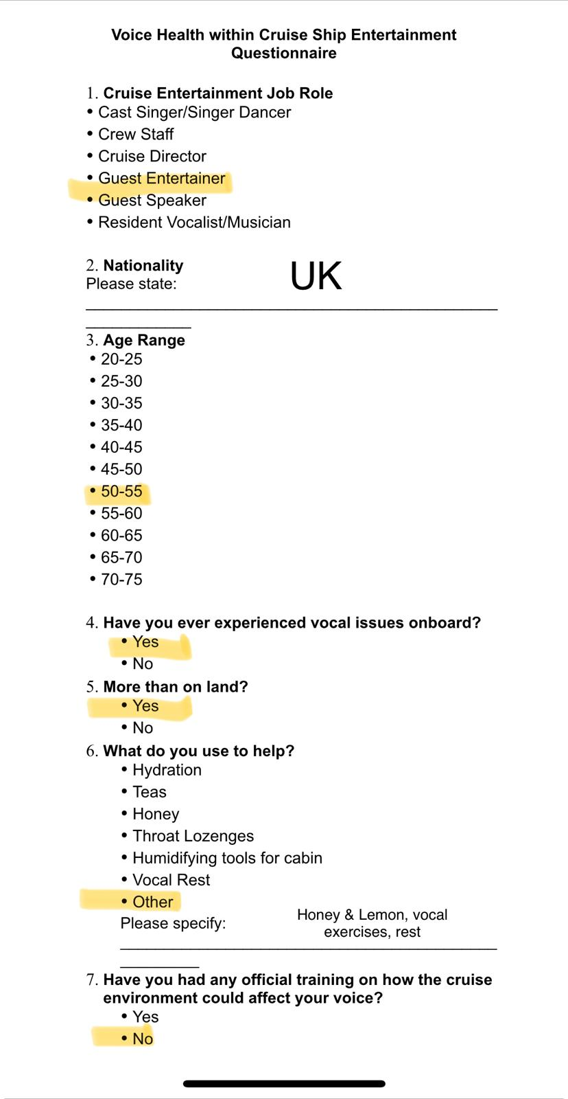

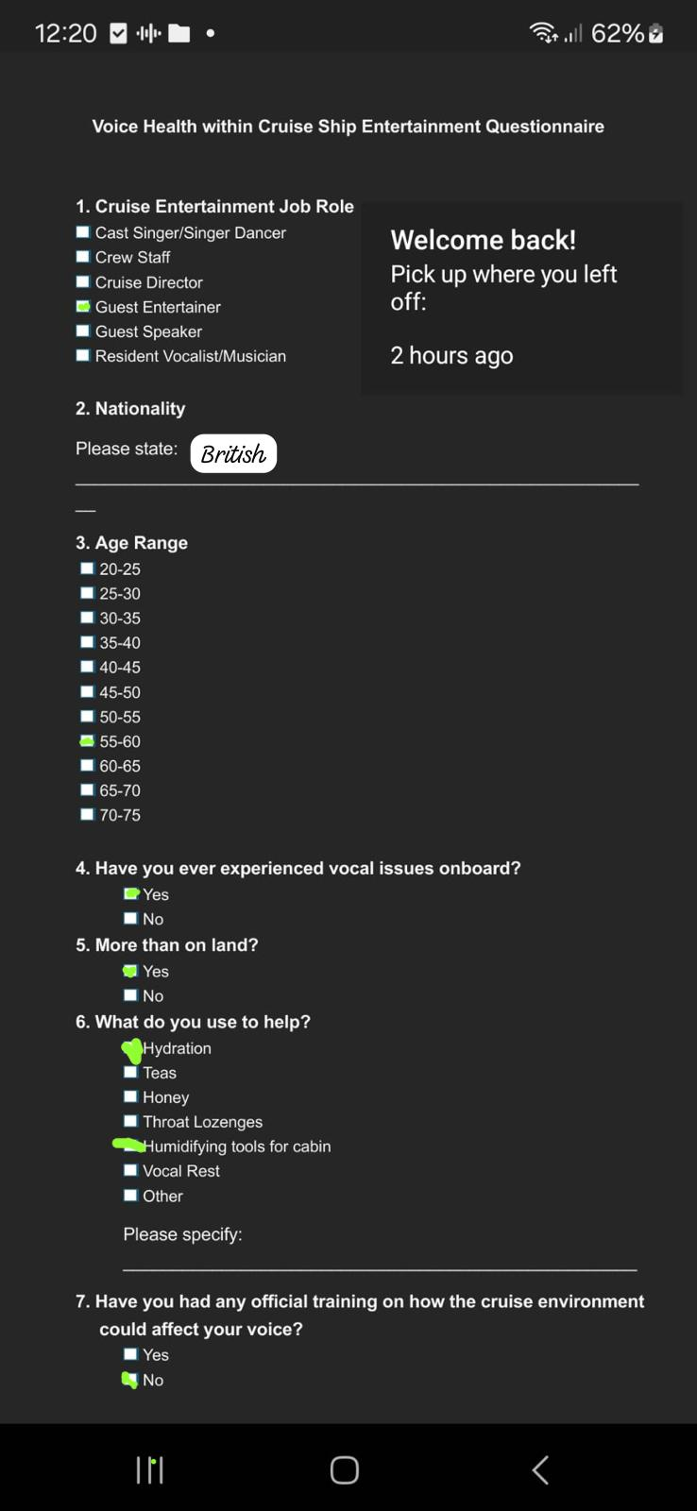
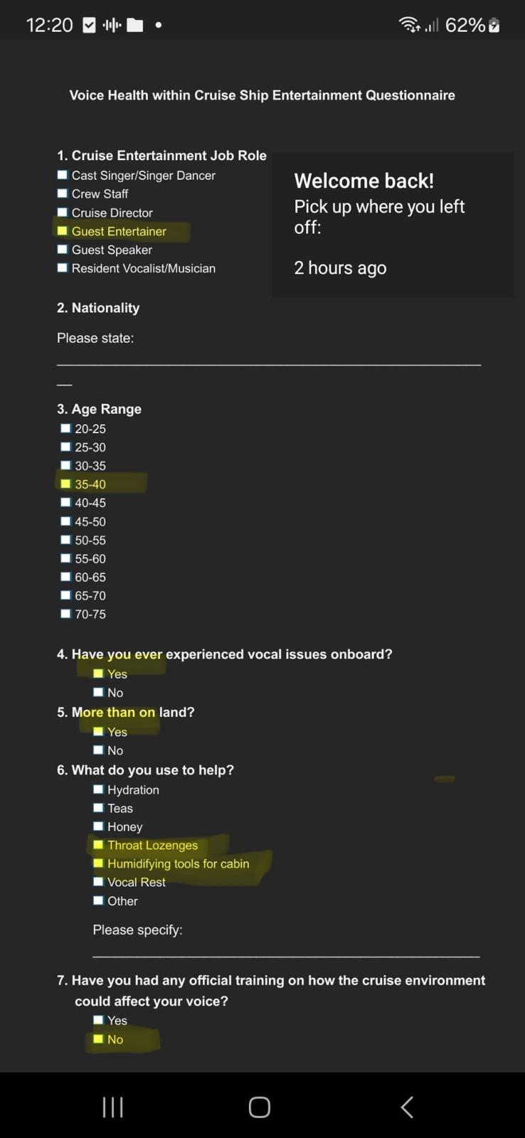

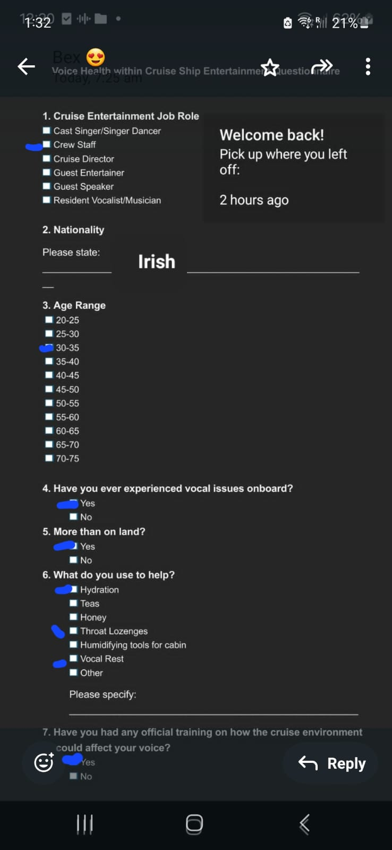

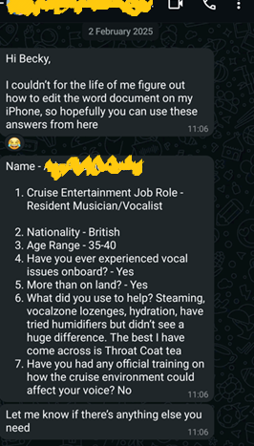

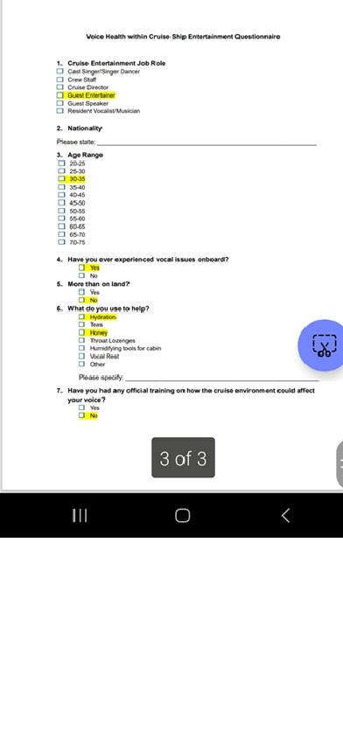
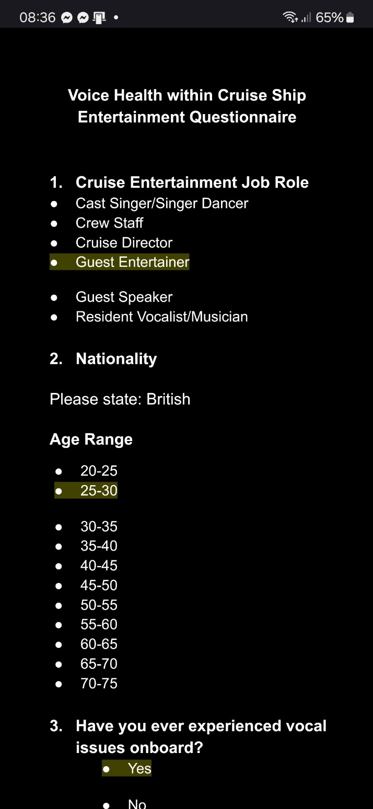
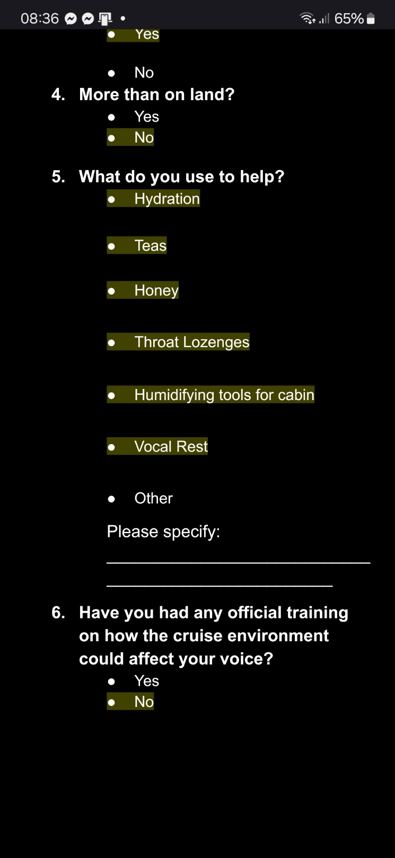

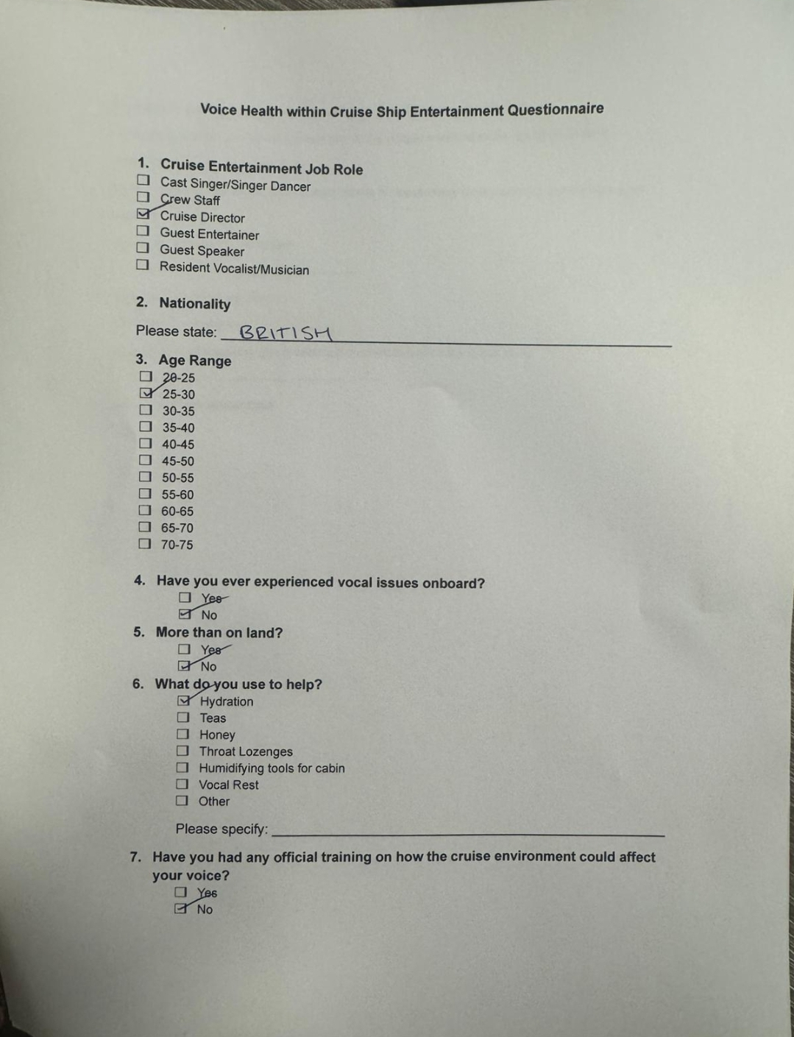

Appendix C
Consent Forms

Participant consent form
Title of Project-
Vocal Health Within the Cruise Ship Entertainment Industry
Consent to take part in research
- I Rachel Griffiths voluntarily agree to participate in this research study.
- I understand that even if I agree to participate now, I can withdraw at any time
- I understand that I can refuse to answer any question involved during the research process without any consequences of any kind.
- I have had the purpose and nature of the study explained to me in writing and I have had the opportunity to ask questions about the study.
- I understand that participation involves… [outline briefly in simple terms what participation in your research will involve].
- I understand that I will not benefit directly from participating in this research.
- I agree to my interview being audio-recorded.
- I understand that all information I provide for this study will be treated confidentially.
- I understand that in any report on the results of this research my identity will remain anonymous.
- This will be done by changing my name and disguising any details of my interview which may reveal my identity or the identity of people I speak about.
- I understand that disguised extracts from my interview may be quoted in… [list all forum in which you plan to use the data from the interview: dissertation, conference presentation, published papers etc.].
- I understand that if I inform the researcher that myself or someone else is at risk of harm they may have to report this to the relevant authorities - they will discuss this with me first but may be required to report with or without my permission.
- I understand that signed consent forms and original audio recordings will be retained in [specify location, security arrangements and who has access to data] until [specific relevant period – for students this will be until the exam board confirms the results of their dissertation].
- I understand that a transcript of my interview in which all identifying information has been removed will be retained for [specific relevant period – for students this will be two years from the date of the exam board].
- I understand that under freedom of information legalisation I am entitled to access the information I have provided at any time while it is in storage as specified above.
- I understand that I am free to contact any of the people involved in the research to seek further clarification and information.
Names, degrees, affiliations and contact details of researchers (and academic supervisors when relevant).
Signature of research participant

Signature of participant Date
23rd September 2024
Signature of researcher
I believe the participant is giving informed consent to participate in this study

Signature of researcher Date
23rd September 2024

Participant consent form
Title of Project-
Vocal Health Within the Cruise Ship Entertainment Industry
Consent to take part in research
- I Jayne Parry voluntarily agree to participate in this research study.
- I understand that even if I agree to participate now, I can withdraw at any time
- I understand that I can refuse to answer any question involved during the research process without any consequences of any kind.
- I have had the purpose and nature of the study explained to me in writing and I have had the opportunity to ask questions about the study.
- I understand that participation involves… [outline briefly in simple terms what participation in your research will involve].
- I understand that I will not benefit directly from participating in this research.
- I agree to my interview being audio-recorded.
- I understand that all information I provide for this study will be treated confidentially.
- I understand that in any report on the results of this research my identity will remain anonymous.
- This will be done by changing my name and disguising any details of my interview which may reveal my identity or the identity of people I speak about.
- I understand that disguised extracts from my interview may be quoted in… [list all forum in which you plan to use the data from the interview: dissertation, conference presentation, published papers etc.].
- I understand that if I inform the researcher that myself or someone else is at risk of harm they may have to report this to the relevant authorities - they will discuss this with me first but may be required to report with or without my permission.
- I understand that signed consent forms and original audio recordings will be retained in [specify location, security arrangements and who has access to data] until [specific relevant period – for students this will be until the exam board confirms the results of their dissertation].
- I understand that a transcript of my interview in which all identifying information has been removed will be retained for [specific relevant period – for students this will be two years from the date of the exam board].
- I understand that under freedom of information legalisation I am entitled to access the information I have provided at any time while it is in storage as specified above.
- I understand that I am free to contact any of the people involved in the research to seek further clarification and information.
Names, degrees, affiliations and contact details of researchers (and academic supervisors when relevant).
Signature of research participant

Signature of participant Date
03 February 2025
Signature of researcher
I believe the participant is giving informed consent to participate in this study
Signature of researcher Date
03 February 2025

Participant consent form
Title of Project-
Vocal Health Within the Cruise Ship Entertainment Industry
Consent to take part in research
- I Michelle Joly voluntarily agree to participate in this research study.
- I understand that even if I agree to participate now, I can withdraw at any time
- I understand that I can refuse to answer any question involved during the research process without any consequences of any kind.
- I have had the purpose and nature of the study explained to me in writing and I have had the opportunity to ask questions about the study.
- I understand that participation involves… [outline briefly in simple terms what participation in your research will involve].
- I understand that I will not benefit directly from participating in this research.
- I agree to my interview being audio-recorded.
- I understand that all information I provide for this study will be treated confidentially.
- I understand that in any report on the results of this research my identity will remain anonymous.
- This will be done by changing my name and disguising any details of my interview which may reveal my identity or the identity of people I speak about.
- I understand that disguised extracts from my interview may be quoted in… [list all forum in which you plan to use the data from the interview: dissertation, conference presentation, published papers etc.].
- I understand that if I inform the researcher that myself or someone else is at risk of harm they may have to report this to the relevant authorities - they will discuss this with me first but may be required to report with or without my permission.
- I understand that signed consent forms and original audio recordings will be retained in [specify location, security arrangements and who has access to data] until [specific relevant period – for students this will be until the exam board confirms the results of their dissertation].
- I understand that a transcript of my interview in which all identifying information has been removed will be retained for [specific relevant period – for students this will be two years from the date of the exam board].
- I understand that under freedom of information legalisation I am entitled to access the information I have provided at any time while it is in storage as specified above.
- I understand that I am free to contact any of the people involved in the research to seek further clarification and information.
Names, degrees, affiliations and contact details of researchers (and academic supervisors when relevant).
Signature of research participant

Signature of participant Date
03 February 2025
Signature of researcher
I believe the participant is giving informed consent to participate in this study
Signature of researcher Date
03 February 2025

Participant consent form
Title of Project-
Vocal Health Within the Cruise Ship Entertainment Industry
Consent to take part in research
- I Chris Richie voluntarily agree to participate in this research study.
- I understand that even if I agree to participate now, I can withdraw at any time
- I understand that I can refuse to answer any question involved during the research process without any consequences of any kind.
- I have had the purpose and nature of the study explained to me in writing and I have had the opportunity to ask questions about the study.
- I understand that participation involves… [outline briefly in simple terms what participation in your research will involve].
- I understand that I will not benefit directly from participating in this research.
- I agree to my interview being audio-recorded.
- I understand that all information I provide for this study will be treated confidentially.
- I understand that in any report on the results of this research my identity will remain anonymous.
- This will be done by changing my name and disguising any details of my interview which may reveal my identity or the identity of people I speak about.
- I understand that disguised extracts from my interview may be quoted in… [list all forum in which you plan to use the data from the interview: dissertation, conference presentation, published papers etc.].
- I understand that if I inform the researcher that myself or someone else is at risk of harm they may have to report this to the relevant authorities - they will discuss this with me first but may be required to report with or without my permission.
- I understand that signed consent forms and original audio recordings will be retained in [specify location, security arrangements and who has access to data] until [specific relevant period – for students this will be until the exam board confirms the results of their dissertation].
- I understand that a transcript of my interview in which all identifying information has been removed will be retained for [specific relevant period – for students this will be two years from the date of the exam board].
- I understand that under freedom of information legalisation I am entitled to access the information I have provided at any time while it is in storage as specified above.
- I understand that I am free to contact any of the people involved in the research to seek further clarification and information.
Names, degrees, affiliations and contact details of researchers (and academic supervisors when relevant).
Signature of research participant
Chris Richie
Signature of participant Date
01 February 2025
Signature of researcher
I believe the participant is giving informed consent to participate in this study
Signature of researcher Date
01 February 2025
Participant consent form
Title of Project-
Vocal Health Within the Cruise Ship Entertainment Industry
Consent to take part in research
- I Sophie Tehrani voluntarily agree to participate in this research study.
- I understand that even if I agree to participate now, I can withdraw at any time
- I understand that I can refuse to answer any question involved during the research process without any consequences of any kind.
- I have had the purpose and nature of the study explained to me in writing and I have had the opportunity to ask questions about the study.
- I understand that participation involves… [outline briefly in simple terms what participation in your research will involve].
- I understand that I will not benefit directly from participating in this research.
- I agree to my interview being audio-recorded.
- I understand that all information I provide for this study will be treated confidentially.
- I understand that in any report on the results of this research my identity will remain anonymous.
- This will be done by changing my name and disguising any details of my interview which may reveal my identity or the identity of people I speak about.
- I understand that disguised extracts from my interview may be quoted in… [list all forum in which you plan to use the data from the interview: dissertation, conference presentation, published papers etc.].
- I understand that if I inform the researcher that myself or someone else is at risk of harm they may have to report this to the relevant authorities - they will discuss this with me first but may be required to report with or without my permission.
- I understand that signed consent forms and original audio recordings will be retained in [specify location, security arrangements and who has access to data] until [specific relevant period – for students this will be until the exam board confirms the results of their dissertation].
- I understand that a transcript of my interview in which all identifying information has been removed will be retained for [specific relevant period – for students this will be two years from the date of the exam board].
- I understand that under freedom of information legalisation I am entitled to access the information I have provided at any time while it is in storage as specified above.
- I understand that I am free to contact any of the people involved in the research to seek further clarification and information.
Names, degrees, affiliations and contact details of researchers (and academic supervisors when relevant).
Signature of research participant
Sophie Tehrani
Signature of participant Date
04 February 2025
Signature of researcher
I believe the participant is giving informed consent to participate in this study
Signature of researcher Date
04 February 2025

Participant consent form
Title of Project-
Vocal Health Within the Cruise Ship Entertainment Industry
Consent to take part in research
- I A.J Clarke voluntarily agree to participate in this research study.
- I understand that even if I agree to participate now, I can withdraw at any time
- I understand that I can refuse to answer any question involved during the research process without any consequences of any kind.
- I have had the purpose and nature of the study explained to me in writing and I have had the opportunity to ask questions about the study.
- I understand that participation involves… [outline briefly in simple terms what participation in your research will involve].
- I understand that I will not benefit directly from participating in this research.
- I agree to my interview being audio-recorded.
- I understand that all information I provide for this study will be treated confidentially.
- I understand that in any report on the results of this research my identity will remain anonymous.
- This will be done by changing my name and disguising any details of my interview which may reveal my identity or the identity of people I speak about.
- I understand that disguised extracts from my interview may be quoted in… [list all forum in which you plan to use the data from the interview: dissertation, conference presentation, published papers etc.].
- I understand that if I inform the researcher that myself or someone else is at risk of harm they may have to report this to the relevant authorities - they will discuss this with me first but may be required to report with or without my permission.
- I understand that signed consent forms and original audio recordings will be retained in [specify location, security arrangements and who has access to data] until [specific relevant period – for students this will be until the exam board confirms the results of their dissertation].
- I understand that a transcript of my interview in which all identifying information has been removed will be retained for [specific relevant period – for students this will be two years from the date of the exam board].
- I understand that under freedom of information legalisation I am entitled to access the information I have provided at any time while it is in storage as specified above.
- I understand that I am free to contact any of the people involved in the research to seek further clarification and information.
Names, degrees, affiliations and contact details of researchers (and academic supervisors when relevant).
Signature of research participant
Adam James Clarke
Signature of participant Date
02 February 2025
Signature of researcher
I believe the participant is giving informed consent to participate in this study
Signature of researcher Date
02 February 2025

Participant consent form
Title of Project-
Vocal Health Within the Cruise Ship Entertainment Industry
Consent to take part in research
- I Oli Nez voluntarily agree to participate in this research study.
- I understand that even if I agree to participate now, I can withdraw at any time
- I understand that I can refuse to answer any question involved during the research process without any consequences of any kind.
- I have had the purpose and nature of the study explained to me in writing and I have had the opportunity to ask questions about the study.
- I understand that participation involves… [outline briefly in simple terms what participation in your research will involve].
- I understand that I will not benefit directly from participating in this research.
- I agree to my interview being audio-recorded.
- I understand that all information I provide for this study will be treated confidentially.
- I understand that in any report on the results of this research my identity will remain anonymous.
- This will be done by changing my name and disguising any details of my interview which may reveal my identity or the identity of people I speak about.
- I understand that disguised extracts from my interview may be quoted in… [list all forum in which you plan to use the data from the interview: dissertation, conference presentation, published papers etc.].
- I understand that if I inform the researcher that myself or someone else is at risk of harm they may have to report this to the relevant authorities - they will discuss this with me first but may be required to report with or without my permission.
- I understand that signed consent forms and original audio recordings will be retained in [specify location, security arrangements and who has access to data] until [specific relevant period – for students this will be until the exam board confirms the results of their dissertation].
- I understand that a transcript of my interview in which all identifying information has been removed will be retained for [specific relevant period – for students this will be two years from the date of the exam board].
- I understand that under freedom of information legalisation I am entitled to access the information I have provided at any time while it is in storage as specified above.
- I understand that I am free to contact any of the people involved in the research to seek further clarification and information.
Names, degrees, affiliations and contact details of researchers (and academic supervisors when relevant).
Signature of research participant
Oliver Nez
Signature of participant Date
01 February 2025
Signature of researcher
I believe the participant is giving informed consent to participate in this study
Signature of researcher Date
01 February 2025

Participant consent form
Title of Project-
Vocal Health Within the Cruise Ship Entertainment Industry
Consent to take part in research
- I Niamh Cass voluntarily agree to participate in this research study.
- I understand that even if I agree to participate now, I can withdraw at any time
- I understand that I can refuse to answer any question involved during the research process without any consequences of any kind.
- I have had the purpose and nature of the study explained to me in writing and I have had the opportunity to ask questions about the study.
- I understand that participation involves… [outline briefly in simple terms what participation in your research will involve].
- I understand that I will not benefit directly from participating in this research.
- I agree to my interview being audio-recorded.
- I understand that all information I provide for this study will be treated confidentially.
- I understand that in any report on the results of this research my identity will remain anonymous.
- This will be done by changing my name and disguising any details of my interview which may reveal my identity or the identity of people I speak about.
- I understand that disguised extracts from my interview may be quoted in… [list all forum in which you plan to use the data from the interview: dissertation, conference presentation, published papers etc.].
- I understand that if I inform the researcher that myself or someone else is at risk of harm they may have to report this to the relevant authorities - they will discuss this with me first but may be required to report with or without my permission.
- I understand that signed consent forms and original audio recordings will be retained in [specify location, security arrangements and who has access to data] until [specific relevant period – for students this will be until the exam board confirms the results of their dissertation].
- I understand that a transcript of my interview in which all identifying information has been removed will be retained for [specific relevant period – for students this will be two years from the date of the exam board].
- I understand that under freedom of information legalisation I am entitled to access the information I have provided at any time while it is in storage as specified above.
- I understand that I am free to contact any of the people involved in the research to seek further clarification and information.
Names, degrees, affiliations and contact details of researchers (and academic supervisors when relevant).
Signature of research participant
Niamh Cass
Signature of participant Date
01 February 2025
Signature of researcher
I believe the participant is giving informed consent to participate in this study
Signature of researcher Date
01 February 2025

Participant consent form
Title of Project-
Vocal Health Within the Cruise Ship Entertainment Industry
Consent to take part in research
- I Benjamine Moss voluntarily agree to participate in this research study.
- I understand that even if I agree to participate now, I can withdraw at any time
- I understand that I can refuse to answer any question involved during the research process without any consequences of any kind.
- I have had the purpose and nature of the study explained to me in writing and I have had the opportunity to ask questions about the study.
- I understand that participation involves… [outline briefly in simple terms what participation in your research will involve].
- I understand that I will not benefit directly from participating in this research.
- I agree to my interview being audio-recorded.
- I understand that all information I provide for this study will be treated confidentially.
- I understand that in any report on the results of this research my identity will remain anonymous.
- This will be done by changing my name and disguising any details of my interview which may reveal my identity or the identity of people I speak about.
- I understand that disguised extracts from my interview may be quoted in… [list all forum in which you plan to use the data from the interview: dissertation, conference presentation, published papers etc.].
- I understand that if I inform the researcher that myself or someone else is at risk of harm they may have to report this to the relevant authorities - they will discuss this with me first but may be required to report with or without my permission.
- I understand that signed consent forms and original audio recordings will be retained in [specify location, security arrangements and who has access to data] until [specific relevant period – for students this will be until the exam board confirms the results of their dissertation].
- I understand that a transcript of my interview in which all identifying information has been removed will be retained for [specific relevant period – for students this will be two years from the date of the exam board].
- I understand that under freedom of information legalisation I am entitled to access the information I have provided at any time while it is in storage as specified above.
- I understand that I am free to contact any of the people involved in the research to seek further clarification and information.
Names, degrees, affiliations and contact details of researchers (and academic supervisors when relevant).
Signature of research participant
Benjamine Moss
Signature of participant Date
31 January 2025
Signature of researcher
I believe the participant is giving informed consent to participate in this study
Signature of researcher Date
03 February 2025

Participant consent form
Title of Project-
Vocal Health Within the Cruise Ship Entertainment Industry
Consent to take part in research
- I Rikki Jay voluntarily agree to participate in this research study.
- I understand that even if I agree to participate now, I can withdraw at any time
- I understand that I can refuse to answer any question involved during the research process without any consequences of any kind.
- I have had the purpose and nature of the study explained to me in writing and I have had the opportunity to ask questions about the study.
- I understand that participation involves… [outline briefly in simple terms what participation in your research will involve].
- I understand that I will not benefit directly from participating in this research.
- I agree to my interview being audio-recorded.
- I understand that all information I provide for this study will be treated confidentially.
- I understand that in any report on the results of this research my identity will remain anonymous.
- This will be done by changing my name and disguising any details of my interview which may reveal my identity or the identity of people I speak about.
- I understand that disguised extracts from my interview may be quoted in… [list all forum in which you plan to use the data from the interview: dissertation, conference presentation, published papers etc.].
- I understand that if I inform the researcher that myself or someone else is at risk of harm they may have to report this to the relevant authorities - they will discuss this with me first but may be required to report with or without my permission.
- I understand that signed consent forms and original audio recordings will be retained in [specify location, security arrangements and who has access to data] until [specific relevant period – for students this will be until the exam board confirms the results of their dissertation].
- I understand that a transcript of my interview in which all identifying information has been removed will be retained for [specific relevant period – for students this will be two years from the date of the exam board].
- I understand that under freedom of information legalisation I am entitled to access the information I have provided at any time while it is in storage as specified above.
- I understand that I am free to contact any of the people involved in the research to seek further clarification and information.
Names, degrees, affiliations and contact details of researchers (and academic supervisors when relevant).
Signature of research participant
Rikki Jay
Signature of participant Date
01 February 2025
Signature of researcher
I believe the participant is giving informed consent to participate in this study
Signature of researcher Date
01 February 2025
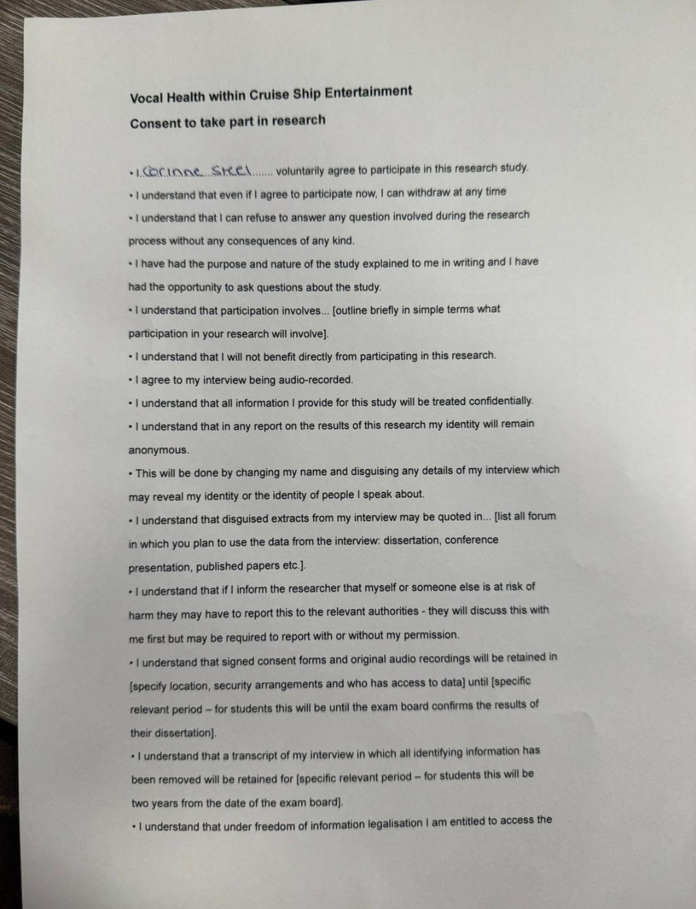
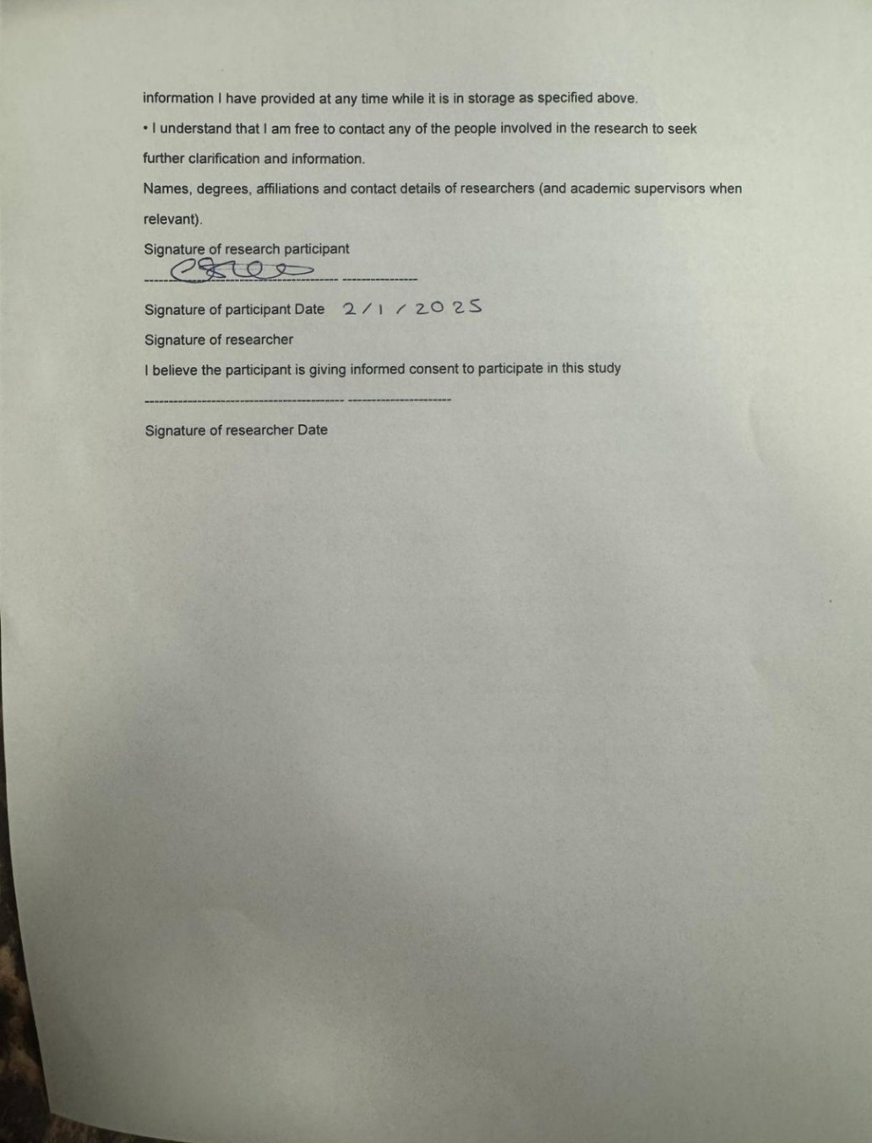
Signature of researcher- Date 13/13/2025


