Narcisa Daniela Trifanov 1812758
University of Wales Trinity Saint David
25th of February 2022
a critical evaluation of the impact ‘customer relationship management’ has on an organisations’ performance- tesco
Understanding and engaging in the customer experience
25

Executive Summary

This report is representative for Tesco’s vision about ethics and sustainability. The report is starting with a short introduction of Tesco, which clarifies the importance of Customer Relationship at Tesco’s. The second part is to look at ethics and sustainability, and the company has lots of policies and a code of Business Conduct that is guiding every action of the company. At the same time, the sustainability at the workplace is represented by the Little Helps Plan, which focus on multiple aspects of sustainability, such as recycling or waste reduction. Furthermore, the company does its segmentation using traditional ways, and they use Tesco Clubcard to gain the loyalty of the customers and gather data. The report ends with appropriate conclusions and recommendations where they can become more ethical, by adhering more to the SDG’s or to collect data from stores from customers that are not part of the loyalty scheme.

Contents
Executive Summary 1
1.0 Introduction 3
2.0 Findings 4
2.2. Ethics and Sustainability 5
2.3 Segmentation and the Loyalty Ladder 5
3.0 Conclusion 7
4.0 Recommendations 7
5.0 Appendix 8
6.0 Acknowledgements 11
7.0 References 12

1.0 Introduction
This report was requested by the Chief Executive Officer of Marketing Week, an online journal produced by Tesco, on the 25th of February 2022, as the CEO and the team are actively researching the influence of ethical trading and the impact of sustainability policies. The report was compiled by the Marketing Representative of Tesco on the 25th of February 2022.
The procedures adopted to prepare this report were a significant number of academic journals, mostly use to define and examine the concepts discussed within the report, and articles and reports which were used to support the arguments and give organisational examples. The report is also using a limited number of books, for both academic insights, as well as company examples.
The purpose of the report is to analyse Tesco’s Customer Relationship Management by looking at factors such as Ethics, Sustainability, Segmentation and Loyalty Ladder.
The report will end with conclusions based on every argument proposed and will contain a list of realistic recommendation that can help Tesco to improve its Customer Relationship Management.

2.0 Findings
2.1 Background to TESCO
Tesco is a known retailer in the United Kingdom and a few other countries, generating annually millions in profit. The company’s history was always based on the idea of selling everything at a cheaper price than anywhere else (EEPH, 2017), which made the company to have an instant success everyone and expand quite fast. The company’s founder was Jack Cohen, and Cohen created the first market stall in 1919 in London, and by 1930 he already started to buy more shops and started the store’s expansion (Tesco, 2022). Statista (2022) showed how Tesco’s sales have oscillated over the last 6 years (Appendix 1), and a significant growth was registered in 2020, following the world’ pandemic and a progressive growth in online sales (Burns, 2020).
Statista (2022) also shared that Tesco’s profit has grown in the past year, but the market shares took a huge hit, at the same time being affected similar companies such as Asda, Sainsbury’s and Morrisons, while discount stores such as Lidl and Aldi have seen a remarkable growth, the reason behind it being the fact that they offer sometimes the same products at a reduced price, and they attract multiple customers (Gale, 2018).
2.1.1. CRM AND TESCO
Customer relationship management is important for Tesco, as their main value is to serve their customers. The company said that ‘everything we do begins and ends with our customers’ (Tesco, 2022). Previously, Garlick argued in 2017 the fact that more companies should put the customers first, as Tesco does, saying that Tesco has 4 successful areas, the customer-focused product development, where the author argued that Tesco understand the needs of the customer and includes products to cover any need, then the customer-focused ranging, where Tesco was faster and better at reaching local audiences, followed by the customer-focused store development, where every store in built for customer’s taste and includes various accessibility options for vulnerable customers as well, ending with a customer-focused loyalty scheme, where the Clubcard is widely used and offers great discounts.
The arguments above are proved by the most recent UK Customer Satisfaction Index (Appendix 2) where Tesco has now a place in the Top 50 companies after a growth of 1.9, compared to the previous year (Jackson, 2021).
Based on the score above, it can be proved the fact that Tesco is showing a constant care for their customer and the Customer Relationship Management is an important focus of the company.
The customer experience is represented by all the actions, products and services of a company that has an impact over customer’s feelings and the experience is different for every person, and a company must be very inclusive, accessible and diverse to be able to satisfy the needs of a wide range of customers (Hueffner, 2020). In the most recent report of the Most Popular Supermarkets Chain provided by YouGov in 2022 (Appendix 3), Tesco and Tesco Express are placed on the places 4 and 5, with a popularity of 98% and a popularity of 69% and 67%. These are followed on the places 6 and 7 by Morrisons and Asda, the direct competitors. This means that customers are having a positive experience in Tesco’s stores, and they are happy to return to shop from the stores.
Tesco (2021) also reported in their annual report the fact that one of their Key Promotor Score is represented by the customer’s recommendation and return, and the company shared the fact their score increased by 3 points and that the overall feeling of the customers was that the store went above and beyond to offer them an excellent service during the pandemic.

2.2. Ethics and Sustainability
Tesco proud itself by being an ethical company, ethics being a part of the organisation’s cultural values (Appendix 4), with every policy being clearly shown on their website (2022) and available in every store. The company adopted the Code of Business Conduct and Ethics, and the company operates under clear guidelines that are used to promote an honest and ethical conduct, where Tesco offers full disclosure, is compliant with all the governmental laws, rules and regulations and provide guidance to all stakeholders, while being applicable to every employee of Tesco (Tesco, 2016)., actions which are increasing the customer’s experience as they are offered an transparent service and they can chose to agree or not. However, the company was not always focused on ethics, but more on growth, as Dresser argued in 2004, when Tesco was criticised for the fact that their expansion is damaging local communities and smaller retailers, which has a huge impact in customer experience. At the same time, there are no doubts that the company adhere to the Freidman’s Stakeholders Theory, (Stakeholder Company, 2018) which means that Tesco is not only focusing on making profit for the managers and CEO, but the company is truly interested in the wellbeing of every employee and every customer.
At the same time, an important aspect that Tesco is focused on is the sustainability. Under the ASBP’s Six Pillars of Sustainable Construction (The Alliance for Sustainable Building Products, 2022), Tesco focused on the Resource Efficiency, which is representative for the fact that Tesco is focus on recycling and creating a more sustainable environment, with reduces waste. The company has an entire plan, called ‘The Little Helps Plan’, where they focus on four main aspects: people, product, planet and places. The company offers an opportunity for employment and skill gain to people from different environments, while promoting diversity and inclusion while respecting the human rights and focusing on the health, safety and wellbeing of every stakeholder. The company is also paying attention to food waste, and they are trying to use recyclable packaging, to support healthy and sustainable diets and pay attention to Animal welfare. On a broader spectrum, the company tries to care for the planet by being careful at the climate change, maintain and promote a sustainable agriculture and tackle deforestation, as well as supporting communities and offer food retribution. All these actions have a positive impact over Customer Relationship Management and prove that Tesco is an ethical and sustainable business (Tesco, 2021).
On the other side, one of the company’s greatest competitors, Morrisons, has seen an increase in customer experience over the years, with an increase of 8% in the financial year 2018/19. The score was mainly given for the sustainable innovation of Morrisons, where they work along British local supplier to offer more organic products, such as eggs. The company’s is also focus on sustainability by having the ‘Naturally Wonky’ brand which reduces waste food and plastic (Morrison, 2019).

2.3 Segmentation and the Loyalty Ladder
The concept of segmentation was first introduced in 1956 by Smith, which recognised the concept as a diverse market that needs to be divided in multiple diverse markets to be able to offer to the consumers a better experience and more precise satisfaction of their needs or wants. The market segmentation is a constant challenge for every company as the needs of the customer are often changing (Wedel, Kamakura, 2003), but there a few models of segmentation that the companies are using and adapting based on the industry or needs. The market segmentation is one of the most used concept among managers to maximise the profit of the company and to increase the exposure, however Blattberg and Sen argued in 1974 that in order to actually benefit from the market segmentation, a company must spend time to recognise every segment and understand the customers’ behaviour from how and on what they spend the money, to how likely are they to became a loyal customer to a certain brand or store.
While some argue that the main focus on segmentation should be the demographics and geographics, as they focus on the typical customer from a certain zone (Thomas, 2020), the most important part of the market segmentation is the psychological one, that can help a company to understand better what the customer are thinking, how they behave while shopping and how to use this data to retain the customer and improve a company’s profits (Frow, Payne, 2009). The model used for market segmentation can have a notable influence in Customer Relationship Management, as it is clear that an in-depth segmentation can help a company focus on understanding the consumers’ needs and wants so that the company can work on those needs and wants, with the goal of creating a meaningful relationship with the customer and retain them (Yoon et el., 2003).
Tesco PLC uses multiple market segmentations. Dudovskiy presented in 2016 exactly how Tesco is using the market segmentation as a tool to retain more customers. The first way is through functional positioning, applicable for those customers that want a more expensive and qualitative range of products, and here Tesco introduces their Tesco Finest category of products, which is satisfactory for these customers and can be purchased at an additional price, and by this Tesco is ensuring that the customers’ needs are met, and the company is gaining profit at the same time. The second way is through symbolic positioning, which is a subjective type of marketing segmentation as it is entirely based on customers’ values and beliefs, and here Tesco has an impressive campaign to sell only ‘Fair Trade’ products from countries that do not practice child labour. Another type of segmentation that Tesco uses is the multi-segment positioning, meaning that people with different incomes can find everything they need within Tesco stores, from affordable products to a range of expensive products, suitable for every budget, which makes Tesco a store for everyone. These positioning are helping Tesco to improve and sustain a great Customer Relationship Management because they allow the company to provide all the tools to cover all customers’ needs.
The Loyalty Ladder is a known marketing framework that represents a consumer’s path from considering becoming a customer, stage known as prospect, to be a brand ambassador, stage known as advocate (Leach, 2022). The goal of this framework (Appendix 5) is to make the company think about how to transform prospects into advocates, and how to learn their loyalty.

A relevant research on this topic was made by Reichheld in 1996, when he identified that the number of loyal customers is different from company to company, and if a company focuses on its own employees, they will provide excellent service and build lasting relationships with the customer, and, at the same time, the leaders must make efforts to create a bond with the prospects (Ahmad, Buttle, 2002). The reason behind the loyalty ladder and the research is to help improve the Customer Relationship Management.
Tesco was able to create an entire Customer Relationship Management strategy by creating and implementing the Clubcard, a membership card that allow customer to gain points for their purchases and to use those point to have further discounts or free products, and, at the same time, allow customers to benefit from the existent sales in every store that are only available to the members (Rowley, 2005). Tesco practices almost its entire Customer Relationship Management though the Clubcard, as they aim to improve their performance every time, can gain data from customers that is helpful in finding the customers’ needs and can act accordingly to make the customer happy and therefore loyal to the customer, while the company is getting bigger profits (Humby, Hunt and Phillips, 2008). The same source argues the fact that the main purpose of the Clubcard is not to make the customers’ loyal, but to show customers that Tesco is loyal to them and wants to be there for them. This in a method used by Tesco to move customer up on the Loyalty Ladder.
After extended research in public’s opinion on the Tesco’s Clubcard, there were no contra arguments or weaknesses found, as the public’s opinion is the same, that Tesco’s Clubcard is a unique way of increasing the Customer Relationship Management, and the success cannot be contested, and the growth over years is impressive compared to other retailers like Asda, Sainsbury’s or Morrisons (Mollah, 2014).

3.0 Conclusion
Every argument on the report is showing the care that Tesco is offering to the Customer Relationship Management through customer experience, ethics and sustainability, as there was no argument that can prove otherwise. The company has grown in the last few years to be a trustful retailer and the care for customer and for the planet grew with the company. Their Clubcard is one of the most innovative loyalty systems on the market, being successful every year and helping customer save an impressive amount every year. The company’s actions are always represented by fact within the Annual report where they show in a transparent way what went great and what went bad, they create new goals to improve and be better as a company. At the same time, in comparison with their competitors, Morrisons and Asda, Tesco has a huge advantage over every segment of the market and the company is gaining popularity each year.

4.0 Recommendations

Based on all the arguments and information from this report, the recommendations are that
4.1 Tesco should continue to work toward sustainability and guide themselves under the Ethical policies, and they can do so by integrating more Sustainable Development Goals in their future plans.
4.2 The company could use to also focus on attracting new customer and find ways to gather data from outside, not only through the Tesco Clubcard, the company can check the spending habits from each store based on stock for the customer who are not part of the Clubcard loyalty scheme.

5.0 Appendix

- Tesco’s sales
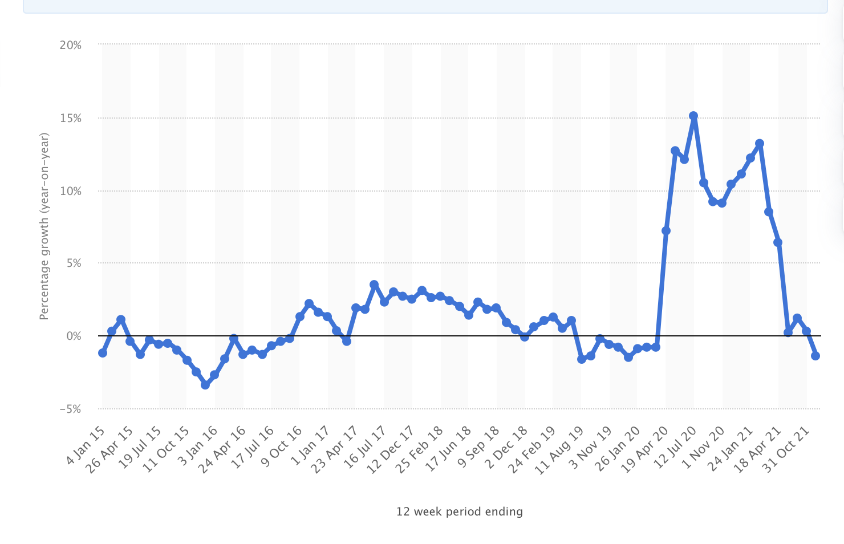

- Tesco’s place in Customer Preference Index

- Most Popular Supermarket Chain
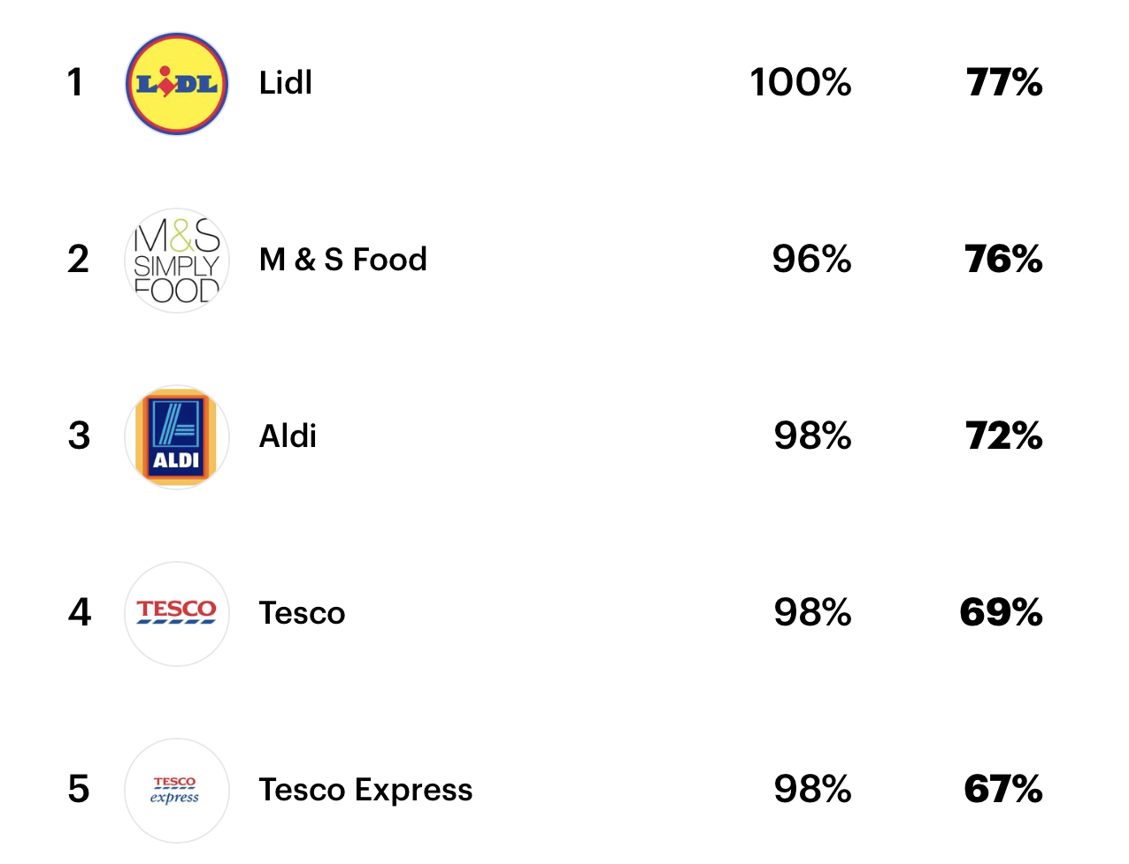

- Tesco’s cultural values
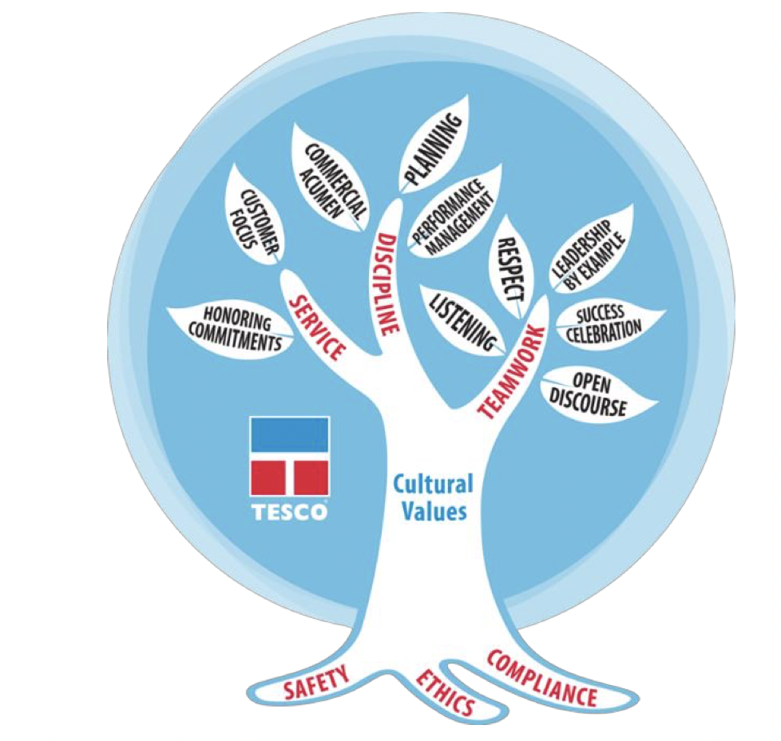

- Loyalty Ladder
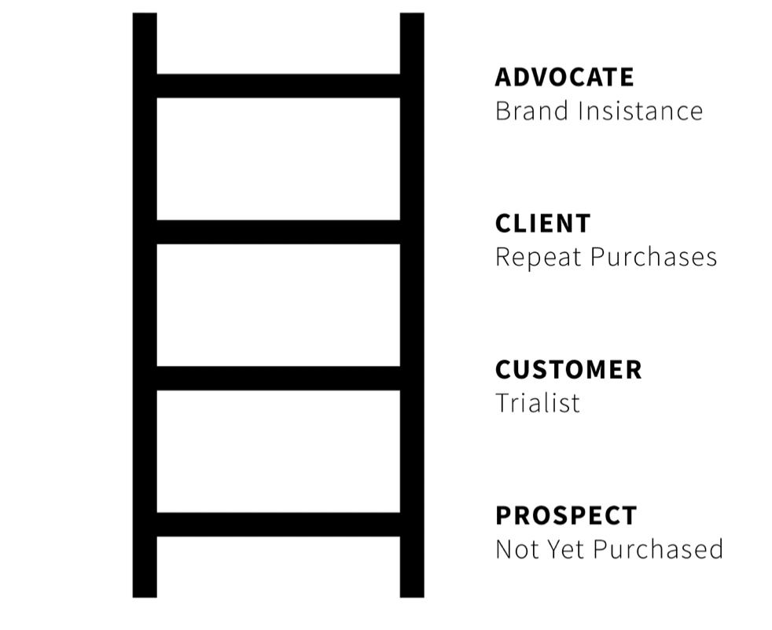

- Tesco’s growth

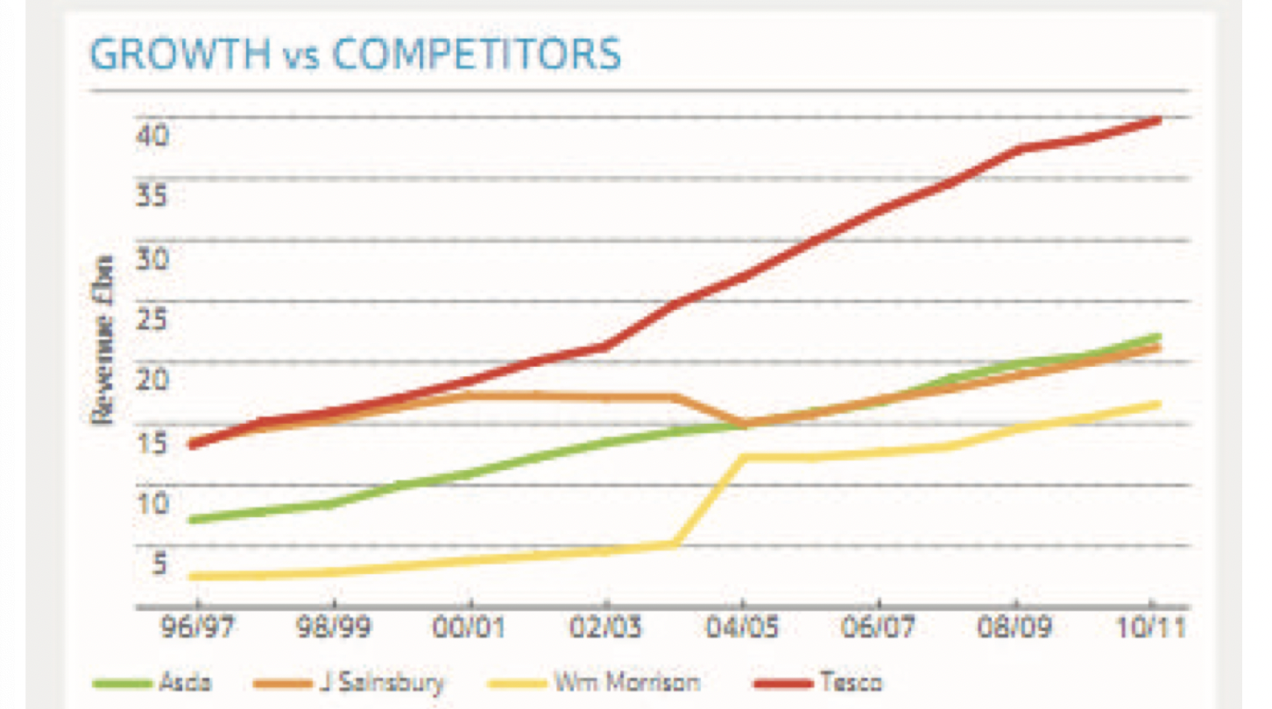

6.0 Acknowledgements
This report was made with information provided from multiple sources and the appreciation goes to every author that helped with information, as well as the lecturer that helped during the semester.

7.0 References

- Blattberg, R. and Sen, S. (1974) Market Segmentation Using Models of Multidimensional Purchasing Behaviours. Journal of Marketing, Vol. 38, Issue 4.
- Burns, H, (2020) Tesco online sales grow 48% during coronavirus lockdown. Available at: https://www.insider.co.uk/company-results-forecasts/tesco-online-sales-grow-48-22255555 (Accessed: the 3rd of February 2022).
- Dresser, G. (2004) Tesco branded ‘unfair and unethical’. Available at: https://www.standard.co.uk/hp/front/tesco-branded-unfair-and-unethical-6949514.html (Accessed: 6th of February 2022).
- Dudovckiy, J. (2016) Tesco Segmentation, Targeting and Positioning. Available at: https://research-methodology.net/tesco-segmentation-targeting-and-positioning-2/ (Accessed: the 4th of February 2022).
- EEPH (2017) Tesco UK brief history and overview. Available at: https://www.eeph.org.uk (Accessed: the 3rd of February 2022).
- Frow, P.E. and Payne, A.F. (2009) Customer Relationship Management: A Strategic Perspective. Journal of business market management, Vol. 3.
- Gale, A. (2018) Why Aldi and Lidl will keep on growing. Available at: https://www.managementtoday.co.uk/why-aldi-lidl-will-keep-growing/article/1386497 (Accessed: the 3rd of February 2022).
- Hueffner, E. (2020) Customer experience: strategies, importance, and examples. Available at: https://www.zendesk.com/blog/why-companies-should-invest-in-the-customer-experience/ (Accessed: the 6th of February 2022).
- Humby, C., Hunt, T., Phillips, T. (2008) Scoring Points: How Tesco is Winning Customer Loyalty. Kogan Page Limited: London.
- Jackson, M. (2021) Tesco Mobile Holds 5th Place in UK Customer Satisfaction Index. Available at: https://www.ispreview.co.uk/index.php/2021/07/tesco-mobile-holds-5th-place-in-uk-customer-satisfaction-index.html (Accessed: the 3rd of February 2022).
- Leach, A. (2022) The basics of loyalty ladder. Available at: https://www.matrix.co.uk/basics-loyalty-ladder/ (Accessed: the 4th of February 2022).
- Mollah, M.A.S. (2014) The Impact of Relationship Marketing on Customer Loyalty at Tesco Plc, UK. European Journal of Business and Management, Vol. 6, No. 3.
- Rigby, C. (2019) Asda puts its focus firmly on the customer. Available at: https://internetretailing.net/customer/customer/asda-puts-its-focus-firmly-on-the-customer-19638 (Accessed: 6th of February 2022).
- Rowley, J. (2005) Building brands web: Customer relationship management through the Tesco Clubcard loyalty scheme. International Journal of Retails & Distribution Management, Vol. 33, Issue 3.
- Smith, W. (1995) Product Differentiation and Market Segmentation as Alternative Marketing Strategies. Journal of Marketing, Vol. 21, No.1.
- Stakeholder Theory (2018) About the Stakeholder Company. Available at: http://stakeholdertheory.org/about/ (Accessed: the 13th of February 2022).
- Statista (2022) Annual revenue of Tesco Group in the United Kingdom (UK) and the Republic of Ireland from financial year 2015 to 2021. Available at: https://www.statista.com/statistics/490931/tesco-group-finance-revenue-united-kingdom-uk/ (Accessed: the 3rd of February 2022).
- Statista (2022) Percentage change in sales at Tesco in Great Britain compared to a year earlier from January 2015 to November 2021. Available at: https://www.statista.com/statistics/386598/tesco-sales-percentage-change-great-britain-uk/ (Accessed: the 3rd of February 2022).
- Tesco (2016) Code of Business Conduct and Ethics.
- Tesco (2021) Serving shoppers a little better every day. Annual Report and Financial Statements 2021. Available at: https://www.tescoplc.com/media/757589/tesco_annual_report_2021.pdf (Accessed: 6th of February 2022).
- Tesco (2022) Core Purpose and Values. Available at: https://www.tescoplc.com/about/how-we-do-business/core-purpose-and-values/ (Accessed: the 3rd of February 2022).
- Tesco (2022) Ethics and Compliance policies. Available at: https://www.tescoplc.com/about/how-we-do-business/ethics-and-compliance-policies/ (Accessed: 6th of February 2022).
- Tesco (2022) Our History. Available at: https://www.tescoplc.com/about/our-history/ (Accessed: the 3rd of February 2022).
- The Alliance of Sustainable Building Products (2022) ASBP’s Six Pillars of Sustainable Construction. Available at: https://asbp.org.uk/six-pillars (Accessed: the 13th of February 2022).
- Thomas, S.R. (2022) 4 Types of Market Segmentation with Real-World Examples. Available at: https://www.yieldify.com/blog/types-of-market-segmentation/ (Accessed: the 4th of February 2022).
- Wedel, M. and Kamakura, W. (2003) Market Segmentation: Conceptual and Methodological Foundations. Kluwer Academic Publisher, Massachusetts.
- Wm Morrison Supermarkets PLC (2019) Annual Report and Financial Statement 2018/19.
- Yoon, J., Hwang, S., Kin, D. and Yoon, J. (2003) A Balanced View for Customer Segmentation in CRM. Available at: https://aisel.aisnet.org/cgi/viewcontent.cgi?article=1533&context=amcis2003 (Accessed: the 3rd of February 2022).
- YouGov (2022) The Most Popular Supermarket Chains. Available at: https://yougov.co.uk/ratings/consumer/popularity/supermarket-chains/all (Accessed: the 6th of February 2022).

