Thermochemistry Calorimetry Report – Assignment 3

Hayden Taylor

31/10/2024

Table of Contents
2 Table of Figures 2
3 Table of Tables 2
4 Section 1 – Introduction 3
5 Section 2 – Results 3
6 Section 3 – Discussion 4
7 Section 4 – Conclusion 4
8 Section 5 – References 4
9 Section 6 – Appendix 5
9.1 Materials 5
9.2 Experimental procedure 5

Table of Figures

Table of Tables
Table 1 - heat capacity of calorimeter 4
Table 2 - specific heat capacity of metal 5

Section 1 – Introduction
The thermochemistry calorimetry experiment that identifies the amount of heat that gets transferred to or from a substance.[1] For the experiment it was split into two parts the heat capacity of the calorimeter, this was done to calibrate the calorimeter, and the specific heat capacity of a metal. The purpose of this experiment was to work out the specific heat capacity of the metal. The hypothesis of this experiment is that the specific heat capacity of the metal will be an increase of the heat of the water, the learner is expecting to see the metal heat up the water initially before then decreasing and becoming a stable number. When completing this experiment, it was important to think about the different variables that are affected, these are the dependent, independent and control. The dependent variable for this experiment is the change in temperature that will be seen, the independent variable is the type of metal that gets used [3] and the control variable is the amount of water used. [2]
When calculating the results some formulas were needed to gather this information. These were:
- Heat change of object (Q) = mass (m) X specific heat capacity (Cp) X change in temperature (ΔT)
- -Q metal = Q water +Q calorimeter
- M metal X Cp metal X ΔT metal = - (M water X Cp water X ΔT water + HC calorimeter X ΔT calorimeter)
- - Q hot water = Q cold water + Q calorimeter
- Q calorimeter = HC calorimeter X ΔT calorimeter
The specific heat is the quantity of heat that is required to raise the temperature of one gram of a substance by one degree Celsius. [4] For this experiment this will be the metal changing temperature.
The first law of thermodynamics is the idea that energy can not be created or destroyed but only transferred to the surroundings. [5] For this experiment it links to the metal transferring its heat to the cold water in the cups.

Section 2 – Results
There were two set of results that were calculated, these were the value of heat capacity of calorimeter and the specific heat capacity of a metal.
The first results and calculations found were the heat capacity of calorimeter: 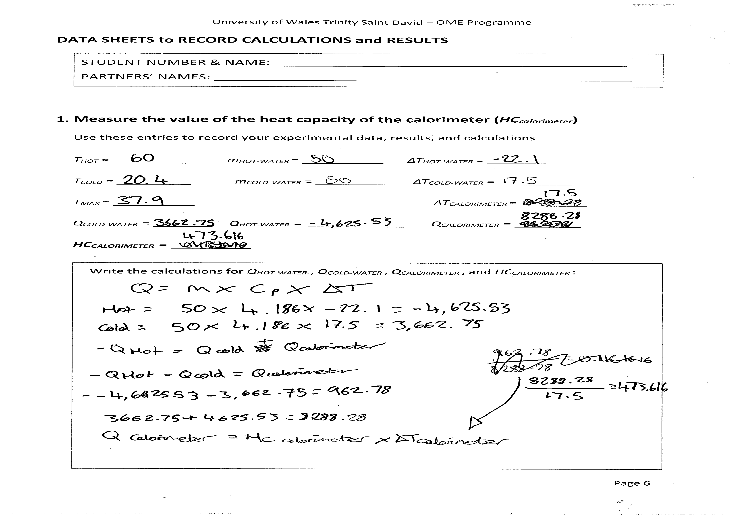
Table 1 - heat capacity of calorimeter
The first part of the results allows the learner to see the heat capacity of the calorimeter, this allows them to know the amoiunt of heat that the calorimeter can reach. These results were needed to work out the specifc heat of the metal.
The second lot of results and calculations were the specific heat capacity of a metal: 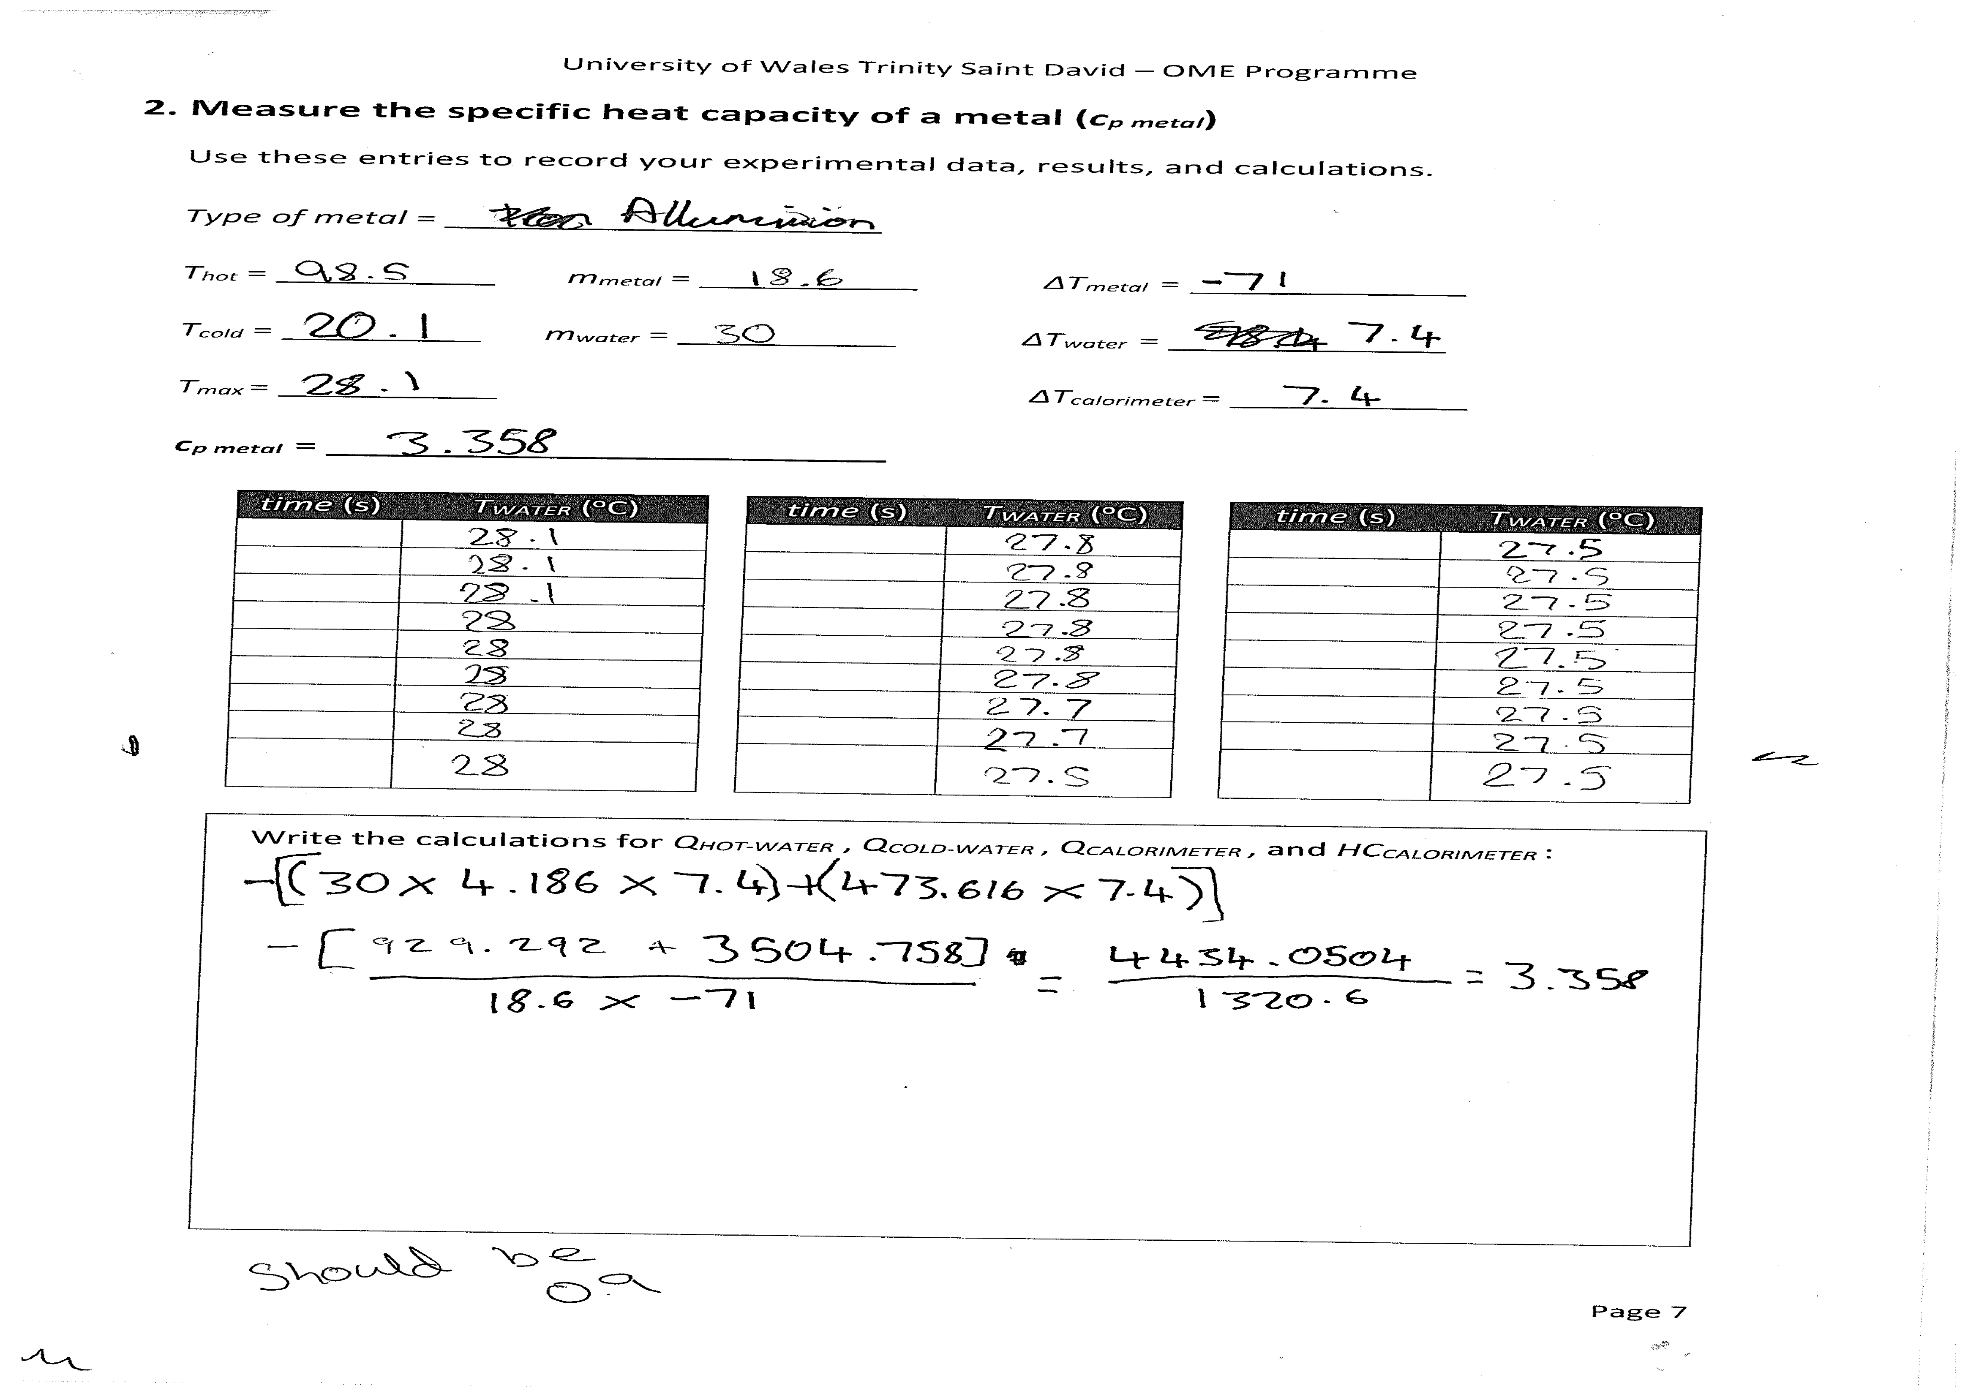
Table 2 - specific heat capacity of metal
The second part of this experiment allows the learner to work out the specific heat of the metal used. The results include 10 second time stamps where the temperature was recorded, this can been seen from going 28.1 degrees celcius to 27.5 degrees celcius. This indicates that the temperature decreases overtime as the heat gets dispersed to the surroundings. The readings get stopped once the temperature hits the equal equilibrium and the temperature stays the same.

Section 3 – Discussion
The first part of the experiment was identifying which metal that was being tested, this was completed visually and from weight. After a discussion with all the learning technicians it was identified to be aluminium. On the completion of the thermochemistry calorimetry of the metal, results were calculated, and the specific heat capacity of the aluminium was 3.358 j/kg degrees Celsius. The results gathered seemed to be a higher number than expected, to investigate this further research of other thermochemistry calorimetry of aluminium was looked at. From the research done one source stated that the specific heat of the aluminium should be 0.9 j/kg degrees Celsius. [6] Another source had a similar result for the specific heat of aluminium being 0.921096 j/kg degrees Celsius. [7] From these results it was determined that some errors had occurred with the experiment that was completed.
The experimental errors that could have occurred would be human error. One of these is the amount of time the metal was heating for, and it wouldn’t have reached the full heating capacity. This would have occurred as the thermometer was only in contact with the water, this meant that the aluminium block could have not been at its heat capacity. This would cause the temperature to be lower than it should have been giving the learner a different result. To avoid this heating the metal for longer and measuring the actual temperature of the block would allow for a closer result of what was expected. Another error was the amount of time taken from transporting the metal from the heating area to the calorimeter. The transportation process was difficult and takes the metal away from the heat and no readings were able to take place in this process, this allowed for the heat to be transferred to the area and not be accounted for. This meant that the learner may have lost too much heat and therefore the rise of temperature in the calorimeter was missed. To avoid this, it would be important to keep the heating station and the calorimeter closer together as this limits the time the metal is out. When completing this part of the experiment there was a difficulty in picking up and moving the metal, this resulted in it taking multiple attempts to transport which increased the time. To avoid this different equipment could be used to make this part of the experiment more effective.
Ordnance munitions and explosives use thermochemistry to work, chemical reactions take place and detonation occurs. One way that thermochemistry can be seen is in explosives. It works when the critical temperature of an explosive is below its nominal melting point which means it decomposes until a change allows its decomposition rate to increase and this causes the explosive to detonate. [8] This means that before the process of detonation can occur thermochemistry is needed and the change in temperature allows for the explosive to function in the way it should. An example of this is RDX. The explosive RDX is a sensitive explosive and the thermochemistry that occurs is not much, this is because of its properties of six nitrogen atoms and how they can transfer the heat energy. [9] The minimum ignition energy of RDX increases from 20mJ to 55mJ. This means that the thermochemistry of the explosive happens quickly with minimal heat energy needed. [10]

Section 4 – Conclusion
To conclude the thermochemistry calorimetry experiment was completed and results were obtained, however the results were not accurate to the research completed. This meant that there were flaws in the completion of the work and reasons for this have been identified. This meant that the hypothesis given was not what was expected to be seen. To agree with the hypothesis the experiment must be completed again with the changes to get an accurate result of the specific heat of the aluminium. Before doing the experiment again it will be important to research how other technicians have completed this experiment and using their methods as this could allow for more accurate results to be attained.

Section 5 – References
[1] University of North Georgia, “Thermochemistry,” 2015. Accessed: Oct. 17, 2024. [Online]. Available: https://web.ung.edu/media/chemistry/Chapter5/Chapter5-Thermochemistry.pdf
[2] M. Horn, “Lesson 6: Calorimetry Lab Preview CT-STEM,” ct-stem.northwestern.edu, Jun. 26, 2019. https://ct-stem.northwestern.edu/curriculum/preview/1685/page/2/ (accessed Oct. 21, 2024).
[3] Brainly website “view the calorimetry procedure: a) what data is needed to calculate the enthalpy change for a reaction? b) - brainly.com,” Brainly.com, 2023. https://brainly.com/question/42989248 (accessed Oct. 21, 2024).
[4] E. Gregersen, “Specific Heat | Physics,” Encyclopædia Britannica. Jun. 03, 2014. Accessed: Oct. 21, 2024. [Online]. Available: https://www.britannica.com/science/specific-heat
[5] B. Zohuri, “First Law of Thermodynamics - an Overview | ScienceDirect Topics,” www.sciencedirect.com, 2018. https://www.sciencedirect.com/topics/chemistry/first-law-of-thermodynamics (accessed Oct. 21, 2024).
[6] BBC, “Suggested Practical - Measuring Specific Heat Capacity - How Does Energy Transform matter? - OCR 21st Century - GCSE Combined Science Revision - OCR 21st Century,” BBC Bitesize. https://www.bbc.co.uk/bitesize/guides/zsy6w6f/revision/4 (accessed Oct. 22, 2024).
[7] Engineers Edge, “Specific Heat Capacity of Metals Table Chart,” Engineersedge.com, Jan. 11, 2015. https://www.engineersedge.com/materials/specific_heat_capacity_of_metals_13259.htm (accessed Oct. 22, 2024).
[8] R. N. Rogers, “Thermochemistry of Explosives,” Thermochimica Acta, vol. 11, no. 2, pp. 131–139, Feb. 1975, doi: https://doi.org/10.1016/0040-6031(75)80016-5.
[9] J. B. Miller, “Nuclear Quadrupole Resonance Detection of Explosives,” Counterterrorist Detection Techniques of Explosives, pp. 157–198, 2007, doi: https://doi.org/10.1016/b978-044452204-7/50026-2.
[10] Y. Xia et al., “Investigation into the Ignition Sensitivity and Detonation Kinetics of Al/RDX Energetic Dust,” Case Studies in Thermal Engineering, vol. 60, pp. 104635–104635, Jun. 2024, doi: https://doi.org/10.1016/j.csite.2024.104635.

Section 6 – Appendix

Materials
The materials used for this experiment was two Styrofoam cups (one inside the other), cup lid, a thermometer, stirring rod, Bunsen burner, aluminium block, triangle stand, beaker, measuring cylinder, ionised water, thongs.

Experimental procedure
The first part of the experiment was the measuring the value of heat capacity of the calorimeter. 50mL of water was added to the Styrofoam cups and lid was closed, the thermometer and stirring rod was added to the calorimeter. 50mL of water was then heated in a separate beaker to about 80 degrees Celsius, the water was then cooled to 60 degrees Celsius, and the temperature was taken as T hot. The temperature of the water in calorimeter was then taken and recorded as T cold. The hot water was then added to the calorimeter and mixed thoroughly, once the temperature hit maximum equilibrium it was recorded by T max. Calculate the heat capacity of the calorimeter using equation:
- - Q hot water = Q cold water + Q calorimeter
- Q calorimeter = HC calorimeter X ΔT calorimeter
The second part of the experiment was to measure the specific heat capacity of a metal. Weigh the metal that is being tested and record mass in M metal. The water bath was then set up and the water was heated until boiling, at this point the metal was placed into the water bath and boil for 5 mins, so the metal is the same temperature as the water. 30mL of water was then added to the calorimeter and the temperature of that water was recorded in T cold. The metal would then hit thermal equilibrium and the water temperature was recorded in T hot. Using the thongs the metal was then transferred to the calorimeter. The water was then stirred, and the temperature was recorded every 10 seconds. The temperature is expected to increase at the start and then allow for it to reach a maximum temperature before allowing it to reduce by 2 degrees Celsius. The maximum temperature was recorded in T max. The specific heat of the metal was then calculated using equation:
- M metal X Cp metal X ΔT metal = - (M water X Cp water X ΔT water + HC calorimeter X ΔT calorimeter)

