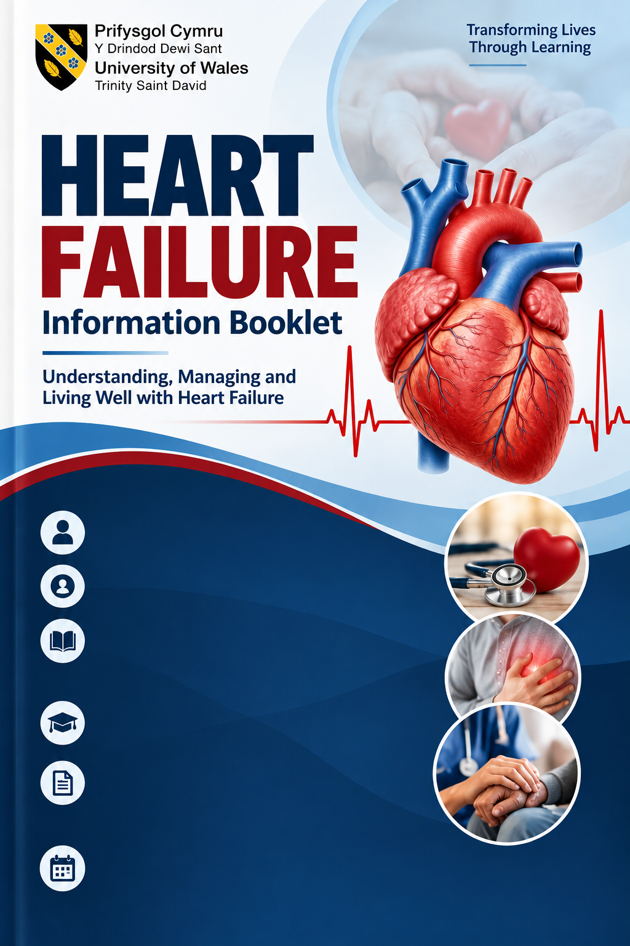
Student’s Name:
Ume Zainab Shah
Student’s Number:
2127507
Module:
LCHS7003
Community Care and Management of Longer-term Conditions
Lecturer: Dr. Aishat Bakre
Component 1
Information Booklet of Long-term Condition Management

Contents
1. Understanding Heart Failure 1
2. How Common Is Heart Failure? 2
3. What Causes Heart Failure and Who Is at Risk? 3
Modifiable and Non-Modifiable Risk Factors 3
4. How Does Heart Failure Affect People? 4
Physical Impacts 4
Psychological and Emotional Impacts 4
Social and Financial Impacts 4
Impact on Families and Carers 5
6. Treatment and Management in the NHS 5
Medicines 6
Medical Devices and Specialist Treatment 6
Rehabilitation and Self-Management 6
Coordinated and Person-Centred Care 6
7. Models for Better Long-Term Care 7
UK Model: NHS Comprehensive Model of Personalised Care 7
International Model: WHO Integrated People-Centred Health Services 9
Critical Comparison 9
8. Policy and Current Healthcare Priorities 9
Health Inequalities and Local Care 10
9. Living Well & Self-Management 10
Everyday Self-Management 11
Emotional Wellbeing and Support 11
Person-Centred Care 12
10. Recommendations & Looking Forward 12
End-of-Life Care and Advance Planning 13
11. Conclusion / Key Messages 13
Reference : 14

1. Understanding Heart Failure
Heart failure is a long-term condition in which the heart cannot pump blood effectively enough to meet the body's needs.
This does not mean the heart has stopped working.

Instead, the heart becomes too weak or stiff to circulate blood properly, affecting the delivery of oxygen and nutrients to the body's organs (NHS, n.d.; McDonagh et al., 2021).
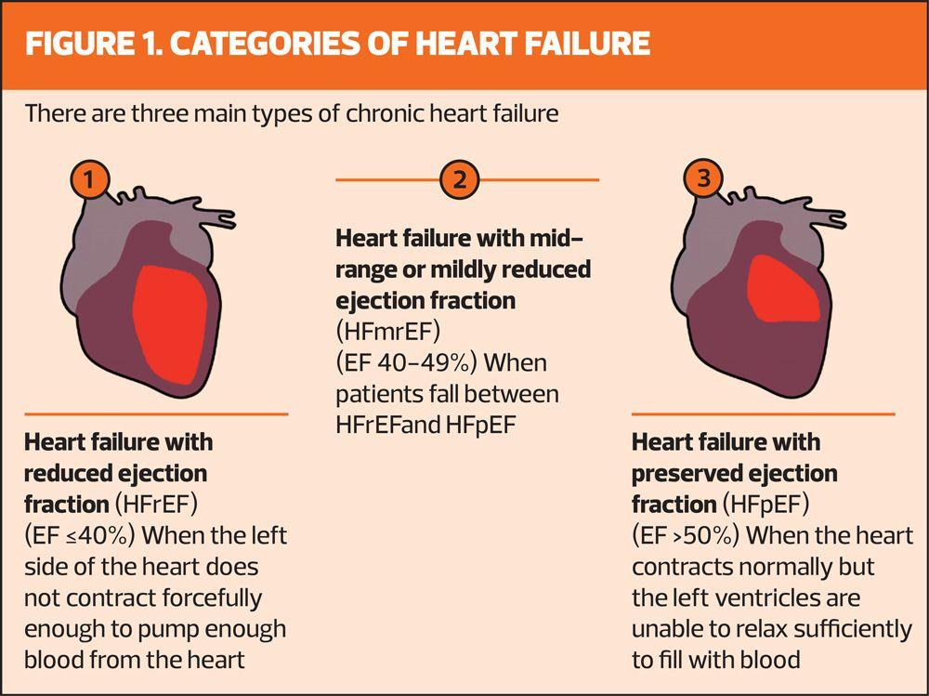
Heart failure may develop gradually or appear suddenly. Common symptoms include breathlessness, tiredness, swollen ankles and difficulty completing everyday activities. Some people also experience coughing, dizziness or breathlessness when lying down. However, these symptoms can occur with other conditions, meaning further medical tests are needed to confirm the diagnosis (NHS, n.d.; NICE, 2018).
Figure 1:Categories of heart failure based on ejection fraction (Source: Haws and Nuttall, 2024).
There are different types of heart failure. Heart failure with reduced ejection fraction (HFrEF) occurs when the heart's main pumping chamber contracts poorly. Heart failure with preserved ejection fraction (HFpEF) occurs when the heart has difficulty filling properly, despite having a relatively normal pumping percentage. This distinction is important because treatment effectiveness differs between the two types. For HFrEF, NICE recommends four

main medicines that can improve survival and reduce hospital admissions. For HFpEF, NICE recommends considering SGLT2 inhibitors and mineralocorticoid receptor antagonists, although the evidence for reducing deaths is less certain. However, treatment decisions must also consider side effects, kidney function and individual needs. Therefore, accurate diagnosis is essential to provide effective, person-centred care (NICE, 2018, updated 2025).
Common causes include coronary heart disease, high blood pressure, damaged heart valves and heart muscle disease. Although heart failure becomes more common with age, it can affect younger adults too. Early diagnosis and appropriate treatment can reduce symptoms and improve quality of life (NHS, n.d.; NICE, 2018).
Heart failure is usually a lifelong condition, but its effects vary considerably between individuals. Some people remain stable for years, while others experience repeated hospital admissions. Therefore, treatment should not focus only on heart function. It must also consider emotional wellbeing, independence and personal circumstances. This supports a person-centred approach rather than treating every patient in the same way (McDonagh et al., 2021; Heidenreich et al., 2022).

2. How Common Is Heart Failure?
Heart failure is a major public health problem affecting millions of people worldwide. Shahim et al. (2023) estimated that approximately 64 million people were living with heart failure globally. However, a more recent analysis by Baudry et al. (2025) estimated 55.4 million people with left-sided heart failure in 2021. These figures differ partly because researchers use different definitions and methods. This highlights the difficulty of measuring the true global burden.
Heart failure is more common among older adults, although younger people can also develop the condition. The number of people living with heart failure is increasing because populations are ageing and more people survive heart attacks and other cardiovascular diseases. However, limited healthcare data in some countries may lead to underestimation (Shahim et al., 2023).

In the UK, the British Heart Foundation (2025) reported that more than one million people were living with heart failure.

The British Society for Heart Failure (n.d.) also estimates approximately 200,000 new diagnoses each year. These figures show the growing need for early diagnosis, specialist treatment and ongoing community support.
Heart failure also creates considerable pressure on NHS services through hospital admissions, long-term medication and regular monitoring. A large UK study involving more than 233,000 patients highlighted the continuing challenges of hospital readmissions and poor outcomes, particularly among people with additional long-term conditions (British Heart Foundation Data Science Centre, 2025).
Nevertheless, prevalence figures alone cannot fully explain the impact of heart failure. They do not show differences in disease severity, quality of life or access to treatment. Therefore, healthcare planning should consider both the number of affected people and their individual needs. Improving early diagnosis, coordinated care and access to specialist services may help reduce avoidable complications and healthcare inequalities.

3. What Causes Heart Failure and Who Is at Risk?
Heart failure develops when the heart muscle becomes damaged, weakened or too stiff to pump blood effectively. It is usually caused by another health condition rather than occurring on its own. The most common causes include coronary heart disease, high blood pressure, heart valve disease and cardiomyopathy (NICE, 2018; McDonagh et al., 2021).
Coronary heart disease reduces blood supply to the heart muscle, while a heart attack can cause permanent damage. High blood pressure makes the heart work harder and may gradually weaken it. Diabetes, obesity and irregular heart rhythms, particularly atrial fibrillation, can also increase the risk of developing heart failure (Heidenreich et al., 2022).

However, effective prevention requires both personal health management and accessible healthcare services, rather than placing responsibility entirely on individuals.

Modifiable and Non-Modifiable Risk Factors
Modifiable risk factors include smoking, physical inactivity, obesity, unhealthy eating and excessive alcohol consumption. Managing blood pressure, diabetes and cholesterol can also reduce cardiovascular risk. However, lifestyle changes cannot prevent every case because some causes are genetic or linked to other illnesses (Heidenreich et al., 2022).
Non-modifiable risk factors include increasing age, inherited heart muscle conditions and family history. Heart failure becomes more common in older adults, although it can affect younger people. Biological sex also influences the patterns and types of heart failure experienced (McDonagh et al., 2021).
Importantly, risk factors do not affect everyone equally. People experiencing poverty may face greater difficulties accessing healthy food, preventive healthcare and timely treatment. Therefore, prevention should not focus only on individual lifestyle choices. Healthcare services must also address wider social inequalities and improve access to early diagnosis and support (WHO, 2023).

4. How Does Heart Failure Affect People?
Heart failure affects more than the heart. It can influence a person's physical health, emotional wellbeing, relationships, independence and everyday life. The effects vary depending on the severity of the condition, other health problems and the support available (McDonagh et al., 2021).

Physical Impacts
People with heart failure commonly experience breathlessness, extreme tiredness, swollen legs and reduced physical strength. These symptoms can make everyday activities, such as walking, shopping, cooking and climbing stairs, difficult. Severe symptoms may also disturb sleep and increase the risk of hospital admission (NHS, n.d.; NICE, 2018).
Research links heart failure symptoms with poorer quality of life. However, clinical measurements do not always reflect patients' experiences. A recent study found only moderate agreement between clinicians' symptom assessments and patients' reported quality of life (van der Meer et al., 2026). This suggests that relying on medical measurements alone may overlook physical and social difficulties. Therefore, patient-reported outcomes should also inform personalised care.

Psychological and Emotional Impacts
Living with heart failure can cause anxiety, depression, fear and uncertainty about the future. Some patients worry about worsening symptoms, repeated hospital admissions or becoming dependent on others. Depression is also associated with poorer treatment adherence and quality of life (Celano et al., 2018).
Celano et al. (2018) linked depression and anxiety with poorer treatment adherence and health outcomes. However, their review found limited evidence for some psychological and medication-based interventions, although cognitive behavioural therapy showed benefits for mental health. This suggests that recognising emotional distress is essential, but not every intervention is equally effective. Therefore, psychological care should be personalised and its outcomes regularly reviewed.

Social and Financial Impacts
Heart failure can limit employment, social activities and independence. People may struggle to continue working because of tiredness, frequent appointments or unpredictable symptoms. Reduced income and additional living costs can create financial pressure, particularly for those already experiencing disadvantage (British Heart Foundation, 2025).
Social isolation may result from breathlessness, reduced mobility and fear of worsening symptoms. However, physical limitations alone do not explain patients' experiences. Research suggests that psychological wellbeing also influences daily functioning and treatment adherence (Celano et al., 2018). This highlights the interaction between physical, emotional and social difficulties. Therefore, community support should address individual circumstances rather than focusing only on disease severity.

Impact on Families and Carers
Heart failure affects not only patients but also their families and carers. As the condition progresses, patients may need support with daily activities, medication, hospital appointments and emotional wellbeing. Family members often provide this care without formal training, which can increase their responsibilities and affect their quality of life (Kitko et al., 2020).
Emotional impacts are particularly important. Carers may experience anxiety, stress and uncertainty because heart failure symptoms can worsen unexpectedly. Research by Kitko et al. (2020) highlights the significant emotional and practical demands of family caregiving. However, carers' experiences differ depending on the patient's condition, their relationship and the support available.
Financial and social pressures can also develop. Some carers reduce their working hours or leave employment to provide care, affecting household income. Caring responsibilities may limit social activities, personal relationships and opportunities for rest. The European Society of Cardiology emphasises the importance of involving families in care planning while recognising their individual support needs (McDonagh et al., 2021).
Although family support can improve medication management and patients' confidence, relying heavily on unpaid carers may create additional inequalities. Patients without family support may struggle to manage their condition, while carers with existing health problems may become overwhelmed (Kitko et al., 2020).
Therefore, healthcare professionals should assess carers' needs, provide clear information and involve families in decisions with the patient's consent. Access to psychological support, carers' assessments and respite services may reduce pressure and improve wellbeing.

Effective heart failure management must support both patients and the people caring for them.

6. Treatment and Management in the NHS
Heart failure cannot always be cured, but NHS treatment can control symptoms, improve quality of life and reduce hospital admissions. Treatment depends on the type and severity of heart failure, other medical conditions and the patient's preferences. NICE recommends a combination of medication, specialist monitoring, lifestyle support and, where appropriate, medical devices (NICE, 2018).

Medicines
For heart failure with reduced ejection fraction (HFrEF), recommended medicines include ACE inhibitors or angiotensin receptor–neprilysin inhibitors (ARNIs), beta-blockers, mineralocorticoid receptor antagonists (MRAs) and sodium–glucose cotransporter-2 (SGLT2) inhibitors. These treatments can reduce hospital admissions and improve survival (McDonagh et al., 2021; Heidenreich et al., 2022).
Diuretics, commonly called water tablets, help remove excess fluid and relieve breathlessness and swelling. However, medicines can cause side effects, including low blood pressure, dizziness and changes in kidney function. Therefore, regular blood tests and medication reviews are essential.

Treatment should be adjusted to individual needs rather than following the same approach for everyone (NICE, 2018).

Medical Devices and Specialist Treatment
Some patients may benefit from implantable cardioverter defibrillators (ICDs), which treat dangerous heart rhythms, or cardiac resynchronisation therapy (CRT), which helps the heart pump more effectively. In severe cases, specialist teams may consider mechanical heart support or transplantation (McDonagh et al., 2021).
Although these treatments can improve outcomes, they are not suitable for everyone. Decisions must consider expected benefits, complications, other illnesses and patient preferences (Heidenreich et al., 2022).

Rehabilitation and Self-Management
The NHS also provides specialist heart failure services and cardiac rehabilitation, including supervised exercise, education and emotional support (NHS England, 2025). Patients are encouraged to take medicines regularly, remain physically active within their abilities, stop smoking and recognise worsening symptoms.
However, self-management can be difficult for people with limited health knowledge, financial difficulties or reduced mobility. Simply giving advice may not be enough. Individualised education and accessible community support are therefore important (McDonagh et al., 2021).

Coordinated and Person-Centred Care
Effective management requires cooperation between GPs, cardiologists, specialist nurses, pharmacists and community services. Regular reviews help identify complications and adjust treatment.
Nevertheless, access to specialist services and rehabilitation may vary between areas. This can create inequalities in outcomes. NHS care should therefore combine evidence-based treatment with shared decision-making, psychological support and coordinated follow-up. For patients with advanced heart failure, palliative care can also help manage distressing symptoms and support future care planning (NICE, 2018; McDonagh et al., 2021).

7. Models for Better Long-Term Care
Managing heart failure requires more than medicines. Patients often need ongoing support from different healthcare professionals. Two useful approaches are the NHS Comprehensive Model of Personalised Care in the UK and the World Health Organization (WHO) Framework on Integrated, People-Centred Health Services internationally.

UK Model: NHS Comprehensive Model of Personalised Care
The NHS model encourages patients to take an active role in decisions about their treatment. It includes shared decision-making, personalised care planning, supported self-management and social prescribing (NHS England, 2019).


Figure 2:The six components of personalised care (Source: North East London Cancer Alliance, n.d.).

For heart failure patients, this may involve agreeing treatment goals with specialist nurses, learning to recognise worsening symptoms and receiving support with exercise or emotional wellbeing.
The model's main strength is that care reflects individual needs rather than focusing only on medical symptoms. However, successful delivery depends on staff availability, communication and access to community services. Patients with limited health literacy may also need additional support to participate fully (NHS England, 2019; NICE, 2018).

International Model: WHO Integrated People-Centred Health Services
The WHO framework promotes coordinated care across hospitals, primary care, community services and social care. It emphasises patient participation, prevention and continuity of care (WHO, 2016).
For heart failure, this approach could improve communication between cardiologists, GPs and community nurses, particularly following hospital discharge.
Its strength is recognising that fragmented services can lead to gaps in care. However, implementation may be difficult in healthcare systems with limited funding, workforce shortages or poor information-sharing systems (WHO, 2016).

Critical Comparison
Both models support person-centred care, but they emphasise different priorities. The NHS model focuses more directly on individual choice and self-management, while the WHO framework places greater emphasis on coordinating services (WHO, 2016).
For heart failure, combining personalised care planning with coordinated specialist and community services may offer a stronger approach. However, improvements should be measured through patient experiences, treatment adherence, avoidable hospital admissions and quality of life, rather than assuming that adopting a framework automatically improves care (NICE, 2018; WHO, 2016).

8. Policy and Current Healthcare Priorities
UK health policies aim to improve heart failure care through earlier diagnosis, better treatment and stronger community services (NHS England, 2023). These priorities are important because heart failure requires long-term monitoring and can lead to repeated hospital admissions.
National Policies and NHS Priorities
The NHS Long Term Plan identifies cardiovascular disease as a major priority and promotes prevention, early detection and improved treatment (NHS England, 2019). Similarly, NICE guideline NG106 provides evidence-based recommendations for diagnosing and managing chronic heart failure, including specialist assessment, medication and follow-up (NICE, 2018).
The NHS 10 Year Health Plan for England places greater emphasis on moving care from hospitals into communities, preventing illness and using digital technology (Department of Health and Social Care, 2025). For heart failure patients, these priorities could support earlier intervention and more convenient monitoring.

However, policy ambitions do not automatically improve outcomes. Their success depends on sufficient staffing, funding and effective coordination between services.

Health Inequalities and Local Care
NHS England's Core20PLUS5 approach aims to reduce healthcare inequalities, including those affecting cardiovascular disease (NHS England, 2023). This is relevant because people living in disadvantaged communities may experience barriers to timely diagnosis and specialist treatment.
At local level, Integrated Care Systems (ICSs) bring together NHS organisations, local authorities and community partners to coordinate services (NHS England, 2022).
A local example is the community heart failure service launched at Washwood Heath Health and Wellbeing Centre in Birmingham in February 2026. The service provides routine appointments and monitoring closer to patients' homes, with specialist heart failure nurses working alongside community and primary care teams (NHS Birmingham and Solihull ICB, 2026). This demonstrates how national priorities for integrated community care are being applied locally. However, the service's long-term impact on hospital admissions, patient satisfaction and healthcare inequalities still needs evaluation. Access may also remain unequal for patients living further away or experiencing transport difficulties (NHS Birmingham and Solihull ICB, 2026).
However, differences in local resources may lead to unequal access to specialist heart failure nurses and rehabilitation.
Overall, UK policies provide a strong framework for improving heart failure management. Nevertheless, their effectiveness should be assessed through measurable outcomes, including earlier diagnosis, equitable access, fewer avoidable hospital admissions and better patient experiences, rather than policy commitments alone.

9. Living Well & Self-Management
Living well with heart failure involves managing symptoms, following treatment and maintaining independence. Self-management helps patients recognise changes in their health and make informed decisions. However, support should reflect individual abilities, preferences and circumstances (NICE, 2018).

Everyday Self-Management
Patients should take prescribed medicines regularly, attend medical reviews and remain physically active within their abilities. Monitoring weight, swelling and breathlessness may help identify fluid retention or worsening symptoms.
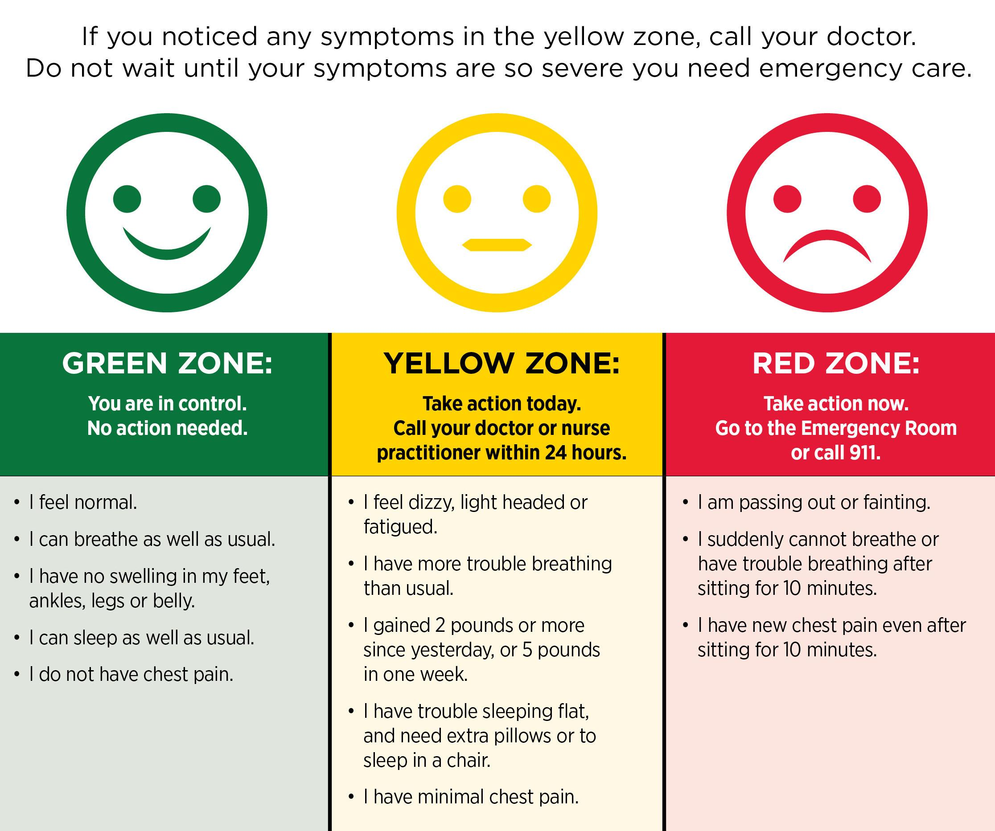
Figure 3: Heart Failure Warning Signs – Green, Yellow and Red Zones (University of Maryland Medical System (2022).

Patients should follow personalised advice about salt and fluid intake rather than making unnecessary restrictions (McDonagh et al., 2021).
Cardiac rehabilitation can improve physical fitness and confidence. However, participation may be limited by transport difficulties, disability or poor access to services. Offering flexible community-based and home-based programmes may improve accessibility (NICE, 2018).

Emotional Wellbeing and Support
Heart failure can cause anxiety, depression and uncertainty. Emotional support, family involvement and patient education can help individuals cope with these challenges. Nevertheless, involving relatives should depend on patient consent and carers' capacity (Kitko et al., 2020).
Digital monitoring and telephone consultations may improve access to ongoing support. However, these approaches may exclude people with limited digital skills or internet access (McDonagh et al., 2021).

Person-Centred Care
Effective self-management requires shared decision-making between patients and healthcare professionals. Individual care plans should include treatment goals, warning signs and clear instructions about seeking help.

Overall, self-management can improve confidence and quality of life, but responsibility should not rest entirely with patients.

Accessible NHS services, regular follow-up and coordinated professional support remain essential (NICE, 2018).

10. Recommendations & Looking Forward
Improving heart failure care requires earlier diagnosis, effective treatment and better coordination between NHS services. The following recommendations could improve patient outcomes and quality of life.
Early diagnosis and treatment: GPs should have timely access to diagnostic tests and specialist heart failure teams. Earlier identification may reduce complications, although improved diagnosis must be supported by sufficient NHS resources (NICE, 2018).
Better coordinated care: Hospitals, GPs, specialist nurses and community services should share information and provide clear follow-up plans. This may reduce gaps in care, particularly after hospital discharge (McDonagh et al., 2021).
Person-centred self-management: Patients should receive understandable information, personalised care plans and support with medicines, physical activity and recognising worsening symptoms. However, digital services must not exclude people with limited technology access (NHS England, 2019a).
Support for families and carers: Healthcare professionals should assess carers' needs and offer emotional, practical and social support (Kitko et al., 2020).
Future priorities: NHS services should improve equitable access to cardiac rehabilitation, psychological support and palliative care when appropriate. Progress should be measured through patient experiences, quality of life and avoidable hospital admissions, rather than service targets alone (NICE, 2018; WHO, 2016).

End-of-Life Care and Advance Planning
For patients with advanced heart failure, palliative care can help manage breathlessness, pain and emotional distress. NICE (2018) recommends assessing palliative care needs when symptoms worsen despite specialist treatment. Advance care planning allows patients to discuss future treatment, personal wishes and preferred place of care (NICE, 2019). Families should be involved with the patient's consent. However, heart failure can worsen unpredictably, making end-of-life discussions difficult. Therefore, healthcare professionals should review care plans regularly and provide sensitive, coordinated support. This promotes dignity, patient choice and quality of life rather than focusing only on extending survival.

11. Conclusion / Key Messages
Heart failure is a serious long-term condition affecting physical health, emotional wellbeing and everyday life. Although modern treatments can improve survival and quality of life, patients may still experience difficulties accessing specialist care and managing symptoms (McDonagh et al., 2021).
Effective management requires early diagnosis, appropriate medication, regular monitoring and coordinated NHS services.

However, medical treatment alone is insufficient. Person-centred care must also address psychological needs, social inequalities and family support (NICE, 2018).

Looking forward, improving access to rehabilitation, self-management education and community services is essential. Success should be measured through better patient experiences, improved quality of life and fewer avoidable hospital admissions.

Reference :
Baudry, G. et al. (2025) ‘Global heart failure epidemiology versus enrolment in pivotal trials: A formidable mismatch’, European Journal of Heart Failure, 27(7), pp. 1237–1241. Available at: https://doi.org/10.1002/ejhf.3707
British Heart Foundation (2025) Heart & Circulatory Disease Statistics 2025. Available at: https://www.bhf.org.uk/what-we-do/our-research/heart-statistics/heart-statistics-publications/cardiovascular-disease-statistics-2025 (Accessed: 9 October 2026).
British Heart Foundation (2025) Heart & circulatory disease statistics 2025. Available at: https://www.bhf.org.uk/what-we-do/our-research/heart-statistics (Accessed: 15 October 2026).
British Heart Foundation Data Science Centre (2025) Nationwide study reveals new data-driven insights for heart failure patients. Available at: https://bhfdatasciencecentre.org/news-and-events/nationwide-study-reveals-new-data-driven-insights-for-heart-failure-patients/ (Accessed: 11 October 2026).
British Society for Heart Failure (n.d.) 25in25. Available at: https://www.bsh.org.uk/25in25 (Accessed: 17 October 2026).
Celano, C.M. et al. (2018) ‘Depression and anxiety in heart failure: a review’, Harvard Review of Psychiatry, 26(4), pp. 175–184. Available at: https://doi.org/10.1097/HRP.0000000000000162
Department of Health and Social Care (2025) Fit for the future: 10 Year Health Plan for England. Available at: https://www.gov.uk/government/publications/10-year-health-plan-for-england-fit-for-the-future (Accessed: 14 October 2026).
Haws, J. and Nuttall, M. (2024) ‘Practice Nurse bite-sized learning: Understanding heart failure management’, Practice Nurse, 54(5), pp. 10–11. Available at: https://practicenurse.co.uk/articles/cardiovascular-disease/practice-nurse-bite-sized-learning-understanding-heart-failure-management
Heidenreich, P.A. et al. (2022) ‘2022 AHA/ACC/HFSA guideline for the management of heart failure: a report of the American College of Cardiology/American Heart Association Joint Committee on Clinical Practice Guidelines’, Circulation, 145(18), pp. e895–e1032. Available at : https://doi.org/10.1161/CIR.0000000000001063
Kitko, L. et al. (2020) ‘Family caregiving for individuals with heart failure: a scientific statement from the American Heart Association’, Circulation, 141(22), pp. e864–e878. Available at: https://doi.org/10.1161/CIR.0000000000000768
McDonagh, T.A. et al. (2021) ‘2021 ESC guidelines for the diagnosis and treatment of acute and chronic heart failure’, European Heart Journal, 42(36), pp. 3599–3726. Available at: https://doi.org/10.1093/eurheartj/ehab368
Miles, L.M., Luckham, K., Mills, J., Mindham, R., Taylor, C.J. and Piper, S. (2026) ‘Chronic heart failure in adults: diagnosis and management—summary of updated NICE guidance’, BMJ, 392, s266. Available at: https://doi.org/10.1136/bmj.s266
National Institute for Health and Care Excellence (NICE) (2018, updated 2025) Chronic heart failure in adults: diagnosis and management. NICE guideline NG106. Available at: https://www.nice.org.uk/guidance/ng106 (Accessed: 9 October 2026).
NHS (n.d.) Heart failure. Available at: https://www.nhs.uk/conditions/heart-failure/ (Accessed: 15 October 2026).
NHS Birmingham and Solihull Integrated Care Board (2026) Community Heart Failure Service Launches in Washwood Heath. Available at: https://www.birminghamsolihull.icb.nhs.uk/news-and-events/news/community-heart-failure-service-launches-washwood-heath (Accessed: 11 October 2026).
NHS England (2019) NHS Long Term Plan to tackle major killer conditions and save up to half a million lives. Available at: https://www.england.nhs.uk/2019/01/long-term-plan/ (Accessed: 17 October 2026).
NHS England (2019) Universal personalised care: implementing the comprehensive model. Available at: https://www.england.nhs.uk/wp-content/uploads/2019/01/universal-personalised-care-easy-read.pdf (Accessed: 10 October 2026).
NHS England (2022) Cardiovascular disease (CVD) prevention recovery: how the NHS is working to restore diagnosis and management of cardiovascular disease. Available at: https://www.england.nhs.uk/publication/cardiovascular-disease-prevention/ (Accessed: 14 October 2026).
NHS England (2022) What is integrated care? Available at: https://www.england.nhs.uk/integratedcare/what-is-integrated-care/ (Accessed: 8 October 2026).
NHS England (2023) Core20PLUS5 (adults) – an approach to reducing healthcare inequalities. Available at: https://www.england.nhs.uk/about/equality/equality-hub/national-healthcare-inequalities-improvement-programme/core20plus5/ (Accessed: 16 October 2026).
NHS England (2025) Commissioning standards for cardiovascular rehabilitation. Available at: https://www.england.nhs.uk/long-read/commissioning-standards-for-cardiovascular-rehabilitation/ (Accessed: 13 October 2026).
NICE (2019) End of life care for adults: service delivery. NICE guideline NG142. Available at: https://www.nice.org.uk/guidance/ng142 (Accessed: 12 October 2026).
North East London Cancer Alliance (n.d.) Personalised Stratified Follow-up appointments. Available at: https://www.nelcanceralliance.nhs.uk/personalised-stratified-follow-appointments (Accessed: 9 October 2026).
Shahim, B., Kapelios, C.J., Savarese, G. and Lund, L.H. (2023) ‘Global public health burden of heart failure: An updated review’, Cardiac Failure Review, 9, e11. Available at: https://doi.org/10.15420/cfr.2023.05
University of Maryland Medical System (2022) Heart disease warning signs: When to call your doctor. Available at: https://health.umms.org/heart-care/heart-failure-warning-signs/ (Accessed: 17 October 2026).
van de Pol, J.A.A., Hafkamp, F.J., van der Voort, P.H., Post, J.C., de Jong, S.F.A.M.S., Monroy, M., Eijsbouts, S.C.M., Spee, R.F., van de Ven, A.R.T. and Klop, B. (2026) ‘Clinician-assessed NYHA and EHRA symptom classifications only moderately reflect patient-reported quality of life in heart failure and atrial fibrillation’, Netherlands Heart Journal, 34(7–8), pp. 274–282. Available at: https://doi.org/10.1007/s12471-026-02051-9
World Health Organization (WHO) (2016) Framework on integrated, people-centred health services. Geneva: WHO. Available at: https://apps.who.int/gb/ebwha/pdf_files/wha69/a69_39-en.pdf (Accessed: 10 October 2026).
World Health Organization (WHO) (2016) World Health Assembly adopts Framework on Integrated People-Centred Health Services. Available at: https://www.who.int/news/item/28-05-2016-world-health-assembly-adopts-framework-on-integrated-people-centred-health-services (Accessed: 14 October 2026).
World Health Organization (WHO) (2023) The contribution of behavioural science to addressing the social and wider determinants of health: Evidence review. Available at: https://www.who.int/publications/i/item/9789240072473 (Accessed: 8 October 2026).
World Health Organization (WHO) (2025) Cardiovascular diseases (CVDs). Available at: https://www.who.int/en/news-room/fact-sheets/detail/cardiovascular-diseases-%28cvds%29 (Accessed: 8 October 2026).

