
University of Wales Trinity Saint David
School of Computing
16/01/2023/ACCA7002
Data Storage Investigation
Database Systems
By Kieran John Ayres

Table of Contents
Table of Contents 2
Table of Figures 3
Abstract 4
1. Introduction 5
2. NoSQL Databases 6
2.1. Document-Based 7
1.1. Graph-Based 9
1.2. Key-Value Based 9
1.3. Wide-Column Based 10
2. When to utilise NoSQL Vs. Relational Database Approach 11
3. Justification of Database Design 13
3.1. Relational 13
3.2. NoSQL Database 13
4. Conclusion 14
References 15
Appendix 18

Table of Figures
Figure 1 - Sharding Diagram in MongoDB [8]. 7
Figure 2 - Terms in NoSQL and SQL that mean similar things [12] 8
Figure 3 - Key Similarities [10]. 10
Figure 4 - Final Tables From the Brief 13
Figure 5 - Embedded Data Model Design 14

Abstract
A database is a fundamentally important technology to any business that are using technology to manage their organisation. A database is a storage system which allows someone to store valuable data in sections [1]. This keeps it organised and furthermore, with the correct enhancements, would keep it protected. While relational databases offer data consistency, NoSQL can offer scalability and better performance [1].

Introduction
The focal point of this assignment is to research and investigate NoSQL databases. This is to understand the best use case scenarios for these. This will critically analyse the different forms of NoSQL databases and compare them to one another. There are various forms, such as Document and key-value. The report will cover what advantages these have in comparison to traditional relational databases and when to use each one. This paper will explore the differences understand which would be better suited for the case study in question, Abertawe Entertainment. It will them justify a design and implementation of the two approaches to make a conclusive recommendation to the organisation.

NoSQL Databases
NoSQL itself is an abbreviation of the term “Not Only SQL” [2], but this is wide term as there is several things encompassed within this, so it also known as a non-relational database [2]. In the technologies’ infancy, it would be accessed via shell scripts, rather than using SQL based commands [2], however it can be identified as a form of database which is widely different to relational types as the way they approach data storage and access is different [3]. These have become increasingly popular in recent years, MongoDB was recognised as the fourth most popular Database technology in 2021 [4] and 2022 [5], further emphasizing it’s rise and overall stability as a chosen Database solution. Generally, research has shown that they are utilised when scalability is a factor to be highly considered in a system’s design, this is because they are stored in a loose but extendable data model which doesn’t require specific declaration before usage [2], scalability enables a business to grow with their application simultaneously and at a time when the increase in technology meaning that applications need to withstand a greater level of interactions, which is why NoSQL may be opted for when mitigating to the cloud as the cloud has higher scalability [6]. Scalability is crucial to successful implementations. Another key theme in NoSQL is sacrificing aspects in favour of higher performance [3]. These reasons emphasise why they are becoming more adopted amongst organisations [1]. There are various NoSQL platforms which users can utilise to implement a database. Some of the commonly used ones are MongoDB, Cassandra and Redis [3]. There are four common types which will be explored in the following sub-chapters, these are:
- Document based.
- Graph based.
- Key-Value based.
- Wide-Column based.

Document-Based
As alluded to previously, NoSQL databases aren’t one form of database. There are several models which can be deployed, depending on an application’s need. Document-based databases are arguably the most popular form of NoSQL to be integrated as solutions [1]. These can be written in JavaScript Object Notation, more commonly known as JSON [7]. A popular Document-based database is MongoDB [8]. In this design, data entries of various structures are stored into a singular data element [2]. These can be distributed across multiple servers, minimalizing dependencies, meaning that they would be stronger, and more scalable [9] [10], specifically in comparison to a relational database [2], as it was found that as relational databases expand, their performance decreases [9]. Certain relational databases, such as MariaDB can only accept small file sizes, whereas MongoDB can accept large file sizes [6]. Partitioning data across multiple servers can also referred to as sharding [11], which MongoDB supports, It shards through automatic load balancers, which partitions equally across servers ensuring higher optimal levels of performance within the database by maximising the available storage space through delegation of workloads [6] [12], which is a form of auto-scaling.
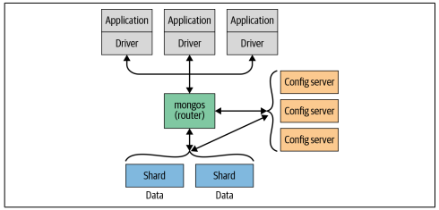
Figure 1 - Sharding Diagram in MongoDB [8].
As the name alludes to, data is stored in the form of documents, and can be grouped into collections of documents [1] [8] [12]. In terms of relational database, collections can be thought of as tables, while documents can be thought of as rows belonging to that table, each entry of data is stored in the form of a Key-Value pair [13]. This enables an implementation to have database tables that associate with one another to be a part of the same collection. Records don’t need to have the same datatype, and they are stored as key-value pairs, so these are varied depending on design and user specific needs [1] [8], this is classified as having a dynamic schema [12]. This differs from a relational database as that has a pre-defined schema which is used to create the database, this is strong to create tables with specific relations to one another [1] [9]. This means that Document-based approaches can manage systems where all content doesn’t necessarily relate, such as an online blog where there are a range of topics [1] [9]. Another advantage to a NoSQL Document-based database like Mongo, is the automatic data replication reduces maintenance downtime, which increases business reputation and enhances customer satisfaction [12].
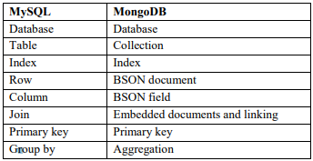
Figure 2 - Terms in NoSQL and SQL that mean similar things [12]
There are different names within MongoDB and SQL databases, the above table shows the names that correspond to the same meaning. Like relational databases, Document-based systems have flexibility to retrieve selections of data, this is useful when analysing a specific set of data [11]. Higher performance is achieved through Indexes, these are like a book’s index, when searching for a particular data entry, the database can access the index, ensuring higher query efficiency [14]. These would be applicable in a library as an Index could be set to represent genres of books. Querying that genre would return all books in that genre.

Graph-Based
Based upon Graph theory [10], Graph databases are a more abstract type as data isn’t only stored but represented in graphs, with edges and nodes [1], as the name suggests. Edges in the graph refer to the connections within the database, while the nodes refer to objects [1] [9]. This one is more abstract in comparison to Document and Column based types. Graph-based is deployed where relationships are essential to how the database would function [9]. These are also scheme less, like Key-Value but not to relational. These are faster than relational databases, as they can form a traversal when they complete queries upon larger datasets, making them performant efficient in comparison [9]. The typical use cases for these databases would be where search speed is imperative to the application, such as in the legal industry. For example, this could be used when performing credit searches on potential loan lenders, as these soft searches usually require efficient checks on someone’s credit history so highly optimal searches would be the ideal solution. The drawback is that Graph databases can’t achieve sharding well. Graph-based types do support sharding, but it is advised not to, whereas the other three types mentioned all auto shard the data [10], which give them increased capabilities. This is something a Document-based solution can do and is a favourable feature when considering choosing a solution.

Key-Value Based
A key-value pair database is another popular adaption of NoSQL, it is a simplistic model [9]. It refers to a non-fixed structured database whereby data is added in the form of key-value pairs. For clarity, these are stored as key, and value [10]. The key is in place as a unique identifier, which is usually a form of string [9], and has a similar role to keys in relational databases, which is to help identify the value in a record [15]. The overarching goal this NoSQL option achieves is accessing data quickly [10] [15]. The key can typically retrieve and post data, more commonly known as get and put. There are lesser known and less able database implementations, such as project Voldemort [16]. This has a limited level of operations which can be performed on the data, these are to add data, retrieve data and delete data [3], this wouldn’t be practical for any large-scale solution that require potential expansion. A more popular and trusted technology to utilise is Redis [10] [15]. The disadvantage of Key-Value databases is that they aren’t as scalable as other NoSQL technologies as the model is simplistic, but it follows the common theme of being efficient in querying data [15]. Like the other types of NoSQL, Key-Value types do not have a schema, this makes it difficult to make custom data views [9]. While being scalable [9] [10], they are not as scalable as other NoSQL types [1] [10]. These would be for smaller scale business with a limited dataset who want to store and access information quickly [1] as they are performant efficient [9] [10].

Wide-Column Based
Column based databases are like relational databases in that they are structured in the form of columns [3] [10]. This results in the design being more organised. They use columns to store data and can grow on demand, emphasising scalability [3] [9]. Cassandra is a popular option that is adopted amongst development teams as a storage solution [3] [9] [10]. Research found that this has a strong performance level [3]. Each row in this type, gets provided with a unique key. Research showed that it can function with large datasets [1]. These types are suited to analytics applications as they access data rapidly [9], similarly to other types. A key theme in NoSQL is high performance, schema flexibility and scalability [10]. It is also worth noting that all databases are different in how they are stored. Wide Column databases, like Document and Key-Value databases, also support sharding, to distribute the application over multiple servers [10]. This provides a richer architecture and increased speed. Something that differentiated between the NoSQL and SQL is that there are usually joins of data completed in SQL databases, whereas there aren’t joins in NoSQL [17].
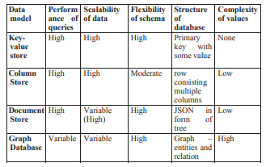
Figure 3 - Key Similarities [10].
To end this section, the above table from a research paper [10] shows the key themes that have been identified in this section. It is effective as it adds further visual clarity to the conclusions made.

When to utilise NoSQL Vs. Relational Database Approach
To conclude on identified areas in the report, there is compelling evidence as to why the NoSQL database should be chosen. It is important to compare, and contrast with the traditional style of relational databases, as SQL was chosen in the top three languages in the Stack Overflow Developer Survey 2021 and 2022 [4] [5]. The two technologies will always coincide with one another, as they have different use cases depending on the system that is being implemented and there is no one definitive solution as they serve different use cases [1].
The design is arguably easier in non-relational as the prior research has shown [6]. The drawback is that there is greater chance of redundant data so precise design is still key to the process, however, MongoDB has a feature which encourages this as it auto replicates data which can be sharded across several servers [8] [12], if one should fail, that data wouldn’t be instantaneously lost. This is advantageous, but not a feature within a relational database, there can be backups made but these aren’t as efficient as having multiple servers which can reproduce that data instantaneously [6] [8]. However, SQL has a solution which is similar, by building a cluster, it could perform in the same way [13], except there is the added integrity of a pre-defined database with a set schema [1] [9], which is an advantage. Ease of development of NoSQL means that solutions are quicker to prototype and develop in comparison to relational which requires more substantial work to implement [15]. NoSQL performance related characteristics would offer reliability to an organisation [10] while enhancing their reputation due to fast query returns [1]. Distributed systems are equalling to be more performant and scalable in the long term [10]. In general, a user would want increased speed when using an application, which is why speed is important, research emphasises the speed of non-relational databases in comparison to relational [1]. A drawback in NoSQL is that security isn’t offered to a high standard [17]. They all share a similar feature to query, where they use CRUD (Create, Read, Update, Delete) operations [10], relational are universally written in SQL which could be argued as more popular, therefore there would be wider community support for [10]. Ultimately, these solution choices do rely on the application. NoSQL can handle growth and changes without needing to redesign the system, it’s quicker to change, so a typical use case for this would be an ever-changing system which requires a dynamic schema, rather than pre-defined, like a social media application would require growth every day, due to the level of data it would need to consume [13]. What type of NoSQL would largely depend on the application too. NoSQL also has use cases for those who are new to building databases as SQL may have a larger learning curve than the languages built to interact with non-relational databases, such as JSON [7]. Newer, private companies may deploy NoSQL as it could be classed by modern. An example of a use case when it would be important to deploy a SQL database, is from a public company, such as the DVLA, they hold public records where integrity, consistency and flexibility is essential so it’s important that they utilise a strong technology to do this. SQL enforces through ACID properties [18] [19]. ACID is an acronym for the words; Atomicity, Consistency, Isolation and Durability [13] [18] [19]. Atomicity, requires all tasks to run, this refers to a transaction failing, if one operation fails, the whole transaction will fail [19], Consistency, as implied, enforces that the system is built the way it is intended and remains that way [19]. This can be enforced through constraints such as primary or foreign keys. Isolation refers that access is limited between the transactions; this improves the performance of the database [19]. Durability refers to the database completing a transaction and not being able to undo it [19]. Having these enforce referential integrity and security to the system, when valuable data, such as personal data is concerned, this is imperative.

Justification of Database Design
This section will outline and briefly justify the design decisions that were made in the implementation process. These are for the relational database (SQL), and the non-relational database (NoSQL).

Relational
Regarding relational databases, the first step is to first build an idea of potential tables, and then to normalise them. For this. it was normalised to 3rd Normal Form (3NF), as this mitigates several risks in the implementation by separating data into necessary tables to minimise dependencies and link through primary and foreign keys [20] [21]. It reduces the chance of data redundancy [20] which would help the performance of the database which is important.
The tables were designed as follows.
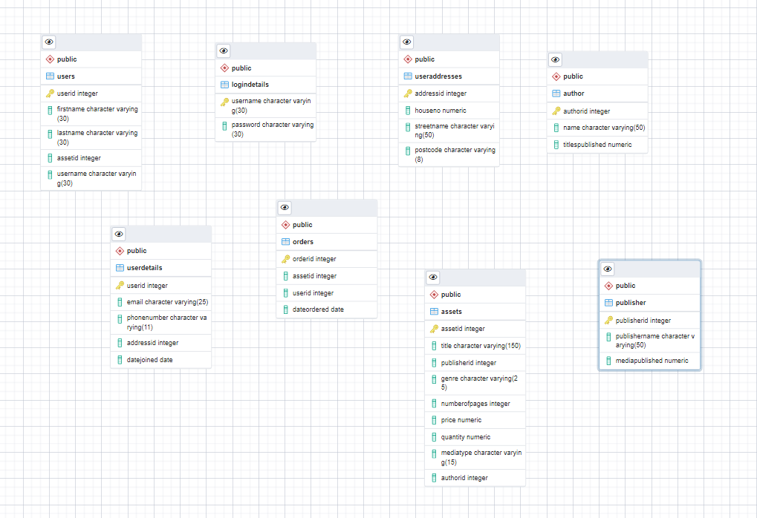
Figure 4 - Final Tables From the Brief

Explaining the relationships
- The user could only have one set of login details - One-to-Many relationship.
The user could have many assets - One-to-Many relationship.
- The user would have one address – One-to-One relationship.
- The user would have one set of details – One-to-Many relationship.
- User could have many orders – One-to-Many relationship.
- The Author can have many assets in the Database – One-to-Many.
- The Address has more than one User – Many-to-Many.
- The asset table can have many authors – Many-to-Many.
- Details would have many users – Many-to-Many.
- Assets would have many orders, while orders could have multiple assets – Many-to-Many.
- Publisher could have many assets – One-to-Many.

The ids are primary and foreign keys, and they are to retain integrity, reduce redundancy in the data, while being there to maintain relationships between the tables.

NoSQL Database
Based on research, the NoSQL type chosen was Document-based, specifically MongoDB. Although relationships aren’t emphasized in NoSQL. The advantage of pre-designing the relational was it builds ideas of what each table, collection in the case of MongoDB [12], to implement. This removes one process from this implementation. Strong design decisions within NoSQL types are to plan a design choice and indexes which will prove effective and efficient.
There were two potential design options that could be completed within MongoDB. The first is embedded design, this refers to a technique used in Mongo to have fewer collections, while storing related entries into the same document [22] [23], rather than writing separate collections. NoSQL doesn’t generally promote relationships, so this method is a way to display relevant data and is considered more natural data flow to having two separate tables [23]. The other method that was thought of was to model it closely after the relational implementation where each table will have the corresponding data which is in the relational database. The way in which these could be connected to extract meaningful information would be through aggregation. These work by grouping data to group together data for a specific use case [12] [24]. Embedded was chosen and here is the example of it below. This was done using a code editor, the SQL statements to create tables, and then annotated to understand where the data could be embedded, this resulted in 2 collections being made to represent all the data with embedded data, the drawback of the implementation was that the embedded documents didn’t have IDs, this would have improved integrity.
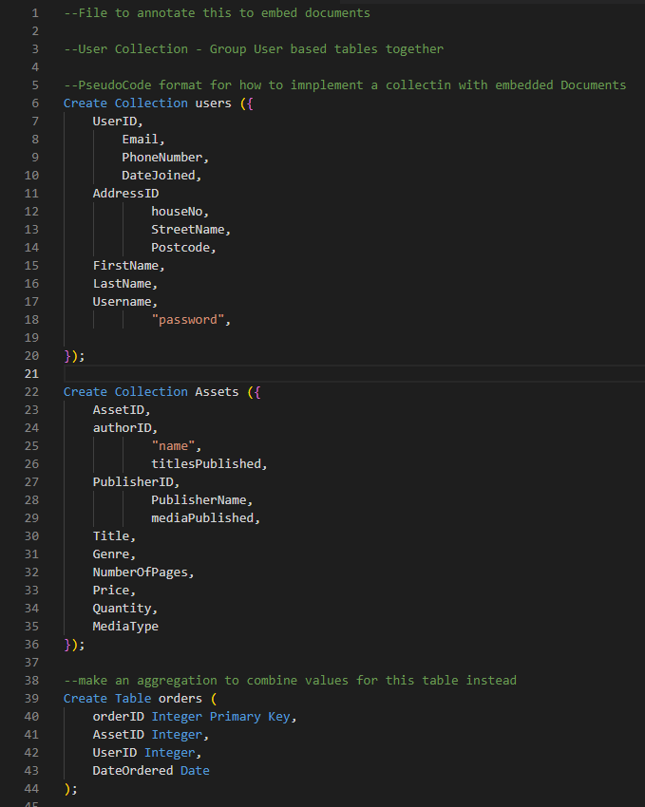
Figure 5 - Embedded Data Model Design
In theory, this design will allow more flexibility while still being scalable, queries tested on the collections were quicker than the queries done in the SQL database. The database was called ‘AbertaweEntertainment’, for both SQL and NoSQL versions.

Conclusion
In conclusion, non-relational databases have been explored, this was to understand the advantages of these, why and when they are used and how they can be a better solution over relational databases in certain use-case scenarios. It then compared the two types of databases to form a conclusion. Once this was completed, two databases were implemented to show the strength of the database. Overall, the relational database was easier to implement, due to greater familiarity with the technology and relationships between tables were easy to implement securely, whereas the NoSQL database presented challenge due to unfamiliarity, but the NoSQL solution was a better solution due to scalability and ease of query so that would be recommended for business expansion. It’s also important to add that the implementations weren’t perfect, there were duplicate primary keys or sequences not working as intended, but this isn’t a reflection of a production application, but a proof of concept. In future practice, these would be improved to reflect that.

References

[1] | T. A. TAHA, “The SQL vs NoSQL Differences and Similarities,” International Journal of Scientific & Engineering Research, vol. 10, no. 8, p. 6, 2019.
[2] | L. J.-j. LI Jun-shan, “Research on NoSQL Database Technology,” in International Conference on Management, Education and Social Science, Guangzhou, 2018.
[3] | B. C. P. C. M. V. J. B. João Ricardo Lourenço, “Choosing the right NoSQL database for the job: a quality attribute evaluation,” Journal of Big Data, vol. N/A, no. N/A, p. 26, 2015.
[4] | S. Overflow, “Stack Overflow Developer Survey,” N/A N/A 2021. [Online]. Available: https://insights.stackoverflow.com/survey/2021#most-popular-technologies-database. [Accessed 16 January 2023].
[5] | S. Overflow, “Stack Overflow Developer Survey,” N/A N/A 2022. [Online]. Available: https://survey.stackoverflow.co/2022/#technology. [Accessed 16 January 2023].
[6] | C. V. N. R. Shivam Kumar Giri, “Research of NOSQL and SQL and Designing a Better Database Schema for Databases,” International Journal of Engineering and Advanced Technology, vol. 8, no. 6, p. 6, 2019.
[7] | A. S. K. Garima Dutt, “Review of JSON Data Interchange Format,” International Journal of Innovative Research in Technology, vol. 3, no. 1, p. 5, 2016.
[8] | E. B. K. C. Shannon Bradshaw, “Introdution,” in MongoDB: The Definitive Guide, N/A, O'Reilly, 2019, p. 1.
[9] | A. P. D. P. Ameya Nayak, “Type of NOSQL Databases and its Comparison with Relational Databases,” International Journal of Applied Information Systems, vol. 5, no. 4, p. 4, 2013.
[10] | S. T. N. P. S. S. U. S. Adity Gupta, “NoSQL Databases: Critical Analysis and Comparison,” in International Conference on Computing and Communication Technologies for Smart Nation, N/A, 2017.
[11] | W. W. S. F. N. R. Felix Gessert, “NoSQL database systems: a survey and decision guidance,” Comput Sci Res Dev, vol. N/A, no. N/A, p. 13, 2016.
[12] | A. Chauhan, “A Review on Various Aspects of MongoDb Databases,” International Journal of Engineering Research and Technology, vol. 8, no. 5, p. 3, 2019.
[13] | M. D. Vatika Sharma, “SQL and NoSQL Databases,” International Journal of Advanced Research in Computer Science and Software Engineering, vol. 2, no. 8, p. 8, 2012.
[14] | E. B. K. C. Shannon Bradshaw, “Introduction to Indexes,” in MongoDB: The Definitive Guide, N/A, O'Reilly, 2019, pp. 75-75.
[15] | J. Pokorný, “Integration of Relational and NoSQL Databases,” Vietnam Journal of Computer Science, vol. 6, no. 4, p. 17, 2019.
[16] | A. G. Adarsh Kumar, “Big Data Database Systems: A Comparative Study,” International Journal of Scientific & Engineering Research, vol. 7, no. 12, p. 6, 2016.
[17] | V. S. M. S. J. Ms. Deepika, “Comparative Study of SQL and NoSQL Databases to evaluate their suitability for Big Data Application,” International Journal of Computer Science and Information Technology Research, vol. 4, no. 2, p. 5, 2016.
[18] | H. P. Douglas Kunda, “A Comparative Study of NoSQL and Relational Database,” ZAMBIA NFORMATION COMMUNICATION TECHNOLOGY JOURNAL, vol. 1, no. 1, p. 5, 2017.
[19] | M. R. K. ,. J. S. ,. S. M. Mr. Keith Machado, “A Comparative Study of ACID and BASE in Database Transaction Processing,” International Journal of Scientific & Engineering Research, vol. 8, no. 5, p. 4, 2017.
[20] | E. EESSAAR, “The Database Normalization Theory and the Theory of Normalized Systems: Finding a Common Ground,” Baltic Journal of Modern Computing , vol. 4, no. 1, p. 30, 2016.
[21] | P. Swathi, “A Study on SQL - RDBMS Concepts and Database Normalization,” Journal of Applied Science and Computations, , vol. 7, no. 8, p. 6, 2020.
[22] | MongoDB, “Embedded Data Models - MongoDB Documentation,” N/A N/A N/A. [Online]. Available: https://www.mongodb.com/docs/manual/core/data-model-design/. [Accessed 19 January 2023].
[23] | E. B. K. C. Shannon Bradshaw, “Chapter 2: Getting Started,” in MongoDB: The Definitive Guide, N/A, O'Reilly, 2019, pp. 19-20.
[24] | MongoDB, “Aggregation Operations - MongoDB Documentation,” N/A N/A N/A. [Online]. Available: https://www.mongodb.com/docs/manual/aggregation/. [Accessed 19 January 2023].
[25] | M. R. W. Mr. Ambrish Kishan, “A Study of Performance NoSQL Databases,” International Journal of Innovative Research in Advanced Engineering, vol. 4, no. 4, p. 5, 2017.
[26] | W3Schools, “SQL Tutorial,” N/A N/A N/A. [Online]. Available: https://www.w3schools.com/sql/. [Accessed 18 January 2023].
[27] | Postgres, “Postgres Documention,” N/A N/A N/A. [Online]. Available: https://www.postgresql.org/docs/. [Accessed 18 January 2023].
[28] | S. M. P. k. P. Biswajeet Sethi, “A Study of NoSQL Database,” International Journal of Engineering Research & Technology, vol. 3, no. 4, p. 5, 2014.

Appendix
Key-Value are used to store sessions, such as saving preferences or a shopping basket
While Column based are used in data warehouses

