

Module name: International Business Concepts

Module code: LCMB7034

Lecturer name: Dr. Jean Wang

Country- New Zealand | Industry- Dairy | Company- Nestlé

Student name: Ayushkumar Sudhirbhai Savaliya

Student ID: 2509580

Word count: 5242 words

Table of Contents

SECTION 1 — INTERNATIONAL BUSINESS REPORT 4
1. Introduction 4
2. Industry and Country Overview 4
2.1 Introduction: Dairy Industry in New Zealand 4
2.2 Size, Scope and Economic Importance 5
2.3 Major Domestic and Multinational Firms 6
3. The Porter's Diamond Model and the Global Competitiveness of the New Zealand Dairy Industry 7
3.1 Factor Conditions 8
3.2 Demand Conditions 9
3.3 Related and Supporting Industries 9
3.4 Firm Strategy, Structure and Rivalry 9
3.5 Government 10
3.6 Chance 10
4. Nestlé in the New Zealand Dairy Industry: Market Attractiveness and Success Factors 10
4.1 Nestlé's Position in the New Zealand Dairy Industry 10
4.2 Political Environment 11
4.3 Economic Environment 12
4.4 Legal and Regulatory Environment 12
4.5 Social and Cultural Environment 13
4.6 Market Attractiveness: Benefits, Costs and Risks 13
4.7 Competitive Forces Affecting Nestlé 15
4.8 Key Success Factors for Nestlé 15
4.9 Overall Strategic Assessment 16
5. Conclusion 17
SECTION 2: REFLECTIVE ACCOUNT WITH THE GIBBS' REFLECTIVE CYCLE 19
2.1 Description 19
2.2 Feelings 19
2.3 Evaluation 19
2.4 Analysis 20
2.5 Conclusion 20
2.6 Action Plan 21
References 22
Appendix 1: Porter’s Diamond Model and the Global Competitiveness of New Zealand Dairy 25

SECTION 1 — INTERNATIONAL BUSINESS REPORT

1. Introduction
Dairy industry is a noteworthy component of the New Zealand nation’s primary sector and it plays an imperative role in its export economy (Ledgard et al., 2020). The industry benefits from a pasture-based farming system, favourable climatical conditions and established production capabilities, enabling this nation to compete strongly in international dairy markets.
Furthermore, Dairy products are exported to more than 130 countries and contribute substantially to national export earnings (OECD, 2024; WorldMetrics, 2026). The industry is highly export-oriented, with Fonterra Co-operative Group, Synlait Milk and Westland/Yili among the major firms operating across different segments of the value chain (Statista, 2025). However, the industry faces increasing environmental pressures relating to greenhouse-gas emissions and water quality (MfE, 2024).
Yet, this report examines the international competitiveness of New Zealand’s dairy industry using Porter’s Diamond Model and evaluates Nestlé as a foreign multinational corporation operating within this country-industry context. It also assesses the political, economic, legal and socio-cultural factors affecting Nestlé’s market attractiveness and operational success.

2. Industry and Country Overview

2.1 Introduction: Dairy Industry in New Zealand
New Zealand's dairy industry is an important economic part of the agricultural sector and has a close association with New Zealand's economic identity (Ledgard et al., 2020). The advantage of New Zealand's dairy system is that it is a pastoral-based system with favourable climatic conditions, allowing relatively efficient milk production. Such circumstances have contributed to the nation becoming an international competitor despite its small domestic market and consumer base (Statista, 2025). The industry has experienced major restructuring after Fonterra was founded in 2001, bringing processing operations together, and enhancing the sector's international competition capabilities (OECD, 2024). This has led New Zealand dairy to be highly export focused and to be deeply tied in with international business networks.

2.2 Size, Scope and Economic Importance
In comparison to New Zealand's population, the scale of the dairy industry is large. At around 535 thousand metric tons in 2025, the consumption volume of milk has remained stable across New Zealand over the past three years. New Zealand has one of the highest per capita consumption rates of fresh white milk in the world (Statista 2025a; WorldMetrics, 2026), and dairy products are exported to over 130 countries. Its key products are milk powder, butter, cheese and infant formula (Statista, 2025).
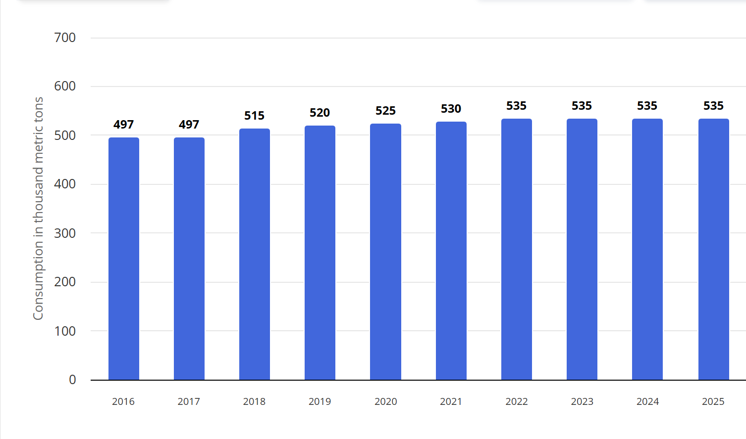
Figure 1: Domestic consumption of milk in New Zealand from 2016 to 2025 (in 1,000 metric tons)
Source: Statista (2025a)
These statistics show that it is a large-scale industry with a large-scale international customer base. The diversity of its export markets also reflects that dairy is not just domestically consumed, export markets are the backbone of dairy's commercial size and economic importance.
The industry includes a wide value chain from on-farm dairy production to processing and manufacturing to export and international distribution (StatLedger, 2025). The primary source of milk is from farmers, followed by the cooperatives and private processors who convert the milk into commodity and value-added products which are then sold through international markets. This is a structure that illustrates that New Zealand's competitiveness cannot be looked at as only being based on agricultural output. Processors can take advantage of the nation's natural capabilities and turn them into products that can be exported around the world through capacity, supply-chain coordination and access to distribution networks. As a result, the industry is very reliant on the international market and market conditions.
Dairy also has a significant impact on the broader New Zealand economy. The dairy sector exports NZ$23-27 billion annually and exports NZ$28% of export earnings (Colliers, 2025; Statista, 2025; OECD, 2024). The industry also provides significant jobs and is estimated to represent about 3.1% of GDP, and with approximately 150,000 people linked to jobs related to the dairy industry (Gitnux, 2026). These statistics highlight the export earnings, employment and economic activity dairy provides. The industry is also reliant on export markets which means it faces volatility in international dairy markets, fluctuations in demand from overseas markets and geopolitical risks.

2.3 Major Domestic and Multinational Firms
The NZ dairy scale-based model is Fonterra Co-operative Group. Fonterra is a farmer owned co-operative, with over 10,000 farmers involved in the milk supply chain, and holding a strong position in milk trading internationally. Its strategy consists of products based on commodities and more and more added value ingredients, along with branded products and serving customers in a wide spectrum of international markets (DairyNews, 2023; Rathore, 2025; Fonterra, 2025; TDB Advisory, 2025). Its competitive edge is thus in the size of its operations and power in its network. But having a large share of the world market also means that Fonterra is vulnerable to commodity price volatility and currency changes.
Synlait has a more targeted approach. The company's primary business interests are value added nutritionals, infant formula and contract manufacturing for international brands, in which the quality, traceability and B2B relationships stand out (TDB Advisory, 2025). Synlait is aiming to create more value from specialized products and manufacturing processes, rather than trying to compete at Fonterra's level of scale. This results in a level of industry differentiation but can also lead to greater exposure to fluctuations in demand and customer relationships as a result of being dependent on key customers and markets in the rest of the world.
After being taken over by Chinese multinational Yili, Westland Milk Products is another way of achieving competitive positioning. The company's focus is on product offerings such as butter, anhydrous milk fat (AMF) and speciality powders, and its ties with Yili bring distribution channels established in Asia (DairyNews, 2023; TDB Advisory, 2025). This is a combination of New Zealand origin positioning and multi-national market access. The company's strategic focus and performance, however, are now more reliant on those of its multinational parent.

Dimension | Fonterra | Synlait | Westland/Yili
Strategy | Scale and diversification | Value-added nutrition | Asian integration
Main strength | Scale and supply network | Specialisation | MNC distribution access
Market focus | Global | B2B/high-value | Asian markets
Key vulnerability | Commodity volatility | Customer/market dependence | Dependence on parent/MNC

3. The Porter's Diamond Model and the Global Competitiveness of the New Zealand Dairy Industry
The Porter's Diamond Model is an explanation that tries to account for the emergence and sustainability of global competitive advantage of specific industries in a country. Four key determinants: factor conditions, demand conditions, related and supporting industries, and firm strategy, structure and rivalry are evaluated in the model. Porter also points to the role of national government and dedication in determining national competitiveness (Porter, 1990).
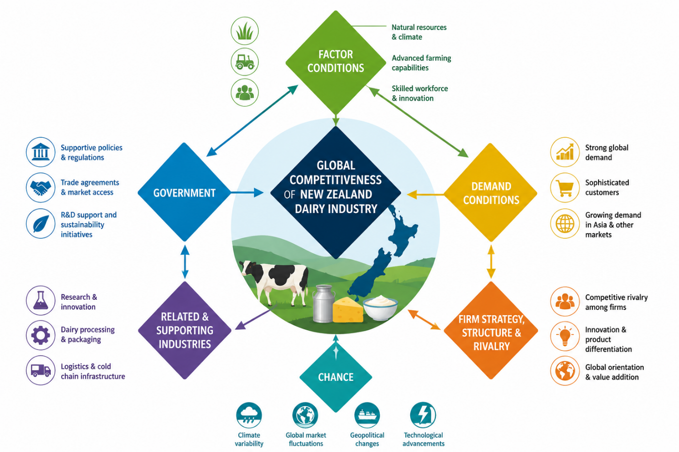
Figure 2: Porter’s Diamond Model – New Zealand Dairy Industry
(Source: Self-made)

3.1 Factor Conditions
New Zealand has very favourable factor conditions for dairy farming, being arable pasture, a temperate climate and water resources. Pasture farming and fairly productive milk generation are fostered by these conditions (Hivelr, 2024). In addition, modern farming technology and skilled labour assist the nation's milk production capability, and research institutes like DairyNZ and AgResearch provide research into methane reduction, genetics and pasture management (DairyNZ, 2024). They constitute a solid basis for international competitiveness as they are a mix of natural features and production know-how.
The benefit is becoming more conditional though. Production is under greater restriction due to environmental requirements for methane and freshwater (Treasury NZ, 2024). In summary, it is not possible to rely solely on natural resource advantages to be competitive in New Zealand for the long term.

3.2 Demand Conditions
The demand for the dairy products in domestic market is comparatively small, whereas the demand in the international market is quite big and sophisticated. China, Japan, the UAE and Singapore are significant markets and over 90% of production is exported (Nuffield, 2023; Treasury NZ, 2024). This export orientation can result in high expectations being placed by customers overseas on New Zealand organisations and processors are encouraged to produce products that satisfy the various quality, safety and nutritional expectations of customers.
Therefore, the weakness of domestic markets is more than offset by strong international demand. Nevertheless, focus in specific markets makes for vulnerability. The impact of changes in Chinese demand or regulation can be particularly significant for New Zealand processors, particularly in a Chinese context. The demand conditions thereby help to achieve international competitiveness, but also raise the risk of geopolitical and market risks.

3.3 Related and Supporting Industries
New Zealand has built up support industries to complement the dairy industry and enhance its competitiveness; such as agricultural technology, biotechnology and food science and refrigerated transportation. Wearable livestock sensors and automated milking are among the technologies that enhance farm efficiency, and biotechnology and research into food production drive innovation in both production and product development (Hivelr, 2024). Refrigerated logistics are also a key part as products must be transported throughout New Zealand to get to international markets.
These supporting industries are contributing to New Zealand's natural production advantages being translated into a more advanced competitive system. However, the added value from efficient domestic production is partially reduced by the increased transport expenses due to geographical isolation (Hivelr, 2024).

3.4 Firm Strategy, Structure and Rivalry
There is competition in the New Zealand dairy processing industry among large companies like Fonterra, Synlait (both have shares), Westland/Yili and Open Country Dairy. Fonterra has scale and a large milk supply in New Zealand and exports much of New Zealand's dairy products, whilst Synlait concentrates on premium infant nutrition and contract manufacturing. Westland/Yili focuses on markets for butter, AMF and Asian markets, while Open Country Dairy is a key exporter of whole milk powder (Statista, 2025).
This combination forces companies to develop more value-added products, sustainability and traceability. The cooperative organisation of Fonterra has good farmer connections, but can also limit investment flexibility due to the focus on farmer returns. Further, the profitability is also affected by the international commodity cycles (Statista, 2025).

3.5 Government
Environmental regulation, trade policy, research and development, labour policy and biosecurity are all aspects of government policy that have a significant influence on the industry. Environmental rules on methane, nitrogen leaching, freshwater use and stocking affect compliance costs, and can limit production, but are also incentives to invest in reduced-emissions technologies and more sustainable production methods (MfE, 2024).
Trade agreements are a valuable counterweight. New Zealand has a long history of free trade agreements, and has recently implemented agreements with key markets such as China, which provide better access to markets and lower trade barriers (MFAT, 2024). Research into methane reduction, and precision farming and pasture management, which is supported by the government, also enhances the long-term competitiveness (MPI, 2024).

3.6 Chance
External events not under the control of the firms or government also impact the industry. Farm-gate prices may be heavily influenced by global dairy price volatility, whereas processors like Synlait (GDT, 2024) could be impacted by changes in China's infant formula regulations or demand. Production and milk collection can be interrupted during natural disasters such as Cyclone Gabrielle and during dry spells, growth of pasture can be reduced. There has been a rise in shipping and fertiliser costs due to international crises as well (MPI, 2024; Treasury NZ, 2024).

4. Nestlé in the New Zealand Dairy Industry: Market Attractiveness and Success Factors

4.1 Nestlé's Position in the New Zealand Dairy Industry
Nestlé is a Swiss multinational food and beverage company that has a presence in the New Zealand market and operates in over 190 countries worldwide (Nestlé, 2025). Nestlé is not a strong dairy player in New Zealand, where they are not the main producers of milk. Rather, it is a strategic opportunity that is focused in the higher value segments of the dairy value chain, where New Zealand dairy products can be used as ingredients for nutrition products, dairy powders and processed food products. By combining New Zealand's international reputation for high-quality pasture-based dairy farming with Nestlé's capabilities and expertise in product development, processing, branding and distribution, this role will enable Nestlé to take advantage of New Zealand's unique position in the international market.
Nestlé's involvement with New Zealand dairy is therefore a mutually complementary one. New Zealand offers a solid supply base for agriculture, internationally recognized dairy ingredients and Nestlé brings market knowledge, product-development and access to international consumers. The company's sourcing agreements with local dairy farmers, like Fonterra and Synlait, enable it to join an export-focused value chain without a need to duplicate the domestic production system (Nestlé, 2025a). This approach provides Nestle with greater flexibility while allowing it to focus its resources on higher value activities.
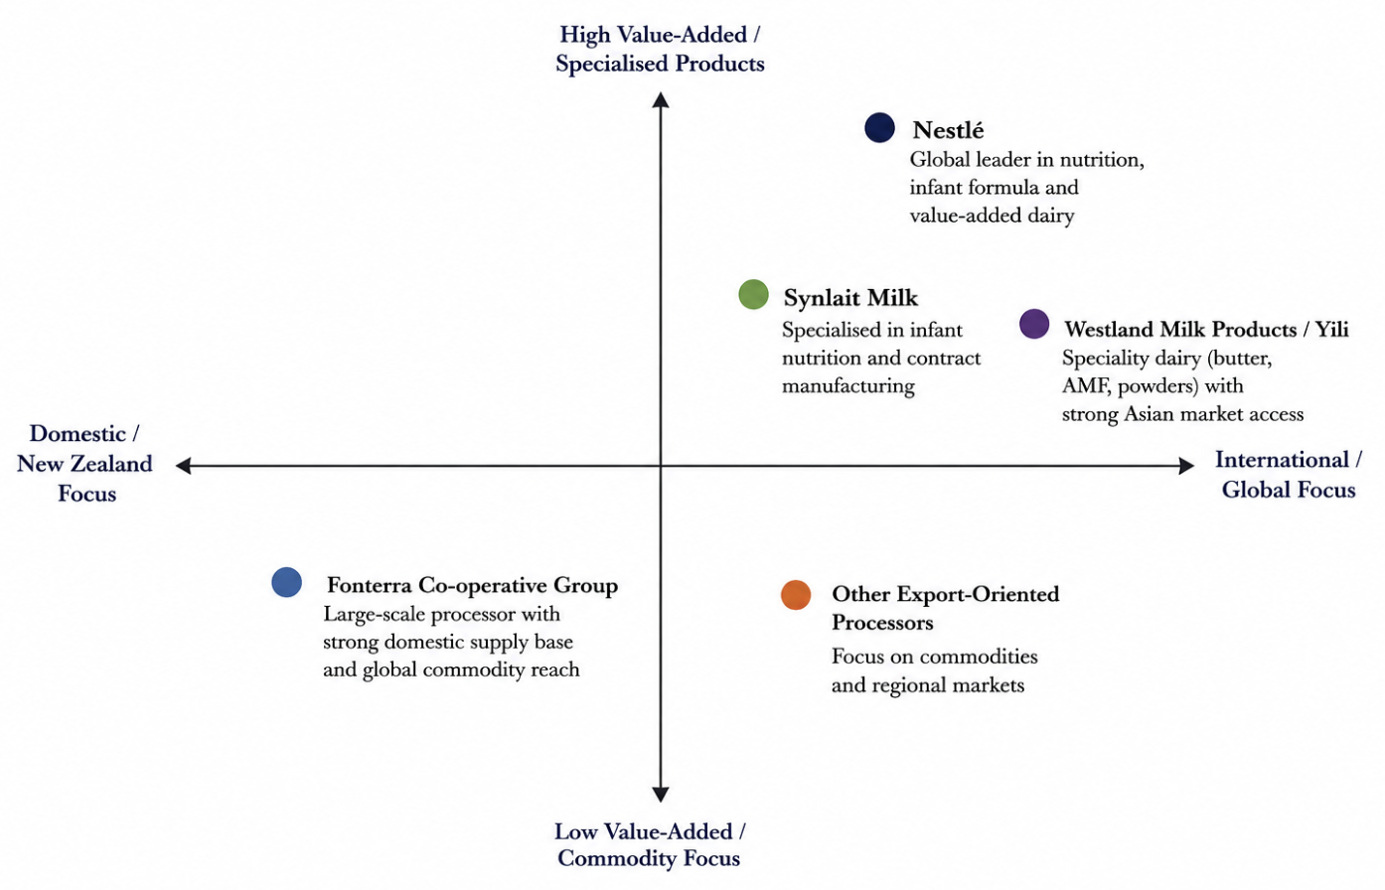
Figure 3: Positioning Map
Source: Self-made
Therefore, New Zealand offers a mix of quality production and existing processing facilities and international market linkages. This is good for Nestlé because it enables it to leverage the locally sourced dairy ingredients into its global product range. The industry's appeal is, however, accompanied by risks of international price fluctuations, environmental regulation, supply chain risks, and consumer preference changes for Nestlé.

4.2 Political Environment
New Zealand offers Nestlé a fairly stable political environment and a well-established institutional setup. Political stability and fairly transparent institutions and relatively low corruption foster long term business relationships and investment. These conditions minimise uncertainty for a multinational company like Nestlé and help to build trust with suppliers, processors and government agencies.
Political conditions are also a constraint as the New Zealand government has placed more focus on environmental sustainability in agriculture. The dairy supply chain is directly impacted by policies regarding greenhouse-gas emissions, water quality and the agricultural environment, as well as its performance (OECD, 2024). While Nestlé is not a dairy farmer in NZ, having access to dairy ingredients is indirectly linked to the requirements as suppliers and processors must adapt to evolving environmental codes.

4.3 Economic Environment
New Zealand's dairy industry is very export oriented, making the economic environment very significant. The dairy industry is well embedded in the international trade, with about 95% of the production being exported (Statista, 2025). It is very similar to the multinational business model used by Nestlé, which is able to source its dairy input from New Zealand and use this in its product offering to export markets.
Though, the pasture-based production system also offers potential cost benefits as it provides relatively efficient dairy production (LIC, 2025). As to access of high-quality dairy ingredients, Nestlé can sustain its competitiveness in the nutritional products and other dairy based products. The existing processing and export systems in the country also decrease the need to create a new supply chain for Nestlé.
However, there are significant economic risks. International dairy prices can fluctuate and the industry is subject to fluctuations in demand by major markets like China. The exchange rate can also impact the price of imports and exports, as well as the profitability of international business activities. Hence New Zealand offers a good supply environment for Nestlé, but that is dependent on the volatility of international dairy markets.
Nestlé's capacity to control in lieu of effectively removes these risks thus determines the attractiveness of the market. Besides establishing long-term supplier agreements, diversifying sourcing and increasing the focus on value added products can help to minimize the company's vulnerability to commodity market fluctuations. New Zealand dairy ingredients could be more strategically valuable for use in differentiated nutritional products, than in bulk commodity markets, for Nestlé.

4.4 Legal and Regulatory Environment
There are strict requirements in place in New Zealand for food safety, environmental protection and animal welfare. Meeting these requirements is a must for Nestlé as non-compliance may impact the company's market access, legal liability and reputation. A food company that operates in multiple countries has a high level of importance when it comes to food safety requirements, as consumers and foreign customers will have high expectations that the food supply chain is maintained at a consistently high standard.
Environmental regulation is another important consideration. The dairy suppliers that Nestlé buys ingredients from are impacted by rising demands for emissions and water use. While these regulations may lead to higher operational and compliance expenses, they can enhance the credibility of New Zealand-origin products if environmental performance can be demonstrated (OECD, 2024).
The legal context is thus a facilitating and a limiting factor. New Zealand is a world-class food-producing nation, supported by reliable regulation and robust food-safety standards. Meanwhile, sustainability expectations are getting higher; Nestlé is constantly keeping an eye on these developments and making sure that its suppliers adhere to required standards. Legal compliance should thus be seen as a strategic supply-chain management requirement of Nestlé instead of as an administrative one.

4.5 Social and Cultural Environment
The New Zealand dairy industry is becoming more attractive due to social and cultural issues. New Zealand's attitude to environment protection and sustainable farming is strong and socially important, similarly increased consumer awareness of sustainability and source of food in countries around the world. As a result of these trends, Nestlé has the opportunity to develop and market products related to responsible sourcing and sustainability (Nestlé, 2025a).
The international reputation of NZ for high-quality pasture-based dairy production can also help to create premium positioning. Nestlé may be able to leverage its New Zealand sourced dairy ingredients to further build confidence in quality, safety and responsible production. This is especially true of nutritional products, where consumers have a high level of interest in the quality of the product and reliance on it.
Social trends present problems as well, though. Demand for some traditional dairy products could also decline due to consumers' growing focus on health and plant-based options. Further, Nestlé is exposed to reputational risks due to environmental and ethical issues related to other multinational food companies. This can be a major concern in markets where consumers are “green”.

4.6 Market Attractiveness: Benefits, Costs and Risks
The dairy industry in New Zealand can be evaluated under three general categories: benefits, costs and risks. The main advantage is the presence of a well-developed dairy production system based on pasture farming, with efficient production capacities and good international reputation, (LIC, 2025). High export orientation of the industry also opens access to international markets and New Zealand's trade relationships open access to markets (Statista 2025; OECD 2024).
The political and institutional stability is another added benefit. Multinational companies are less uncertain because of a secure political environment, clear regulation and trade conditions. Well-enforced food-safety regulation also helps New Zealand dairy products maintain their international reputation. Socially, greater demand for health and high quality and responsibly sourced products presents opportunities in line with Nestlé's nutrition and sustainability efforts.
There are also significant operational expenses associated with the market, however. The geographic isolation of New Zealand, especially for dairy products and ingredients being transported long international distances, results in relatively high transportation and logistics costs. Environmental regulations may also result in higher compliance costs, and maintaining international food safety standards may also continue to involve significant costs in quality management (OECD, 2024). Some of these costs may offset some of the financial benefits of efficient dairy production.
Some matters most are the risks external uncertainty. The volatility of global dairy prices can have an impact on input costs and margins, while reliance on key markets outside the country, in particular China, can expose to shifts in economic, regulatory and consumer demand. Another source of uncertainty is exchange-rate movements. Moreover, future environmental needs may drive up dairy costs, and an expanding consumer demand for plant-based options could help drive competition.
Benefits | Costs | Risks
Efficient pasture-based dairy production | High logistics and transport costs | Global dairy price volatility
Strong export infrastructure and market access | Environmental compliance costs | Dependence on China
High-quality dairy reputation | Geographic isolation | Exchange-rate fluctuations
Stable political and legal environment | Small domestic market | Plant-based alternatives
Sustainability and premium-product opportunities | Increasing regulatory requirements | Climate and natural-disaster disruption

4.7 Competitive Forces Affecting Nestlé
The organisation of the dairy industry also affects Nestlé's strategic position in New Zealand. There is moderate to highly competitive rivalry as there is a number of established processors in the industry, and New Zealand processors compete internationally with processors from the European Union, United States and Australia (TDB Advisory, 2025). While the processing is fairly concentrated, strong international competition generates ongoing downward pressure on prices, product quality and innovation.
However, the threat of new entrants is relatively low as dairy production and processing involves significant capital investments, land, economies of scale, access to milk supply and compliance with environmental requirements. High investment costs and regulations are making it more difficult for large investors to enter the playing field (Colliers, 2025). This is good for the established businesses like Nestlé as they have effective relationships and supply chain, which makes it difficult for the potential competitors to enter the market.
Supplier power is moderate to high as dairy farmers are supplying an essential raw material that cannot be easily replaced in the traditional dairy production method. Large processors like Fonterra have a lot of influence though, because of the volume of milk they process and their capacity to pull milk together. The relationship with the large processors can thus be an important, strategic aspect for Nestlé to ensure the availability of good quality dairy ingredients.
There is also a high level of buyer power as international food manufacturers, importers and retailers can purchase dairy products from various food suppliers around the world. New Zealand is a highly export-oriented country and hence can put pressure on price and contract terms. This risk is mitigated somewhat by Nestlé's size and the purchasing power it has as well as its knowledge of international market conditions, but it is not immune from market conditions elsewhere around the world.
There is a moderate to high threat of substitutes. As consumer preference shifts to plant-based alternatives, including almond, soy and oat-based products, and new technologies like alternative proteins, these options are presenting competitive challenges (McKinsey, 2025).

4.8 Key Success Factors for Nestlé
For example, success in the dairy industry depends on a few integrated capabilities in New Zealand that Nestlé has achieved. First, it is essential to maintain a quality supply of dairy ingredients. Access to established processors, such as Fonterra and Synlait can help protect access to production scale, specialist ingredients and quality-controlled supply chains. Secondly, Nestlé should be concerned with value addition rather than commodity prices. The efficiency New Zealand has in milk production is being rapidly matched by niche products in other high value uses, such as nutrition and infant products. This is an opportunity for Nestlé to make additional value using its universal product development strategies and brand building capabilities.
Thirdly, sustainability and traceability have become key strategic priorities and no longer options. As consumers and stakeholders place greater demands on the environment, Nestlé will have to show responsible sourcing, actions to cut emissions and more transparency in its supply chain (Nestlé, 2025). This is especially significant as dairy suppliers can have a significant environmental footprint that can affect the overall sustainability of Nestlé's dairy products.

4.9 Overall Strategic Assessment
Over all, New Zealand, in general, is an attractive strategic region for Nestlé, with the advantage of good dairy production with processing plants already in place, market access and food safety having a good international reputation. The country's favourable dairy supplies make it a good fit for Nestlé's global business model as they can be used in higher valued products and exported via their global network.
However, that does not necessarily mean that the opportunity is low-risk. The challenges are huge: high export dependency, shifts in dairy price in the world, environmental laws, geographical barriers and shifts in consumer preferences. The company will no longer be able to rely on inexpensive raw materials for the dairy industry and must begin to add value to itself in terms of nutrition, innovation, sustainability and global distribution.
The strengths of both Nestlé and New Zealand are their global experience and New Zealand's production and origin, respectively, and they meet at the potential for consolidation. New Zealand can provide the quality of supply and the reputation, and Nestlé can provide the product innovation, brand and the knowledge of the international market and supply.
Nestlé can enter into the more lucrative segments of the dairy industry and minimise the competition they face from commodity products. New Zealand must be considered not only as a source of dairy inputs, but as a platform to undertake the creation and marketing of differentiated nutrition and food products internationally.

5. Conclusion
This report finds that New Zealand's dairy industry is still competitive globally and is a good strategic place for Nestlé. Favourable Climate, Pasture Production, Effective Dairy Production, Existing Processing Facilities, and Good Integration with International Markets are elements that give it a competitive position. New Zealand's major share of exports and well-developed global supply chains give the industry a significant role internationally and produce value chains and good quality dairy inputs for Nestlé.
The industry is constrained, though, as well. Firms are highly reliant on international markets, which means that they are vulnerable to international dairy price fluctuations, fluctuations in international demand and geopolitical risks; New Zealand's geographical isolation also contributes to higher logistics costs. Increased emissions, water usage and sustainable production, which are environmental requirements, also put additional pressures on the business and compliance. Moreover, consumer preferences are evolving and other products are emerging, offering longer-term competition.
New Zealand is thus a very appealing but challenging territory for Nestlé. Nonetheless, the strategic value is not only to be able to source relatively efficient milk production; Nestlé can leverage New Zealand's dairy quality and international reputation with its own expertise in value-added nutrition and product development and global distribution. The strategic message is that Nestlé needs to concentrate on higher value and differentiated products and on the improvement of sustainable sourcing, traceability and resilience of its supply chain. This would give the company the chance to realise a higher value from New Zealand's dairy capability whilst minimising the threat of commodity-based competition.

SECTION 2: REFLECTIVE ACCOUNT WITH THE GIBBS' REFLECTIVE CYCLE

2.1 Description
I used a structured process to research and analyse the New Zealand dairy industry and Nestlé for the international business report. I started with the secondary data regarding size, structure and competitiveness of the dairy industry, which I then gathered from a variety of sources including OECD, Statista, WorldMetrics and the Ministry for the environment. I then looked at the market share of the main dairy companies and Nestlé in the New Zealand market. The analysis was then structured based on Porter's Diamond Model, the PESTEL analysis and the Benefits, Costs and Risks approach. In this process, I had to integrate quantitative and qualitative aspects such as production quantities, export value, sustainability, regulation, market dependence, and customer expectations.

2.2 Feelings
I started off the assessment with a certain level of self-assurance as it was related to international business strategy and sustainability. But as I started to delve into all the information that was available about the New Zealand dairy industry, my confidence waned. It was not easy to determine what evidence was most pertinent and what information to include. I also was not sure how to apply multiple analysis methods without restating claims. More critical consideration was required in balancing benefits arising from New Zealand's position in the dairy export market with the pressures and international market risks to the environment (Stats NZ, 2024). This experience helped me to realize that lots of information doesn't always yield a well-done grade-level analysis.

2.3 Evaluation
The research process as a whole proved to be effective, as it enabled me to gain a wider understanding of the way in which an international competitive industry works. The established sources enabled me to create a more robust evidence base, and the various analytical frameworks gave alternative views of the same business environment. Porter's Diamond model was found to be helpful in understanding the element of factor conditions, demand, supporting industries, firm rivalry in the context of national competitiveness. In the same way, PESTEL enabled me to look at political, economic, legal and social aspects that may affect activities of Nestlé.
One drawback of my original plan was that I concentrated too much on detailing information. My first attempt at gathering statistics and company data was lacking the depth of explanation of the strategic value of that data. In revision, I realised I needed to link evidence to interpretation. For instance, the regulation of the environment was not viewed as a constraint but as an opportunity to raise compliance costs and stimulate innovation and sustainable production. Another area of weakness was time management as I was spending more time collecting data than analysing and interpreting it.

2.4 Analysis
It was found that in the research process, one must have both a broad and focused scope to effectively analyse international business. At first, I thought of all of the different frameworks as separate tasks but I eventually came to realize that they could complement each other. Porter's Diamond theory gave an explanation as to the internal factors giving New Zealand its competitive advantage and PESTEL theory showed the external factors influencing Nestlé. The Benefits, Costs and Risks approach then enabled me to evaluate if the market benefits are greater than the operational and strategic issues.
An important lesson learned was the importance of using a combination of quantitative and qualitative evidence. The facts on dairy exports and production showed how big the industry is but they did not provide any explanation as to why the industry is still competitive or as to the opportunities and risks of the industry to Nestlé (Stats NZ, 2024). The figures were anchored to subjects like sustainability, overseas demand and geopolitical dependency, which made for a more coherent analysis. It was also a process that made me think about certain “gifts” that seemed to be good and ask questions about them. An example of this is that New Zealand's political stability and robust regulatory framework can benefit multinational business, whilst environmental regulation can have a positive impact on both operating and compliance pressures. This reaffirmed Gibbs' principle of reflection; the critical examination of experience, and what can be learned from it (Gibbs, 1988).

2.5 Conclusion
This assessment helped me to understand the dissimilarity between the descriptive research and critical academic analysis. I gained insight into the status of gathering reliable information as the initial step in creating a successful international business report. The challenge is rather to find the relevant evidence, link it to the right theory and interpret it in relation to the analysis of the company.
Consequently, I was also more conscious of the need to keep the line of the argument clear. Although New Zealand's dairy sector has strong assets, such as efficient production, international markets and proven supply chains, these need to be balanced against environmental, economic and geopolitical pressures. I found myself looking back at this balance, as I learned how to progress from factual information into a reasoned strategic judgement by means of theoretical models.

2.6 Action Plan
Future assessments will set up a conceptual framework prior to collecting extensive data. This will assist me to determine the evidence needed and not gather extraneous data. I will also invest more time in synthesis and critical evaluation, and not spend as much time as I would on collecting sources.
I will utilise tables and diagrams earlier in the research process to recognise relationships between evidence, theory and strategic implications. I will also keep building my academic writing skills, minimizing the description of information and clarifying the analytical meaning of evidence. With these actions I should be able to create future reports that are more focused and coherent, critically informed. Most importantly, I will consider reflection as a means of improving my research process, not just a description of what I have complied. This will enable enhanced independent study and application of international business theory for future assessments (Gibbs, 1988).

References
Colliers (2025) New Zealand Dairy Property Market Report. Available at: https://www.colliers.co.nz (Accessed: 16 April 2026).
Colliers (2025) New Zealand Dairy Property Market Report. Available at: https://www.colliers.co.nz
DairyNews (2023) ‘New Zealand’s dairy industry in 2023’, DairyNews Today.
DairyNZ (2024) New Zealand Dairy Statistics 2023–24. Hamilton: DairyNZ.
Fonterra (2025) Global dairy update. Auckland: Fonterra Co-operative Group Limited.
GDT (2024) Global Dairy Trade Price Index Report 2021–2024. Global Dairy Trade, Auckland.
Gibbs, G. (1988) Learning by Doing: A Guide to Teaching and Learning Methods. Oxford Polytechnic, Oxford. (Accessed: 13 April 2026).
Gitnux (2026) New Zealand Dairy Industry Statistics. Available at: https://gitnux.org (Accessed: 16 April 2026).
Hivelr (2024) ‘New Zealand: Porter’s Diamond Model – The Competitive Advantage of Nations’, Hivelr Economics Review.
Ledgard, S. F., Falconer, S. J., Abercrombie, R., Philip, G., and Hill, J. P. (2020). Temporal, spatial, and management variability in the carbon footprint of New Zealand milk. Journal of dairy science, 103(1), 1031-1046. https://www.sciencedirect.com/science/article/pii/S0022030219310379
LIC (2025) New Zealand dairy industry overview. Available at: https://licnz.com (Accessed: 20 April 2026).
MBIE (2024) Dairy Sector Workforce and Immigration Trends. Ministry of Business, Innovation and Employment, Wellington.
McKinsey & Company (2025) Dairy industry insights report. Available at: https://www.mckinsey.com
MFAT (2024) New Zealand Free Trade Agreements Overview. Ministry of Foreign Affairs and Trade, Wellington.
MfE (2024) New Zealand Greenhouse Gas Inventory 2024. Ministry for the Environment, Wellington.
MPI (2024) Situation and Outlook for Primary Industries (SOPI) 2024. Ministry for Primary Industries, Wellington.
Nestlé (2025) Creating Shared Value and Sustainability Report 2024. Vevey: Nestlé S.A.
Nestlé (2025a) Dairy sourcing and sustainability in New Zealand. Available at: https://www.nestle.co.nz (Accessed: 17 April 2026).
Nuffield Farming Scholarships (2023) New Zealand Dairy Trade and Market Expansion Opportunities. New Zealand: Nuffield NZ.
OECD (2024) Agricultural Policy Monitoring and Evaluation: New Zealand. Paris: OECD Publishing.
OECD (2024) OECD Economic Surveys: New Zealand 2024. Available at: https://www.oecd.org (Accessed: 16 April 2026).
OECD (2024) OECD Economic Surveys: New Zealand 2024. Available at: https://www.oecd.org (Accessed: 18 April 2026).
OECD (2024) OECD Economic Surveys: New Zealand 2024. Available at: https://www.oecd.org (Accessed: 20 April 2026).
Porter, M.E. (1980) Competitive Strategy: Techniques for Analysing Industries and Competitors. New York: Free Press.
Porter, M.E. (1990) The Competitive Advantage of Nations. New York: Free Press.
Porter, M.E. (1990) The Competitive Advantage of Nations. New York: Free Press.
Porter, M.E. (1998) Competitive Advantage: Creating and Sustaining Superior Performance. New York: Free Press.
Rabobank (2025) Global dairy production costs report. Available at: https://www.rabobank.co.nz
Rabobank (2025) Global Dairy Quarterly Report. Available at: https://www.rabobank.co.nz
Rathore, M. (2025) ‘Dairy industry in New Zealand – statistics & facts’, Statista, 17 December. Available at: https://www.statista.com (Accessed: 17 April 2026).
Statista (2025) Dairy Industry in New Zealand - Statistics & Facts. Available at: https://www.statista.com (Accessed: 22 April 2026).
Statista. (2025a). Dairy milk consumption in New Zealand 2025. [online] Available at: https://www.statista.com/statistics/1099604/new-zealand-milk-consumption/?srsltid=AfmBOooxaxUlXZ9ta-pS_L5eGz24CHdTf671n-6UaEe8BzPcLvLSHPkM [Accessed 8 Aug. 2026].
StatLedger (2025) New Zealand Dairy Industry Analysis. Available at: https://statledger.com (Accessed: 16 April 2026).
Stats NZ (2024) Overseas Merchandise Trade: Dairy Export Statistics 2023–24. Statistics New Zealand, Wellington.
TDB Advisory (2025) New Zealand Dairy Processors Review 2025. Available at: https://www.tdb.co.nz
TDB Advisory (2025) New Zealand dairy processors review 2025. Wellington: TDB Advisory Ltd.
The Treasury New Zealand (2024) FEU Special Topic: The Outlook for Dairy Exports. Wellington: The Treasury.
Treasury New Zealand (2024) Special Topic: Global Shocks and the Dairy Sector. The Treasury, Wellington.
Treasury NZ (2024) Economic Outlook: Agriculture and Exports. Wellington: The Treasury.
WorldMetrics (2026) New Zealand Dairy Industry Statistics. Available at: https://worldmetrics.org (Accessed: 16 April 2026).

Appendix 1: Porter’s Diamond Model and the Global Competitiveness of New Zealand Dairy
Porter Diamond Heading | Impact on New Zealand Dairy Industry
Factor Conditions | Positive: Favourable climate, pasture-based farming, natural resources, skilled labour and agricultural technology support efficient milk production. Negative: Environmental restrictions on emissions and freshwater use increasingly constrain production. (Hivelr, 2024; Treasury NZ, 2024; DairyNZ, 2024)
Demand Conditions | Positive: Strong international demand, particularly from Asian markets, supports export competitiveness. Negative: High dependence on overseas markets, especially China, increases exposure to changes in demand and political risk. (Nuffield, 2023; Treasury NZ, 2024)
Related & Supporting Industries | Positive: Agricultural technology, research, biotechnology, food science and refrigerated logistics strengthen productivity, innovation and export capability. Negative: New Zealand's geographical isolation increases transportation costs. (Hivelr, 2024)
Firm Strategy, Structure & Rivalry | Positive: Competition among Fonterra, Synlait, Westland/Yili and other processors encourages value addition, innovation and market differentiation. Negative: Industry concentration and dependence on global commodity prices create competitive pressures. (Statista, 2025; TDB Advisory, 2025)
Government | Positive: Free-trade agreements, R&D support and biosecurity measures strengthen international competitiveness. Negative: Environmental regulation and compliance requirements increase operating costs and may constrain production. (MFAT, 2024; MPI, 2024; MfE, 2024)
Chance | Negative: Commodity-price volatility, Chinese market changes, natural disasters, global crises and geopolitical shocks can disrupt production, demand and export costs. Opportunity: Technological innovation and diversification can improve resilience. (GDT, 2024; Stats NZ, 2024; MPI, 2024; Treasury NZ, 2024)

