Introduction to Health and Social Care
Component 1
Student number: 2441882
Module Leader: Mark Kane
Course: Health And Social Care
University : University Of Wales London
17th November 2025

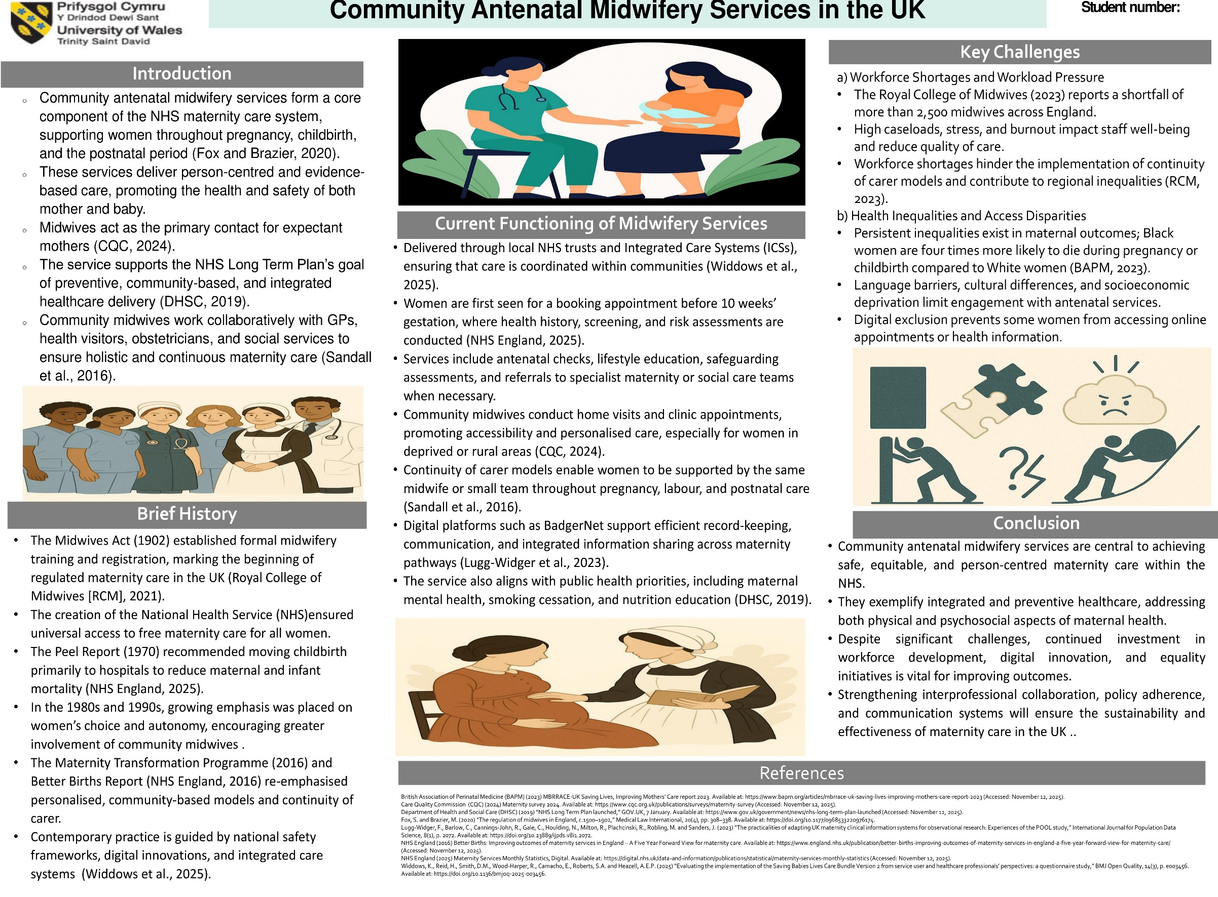
Task 2: The Origin and Structure of the National Health Service (NHS)
The National Health Service (NHS) stands out as perhaps the most consequential institution in the UK. The NHS, as established in 1948, remains, to this day, one of the largest systems of publicly funded healthcare, providing a full range of medical services to all of the UK’s residents (Roderick and Pollock, 2022).
Historical Context and Origins
Prior to the founding of the NHS, the healthcare system in Britain was inequitable, insufficient and highly privatised and reliant on charitable or local authority settlement (Nuffield Trust, 2025). Health care access in Britain was, and for the most part still is, determined by economic status. The poor had to depend on voluntary hospitals or workhouse infirmaries, the wealthier population could pay for private care (Gorsky, 2015). The 1942 Beveridge Report, by economist William Beveridge, was a key turning point in the development of an inclusive welfare state aimed at combating the five giants of want, disease, ignorance, squalor and idleness (Nuffield Trust, 2025). His proposals for social insurance and the state’s responsibility for health triggered the development of the NHS. In the years immediately after World War II, the National Health Service Act (1946) was passed despite reluctance from some in the medical profession (Klein, 2019). The NHS became operational on 5 July 1948, meeting the needs of the population regardless of the beneficiaries’ ability to pay at the point of delivery or the beneficiary's ability to pay for the provided services (NHS England, 2023).
Key Principles and Evolution
Funded through the general taxation system, the NHS was the first system to operate on a universal, comprehensive, and publicly used method. Initially, it unified the previously disparate hospital, general practitioner, and local government health system in a single structure on a national scale (Gorsky, 2015). The NHS gradually modified to changes in population, technological advancements, and shifts in the economy. The implementation of the NHS and Community Care Act (1990) introduced a major period of reform to the system, fostering the creation of internal markets and internal fragmentation of the NHS by separating the commissioners from the providers (Williams, 2024). Altogether the Health and Social Care Act (2012) further changed by enhancing local self-governance and creating Clinical Commissioning Groups (CCGs), which under the 2022 reforms later became Integrated Care Systems (ICSs) (Ham, 2021). However, the NHS universalism ideals have continued to be tested by increasing costs, insufficient workforce, and rising demand from chronic age and disease patients (Snow and Whitecross, 2022).
Current Structure and Functioning
The NHS has four distinct arms, each devolved in England, Scotland, Wales, and Northern Ireland (Williams, 2024). In England, the DHSC supervises the NHS while NHS England handles the strategic framework for and leadership of the NHS while commissioning some specialist services and supervising the quality and safety of services. Service delivery is predominantly through Integrated Care Systems (ICSs) which focuses on coordinating the efforts of NHS organisations, local government, and other community stakeholders to plan and deliver integrated health services (NHS England, 2024). This marks a paradigm shift from a competition-based, market-driven approach to cooperation and population health management.
Most patients access primary care through their general practitioners, dentists, pharmacists, and optometrists as the first point of contact. Secondary Care is provided via hospitals, specialised outpatient clinics, and mental health trusts, as well as tertiary care (Gorsky, 2015; RCN, 2023). the Public Health and preventative services such as vaccinations and screening tests, is the responsibility of the UK Health Security Agency (UKHSA) and the Office for Health Improvement and Disparities (OHID) (NHS England, 2024). The primary funding source for the NHS continues to be general taxation, complemented by a small contribution from National Insurance. However, current financial pressures in conjunction with increasing demand have resulted in concerns about the long-term sustainability of the system, particularly waiting times (Snow and Whitecross, 2022).
Conclusion
In conclusion, even though the NHS still faces the unrelenting burden of limited funding, workforce shortages, and unmet demand, it has remained devoted to the principles of universal and high-quality care, making it central to the UK welfare state.

References
NHS England (2024b) Milestones of the NHS. Available at: https://www.england.nhs.uk/about/nhs-history/ (Accessed: October 15, 2025).
Powell, T. (2023) The structure of the NHS in England, House of Commons Library. Available at: https://researchbriefings.files.parliament.uk/documents/CBP-7206/CBP-7206.pdf (Accessed: October 15, 2025).
Roderick, P. and Pollock, A.M. (2022) “Dismantling the National Health Service in England,” International Journal of Health Services, 52(4), pp. 470–479. Available at: https://doi.org/10.1177/00207314221114540.
Royal College of Nursing (RCN) (2023) NHS 75: the history of our National Health Service | RCN Magazine | Royal College of Nursing, The Royal College of Nursing. Available at: https://www.rcn.org.uk/magazines/History/2023/July/NHS-75-anniversary-history-of-the-National-Health-Service.
Nuffield Trust (2025) The history of the NHS, Nuffield Trust. Available at: https://www.nuffieldtrust.org.uk/health-and-social-care-explained/the-history-of-the-nhs (Accessed: November 12, 2025).
Gorsky, M. (2015) The NHS in Britain: Any Lesson from History for Universal Health Coverage? Health for All - NCBI Bookshelf. Available at: https://www.ncbi.nlm.nih.gov/books/NBK316274/.
Snow, S.J. and Whitecross, A.F. (2022) “Making history together: the UK’s National Health Service and the story of our lives since 1948,” Contemporary British History, 36(3), pp. 403–429. Available at: https://doi.org/10.1080/13619462.2022.2045199.
Williams, B. (2024) “The British NHS at 75: Past, contemporary, and future challenges,” International Journal of Social Determinants of Health and Health Services, 55(1), pp. 76–87. Available at: https://doi.org/10.1177/27551938241280175.

