April Fuge
1712455

INNOVATION IN A CRISIS: WHY IT IS
MORE CRucial THAN EVER!
SPECSAVERS


EXECUTIVE SUMMARY.
This report investigates the concepts of creativity and innovation and concludes creativity alone does not lead to innovation. Specsavers organisational incapability of capturing creativity to even consider innovation has led to a company that has relied on historical success as appose to embracing the digital age. The pandemic crisis has still not been enough for this company to respond in a competitive manner and has not met customers expectations, let alone exceed them. A proposed innovation is put forward with various models to give Specsavers a holistic and realistic academic standpoint as to its feasibility and subsequent competitive opportunity. Recommendations are given regarding the appropriate management required for this innovation with preliminary research needed and continuous improvement.

CONTENTS PAGE PAGE NO.
1.0. Introduction…………………………………………………………………………………………… 3-7
1.1. Terms of Reference…………………………………………………………………………………… 3
1.2. Business in Crisis………………………………………………………………………………………… 3
1.3 Specsavers Current Position…………………………………………………………………………. 3
1.4. Proposed Innovation Opportunity………………………………………………………………… 3
1.5. Creativity…………………………………………………………………………………………………….. 4
1.6. Specsavers Organisational Influence on Creativity……………………………………….. 4-6
1.7. Innovation………………………………………………………………………………………………….. 7
2.0. Findings……………………………………………………………………………………………………… 8-17
2.1. Types of Innovation……………………………………………………………………………………… 8
2.2. Open or Closed Innovation…………………………………………………………………………….. 9
2.3. Force Field Analysis……………………………………………………………………………………… 10-13
2.4. Implementation…………………………………………………………………………………………… 14-15
2.5. The 4 P’ s of Innovation……………………………………………………………………………… 15-17
3.0. Conclusion…………………………………………………………………………………………………… 18
4.0. Recommendations……………………………………………………………………………………… 19-20
5.0. References…………………………………………………………………………………………………. 21-23

1.O. INTRODUCTION.

1.1. TERMS OF REFERENCE.
This report was requested by the CEO of Specsavers on the 23/4/2021. Covid-19 and the subsequent pandemic in March 2020 has led to the biggest catastrophe since the second world war. Every sector without exception has been impacted. Secondary research has been conducted using various academic sources to investigate the concepts of creativity and innovation and to propose a valid opportunity with support from various innovation models and techniques underpinned by Specsavers organisational capabilities and/or incapability to successfully implement this innovation to gain a competitive advantage in this crisis.

1.2. BUSINESS IN A CRISIS.
According to (Bar Am, et, al, 2020) Historical success can no longer be taken for granted and applied as a realistic business differentiate. Covid-19 has not only changed life as we know it but also consumer habits and the ‘way things are done’ in- regards to communication and work restructuring. The inevitable rise of the digital age has accelerated due to the pandemic and can no longer be ‘held off’ or allowed to progress slowly if any business not only wants to survive, but especially to thrive. A crisis such as this with dynamics such as social and economic dislocation, forces leaders to either conserve resources deprioritizing innovation or take action to build the foundation during a crisis to remain competitive in the recovery period.

1.3. SPECSAVERS CURRENT POSITION.
(Curated, 2020) Says Specsavers strategy amid Covid-19 is to avoid direct contact with secondary care, with procedures in place to carry out emergency eye-care only. Remote communication is triaged to establish those warranting emergency treatment and the main focus is not to drive bookings or revenue but to empathise and address customers concerns using various platforms and communication channels. Specsavers have been reactive rather than pro-active, claiming government help with furloughing staff, business interruption loan scheme and grants, and also believe the economy is declining with worse to come. Specsavers plan to employ fewer people moving forward (Braemar Finance, 2020).

1.4. PROPOSED INNOVATION OPPORTUNITY.
According to (Optician, 2020) Tele-optometry is remote testing of a patient with results securely transferred to the clinician, with no need to attend a facility and involvement of support staff. While this has been a topic of interest for years it has been slow to evolve and still seen as futuristic. Dr Andrew Bastawrous discovered countries with only a small percentage of its population able to access healthcare, had the use of a mobile phone network. He developed a smartphone based retinal imaging system and a range of smartphone app-based vision checks. A review by Saleem, et, al (ND) Cited in: Optician, (2020) concluded home-based remote monitoring is premature and not widely available.
1.5. CREATIVITY
According to (Chamorro-Premuzic, 2015) There are two perspectives of the concept of creativity, some say its spontaneous nature can be nurtured and learned, others say in order to be creative, knowledge and facts stored in the brains long-term memory are needed.
“Starting with nothing and ending up with something you saw or experienced and processing it, so it comes out different than how it went in.” Henry Pollins quote on what is creativity? (Farnworth, 2021).
The quote above would suggest that creativity is nurtured and learned by experience.
“Living in possibility and abundance rather than limitation and scarcity” CJ Lyons (Farnworth, 2021).
The next quote suggests this creative knowledge is based on facts stored in the brain.
While both may be true, it is the organisations capability to create conditions for both perspectives that is key in capturing creativity.
Creativity can however be counter-productive, having a lower tolerance of boredom means having a vivid imagination and therefore developing sophisticated mental tools to self- deceive and deceive others. Steve Jobs famous “reality distortion field” convinces people in a compelling way with no evidence to back the notion. This is seen as narcissism and research has shown that narcissists even when not being creative can sell ideas to others. Furthermore, narcissism correlates to the transformational leadership style, with charisma as a key influence on followers, this can be detrimental to the entire company if the leader is only self-fulfilling their own ego and believe they are more creative than they actually are. This deception stifles creativity in followers as they are swayed by the leader’s abilities, seeing the leader as a ‘hero’ with answers and solutions to everything (Chamorro-Premuzic, 2015).

1.6. SPECSAVERS ORGANISATIONAL INFLUENCE ON CREATIVITY.
For Specsavers to adopt a ‘helicopter view’ of the level of creativity in its organisation, rather than look at its employees from the ‘inside out’ which is hard to measure. Assessing key areas from the ‘outside in’ analyses barriers and where creativity flows freely. The researcher draws your attention to Figure 1.
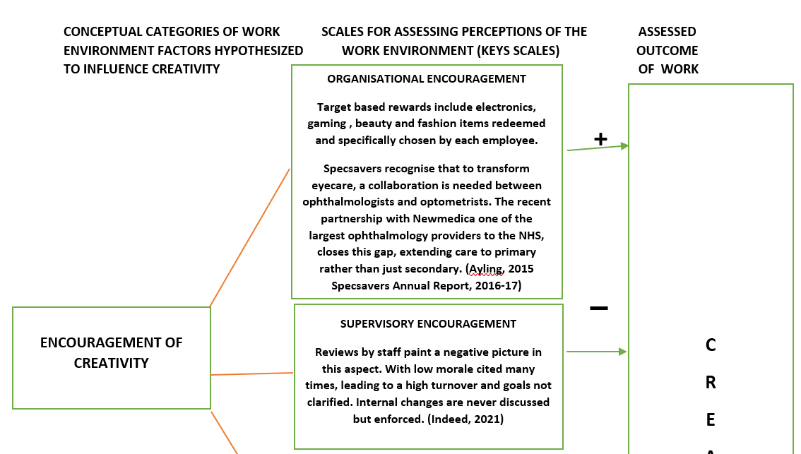
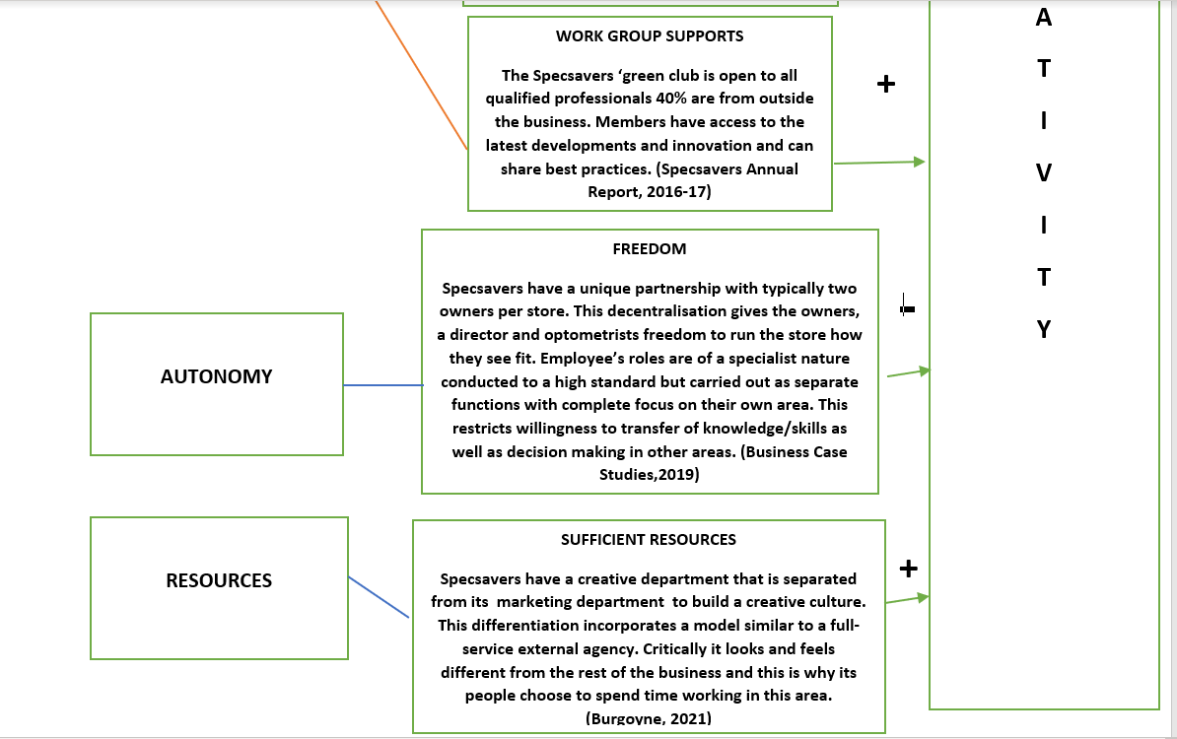

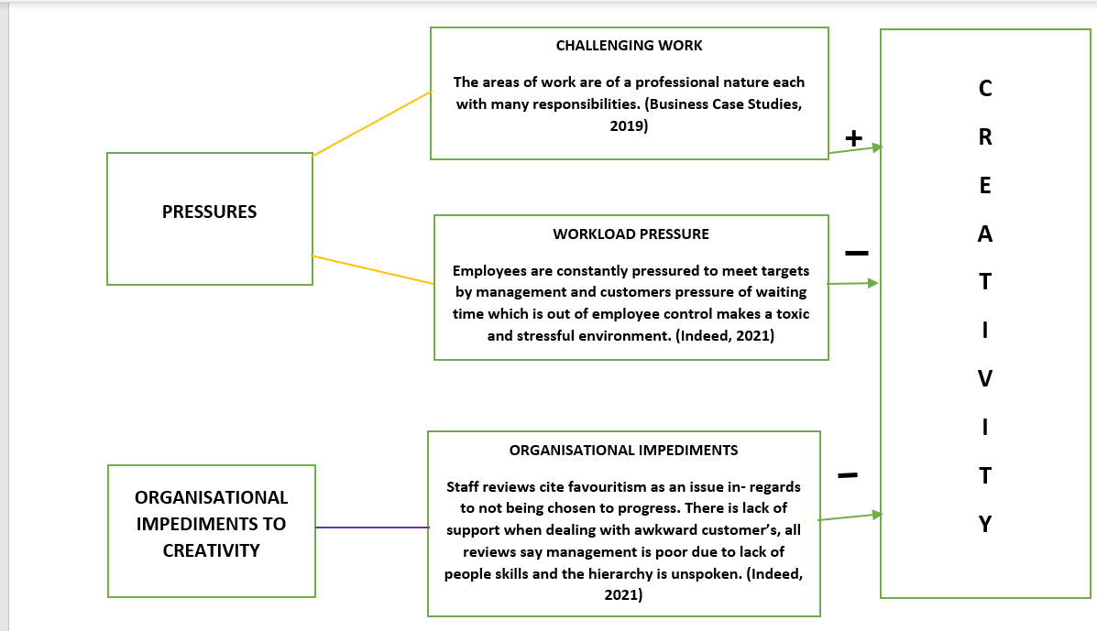

Figure 1 Assessing The Work Environment For Creativity (Amabile, et, al, 1996)
According to (Amabile, et, al, 1996) The work environment dimensions reveal equal negative and positive outcomes overall. Organisational encouragement is positive giving license for optometrists to produce unusual and useful ideas in a situation the organisation puts them in, with the new partnership. Supervisory encouragement is negative, identifying lack of goal clarity and negative criticism from managers, leading to low morale and high turnover. This impedes intrinsic motivation necessary for creativity. Work group encouragement is positive but focused with links outside of the organisation, while this gives access to the latest innovations and sharing of best practices it clear from the autonomy element that the decision made by these individuals to not transfer this knowledge, is a missed opportunity to utilize the diversity a group has to offer to extend this to a wider variety of ideas and thus a collective contribution. The Management style is transactional, hindering creativity due to favouritism and lack of support in day-day activities and clearly does not challenge the status quo, but Specsavers do recognise the importance of a creative ‘culture’ however this is separated from the mainstream business and is more of a ‘silo’.

1.7. INNOVATION
“Innovation is the specific tool of entrepreneurs, the means by which they exploit change as an opportunity for a different business or service. It is capable of being presented as a discipline, capable of being learned, capable of being practised”. (Drucker, 1985: cited in Tidd and Bessant, 2013).
This quote draws out certain aspects an organisation has to consider for innovation to become a part of its DNA. This starts with how people want to lead and be led, the transformational style of leadership delivered in the appropriate context is not only inspiring but also promotes intellectual stimulation, encouraging followers to be creative and to challenge their own beliefs as well as those of the organisation, leading to the capability of innovation being learned and practised. Change is the key element, as the leaders is always looking at the horizon to transform with opportunities (CMI, 2013, Llopis, 2014).
According to (Simpson, et, al, 2006) Innovation can become an end unto itself. Innovating just for the sake of it means novelty becomes the goal rather than integrated into the business, leading to customer dissatisfaction. Fewer companies are ‘true’ innovators due to failure in commitment of adequate resources and many employees are driven away due to employer’s perception of employee ‘laziness’ in a loose structure required in an innovative environment. Also due to the business fundamentally promoting chaos, comfort levels are reduced leading to pressure and stress some employees cannot deal with.
According to (Business Insider, 2013) Creativity is the potential in one’s mind to conceive new ideas, however, due to this being subjective it is hard to measure. Organisations that solely chase creativity rather than pursue innovation will not see ideas come to fruition. The assumption that creativity adds value alone does not lead to innovation. Creativity must not be seen as the initial concept, but as the driver placed upon an innovation process with a framework that acts as a marriage to entwine both concepts resulting in innovation. An organisation that has the capability to make content specific in- regards to creativity mean the requirements for creativity also becomes more specific, this is a crucial element to align people’s minds with organisational benefit (Thomassen, et, al, 2018).

2.0. FINDINGS.
2.1. TYPES OF INNOVATION.
Refer to figure 2.

INNOVATION MATRIX 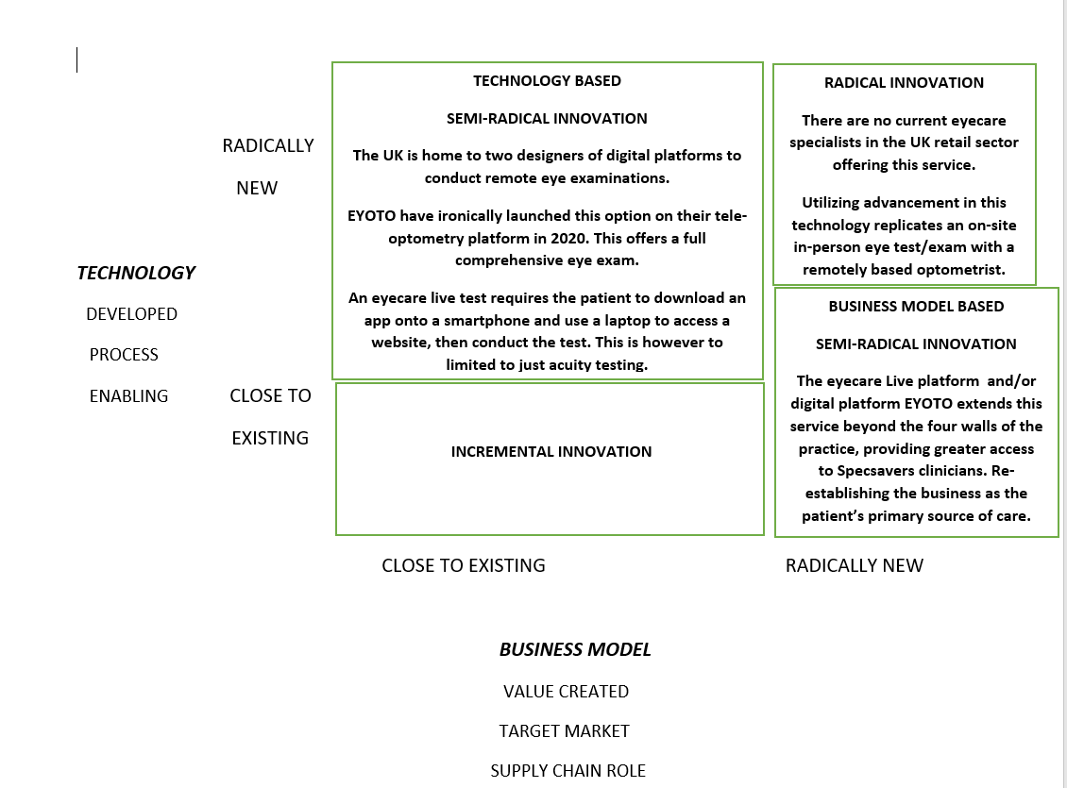 Figure 2 Innovation Matrix. (Davila, et, al, 2013)
Radical innovation usually suits new players having no incumbent history that would restrain its fruition. However, timing is critical, if a product/service is ‘mistimed’ customers either ‘do not get it’ yet alone want it. The pandemic is a prime opportunity for Specsavers to seize this radical innovation, with timing prudent due to changing consumer habits and the need for a service currently out of reach. Radical innovations generally provide lower performance early in the life cycle and do not satisfy ‘current’ customers and appeal to a different market instead. This model demonstrates through disruption and with existing technology the business model is changed significantly to reach both existing and new customers. The limitation of this model is that the innovation identified is not incremental during its inception but will be after the implementation as employees and customers alike encounter problems, prompting many incremental improvements in the daily running of the service. (Barbieri and Alvares, 2016, Fullagar, 2021).

2.2. OPEN OR CLOSED INNOVATION.
A closed innovation does not accomplish increasing demand and a shorter time to market. Too much ‘openness’ can however negatively impact long-term success with loss of control and core competencies. Refer to figure 3

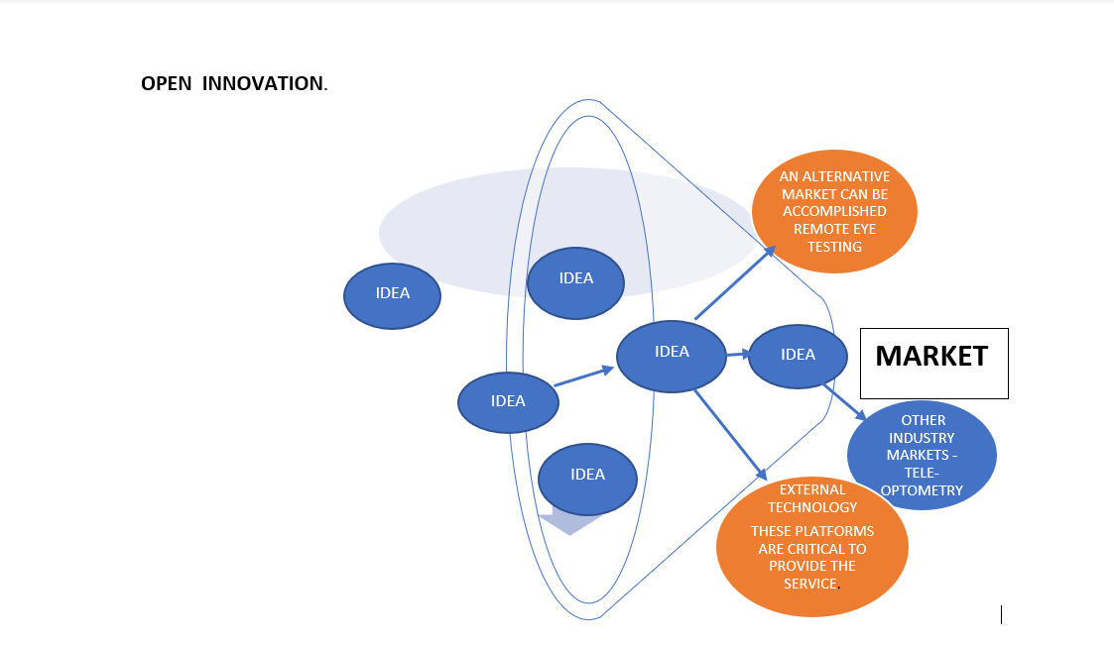
Figure 3 Open innovation
(R&D Today, 2020) The cause and effect of open innovation in such a crisis must overcome misconceptions and misunderstandings of mechanisms inside and outside of the organisation, the time is ‘now’ to fully profit from the concept that a wealth of knowledge outside Specsavers is not only a strategic notion to overcome barriers in a crisis but also builds core competencies within the company for long-term closed innovation. Utilizing the practice of tele-optometry through external technology gives Specsavers the ‘upperhand’ and the first company to provide an alternative market in the UK, however this has to be underpinned by a better business model as demonstrated in figure 2 to solidify the advantage. Accquring third party intellectual property and combining this with Specsavers own intellectual property will give licence for its research and development team to begin work on developing this technology as Specsavers ‘own’ closed innovation with patents to protect it (LEAD, 2021).

2.3. FORCE FIELD ANALYSIS.
This model establishes how this proposal is maintained by an equilibrian between forces for and against it. Refer to figure 4
FORCE FIELD ANALAYSIS.

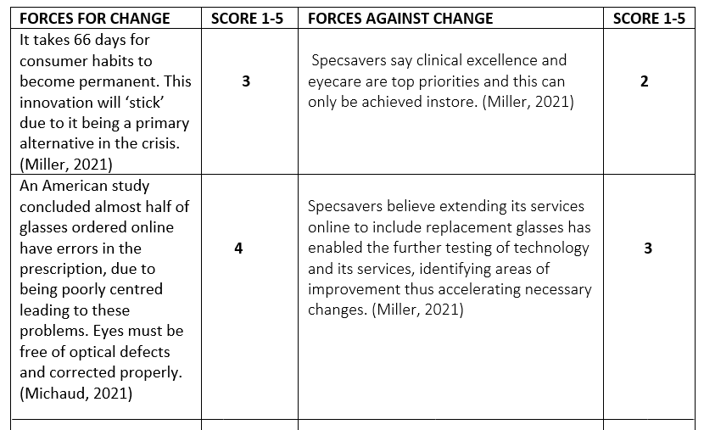

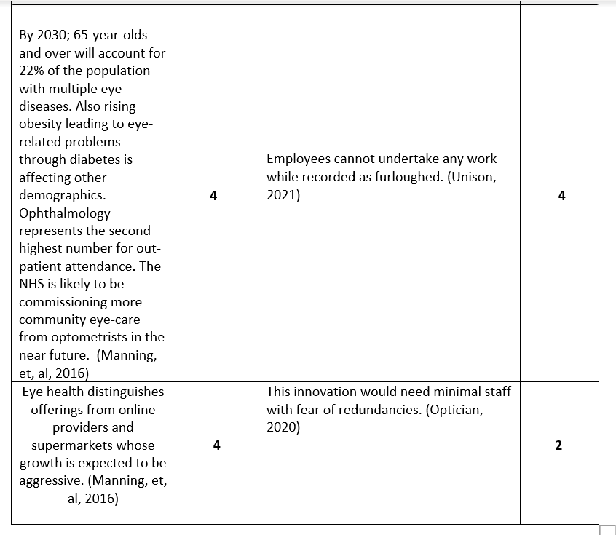

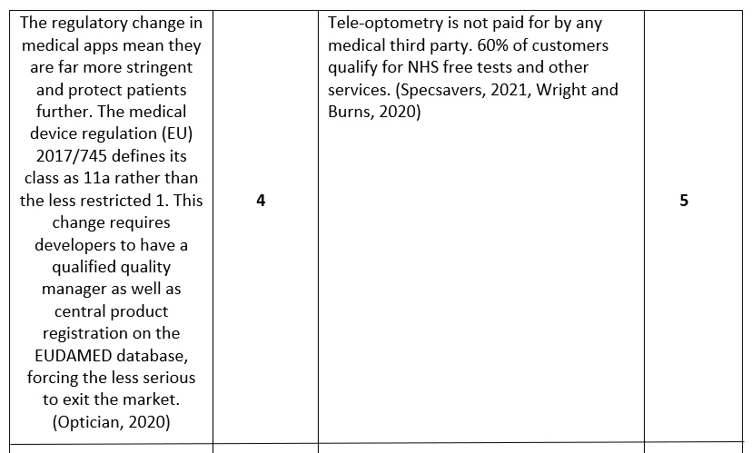

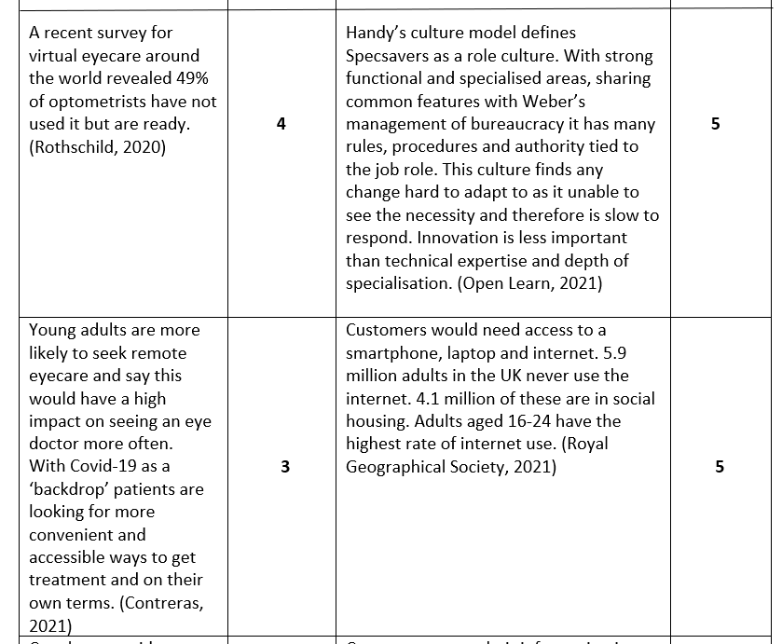

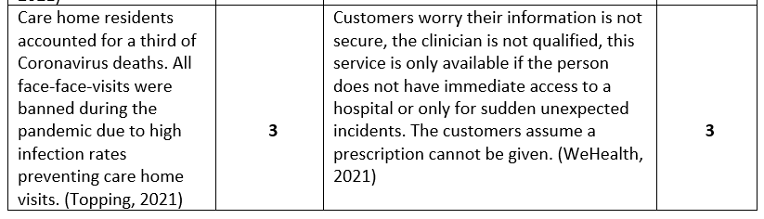
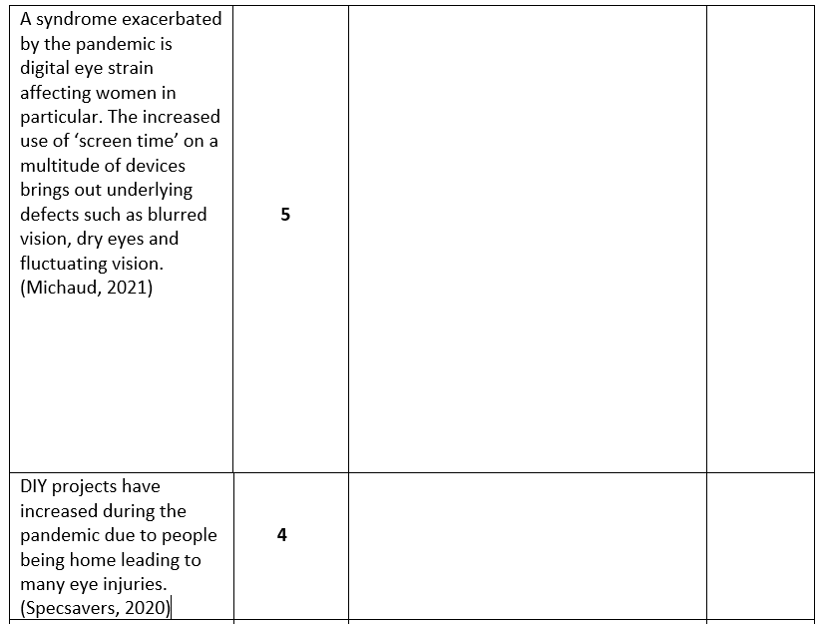

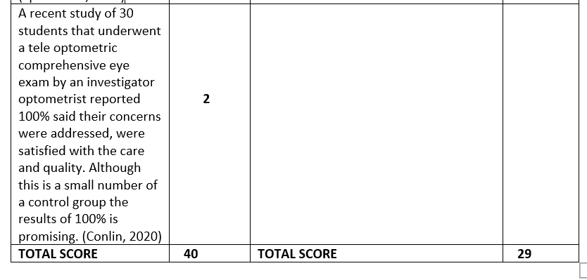
Figure 4 Force field analysis (Kurt Lewins 1943 cited in: Mind Tools, 2021)

Specsavers current business model of closed innovation to offer more services online is not a significant penetration in the market as competitors are also seizing this opportunity. Specsavers belief that clinical excellence can only be achieved ‘face-to-face’ is a significant barrier. Customer inability to access to technology is also a significant limitation and needs further statistical investigation to establish key areas of this barrier such as poor connectivity, poverty and geographical areas with low usage of the internet. There are also many misconceptions surrounding the level and quality of the service, as well as when it would be appropriate to access it. Eye health care is the service in demand rather than repeat prescriptions with much of the population needing not only preventative measures, but access to thorough eye-examinations and treatment. The pandemic is not only exacerbating eye-problems but leading to people neglecting this important aspect of their health. Areas of strength and concern also gives the researcher adequate data and information to begin the innovation process.

2.4. IMPLEMENTATION.
Refer to figure 5.
INNOVATION PROCESS
STRATEGIC VISION AND DIRECTION
PRO-ACTIVE LINKAGES

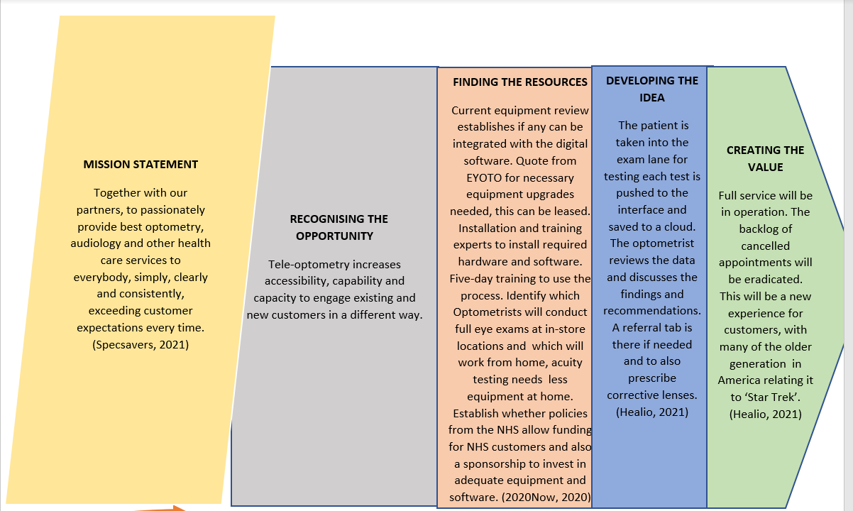
INNOVATIVE ORGANISATION
LEARNING
Figure 5 Innovation process (Tidd and Bessant, 2013)
While this model looks deceptively simple, it is in fact extracting the essence of the innovation and makes sense of what the organisation may assume is ‘pie-in-the-sky’. Specsavers are used to law and order and this gives its managers a somewhat sense of security in what may seem a ‘chaotic’ turmoil as it reveals what is manageable and what is not. While this model is displayed as linear, success and failures in the process cannot be measured without revisiting each stage when necessary, feedback loops are critical to evaluate and enhance, improve or isolate issues along the way. Allowing a few steps back before moving forward again increases the success rate. While this model has the element of creating value it does not consider the actual perception of the consumers ‘take’ on the innovation and assumes the value is what the consumer wants warranting more evidential data. Kamal (2006) Theory has the critical factor this model does not, which is the testing of ‘user acceptance’ and the integration of innovative technology with other information systems giving more evaluation (Meissner and Kotsemir, 2016).

2.5. THE 4 P’S OF INNOVATION.
Refer to figure 6.
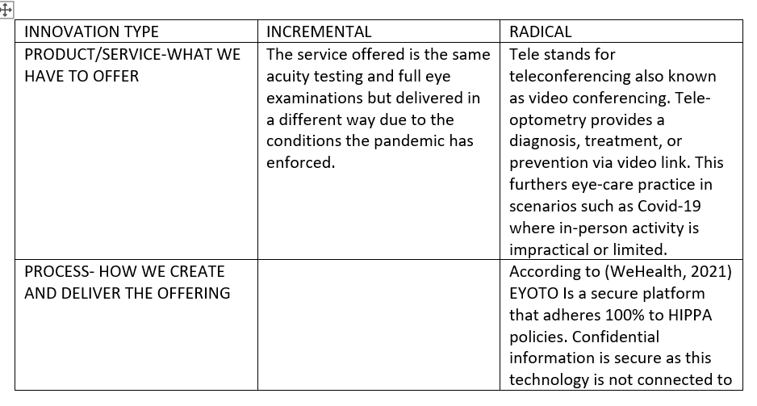
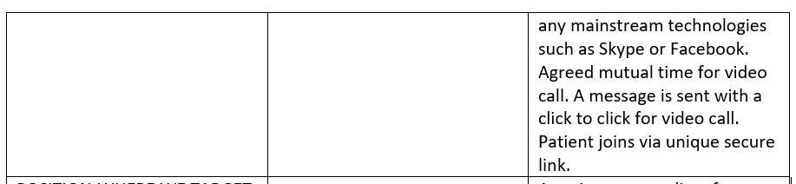

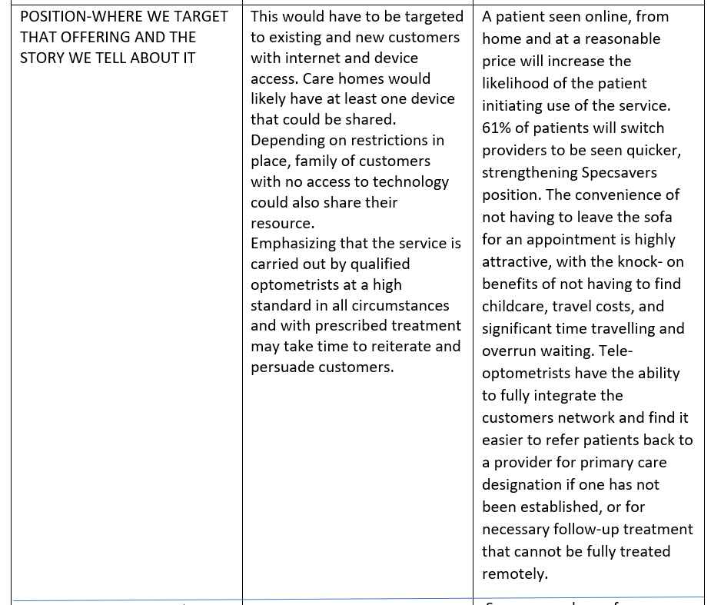
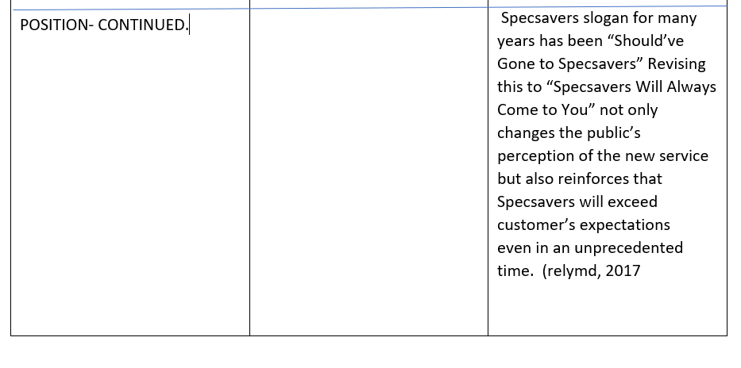
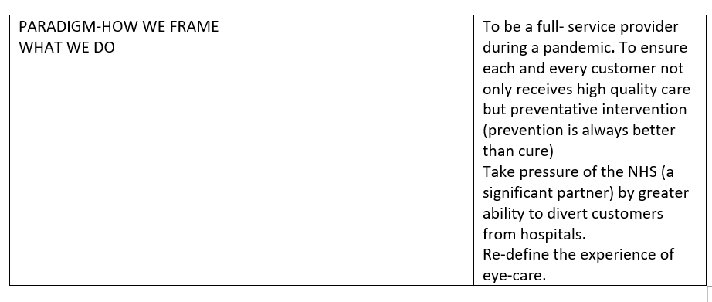

Figure 6 4 P’ s of Innovation (Tidd and Bessant, 2013)
This model is effective by support of its incremental ability to define the innovation in more detail and how Specsavers can manoeuvre its position at target markets to adopt this radical innovation. This model however does not allow the researcher to consider risk in the underdeveloped market of tele-optometry. The incorporation of a ‘5th P’ (Payment) would address how payment for the service can be expedited to overcome the issue of lack of funds (Aglo & Hunter cited in: Innovation Management, 2021).

3.0. CONCLUSION.
Specsavers has historically been successful both economically and socially given the strong connection with customers due to a high quality of service and professionalism created physically in its stores. The large number of clientele funded by the NHS has also been highly lucrative and Specsavers ‘security blanket’. The pandemic and subsequent crisis has highlighted Specsavers slow growth digitally with offerings and services online minimal and barely penetrating the market, with more aggressive competition expected from more sources such as supermarkets. Specsavers strategy amid Covid-19 has been superficial with heavy reliance on government funding and more of an advisory agent to customers. The pandemic exacerbated eye issues even further due to activities heightened with increased screen time and restrictions preventing eye exams, treatment and referrals. Customers fears surrounding Covid-19 have led to neglection of eye-care suggesting Specsavers advisory and support measures are not adequate, risking the loss of customer connection. The organisation influence on creativity is limited due to the transactional management style hindering intrinsic motivation with negative criticism and lack of support. The culture being that of ‘roles’ also hinders sharing of best practices as employees focus on their own areas and functions. The creativity department while a positive feature is not built totally into all of the business, creativity therefore is not flowing freely from the individual to reach team level as a collective strength, this means opportunities are missed to combine creativity with innovation.
The proposed innovation applied to the innovation matrix identifies this as radical and although this demonstrates it would be a business advantage, it is the change of the business model that solidifies this innovation as feasible. Open innovation allows Specsavers to utilize existing technology to open an alternative market and also begin to build core competencies surrounding this with third party rights and integrating this to strengthen its own intellectual property and continue as a closed innovation to avoid further competition. The force field analysis identified significant barriers that will have to be overcome predominately with the customer, this is the ‘myths’ they associate with this service and inaccessibility to technology to carry out the service.
The innovation process requires high levels of creativity to ensure each stage is revisited when necessary to evaluate progress and isolate issues that may arise with resources or development. Assuming what the value actually is for customers is a limitation and the testing of ‘user acceptance’ would overcome this to capture the true value customers are seeking. The 4 P’s model allows for more depth with the knowledge extracted from the forcefield analysis of barriers and risks. This leads to incremental stages with target markets and the issue of customer lack of access to technology, which can start to be addressed giving Specsavers a realistic and more defined view of its position with this proposed radical innovation of Tele-optometry.

4.0. RECOMMENDATIONS

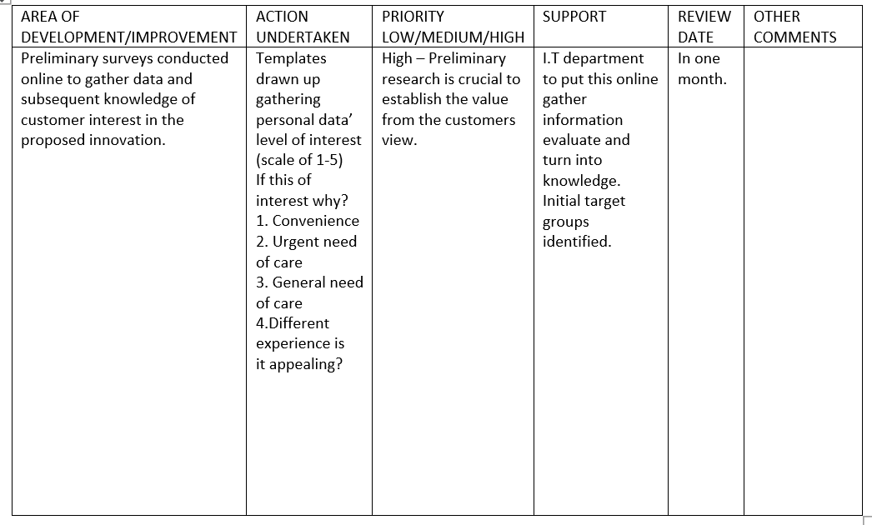
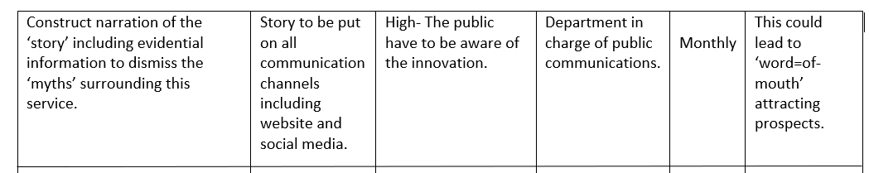

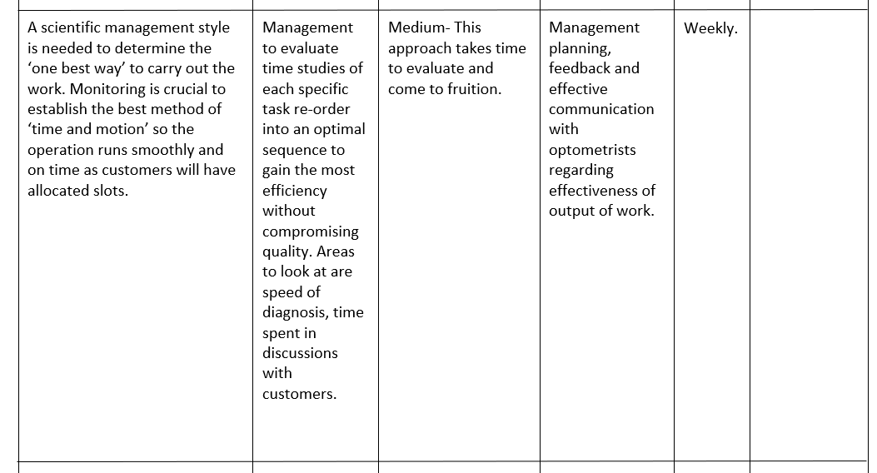
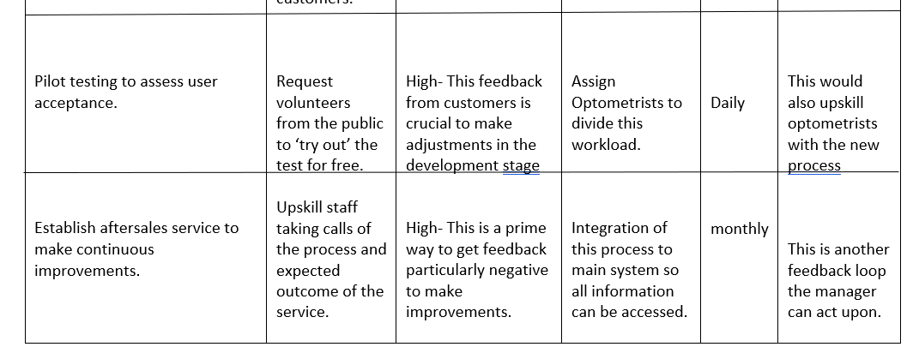

5.0. REFERENCES.
20/20 Now (2020) ‘Three Easy Steps to Implement Tele-Optometry into Your Practice’ 20/20 Now [Blog] 4th May [Online] Available at https://for2020now.com. (Accessed 29/3/2021)
Amabile, T.M, Conti, R, Coon, H, Lazenby, L and Herron, M (1996) ‘Assessing the Work Environment for Creativity’ Academy of Management Journal vol 39(5) p, 1154 [Online] Available at www.proquest.com. (Accessed 1/4/2021)
Ayling, J (2015) ‘Specsavers Brings in Staff Reward Scheme’ Optician Career-Long Support For Optical Professionals 15th July [Online] Available at www.opticianonline.net (Accessed 6/4/2021)
Bar Am, J, Furstenthal, L, Jorge, F and Roth, E (2020) ‘Innovation in a Crisis: Why it is More Critical Than Ever’ McKinsey & Company 17th June [Online] Available at www.mckinsey.com. (Accessed 29/3/2021)
Barbieri, J.C, Alvares, A.T.C (2016) ‘Sixth Generation Model: Description of a Success Model’ Innovation Management Review vol 13(2) pp, 116-127 [Online] Available at www.sciencedirect.com. (Accessed 12/4/2021)
Biznews (2020) The 4 P’s Innovation Space Model |Product | Process| Position| Paradigm Innovation [Online] Available at https://biznewske.com. (Accessed 7/4/2021)
Braemar Finance (2020) ‘Covid-19: Thoughts of the Optical Sector’ Braemar Finance 16th September [Online] Available at www.braemarfinance.co.uk. (Accessed 7/4/2021)
Burgoyne, P (2021) ‘Lesson’s from Specsavers’ IHA’ WDC [Blog] 4th January [Online] Available at www.wdc.-london.com. (Accessed 30/3/2021)
Business Case Studies (2019) ‘Job Roles at Specsavers’ Business Case Studies 25th September [Online] Available at https://businesscasestudies.co.uk. (Accessed 7/4/2021)
Business Insider (2013) ‘There’s A Critical Difference Between Creativity and Innovation’ Insider 10th April [Online] Available at www.businessinsider.com. (Accessed 3/4/2021)
CMI (2013) ‘Understanding Leadership Styles Checklist 256’ Chartered Management Institute November [Online] Available at www.managers.org.uk. (Accessed 8/4/2021)
Conlin, L (2020) ‘Tele-Optometry – What Do Patients Think?’ 20/20 July [Online] Available at https://www.2020mag.com. (Accessed 29/3/2021)
Contreras, B (2021) ‘Americans Show New Interest in Virtual Eye Care Options’ Managed Healthcare Executive 11TH February [Online] Available at www.managedhealthcareexecutive.com. (Accessed 2/4/2021)
Curated (2020) How Our Assurance Framework Helped Support Specsavers’ Customers Through Covid-19 [Online] Available at https://curated -digital.com. (Accessed 29/3/2021)
Chamorro-Premuzic, T (2015) ‘The Dark Side of Creativity’ Harvard Business Review 24th November [Online] Available at https://www.hbr.org. (Accessed 2/4/2021)
Davila, T, Epstein, M.J and Shelton, R.D (2013) Making Innovation Work How to Manage it, Measure it and Profit from its New Jersey: Pearson Education Inc [Online] Available at https://ptgmedia.pearsoncmg.com. (Accessed 6/4/2021)
Farnworth, D (2021) ‘What is Creativity? 21 Authentic Definitions You’ll Love’ Media Marketing Copy Blogger 8th January [Online] Available at www.media-marketing.com. (Accessed 5/4/2021)
Fullagar, P (2021) ‘Incremental vs. Radical: What’s the Future of Product Innovation? (ND) Design Council [Online] Available at www.designcouncil.org.uk. (Accessed 12/4/2021)
Healio (2018) ‘Tele-Optometry System Allows for Remote Eye Exams’ Primary Care Optometry News 20th March [Online Available at www.healio.com. (Accessed 1/4/2021)
Indeed (2021) Specsavers Employee Reviews in United Kingdom [Online] Available at ww.indeed.com. (Accessed 5/4/2021)
Innovation Development (2018) ‘Open Innovation vs. Closed Innovation’ [Blog] LEAD Innovation Management 3rd October [Online] Available at www.lead-innovation.com. (Accessed 10/4/2021)
Innovation Management (2021) Advantages and Limitations of the 4P Model Group 4 [Online] Available at https://pla55106group4.wordpress.com. (Accessed 15/4/2021)
Llopis, G (2014) ‘5 Ways Leaders Enable Innovation in Their Teams’ Forbes 7th April [Online] Available at www.forbes.com. (Accessed 7/4/2021)
Manning, J, Paxman, J, Blackwell, A and James, M (2016) A Discussion of the Potential Impact of Technology on the UK Optical Sector London: The Optical College of Optometrists [Online] Available at www.college-optometrists.org. (Accessed 4/4/2021)
Michaud, L (2021) ‘How Living a Life on a Screen During Covid-19 Affects Your Eyes’ The Conversation 11th March [Online] Available at https://theconversation.com (Accessed 4/4/2021)
Meissner, D and Kotsemir, M (2016) ‘Conceptualizing the Innovation Process Towards the ‘Active Innovation Paradigm ‘- Trends and Outlook’ Journal of Innovation and Entrepreneurship vol 5(14) [Online] Available at https://innovation-entrepreneurship.springeropen.com. (Accessed 15/4/2021)
Miller, L (2021) ‘Businesses that Thrive are Those that Adapt to Shifts in Consumer Behaviour’ Optometry Today 4th January [Online] Available at www.aop.org.uk. (Accessed 9/4/2021)
Mind Tools (2021) Force Field Analysis Analysing the Pressures for and Against Change [Online] Available at www.mindtools.com. (Accessed 6/4/2021)
Open Learn (2021) Handy’s Four Types of Organisational Culture Open University [Online] Available at www.open.edu. (Accessed 2/4/2021)
Optician (2020) ‘Tele-optometry- In the Time of Lockdown’ Optician Career-Long Support For Optical Professionals 26th June [Online] Available at www.opticianonline.net. (Accessed 20/3/2021)
R&D Today (2020) ‘Open Versus Closed Innovation: Are the Metrics Good Enough?’ Research and Development Management Association [online] Available at www.rndtoday.co.uk. (Accessed 3/4/2021)
Royal Geographical Society (2021) ‘Tackling the Digital Divide’ 21st Century Challenges [Online] Available at www.rgs.org. (Accessed 1/4/2021)
Simpson, P.M, Siguaw, J.A and Enz, C.A (2006) ‘Innovation Orientation Outcomes: The Good and the Bad’ Journal of Business Research vol 59(10) pp, 1133-1141 [Online] Available at https://ecommons.cornell.edu. (Accessed 6/4/2021)
Specsavers (2016-2017) Annual Report 2016-17 [Online] Available at www.specsavers.co.uk. (Accessed 5/4/2021)
Specsavers (2021) Experience Specsavers [Online] Available at https://joinspecsavers.com. (27/3/2021)
Specsavers (2021) The Specsavers Partnership [Online] Available at www.specsavers.co.uk. (Accessed 2/4/2021)
Thomassen, M.L, Logie, H and Basaiawmoit, R.V (2018) ‘Creativity, Invention, Innovation and Entrepreneurship, Connected in Theory Separated in Practice: Can We Strengthen Engineering Education by Understanding the Overlaps and the Differences Between the Four Concepts in an Educational Context’. 46th SEFI Annual Conference. European Society for Engineering Education (SEFI) [Online] Available at https://backend.orbit.dtu.dk. (Accessed 2/2/2021)
Tidd, J, and Bessant, J (2013) ‘Managing Innovation: Integrating Technological Market and Organisational Change’ Chapter 1 Innovation- What it is and Why it Matters? [Online] Available at www.researchgate.net. (Accessed 1/4/2021)
Topping, A (2021) ‘Care Homes in England: What’s Going to Change from 8 March?’ The Guardian 20th February [Online] Available at www.theguardian.com. (Accessed 2/4/2021)
Unison (2021) Furlough, Job Retention Scheme (JRS) and Redundancy Unison The Public Service Union [Online] Available at www.unison.org.uk. (Accessed 3/4/2021)
WeHealth (2021) Top Ten Telemedicine Myths WeHealth [online] Available at https://wehealth.nyc. (Accessed 2/4/2021)
Wright, M.R, Burns, C.R and Rothschild, M (2020) Telemedicine: The Time for Optometry is Now. USA: Review Optometric Business [Online] Available at https://reopeneyecare.com. (Accessed 1/4/2021)

