Context
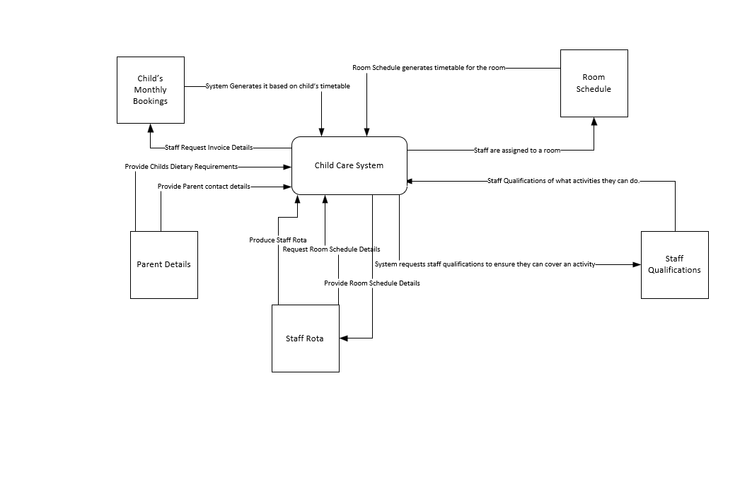

Level 0
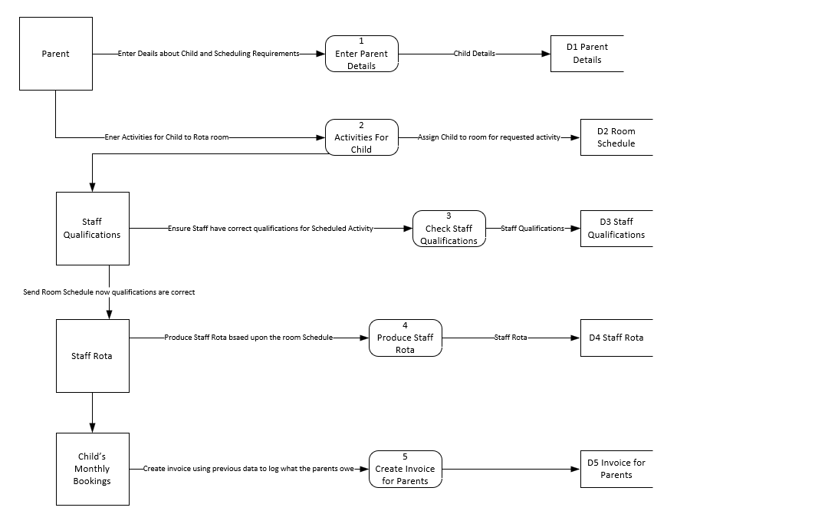

Level 1
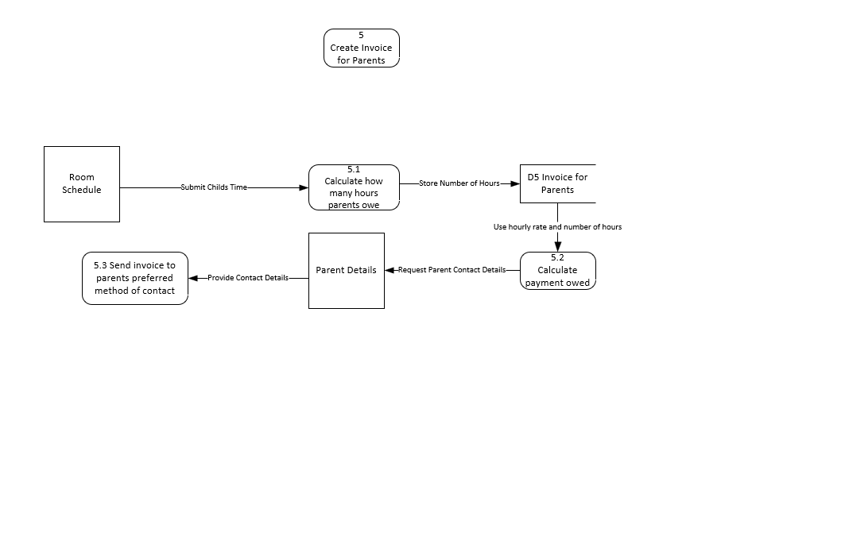

ERD
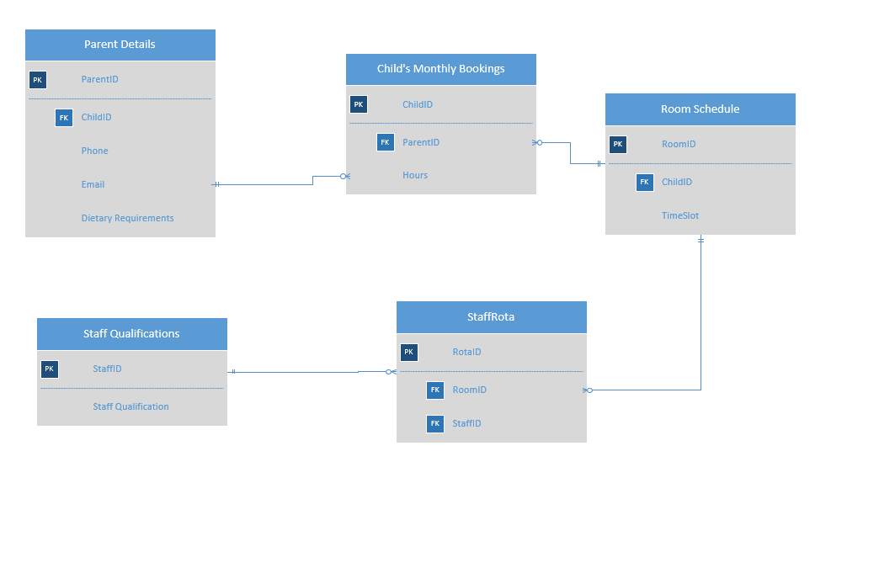

Parent Details
Parent Details has a one to many relationships with the Child’s Monthly Bookings. This is because a parent might have multiple children who may be in different days and this allows the system to recognized multiple children for one parent.

Child’s Monthly Bookings
Child’s monthly bookings has a many to one relationship with Parent Details as previously mentioned for the same reasons. The reason why room schedule has a one to many relationships with Child’s Monthly Bookings is so that the staff know where a child should be and what activity they should be in. This allows for a room to have multiple children.

Staff Rota
Staff Rota has many to one relationship with both Staff Qualifications and Room Schedule to ensure that the staff is qualified for an activity and to ensure that the rota can have multiple rooms and multiple staff as there is more than one room required. The rota combines the time slot with the Room and member of Staff.

