  Component One:  What are the key skills required when working in the housekeeping team? 750 words (+/- 10%)  Contribution to Overall Module Assessment: 25% | Student No: | 2212035
 | Module Title: | Operating Hotel Facilities
 | Module Code: | BMIH4006
 | Lecturer: | Lola Villard
Working in the housekeeping team requires a combination of technical skills, attention to detail, physical stamina, and strong interpersonal skills. Here are the key skills required to excel in a housekeeping role:
Cleaning and maintenance knowledge. Housekeeping staff members should have a solid foundation in cleaning and upkeep methods. The right cleaning techniques, careful handling of cleaning supplies and employees, and awareness of various surface materials' upkeep needs are all part of this. To maintain high standards of cleanliness and hygiene, they must be capable of doing duties including vacuuming, dusting, mopping, and sanitising surfaces. Housekeepers need to pay close attention to detail to make sure that rooms and common areas are fully cleaned and organised. They must be able to quickly identify any stains, dirt, or damage and fix it. A high quality of cleanliness and client pleasure are ensured by paying close attention to the little things. Efficiency in time management. Housekeeping personnel frequently face time restrictions, particularly during periods of high occupancy. To do duties in the time allocated, they need have outstanding time management abilities. For deadlines to be met and productivity to be maintained, job prioritisation, good work organisation, and multitasking are essential. Housekeeping requires a lot of physical strength because it requires continuous walking, lifting, and bending. To bear the physical demands of the job and sustain constant performance throughout the shift, energy and physical health are essential. Energy levels may be maintained, and injuries can be avoided with regular exercise and good body mechanics. Housekeepers need to be well organised to efficiently handle their task. This entails organising and prioritising work, keeping track of cleaning materials inventory, and making sure that all necessary amenities are provided in guest rooms. A methodical approach to work aids in efficiency maintenance and prevents supervision of any crucial duties. Effective communication is crucial for housekeeping personnel to cooperate with other departments, team members, and managers. Both vocally and in writing, they must be able to communicate effectively and professionally. Requests, instructions, and information are correctly understood and carried out when there is clear communication. The housekeeping team frequently deals with unanticipated problems or demands from visitors. They should be able to tackle problems quickly and come up with the best answers if they have strong problem-solving abilities. To solve problems and guarantee client happiness, quick thinking, adaptability, and creativity are important. Housekeepers often engage with visitors, co-workers, and other staff members. Positive visitor experiences are influenced by strong interpersonal skills, including friendliness, empathy, and patience. Inquiries, requests, and concerns from guests should be professionally handled by them, and they should be able to help or refer them to the right staff. Trustworthiness and secrecy are essential since housekeeping employees have access to visitors' private areas and belongings. They are required to uphold guests' privacy, respect their property, and handle any sensitive data or goods with tact and honesty. Collaboration and teamwork: housekeeping personnel frequently work as a team, helping one another to do duties quickly. For a successful operation and the maintenance of a pleasant work environment, it is crucial to operate as a team, collaborate with coworkers, and help when required. Developing and honing these skills can be achieved through on-the-job training, mentorship, and experience. Continuous learning and staying updated on the latest cleaning techniques and industry trends can further enhance the skills of housekeeping professionals. Customer service skills: While housekeepers primarily focus on cleaning and maintenance, they also interact with guests and contribute to their overall experience. Demonstrating excellent customer service skills, such as being friendly, courteous, and responsive, can make a positive impression on guests. Housekeepers should be approachable, attentive to guest needs, and willing to go the extra mile to ensure guest satisfaction. Flexibility and adaptability: The cleaning crew works in an environment that is always changing due to shifting schedules, varying visitor expectations, and unexpected occurrences. To deal with unanticipated events such as last-minute room alterations or urgent cleaning requests, flexibility and adaptability are essential. The ability to change priorities, perform well under pressure, and maintaining a good attitude in stressful circumstances are all skills that housekeepers should possess.

Word Count | 688

Component Two:
Contribution to Overall Module Assessment: 25%
In this scenario – You have just been promoted to team leader for a floor within the hotel. A guest complains that on their arrival, their room had not been properly cleaned. Create an action plan and answer the following questions.

Problem | Why did it happen? | What are you going to do? | How will you prevent this from happening in the future? | What measures would you introduce to improve team effectiveness?
The problem in this case is that a guest has complained that upon their arrival, their room was not properly cleaned. | Due to mistakes or a heavy workload, housekeeping personnel may have accidentally missed some cleaning jobs or locations in the room. Human mistake while cleaning might also be caused by distractions or fatigue. | I would personally apologize to the guest for the inconvenience and assure them that their feedback is valuable. Expressing empathy and understanding their frustration is important to establish a positive rapport and demonstrate a commitment to resolving the issue. | I would provide the members of the housekeeping team with extensive training on proper cleaning techniques, attention to detail, and the value of client happiness. Training would emphasise accuracy, reliability, and effective time management. In order to reinforce the training and address any particular areas for improvement, periodic refresher courses would be held. | The tasks and responsibilities of each team member within the housekeeping team should be clearly defined and communicated. This prevents misunderstanding and increases efficiency by ensuring that everyone is aware of their precise responsibilities and areas of accountability.
This indicates a lapse in the housekeeping operations, resulting in a guest experiencing a subpar level of cleanliness in their room. | The cleaning personnel could have been under pressure to finish their jobs if the hotel had a high occupancy rate or faced other operational difficulties. They may have prioritised efficiency above thoroughness in these situations, resulting in a lack of cleanliness. | In order to get more information on the cleaning problem, I would chat with the guest. I would pay close attention to their worries, take notes, and ask targeted inquiries to determine the scope and character of the issue. This will enable me to pinpoint the precise problems and find opportunities for development. | To guarantee accurate and fast information sharing, I would set up good communication lines between the housekeeping staff and front desk. To prevent misunderstandings or oversight, this would include accurate documentation of guest requests, updates on the condition of the accommodation, and any specific instructions. | For the team, establish clear objectives and performance standards. This might include goals for cooperation, production, guest satisfaction ratings, and cleaning requirements. The team is motivated when these objectives are communicated clearly, and it also provide performance evaluation criteria.
The problem needs to be addressed promptly to resolve the guest's concerns, ensure their satisfaction, and prevent similar incidents from occurring in the future. | It's possible that there was a communication failure between the front desk, housekeeping, and the person who arrived. It's possible that the front desk employees miscommunicated the guest's arrival or particular demands, which led to a delay or confusion with regard to room preparation. | If it were possible, I would provide the guest with a suggestion for a quick relief. This can entail switching to a cleaner room, checking and physically cleaning the room to their satisfaction, or making arrangements for the housekeeping staff to re-clean the room right away. The problem's immediate solution and the guest's comfort are the main priorities. | In order to maintain the criteria for cleanliness and guarantee loyalty to set processes, regular quality inspections would be carried out. This might entail conducting unexpected inspections, utilising checklists or standardised cleaning procedures, and giving the housekeeping staff guidance based on the findings. | To improve the abilities and knowledge of the team members, make investments in training and development programmes. Technical instruction in cleaning methods, customer service abilities, time management abilities, and leadership development could be included. Giving people the chance to learn and grow enhances both individual and group effectiveness.
It's important to investigate the specific circumstances surrounding the incident to determine the exact cause and address it accordingly. This may involve reviewing procedures, providing additional training or resources, improving communication channels, or implementing quality control measures to prevent similar issues in the future. | Housekeeping workers may not have been fully trained or properly supervised, which might have resulted in a lack of knowledge or abilities needed to carry out cleaning tasks. | I would determine the reasons why the room was not first cleaned thoroughly. I would talk to the housekeeper who was in charge of the room and get their opinion. I would analyse the usual cleaning practises, look for any errors or omissions, and determine whether there were any outside influences that made cleaning more difficult. | I would make sure the cleaning staff had access to sufficient and functional cleaning materials, tools, and equipment. To prevent shortages or equipment-related problems that can slow the cleaning process, routine maintenance and prompt inventory restocking would be put into place. | Giving team members regular performance feedback will assist them develop their abilities and performance. Individual coaching sessions, helpful criticism, and direction on areas for improvement may be part of this. Promoting a culture of continuous improvement helps team members advance their careers and improves the efficiency of the group.
 | The housekeeping staff's ability to uphold cleanliness standards may be affected by inadequate, broken down, or lacking cleaning materials. | Based on the findings, if training or resource deficiencies are identified, I would take necessary actions to address them. After resolving the immediate issue and implementing preventive measures, I would follow up with the guest to ensure their satisfaction and address any remaining concerns. This follow-up demonstrates a commitment to excellent service and provides an opportunity to rebuild trust and mitigate any negative impact caused by the initial issue. | Guest input from sources including internet reviews, comment cards, and questionnaires will be continuously monitored. This would give insightful information about the experiences of visitors and reveal any reoccurring issues with cleanliness. To fill up any gaps, make the required adjustments, and monitor development over time, feedback would be used. | Implementing in place a system for recognising and thanking achievements and outstanding performance of team members. This can entail recognising exceptional work, offering rewards, or setting up team-building exercises. The efficacy of the team is increased when team members' efforts are acknowledged and valued.

Component Three:
Contribution to Overall Module Assessment: 50%
Your task is to create and prepare a presentation following the detailed scenario provided below.

As the floor housekeeping manager and given the recent guest complaints you need to put together a basic training presentation for your colleagues within the housekeeping team to get the best out of them, ensure that brand standard is being achieved and that Health and Safety procedures are also being followed.

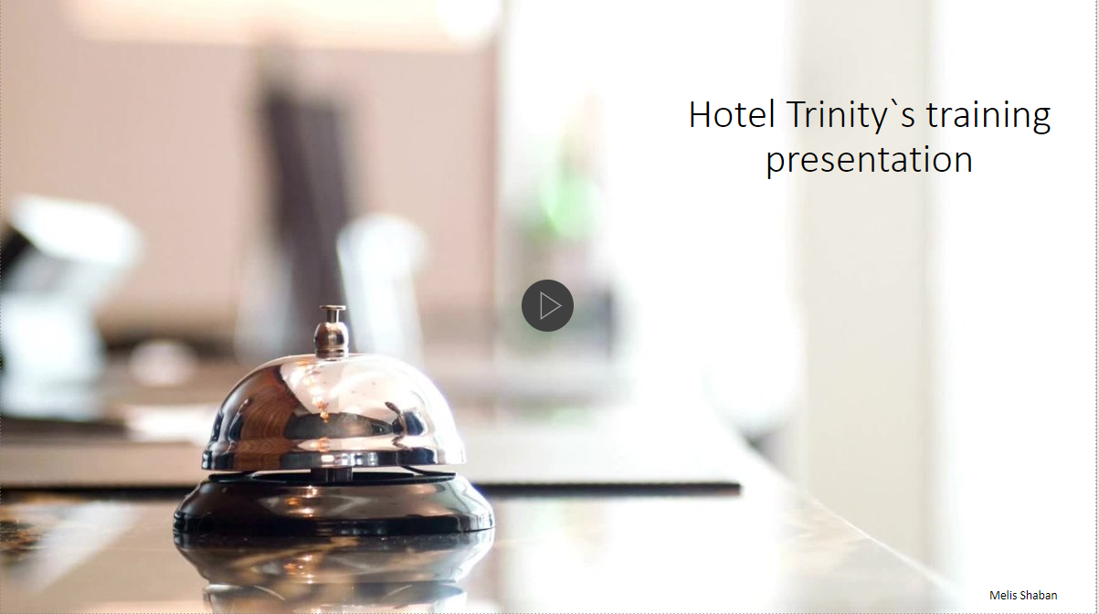

Training Notes:
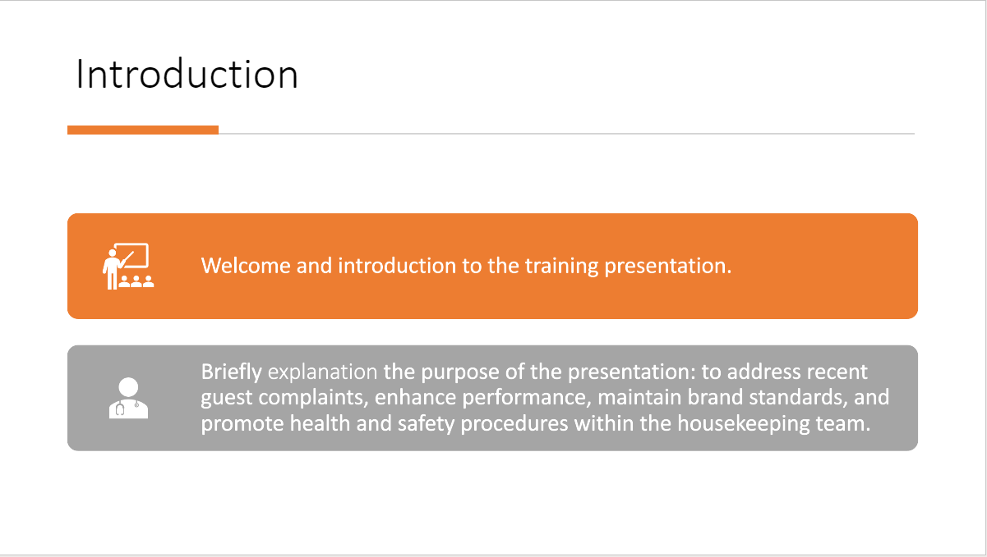

Training Notes:
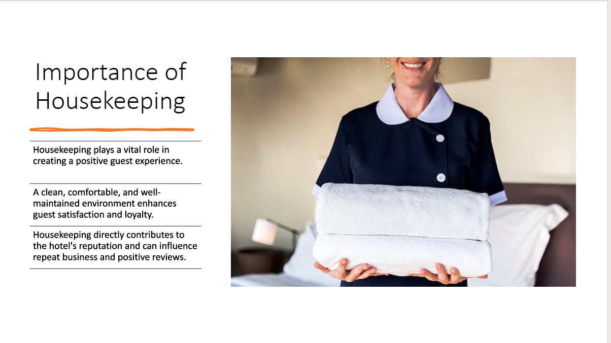

Training Notes:
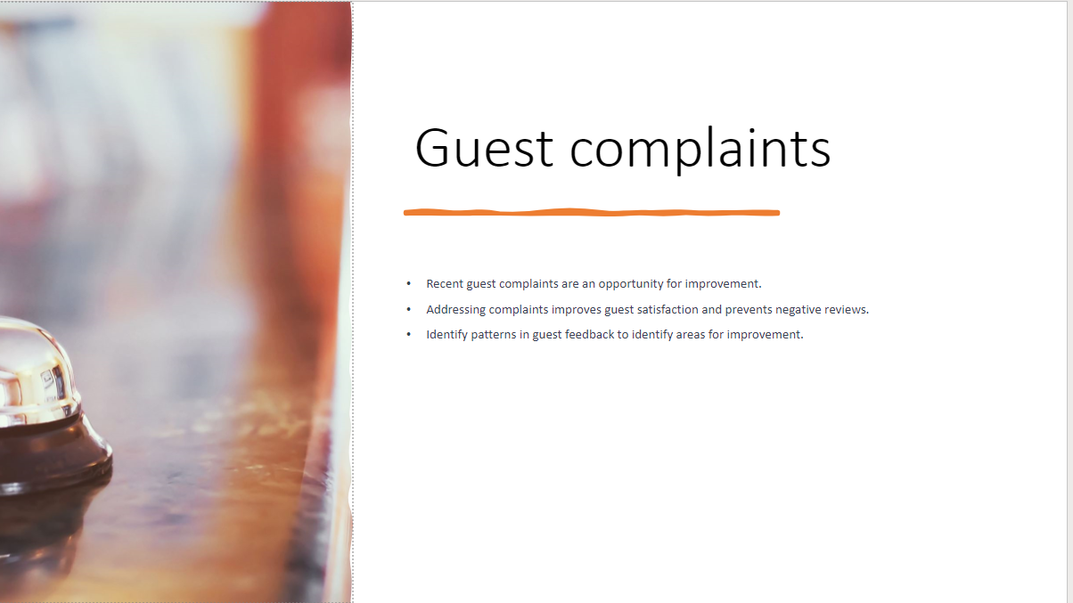

*Discuss the recent guest complaints and their impact on the hotel.
*Explain how addressing these complaints can help improve guest satisfaction and prevent negative reviews.
*Emphasize the importance of identifying patterns in guest feedback to identify areas for improvement.

- Adhering to brand standards maintains the hotel's image and reputation.
- Hotel cleanliness is one of the chief driving factors in guests booking a stay at your property. Recent surveys show that the cleanliness, safety, and hygiene practices at a hotel are of top concern to the modern traveler. Today’s hotels are expected to maintain high levels of cleanliness across hotel spaces to meet guest satisfaction standards.
- Clean guest rooms is just one piece of the puzzle.
- The goal of every housekeeping team should be spotless facilities through the entire guest journey. The public areas at your hotel, such as the front desk, lobby, bar, or waiting areas are the first spaces your guests see when entering your property. Since first impressions are so important, it’s necessary to have regular cleaning procedures and scheduled housekeeping for these public areas.

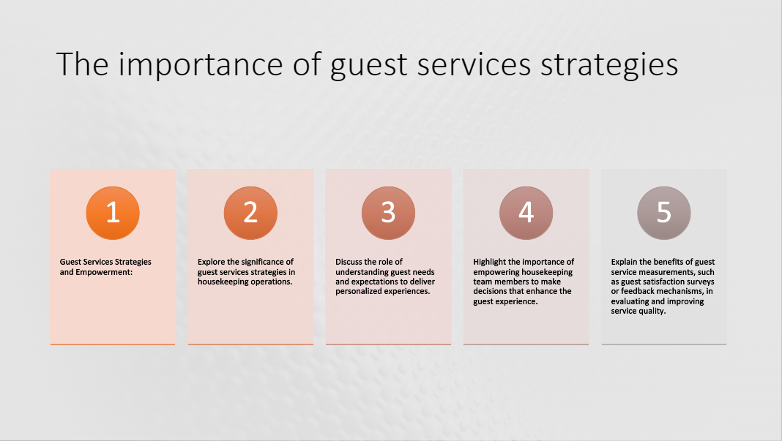

- Guest Services Strategies and Empowerment:
- Explore the significance of guest services strategies in housekeeping operations.
- Discuss the role of understanding guest needs and expectations to deliver personalized experiences.
- Highlight the importance of empowering housekeeping team members to make decisions that enhance the guest experience.
- Explain the benefits of guest service measurements, such as guest satisfaction surveys or feedback mechanisms, in evaluating and improving service quality.

Training Notes:
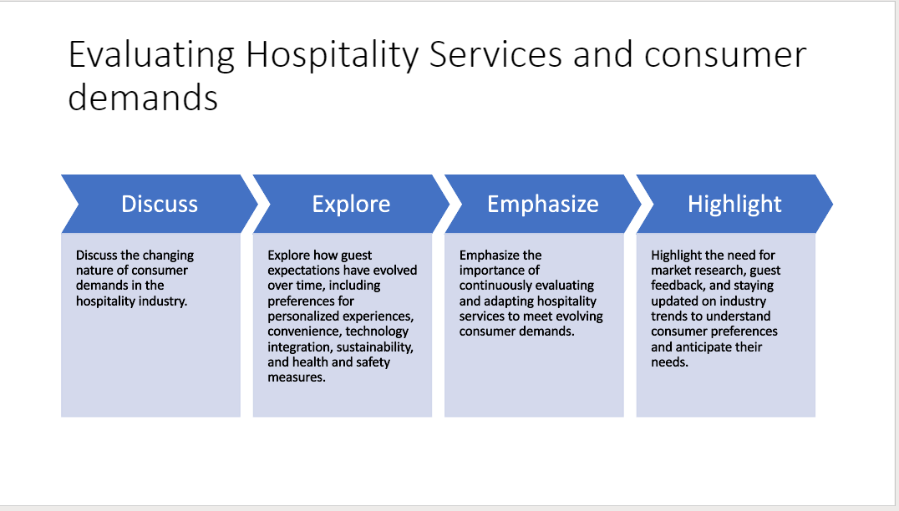
- Discuss
  - Discuss the changing nature of consumer demands in the hospitality industry.
- Explore
  - Explore how guest expectations have evolved over time, including preferences for personalized experiences, convenience, technology integration, sustainability, and health and safety measures.
- Emphasize
  - Emphasize the importance of continuously evaluating and adapting hospitality services to meet evolving consumer demands.
- Highlight
  - Highlight the need for market research, guest feedback, and staying updated on industry trends to understand consumer preferences and anticipate their needs.

Training Notes:
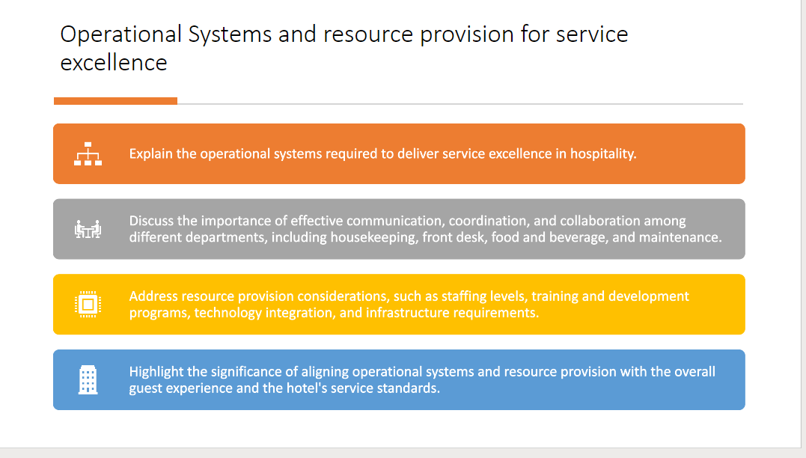

- Explain the operational systems required to deliver service excellence in hospitality.
- Discuss the importance of effective communication, coordination, and collaboration among different departments, including housekeeping, front desk, food and beverage, and maintenance.
- Address resource provision considerations, such as staffing levels, training and development programs, technology integration, and infrastructure requirements.
- Highlight the significance of aligning operational systems and resource provision with the overall guest experience and the hotel's service standards.

Training Notes:

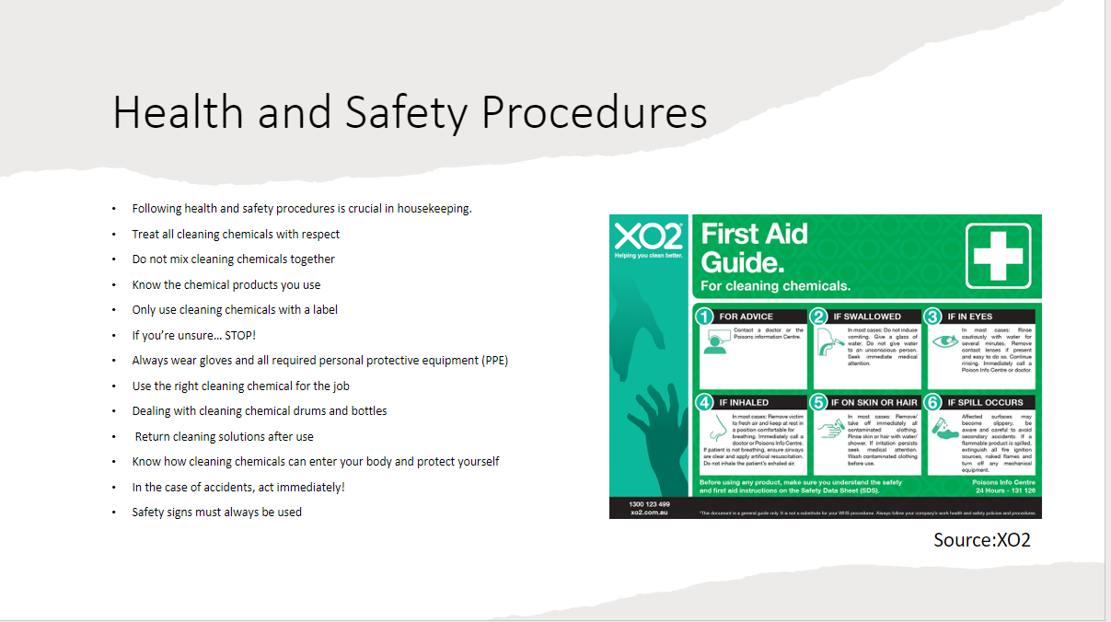
- Highlight the significance of following health and safety procedures in housekeeping.
- Discuss specific procedures related to handling cleaning chemicals, proper lifting techniques, and PPE usage.
- Explain the importance of these procedures in maintaining a safe working environment for both employees and guests.
- Following health and safety procedures is crucial in housekeeping.
- Treat all cleaning chemicals with respect
- Do not mix cleaning chemicals together
- Know the chemical products you use
- Only use cleaning chemicals with a label
- If you’re unsure… STOP!
- Always wear gloves and all required personal protective equipment (PPE)
- Use the right cleaning chemical for the job
- Dealing with cleaning chemical drums and bottles
- Return cleaning solutions after use
- Know how cleaning chemicals can enter your body and protect yourself
- In the case of accidents, act immediately!
- Safety signs must always be used

Training Notes:
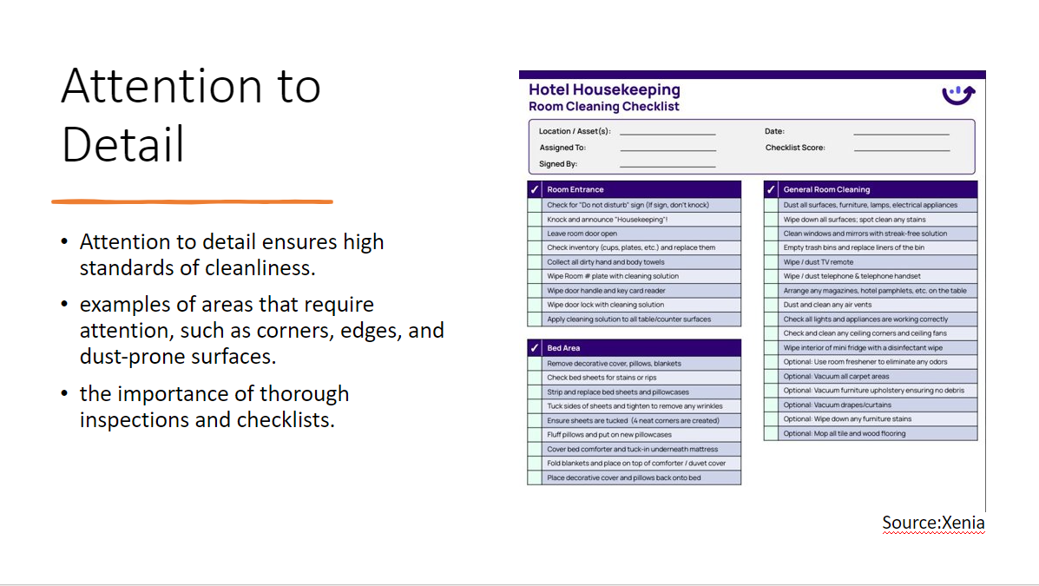
- Explain why attention to detail is crucial in housekeeping tasks.
- Provide examples of areas that require attention, such as corners, edges, and surfaces prone to dust accumulation.
- Discuss the impact of thorough inspections and checklists in ensuring high standards of cleanliness.

- Attention to detail ensures high standards of cleanliness: examples of areas that require attention, such as corners, edges, and dust-prone surfaces.
- The importance of thorough inspections and checklists.

Training Notes:
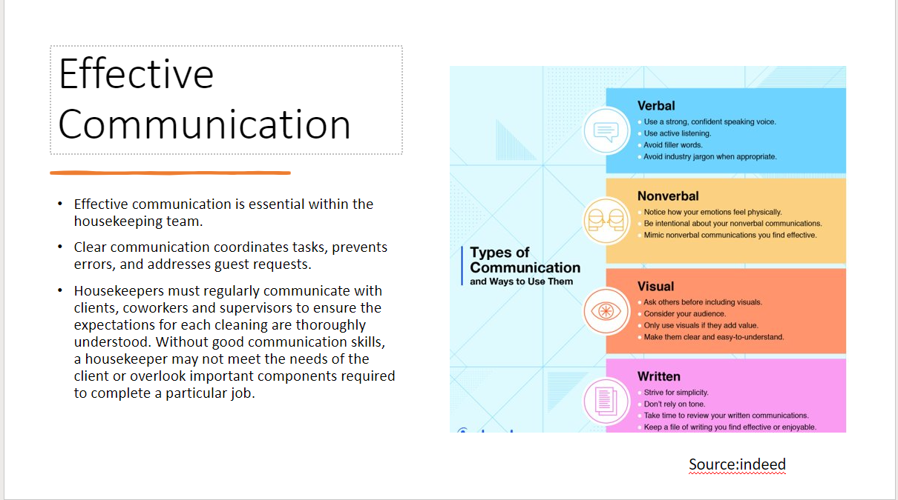
- Explain the importance of effective communication within the housekeeping team.
- Discuss how clear communication helps in coordinating tasks, preventing errors, and addressing guest requests.
- Provide examples of communication tools and techniques, such as radios, task assignment boards, and team huddles.

- Effective communication is essential within the housekeeping team.
- Clear communication coordinates tasks, prevents errors, and addresses guest requests.
- Housekeepers must regularly communicate with clients, coworkers and supervisors to ensure the expectations for each cleaning are thoroughly understood. Without good communication skills, a housekeeper may not meet the needs of the client or overlook important components required to complete a particular job.

Training Notes: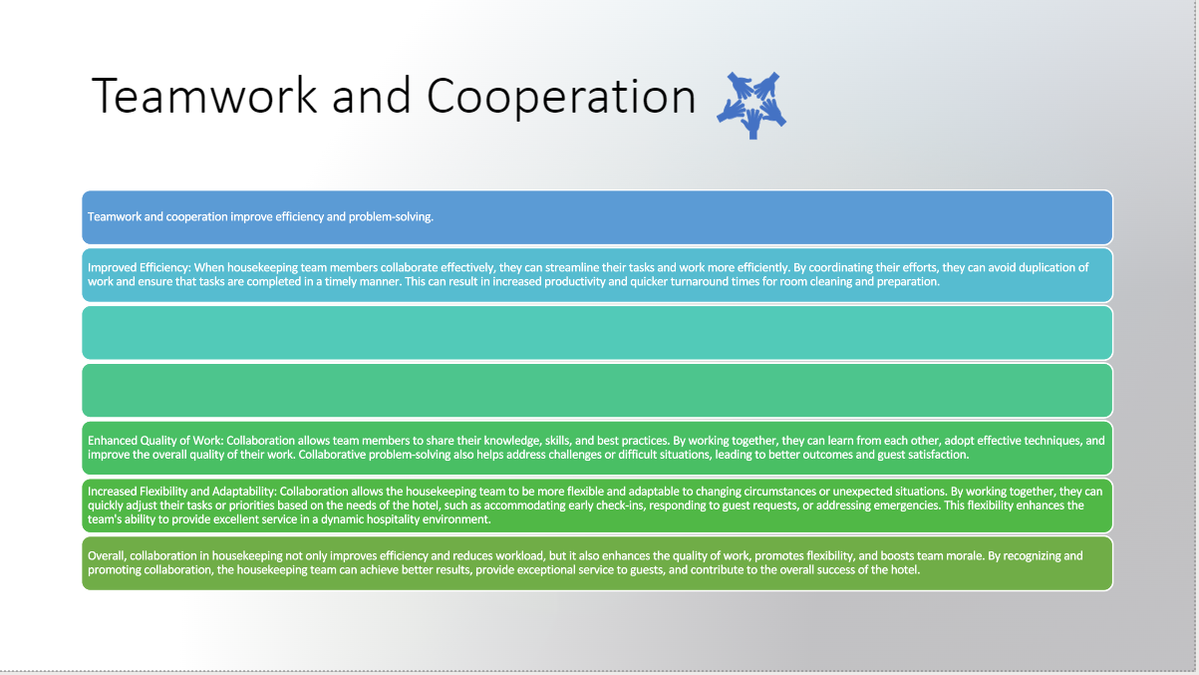
Highlight the benefits of teamwork and cooperation in housekeeping operations.
- Discuss how collaboration improves efficiency, reduces workload, and enhances problem-solving.
- Provide examples of team-building activities, cross-training opportunities, and ways to recognize and appreciate team members' contributions.
- Teamwork and cooperation improve efficiency and problem-solving.
- Improved Efficiency: When housekeeping team members collaborate effectively, they can streamline their tasks and work more efficiently. By coordinating their efforts, they can avoid duplication of work and ensure that tasks are completed in a timely manner. This can result in increased productivity and quicker turnaround times for room cleaning and preparation.
- Enhanced Quality of Work: Collaboration allows team members to share their knowledge, skills, and best practices. By working together, they can learn from each other, adopt effective techniques, and improve the overall quality of their work. Collaborative problem-solving also helps address challenges or difficult situations, leading to better outcomes and guest satisfaction.
- Increased Flexibility and Adaptability: Collaboration allows the housekeeping team to be more flexible and adaptable to changing circumstances or unexpected situations. By working together, they can quickly adjust their tasks or priorities based on the needs of the hotel, such as accommodating early check-ins, responding to guest requests, or addressing emergencies. This flexibility enhances the team's ability to provide excellent service in a dynamic hospitality environment.
- Overall, collaboration in housekeeping not only improves efficiency and reduces workload, but it also enhances the quality of work, promotes flexibility, and boosts team morale. By recognizing and promoting collaboration, the housekeeping team can achieve better results, provide exceptional service to guests, and contribute to the overall success of the hotel.

Training Notes:
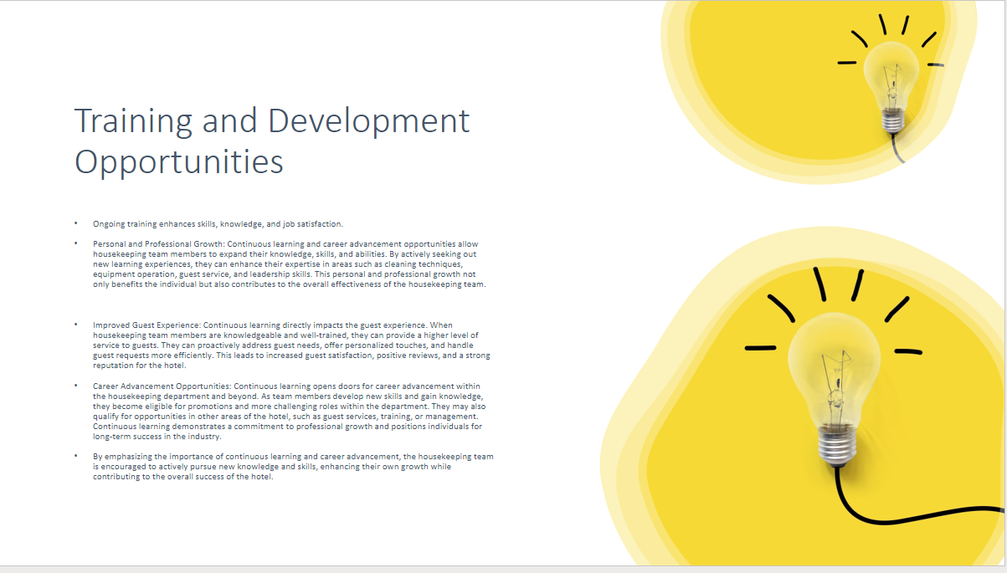

- Highlight the benefits of teamwork and cooperation in housekeeping operations.
- Discuss how collaboration improves efficiency, reduces workload, and enhances problem-solving.
- Provide examples of team-building activities, cross-training opportunities, and ways to recognize and appreciate team members' contributions.

- Ongoing training enhances skills, knowledge, and job satisfaction.
- Personal and Professional Growth: Continuous learning and career advancement opportunities allow housekeeping team members to expand their knowledge, skills, and abilities. By actively seeking out new learning experiences, they can enhance their expertise in areas such as cleaning techniques, equipment operation, guest service, and leadership skills. This personal and professional growth not only benefits the individual but also contributes to the overall effectiveness of the housekeeping team.

- Improved Guest Experience: Continuous learning directly impacts the guest experience. When housekeeping team members are knowledgeable and well-trained, they can provide a higher level of service to guests. They can proactively address guest needs, offer personalized touches, and handle guest requests more efficiently. This leads to increased guest satisfaction, positive reviews, and a strong reputation for the hotel.
- Career Advancement Opportunities: Continuous learning opens doors for career advancement within the housekeeping department and beyond. As team members develop new skills and gain knowledge, they become eligible for promotions and more challenging roles within the department. They may also qualify for opportunities in other areas of the hotel, such as guest services, training, or management. Continuous learning demonstrates a commitment to professional growth and positions individuals for long-term success in the industry.
- By emphasizing the importance of continuous learning and career advancement, the housekeeping team is encouraged to actively pursue new knowledge and skills, enhancing their own growth while contributing to the overall success of the hotel.
Training Notes:

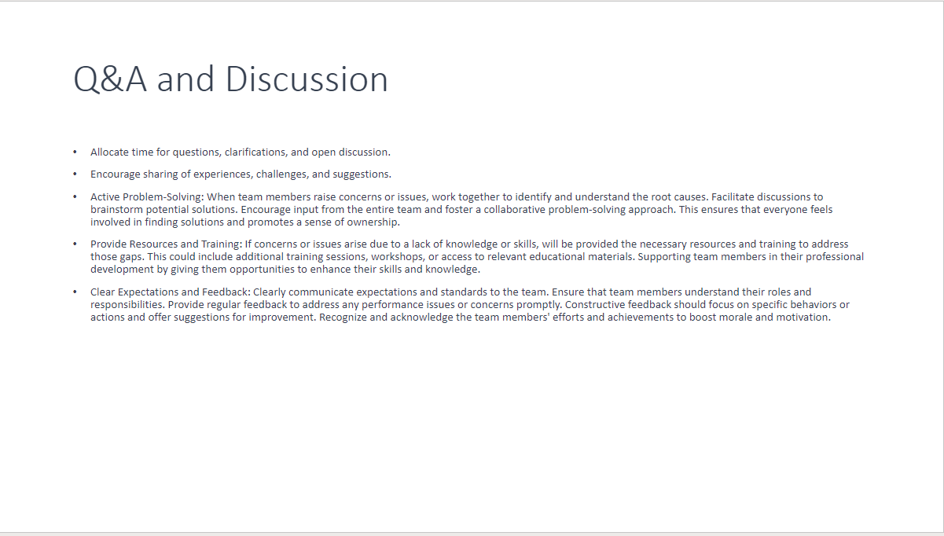
- Allocate time for questions, clarifications, and open discussion.
- Encourage sharing of experiences, challenges, and suggestions.
- Active Problem-Solving: When team members raise concerns or issues, work together to identify and understand the root causes. Facilitate discussions to brainstorm potential solutions. Encourage input from the entire team and foster a collaborative problem-solving approach. This ensures that everyone feels involved in finding solutions and promotes a sense of ownership.
- Provide Resources and Training: If concerns or issues arise due to a lack of knowledge or skills, will be provided the necessary resources and training to address those gaps. This could include additional training sessions, workshops, or access to relevant educational materials. Supporting team members in their professional development by giving them opportunities to enhance their skills and knowledge.
- Clear Expectations and Feedback: Clearly communicate expectations and standards to the team. Ensure that team members understand their roles and responsibilities. Provide regular feedback to address any performance issues or concerns promptly. Constructive feedback should focus on specific behaviors or actions and offer suggestions for improvement. Recognize and acknowledge the team members' efforts and achievements to boost morale and motivation.

Training Notes:
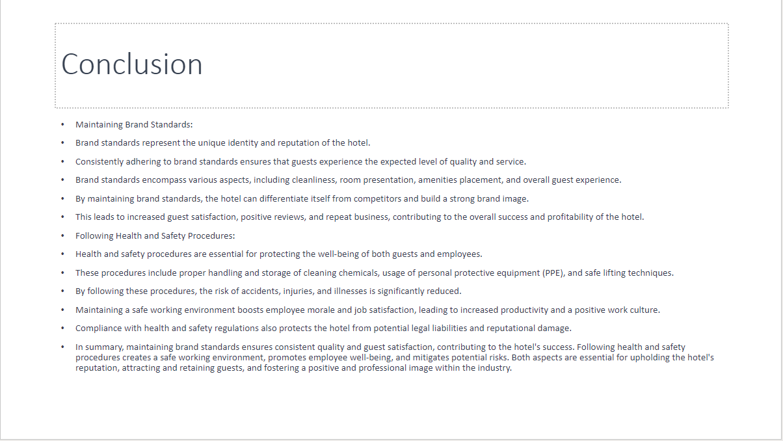
- Maintaining Brand Standards:
- Brand standards represent the unique identity and reputation of the hotel.
- Consistently adhering to brand standards ensures that guests experience the expected level of quality and service.
- Brand standards encompass various aspects, including cleanliness, room presentation, amenities placement, and overall guest experience.
- By maintaining brand standards, the hotel can differentiate itself from competitors and build a strong brand image.
- This leads to increased guest satisfaction, positive reviews, and repeat business, contributing to the overall success and profitability of the hotel.
- Following Health and Safety Procedures:
- Health and safety procedures are essential for protecting the well-being of both guests and employees.
- These procedures include proper handling and storage of cleaning chemicals, usage of personal protective equipment (PPE), and safe lifting techniques.
- By following these procedures, the risk of accidents, injuries, and illnesses is significantly reduced.
- Maintaining a safe working environment boosts employee morale and job satisfaction, leading to increased productivity and a positive work culture.
- Compliance with health and safety regulations also protects the hotel from potential legal liabilities and reputational damage.
- In summary, maintaining brand standards ensures consistent quality and guest satisfaction, contributing to the hotel's success. Following health and safety procedures creates a safe working environment, promotes employee well-being, and mitigates potential risks. Both aspects are essential for upholding the hotel's reputation, attracting and retaining guests, and fostering a positive and professional image within the industry.

Training Notes:
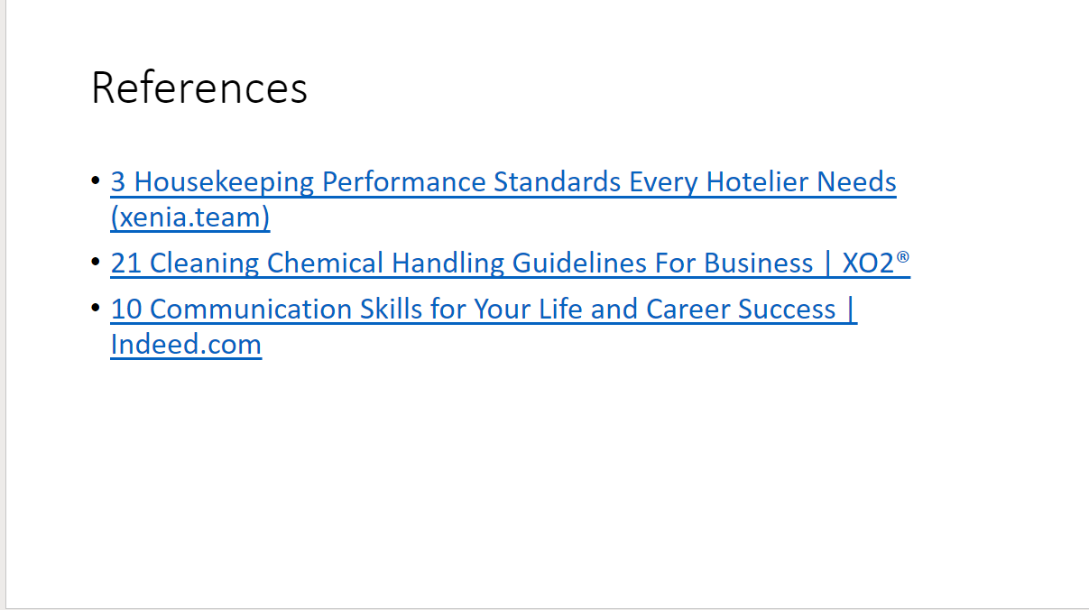

References:

Hotel Quality Standards. (n.d.). Available at: https://www.theaa.com/~/media/the-aa/hotel-services/scheme-documents/hotels/aa-hotel-quality-standards-2018.pdf?rev=ee58ce2d6d0843578c928df13d4dc223&hash=872A296ABCC19DC2EAE37DB77BD3C8BF [Accessed 22 May 2022].
Oracle (2021). What is Customer Loyalty. [online] Oracle.com. Available at: https://www.oracle.com/uk/cx/marketing/customer-loyalty/what-is-customer-loyalty/.
Otar, C. (n.d.). Council Post: How Review Sites Can Affect Your Business (And What You Can Do About It). [online] Forbes. Available at: https://www.forbes.com/sites/forbesfinancecouncil/2018/10/05/how-review-sites-can-affect-your-business-and-what-you-can-do-about-it/?sh=7eb8d3ca266a
Snehal Mistry (2018). How to Deal with 13 Common Challenges in the Hotel Industry? - eZee Absolute. [online] eZee Absolute. Available at: https://www.ezeeabsolute.com/blog/how-to-deal-with-challenges-in-hotel-industry/.
‌www.revinate.com. (n.d.). How to Respond to Negative Hotel Reviews - Revinate. [online] Available at: https://www.revinate.com/blog/how-to-respond-to-negative-hotel-reviews/.

Presentation Reference:
‌ Cycles, T. text provides general information S. assumes no liability for the information given being complete or correct D. to varying update and Text, S.C.D.M. up-to-Date D.T.R. in the (n.d.). Topic: Hotel industry worldwide. [online] Statista. Available at: https://www.statista.com/topics/1102/hotels/#statisticChapter.
hospitalityinsights.ehl.edu. (n.d.). Evaluating hotel performance: 6 key factors. [online] Available at: https://hospitalityinsights.ehl.edu/evaluating-hotel-performance.
Indeed Editorial Team (2018). Communication Skills: Definitions and Examples | Indeed.com. [online] Indeed.com. Available at: https://www.indeed.com/career-advice/resumes-cover-letters/communication-skills.
Kefgen, K. and Houran, J. (2018). 4 characteristics of successful teams and how to make them work for you. [online] Hotel Management. Available at: https://www.hotelmanagement.net/operate/how-hospitality-leaders-can-foster-effective-teamwork.
ProProfs Help Desk Blog. (2022). What is Hotel Customer Service? [online] Available at: https://www.proprofsdesk.com/blog/hotel-customer-service/.
Tiernan, D. (2022). What are health and safety protocols in hotels? - Amenitiz Blog. [online] Amentiz. Available at: https://www.amenitiz.com/en/blog/health-and-safety-protocols-in-the-hospitality-industry/.
www.ramsaytodd.co.uk. (n.d.). Attention To Detail In Hospitality. [online] Available at: https://www.ramsaytodd.co.uk/article/18/Attention-to-detail/ [Accessed 11 Jun. 2023].
www.voxer.com. (n.d.). The Importance of Effective Communication in your Hotel. [online] Available at: https://www.voxer.com/The-Importance-of-Effective-Communication-in-your-Hotel.
www.xenia.team. (n.d.). 3 Housekeeping Performance Standards Every Hotelier Needs. [online] Available at: https://www.xenia.team/articles/hotel-housekeeping-performance-standards.
XO2® Pty Ltd. (2023). 21 Cleaning Chemical Handling Guidelines For Business | XO2®. [online] Available at: https://xo2.com.au/blog/articles-2/21-cleaning-chemical-handling-guidelines-for-your-workplace-253.

