A Critical Analysis of the Relationship Between Gender Marketing and Stereotypes
  - Business Management

  - 19.11.18

Table of Contents

1. Introduction 1
1.1 Background 2
1.2 Rational 3
1.3 Aims and Objective 4

2. Research Design 5
2.1 Methodology 5
2.2 Paradigm 6
2.3 Research Approach 6
2.3.1 Research Collection 6
2.3.2 Research Analysis 6
2.4 Limitations 7
2.5 Ethical Risks 7

3. Resources and Planning 8
3.1 Resources 8
3.1 Gantt Chart 8

5. Bibliography 9

1. Introduction

This dissertation will be analysing the relationship between gender marketing and gender stereotypes. The two are very closely interlinked and this will be examined within the piece of work with the aid of primary and secondary research.

1.1 Background
Marketing has been defined by McCarthy (2014) as being built up by four main elements. These four variants are said to be; price, place, product, and promotion. Each element of this marketing mix creates marketing as a whole with the mail aim to sell a product or a service. The purpose of this marketing is said to capture the attention of a customer and to increase awareness of a business and its’ products (McCarthy, 2014). Gendered marketing is, as the name would suggest, marketing which is aimed at a customer in accordance to the gender that they identify with. An example of this is found in the marketing of razors for hair removal in women. Razors were originally created for men to shave their beards, however when men went to war in the early 1900s razor companies needed to market to a new consumer type in order to keep their companies running. With the men at war women were left being back in their home countries; razor companies took notice of this and in 1915 the first women’s razor was invented. After this magazines started running ads where women had hairless armpits, and due to this idea that women should shave their armpits and legs began (Barringer, 2013). With this, the social norm for women changed therefore changing the stereotype of women. From this point onwards women were expected to be hairless. From this example it is shown that marketing shapes the stereotype of women as the marketing team decided that they would change their target audience, which in turn changed stereotypes.
Due to a wider understanding of gender in recent society, the idea of gender and gender stereotypes has become more and more complicated. According to the Cassandra Gender Report, 60% of people aged between 14 and 34 have said that ‘the lines of gender have been blurred’ meaning that there is less of a need to conform to gender stereotypes and typical gender roles (Follows, 2017). As these boundaries of gender stereotypes change, the marketing of products is also changes. An example of this can be found in the store John Lewis. They have recently re branded their children’s clothing range so that, up to the age of 14, all their clothes will be gender neutral (Williams, 2017). This has created controversial views within the consumers, ranging from full support to people claiming that it is not politically correct. Chris McGoven, who is part of the Campaign for Real Education, claims that it risks confusing children and can be dangerous to ‘gender identity theft’ (Newbold, 2017). Members of the LGBT+ have been seen to show a lot of support, as gender plays a big part in this demographic, and the breaking down of gender would also break down what separates those who are in the LGBT+ and those who are not.
In 2018 the Advertising Standards Association (ASA) introduced a new rule to ensure that any harmful gender stereotyping will be taken away from marketing campaigns. Their definition of harmful gender stereotypes consists of scenarios such as people failing at tasks due to their gender and adverts that emphasise difference in personality between males and females. Showing such stereotypes within marketing has the potential of causing harm to the viewers as it is it reinforcing stereotypes which can make people feel like they can’t make certain choices or be present themselves in certain ways (CAPNews, 2018). This shows that the way in which items were gendered does create a mirroring effect on society, and that this amount of influence on the wider public should be monitored.

1.2 Rational
Due to the research found above, and the new rules in gendered marketing, the subject area is growing and becoming a wider area for research. However, the effects of gender marketing on adults are much less researched than that in children. All of these factors have been taken into account, and thus formed the basis of this research. The dissertation will focus on the age groups 18-25, and how gendered marketing has affected them. There has also been a recent legislation passed by the ASA which has not been analysed which could be beneficial to research into gender marketing; this has been discussed in the literature review (CAPNews, 2018).

1.3 Aims and Objectives
The overall aim of this dissertation is to explore the relationship between gender marketing and stereotypes and the extent to which they influence each other. This will include primary research in order to meet the following objectives:
- To undertake a review of the literature exploring the history of gender marketing

- To examine the extent to which gender marketing influences stereotypes through undertaking of qualitative primary research

- To identify whether using gender stereotypes for marketing purposes is effective in today’s society through the analysis of primary data.

2. Research Design

2.1 Methodology
The term research has been defined as a systematic study that explores a hypothesis or a theory in order to enlighten facts and come to new conclusions (Punch, 2016). There are different theories that can be followed in order to conduct research. An example of this is ‘The Research Onion’ which was developed by Saunders (2009) as see below in Figure 1.
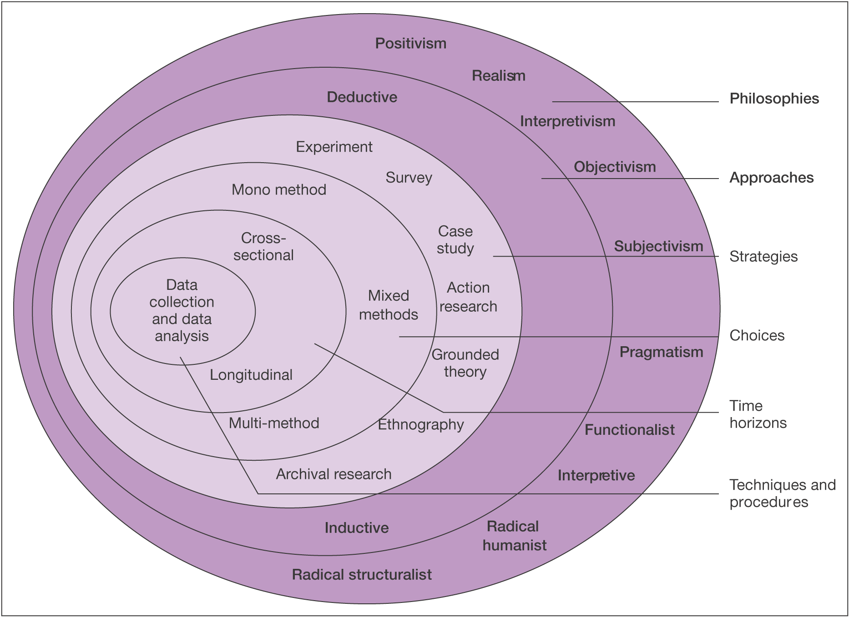
Figure 1: The Research Onion, Source: (Saunders, et al., 2009)
The Research Onion is made up of different layers which indicate different stages of research. The centre of the onion is data collection and data analysis; this is the first stage of using the research onion. After this stage, a systematic pathway can be found in order to create a successful outcome of the research question. (Saunders et al., 2009). It will also ensure that the research is conducted in the correct way as it gives a step by step guide. For this study a cross-sectional, mono method approach will be used. An inductive analysis will be used in the analysing of the data due to the nature of the mixed method study including interviews, and focus groups.
.

2.2 Paradigm
Factual knowledge can be seen to only be gained through the use of observation (Saunders et al., 2009). Being scientifically accurate is essential when conducting a research study. There are multiple methods which can be used in order to interpret and collect data. The first method is through the positive approach. The positive approach is mostly used in studies where data collection is quantitative. Due to this, this approach is not the most suited to the study that is being conducted in this research dissertation. The second approach is interpretivism. This method is more suited to qualitative research. This approach takes into consideration human interests. This method separates the real world from ones social world, and analyses it as such (Saunders et al., 2009). Due to the nature of this research, and the methods including interviews and focus groups, this method is the most suited.

2.3 Research Approach

2.3.1 Research Collection
This research will be conducted in the form of four focus groups with approximately 5 people in each discussion. This will be split into gender demographics, one with men, one with women, one that is mixed gender and one that is made up of LGBT+ people. It has been separated this way to minimise bias and to ensure the data collected is as accurate as possible. Three people from these focus groups will be selected for an in depth interview, they will be selected through observation of their depth of opinion and experience on the subject. The participants will consist of students from the University of Wales Trinity Saint David aged over the age of 18. They will be willing volunteers selected through convenience sampling. This form of research is relevant to the study as it will create qualitative data which will benefit the study through the richness of data in relation to participant’s opinions.

2.3.2 Research Analysis
The data that will be collected will be qualitative data, which can be analysed through the use of inductive approaches. The ways in which the data will be analysed will be through a thematic approach. Themes will be identified within the data collected through focus groups and interviews. Quotes that are most important will be highlighted to explain views within the analysis of the research. The grouped themed that have the most popularity within the texts will be analysed further.

2.4 Limitations
There are limitations involved in this research in the form of time limitations and participant demographics. In order to complete the research within the time frame a Gantt chart has been created. The data collection, in the form of focus groups, will be collected over the space of 4 weeks, and the data will be analysed over a 5 week period (see Figure 2). This could limit the research as it is only a short amount of time and may not be fully conducted or analysed before the research is written up. The other limitation of the research is the demographic of the participants. Due to the larger demographic of universities being people aged between 18 – 25 it is likely that this will be the majority within the focus groups and interviews. This will not give a true reflection of the general population and could therefore create an unreliable outcome.

2.5 Ethical risks
Within this study, the extent of ethical risk involved is minimal. The research for this study will be in the form of focus groups and in depth interviews; all participants will be volunteers over the age of 18. All the data collected will be kept confidential and if a participant wishes to withdraw their data it will have to be discounted. The ethics form filled out prior to the research follows the OECD and BPS ethics guidelines which ensures that all that are involved within the study are protected from ethical risk (OECD, 2016).

3. Resources and Planning

3.1 Resources
To create this dissertation secondary data will be used; this will be in the form of previous research and relevant theories. Within the literature review section of the dissertation the secondary data will be analysed in order to create an understanding of the underlying information. The majority of the secondary data will be accesses through the university’s resources, such as the online library and physical books from the library. It was also consist of peer reviewed journals and relevant websites on the internet.

3.2 Gantt chart
The Gantt Chart is used by many researches to ensure that they are keeping to their timescale. It consists of activities such as completing a section of the research, along with a timescale and a date, so the researcher is aware of the time restrictions in place (Saunders, et al., 2009). Below is a Gantt Chart to track the timescale for this dissertation to ensure it is completed by 13th May 2019.
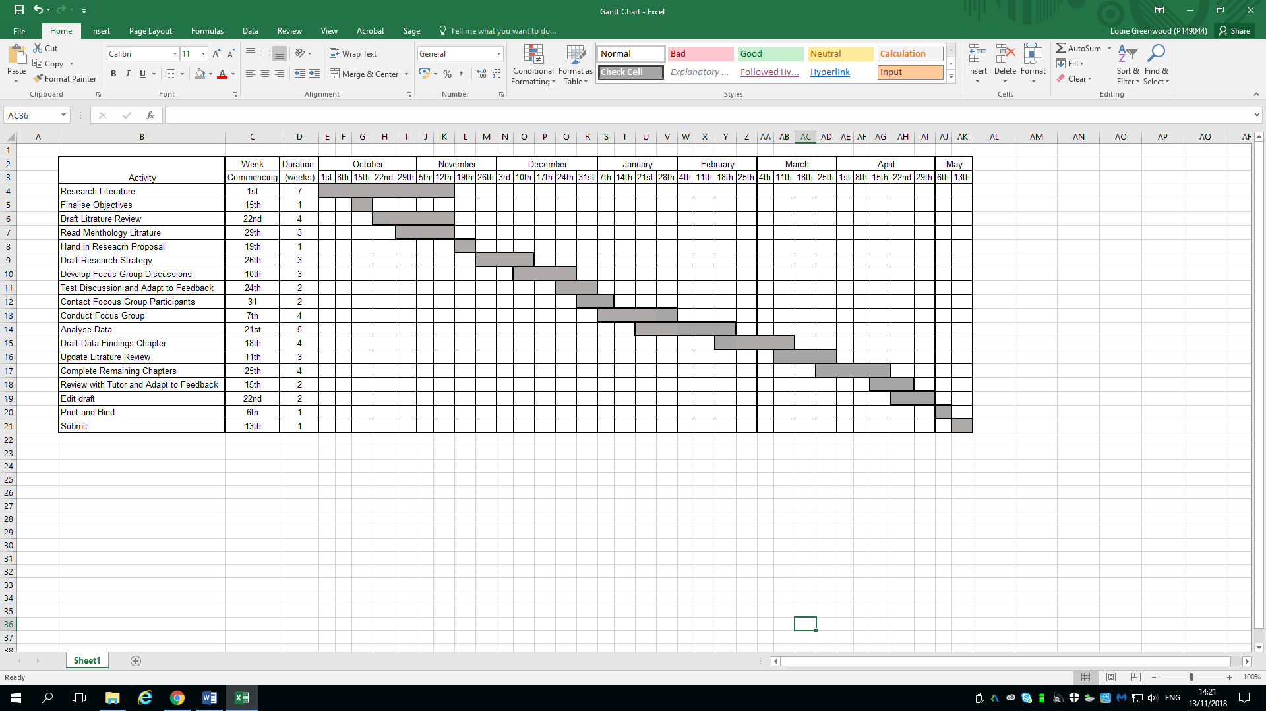
Figure 2: Gantt Chart

4. Bibliography

Anderson, E., 2006. Marketing Channels. 7th ed. s.l.:Prentice Hall.
Barringer, T., 2013. History of Hair Removal. [Online]
Available at: https://www.elle.com/beauty/makeup-skin-care/tips/g8155/history-of-hair-removal/?slide=5
[Accessed 10 November 2018].
CAPNews, 2018. Consulting on a new rule to tackle harmful gender stereotype. [Online]
Available at: https://www.asa.org.uk/news/consulting-on-a-new-rule-to-tackle-harmful-gender-stereotypes.html
[Accessed 11 November 2018].
Fine, C., 2018. “Why Does all the Girls have to Buy Pink Stuff?” The Ethics and Science of the Gendered Toy Marketing Debate. Journal of Business Ethics, 149(4), pp. 169-184.
Follows, T., 2017. The Future of Gender Marketing. [Online]
Available at: https://www.campaignlive.co.uk/article/future-gender-marketing/1442147
[Accessed 10 November 2018].
Francis, B., 2010. Gender, toys and learning. Oxford Review of Education, 36(3), pp. 325-344.
GFW, 2018. About GFW Clothing. [Online]
Available at: https://www.genderfreeworld.com/pages/about-us
[Accessed 11 November 2018].
Goffman, E., 1979. Gender Advertisements. 1st ed. New York: Harper & Row.
Healy, E., 2009. Profile: Gender stereotypes in MTV commercials: The beat goes on. Journal of Broadcasting & Electronic Media, 38(1), pp. 91-101.
Hobbs, T., 2017. Majority of Christmas toy catalogues play to gender stereotypes, study finds. [Online]
Available at: https://www.marketingweek.com/2017/12/06/christmas-toys-still-playing-to-gender-stereotypes-says-study/
[Accessed 10 November 2018].
Jones, M., 2017. The pros and cons of the rise of Gender Neutral clothing with this ultimate Gender Neutral Clothing Guide. [Online]
Available at: https://www.pinknews.co.uk/2017/11/24/the-pros-and-cons-of-the-rise-of-gender-neutral-clothing/
[Accessed 11 November 2018].
Klein, D., 2017. Why is gender stereotyping still such an issue for advertisers. [Online]
Available at: https://www.campaignlive.co.uk/article/why-gender-stereotyping-issue-advertisers/1447563
[Accessed 10 November 2018].
McCarthy, 2014. Basic Marketing: A Marketing Strategy Planing Approach. 19th ed. New York: McGraw-Hill/Irwin.
Moss, G., 2017. Gender, Design and Marketing. 1st ed. London: Routledge.
Newbold, A., 2017. Childrenswear Goes Genderless At John Lewis. [Online]
Available at: https://www.vogue.co.uk/article/john-lewis-genderless-childrens-wear
[Accessed 11 November 2018].
OECD, 2016. Research Ethics and New Forms of Data for Social and Economic Research, Paris: OECD Publishing.
Punch, K., 2016. Developing Effective Reseacrh Proposals. 3rd ed. London: SAGE Publications Inc. .
Saunders et al., 2009. Research methods for business students. Essex: Pearson Education Limited.
Saunders, M., Lewis, P. & Thornhill, A., 2009. Research Methods for Business Students. 5th ed. Essex: Pearson Education Limited.
Williams, R., 2017. John Lewis scraps 'boys' and 'girls' labels from children's clothes in bid to tackle gender stereotypes. [Online]
Available at: https://www.manchestereveningnews.co.uk/whats-on/family-kids-news/john-lewis-scraps-boys-girls-13564901
[Accessed 12 November 2018].
Zimmerman, D. H., 1987. Doing Gender. Gender & Society.

